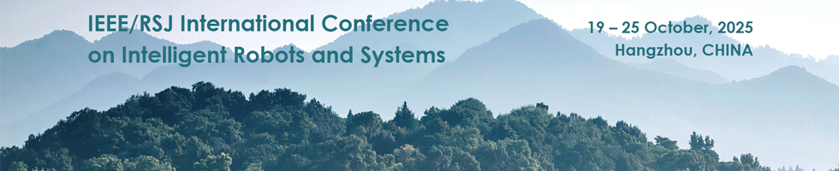
2025 IEEE/RSJ International Conference on Intelligent Robots and Systems (IROS 2025)
October 26, 2025

CERTIFICATE OF CONFERENCE ATTENDANCE
To Whom It May Concern,

This letter serves as official confirmation that [Given Name] [Family Name] attended the 2025 IEEE/RSJ International Conference on Intelligent Robots and Systems (IROS 2025). The conference took place from October 19 to October 25, 2025, in Hangzhou, China.

[Given Name] [Family Name] actively participated in various sessions and workshops during the conference, gaining valuable insights into the latest advancements in intelligent robotics and systems. The involvement in the event underscores a commitment to professional development and contribution to the field.

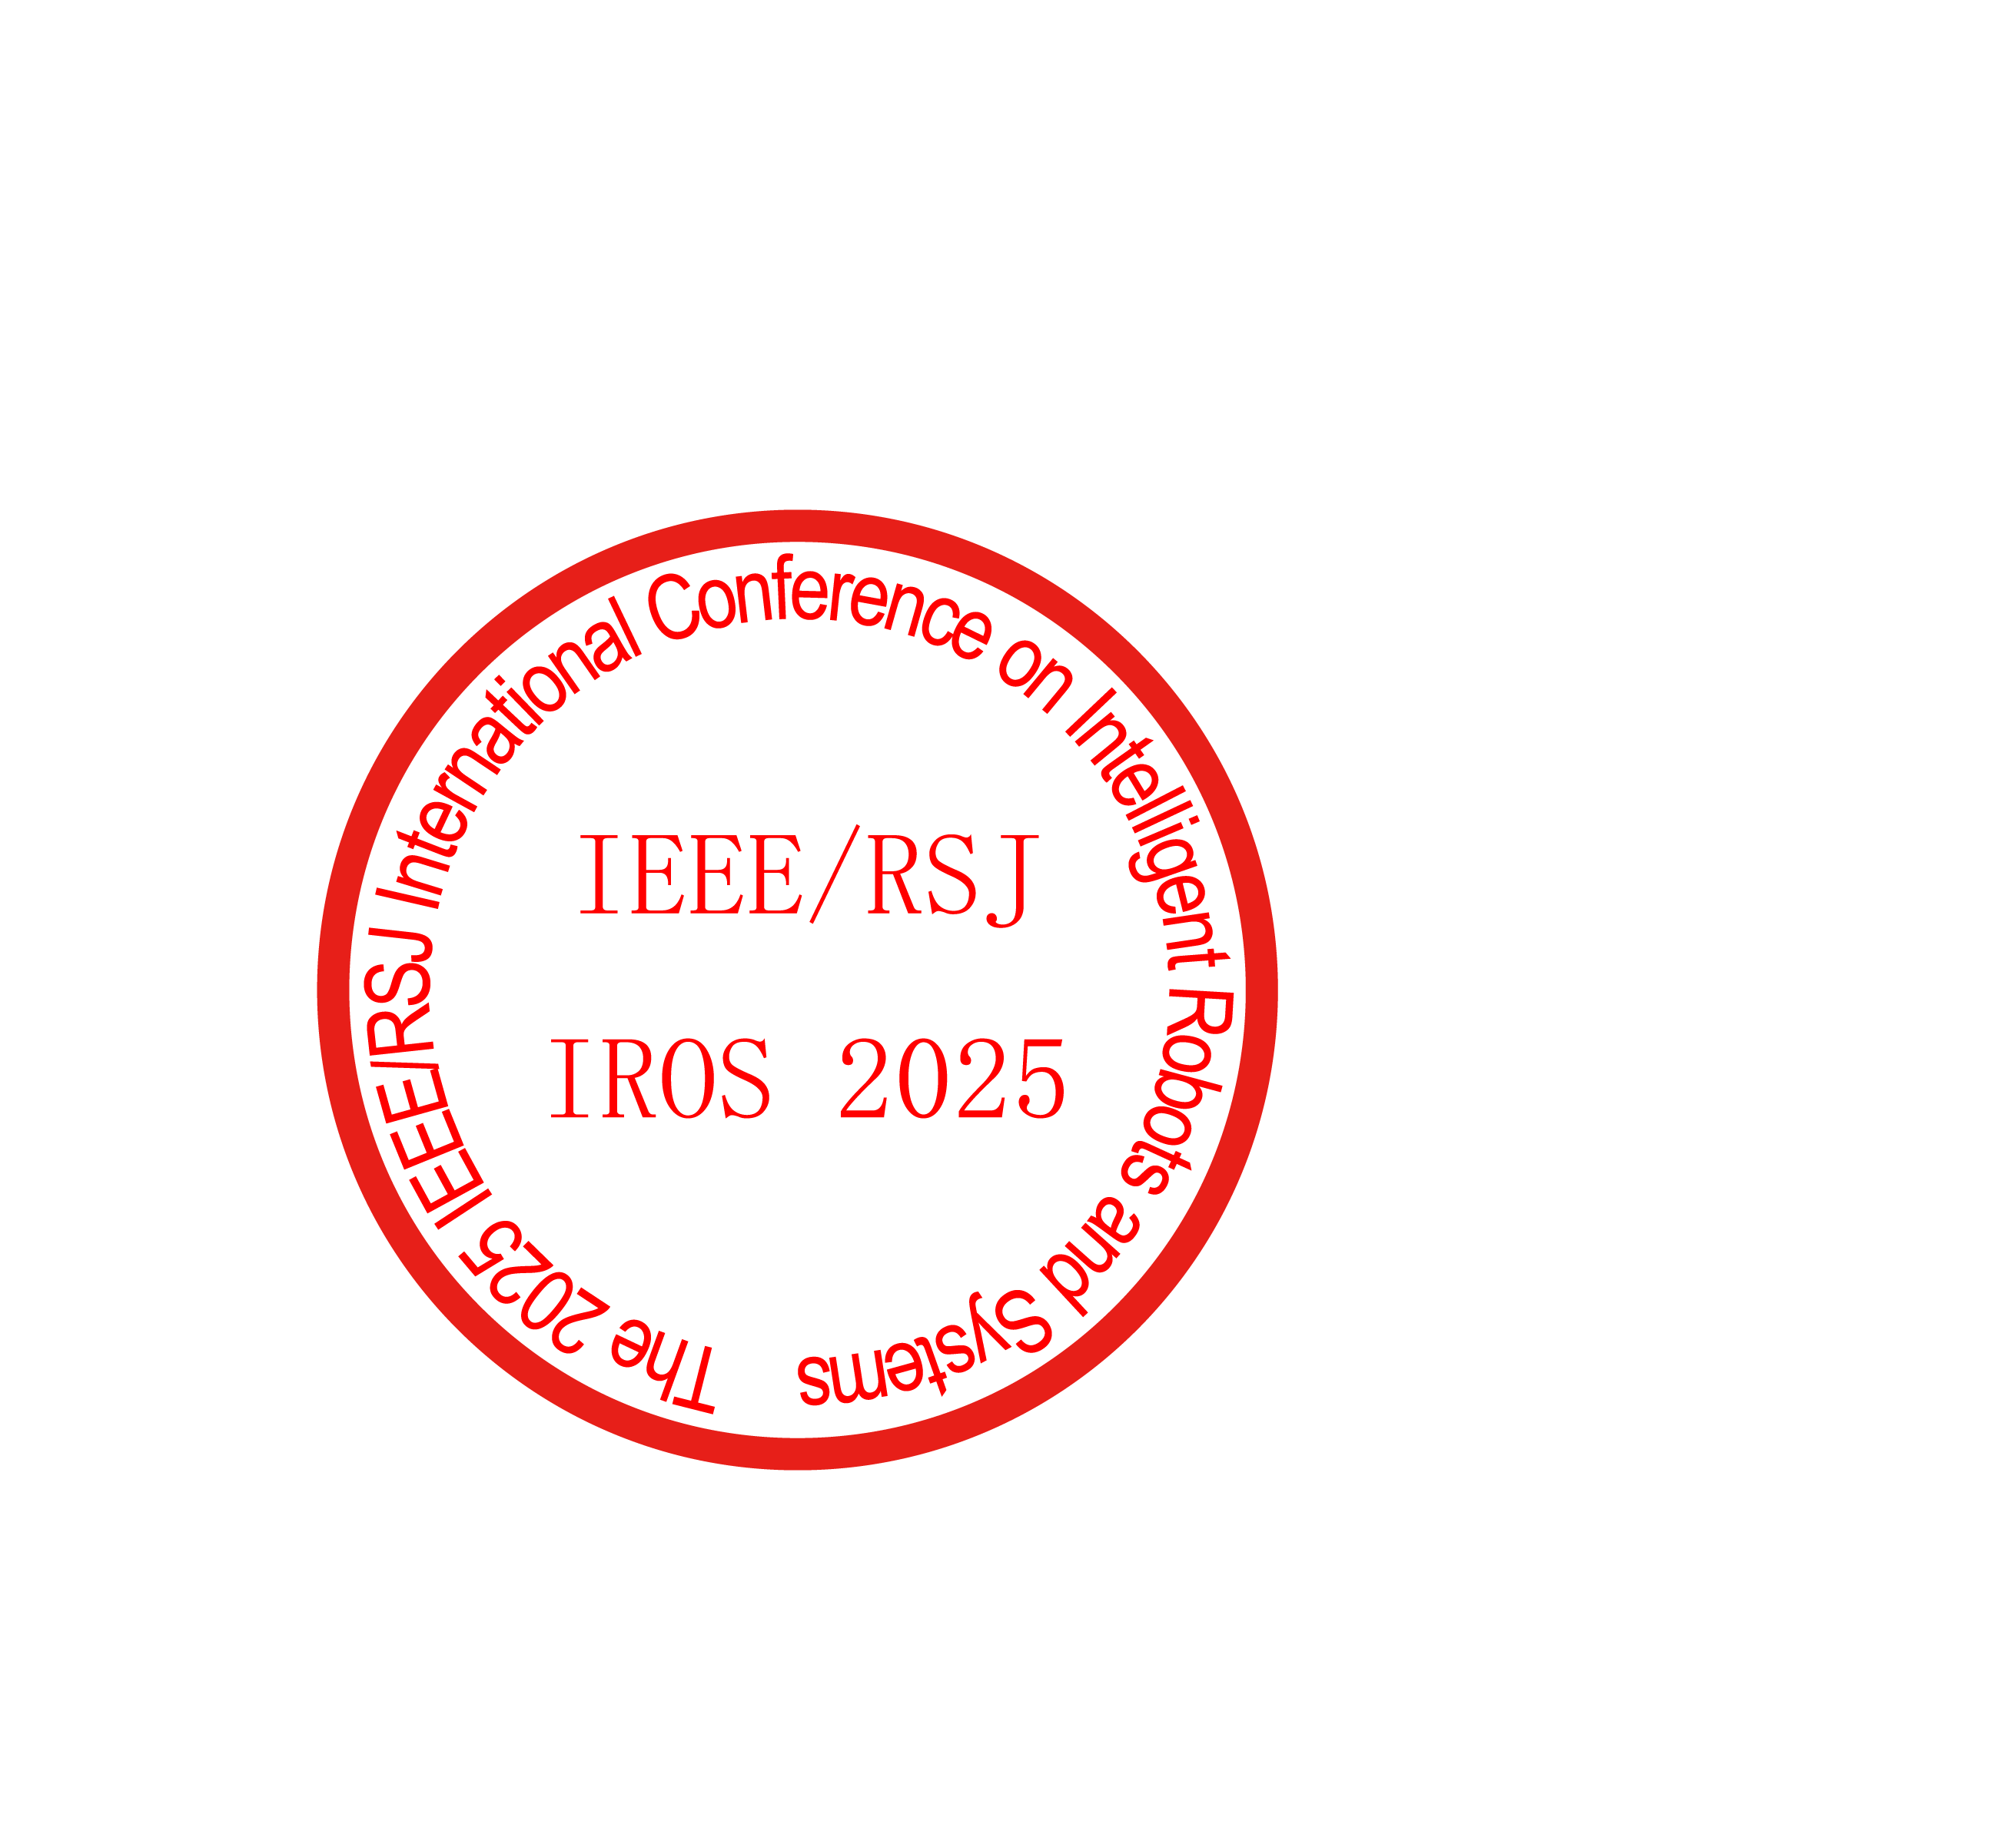
Should you require any further information or verification, please do not hesitate to contact us.


Sincerely,

Hesheng Wang
General Chair | IROS 2025
Email: wanghesheng@sjtu.edu.cn
Contact Phone: +86-2134207252
Address: Room 2-509, SEIEE Buildings, Shanghai Jiao Tong University,
Minhang District, Shanghai 200240, China

