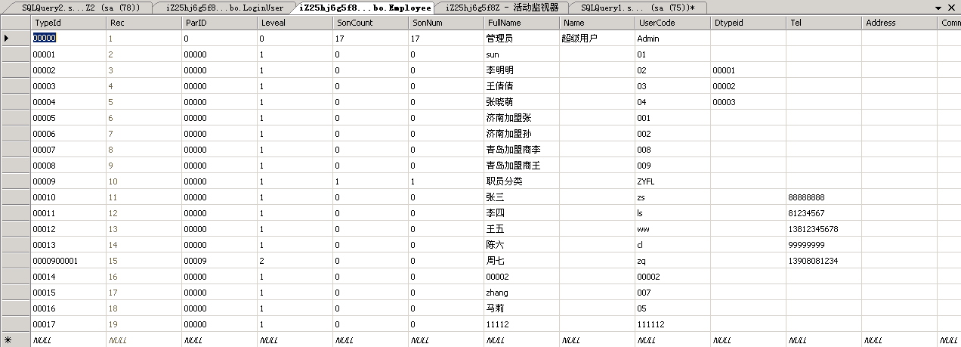
注：下文所说用户TypeId字段皆指Empleyee表对应的TypeId字段

(一)销售订单

1、生成销售编号

declare @p6 nvarchar(4000)
set @p6=N''
exec FN_VchNumber_Get @VchType=8,@Date=N'2015-12-25',@BranchId=N'',@PCName=N'127.0.0.1',@IsMustNoSame=0,@Number=@p6 output
select @p6

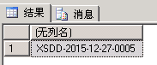

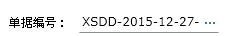

2、一级机构

exec FN_TCGetBCtypeTree @szparid=N'00000',@OperatorID=N'00002',@usertype=23,@where=N' 1=1 And selfhelp=0 '

BCtypeid | BCSonnum | BCFullName | BCUserCode | BCrec | btypeid | BranchType | parid | Branchid | selfHelp
机构标识 |  | 机构名称 | 机构编号

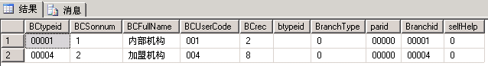
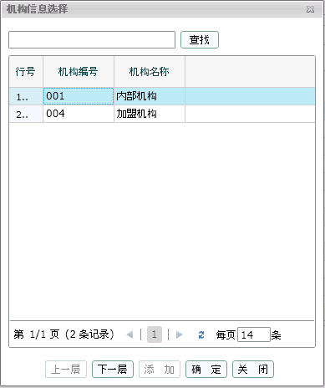

3、二级机构

exec FN_TCGetBCtypeTree @szparid=N'00001',@OperatorID=N'00002',@usertype=23,@where=N' 1=1 And selfhelp=0 '

BCtypeid | BCSonnum | BCFullName | BCUserCode | BCrec | btypeid | BranchType | parid | Branchid | selfHelp
机构标识 |  | 机构名称 | 机构编号

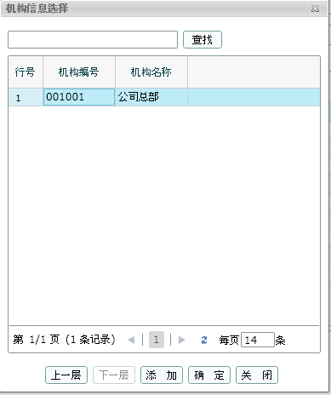

4、选择机构后选择经手人

exec FN_TCGetEtypeTree @szparid=N'',@BranchId=N'0000100001',@bDisplayStop=0,@OperatorID=N'00002',@shopid=N'0',@UserType=0,@where=N' 1=1 '

etypeid | esonnum | efullname | eusercode | erec | dtypeid | BranchID | parid | BctypeId | selfhelp | etel
职员标识 |  | 职员名称 | 职员编号

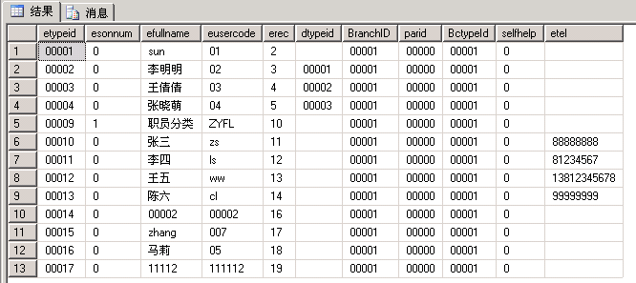

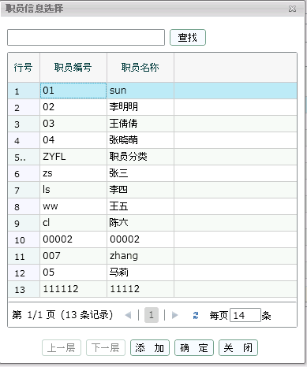

5、选择经手人后显示默认部门

Select typeid as dtypeid, fullname as dfullname, usercode as dusercode, sonnum as dsonnum, rec as drec, parid From department a Where typeid = (Select dtypeid From Employee Where typeid='00003')

dtypeid | dfullname | dusercode | dsonnum | drec | parid
部门标识 | 部门名称

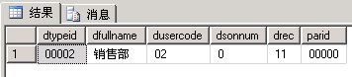

6、选择部门

exec FN_TCGetDeptTree @szparid=N'00000',@OperatorID=N'00002',@BranchId=N'0000100001',@where=N' 1=1 '

dtypeid | dsonnum | dfullname | dusercode | drec | parid | branchid | selfhelp
部门标识 |  | 部门名称 | 部门编号

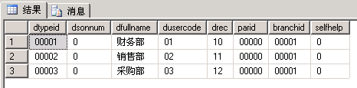

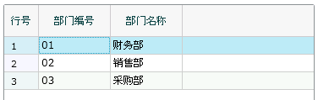

7、选择一级客户

declare @p10 int
set @p10=1
exec FN_TCGetBtypeTree @usertype=2,@szparid=N'00000',@bHaveTotal=0,@OperatorID=N'00002',@Branchid=N'0000100001',@bDisplayStop=0,@where=N' 1=1 ',@PageNo=1,@PageSize=14,@itemCount=@p10 output
select @p10

btypeid | bsonnum | bfullname | busercode | brec | usertype | parid | selfhelp
客户标识 |  | 客户名称 | 客户编号

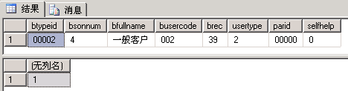

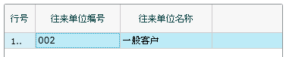

8、选择二级客户

declare @p10 int
set @p10=4
exec FN_TCGetBtypeTree @usertype=2,@szparid=N'00002',@bHaveTotal=0,@OperatorID=N'00002',@Branchid=N'0000100001',@bDisplayStop=0,@where=N' 1=1 ',@PageNo=1,@PageSize=14,@itemCount=@p10 output
select @p10

btypeid | bsonnum | bfullname | busercode | brec | usertype | parid | selfhelp
客户标识 |  | 客户名称 | 客户编号

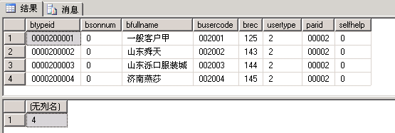

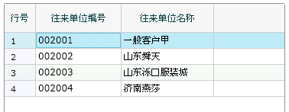

9、选择机构后显示默认仓库

SELECT TypeID,FullName FROM dbo.Stock WHERE BranchID='0000100001' AND Deleted='0' AND IsDefault='1'

TypeID | FullName
仓库标识 | 仓库名称

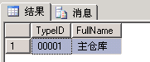

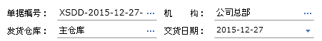

10、选择仓库

exec FN_TCGetKtypeTreeForWhere @usertype=31,@szparid=N'00000',@OperatorID=N'00002',@BranchId=N'0000100001',@where=N' 1=1 ',@hastransferstock=0

BCtypeid | ktypeid | kSonnum | kfullname | kUserCode | krec | BranchType | parid | bcusercode | bcfullname | selfhelp
 | 仓库标识 |  | 仓库名称 | 仓库编号 |  |  |  | 所属机构编号 | 所属机构名称

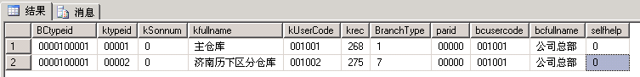
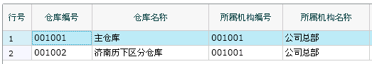

11、选择发货类型

select * from OperationInfo where OpType=1 and IsDel=0 and branchid like '00001%' order by opid

OpID | OpType | BranchID | AtypeID | IsDefault | IsSysDefault | SysCode | UserCode | OperName | IsControl | IsDel | Comment | CodeID
发货标识 |  |  |  |  |  |  |  | 发货类型

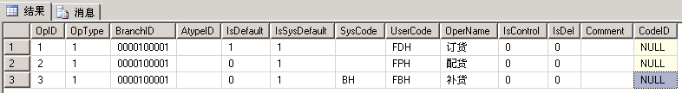
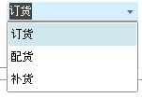

12、选择商品

declare @p10 int
set @p10=12
exec FN_TCGetPtypeTree @szparid=N'00000',@szktypeid=N'00001',@bHaveQty=0,@bDisplayStop=0,@selecttype=0,@OperatorID=N'00002',@where=N' 1=1 ',@PageNo=1,@PageSize=14,@itemCount=@p10 output
select @p10
Ptypeid | Psonnum | Pfullname | Pusercode | costmode | stop | standard | type | area | Prec | unit1 | unit2 | unitrate1 | barcode | sizeidlist | Coloridlist | porder | Parid | stocktype | accountingcourses
商品标识 |  | 商品名称 | 货号

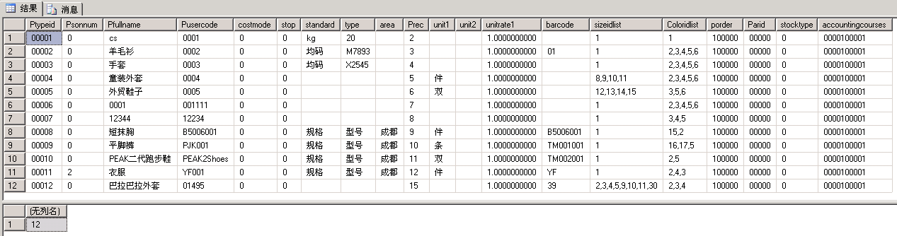

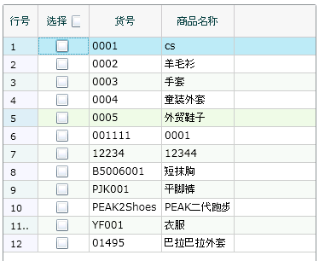

13、选择商品颜色

exec FN_TCGetPCtypeList @nSearchType=0,@sSearStr=N'%%',@szid=-1,@ktypeid=N'00001',@ptypeid=N'00008',@commtype=9,@bHaveQty=N'0'

PCFullName | PCUserCode | PCCOMMENT | PCREC | PCTYPEID
颜色名称 | 颜色条码 |  |  | 颜色标识

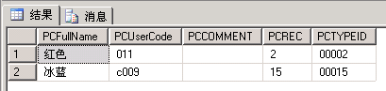

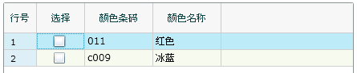

14、选择商品颜色后根据商品标识查询商品尺码（控制界面显示）

Select a.sizeid,b.name as sizename from PtypeSize a inner join Size b on a.SizeId=b.SizeId where a.PtypeId='00012' order by b.[order]

sizeid | sizename
尺寸标识 | 尺寸名称
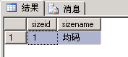
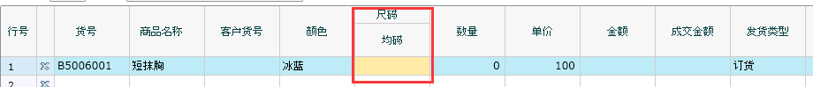

15、选择商品单价（可录入）

exec FN_FZGetPriceAndDiscount @ptypeid=N'00008',@priceMode=N'SR',@searStr=N'%%',@OperatorID=N'00002',@shopid=N'0'

DisplayName | price | PriceTypeID
售价类型 | 价格 | 售价类型标识

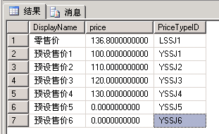

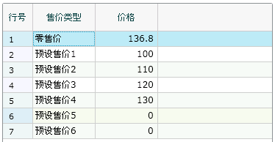

16、提交判断订单是否重复

declare @p5 nvarchar(4000)
set @p5=N'0'
exec FZGetVchNumber @nWork=1,@nVchtype=0,@szDate=N'0',@szNumberin=N'XSDD-2015-12-23-0001',@szNumber=@p5 output
select @p5

1-表示订单编号可用
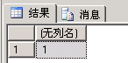

17、保存

declare @p1 dbo.tvpdlyndxorder
insert into @p1 values(0,N'1543140627735185292',N'2015-12-27',N'XSDD-2015-12-27-0005',8,N'0000200001',N'0000100001',N'',N'00003',N'00001',N'',N'00002',N'0',N'',0,N'',N'00002',N'2015-12-27',N'0',0,0,0,N'100',N'',N'0',0,N'摘要',N'附加说明',2,N'',N'',N'',N'',N'',0,N'0',N'',0,N'23',N'0',N'0',N'0',0,0,N'',N'0',N'运输方式',N'送货地址',N'联系人',N'联系电话','2015-12-27 18:00:00')

declare @p2 dbo.tvpBakDlyOrder
insert into @p2 values(0,0,N'1543140627735185292',8,N'0000100001',N'0000100001',N'0000200001',N'00003',N'00001',N'00002',N'00008',N'11',N'100.00',N'136.80',0,N'100',N'0',N'0.00',N'136.80',N'136.80',N'1504.80',N'2015-12-27',0,N'0.00',N'136.80',N'0.00',N'1504.80',N'0',0,0,N'0',0,15,0,N'0.00',N'1504.80',N'',N'',N'0',N'0',N'',0,0,N'',N'',N'',N'',N'',N'',1,N'1',0,1,N'0',N'0',N'136.80',N'0')

insert into @p2 values(0,0,N'1543140627735185292',8,N'0000100001',N'0000100001',N'0000200001',N'00003',N'00001',N'00002',N'00002',N'12',N'100.00',N'111.00',0,N'100',N'0',N'0.00',N'399.00',N'111',N'1332.00',N'2015-12-27',0,N'0.00',N'111.00',N'0.00',N'1332.00',N'0',0,0,N'0',0,3,0,N'0.00',N'1332.00',N'',N'',N'0',N'0',N'',0,0,N'',N'',N'',N'',N'',N'',1,N'1',0,2,N'0',N'0',N'111.00',N'0')

declare @p3 dbo.tvpBakDlyOrderDetail
insert into @p3 values(0,N'1543140627735185292',1,15,N'11',N'0',N'0.00',N'0',N'0.00',N'1504.80',N'1504.80',N'0.00',N'1504.80',1,N'0',N'0',N'0')
insert into @p3 values(0,N'1543140627735185292',1,3,N'12',N'0',N'0.00',N'0',N'0.00',N'1332.00',N'1332.00',N'0.00',N'1332.00',2,N'0',N'0',N'0')

exec SaveOrderBill @tvpDlyNdxOrder=@p1,@tvpBakdlyOrder=@p2,@tvpBakDlyOrderDetail=@p3,@Operator=N'00002'

如仍有疑虑，请看文档末尾“附：订单保存追加描述”。

18、保存单据最大值

exec FZModifyVchnumber @nVchtype=8,@Date='2015-12-28'

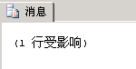

19、判断是否需要审核

exec FN_BillAudtingCheckReason_Order @vchcode=0123456789010231547,@BillIndexType=0,@OperatorID=N'00002'

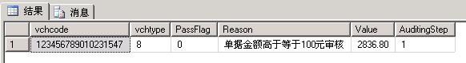

注，判断金额是否需要人工审核。如返回以上内容，则需要进行19步骤，否则不需要，自动形成已审单。


20、需审核执行此语句，形成待审单

exec FN_AddDataToAuditingBill @VchCode=0123456789010231546,@BillIndexType=0,@OperatorETypeID=N'00002',@tbName=N'DlyNdxOrder'

21、销售主单视图（xszd）

jsrId | jsr | bmId | bm | khId | kh | fhckId | fhck | zdrId | zdr | jgId | jg | ldrq | djbh | jhrq | id
经手人ID | 经手人 | 部门ID | 部门 | 客户ID | 客户 | 发货仓库ID | 发货仓库 | 制单人ID | 制单人 | 机构ID | 机构 | 录单日期 | 单据编号 | 交货日期 | 唯一标识

视图语句：
SELECT dbo.Employee.TypeId AS jsrId, dbo.Employee.FullName AS jsr, dbo.Department.TypeId AS bmId, dbo.Department.FullName AS bm,
dbo.Btype.TypeId AS khId, dbo.Btype.FullName AS kh, dbo.Stock.TypeID AS fhckId, dbo.Stock.FullName AS fhck, Employee_1.TypeId AS zdrId,
Employee_1.FullName AS zdr, dbo.Branch.BranchID AS jgId, dbo.Branch.FullName AS jg, dbo.DlyNdxOrder.Date AS ldrq,
dbo.DlyNdxOrder.Number AS djbh, dbo.DlyNdxOrder.ToDate AS jhrq, dbo.DlyNdxOrder.Vchcode AS id
FROM dbo.Branch RIGHT OUTER JOIN
dbo.DlyNdxOrder ON dbo.Branch.BranchID = dbo.DlyNdxOrder.BranchId LEFT OUTER JOIN
dbo.Employee AS Employee_1 ON dbo.DlyNdxOrder.InputNo = Employee_1.TypeId LEFT OUTER JOIN
dbo.Stock ON dbo.DlyNdxOrder.KtypeId = dbo.Stock.TypeID LEFT OUTER JOIN
dbo.Btype ON dbo.DlyNdxOrder.BtypeId = dbo.Btype.TypeId LEFT OUTER JOIN
dbo.Department ON dbo.DlyNdxOrder.Dtypeid = dbo.Department.TypeId LEFT OUTER JOIN
dbo.Employee ON dbo.DlyNdxOrder.EtypeId = dbo.Employee.TypeId

22、销售细单视图（xsxd）

spid | spmc | ysid | ys | cm | sl | lsj | ljje | ldrq | id
商品ID | 商品名称 | 颜色ID | 颜色 | 尺码 | 数量 | 零售价 | 金额 | 录单日期 | 主单唯一标识

视图语句：
SELECT dbo.Ptype.TypeID AS spId, dbo.Ptype.FullName AS spmc, dbo.Color.ColorID AS ysId, dbo.Color.Name AS ys, dbo.BakDlyOrder.Qty AS cm,
dbo.BakDlyOrder.Qty AS sl, dbo.BakDlyOrder.Price AS lsj, dbo.BakDlyOrder.Total AS ljje, dbo.BakDlyOrder.Date AS ldrq,
dbo.BakDlyOrder.Vchcode AS id
FROM dbo.BakDlyOrder LEFT OUTER JOIN
dbo.Color ON dbo.BakDlyOrder.ColorId = dbo.Color.ColorID LEFT OUTER JOIN
dbo.Ptype ON dbo.BakDlyOrder.PtypeId = dbo.Ptype.TypeID

(二)采购订单

1、生成采购订单

declare @p6 nvarchar(4000)
set @p6=N''
exec FN_VchNumber_Get @VchType=7,@Date=N'2015-12-28',@BranchId=N'',@PCName=N'127.0.0.1',@IsMustNoSame=0,@Number=@p6 output
select @p6

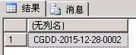
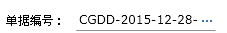

2、一级机构

exec FN_TCGetBCtypeTree @szparid=N'00000',@OperatorID=N'00002',@usertype=15,@where=N' 1=1 '

BCtypeid | BCSonnum | BCFullName | BCUserCode | BCrec | btypeid | BranchType | parid | Branchid | selfHelp
机构标识 |  | 机构名称 | 机构编号

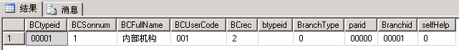

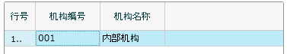

3、二级机构

exec FN_TCGetBCtypeTree @szparid=N'00001',@OperatorID=N'00002',@usertype=15,@where=N' 1=1 '

BCtypeid | BCSonnum | BCFullName | BCUserCode | BCrec | btypeid | BranchType | parid | Branchid | selfHelp
机构标识 |  | 机构名称 | 机构编号

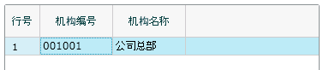

4、结算机构

结果同二级机构相同

5、选择机构后选择经手人

exec FN_TCGetEtypeTree @szparid=N'',@BranchId=N'0000100001',@bDisplayStop=0,@OperatorID=N'00002',@shopid=N'0',@UserType=0,@where=N' 1=1 '

etypeid | esonnum | efullname | eusercode | erec | dtypeid | BranchID | parid | BctypeId | selfhelp | etel
职员标识 |  | 职员名称 | 职员编号

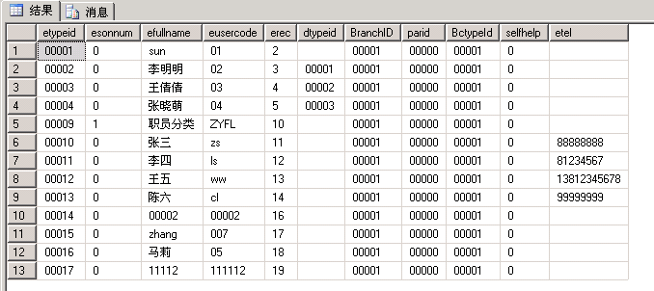
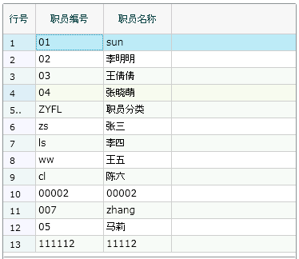

6、选择经手人后显示默认部门

Select typeid as dtypeid, fullname as dfullname, usercode as dusercode, sonnum as dsonnum, rec as drec, parid From department a Where typeid = (Select dtypeid From Employee Where typeid='00004')

dtypeid | dfullname | dusercode | dsonnum | drec | parid
部门标识 | 部门名称

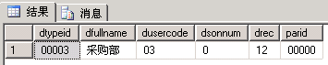
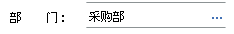

7、选择部门

exec FN_TCGetDeptTree @szparid=N'00000',@OperatorID=N'00002',@BranchId=N'0000100001',@where=N' 1=1 '

dtypeid | dsonnum | dfullname | dusercode | drec | parid | branchid | selfhelp
部门标识 |  | 部门名称 | 部门编号

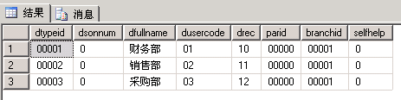
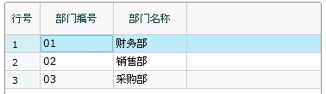

8、选择一级供货单位

declare @p10 int
set @p10=1
exec FN_TCGetBtypeTree @usertype=1,@szparid=N'00000',@bHaveTotal=0,@OperatorID=N'00002',@Branchid=N'0000100001',@bDisplayStop=0,@where=N' 1=1 ',@PageNo=1,@PageSize=14,@itemCount=@p10 output
select @p10

btypeid | bsonnum | bfullname | busercode | brec | usertype | parid | selfhelp
供货单位标识 |  | 供货单位名称 | 供货单位编号

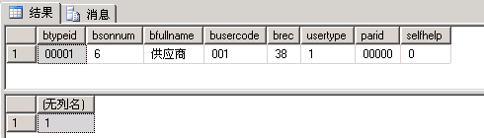
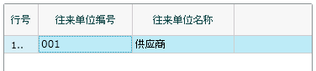

9、选择二级供货单位

declare @p10 int
set @p10=6
exec FN_TCGetBtypeTree @usertype=1,@szparid=N'00001',@bHaveTotal=0,@OperatorID=N'00002',@Branchid=N'0000100001',@bDisplayStop=0,@where=N' 1=1 ',@PageNo=1,@PageSize=14,@itemCount=@p10 output
select @p10

btypeid | bsonnum | bfullname | busercode | brec | usertype | parid | selfhelp
供货单位标识 |  | 供货单位名称 | 供货单位编号

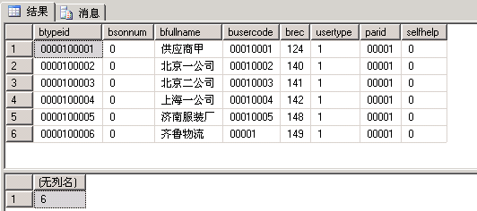
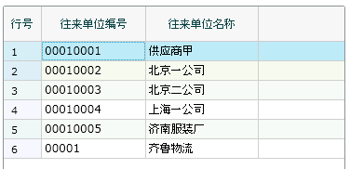

10、选择机构后显示默认仓库

SELECT TypeID,FullName FROM dbo.Stock WHERE BranchID='0000100001' AND Deleted='0' AND IsDefault='1' AND EXISTS(SELECT 1 FROM dbo.FN_GetStockListOfBranch('00002','','') WHERE TypeID = KtypeId)

TypeID | FullName
仓库标识 | 仓库名称

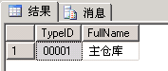
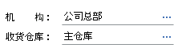

11、选择仓库

exec FN_TCGetKtypeTreeForWhere @usertype=31,@szparid=N'00000',@OperatorID=N'00002',@BranchId=N'0000100001',@where=N' 1=1 ',@hastransferstock=0

BCtypeid | ktypeid | kSonnum | kfullname | kUserCode | krec | BranchType | parid | bcusercode | bcfullname | selfhelp
 | 仓库标识 |  | 仓库名称 | 仓库编号 |  |  |  | 所属机构编号 | 所属机构名称

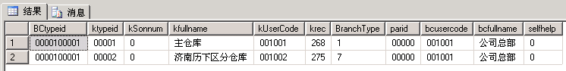
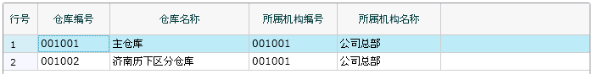

12、选择收货类型

select * from OperationInfo where OpType=2 and IsDel=0 and branchid like '00001%' order by opid

OpID | OpType | BranchID | AtypeID | IsDefault | IsSysDefault | SysCode | UserCode | OperName | IsControl | IsDel | Comment | CodeID
发货标识 |  |  |  |  |  |  |  | 发货类型

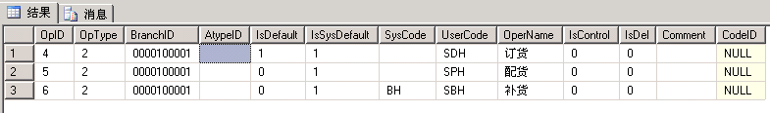
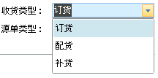

13、选择商品

declare @p10 int
set @p10=12
exec FN_TCGetPtypeTree @szparid=N'00000',@szktypeid=N'00001',@bHaveQty=0,@bDisplayStop=0,@selecttype=3,@OperatorID=N'00002',@where=N' 1=1 ',@PageNo=1,@PageSize=14,@itemCount=@p10 output
select @p10

Ptypeid | Psonnum | Pfullname | Pusercode | costmode | stop | standard | type | area | Prec | unit1 | unit2 | unitrate1 | barcode | sizeidlist | Coloridlist | porder | Parid | stocktype | accountingcourses
商品标识 |  | 商品名称 | 货号

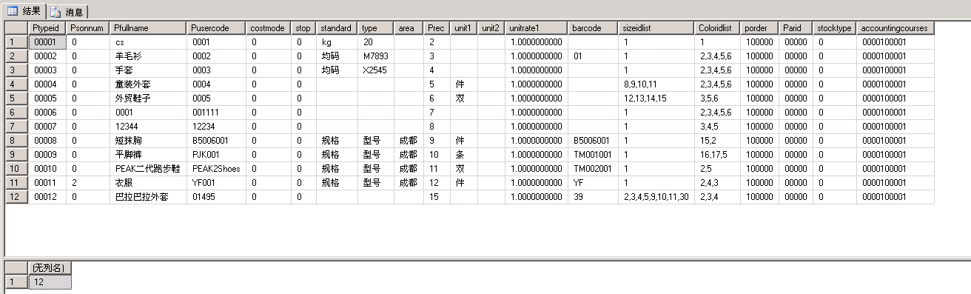

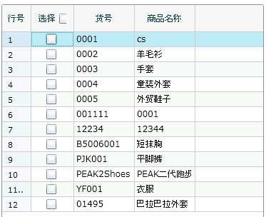

14、选择商品颜色

exec FN_TCGetPCtypeList @nSearchType=0,@sSearStr=N'%%',@szid=-1,@ktypeid=N'00001',@ptypeid=N'00008',@commtype=9,@bHaveQty=N'0'

PCFullName | PCUserCode | PCCOMMENT | PCREC | PCTYPEID
颜色名称 | 颜色条码 |  |  | 颜色标识

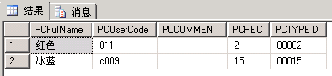
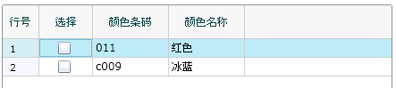

15、选择商品颜色后根据商品标识查询商品尺码（控制界面显示）

Select a.sizeid,b.name as sizename from PtypeSize a inner join Size b on a.SizeId=b.SizeId where a.PtypeId='00008' order by b.[order]

sizeid | sizename
尺寸标识 | 尺寸名称

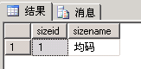
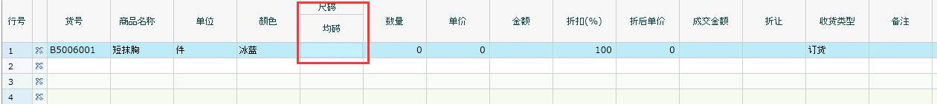

16、选择商品单价（可录入）

exec FN_FZGetPriceAndDiscount @ptypeid=N'00008',@priceMode=N'B',@searStr=N'%%',@OperatorID=N'00002',@shopid=N'0'

DisplayName | price | PriceTypeID
采购价种类 | 价格 | 采购价种类标识

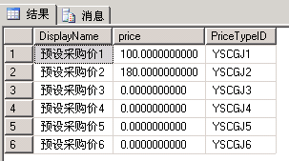

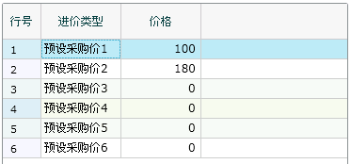

17、提交判断采购单号是否重复

declare @p5 nvarchar(4000)
set @p5=N'0'
exec FZGetVchNumber @nWork=1,@nVchtype=0,@szDate=N'0',@szNumberin=N'CGDD-2015-12-27-0001',@szNumber=@p5 output
select @p5

注：1-表示单号无重复
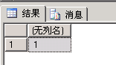

18、保存

declare @p1 dbo.tvpdlyndxorder
insert into @p1 values(0,N'1543703579209219202',N'2015-12-28',N'CGDD-2015-12-28-0002',7,N'0000100001',N'0000100001',N'',N'00004',N'00001',N'',N'00003',N'0',N'',0,N'',N'00002',N'2015-12-31',N'0',0,0,0,N'100',N'',N'0',0,N'摘要',N'附加说明',2,N'',N'',N'',N'',N'',0,N'0',N'0000100001',0,N'11',N'0',N'0',N'0',0,0,N'',N'0',N'运输方式',N'送货地址',N'联系人',N'联系电话','2015-12-28 22:05:00')

declare @p2 dbo.tvpBakDlyOrder
insert into @p2 values(0,0,N'1543703579209219202',7,N'0000100001',N'0000100001',N'0000100001',N'00004',N'00001',N'00003',N'00008',N'11',N'100.00',N'12.00',0,N'100',N'0',N'0.00',N'136.80',N'12',N'132.00',N'2015-12-28',0,N'0.00',N'12.00',N'0.00',N'132.00',N'0',0,0,N'0',0,15,0,N'0.00',N'132.00',N'',N'',N'0',N'0',N'',0,0,N'',N'',N'',N'',N'',N'',4,N'1',0,1,N'0',N'0',N'12.00',N'0')

declare @p3 dbo.tvpBakDlyOrderDetail
insert into @p3 values(0,N'1543703579209219202',1,15,N'11',N'0',N'0.00',N'0',N'0.00',N'132.00',N'132.00',N'0.00',N'132.00',1,N'0',N'0',N'0')

exec SaveOrderBill @tvpDlyNdxOrder=@p1,@tvpBakdlyOrder=@p2,@tvpBakDlyOrderDetail=@p3,@Operator=N'00002'

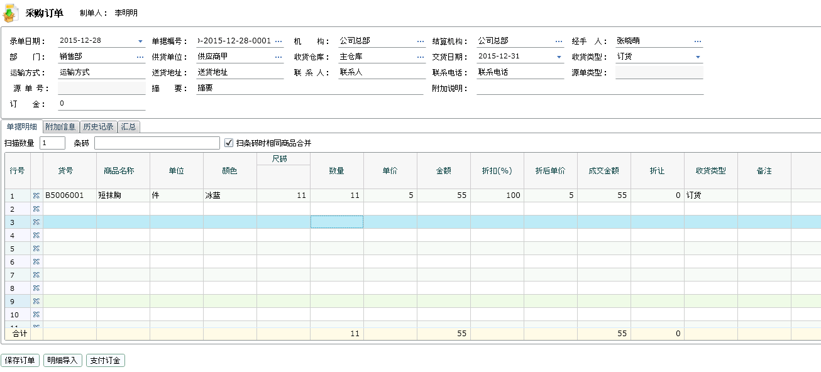

19、保存单据最大值

exec FZModifyVchnumber @nVchtype=7,@Date='2015-12-28'

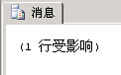

20、处理单据虚拟库存

exec BillOrderUpdateVirtualQty @vchcode=1543703579209219202,@sign=1
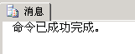

insert into auditingbill(vchcode,auditingid,auditingsteps,ifaudit,etypeid,billdate,billcode,billdetail,billindextype,passsteps,stepreasons) values('1543703579209219202','0','0','1','00002','2015-12-28','CGDD-2015-12-28-0002','2015-12-28ж特别审核ж管理员жжжжжи-12-28ж第一级审核ж李明明жжжжжи','0','','0ж必须全部审核жиж必须全部审核жи')

exec sp_executesql N'UPDATE dlyndxorder SET IfAudit=1 WHERE vchcode=@vchcode',N'@vchcode bigint',@vchcode=1543703579209219202

21、采购主单视图（cgzd）

jsrId | jsr | bmId | bm | ghdw | wldwbh | ghdwid | shck | shckid | jgId | jg | jsjg | jsjgid | zdr | zdrid | ldrq | djbh | id
经手人ID | 经手人 | 部门ID | 部门 | 供货单位 | 往来单位编号 | 供货单位ID | 收货仓库 | 收货仓库id | 机构ID | 机构 | 结算机构 | 结算机构id | 制单人 | 制单人id | 录单日期 | 单据编号 | 唯一标识

视图语句：
SELECT dbo.Employee.FullName AS jsr, dbo.Employee.TypeId AS jsrId, dbo.Department.FullName AS bm, dbo.Department.TypeId AS bmId,
dbo.Btype.FullName AS ghdw, dbo.Btype.UserCode AS wldwbh, dbo.Btype.TypeId AS ghdwId, dbo.Stock.FullName AS shck, dbo.Stock.TypeID AS shckId,
dbo.Branch.FullName AS jg, dbo.Branch.BranchID AS jgId, Branch_1.FullName AS jsjg, Branch_1.BranchID AS jsjgId, Employee_1.FullName AS zdr,
Employee_1.TypeId AS zdrId, dbo.DlyNdxOrder.Date AS ldrq, dbo.DlyNdxOrder.Number AS djbh, dbo.DlyNdxOrder.Vchcode AS id
FROM dbo.DlyNdxOrder LEFT OUTER JOIN
dbo.Employee AS Employee_1 ON dbo.DlyNdxOrder.InputNo = Employee_1.TypeId LEFT OUTER JOIN
dbo.Branch AS Branch_1 ON dbo.DlyNdxOrder.BranchId3 = Branch_1.BranchID LEFT OUTER JOIN
dbo.Branch ON dbo.DlyNdxOrder.BranchId = dbo.Branch.BranchID LEFT OUTER JOIN
dbo.Stock ON dbo.DlyNdxOrder.KtypeId = dbo.Stock.TypeID LEFT OUTER JOIN
dbo.Btype ON dbo.DlyNdxOrder.BtypeId = dbo.Btype.TypeId LEFT OUTER JOIN
dbo.Department ON dbo.DlyNdxOrder.Dtypeid = dbo.Department.TypeId LEFT OUTER JOIN
dbo.Employee ON dbo.DlyNdxOrder.EtypeId = dbo.Employee.TypeId

22、采购细单视图（cgxd）

zdid | spmc | dw | ys | cm | sl | dj | je | ldrq
主单id | 商品名称 | 单位 | 颜色 | 尺码 | 数量 | 单价 | 金额 | 录单日期

视图语句：
SELECT dbo.BakDlyOrder.Vchcode AS zdId, dbo.Ptype.FullName AS spmc, dbo.Ptype.Unit1 AS dw, dbo.Color.Name AS ys, dbo.BakDlyOrder.Qty AS cm,
dbo.BakDlyOrder.Qty AS sl, dbo.BakDlyOrder.Price AS dj, dbo.BakDlyOrder.Total AS je, dbo.BakDlyOrder.Date AS ldrq
FROM dbo.BakDlyOrder LEFT OUTER JOIN
dbo.Color ON dbo.BakDlyOrder.ColorId = dbo.Color.ColorID LEFT OUTER JOIN
dbo.Ptype ON dbo.BakDlyOrder.PtypeId = dbo.Ptype.TypeID

(三)往来账目（应收款查询、应付款查询合并形成往来账目）

注：此章节跟踪应收款查询、应付款查询。
应收款查询分内部机构、加盟机构；应付款查询亦分内部机构、加盟机构。
例如，一级单位查询会用到4次：
应收款查询-内部机构
应收款查询-加盟机构
应付款查询-内部机构
应付款查询-加盟机构
实际为21个小章节。
在跟踪过程中，发现调用过程一致，只是参数不同，实际上此处并非单查应收或应付模块。故，经过对比，也为了便于理解，将相同的存储过程的糅合成一条，使用中根据需要可传不同参数，显示不同结果。
请参照软件界面操作使用以下sql语句。

1、一级分支机构

exec FN_TCGetBCtypeTree @szparid=N'00000',@OperatorID=N'00002',@usertype=15,@where=N' 1=1 '

BCtypeid | BCSonnum | BCFullName | BCUserCode | BCrec | btypeid | BranchType | parid | Branchid | selfHelp
机构标识 |  | 机构名称 | 机构编号

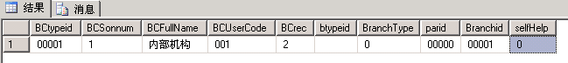
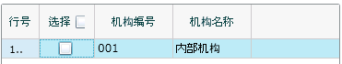

2、二级分支机构

exec FN_TCGetBCtypeTree @szparid=N'00001',@OperatorID=N'00002',@usertype=15,@where=N' 1=1 '

BCtypeid | BCSonnum | BCFullName | BCUserCode | BCrec | btypeid | BranchType | parid | Branchid | selfHelp
机构标识 |  | 机构名称 | 机构编号

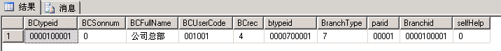
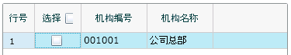

3、一级单位

declare @p10 int
set @p10=3
exec FN_TCGetBtypeTree @usertype=30,@szparid=N'00000',@bHaveTotal=0,@OperatorID=N'00002',@Branchid=N'0000100001',@bDisplayStop=1,@where=N' 1=1 ',@PageNo=1,@PageSize=14,@itemCount=@p10 output
select @p10

btypeid | bsonnum | bfullname | busercode | brec | usertype | parid | selfhelp
单位标识 |  | 单位名称 | 单位编号

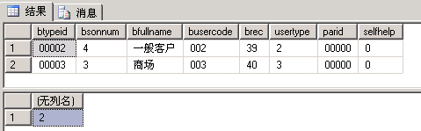
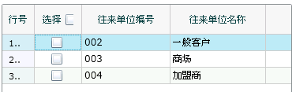

4、二级单位

declare @p10 int
set @p10=4
exec FN_TCGetBtypeTree @usertype=30,@szparid=N'00002',@bHaveTotal=0,@OperatorID=N'00002',@Branchid=N'0000100001',@bDisplayStop=1,@where=N' 1=1 ',@PageNo=1,@PageSize=14,@itemCount=@p10 output
select @p10

btypeid | bsonnum | bfullname | busercode | brec | usertype | parid | selfhelp
单位标识 |  | 单位名称 | 单位编号

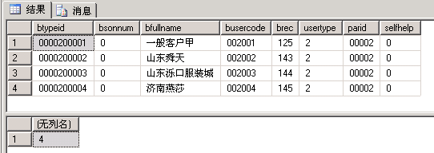
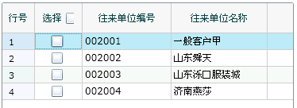

5、查询

exec FZDISPArApMSD @cMode=N'AR',@Btypeid=N'0000200001',@BranchId=N'0000100001',@OperatorId=N'00002',@includeYSYF=0,@Filter=N'0'

 | btypeid | userType | ArTotal00 | APTotal00 | ArTotal | APTotal | ArTotalAdd | ArTotalDec | ApTotalAdd | ApTotalDec | ArTotalYS
应收款字段说明 | 单位标识 |  | 期初应收 |  | 应收余额 |  | 应收增加 | 应收减少 |  |  | 预收余额

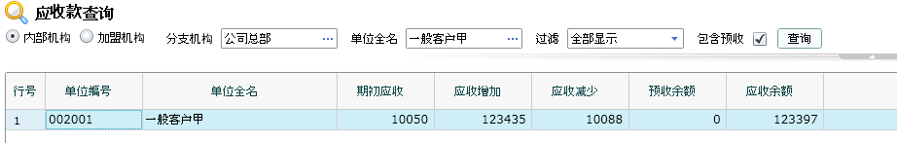

 | btypeid | userType | ArTotal00 | APTotal00 | ArTotal | APTotal | ArTotalAdd | ArTotalDec | ApTotalAdd | ApTotalDec | APTotalYF
应付款字段说明 | 单位标识 |  |  | 期初应付 |  | 应付余额 |  |  | 应付增加 | 应付减少 | 预付余额

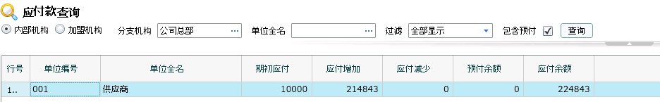

注：
1、表格内标红字段为动态生成，例如在应收查询下，显示ArTotalYS；在应付查询下，显示APTotalYF。
 | btypeid | userType | ArTotal00 | APTotal00 | ArTotal | APTotal | ArTotalAdd | ArTotalDec | ApTotalAdd | ApTotalDec | ArTotalYS | APTotalYF
应收款字段说明 | 单位标识 |  | 期初应收 |  | 应收余额 |  | 应收增加 | 应收减少 |  |  | 预收余额
应付款字段说明 | 单位标识 |  |  | 期初应付 |  | 应付余额 |  |  | 应付增加 | 应付减少 |  | 预付余额

2、根据查出的二级单位btypeid字段关联单位表，得出单位编号、单位名称即可。

exec xw_GetBasicData @cMode='B',@nUpdateTag=0

btypeid | bsonnum | brec | updatetag | bfullname | bname | bnamepy | busercode | bcomment | address | postcode | person | tel1 | faxno | Account | email | Bank | TaxNo
单位标识 |  |  |  | 单位全名 |  |  | 单位编号

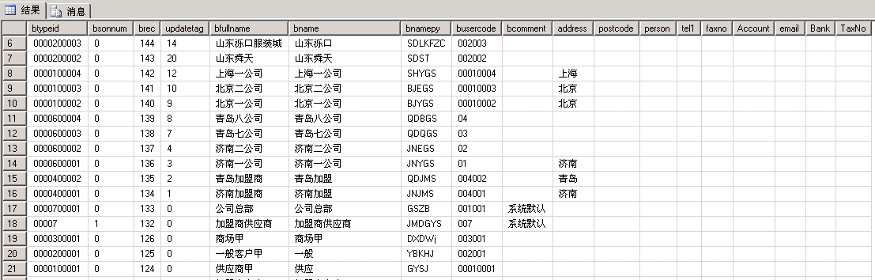

(四)库存状况

1、一级机构

exec FN_TCGetBCtypeTree @szparid=N'00000',@OperatorID=N'00002',@usertype=31,@where=N' 1=1 '

BCtypeid | BCSonnum | BCFullName | BCUserCode | BCrec | btypeid | BranchType | parid | Branchid | selfHelp
机构标识 |  | 机构名称 | 机构编号

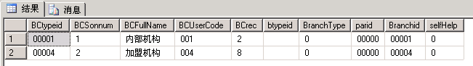
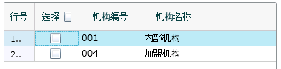

2、二级机构

exec FN_TCGetBCtypeTree @szparid=N'00001',@OperatorID=N'00002',@usertype=31,@where=N' 1=1 '

BCtypeid | BCSonnum | BCFullName | BCUserCode | BCrec | btypeid | BranchType | parid | Branchid | selfHelp
机构标识 |  | 机构名称 | 机构编号

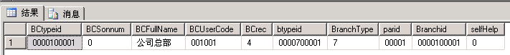

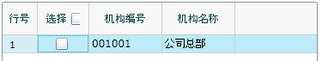

3、选择机构后选择仓库

exec FN_TCGetKtypeTreeForWhere @usertype=31,@szparid=N'00000',@OperatorID=N'00002',@BranchId=N'0000100001',@where=N' 1=1 ',@hastransferstock=1

BCtypeid | ktypeid | kSonnum | kfullname | kUserCode | krec | BranchType | parid | bcusercode | bcfullname | selfhelp
 | 仓库标识 |  | 仓库名称 | 仓库编号 |  |  |  | 所属机构编号 | 所属机构名称

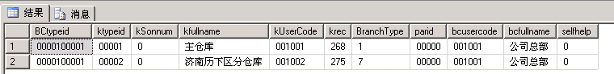
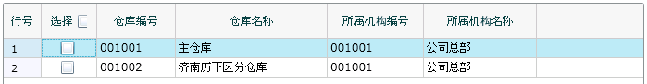

4、选择商品

declare @p10 int
set @p10=13
exec FN_TCGetPtypeTree @szparid=N'00000',@szktypeid=N'',@bHaveQty=0,@bDisplayStop=1,@selecttype=0,@OperatorID=N'00002',@where=N' 1=1 ',@PageNo=1,@PageSize=14,@itemCount=@p10 output
select @p10

Ptypeid | Psonnum | Pfullname | Pusercode | costmode | stop | standard | type | area | Prec | unit1 | unit2 | unitrate1 | barcode | sizeidlist | Coloridlist | porder | Parid | stocktype | accountingcourses
商品标识 |  | 商品名称 | 货号

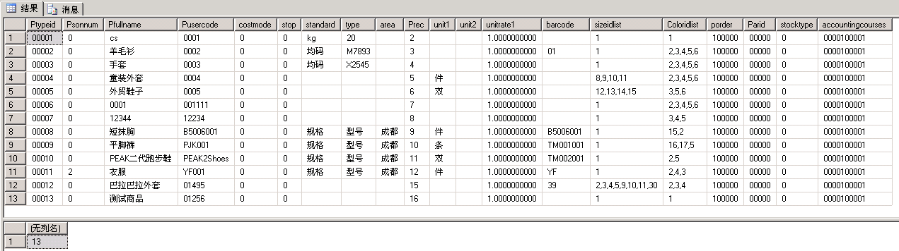
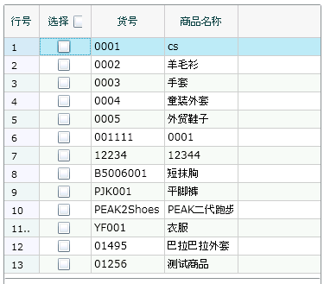

5、参考价格

select * from (Select r.PriceTypeid as id, r.priceName, r.displayName,R.type,r.sortlevel from (SELECT A.* FROM PriceType A INNER JOIN (SELECT ActionID FROM EmployeePower WHERE Etypeid='00002' AND ModuleID in(1201,1202,1203,1204) )B ON A.PriceTypeID=B.ActionID ) R where R.Type in ('R','S') Union Select PriceTypeid as id, priceName, displayName,type,sortlevel From (SELECT A.* FROM PriceType A INNER JOIN (SELECT ActionID FROM EmployeePower WHERE Etypeid='00002' AND ModuleID in(1201,1202,1203,1204) )B ON A.PriceTypeID=B.ActionID ) R where R.type='R' ) x order by type,sortlevel

id | priceName | displayName | type | sortlevel
价格标识 | 名称 | 显示名称

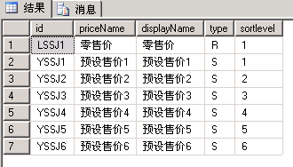

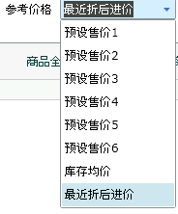
注：此处发现执行结果与界面不符。后发现，参考价格在使用时，预设售价1-6对应id，库存均价传空值，最近折后进价传recprice。故，在使用此章节时，请注意。

6、查询

exec FzDispGoodsStock @szParID=N'00010',@szBranchId=N'0000100001',@szPtypeID=N'00010',@szktypeid=N'00001',@attrib1=-1,@attrib2=-1,@attrib3=-1,@attrib4=-1,@Main=1,@Join=0,@Substitute=0,@Commission=0,@Order=0,@Stop=1,@iflist=0,@PriceMode=N'',@attrib5=-1,@attrib6=-1,@attrib7=-1,@attrib8=-1,@attribTypeid1=-1,@attribTypeid2=-1,@attribTypeid3=-1,@attribTypeid4=-1,@attribTypeid5=-1,@attribTypeid6=-1,@attribTypeid7=-1,@attribTypeid8=-1,@OperatorId=N'00002',@ptypeBarcode=N'',@wayqty=1,@stocktype=0

PtypeID | IssueDate | Qty | total | wayqty | totalqty | waytotal | totaltotal | AvgTotal | Price | PriceTotal | retailprice | RetailTotal | unit2qty | duqty | ckcbtotal | ckcbprice
商品标识 | 上市日期 | 实际数量 | 金额 | 在途数量 | 汇总数量 | 在途金额 | 汇总金额 | 库存均价 |  |  | 机构零售价 | 机构零售金额 |  |  | 参考金额 | 参考成本

库存比例不知道怎么计算得出的
商品标识与商品关联，带出货号、商品全名。
exec FzGetGroupList @OperatorID=N'00002',@cMode=N'P',@szTypeid=N'',@szFullName=N'',@szUserCode=N'',@szStopDate=N'',@szBarCode=N'',@szName=N'',@szIssueDate=N'',@SearchFlag=1,@BranchId=N'',@FZCSCASHBANK=N'',@exstyle=0,@shopid=N'0'
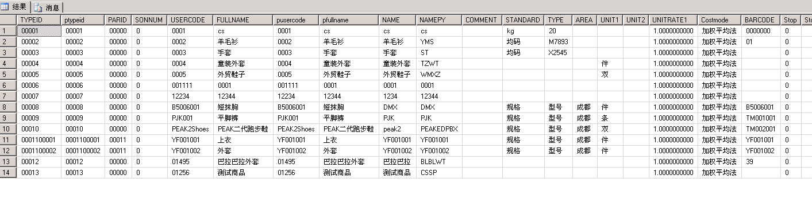

注：勾选显示无库存数量的商品时，调用的存储过程改变。改为调用以下存储过程

exec FzDispGoodsStockDispZero @szParID=N'00010',@szBranchId=N'0000100001',@szPtypeID=N'00010',@szktypeid=N'00001',@attrib1=-1,@attrib2=-1,@attrib3=-1,@attrib4=-1,@Main=1,@Join=0,@Substitute=0,@Commission=0,@Order=0,@Stop=0,@iflist=0,@PriceMode=N'recprice',@attrib5=-1,@attrib6=-1,@attrib7=-1,@attrib8=-1,@attribTypeid1=-1,@attribTypeid2=-1,@attribTypeid3=-1,@attribTypeid4=-1,@attribTypeid5=-1,@attribTypeid6=-1,@attribTypeid7=-1,@attribTypeid8=-1,@OperatorId=N'00002',@ptypeBarcode=N'',@wayqty=1,@stocktype=0

PtypeID | Stop | Qty | total | wayqty | waytotal | totalqty | totaltotal | AvgTotal | Price | PriceTotal | retailprice | RetailTotal | IssueDate | unit2qty | duqty | ckcbtotal | ckcbprice
商品标识 |  | 实际数量 | 金额 | 在途数量 | 在途金额 | 汇总数量 | 汇总金额 | 库存均价 |  |  | 机构零售价 | 机构零售金额 | 上市日期 |  |  | 参考金额 | 参考成本

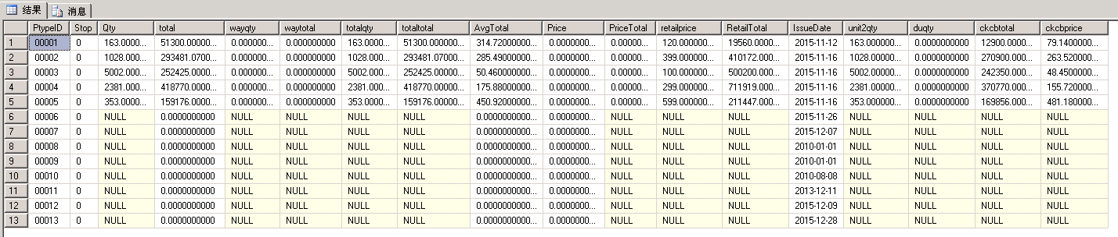
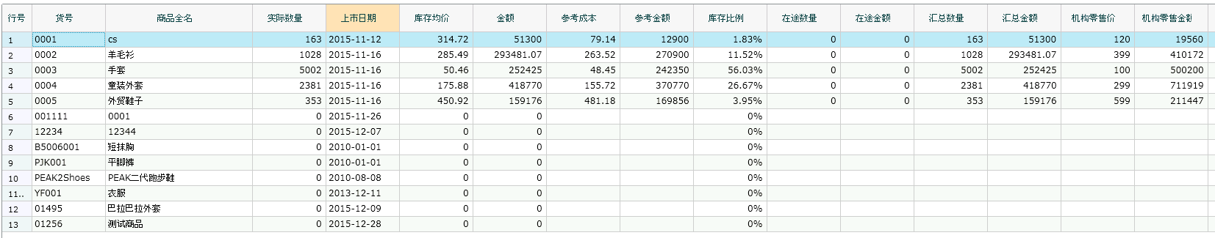

附：订单保存追加描述
注：此处对销售订单保存进一步说明。个人跟踪理解，保存分三小块：
第一块为主单信息；
第二块为细单信息。有几个商品即有几条记录；
第三块为细单商品的尺码信息。一个商品可能有好几个尺码，每个尺码对应的数量、金额都在第三块中体现。以下以2个列子对比描述。

示例一
declare @p1 dbo.tvpdlyndxorder
insert into @p1 values(0,N'1549333078098932907',N'2016-01-07',N'XSDD-2016-01-07-0002',8,N'0000200001',N'0000100001',N'',N'00003',N'00001',N'',N'00002',N'0',N'',0,N'',N'00002',N'2016-01-07',N'0',0,0,0,N'100',N'',N'0',0,N'摘要',N'附加说明',2,N'',N'',N'',N'',N'',0,N'0',N'',0,N'11',N'0',N'0',N'0',0,0,N'',N'0',N'运输方式',N'送货地址',N'联系人',N'联系电话','2016-01-07 18:55:00')

declare @p2 dbo.tvpBakDlyOrder
insert into @p2 values(0,0,N'1549333078098932907',8,N'0000100001',N'0000100001',N'0000200001',N'00003',N'00001',N'00002',N'00008',N'11',N'100.00',N'12.00',0,N'100',N'0',N'0.00',N'136.80',N'12',N'132.00',N'2016-01-07',0,N'0.00',N'12.00',N'0.00',N'132.00',N'0',0,0,N'0',0,2,0,N'0.00',N'132.00',N'',N'',N'0',N'0',N'',0,0,N'',N'',N'',N'',N'',N'',1,N'1',0,1,N'0',N'0',N'12.00',N'0')

declare @p3 dbo.tvpBakDlyOrderDetail
insert into @p3 values(0,N'1549333078098932907',1,2,N'11',N'0',N'0.00',N'0',N'0.00',N'132.00',N'132.00',N'0.00',N'132.00',1,N'0',N'0',N'0')

exec SaveOrderBill @tvpDlyNdxOrder=@p1,@tvpBakdlyOrder=@p2,@tvpBakDlyOrderDetail=@p3,@Operator=N'00002'
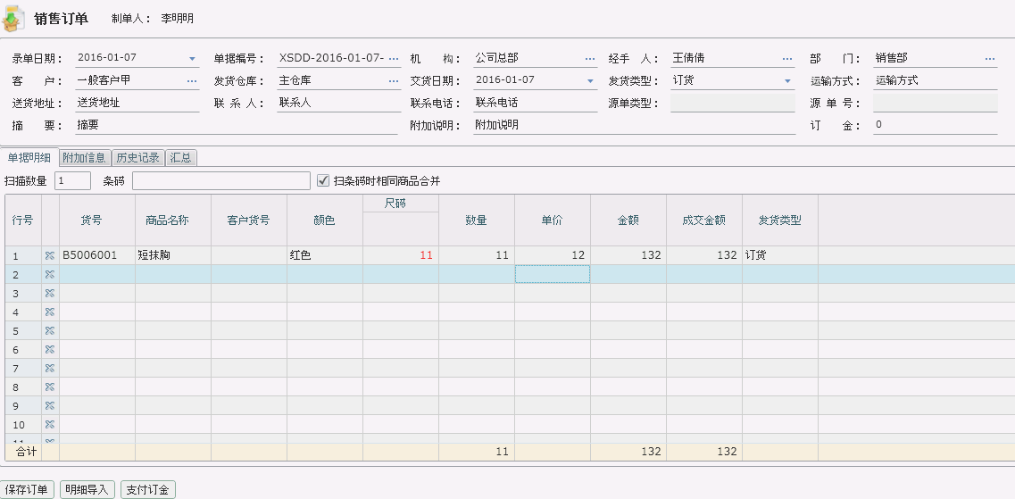

示例二
declare @p1 dbo.tvpdlyndxorder
insert into @p1 values(0,N'1549333078058801283',N'2016-01-07',N'XSDD-2016-01-07-0001',8,N'0000200001',N'0000100001',N'',N'00003',N'00001',N'',N'00002',N'0',N'',0,N'',N'00002',N'2016-01-07',N'0',0,0,0,N'100',N'',N'0',0,N'摘要',N'附加说明',2,N'',N'',N'',N'',N'',0,N'0',N'',0,N'361',N'0',N'0',N'0',0,0,N'',N'0',N'运输方式',N'送货地址',N'联系人',N'联系电话','2016-01-07 18:48:00')

declare @p2 dbo.tvpBakDlyOrder
insert into @p2 values(0,0,N'1549333078058801283',8,N'0000100001',N'0000100001',N'0000200001',N'00003',N'00001',N'00002',N'00004',N'350',N'100.00',N'12.00',0,N'100',N'0',N'0.00',N'299.00',N'12',N'4200.00',N'2016-01-07',0,N'0.00',N'12.00',N'0.00',N'4200.00',N'0',0,0,N'0',0,3,0,N'0.00',N'4200.00',N'',N'',N'0',N'0',N'',0,0,N'',N'',N'',N'',N'',N'',1,N'1',0,1,N'0',N'0',N'12.00',N'0')
insert into @p2 values(0,0,N'1549333078058801283',8,N'0000100001',N'0000100001',N'0000200001',N'00003',N'00001',N'00002',N'00009',N'11',N'100.00',N'13.00',0,N'100',N'0',N'0.00',N'218.00',N'13',N'143.00',N'2016-01-07',0,N'0.00',N'13.00',N'0.00',N'143.00',N'0',0,0,N'0',0,17,0,N'0.00',N'143.00',N'',N'',N'0',N'0',N'',0,0,N'',N'',N'',N'',N'',N'',1,N'1',0,2,N'0',N'0',N'13.00',N'0')

declare @p3 dbo.tvpBakDlyOrderDetail
insert into @p3 values(0,N'1549333078058801283',8,3,N'80',N'0',N'0.00',N'0',N'0.00',N'960.00',N'960.00',N'0.00',N'960.00',1,N'0',N'0',N'0')
insert into @p3 values(0,N'1549333078058801283',9,3,N'85',N'0',N'0.00',N'0',N'0.00',N'1020.00',N'1020.00',N'0.00',N'1020.00',1,N'0',N'0',N'0')
insert into @p3 values(0,N'1549333078058801283',10,3,N'90',N'0',N'0.00',N'0',N'0.00',N'1080.00',N'1080.00',N'0.00',N'1080.00',1,N'0',N'0',N'0')
insert into @p3 values(0,N'1549333078058801283',11,3,N'95',N'0',N'0.00',N'0',N'0.00',N'1140.00',N'1140.00',N'0.00',N'1140.00',1,N'0',N'0',N'0')
insert into @p3 values(0,N'1549333078058801283',1,17,N'11',N'0',N'0.00',N'0',N'0.00',N'143.00',N'143.00',N'0.00',N'143.00',2,N'0',N'0',N'0')

exec SaveOrderBill @tvpDlyNdxOrder=@p1,@tvpBakdlyOrder=@p2,@tvpBakDlyOrderDetail=@p3,@Operator=N'00002'

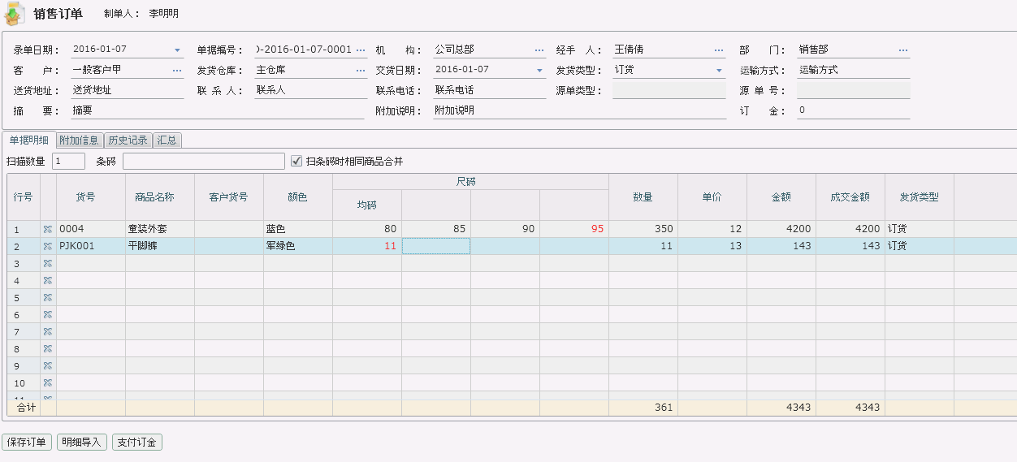

注：勾选扫描唯一码复选框，调用存储过程改变。先调用以下存储过程，在根据条件选择上边2个存储过程中的一个

exec FN_FZGetPtypeFromBar @BarCode=N'asdasfds',@OperatorId=N'00002',@IsUnique=0,@bDisplayStop=1

displaybarname | PRI | PtypeID | ColorID | SizeID | BarCheckDigit | FullBarCode | usercode | fullname | cname | sname
 |  | 商品标识 | 颜色标识 | 尺寸标识

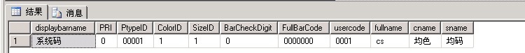

exec FzDispGoodsStock @szParID=N'00000',@szBranchId=N'',@szPtypeID=N'',@szktypeid=N'',@attrib1=-1,@attrib2=-1,@attrib3=-1,@attrib4=-1,@Main=1,@Join=0,@Substitute=0,@Commission=0,@Order=0,@Stop=1,@iflist=0,@PriceMode=N'',@attrib5=-1,@attrib6=-1,@attrib7=-1,@attrib8=-1,@attribTypeid1=-1,@attribTypeid2=-1,@attribTypeid3=-1,@attribTypeid4=-1,@attribTypeid5=-1,@attribTypeid6=-1,@attribTypeid7=-1,@attribTypeid8=-1,@OperatorId=N'00002',@ptypeBarcode=N'00001,1,1;',@wayqty=1,@stocktype=0

PtypeID | IssueDate | Qty | wayqty | waytotal | totaltotal | totalqty | total | AvgTotal | Price | PriceTotal | retailprice | RetailTotal | unit2qty | duqty | ckcbtotal | ckcbprice
1 | 2015/11/12 | 163 | 0 | 0 | 51300 | 163 | 51300 | 314.72 | 0 | 0 | 120 | 19560 | 1900/6/11 | 0 | 12900 | 79.14

