Automated Clause-Level Risk Detection and Summarisation for Legal Documents
CASE STUDY - 3

Team Members:
22BCE0962 Sandhya C V
22BCE3735 Nia Saji

Vellore Institute of Technology, Vellore
BCSE409L - Natural Language Processing
Dr. Rajeshkannan R
31st October 2025

GitHub Project Link: https://github.com/niasaji/Contract-analyzer

Abstract
The manual review of legal documents, particularly contracts, poses significant challenges due to their length, complexity, and the nuanced interpretation of legal clauses. This project presents a lightweight NLP pipeline for clause-level risk detection and explanation in legal documents. Key steps in this pipeline include sentence segmentation, clause extraction, and clause classification. The process begins with preprocessing the contract text and clause annotations from the CUAD dataset. A domain-specific language model, BERT, is fine-tuned on extracted clause segments to capture contextual embeddings and classify clauses. Once trained, the system can analyze new contracts, highlight relevant sections, and predict clause categories with confidence scores. Extractive summarisation is then applied to isolate the most relevant text segments from contracts, which is then compiled into a report. This work contributes to the development of interpretable, domain-aware NLP systems for legal document analysis, offering a scalable tool for compliance monitoring, risk assessment, and legal review.

Keywords: Legal Explainability, NLP, Clause Risk Detection, Legal Document Analysis, Contract Review Automation, AI in Law

1. Introduction
The manual review of legal documents, particularly contracts, presents formidable challenges due to their considerable length, inherent complexity, and the nuanced interpretation required for legal clauses (Chianumba et al., 2022). This process is not only time-consuming and costly but also prone to human errors, which can lead to significant financial and legal consequences, including costly delays, failed deals, or unnoticed legal risks (Davane et al., 2025). This challenge is exacerbated by the growing volume of legal texts and the rapid globalisation of business, necessitating a shift in how legal documents are processed and understood (Oyasiji et al., 2024)..
Traditionally, the legal industry has heavily relied on human expertise to navigate this intricate terrain. However, Artificial Intelligence and Natural Language Processing are reshaping the legal and regulatory landscape by enhancing the ability to interpret legal texts (Oyasiji et al., 2024). NLP, a subfield of AI, enables machines to understand, interpret, and generate human language, making it crucial for analysing large volumes of text data in fields like legal informatics (Zhong et al., 2020). Many AI-driven solutions, such as Legal Document Summarisation, Legal Argument Mining, legal text comprehension for laypersons, and improving Legal Question Answering and Legal Judgement Prediction, have significantly reduced the time and effort required for document review, minimising human errors and improving overall efficiency and accuracy in legal work (Ariai et al., 2025).
This paper addresses these critical challenges by proposing a lightweight NLP pipeline for clause-level risk detection and explanation in legal documents, such as Intellectual Property (IP) documents, Non-Disclosure Agreements (NDAs), and terms of service documents.
A significant contribution of this work lies in its emphasis on guidance and explainability. Most prior work focuses on clause classification alone (such as “this is a liability clause”) but does not provide business-friendly insights (such as “this liability clause poses this risk, negotiate it”). This additional layer of explainability also improves trust by providing clear reasons for every risk-classified clause. The risk assessment report generated at the end includes an overall risk score and contract grade, which can help benchmark contracts in general and track negotiation improvements in business.

2. Literature Survey

Descriptive Analysis
Recent advances in NLP have spurred interest in legal document analysis, particularly for clause classification, summarisation, and risk assessment. For clause classification, models like LegalBERT and LLMs may achieve high accuracy but are prone to hallucinations, upto 58% is certain cases (Ariai et al., 2025). Summarisation techniques, including abstractive (e.g., BART) and extractive (e.g., TextRank) methods, face challenges like hallucinations or scalability issues. Explainability remains underdeveloped, with few neural models offering transparent, clause-level reasoning (e.g., via LIME/SHAP). These gaps motivate our work on interpretable, hybrid AI solutions for legal text analysis.

S. No. | Title of the Paper, Author(s), Year | Methodology/  Approach & Dataset | Key Findings/  Contributions | Research Gaps
01 | AI System to Summarize and Analyze Legal Documents: A Transformative Approach  Dr. V. Shanmugapriya, Guru Moorthy S, Akash K, Sanjay S  (2025) | - NLP (BERT-based) for summarisation and clause classification.  - OCR integration for scanned/printed documents.  - Machine Learning for risk detection (precision: 0.85).  - ROUGE score (0.75) for summary quality evaluation. | - 82% accuracy in risk detection.  - 2-minute processing time per document (vs. 45–60 mins manually).  - Outperformed rule-based tools in summarisation and context understanding. | - Limited to English (no multilingual support).  - Lack of explainability in AI decisions.  - Dependence on structured datasets (generalizability to niche legal domains unverified).
02 | Automated construction contract analysis for risk and responsibility assessment using natural language processing and machine learning  Irem Dikmen, Gorkem Eken, Huseyin Erol, M. Talat Birgonul  (2025) | - NLP and ML for text classification  - 12 models combining vectorisation techniques (BoW, TF-IDF, word embeddings) and algorithms (Logistic Regression, SVM, Decision Tree, RNN, BERT)  - Binary classification and ensemble methods (competitive voting) | - Best model (BERT) achieved 89% accuracy for sentence types and 83% for related parties  - Binary classification and ensemble methods improved performance  - Automated review can expedite risk management in construction contracts | - Training data limited to FIDIC contracts; generalisation to other contract types needed  - Subjective manual labelling may not reflect industry-wide risk perceptions  - Ambiguity detection is not addressed
03 | Automated legal consulting in construction procurement using metaheuristically optimised large language models  Chi-Yun Liu, Jui-Sheng Chou  (2025) | - Hybrid PWO-DE algorithm for LLM optimization  - Development of Taiwan-LLM and Llama3-TAIDE models  - LoRA for efficient fine-tuning | - PWO-DE outperformed 20 benchmark algorithms  - Llama3-TAIDE achieved 67.27% accuracy in legal tasks  - Improved Traditional Chinese text processing | - Limited accuracy in complex legal scenarios  - Need for continuous updates to reflect legal changes  - Lack of integration with real-world workflows
04 | Codifying Justice: AI-Driven Legal Decision Models and Policy Automation for Real-Time Governance and Compliance Systems  Murali Krishna Pasupuleti  (2025) | - Hybrid AI models (Legal-BERT, LegalBART)  - Rule-based ontologies and legal knowledge graphs  - NLP and symbolic reasoning  - Predictive analytics for compliance | - Achieved 93.6% accuracy in legal reasoning tasks  - Reduced compliance processing time by 41%  - LegalBART outperformed rule-based systems (90.2% accuracy) | - Limited interpretability in deep learning models  - Domain-specific overfitting  - Lack of international harmonisation for AI legal standards
05 | Content Analysis of Judges’ Sentiments Toward Artificial Intelligence Risk Assessment Tools  Anna Fine, Stephanie Le, Monica K. Miller  (2023) | - Secondary data analysis of 381 judges' responses to a survey question.  - Qualitative coding of 168 open-ended responses using a priori themes (algorithm aversion/appreciation, locus of control, procedural justice, legitimacy).  - Holsti’s interrater reliability (.89) for coding consistency. | - 64% of judges doubted AI's promise to reduce bias in bail/sentencing.  - Judges exhibited algorithm aversion, ethical concerns, and fears of bias amplification in data.  - Strong internal locus of control: valued judicial discretion over AI.  - Concerns about threats to procedural justice (e.g., lack of "human element") and legitimacy (e.g., public trust).  - Some acknowledged potential utility (e.g., efficiency, implicit bias reduction). | - Limited demographic data (e.g., age, gender, experience).  - Potential sampling bias (NJC-affiliated judges).  - No pre/post-pandemic sentiment comparison.  - Need for broader public sentiment analysis on AI in the judiciary.  - Lack of experimental designs to test AI exposure effects.
06 | Developmental AI Models for Legal Text Interpretation and Regulatory Compliance Automation  Odumayo Oyasiji, Adeola Okesiji, Adeyinka Lawal, Bisayo Otokiti, Sibonglie Gobile  (2024) | - Conceptual AI model integrating NLP (Legal-BERT, RoBERTa), Legal Knowledge Graphs (LegalRuleML), and rule-based reasoning.  - Case studies in finance (AML), healthcare (HIPAA), and cross-jurisdictional contracts (GDPR/CCPA).  - Explainable AI (XAI) techniques (LIME, attention heatmaps). | - High accuracy: 93% compliance classification, 96% recall in AML case study.  - Efficiency gains: 37% faster HIPAA audits, 42% quicker contract reviews.  - Cross-jurisdictional adaptability: Legal Knowledge Graph mapped multi-regulatory requirements.  - Human-in-the-loop design ensured transparency and trust. | - Limited real-world deployment (simulated case studies).  - Bias mitigation needs further validation.  - Multilingual support for non-English legal systems.  - Ethical accountability frameworks require refinement.  - Scalability to smaller enterprises is untested.
07 | Empowering legal justice with AI: A reinforcement learning SAC-VAE framework for advanced legal text summarization  Xukang Wang, Ying Cheng Wu  (2024) | Combines Variational Autoencoder (VAE) for dimensionality reduction with Soft Actor-Critic (SAC) reinforcement learning for policy optimisation. | - SAC-VAE outperforms baseline SAC in ROUGE/BLEU scores (e.g., ROUGE-1: 0.833 vs. 0.587).  - Achieves 59.86% faster training convergence.  - Optimal feature compression dimension: 60. | - Limited to English legal texts (U.S. Congressional bills).  - No evaluation on multilingual or non-Western legal systems.  - Real-world deployment challenges unaddressed.

S. No. | Title of the Paper, Author(s), Year | Methodology/  Approach & Dataset | Key Findings/  Contributions | Research Gaps
08 | Enhancing Legal Document Analysis with Large Language Models: A Structured Approach to Accuracy, Context Preservation, and Risk Mitigation  Mark J. Davenport  (2025) | - Hierarchical segmentation of legal documents.  - Chain-of-thought (CoT) prompting for context preservation.  - Multi-stage summarisation to overcome token limits.  - Empirical comparison of AI-generated summaries with human benchmarks. | - OpenAI’s GPT-4 API effectively summarises legal contracts, preserving key obligations and clauses with high accuracy.  - AI reduces contract review time from weeks to hours while maintaining comparable accuracy to human analysts.  - Hierarchical segmentation and CoT prompting mitigate context fragmentation in long documents.  - AI identifies ambiguities and contradictions missed by human reviewers due to cognitive limitations. | - Limited generalizability to highly complex or poorly structured contracts (e.g., M&A agreements).  - Potential for AI hallucinations (fabrications) in summaries without careful prompting.  - Ethical concerns around confidentiality, bias, and over-reliance on AI outputs.  - Need for broader evaluation across diverse legal documents (e.g., multilingual contracts, case law).  - Integration of fine-tuned legal-specific models to improve domain accuracy.
09 | Inherent risks identification in a contract document through automated rule generation  Junho Kim, Baekgyu Kwon, JeeHee Lee, Duhwan Mun  (2025) | - NLP models (BERT, dependency parser, KeyBERT)  - Sentence disassembly (adjunct/parallel/SVO separation)  - Automated rule generation with contract lexicon  - OCR + rule-matching for risk identification | - 95.5% accuracy in sentence disassembly  - 91.3% accuracy in risk identification  - 39-second rule generation vs. 6 hours manually  - Handles complex contract language via component-based rules | - Dependency parsing errors in long/complex sentences  - Lexicon limitations for new vocabulary  - Domain knowledge needed to input risk words  - OCR inaccuracies vs. PDF text parsing
10 | Intelligent detection on construction project contract missing clauses based on deep learning and NLP  Hong Zhou, Binwei Gao, Shilong Tang, Bing Li, Shuyu Wang  (2025) | - NLP and deep learning (BERT model)  - Multi-label classification  - MatchPyramid for similarity matching  - Text segmentation and preprocessing | - Achieved 93% accuracy in multi-label classification  - 83% accuracy in similarity matching  - Effective for long-text contracts (>512 characters) | - Limited to Chinese contracts  - Requires large labelled datasets  - Struggles with highly unstructured clauses
11 | Legal Text Classification in Turkey: A Machine Learning Approach to Divorce and Zoning Decisions  Tulay Turan, Ecir Uğur Küçüksille  (2024) | - Dataset: Turkish court decisions (divorce and zoning cases).  - NLP preprocessing (TF-IDF, stopword removal).  - ML models: KNN, SVM, DT, RF.  - Hyperparameter optimization (GridSearchCV + 10-fold CV).  - Evaluation metric: Accuracy. | - SVM achieved 90% accuracy, outperforming KNN, DT, and RF.  - TF-IDF effectively captured semantic differences in legal texts.  - Hybrid human-AI validation improved reliability.  - The study fills a gap in Turkish legal NLP, which is underrepresented compared to English/Chinese. | - Limited to two legal categories (divorce/zoning).  - Small dataset (no size specified).  - No use of pre-trained language models (e.g., BERT for Turkish).  - Generalizability to other legal domains is untested.  - Ethical/legal implications of AI in the judiciary were not discussed.
12 | Legal-Lens: AI-Driven Legal Document Review and Risk Analysis  Devarshi R. Davane, Abhishek P. Shirsath, Gautam A. Kalamkar, Dr. Prashant Y. Itankar  (2025) | - Hybrid AI combining NLP (BERT, GPT) and OCR (Tesseract).  - Flutter/Firebase for cross-platform UI and secure cloud storage.  - Rule-based + ML for risk detection and clause classification. | - >95% text extraction accuracy.  - 92% precision in summarisation.  - 40% faster review time.  - 88% accuracy in risk detection. | - Limited to English documents.  - No real-world deployment challenges discussed.  - Dependence on cloud infrastructure (offline limitations).
13 | Satellite-inspired deep semantic mining for classifying contractual risk clauses  Min-Yuan Cheng, Quoc-Tuan Vu, Husni Mubarok  (2025) | - Hybrid BERT-BiGRU model for contextual and sequential text analysis.  - Artificial Satellite Search Algorithm (ASSA) for hyperparameter optimisation.  - NLP preprocessing (stop word removal, tokenisation, lemmatisation, embedding). | - Achieved F1 score of 0.9059, outperforming baseline models (BERT, BiGRU, SVM, Naive Bayesian).  - ASSA optimisation improved model accuracy by 3.6% over non-optimised BERT-BiGRU.  - Effective for multi-class risk clause classification (e.g., payment, safety, temporal). | - Limited to English-language contracts; needs validation in other languages.  - Class imbalance in datasets may affect generalizability.  - Computational cost of ASSA optimisation is high.
14 | Software engineering meets legal texts: LLMs for auto-detection of contract smells  Moriya Dechtiar, Daniel Martin Katz, Hongming Wang  (2025) | - LLMs (GPT-4, BERT, Legal-BERT) for semi-automated labelling and detection  - Contract smells (e.g., overly long clauses, redundant language) adapted from software engineering  - Hyperparameter tuning (learning rate, batch size, epochs)  - Multi-class vs. single-class detection | - High accuracy (up to 98.6% for some smells)  - Legal-BERT outperforms baseline BERT in domain-specific tasks  - Single-class detection yields better accuracy than multi-class  - GPT-4 labelling validated by legal experts (disagreement <10%) | - Limited generalizability due to dataset biases (CUAD contracts)  - GPT-4 limitations in legal context (terminology, truncation)  - Class imbalance (rare smells like "Inappropriate Intimacy" harder to detect)  - Need for broader legal domain adaptation (e.g., subjective anomalies)
15 | Transforming Contract Management: A Comprehensive Analysis of AI Integration in Legacy and Ongoing Contracts  Niraj Ittan  (2024) | - Comparative analysis of AI-driven vs. traditional contract management.  - Case studies and industry data (e.g., 82% efficiency gain in AI systems).  - Metrics on processing time, accuracy, compliance, and cost savings. | - AI reduces contract processing time by 76% and improves accuracy to 95%.  - Legacy contracts benefit from hybrid human-AI review (94.5% accuracy).  - Ongoing contracts achieve real-time processing (75% latency reduction).  - Cost savings: $1.8M/year for enterprises.  - Compliance rates rise from 82.4% (traditional) to 95.3% (AI). | - Limited discussion on SME adoption challenges (cost, scalability).  - Ethical implications of AI-driven decisions (bias, accountability).  - Long-term impact of reduced human oversight.  - Integration hurdles with legacy systems (42% struggle).  - Need for sector-specific AI models (e.g., healthcare vs. energy).

Summary
The reviewed literature highlights several research gaps that inform our problem formulation. Key limitations include the limited generalizability of AI models to complex contracts (Davenport, 2025; Cheng et al., 2025), risks of AI hallucinations and ethical concerns (Davenport, 2025; Fine et al., 2023), computational costs (Cheng et al., 2025), integration hurdles with legacy systems (Ittan, 2024), and lack of explainability (Shanmugapriya et al., 2025). These challenges underscore the need for a robust, hybrid approach. Our work addresses these gaps by fine-tuning and training BERT on a legal clause dataset for clause-level risk detection and extractive summarisation for added explainability.

3. Problem Description
Contracts form the foundation of business transactions, establishing the rights, responsibilities, and obligations of all involved parties. They serve as critical instruments for risk allocation and dispute resolution. However, contracts are often lengthy, complex, and written in highly specialized legal language that can be difficult for non-experts to interpret. This complexity poses significant challenges, particularly for individuals, startups, and small to medium-sized enterprises (SMEs), which often lack access to dedicated legal teams.
The process of contract review is traditionally manual, requiring extensive time, resources, and professional legal expertise. While large corporations may rely on in-house legal departments or retain external counsel, smaller organizations face considerable barriers in obtaining cost-effective legal review. As a result, clauses with potentially adverse implications may remain undetected. These include indemnity clauses that disproportionately transfer risk, restrictive termination provisions that reduce flexibility, or the absence of essential liability protections. Failure to identify such clauses can lead to financial loss, regulatory non-compliance, or prolonged legal disputes. Consequently, there is a critical need for tools that democratize access to reliable contract analysis without requiring extensive legal knowledge or high financial investment.
This project addresses that gap by developing an AI-driven pipeline that can automatically identify risky clauses, explain why they are problematic, and provide a concise extractive summary of the contract. By combining machine learning, rule-based checks, and explainability tools, the system aims to make contract review faster, more reliable, and accessible to non-experts.

Framework Diagram
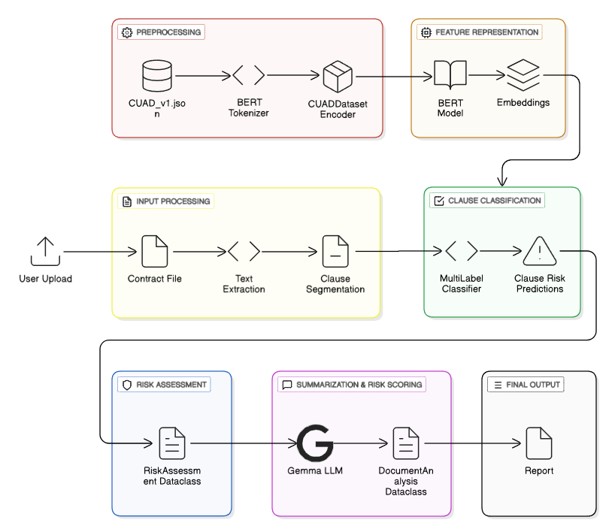

Framework Explanation
The pipeline begins with preprocessing the CUAD dataset to prepare it for training. The process loads the master_clauses.csv file along with JSON files containing clause categories. Each clause is tokenized using the nlpaueb/legal-bert-base-uncased tokenizer, ensuring the text is transformed into a representation that BERT can process. These tokenized clauses are then wrapped into a custom dataset class, CUADDataset, which prepares the standard inputs required for model training—namely input_ids, attention_mask, and labels. At this stage, raw legal clauses are normalized into a format compatible with transformer-based models.
For feature representation, the system employs a BERT backbone initialized through AutoModelForSequenceClassification.from_pretrained(...). This model generates dense embeddings for each clause, capturing the semantic meaning of legal text. These embeddings are subsequently passed into a classification head that performs multi-label prediction, turning unstructured legal language into numerical vectors encoding risk-related features.
When processing new contracts, the system first extracts plain text from uploaded files, whether in TXT or PDF format. A segmentation function—built using a combination of regex patterns and heuristics—splits the text into individual clauses. Each clause is then fed through the same tokenizer, BERT encoder, and classifier pipeline that was trained on the CUAD dataset. This design ensures that the model can generalize effectively to previously unseen contracts while maintaining consistency with its training procedure.
The clause classification stage implements multi-label classification across 41 predefined risk categories using Binary Cross-Entropy with Logits Loss. Each clause is assigned probabilities across categories such as Termination, Liability, Intellectual Property Ownership, Exclusivity, and more. The output of this step provides clause-level predictions, highlighting which parts of the contract are potentially risky.
Following classification, the pipeline enters the risk assessment stage. Here, the predictions are organized into a structured format using dataclass objects. Each clause is represented alongside its original text, the predicted risk categories, and corresponding confidence scores. This structured representation forms the basis for higher-level contract analysis and downstream tasks.
In the extractive summarization and risk scoring phase, a large language model (LLM) is used to transform raw predictions into meaningful insights. The system generates human-readable summaries of risky clauses and computes an overall contract risk score. These results are stored within a DocumentAnalysis object, bridging the gap between technical machine learning predictions and business or legal insights that end-users can act upon.
Finally, the output is delivered in document form, presenting a complete breakdown of the contract. The deliverable includes each clause, its associated predicted risks, extractive summaries, and the aggregated risk score for the entire document. This comprehensive report allows users to quickly understand contractual risks without manually parsing lengthy legal text, making contract analysis faster, more transparent, and more accessible.

Pseudocode of Proposed System
BEGIN
LOAD CUAD dataset (contracts, clause questions)
DEFINE clause_labels = [41 predefined legal clause categories]

FUNCTION preprocess_data():
FOR each contract IN CUAD:
extract context (contract text)
map questions → clause type (keyword-based)
create (text, label) pairs
SPLIT data INTO train, validation, test sets
SAVE AS JSON files

FUNCTION extractive_summarisation(contract_text):
SPLIT contract_text INTO sentences
COMPUTE embeddings for each sentence
RANK sentences by relevance to clause questions
SELECT top-ranked sentences as summary
RETURN summary_text

CLASS BERTMultiLabel:
INIT model = pretrained BERT
ADD dropout + linear classification layer (41 outputs)
DEFINE forward(input_ids, attention_mask):
pass through BERT
pooled_output = CLS token embedding
logits = classifier(pooled_output)
RETURN logits

CLASS BERTTrainer:
INIT load tokenizer, label mappings
FUNCTION create_dataloaders(): return train/val/test dataloaders
FUNCTION calculate_class_weights(): handle imbalance
FUNCTION train():
FOR each epoch:
TRAIN model on train_loader
VALIDATE on val_loader
SAVE best model
FUNCTION predict(text):
summary = extractive_summarisation(text)
tokenize summary
model forward pass → probabilities
RETURN clause types with confidence > threshold

MAIN:
trainer = BERTTrainer()
model = trainer.train(epochs=3, batch_size=8)
predictions = trainer.predict(new_contract_text)
PRINT predictions
Documentation.generate()
END

System Flow Diagram
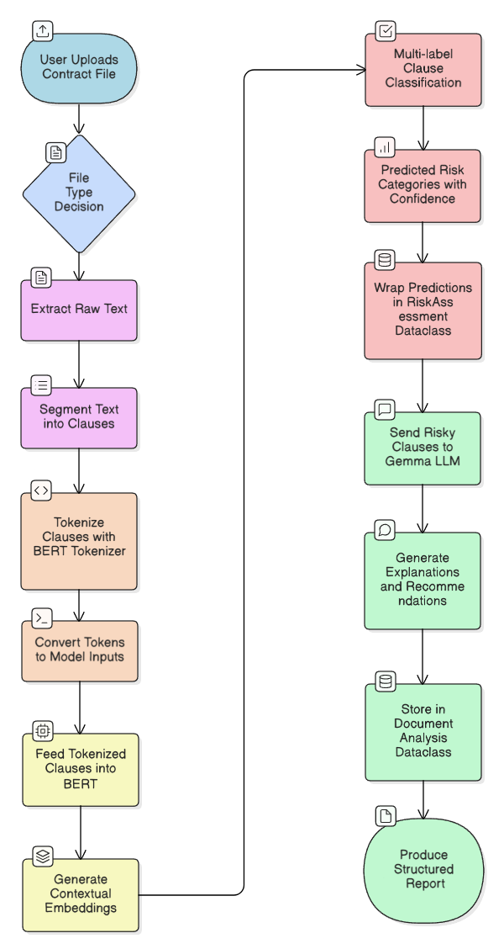

Data Flow Diagram

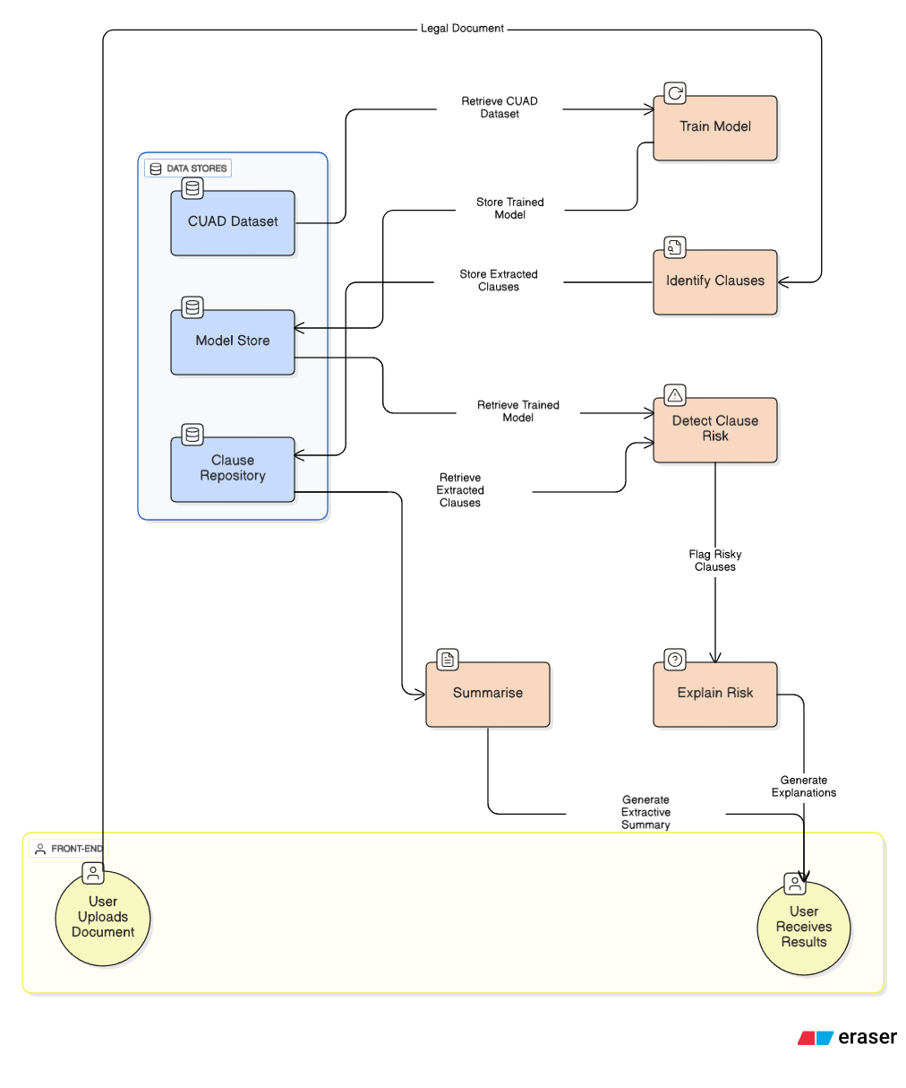

4. Experiments

Dataset Description
The Contract Understanding Atticus Dataset (CUAD) is a large-scale dataset specifically curated for legal AI research, released by The Atticus Project.
It comprises 510 legal contracts with over 13,000 expert-annotated legal clauses. The clauses are annotated with one of 41 categories (e.g., termination, indemnification, limitation of liability, exclusivity).
The dataset contains 83 columns x 510 rows.

Dataset Parameters
The parameters are as follows:
- Contract Name: Each record contains the name of the contract it is sourced from.
- Remaining Columns: Pairs of category columns of the form (clause, yes/no) where the first column contains a clause from the contract (if any) in that category and the second column specifies if a clause in that category is present in the contract.
The complete list of parameters is as follows:
- Filename | - Document Name
- Document Name-Answer | - Parties | - Parties Answer
- Agreement Date | - Agreement Date Answer | - Effective Date
- Effective Date Answer | - Expiration Date | - Expiration Date-Answer
- Renewal Term | - Renewal Term Answer | - Notice Period To Terminate Renewal
- Notice Period To Terminate Renewal Answer | - Governing Law | - Governing Law Answer
- Most Favored Nation | - Most Favored Nation Answer | - Competitive Restriction Exception
- Competitive Restriction Exception Answer | - Non-Compete | - Non-Compete Answer
- Exclusivity | - Exclusivity-Answer | - No-Solicit Of Customers
- No-Solicit Of Customers Answer | - No-Solicit Of Employees | - No-Solicit Of Employees Answer
- Non-Disparagement | - Non-Disparagement Answer | - Termination For Convenience
- Termination For Convenience Answer | - Rofr/Rofo/Rofn | - Rofr/Rofo/Rofn-Answer
- Change Of Control | - Change Of Control-Answer | - Anti-Assignment
- Anti-Assignment-Answer | - Revenue/Profit Sharing | - Revenue/Profit Sharing Answer
- Price Restrictions | - Price Restrictions Answer | - Minimum Commitment
- Minimum Commitment Answer | - Volume Restriction | - Volume Restriction-Answer
- IP Ownership Assignment | - IP Ownership Assignment Answer | - Joint IP Ownership
- Joint IP Ownership-Answer | - License Grant | - License Grant-Answer
- Non-Transferable License | - Non-Transferable License Answer | - Affiliate License-Licensor
- Affiliate License-Licensor Answer | - Affiliate License-Licensee | - Affiliate License-Licensee Answer
- Unlimited/All-You-Can-Eat-License | - Unlimited/All-You-Can-Eat-License Answer | - Irrevocable Or Perpetual License
- Irrevocable Or Perpetual License-Answer | - Source Code Escrow | - Source Code Escrow-Answer
- Post-Termination Services | - Post-Termination Services-Answer | - Audit Rights
- Audit Rights Answer | - Uncapped Liability | - Uncapped Liability Answer
- Cap On Liability | - Cap On Liability Answer | - Liquidated Damages
- Liquidated Damages Answer | - Warranty Duration | - Warranty Duration Answer
- Insurance | - Insurance Answer | - Covenant Not To Sue
- Covenant Not To Sue-Answer | - Third Party Beneficiary | - Third Party Beneficiary-Answer

Sample Records
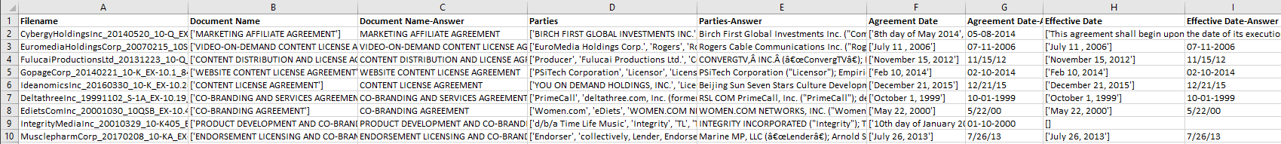
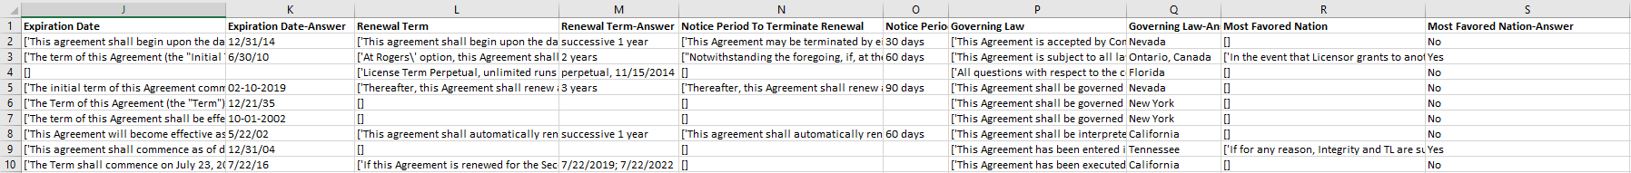
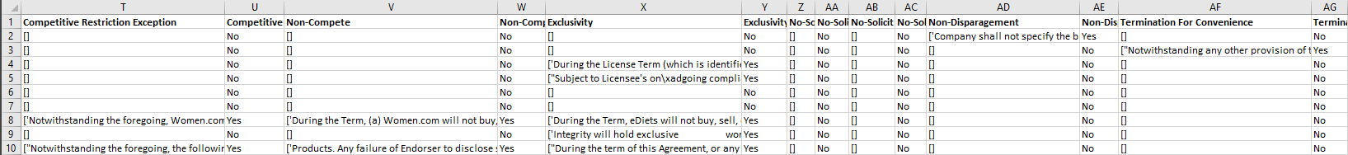
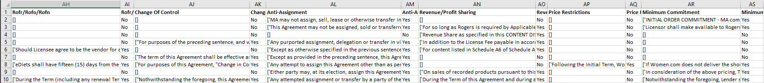
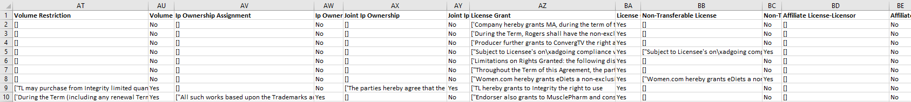
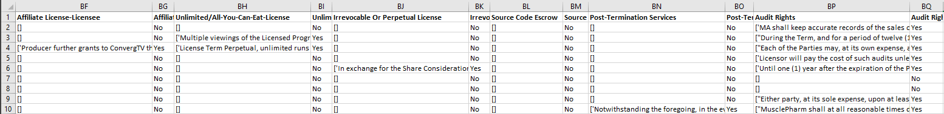
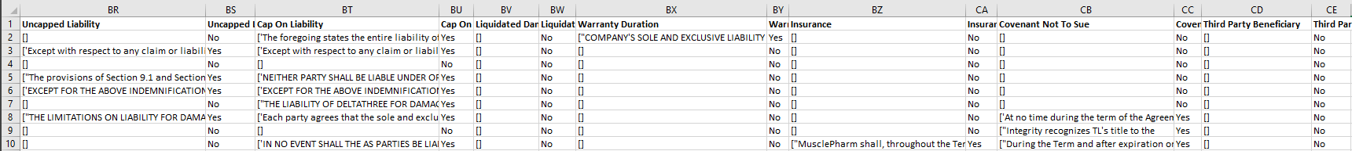

Why CUAD Was Chosen
- Granularity: Labels exist at the clause level, not just the document level, which matches the requirement to highlight risky parts of contracts.
- Domain-Specific: Unlike generic text datasets, CUAD is tailored for contracts and specific clause types that this system aims to identify.
- Expert-Labelled: Annotations were created by legal professionals, ensuring high-quality ground truth for training.
- Widely Used: CUAD is benchmarked in academic and industry research, making it reliable and comparable.
- Openly Available: Freely accessible via Hugging Face, enabling reproducibility and lowering dataset acquisition cost.

Limitations
- Jurisdiction Bias: Primarily U.S. contracts, may not generalise well to Indian contracts.
- Static Dataset: CUAD may not reflect the latest laws and regulations.

Alternatives Considered
- EDGAR Contracts Dataset (SEC filings): A large corpus of contracts, but unlabeled, would require manual annotation or weak supervision.
- Legal-BERT Pretraining Corpora (e.g., EUR-Lex, Case Law datasets): Rich legal text, but focus is on regulations, case law, not contracts. Lacks clause-level risk labels.
- Proprietary Contract Datasets: Not publicly accessible, restricted by NDAs and data privacy.

Comparison of Proposed Model Against Existing Methods
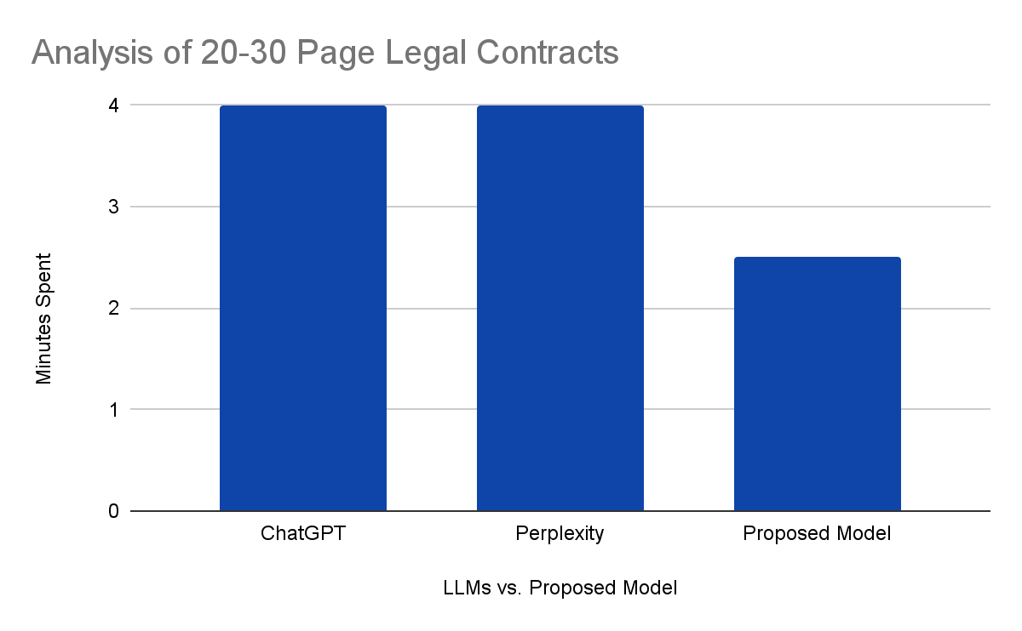

Screenshots of Output & Interface
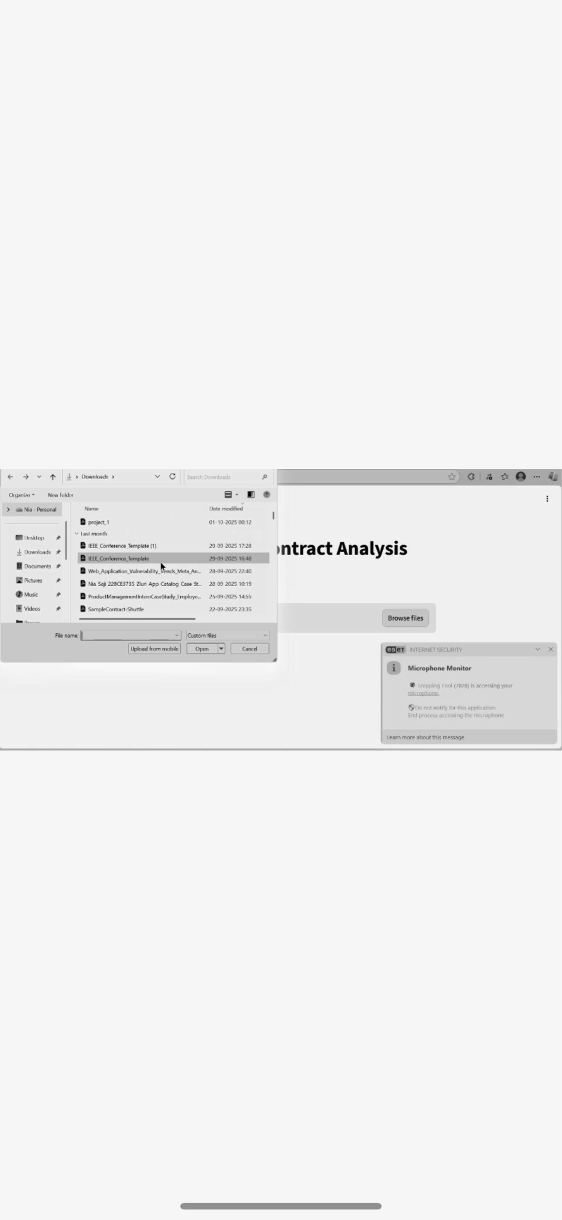
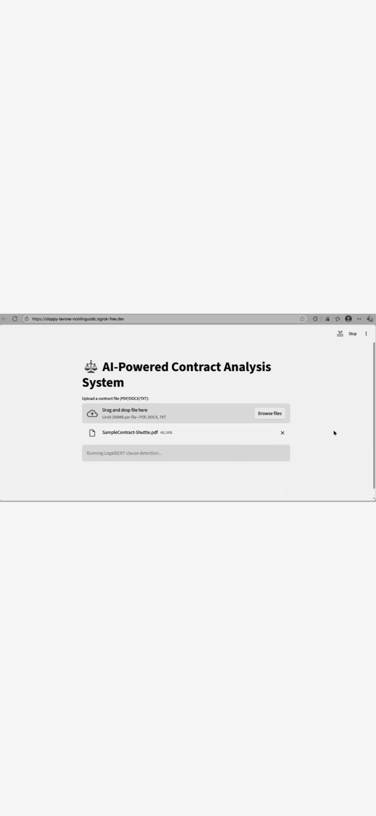
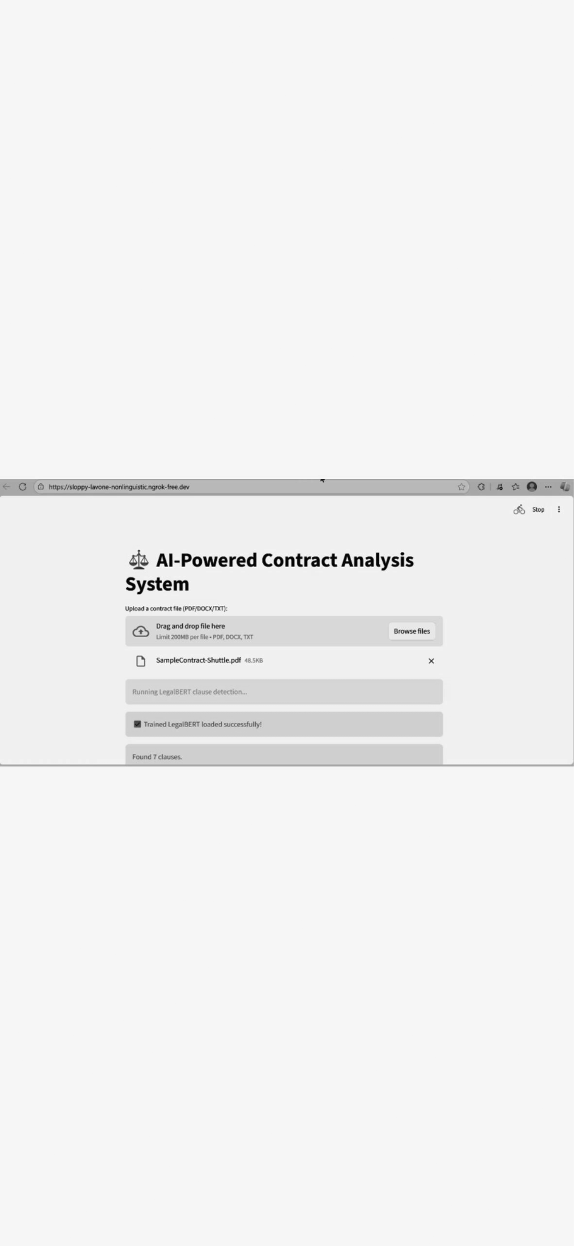
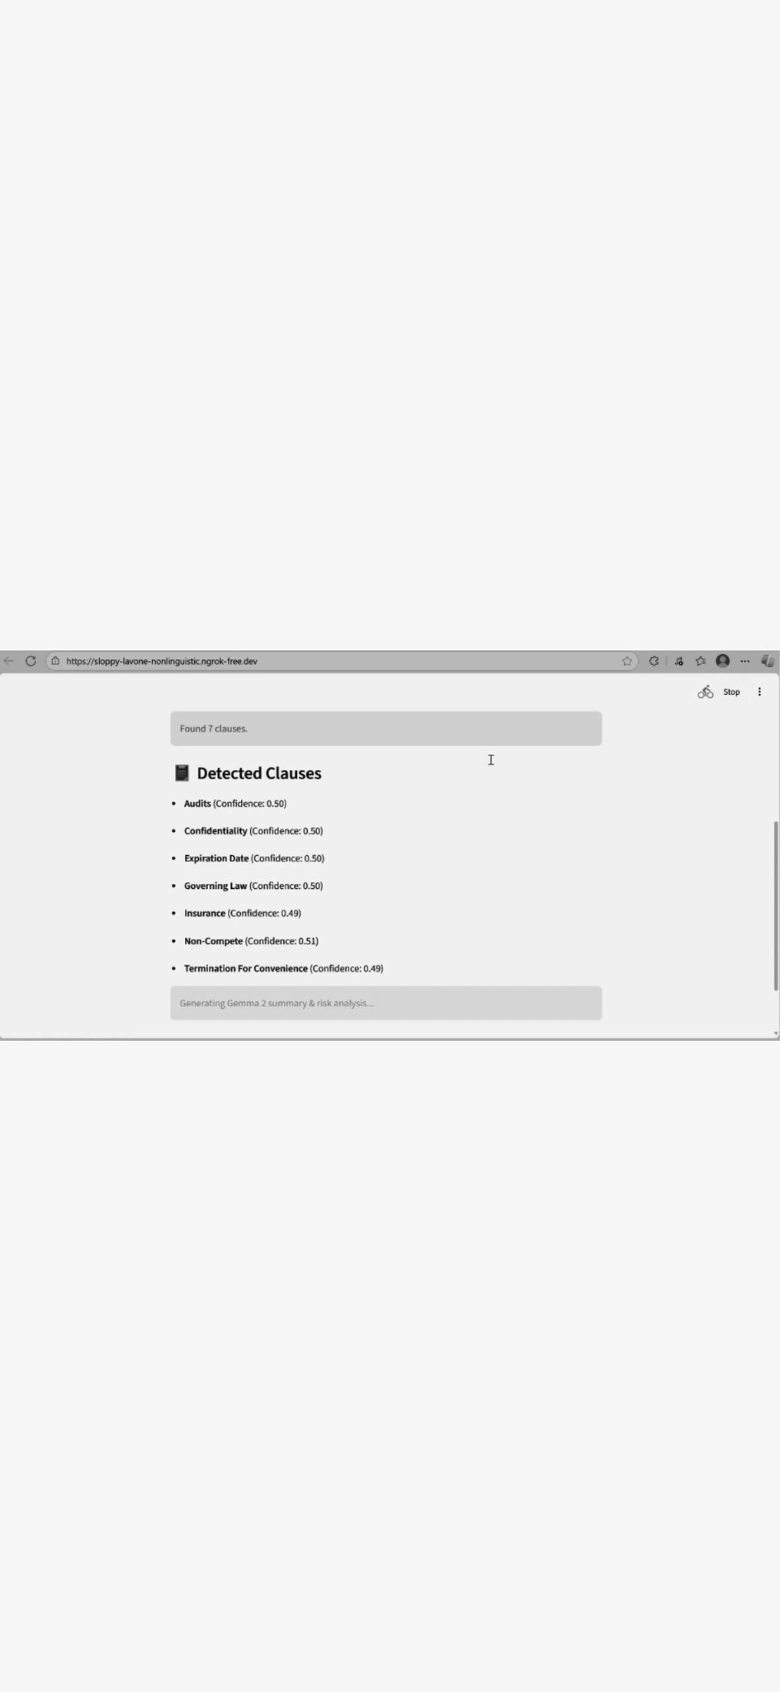
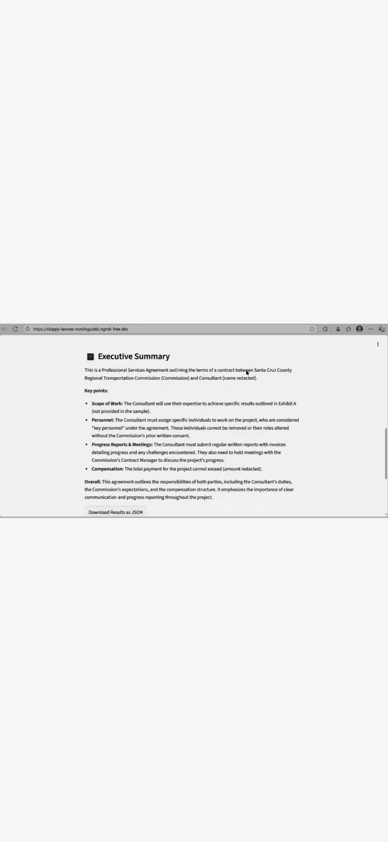
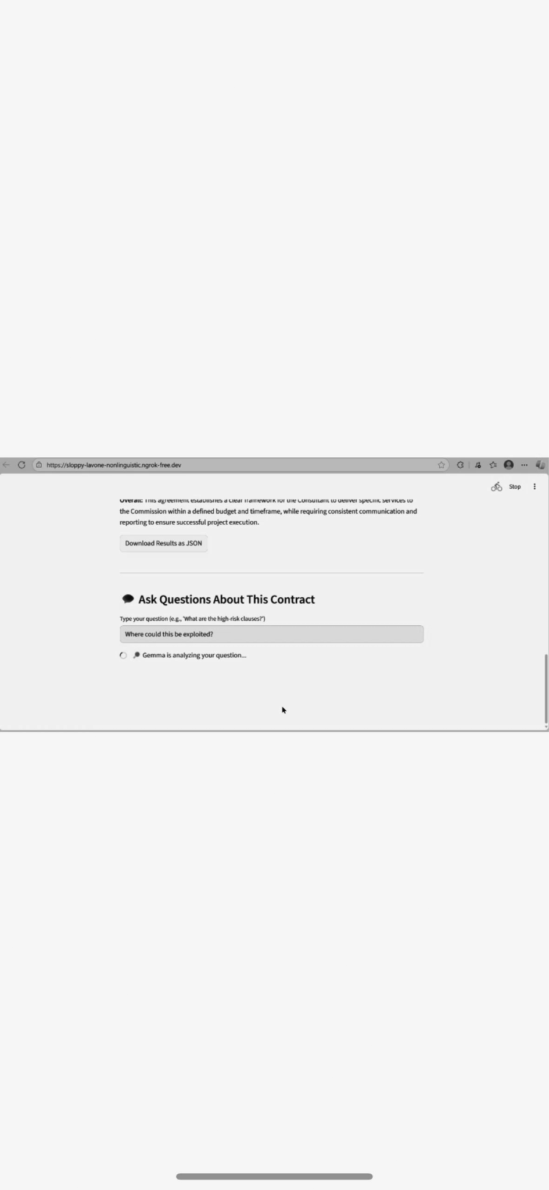
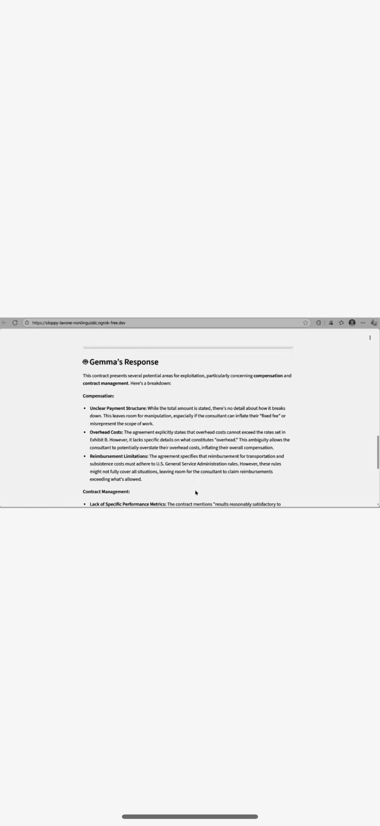

5. Conclusion & Future Work
This project presents a lightweight NLP pipeline to automatically detect risky clauses in legal contracts using Legal-BERT fine-tuned on CUAD.
The model transforms lengthy, complex legal documents into structured clause predictions with confidence scores, making it easier for startups and SMEs to identify risk without hiring legal experts.

Findings & Contributions
- Automated detection of 41 legal clause categories.
- Handling of imbalanced data using class weights.
- Achieved an efficient multi-label classification system for contract risk detection.
- Provides a foundation for real-world contract review tools (legal tech applications).

Scope for Future Enhancement
- Cross-Jurisdictional Adaptation: Fine-tune the model on contracts from multiple jurisdictions, particularly Indian, European, and Asian legal systems.
- Temporal Awareness: Incorporate time-sensitive analysis to flag clauses that may become risky due to recent regulatory changes. This could involve connecting the system to legal update feeds and implementing a change-detection mechanism.
- Comparative Analysis: Enable users to upload multiple contract versions or compare their contract against industry-standard templates, highlighting deviations and suggesting improvements based on best practices.

References
Ariai, F., Mackenzie, J., & Demartini, G. (2024). Natural language processing for the legal domain: A survey of tasks, datasets, models, and challenges. arXiv preprint arXiv:2410.21306.
Cheng, M. Y., Vu, Q. T., & Mubarok, H. (2025). Satellite-inspired deep semantic mining for classifying contractual risk clauses. Expert Systems with Applications, 128933.
Chianumba, E. C., Ikhalea, N., Mustapha, A. Y., Forkuo, A. Y., & Osamika, D. (2022). Integrating AI, blockchain, and big data to strengthen healthcare data security, privacy, and patient outcomes. Journal of Frontiers in Multidisciplinary Research, 3(1), 124-129.
Davane, D. R., Shirsath, A. P., Kalamkar, G. A., Itankar, P. Y. (2025) Legal-Lens: AI-Driven Legal Document Review and Risk Analysis. International Journal of Scientific Research in Engineering and Management, 09(04).
Davenport, M. J. & Independent Researcher, Toronto, Canada. (2025). Enhancing Legal Document Analysis with Large Language Models: A Structured Approach to Accuracy, Context Preservation, and Risk Mitigation. In Open Journal of Modern Linguistics (Vols. 232–280, pp. 232–280).
Dechtiar, M., Katz, D. M., & Wang, H. (2025). Software engineering meets legal texts: LLMs for auto detection of contract smells. Machine Learning With Applications, 100639.
Deroy, A., & Maity, S. (2023). Questioning Biases in Case Judgment Summaries: Legal Datasets or Large Language Models?. arXiv preprint arXiv:2312.00554.
Dikmen, I., Eken, G., Erol, H., & Birgonul, M. T. (2025). Automated construction contract analysis for risk and responsibility assessment using natural language processing and machine learning. Computers in Industry, 166, 104251.
Fine, A., Miller, M. K., & Le, S. (2024). Content Analysis of Judges' Sentiments Toward Artificial Intelligence Risk Assessment Tools. Russ. J. Econ. & L., 246.
Hassan, F. U., Le, T., & Lv, X. (2021). Addressing legal and contractual matters in construction using natural language processing: A critical review. Journal of Construction Engineering and Management, 147(9), 03121004.
Ittan, N. & Conga. (2024). Transforming Contract Management: A comprehensive analysis of AI integration in legacy and ongoing contracts. International Journal for Multidisciplinary Research (IJFMR), 6(6), 1–2.
Kim, J., Kwon, B., Lee, J., & Mun, D. (2025). Inherent risks identification in a contract document through automated rule generation. Automation in Construction, 172, 106044.
Liu, C. Y., & Chou, J. S. (2025). Automated legal consulting in construction procurement using metaheuristically optimized large language models. Automation in Construction, 170, 105891.
Oyasiji, O., Okesiji, A., Lawal, A., Otokiti, B. O., & Gobile, S. (2024). Developing Conceptual AI Models for Legal Text Interpretation and Regulatory Compliance Automation. International Journal of Multidisciplinary Research and Growth Evaluation.
Pasupuleti, M. K. & National Education Services. (2025). Codifying Justice: AI-Driven legal decision models and policy automation for Real-Time Governance and Compliance systems. In International Journal of Academic and Industrial Research Innovations(IJAIRI) (Issue 07, p. 82)
Shanmugapriya, D., S, G. M., K, A., & S, S. (2025). AI system to Summarize and Analyze Legal Documents: A Transformative approach. International Scientific Journal of Engineering and Management, 04(02), 1–6.
Turan, T., Küçüksille, E. U., Department of Computer Technologies, Burdur Mehmet Akif Ersoy University, Burdur, Türkiye, & Department of Computer Engineering, Süleyman Demirel University, Isparta, Türkiye. (2024). Legal text classification in Turkey: A machine learning approach to divorce and zoning decisions. In International Journal of Engineering, Design and Technology (Vols. 6–2, pp. 53–63).
Wang, X., & Wu, Y. C. (2024). Empowering legal justice with AI: A reinforcement learning SAC-VAE framework for advanced legal text summarization. PLoS ONE, 19(10), e0312623
Zhong, H., Xiao, C., Tu, C., Zhang, T., Liu, Z., & Sun, M. (2020). How does NLP benefit legal system: A summary of legal artificial intelligence. arXiv preprint arXiv:2004.12158.
Zhou, H., Gao, B., Tang, S., Li, B., Wang, S., & Xiamen University. (2025). Intelligent detection on construction project contract missing clauses based on deep learning and NLP. In Engineering, Construction and Architectural Management (Vols. 32–32, Issue 3, pp. 1546–1580)

