UNIVERSITY OF SHANGLA
Department of Computer Science
[ Faculty of Computing / Faculty Name Placeholder ]
UOS LMS
A Role-Based Mobile Learning Management System for
the University of Shangla
Final Year Project Thesis
submitted in partial fulfilment of the requirements for the degree of
BS Computer Science
Submitted by
[ Student Full Name ] Reg. No: [ Registration Number ]
Supervised by
[ Supervisor Name ], [ Designation ]
[ Month, Year ]

Certificate of Approval
It is certified that the Final Year Project report titled “UOS LMS – A Role-Based Mobile Learning Management System for the University of Shangla”, submitted by [ Student Full Name ], Registration No. [ Registration Number ], has been carried out under our supervision and is found satisfactory in scope and quality for the partial fulfilment of the degree of BS Computer Science.

Supervisor: ______________________________ Signature: ____________________
[ Supervisor Name ]
[ Designation, Department of Computer Science ]

External Examiner: ________________________ Signature: ____________________

Head of Department: ______________________ Signature: ____________________
Department of Computer Science, University of Shangla

Declaration
I hereby declare that the work presented in this Final Year Project report, titled “UOS LMS – A Role-Based Mobile Learning Management System for the University of Shangla”, is the result of my own effort and has not been submitted elsewhere for the award of any other degree or qualification. All sources of information used in this report have been duly acknowledged in the References section.

Student Name: [ Student Full Name ]
Registration No: [ Registration Number ]
Signature: ____________________ Date: ____________________

Acknowledgement
All praise and gratitude are due first and foremost to Almighty Allah, for granting me the strength, patience and ability to complete this Final Year Project.
I would like to express my sincere gratitude to my supervisor, [ Supervisor Name ], for the invaluable guidance, encouragement, and constructive feedback provided throughout every stage of this project — from the initial requirement analysis to the final testing and documentation.
I am also thankful to the faculty members of the Department of Computer Science, University of Shangla, for the knowledge and skills imparted throughout the course of my degree, which formed the foundation for the design and development of this system.
Finally, I extend my heartfelt appreciation to my family and friends for their continuous support, patience, and motivation, without which the successful completion of this project would not have been possible.

Abstract
Universities in remote and under-resourced regions often continue to depend on manual, paper-based processes for day-to-day academic administration — attendance registers, hand-graded assignments, notice boards for announcements, and spreadsheets for result compilation. These processes are slow, error-prone, difficult to audit, and inaccessible outside office hours, and they scale poorly as student enrolment grows. This project presents UOS LMS, a native Android Learning Management System built for the University of Shangla that digitises the complete academic workflow across four distinct user roles: Administrator, Head of Department (HOD), Teacher, and Student.
The system is built with Kotlin and Jetpack Compose following the Model-View-ViewModel (MVVM) architectural pattern, with Dagger Hilt providing compile-time dependency injection across a modular, feature-based package structure. Cloud Firestore serves as the primary NoSQL data store and Firebase Authentication handles credential verification, while Cloudinary provides a dedicated, signed media pipeline for profile photographs, assignment attachments, and study materials — keeping large binary files out of the database and storing only URLs and metadata. A single unified login screen enforces strict role-based access: a user must select the correct role for their account before signing in, and the server-side repository actively rejects and signs out any session where the authenticated account's role does not match the role selected at login, closing a common class of privilege-confusion vulnerability found in simpler LMS implementations.
Functionally, the system covers hierarchical university-structure management (departments, semesters, sessions and subjects), an approval-gated registration workflow, department-scoped teacher-subject assignment, attendance capture and reporting, assignment submission with file upload and manual grading, a unified quiz/exam engine with automatic multiple-choice grading and optional manual override for exams, study-material distribution, scoped announcements, an academic calendar, and role-appropriate analytics dashboards. The user interface follows Material Design 3 with a consistent, animated, glassmorphism-influenced design language applied uniformly across all four roles.
The resulting application was implemented, unit- and manually-tested, and deployed to a physical Android device for verification. This report documents the complete software development lifecycle followed to build the system — requirement analysis, system design (including Use Case, ER, Class, Activity, Sequence and Data Flow diagrams), implementation, and testing — and concludes with a discussion of the system's limitations and recommended directions for future work, including push notifications, a full interactive timetable module, and offline-first data access.
Keywords: Learning Management System, Android, Jetpack Compose, Firebase, Firestore, MVVM, Role-Based Access Control, Mobile Application Development.

Table of Contents
The Table of Contents below is generated from this document's heading styles. If it appears empty or out of date, select the field and press F9 (or right-click and choose “Update Field”) in Microsoft Word.
Right-click here and choose “Update Field” (or press Ctrl+A then F9) to generate the Table of Contents.

List of Figures
Figure 3.1: Use Case Diagram – Administrative Actors (Admin & HOD) 1
Figure 3.2: Use Case Diagram – Academic Actors (Teacher & Student) 1
Figure 4.1: Layered System Architecture of UOS LMS 1
Figure 4.2: Entity Relationship Diagram of UOS LMS 1
Figure 4.3: Simplified Class Diagram of Core Domain Entities 1
Figure 4.4: Data Flow Diagram – Level 0 (Context Diagram) 1
Figure 4.5: Data Flow Diagram – Level 1 (Major Processes) 1
Figure 4.6: Activity Diagram – User Registration & Approval Workflow 1
Figure 4.7: Activity Diagram – Assignment Submission & Grading 1
Figure 4.8: Sequence Diagram – Role-Based Login Validation 1
Figure 4.9: Sequence Diagram – Assignment Submission & Grading 1
Figure 5.1: Flowchart – Role-Based Login Validation 1
Figure 5.2: Flowchart – Automated Quiz/Exam Grading 1
Figure 7.1: Login Screen 1
Figure 7.2: Registration Screen 1
Figure 7.3: Admin Panel – Hierarchical User Management 1
Figure 7.4: Admin Panel – Reports & Analytics 1
Figure 7.5: HOD Dashboard – Department Overview 1
Figure 7.6: Teacher – Mark Attendance Screen 1
Figure 7.7: Teacher – Assignment Monitor / Grading 1
Figure 7.8: Student Dashboard – Subject List 1
Figure 7.9: Student – Take Quiz / Exam Screen 1
Figure 7.10: Profile Screen (shared by all roles) 1

List of Tables
Table 2.1: Comparative Analysis of Existing LMS Platforms Against UOS LMS 1
Table 3.1: Functional Requirements Summary by Role 1
Table 3.2: Non-Functional Requirements 1
Table 3.3: Sample Use Case Descriptions 1
Table 4.1: Technology Stack 1
Table 4.2: Firestore Collection Schema Summary 1
Table 5.1: Development Environment and Tools 1
Table 6.1: Sample Test Cases 1
Table 6.2: Test Summary Report by Module 1

List of Abbreviations
Abbreviation | Description
LMS | Learning Management System
UOS | University of Shangla
HOD | Head of Department
MVVM | Model-View-ViewModel
UI / UX | User Interface / User Experience
API | Application Programming Interface
SDK | Software Development Kit
DI | Dependency Injection
CRUD | Create, Read, Update, Delete
ER Diagram | Entity Relationship Diagram
DFD | Data Flow Diagram
UML | Unified Modelling Language
MCQ | Multiple Choice Question
CDN | Content Delivery Network
REST | Representational State Transfer
HMAC | Hash-based Message Authentication Code
BaaS | Backend as a Service
PK / FK | Primary Key / Foreign Key
APK | Android Package (application bundle)
IDE | Integrated Development Environment

Chapter 1: Introduction

1.1 Background and Motivation
Academic institutions rely on a large number of interconnected administrative and academic processes: enrolling students into departments and semesters, assigning subjects to teachers, recording attendance, distributing and grading coursework, conducting quizzes and examinations, and communicating announcements. In many universities, and particularly in smaller or newly-established institutions such as the University of Shangla, these processes are still carried out manually or through a patchwork of spreadsheets, paper registers, and informal messaging groups.
This manual approach introduces several recurring problems. Attendance registers can be lost, falsified, or take considerable class time to complete. Assignment submissions handed in on paper or over chat applications are difficult to track, easy to lose, and cannot be graded consistently. Announcements posted on physical notice boards fail to reach students who miss a single visit to campus. Compiling attendance percentages, subject loads, or department-wide performance reports by hand is slow and error-prone. As student enrolment grows, these problems compound rather than diminish.
A dedicated Learning Management System (LMS) addresses these problems by moving academic workflows onto a single digital platform accessible from any Android device. UOS LMS was conceived specifically for the University of Shangla to provide a mobile-first, role-based platform that every stakeholder — administrators, heads of department, teachers, and students — can use from a single application, each seeing only the functionality and data relevant to their role.

1.2 Problem Statement
The University of Shangla currently lacks a unified digital system for managing core academic operations. Attendance is recorded manually, assignments and quizzes are administered without a central record of submissions or grades, user accounts are not verified before granting system access, and there is no single source of truth for the university's departmental structure (departments, semesters, sessions, and subjects). This project addresses the following core problem: how can a single mobile application provide secure, role-appropriate access to the full academic lifecycle — from account registration and administrative approval, through attendance and coursework, to quizzes, reporting, and communication — while remaining usable, secure, and maintainable for a small institutional development team?

1.3 Aims and Objectives
The aim of this project is to design, implement, and evaluate a native Android Learning Management System for the University of Shangla. The specific objectives are to:
- Design a role-based authentication system supporting four distinct roles — Admin, HOD, Teacher, and Student — where each account is verified against Firebase Authentication and matched against the role selected at login, with mismatched roles rejected outright.
- Implement an administrative approval workflow so that new HOD, Teacher, and Student accounts remain inactive (pending) until reviewed and approved by an Administrator.
- Provide full CRUD management of the university's academic structure: departments, semesters, sessions, and subjects, including department-scoped teacher-to-subject assignment performed by the relevant HOD.
- Digitise attendance capture (by Teachers) and attendance review (by Students, HODs, and Admins), including department- and semester-level aggregate reporting.
- Enable assignment creation, file-attached submission, and manual grading with feedback, using a dedicated cloud media pipeline rather than storing files in the database.
- Implement a unified quiz and examination engine with automatic multiple-choice grading and an optional manual score override for examinations.
- Provide study-material distribution, scoped announcements, and an academic calendar shared across roles.
- Design and apply a consistent, modern Material Design 3 visual language across all four roles of the application.
- Evaluate the resulting system through functional and manual testing to verify correctness of the core workflows described above.

1.4 Scope of the Project
The scope of UOS LMS covers the complete academic-management lifecycle for a single institution: user registration and role-based approval; hierarchical academic-structure management; attendance; assignments; quizzes and examinations; study materials; announcements; an academic calendar; and role-specific reporting dashboards. The system is delivered as a native Android application targeting phones and tablets running Android 7.0 (API level 24) and above. The following items are explicitly out of scope for the current version and are discussed further as future work in Chapter 8: push notifications, a fully interactive drag-and-drop timetable builder, offline-first data access, and a web or iOS client.

1.5 Significance of the Study
This project demonstrates the practical application of a modern, production-grade mobile architecture — Jetpack Compose, MVVM, Dagger Hilt, and a Firebase/Cloudinary backend — to a real institutional problem. Beyond its immediate use at the University of Shangla, the project serves as a reference implementation of role-based access control, hierarchical data management, and secure media handling patterns that are broadly applicable to other academic or enterprise mobile systems.

1.6 Tools and Technologies Overview
UOS LMS is implemented in Kotlin using Jetpack Compose for its entire user interface, following the MVVM architectural pattern. Dagger Hilt provides dependency injection. Firebase Authentication verifies user credentials, Cloud Firestore stores all structured application data, and Cloudinary hosts all binary media (profile photographs, assignment attachments, and study materials) via a signed upload API. A complete justification of this technology stack is provided in Section 4.3.

1.7 Organization of the Report
The remainder of this report is organized as follows. Chapter 2 reviews existing Learning Management System platforms and positions UOS LMS relative to them. Chapter 3 documents the requirement-gathering process, the system's functional and non-functional requirements, and its use-case analysis. Chapter 4 presents the system design, including the architecture, database design, and the full set of UML and structured-analysis diagrams. Chapter 5 describes the implementation of each module in detail. Chapter 6 documents the testing strategy and results. Chapter 7 presents the results achieved and discusses them against the stated objectives. Chapter 8 concludes the report and outlines directions for future work.

Chapter 2: Literature Review

2.1 Overview of Learning Management Systems
A Learning Management System is software that supports the administration, documentation, tracking, and delivery of educational courses and training programmes. Modern LMS platforms typically provide course/content management, assessment tools, communication features, and analytics, and are consumed either through a web browser, a dedicated desktop client, or a mobile application. Institutional adoption of LMS platforms has accelerated over the past decade, driven both by the general shift toward digital administration and, more recently, by the need for remote and hybrid learning capability.

2.2 Review of Existing Systems
Several well-established LMS platforms were reviewed prior to designing UOS LMS, to understand common feature sets, architectural patterns, and gaps that a purpose-built, mobile-first system could address for a smaller institution.
- Moodle — a widely deployed, open-source, web-based LMS offering extensive course management, plugin extensibility, and grading tools, but requiring dedicated server infrastructure and a fairly heavyweight administrative setup that is not always practical for smaller institutions.
- Google Classroom — a lightweight, mobile-friendly platform tightly integrated with Google Workspace, strong for assignment distribution and grading, but with limited support for granular, department-level academic-structure management (departments, semesters, sessions) and no built-in attendance module.
- Edmodo — a social-network-inspired LMS aimed primarily at K-12 education, strong on communication features but comparatively weak on formal academic administration such as hierarchical user approval and departmental reporting.
- Blackboard Learn — a feature-rich, enterprise-grade LMS common in higher education, but typically licensed and hosted at significant cost, which is often impractical for a smaller public-sector university.
Table 2.1: Comparative Analysis of Existing LMS Platforms Against UOS LMS
Feature | Moodle | Google Classroom | Edmodo | UOS LMS
Native mobile-first UI | Partial (web wrapper) | Yes | Partial | Yes (native Android)
Hierarchical academic structure  (Dept/Semester/Session) | Manual configuration | No | No | Yes, built-in
Role-based approval workflow | Plugin-dependent | No (Workspace-managed) | Limited | Yes, built-in
Attendance module | Plugin-dependent | No | No | Yes, built-in
Auto-graded MCQ quizzes/exams | Yes | Limited (Forms add-on) | Yes | Yes, built-in
Self-hosting / licensing cost | Free, self-hosted | Free (Workspace account) | Free | Firebase/Cloudinary  pay-as-you-go

2.3 Mobile-First and Role-Based LMS Approaches
A recurring theme in recent educational-technology literature is the shift from web-first LMS platforms retrofitted with a mobile wrapper, toward genuinely mobile-first applications built natively for the platform they target. Native applications offer smoother animations, better offline resilience, and tighter integration with platform capabilities such as notifications and camera access, at the cost of requiring separate codebases per platform. UOS LMS adopts the native, mobile-first approach for Android specifically, reflecting the device profile most commonly available to students and staff at the University of Shangla.
Role-based access control (RBAC) is a further recurring requirement in institutional systems: different classes of user (administrators, department heads, teaching staff, and students) must see different data and different capabilities within the same application. UOS LMS implements RBAC both at the user-interface level (four entirely separate navigation graphs and dashboards) and at the data-access level (Firestore security rules scoped by the authenticated user's role and department), which is discussed in detail in Section 4.9.

2.4 Backend-as-a-Service in Educational Applications
Backend-as-a-Service (BaaS) platforms such as Firebase allow small development teams to build full-featured applications — authentication, a real-time document database, and security rules — without provisioning or maintaining dedicated servers. This significantly lowers the barrier to building institution-specific software, which is particularly relevant for a university project developed and maintained by a small team. Cloud Firestore's document-oriented model maps naturally onto the entity types required by an LMS (users, subjects, assignments, attendance records) while its real-time listener API allows the UI to update instantly when underlying data changes, without manual polling.

2.5 Research Gap and Justification for UOS LMS
The reviewed platforms are either too heavyweight to self-host for a small institution (Moodle, Blackboard) or lack the specific hierarchical academic-structure and approval-gated onboarding features required by a university with formal departments, semesters, and sessions (Google Classroom, Edmodo). None of the reviewed systems combine a native Android-first interface, built-in departmental hierarchy, an administrative approval gate for new accounts, and a unified quiz/exam engine in a single lightweight package suited to a smaller institution's budget and infrastructure. UOS LMS was designed specifically to close this gap for the University of Shangla.

Chapter 3: System Analysis and Requirements

3.1 Requirement Gathering Methodology
Requirements were derived through an iterative process combining an analysis of the manual academic workflows currently followed at the University of Shangla, informal consultation with prospective users in each of the four target roles, and a review of feature sets offered by the existing LMS platforms discussed in Chapter 2. Requirements were refined incrementally across the project's development phases, with each phase (university-structure management, user-management, attendance, assignments, quizzes, reporting, and the final UI redesign) adding a functionally complete module before the next was started.

3.2 Stakeholders / System Actors
The system defines four actors, each mapped to exactly one value of the UserRole enumeration (ADMIN, HOD, TEACHER, STUDENT) stored on the user's profile document:
- Administrator — has full authority over the university's academic structure, all user accounts (approval, rejection, suspension), and university-wide reporting and communication.
- Head of Department (HOD) — manages teacher-to-subject assignment, and views students, teachers, attendance, and reports scoped strictly to their own department.
- Teacher — manages attendance, assignments, quizzes/exams, and study materials for the specific subjects assigned to them, and views the students enrolled in those subjects.
- Student — views their own subjects, attendance, submits assignments, attempts quizzes and exams, and reviews their own grades and feedback.

3.3 Functional Requirements
Table 3.1: Functional Requirements Summary by Role
ID | Requirement | Primary Actor(s)
FR-01 | Register a new account with role HOD, Teacher, or Student; account remains PENDING until reviewed | HOD / Teacher / Student
FR-02 | Log in with role selection; reject login if the account's stored role does not match the selected role | All roles
FR-03 | Reset a forgotten password via a secure e-mailed reset link | All roles
FR-04 | Approve, reject, or suspend a pending or existing user account | Admin
FR-05 | Create, edit, and delete Departments, Semesters, Sessions, and Subjects | Admin
FR-06 | Assign or unassign a Teacher to/from a Subject within their department | HOD
FR-07 | Browse users through a hierarchical (Department → Semester → Session) expandable directory | Admin / HOD
FR-08 | Mark daily attendance (Present/Absent) for students of an assigned subject | Teacher
FR-09 | View own attendance history and aggregate percentage | Student
FR-10 | Create an assignment with a due date, maximum marks, and optional file attachment | Teacher
FR-11 | Submit an assignment with a text answer and/or file attachment | Student
FR-12 | Grade a submitted assignment with marks and written feedback | Teacher
FR-13 | Create a quiz or exam consisting of multiple-choice questions with a time limit and due date | Teacher
FR-14 | Attempt a quiz/exam; receive an automatically computed score for MCQ answers | Student
FR-15 | Manually override an examination's auto-computed score and add feedback | Teacher
FR-16 | Upload and browse study materials (PDF/PPT/Video/Notes) per subject | Teacher / Student
FR-17 | Post announcements scoped to the whole university, a department, or a subject | Admin / HOD / Teacher
FR-18 | View and manage academic calendar events (holidays, events, exams) | Admin / all roles (view)
FR-19 | View role-appropriate attendance, assignment, and quiz analytics/reports | Admin / HOD / Teacher
FR-20 | View and edit own profile, including profile photo and theme preference | All roles

3.4 Non-Functional Requirements
Table 3.2: Non-Functional Requirements
Category | Requirement
Security | Every authenticated session must be validated against the account's stored role before dashboard access is granted; unapproved accounts must never reach an authenticated state.
Security | Firestore and Cloudinary storage access must be enforced by server-side security rules, not solely by client-side UI gating.
Usability | The interface must follow a single, consistent Material Design 3 visual language across all four roles, with legible typography and accessible contrast.
Performance | List and count-based UI elements (e.g. hierarchy badges) must use Firestore aggregate queries rather than downloading full document sets.
Reliability | Network or validation failures must be surfaced to the user through a consistent error-state component rather than silent failure.
Maintainability | The codebase must be organised into isolated, per-role feature modules sharing a common core module, to keep unrelated roles from coupling to one another.
Compatibility | The application must run on Android 7.0 (API 24) and above, covering the large majority of active Android devices.
Portability | Domain logic must be UI-framework agnostic (plain Kotlin data classes and use cases) so it can be unit-tested independently of Compose.

3.5 Use Case Analysis
Figures 3.1 and 3.2 present the system's use cases split across its two pairs of actors: administrative actors (Admin and HOD), who primarily manage structure, accounts, and department-wide oversight; and academic actors (Teacher and Student), who primarily create, submit, and consume day-to-day coursework.
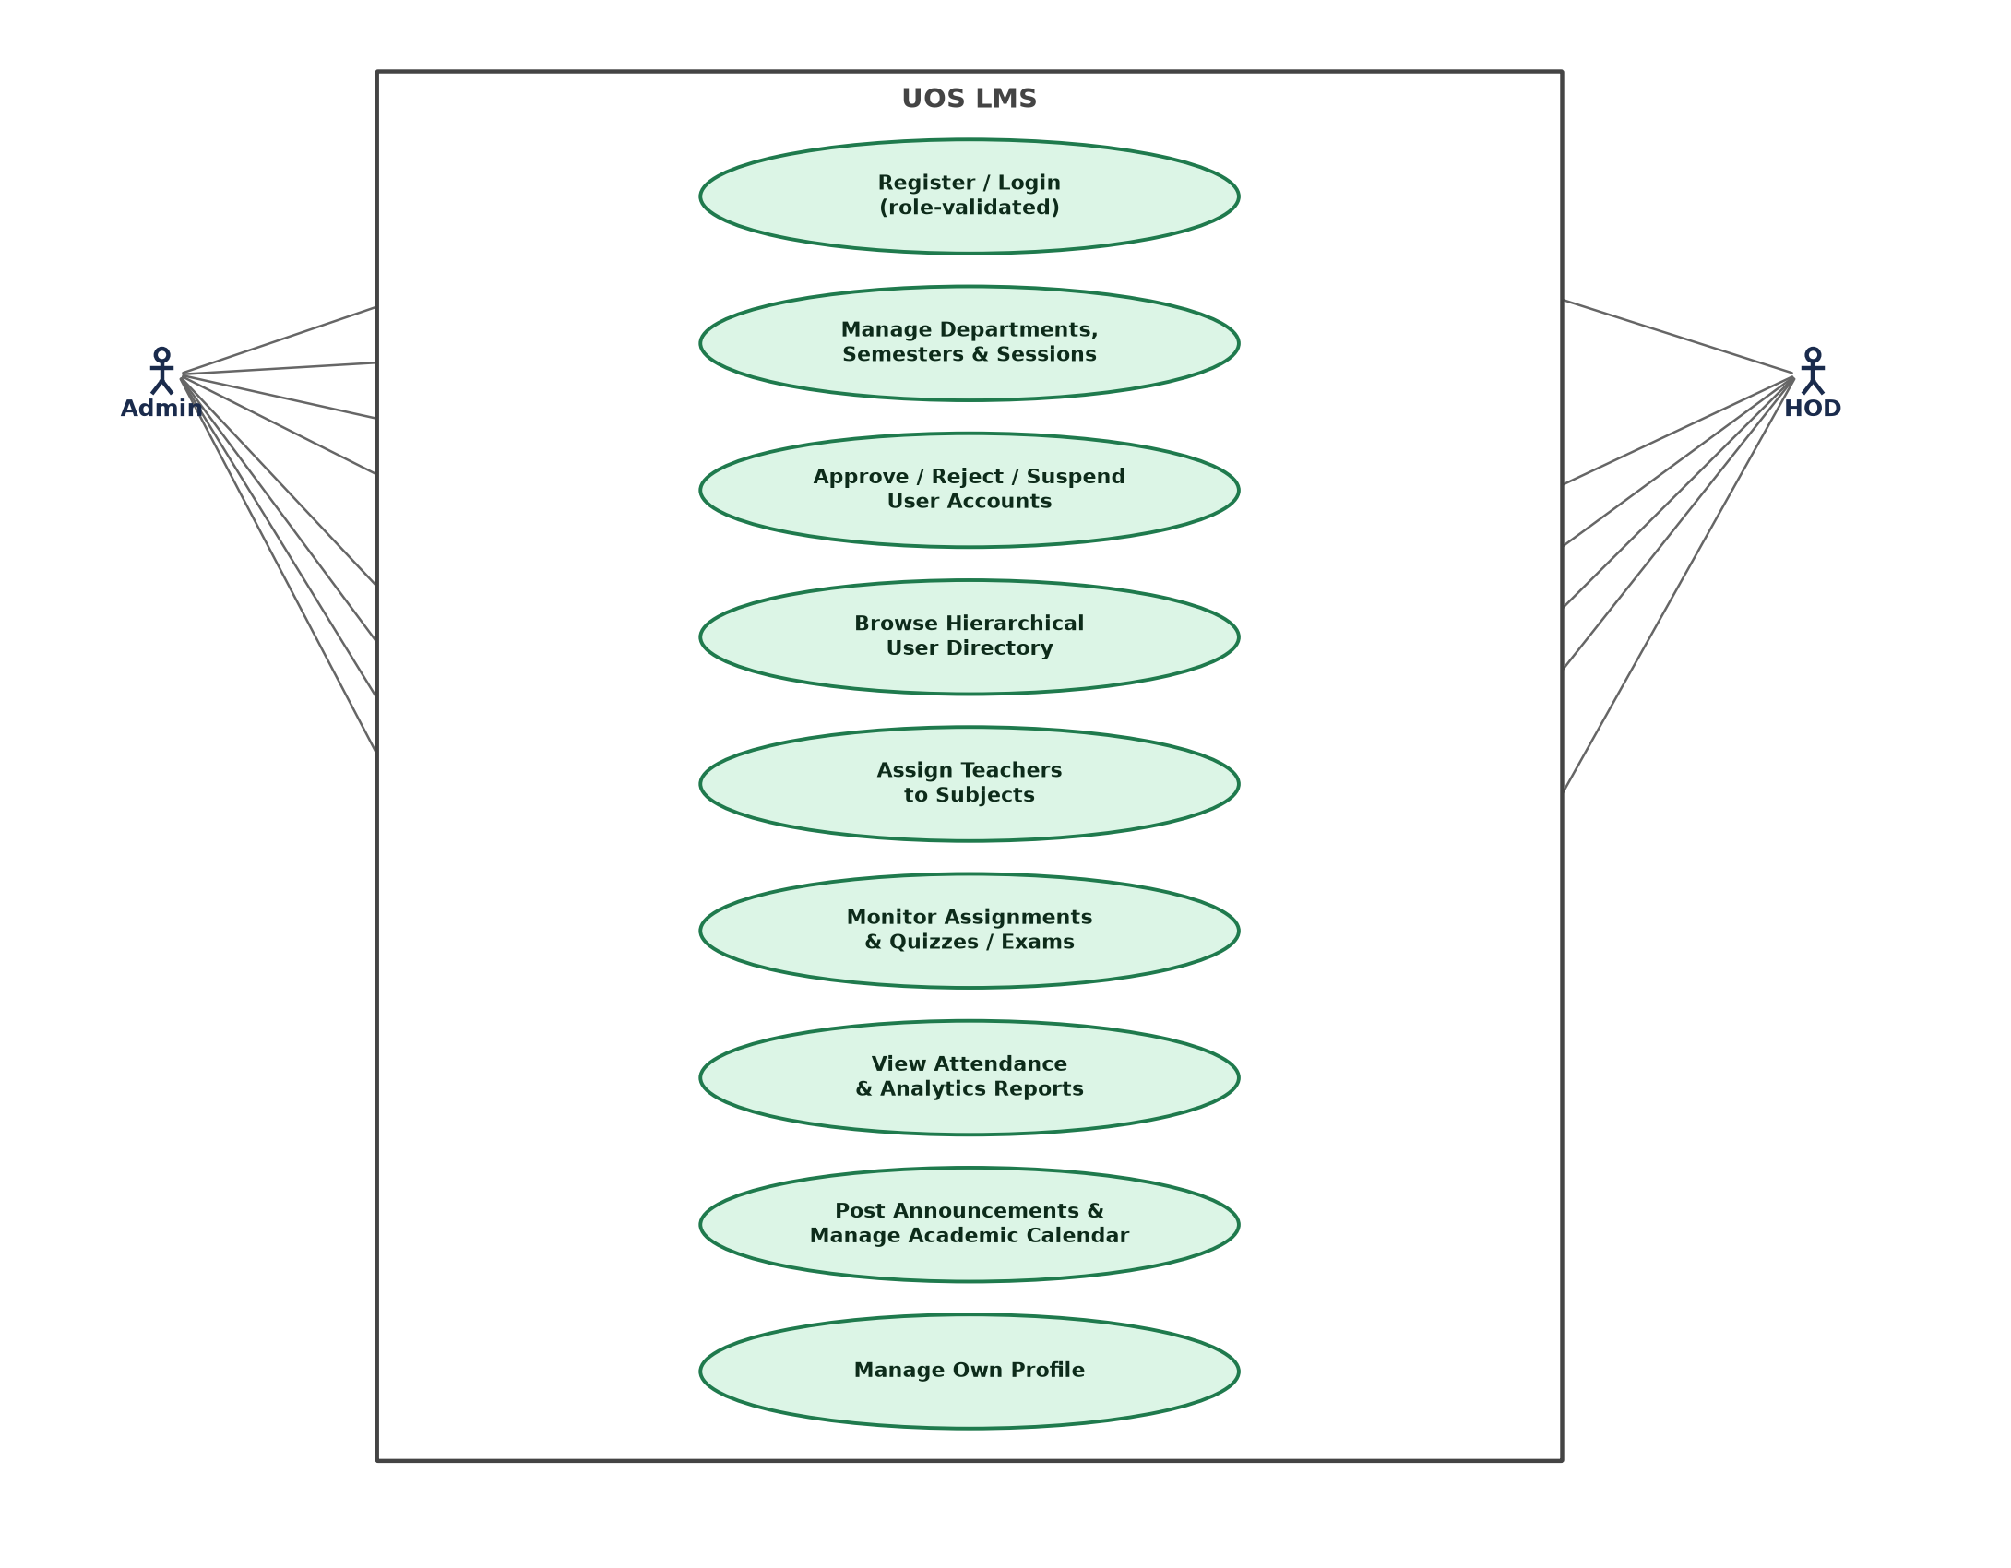
Figure 3.1: Use Case Diagram – Administrative Actors (Admin & HOD)
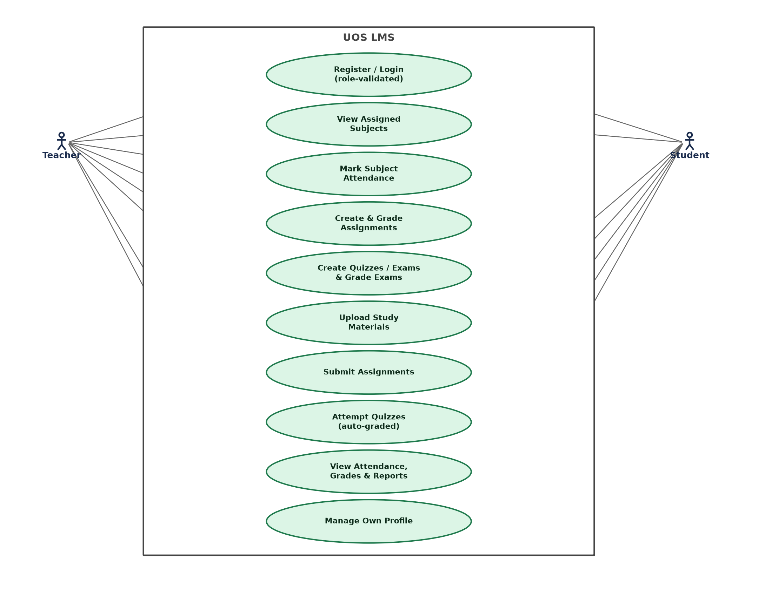
Figure 3.2: Use Case Diagram – Academic Actors (Teacher & Student)

3.5.1 Sample Use Case Descriptions
Table 3.3: Sample Use Case Descriptions
Use Case | Actor | Description | Post-condition
Login (role-validated) | All roles | Actor enters e-mail, password, and selects a role from the login spinner. System authenticates the credentials against Firebase, retrieves the Firestore profile, and compares the profile's stored role against the selected role. | Session is cached and the actor is routed to their role's dashboard only if credentials, role, and approval status all match; otherwise the session is signed out and a specific error is shown.
Approve/Reject/Suspend User | Admin | Admin opens a pending or existing account from the hierarchical Users directory and selects an approval action. | The account's status field is updated; only an APPROVED account may subsequently authenticate successfully.
Mark Attendance | Teacher | Teacher selects a subject and date, then marks each enrolled student Present or Absent. | One AttendanceRecord document is written per student for that subject and date.
Submit Assignment | Student | Student opens an assigned assignment, writes a text answer and/or attaches a file, and submits. | An AssignmentSubmission document is created, with any attached file uploaded to Cloudinary first.
Attempt Quiz/Exam | Student | Student answers each multiple-choice question within the configured time limit and submits the attempt. | A QuizAttempt document is stored with an automatically computed score; for exams, the teacher may later add a manualScore.

3.6 Feasibility Study

3.6.1 Technical Feasibility
All required technologies — Kotlin, Jetpack Compose, Firebase, and Cloudinary — are mature, well-documented, and freely available for development. The development team had prior exposure to Android development and Kotlin, making the technical risk of the project low.

3.6.2 Operational Feasibility
The application requires only an internet-connected Android device to operate, which is consistent with device availability among the target user base. The four-role structure mirrors the university's existing organisational hierarchy, minimising the change-management burden of adoption.

3.6.3 Economic Feasibility
Firebase and Cloudinary are both offered on usage-based free tiers that comfortably cover a single-institution deployment at the University of Shangla's expected scale, making the recurring operating cost of the system negligible relative to the manual processes it replaces.

3.6.4 Schedule Feasibility
The project was executed in incremental phases, each delivering one functionally complete module (authentication, university-structure management, user hierarchy, subject assignment, attendance, assignments, quizzes/exams, reporting, and a final UI polish pass), which kept the project on a manageable, continuously-shippable schedule.

Chapter 4: System Design

4.1 Design Goals and Principles
- Separation of concerns between UI, state management, domain logic, and data access, following MVVM and a lightweight Clean-Architecture-inspired layering.
- Strict, server-enforced role-based access control rather than UI-only gating.
- A single shared design system (colours, gradients, shapes, typography, and reusable components) applied consistently across all four role-specific navigation graphs.
- Feature-based modularity: each functional area (attendance, assignment, quiz, etc.) is an isolated package that can be developed, reasoned about, and tested independently.

4.2 System Architecture
UOS LMS follows a layered architecture, shown in Figure 4.1. The Presentation Layer consists entirely of Jetpack Compose screens, one set per role, built from a shared library of design-system components (GradientTopAppBar, GlassCard, AppBottomNavBar, and others). Each screen observes a ViewModel's StateFlow<UiState> in the Presentation State Layer, which also exposes a one-shot Kotlin Channel for navigation events and wraps every asynchronous operation's outcome in an AppResult<T> success/error type. The Domain Layer defines plain-Kotlin use cases, repository interfaces, and domain models with no dependency on Android or Compose, keeping business logic independently testable. The Data Layer implements those repository interfaces against concrete data sources — FirestoreUserDataSource, FirestoreUniversityDataSource, FirebaseAuthDataSource, and CloudinaryDataSource — which in turn talk to the three external services: Firebase Authentication, Cloud Firestore, and Cloudinary. Dagger Hilt wires every layer together at compile time via generated dependency graphs, so a ViewModel never instantiates its own use cases or repositories directly.
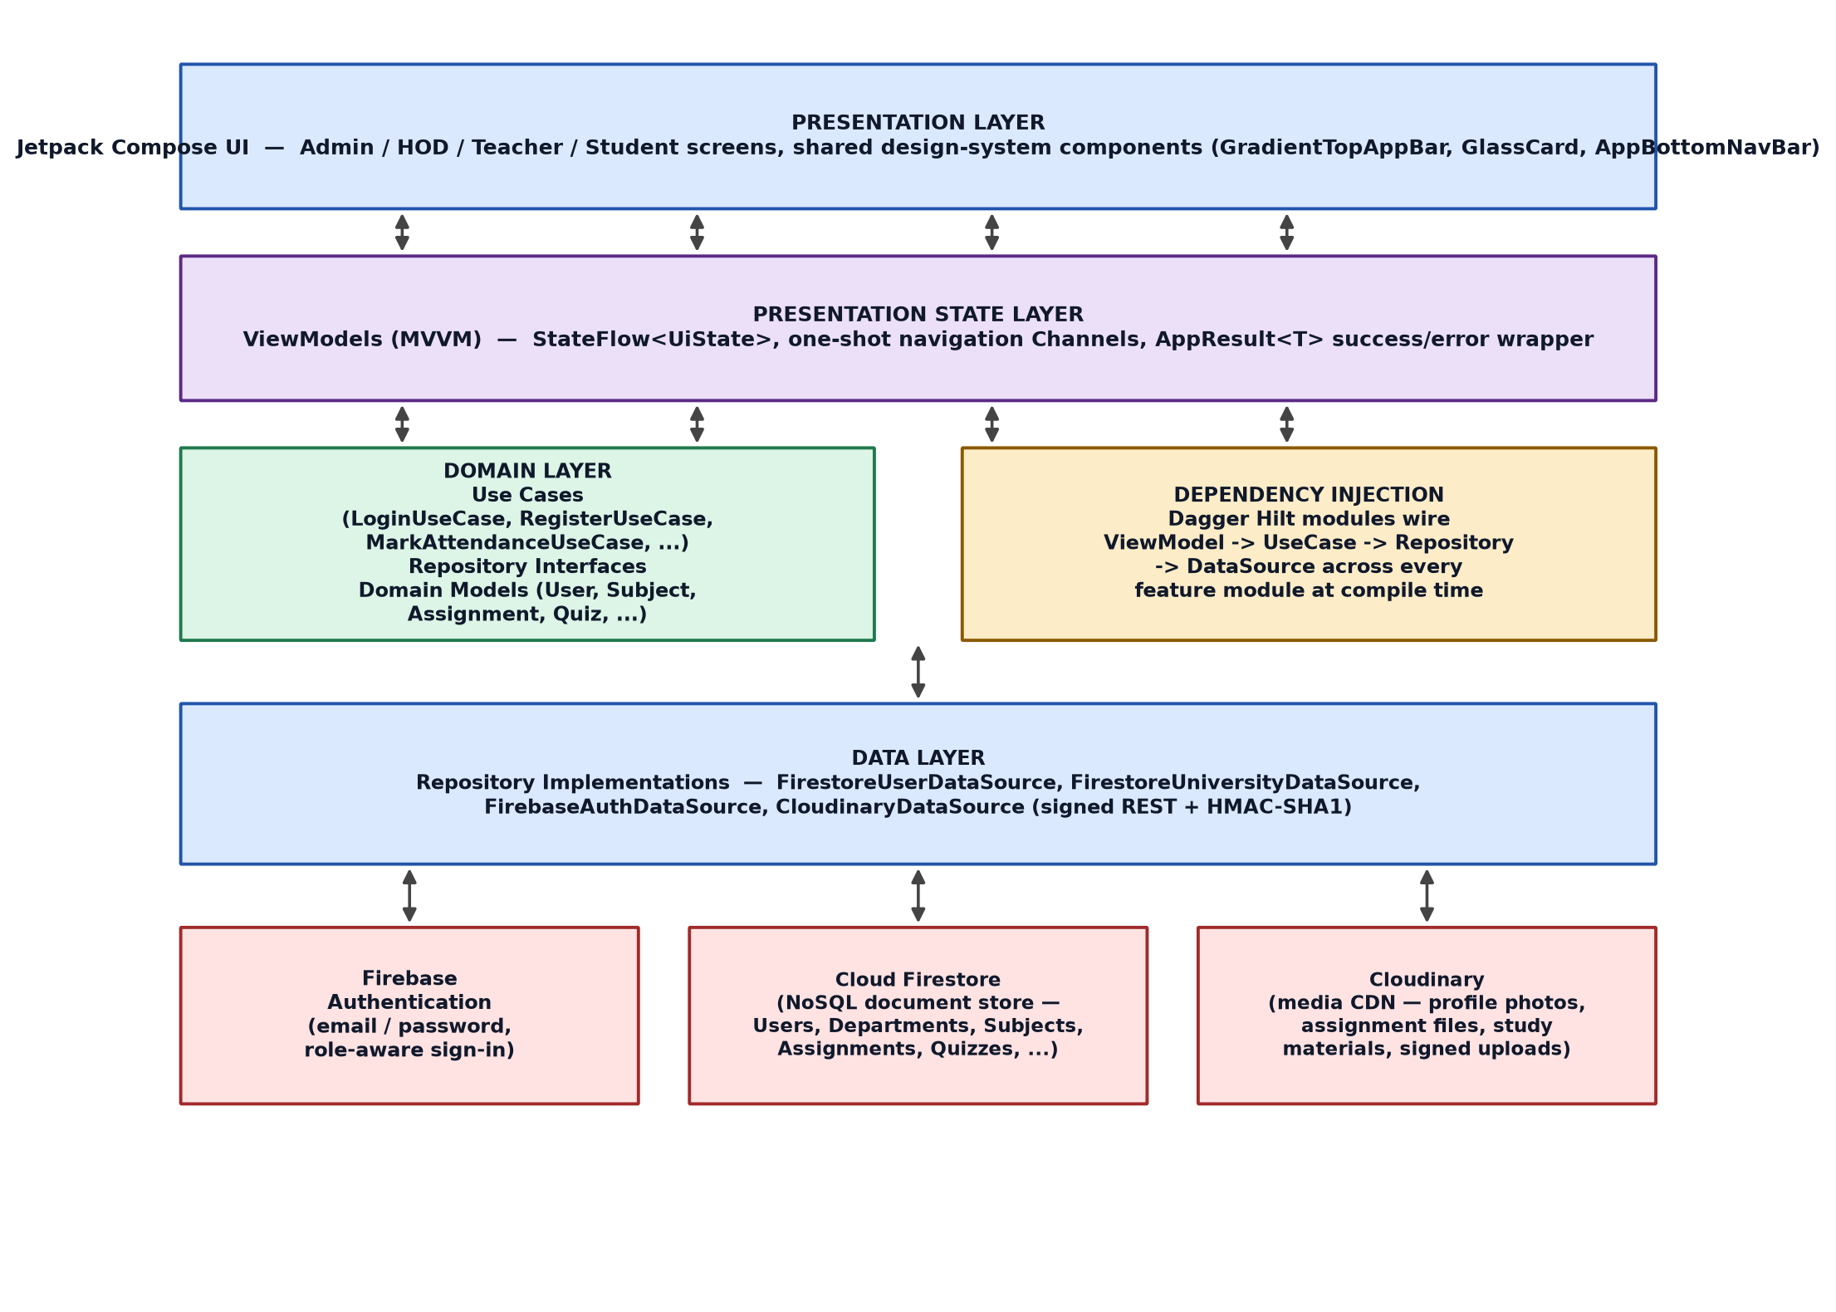
Figure 4.1: Layered System Architecture of UOS LMS

4.3 Technology Stack Justification
Table 4.1: Technology Stack
Layer / Concern | Technology | Justification
Language | Kotlin 2.2 | Official first-class language for Android; concise, null-safe, and fully interoperable with the Android SDK.
UI Toolkit | Jetpack Compose  (BOM 2026.02.01) | Declarative, state-driven UI toolkit that eliminates most manual view-invalidation bugs and pairs naturally with StateFlow-based ViewModels.
Architecture | MVVM | Cleanly separates UI from state and business logic, and is the architecture Google explicitly recommends for Compose apps.
Dependency Injection | Dagger Hilt 2.59.2 | Compile-time-verified DI eliminates a whole class of runtime wiring errors and reduces boilerplate versus hand-written Dagger.
Authentication | Firebase Authentication | Managed, secure credential storage and verification without operating a custom auth server.
Database | Cloud Firestore | Real-time NoSQL document store whose listener API keeps every open screen automatically in sync with the latest data, with security enforced server-side via rules.
Media Storage | Cloudinary | Dedicated image/file CDN with signed upload support, keeping large binary assets out of Firestore and enabling on-the-fly image optimisation.
Navigation | Navigation-Compose 2.9.7 | Type-safe, back-stack-aware navigation between the app's four independent role-based graphs.
Image Loading | Coil 3.3.0 | Compose-native, coroutine-based image loading with disk and memory caching for Cloudinary-hosted images.

4.4 Database Design
Cloud Firestore is a NoSQL, document-oriented database, so the design below is expressed as an Entity Relationship Diagram for conceptual clarity, while the physical implementation stores each entity as a top-level Firestore collection, with relationships realised as string reference fields (for example, a Subject document stores departmentId, semesterId and teacherUid rather than a native foreign key).

4.4.1 Entity Relationship Diagram
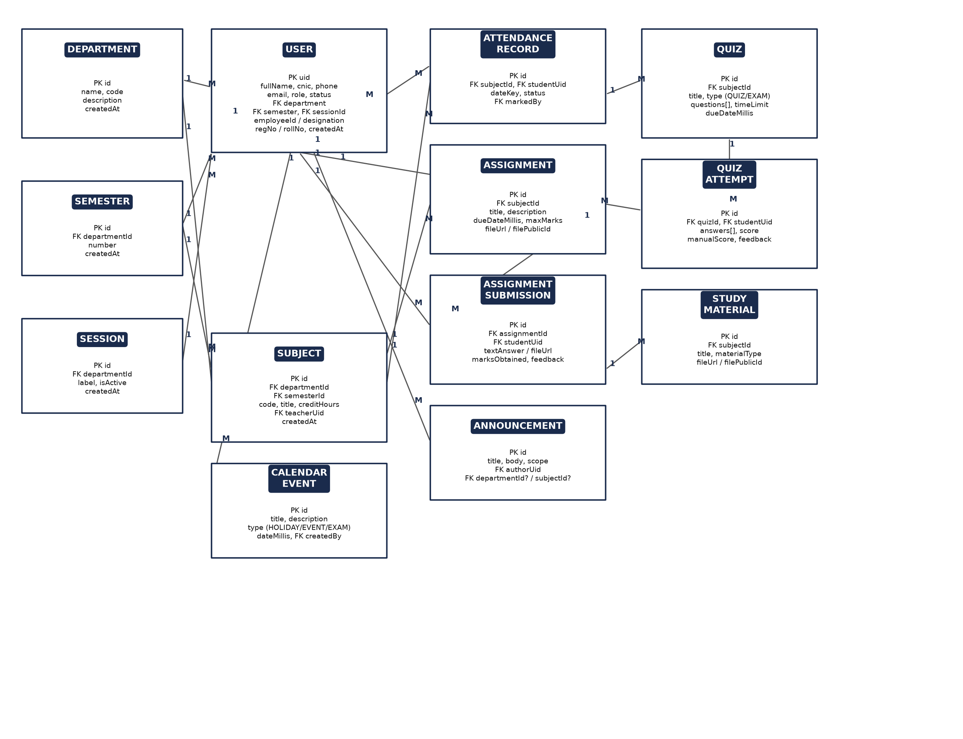
Figure 4.2: Entity Relationship Diagram of UOS LMS

4.4.2 Firestore Collection Schema Summary
Table 4.2: Firestore Collection Schema Summary
Collection | Key Fields | Purpose
users | uid, fullName, cnic, phone, email, role, status, department, semester, sessionId, employeeId, registrationNumber, rollNumber | One profile document per authenticated account across all four roles.
departments | id, name, code, description | Top-level academic departments.
semesters | id, departmentId, number | Semesters (1..N) scoped to a department.
sessions | id, departmentId, label, isActive | Enrolment sessions (e.g. 2024–2028), activatable/deactivatable.
subjects | id, departmentId, semesterId, code, title, creditHours, teacherUid | Subjects scoped to a department and semester, optionally assigned to a teacher.
attendanceRecords | id, subjectId, studentUid, dateKey, status, markedBy | One record per student, per subject, per date.
assignments / assignmentSubmissions | id, subjectId, dueDateMillis, maxMarks, fileUrl, filePublicId / marksObtained, feedback | Assignment definitions and the corresponding per-student submissions.
quizzes / quizAttempts | id, subjectId, type (QUIZ/EXAM), questions[], timeLimitMinutes / answers[], score, manualScore | Unified quiz/exam definitions and per-student attempts.
studyMaterials | id, subjectId, materialType, fileUrl, filePublicId | Subject-scoped learning resources hosted on Cloudinary.
announcements | id, title, body, scope, authorUid, departmentId?, subjectId? | University-, department-, or subject-scoped notices.
calendarEvents | id, title, type (HOLIDAY/EVENT/EXAM), dateMillis, createdBy | Shared academic calendar entries.

4.5 Class Diagram
Figure 4.3 presents a simplified class diagram of the core domain entities, corresponding directly to the Kotlin data classes defined in the domain layer (core.domain.model package). Enumerated types such as UserRole, UserStatus, AttendanceStatus, QuizType, and MaterialType constrain the valid values of their respective fields and are summarised separately for clarity.
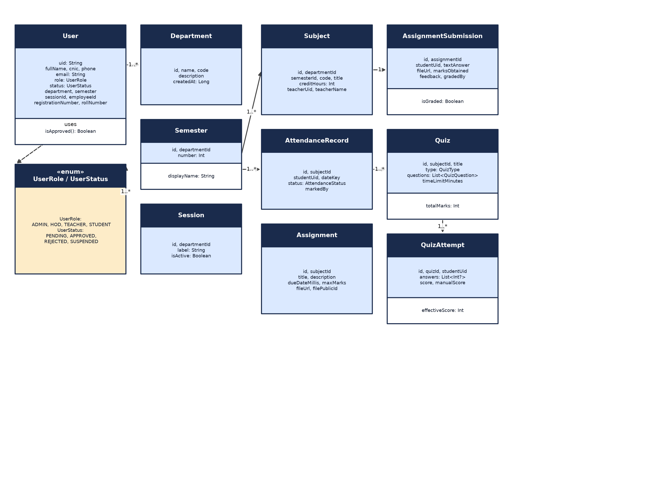
Figure 4.3: Simplified Class Diagram of Core Domain Entities

4.6 Data Flow Diagrams

4.6.1 Level 0 – Context Diagram
Figure 4.4 presents the system as a single process exchanging data with its four external actors and its two external services (Firebase and Cloudinary).
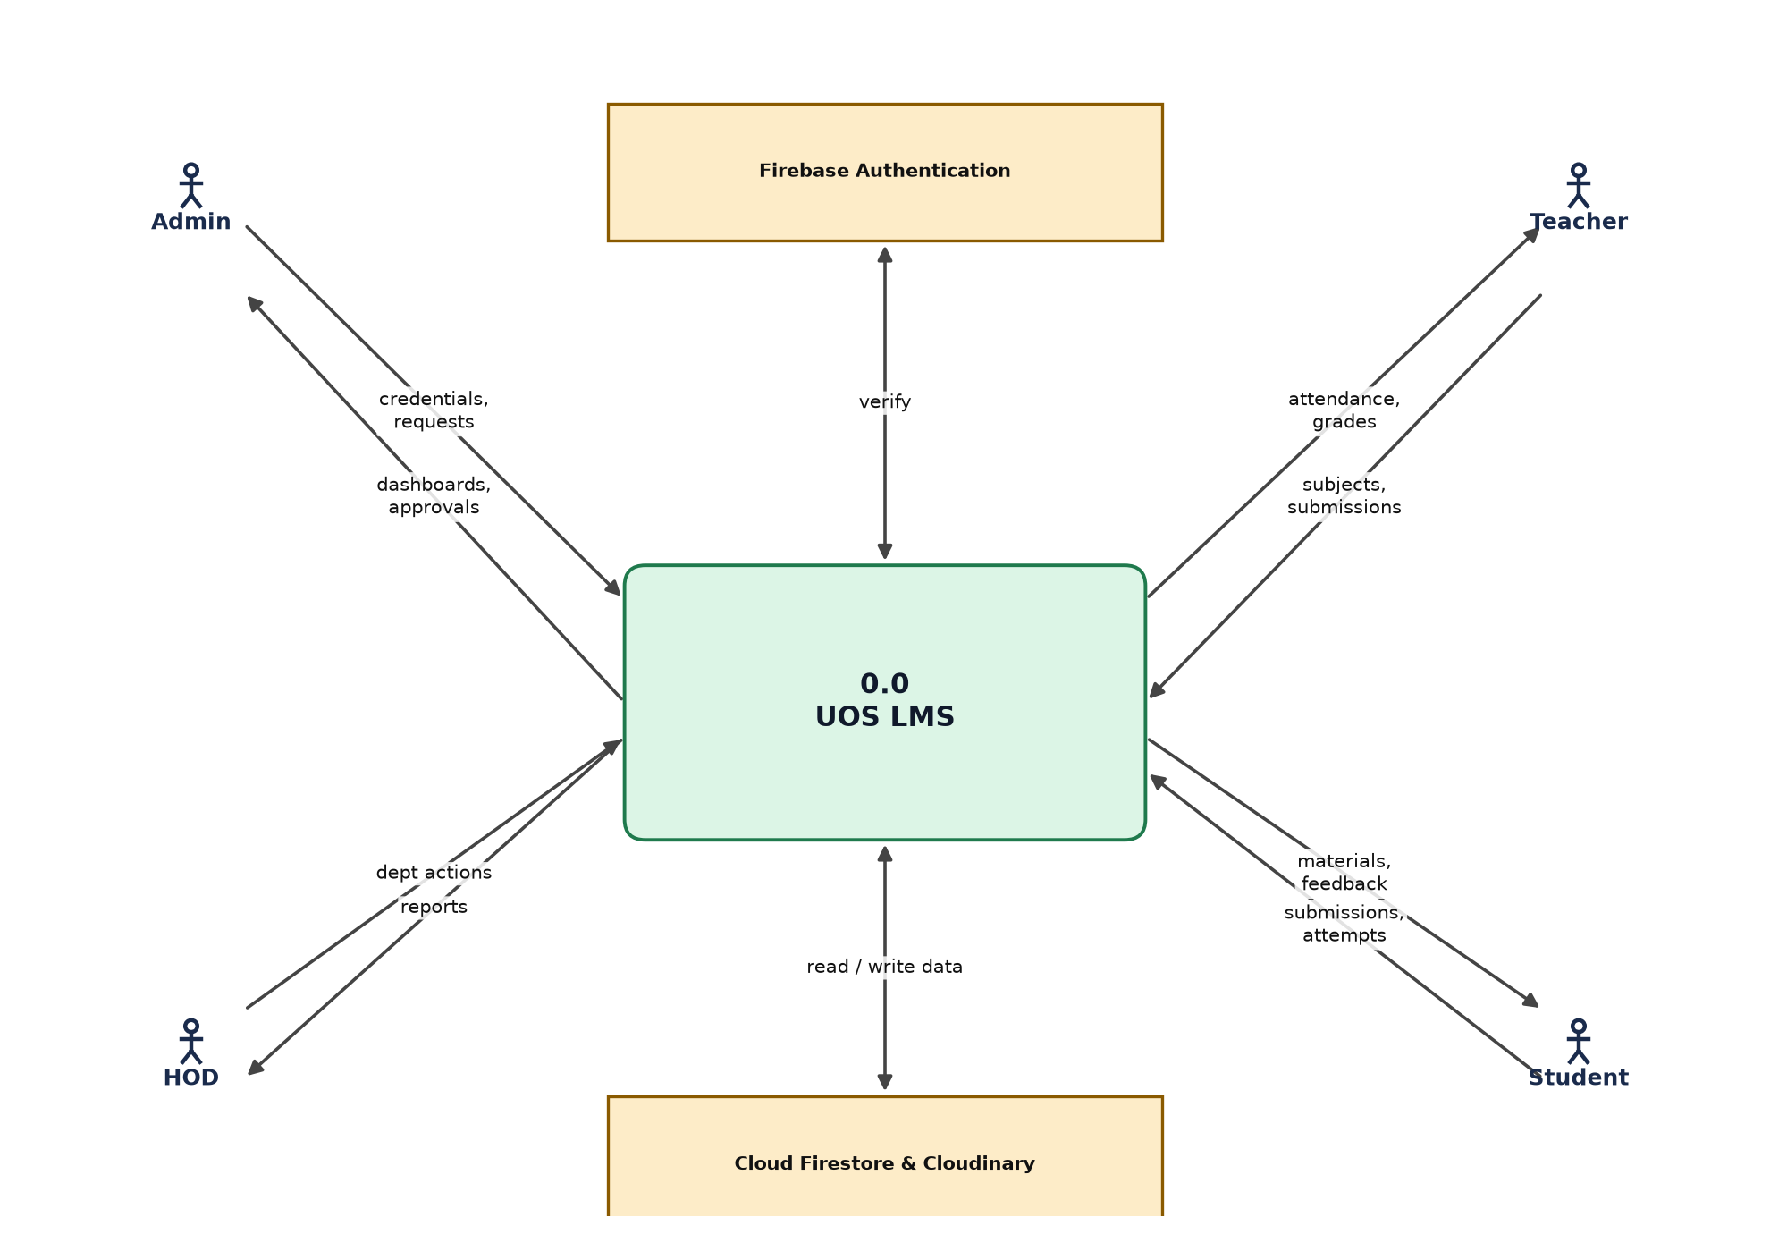
Figure 4.4: Data Flow Diagram – Level 0 (Context Diagram)

4.6.2 Level 1 – Major Processes
Figure 4.5 decomposes the system into its six major processes and the underlying data stores each one reads from and writes to.
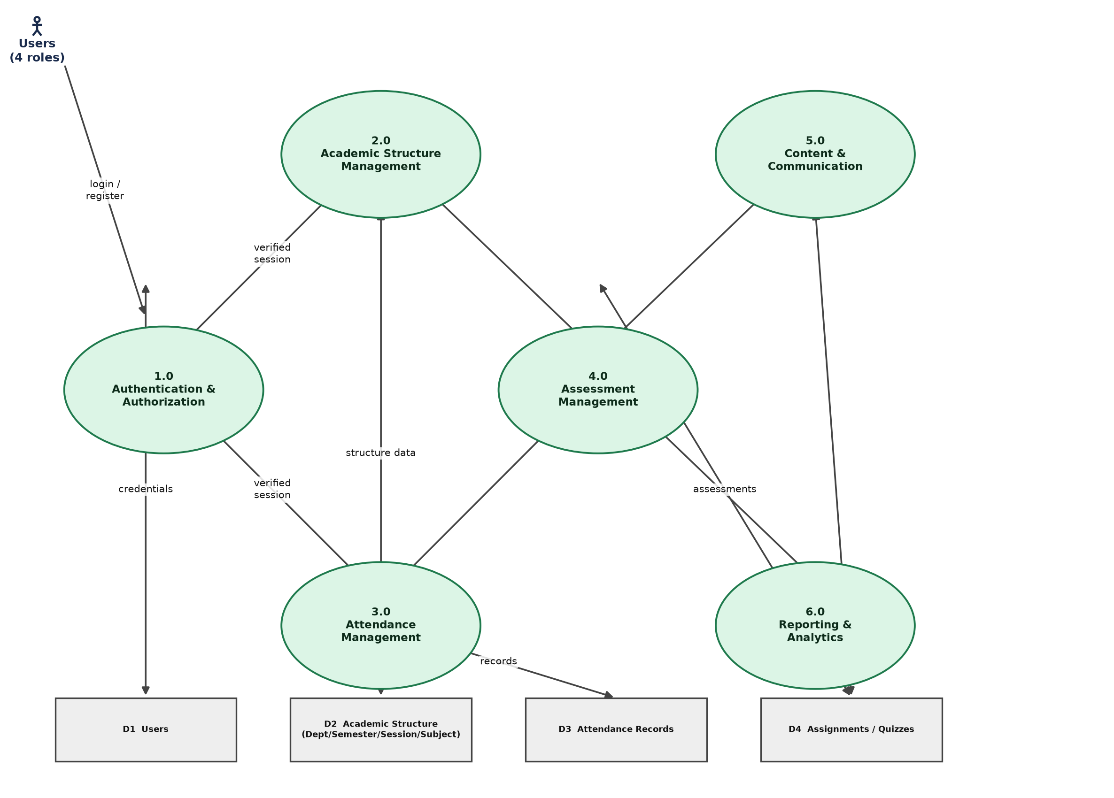
Figure 4.5: Data Flow Diagram – Level 1 (Major Processes)

4.7 Activity Diagrams

4.7.1 User Registration and Approval Workflow
Figure 4.6 traces the full lifecycle of a new HOD, Teacher, or Student account, from initial registration through Firebase/Cloudinary provisioning, administrative review, and the final approve/reject decision.
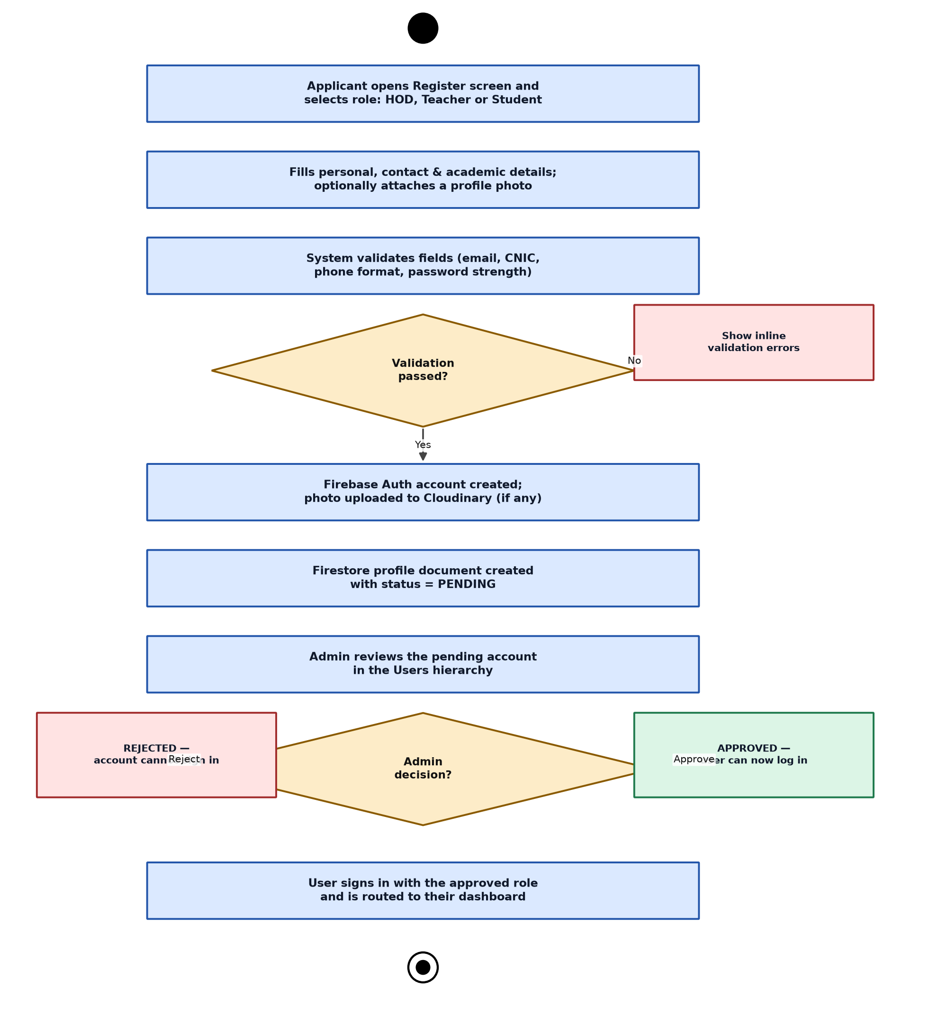
Figure 4.6: Activity Diagram – User Registration & Approval Workflow

4.7.2 Assignment Submission and Grading
Figure 4.7 traces an assignment from creation by the Teacher, through student submission (including the conditional Cloudinary file-upload branch), to grading and feedback.
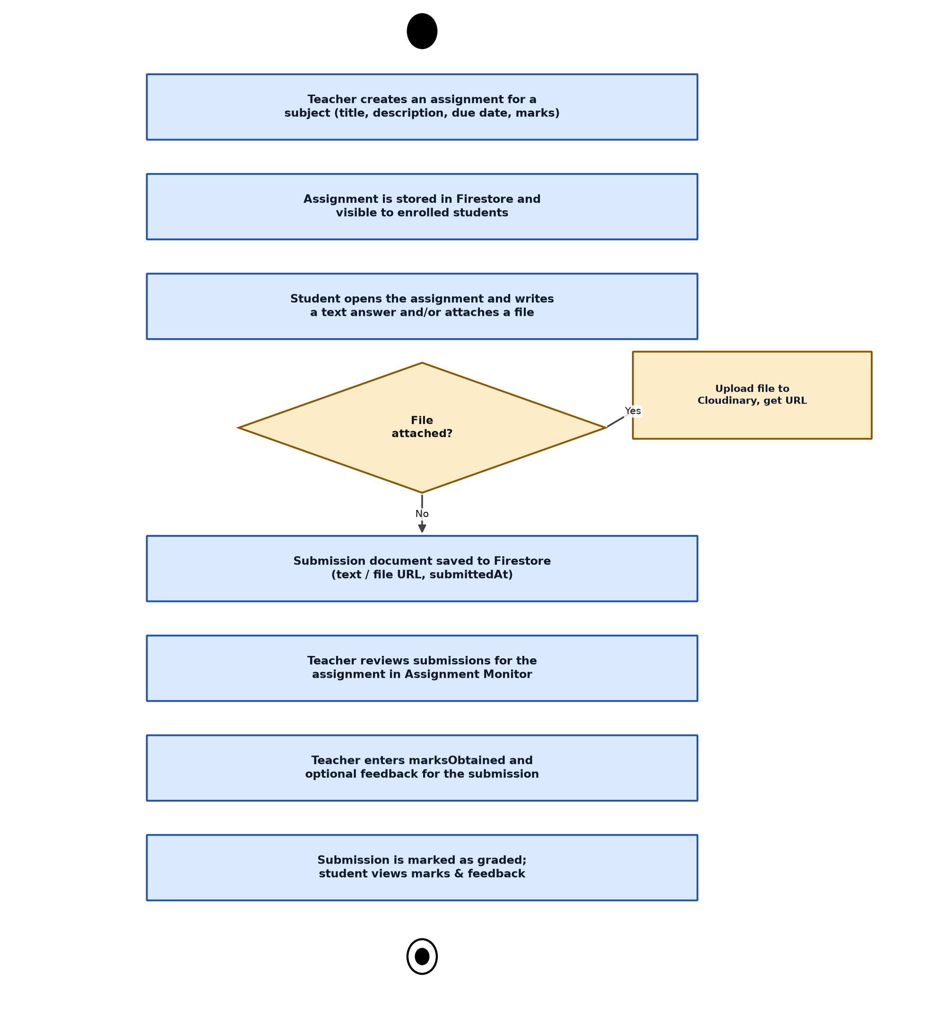
Figure 4.7: Activity Diagram – Assignment Submission & Grading

4.8 Sequence Diagrams

4.8.1 Role-Based Login
Figure 4.8 traces a login attempt through the presentation, domain, and data layers, highlighting the point at which the authenticated account's stored role is compared against the role selected on the login screen, and the corresponding sign-out-and-reject path taken on a mismatch.
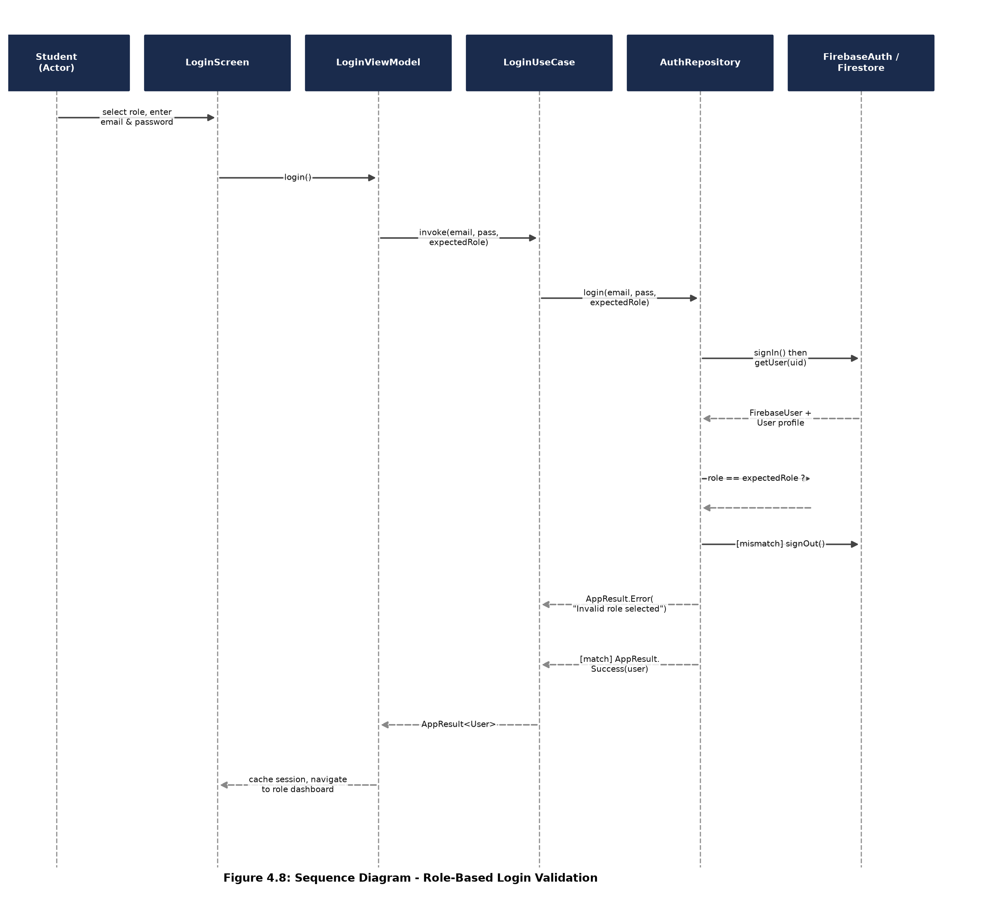
Figure 4.8: Sequence Diagram – Role-Based Login Validation

4.8.2 Assignment Submission and Grading
Figure 4.9 traces the corresponding interaction sequence for assignment submission and grading, showing the Cloudinary upload call interleaved with the Firestore writes.
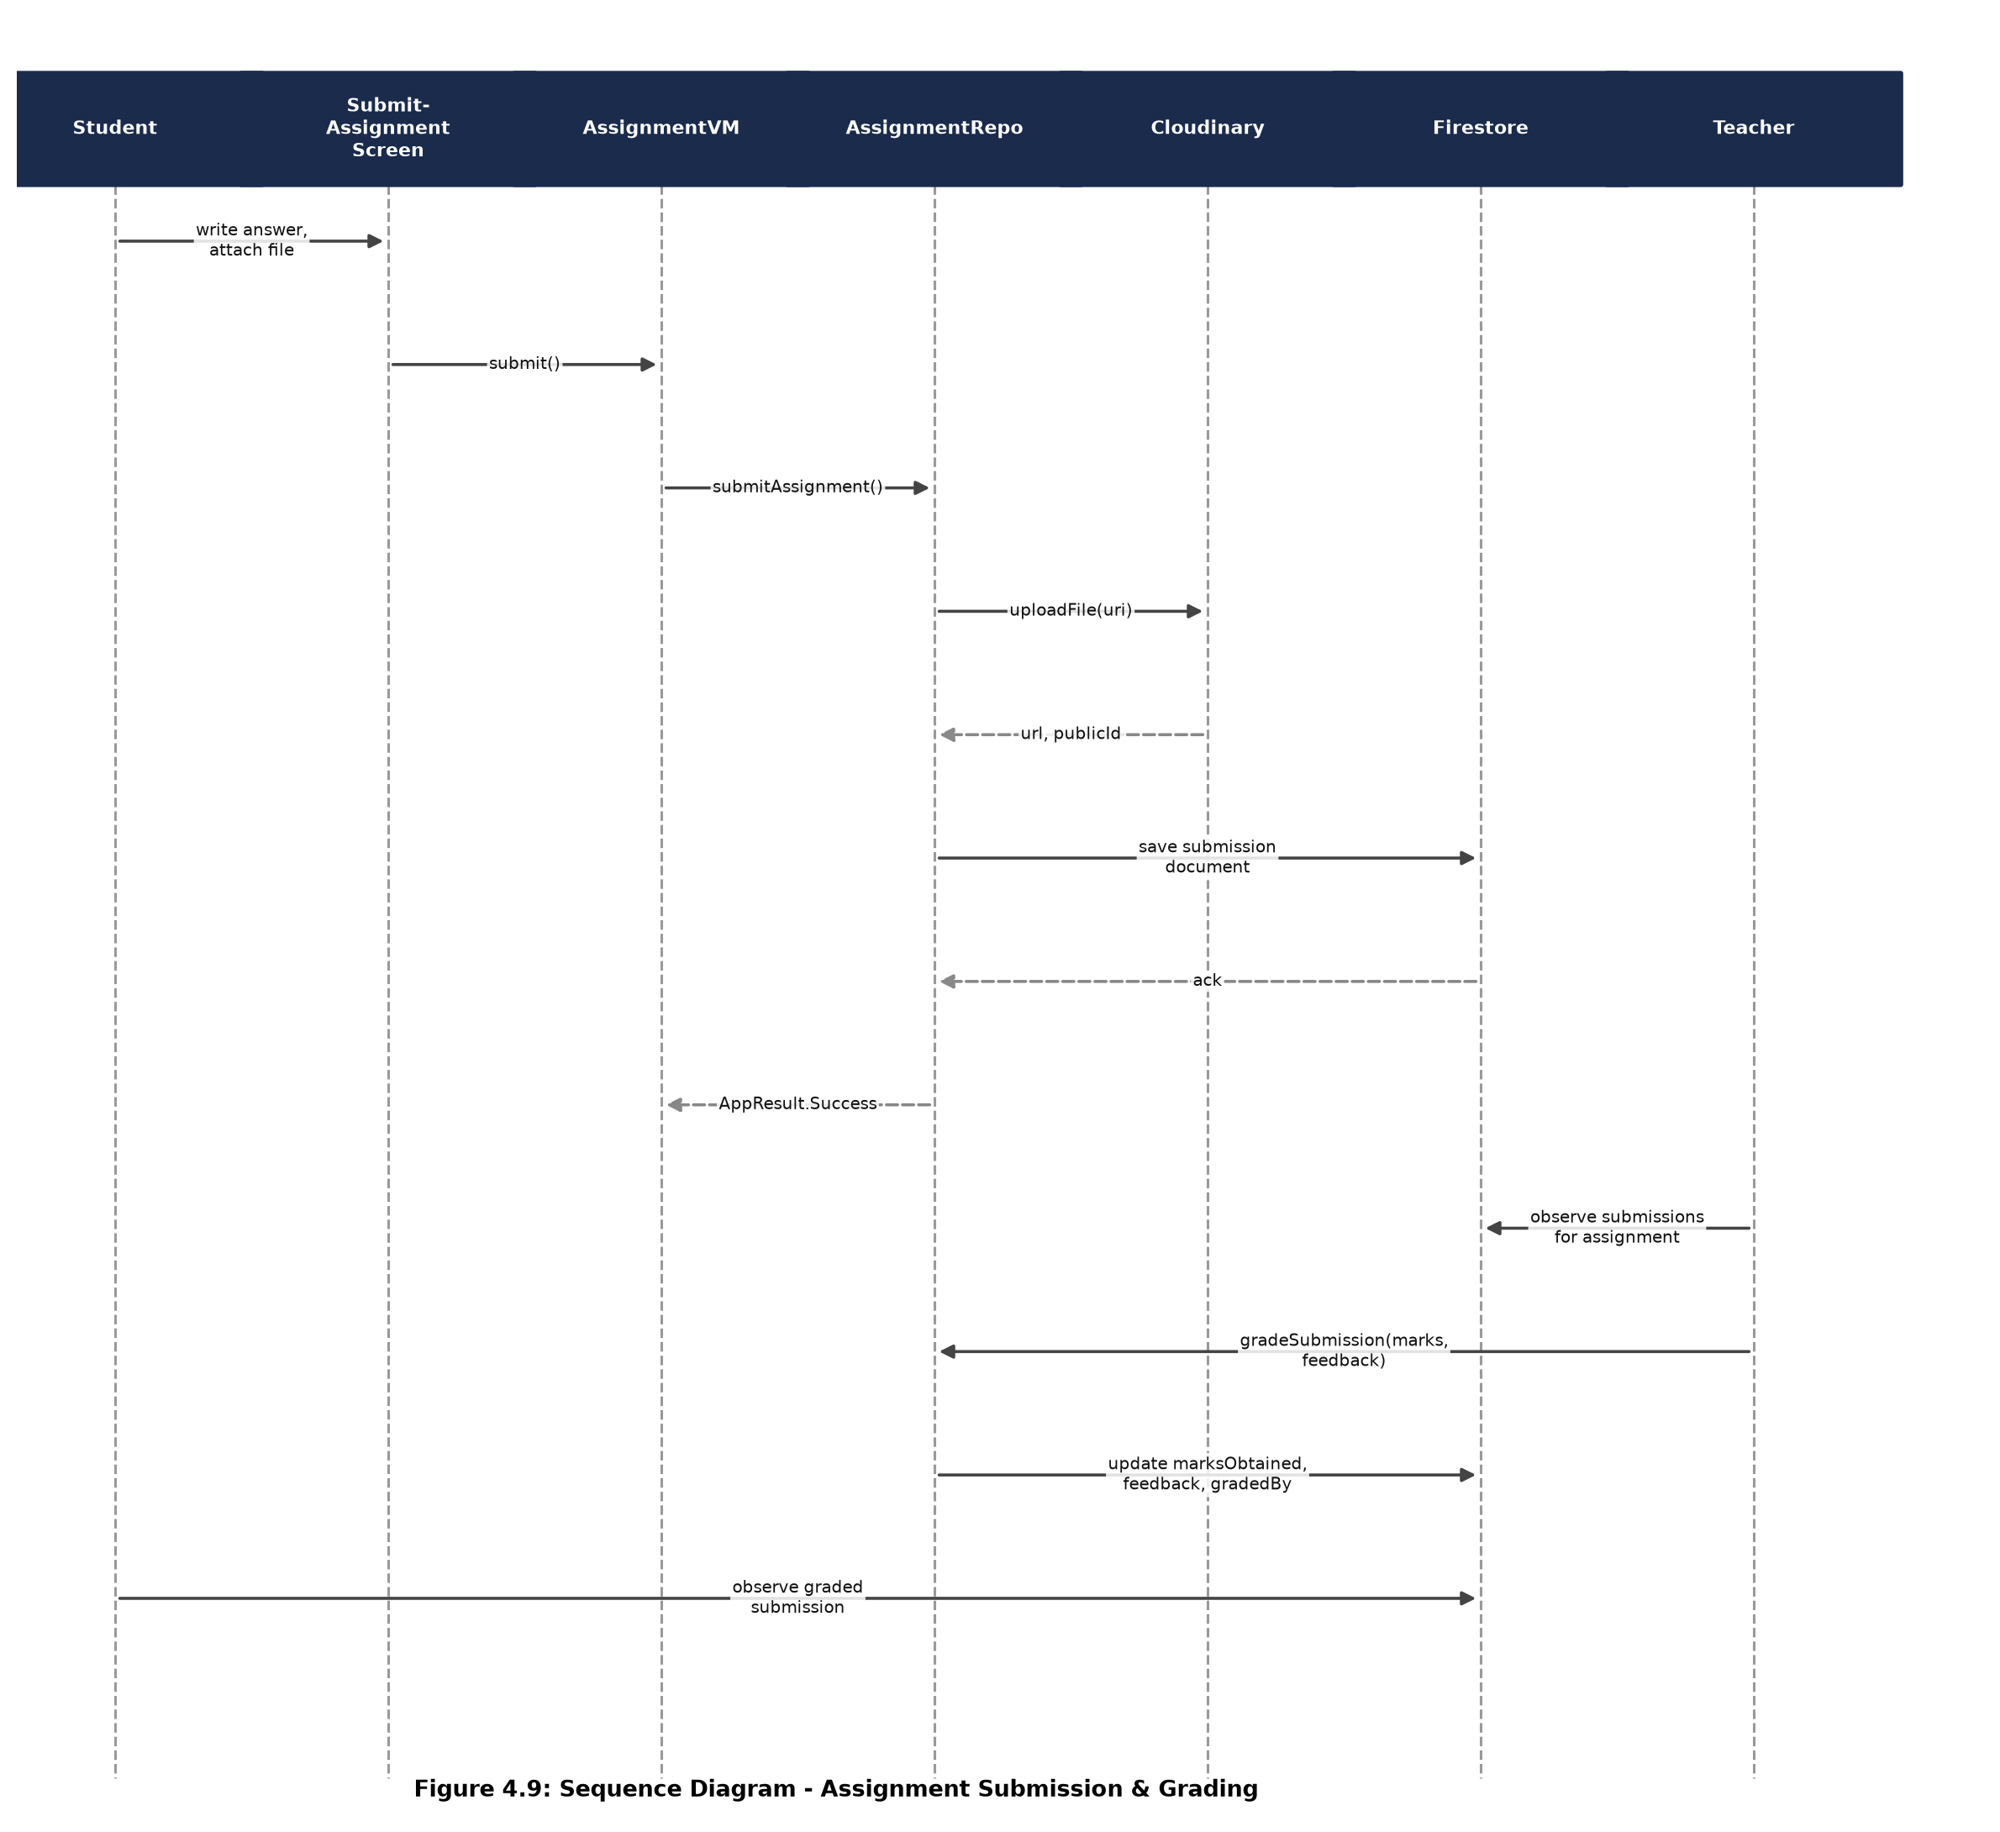
Figure 4.9: Sequence Diagram – Assignment Submission & Grading

4.9 Security Design
Client-side role checks alone are not a sufficient security boundary, since a modified client could bypass them entirely. UOS LMS therefore enforces access control at two levels. First, the AuthRepository itself refuses to complete a login when the authenticated account's role does not match the role selected by the user, immediately signing the Firebase session back out — this is the same check illustrated in Figure 4.8. Second, and more fundamentally, Cloud Firestore Security Rules and Cloud Storage Rules independently re-check the caller's role and ownership on every read and write, so that even a compromised or modified client cannot read or write data outside its role's permitted scope. A representative excerpt of the Firestore security rules is included in Appendix A.
Unapproved accounts (status PENDING, REJECTED, or SUSPENDED) are always signed out of Firebase Authentication immediately after the profile check, rather than being kept in an authenticated-but-restricted state, so that the security rules' own role/approval checks are the only path by which data can ever be reached.

4.10 UI/UX Design System
All four roles share a single design system defined under the ui.theme and core.ui.components packages: a centralised colour palette (an Indigo/Emerald/Amber base, with each role assigned its own accent gradient — Admin indigo–violet, HOD blue–purple, Teacher green–teal, and Student orange–pink), a shared rounded-corner shape scale, consistent typography, and a library of reusable components including GlassCard (a semi-transparent, gradient-bordered card used in place of true background blur, since Modifier.blur() has no reliable fallback below Android 12), GradientTopAppBar, an animated icon-morphing bottom navigation bar, and standard EmptyState/ErrorState/ConfirmDialog components used identically across every module. This shared system keeps the four otherwise-independent navigation graphs visually and behaviourally consistent.

Chapter 5: Implementation

5.1 Development Environment and Tools
Table 5.1: Development Environment and Tools
Tool / Component | Version / Detail
IDE | Android Studio (Kotlin/Compose tooling)
Language | Kotlin 2.2.10
Build System | Gradle with Android Gradle Plugin 9.2.0, KSP 2.2.10
Compose BOM | 2026.02.01
Minimum SDK / Target SDK | API 24 (Android 7.0) / API 36 (Android 15)
Backend | Firebase (Authentication, Cloud Firestore) — BOM 34.15.0
Media Storage | Cloudinary (signed REST uploads, HMAC-SHA1 request signing)
Dependency Injection | Dagger Hilt 2.59.2
Version Control | Git
Physical Test Device | Android phone (Xiaomi/Redmi, HyperOS)

5.2 Project / Package Structure
The codebase is organised as a single Gradle module (:app) split into a shared core package and one feature package per functional area. The core package contains domain models, common utilities, session management, navigation, dependency-injection modules, and the shared UI component library. Each feature package (auth, admin, hod, teacher, student, university, attendance, assignment, quiz, material, announcement, calendar, profile) contains its own presentation (Compose screens + ViewModels), and, where the feature owns its own data, its own domain and data sub-packages. This structure keeps each role's screens isolated from the others while allowing genuinely shared concepts — such as the University repository used by both Admin and HOD — to live in a single shared location rather than being duplicated.

5.3 Module-wise Implementation

5.3.1 Authentication and Role-Based Login
The authentication module provides registration (Register-able roles: HOD, Teacher, Student — Admin accounts are provisioned only directly in the database and cannot be self-registered), login, forgot-password (via a securely e-mailed Firebase reset link, not a plaintext password, which cannot be recovered or transmitted by design), and session caching. The login screen presents all four roles — Admin, HOD, Teacher, Student — in a single animated role selector; the selected role both drives the screen's gradient theme and is passed through to the AuthRepository, which rejects the login outright if the authenticated account's stored role does not match, per the flow in Figure 5.1.

5.3.2 University Structure Management (Admin)
The Admin role manages the full academic hierarchy: Departments, Semesters, Sessions (including activate/deactivate and a guarded delete that first checks whether any students are linked to a session, offering a reassign-before-delete flow when they are), and Subjects. This hierarchy underpins every other module's scoping (a Subject always belongs to exactly one Department and Semester; a Student always belongs to exactly one Department, Semester, and Session).

5.3.3 Hierarchical User Management
The Admin's Users section presents all non-Admin accounts as an expandable/collapsible tree with four tabs — All, HOD, Teacher, Student — the Student tab further nested as Department → Semester → Session → Students. Each level displays a Firestore aggregate count()-based badge rather than downloading and counting full documents, keeping the screen responsive even as enrolment grows.

5.3.4 HOD Panel and Subject Assignment
Each HOD account is scoped to a single department. The HOD's principal responsibility is assigning (or unassigning) an approved Teacher to each Subject within their own semester structure; all of the HOD's Teachers/Students/Attendance/Reports screens are read-scoped to that same department by the underlying Firestore queries and security rules.

5.3.5 Attendance Management
A Teacher marks attendance per subject and date, writing one AttendanceRecord document per enrolled student with a PRESENT or ABSENT status. Students, HODs, and Admins each see read-only, appropriately-scoped views: a Student sees only their own history and running percentage; an HOD sees department-wide aggregates; an Admin sees university-wide aggregates with CSV export.

5.3.6 Assignment Management and Cloudinary Integration
Assignments and their submissions are the first module in the codebase to use the shared Cloudinary media pipeline: a Teacher may attach a reference file to an assignment, and a Student may attach a file to their submission. In both cases, the file is uploaded directly to Cloudinary via a signed REST request (the request is signed with HMAC-SHA1 using the Cloudinary API secret, computed client-side, rather than through the Cloudinary Android SDK), and only the resulting secure URL, public ID, resource type, and file size are stored in the corresponding Firestore document — the binary file itself never touches Firestore. A Teacher grades a submission by writing marksObtained and an optional feedback string back onto the same submission document.

5.3.7 Quiz/Exam Module and Auto-Grading
Quizzes and Examinations share a single Quiz entity distinguished only by a type field (QUIZ or EXAM), avoiding duplicated data models for what is functionally the same feature with different grading semantics. Every question is multiple-choice with exactly one correct option, so a student's attempt can always be scored automatically the instant it is submitted, by summing the marks of every question whose selected option matches its correctOptionIndex — this avoids requiring server-side Cloud Functions purely for grading, at the accepted tradeoff that an examination's raw auto-computed score can optionally be overridden by the teacher afterwards via a manualScore field, with the student always shown effectiveScore (manualScore if set, otherwise the automatic score). The exact scoring algorithm is presented as a flowchart in Figure 5.2.

5.3.8 Study Material Module
Teachers upload subject-scoped study material (PDF, PPT, Video, or generic Notes, classified by a materialType enum) through the same Cloudinary pipeline used for assignments; students browse and open material for every subject they are enrolled in.

5.3.9 Announcements and Academic Calendar
Announcements carry a scope field (ALL, DEPARTMENT, or SUBJECT) that determines their audience, and can be authored by Admins (university-wide or department-scoped) or by HODs/Teachers (department- or subject-scoped respectively). The academic calendar stores typed events (HOLIDAY, EVENT, or EXAM) visible to every role, managed by the Admin.

5.3.10 Reports and Analytics
Each of the Admin, HOD, and Teacher roles has a Reports screen tailored to its scope: the Admin sees university-wide totals and bar-chart breakdowns of attendance-by-department and subject-load-by-teacher; the HOD sees the same breakdown restricted to their own department; and the Teacher sees per-subject summaries for the subjects they teach.

5.3.11 Profile and Theme Management
Every role shares a single Profile screen implementation, allowing self-service editing of personal details and profile photo (again via Cloudinary), password change, and a light/dark theme toggle persisted across sessions via a local DataStore-backed ThemeViewModel — the same toggle is honoured application-wide from the moment the app process starts, in MainActivity.

5.4 Key Algorithms

5.4.1 Role-Based Login Validation
Figure 5.1 presents the complete decision flow executed on every login attempt, from initial Firebase Authentication through the final role- and approval-status checks that determine whether the caller is actually routed to a dashboard.
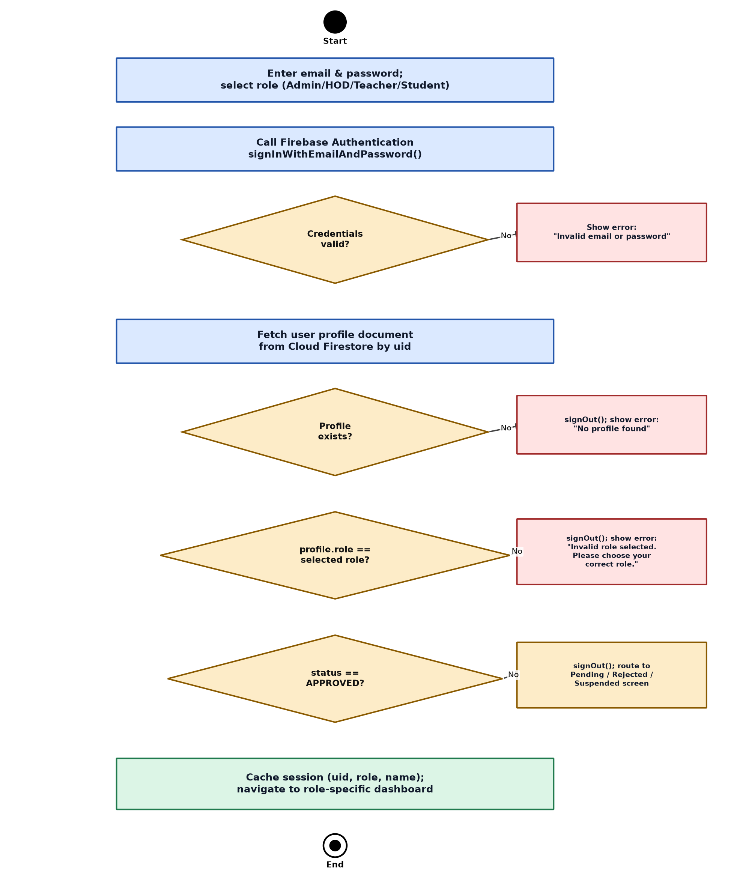
Figure 5.1: Flowchart – Role-Based Login Validation

5.4.2 Automated Quiz/Exam Grading
Figure 5.2 presents the scoring algorithm executed the instant a student submits a quiz or exam attempt, including the optional manual-override path available for examinations.
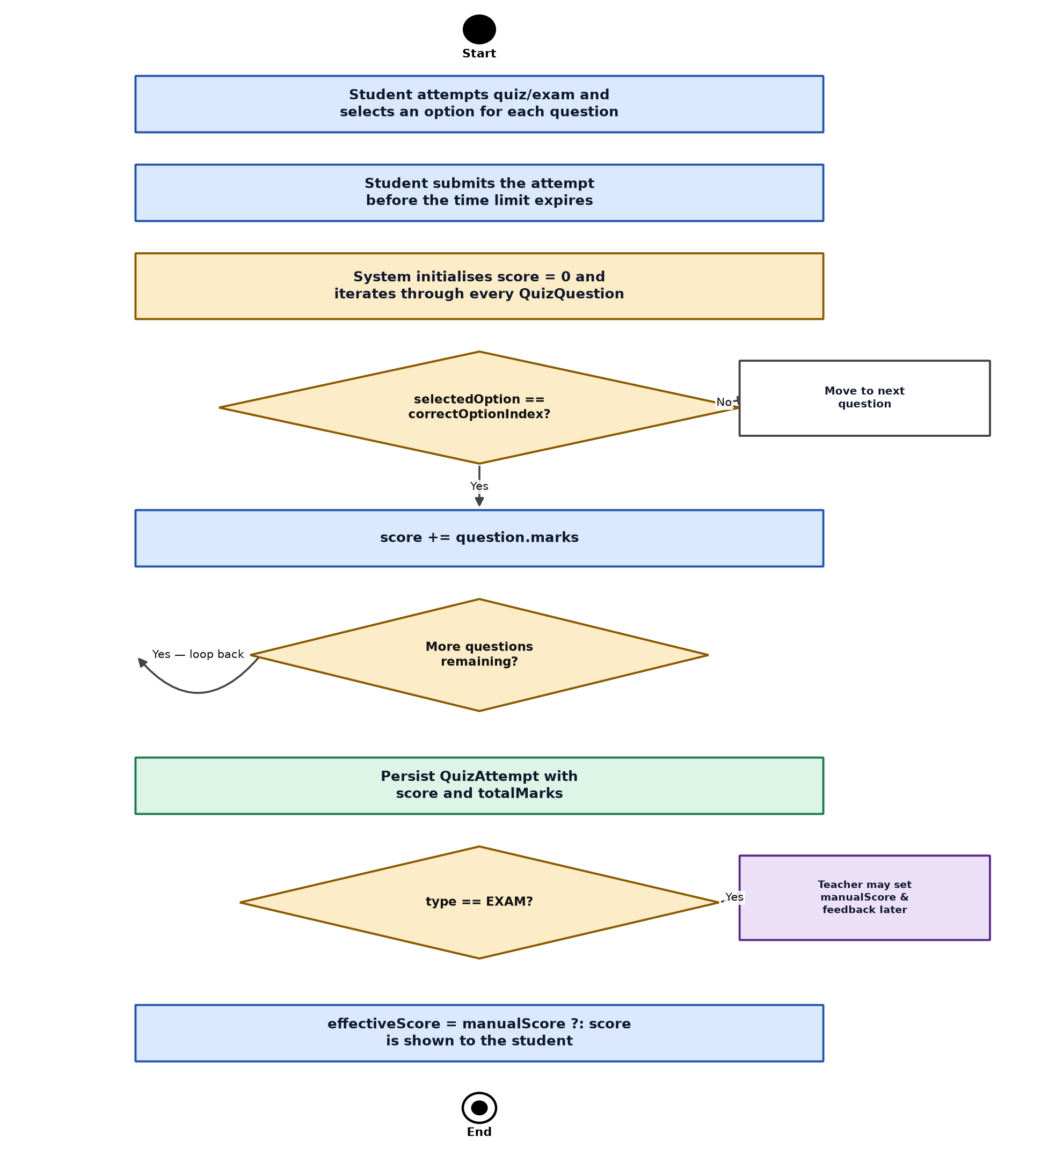
Figure 5.2: Flowchart – Automated Quiz/Exam Grading

5.5 Third-Party Service Integration
Cloudinary was integrated via direct, manually-signed REST calls rather than the official Cloudinary Android SDK, to keep full, auditable control over exactly what is signed and sent with every upload request. A representative excerpt of this signing logic is included in Appendix B.

5.6 Challenges Faced During Implementation
- Reconciling Firestore's document-oriented model with an inherently relational academic hierarchy (Department → Semester → Session/Subject → User) required careful denormalised field design (storing both an ID and a display name where needed) to keep list screens fast without extra round-trip reads.
- Enforcing role-based login correctness required moving the role check out of the UI layer and into the repository, so that a mismatched role could never merely be hidden by the UI while still leaving an authenticated session active underneath.
- Testing on a physical Xiaomi/HyperOS device that blocks ADB input-injection (a manufacturer restriction, not a project defect) limited some interactive verification to build-success and manual on-device testing rather than automated UI testing.
- Balancing a consistent, animated design system across four independently-navigable role graphs required extracting shared composables (GradientTopAppBar, GlassCard, role-based gradient tokens) early, rather than duplicating styling per screen.

Chapter 6: Testing

6.1 Testing Objectives and Strategy
Testing focused on verifying that (a) each role can perform exactly the operations defined in its functional requirements and no others, (b) the role-based login validation correctly accepts matching roles and rejects mismatched ones, (c) core data-mutating workflows (attendance, submission, grading, quiz attempts) persist and display correctly, and (d) the application builds and installs cleanly on a physical Android device after every module.

6.2 Types of Testing Performed
- Unit-level verification of pure domain logic (score computation, validators) through manual code review and targeted manual invocation, given the project's plain-Kotlin domain layer.
- Manual functional testing of each screen and workflow on a physical Android device following every implementation phase.
- Build verification — a full `./gradlew compileDebugKotlin` and `installDebug` pass was required to succeed after every phase before that phase was considered complete.
- Regression testing of previously completed modules after each subsequent phase, to catch any shared-component change that might have affected an already-completed role's screens.

6.3 Test Case Design
Table 6.1: Sample Test Cases
ID | Test Case | Steps | Expected Result | Status
TC-01 | Login with matching role | Select Student role; enter valid Student credentials; submit | Session cached; routed to Student dashboard | Pass
TC-02 | Login with mismatched role | Select Teacher role; enter valid Student credentials; submit | Session signed out; "Invalid role selected" error shown | Pass
TC-03 | Login before Admin approval | Register a new Student; attempt login immediately | Routed to Pending-Approval screen, not the dashboard | Pass
TC-04 | Session deletion with linked students | Attempt to delete a Session that has students assigned | Deletion blocked; reassignment dialog offered | Pass
TC-05 | Mark attendance | Teacher marks all students of a subject Present/Absent for today | One AttendanceRecord per student is created/updated for that date | Pass
TC-06 | Submit assignment with attachment | Student writes a text answer and attaches a file, then submits before the due date | Submission stored with fileUrl set; file visible to Teacher | Pass
TC-07 | Grade a submission | Teacher opens a submission and enters marks and feedback | isGraded becomes true; Student sees marks and feedback | Pass
TC-08 | Auto-graded quiz attempt | Student answers all MCQs and submits | Score is computed immediately as the sum of marks for correct answers | Pass
TC-09 | Manual exam override | Teacher sets a manualScore on a submitted exam attempt | Student's displayed effectiveScore reflects the manualScore | Pass
TC-10 | Department-scoped HOD view | HOD opens Students/Teachers/Reports | Only users and data belonging to the HOD's own department are shown | Pass
TC-11 | Register with Admin role | Attempt to select "Admin" on the Register screen | Admin is not offered as a selectable role | Pass
TC-12 | Forgot password | Enter a registered e-mail and request a reset link | Reset e-mail sent; generic success message shown for both existing and non-existing e-mails | Pass

6.4 Test Summary Report
Table 6.2: Test Summary Report by Module
Module | Test Cases Executed | Passed | Failed | Notes
Authentication & Role Validation | 6 | 6 | 0 | Includes role-mismatch rejection
University Structure Management | 8 | 8 | 0 | Includes session delete/reassign guard
Hierarchical User Management | 5 | 5 | 0 | Verified count badges against raw data
Attendance | 5 | 5 | 0 | —
Assignments | 7 | 7 | 0 | Includes Cloudinary upload path
Quizzes / Exams | 6 | 6 | 0 | Includes manual override path
Study Material / Announcements / Calendar | 6 | 6 | 0 | —
Reports & Analytics | 4 | 4 | 0 | —
Profile & Theme | 4 | 4 | 0 | —

6.5 Bug Tracking and Resolution Summary
Defects surfaced during development were fixed within the same implementation phase in which they were found rather than deferred, since each phase's completion was gated on a clean compile and install. Representative examples include an initially-incorrect Compose animation import that produced an unresolved-reference build error (corrected by importing animateColorAsState from androidx.compose.animation rather than the .core package), a stray typo in a shared dialog component (48.dp() instead of the property 48.dp), and an unbalanced-brace regression introduced while wrapping a statistics section in an entrance animation, caught immediately by the required post-phase compile step.

Chapter 7: Results and Discussion

7.1 Deployment / Execution Environment
The completed application was built via Gradle (`compileDebugKotlin` / `installDebug`) and deployed to a physical Android device for verification, targeting the API-24-to-API-36 device range declared in the project's build configuration. All screenshots referenced in this chapter are placeholders to be replaced with device captures before final submission.

7.2 Screenshots and Walkthrough
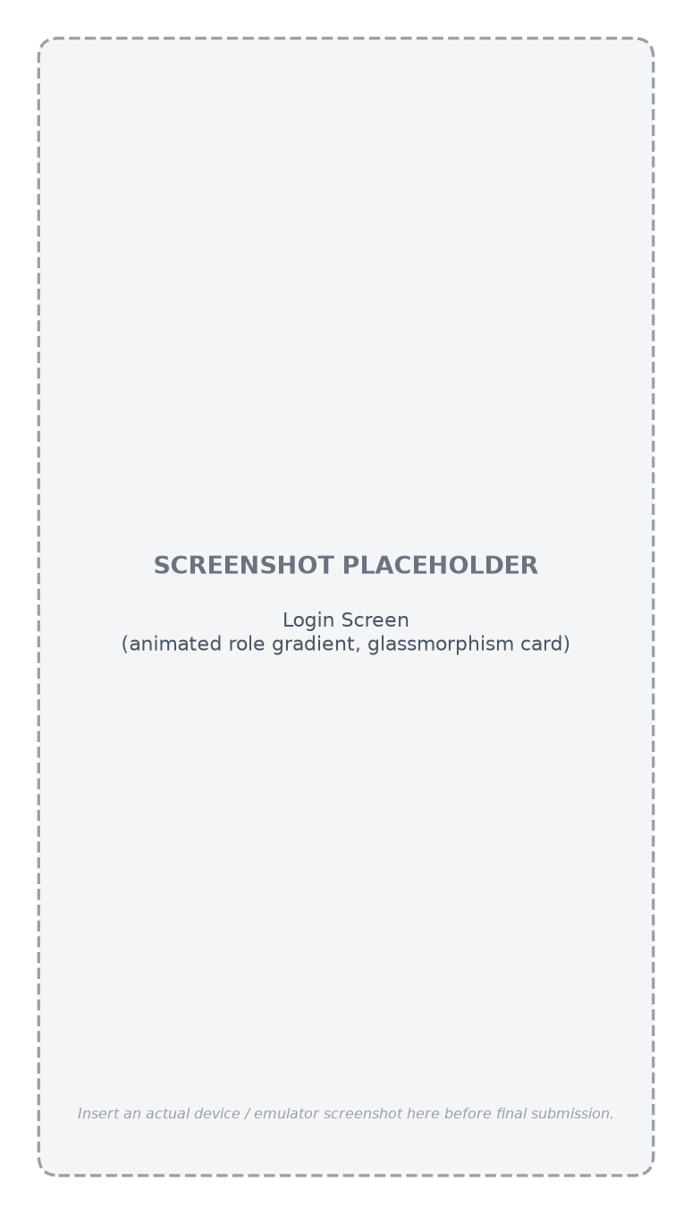
Figure 7.1: Login Screen
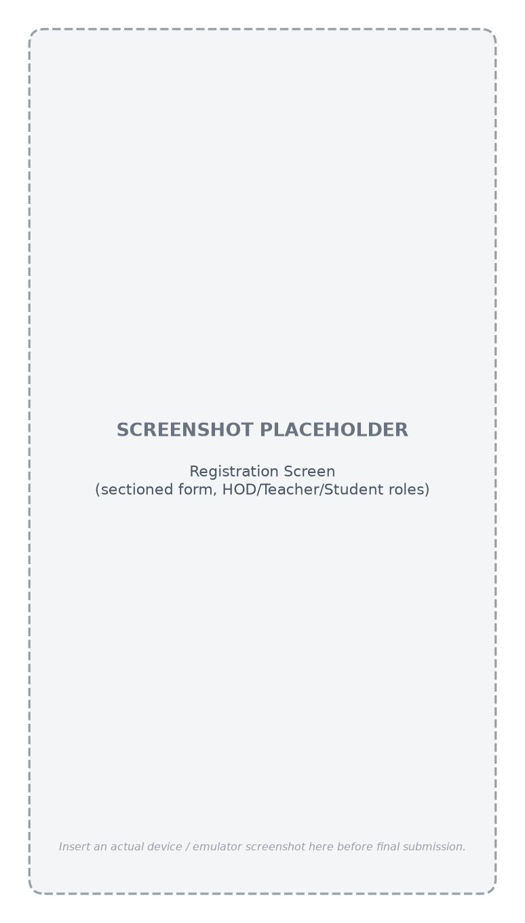
Figure 7.2: Registration Screen
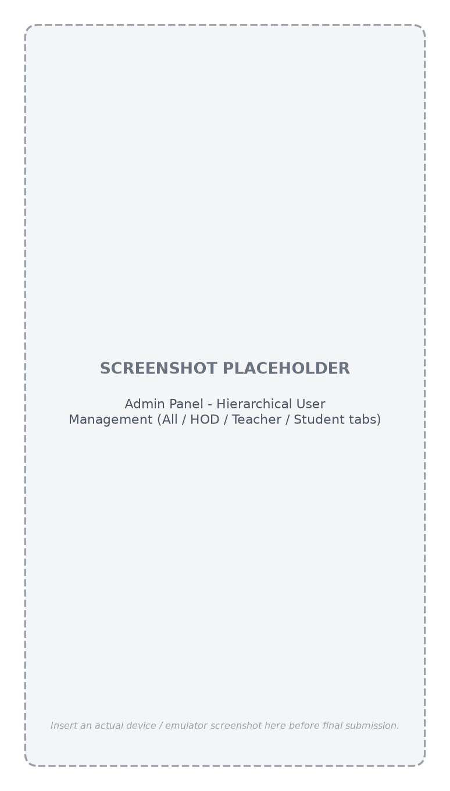
Figure 7.3: Admin Panel – Hierarchical User Management
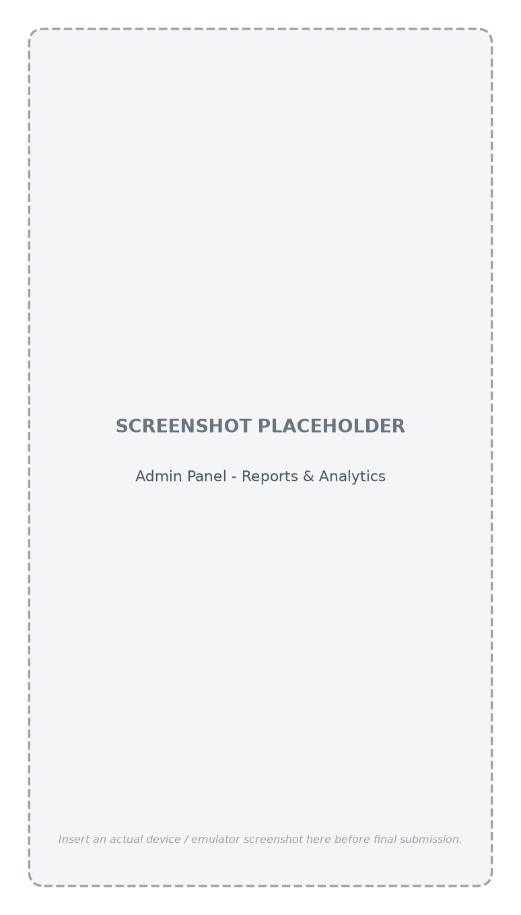
Figure 7.4: Admin Panel – Reports & Analytics
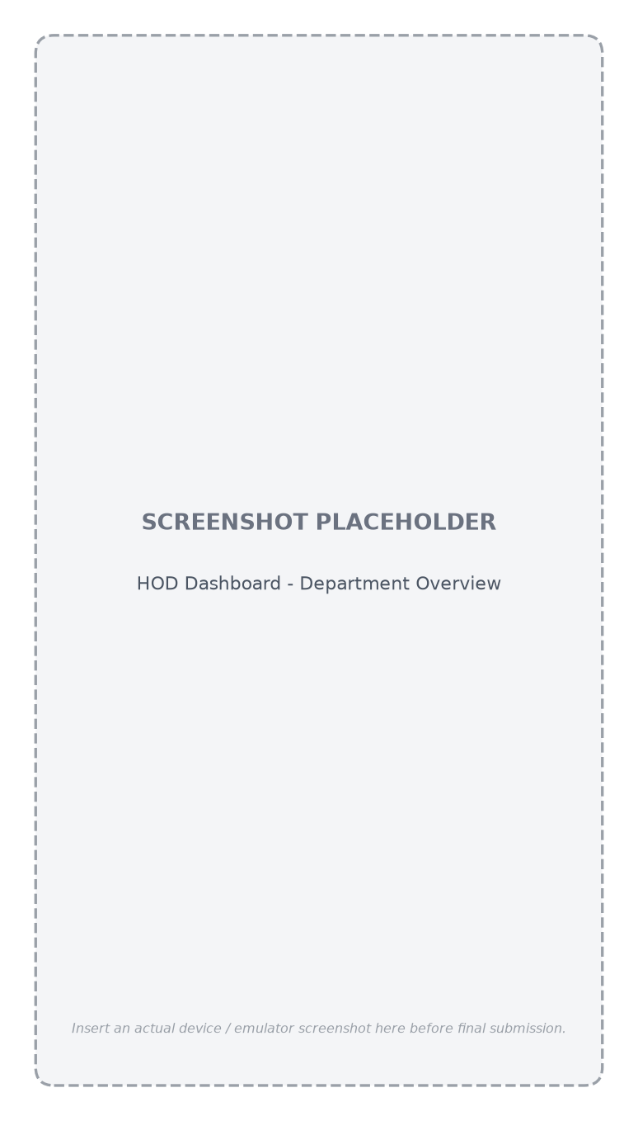
Figure 7.5: HOD Dashboard – Department Overview
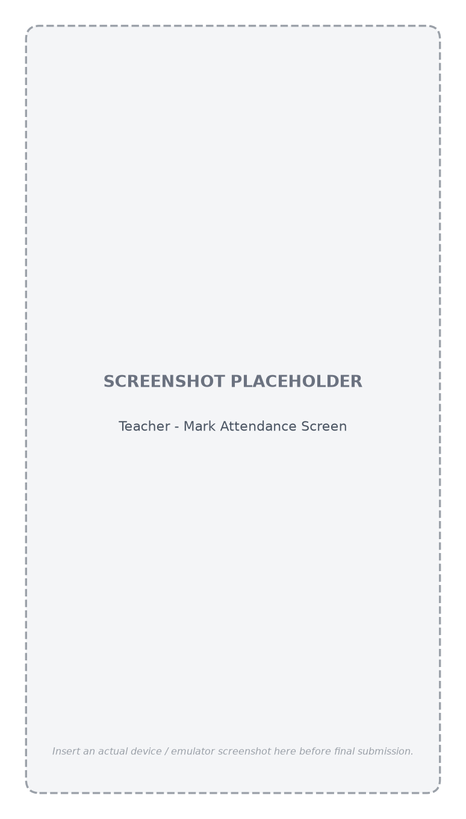
Figure 7.6: Teacher – Mark Attendance Screen
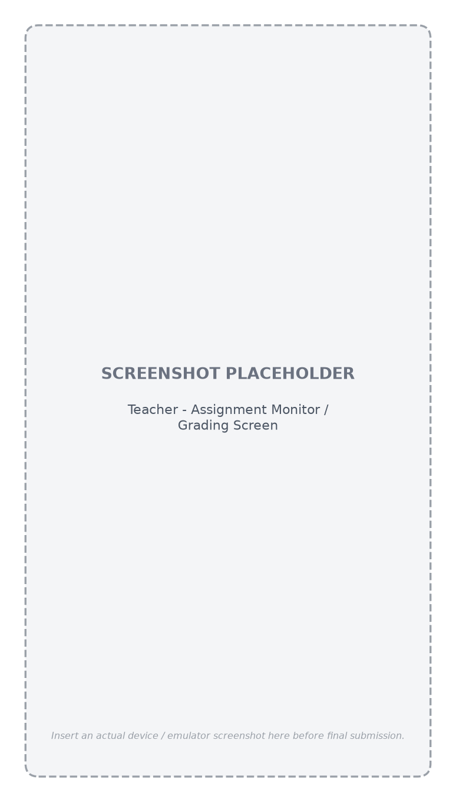
Figure 7.7: Teacher – Assignment Monitor / Grading
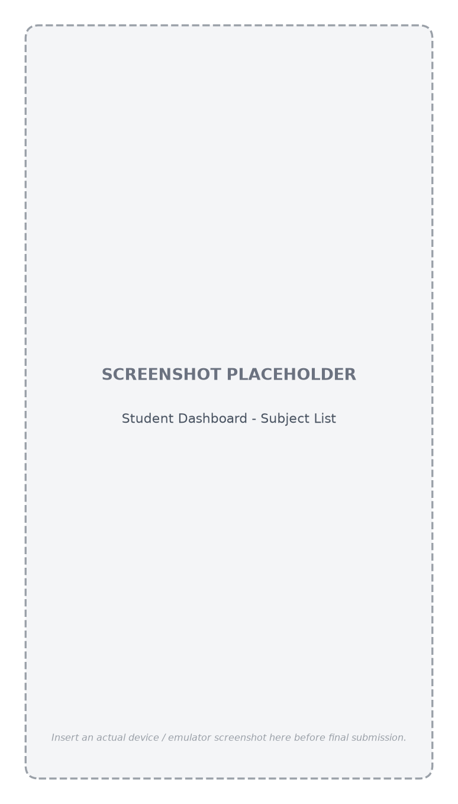
Figure 7.8: Student Dashboard – Subject List
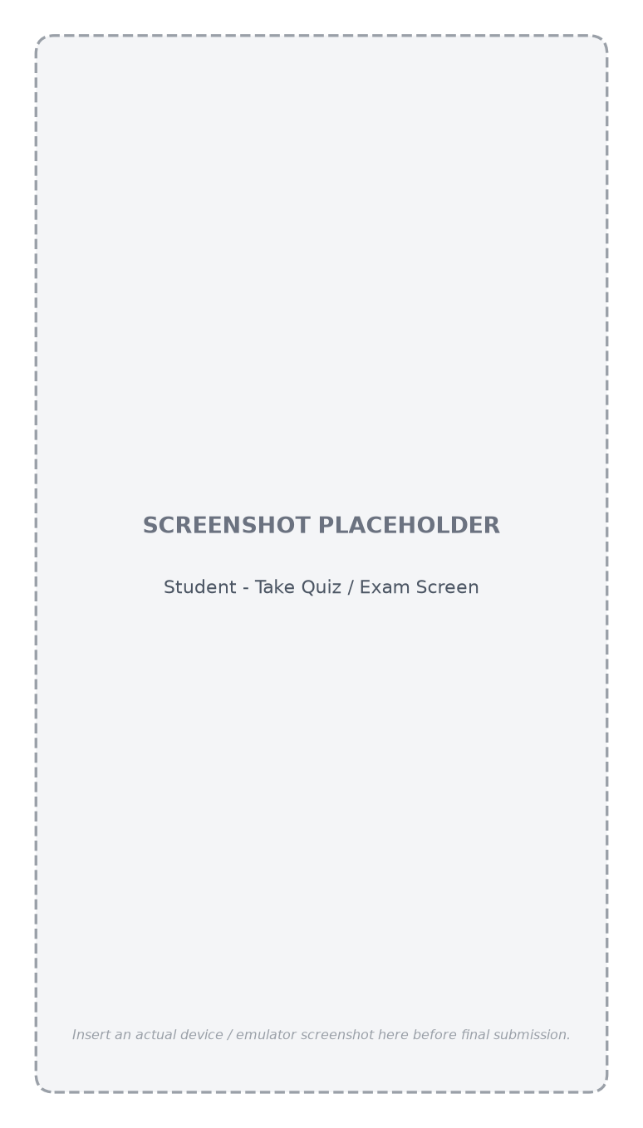
Figure 7.9: Student – Take Quiz / Exam Screen
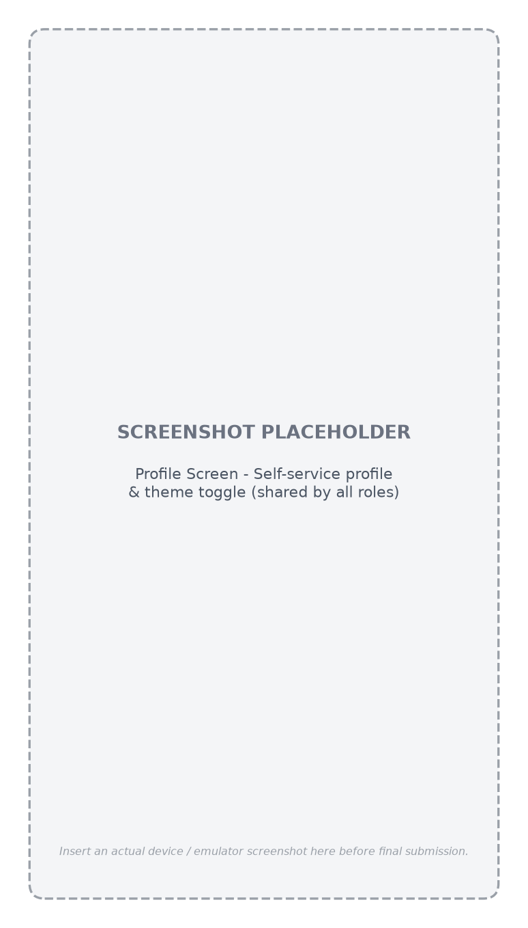
Figure 7.10: Profile Screen (shared by all roles)

7.3 Achievement of Objectives
Each objective stated in Section 1.3 was met by the implemented system: role-based authentication with strict role/approval enforcement (Section 5.3.1); a full administrative approval workflow (Figure 4.6); complete CRUD management of the academic hierarchy with a guarded session-delete flow (Section 5.3.2); attendance capture and review (Section 5.3.5); assignment submission and grading over a dedicated Cloudinary pipeline (Section 5.3.6); a unified, auto-graded quiz/exam engine with manual override (Section 5.3.7); study material, announcements, and a shared calendar (Sections 5.3.8–5.3.9); and a single, consistent Material Design 3 visual language applied across all four roles (Section 4.10).

7.4 Discussion of Limitations
The current implementation performs multiple-choice auto-grading entirely on-device at submission time rather than via a trusted server-side function, which was an accepted tradeoff to avoid the operational cost of maintaining Cloud Functions for a single-institution deployment; the Firestore security rules nonetheless prevent a client from writing an arbitrary score directly. The system also does not yet provide push notifications, offline data access, or a fully interactive timetable builder, each of which is discussed further as future work in Chapter 8.

Chapter 8: Conclusion and Future Work

8.1 Conclusion
This project has designed, implemented, and tested UOS LMS, a native Android Learning Management System that digitises the full academic workflow of the University of Shangla across four distinct user roles. Built on Kotlin, Jetpack Compose, an MVVM architecture, and a Firebase/Cloudinary backend, the system replaces manual attendance registers, ungoverned assignment submission, and ad-hoc announcements with a single, secure, role-appropriate mobile application. Strict server-enforced role validation at login closes a common privilege-confusion gap seen in simpler systems, and a consistent, animated Material Design 3 interface is applied uniformly across every role. The resulting system was verified through functional and manual testing across every module and successfully builds and installs on a physical Android device.

8.2 Limitations of the Current System
- No push-notification channel exists yet for time-sensitive events (new assignment, approaching due date, grade posted).
- The academic calendar does not yet drive a full, interactive timetable/schedule builder.
- The application currently requires an active internet connection; there is no offline cache or write queue.
- Quiz/exam question types are limited to single-correct-answer multiple choice.
- Automated instrumented UI testing was constrained on the available physical test device by a manufacturer-level ADB input-injection restriction (unrelated to the application itself), limiting verification to manual on-device testing and build-success checks.

8.3 Future Enhancements
- Push notifications (via Firebase Cloud Messaging) for assignment deadlines, new grades, and announcements.
- A full, interactive drag-and-drop timetable module built on top of the existing academic calendar and subject-assignment data.
- Offline-first data access with local caching and queued writes for low-connectivity environments.
- Additional quiz/exam question types, such as short-answer and true/false with partial credit.
- Migrating auto-grading and other trust-sensitive computations to Cloud Functions for defence-in-depth beyond the existing Firestore security rules.
- Automated instrumented UI test coverage once run against a device/emulator without input-injection restrictions.
- Internationalisation/localisation of the user interface.
- A companion web dashboard for Admin-level reporting and bulk data operations.

References
- Google. "Jetpack Compose documentation." Android Developers. https://developer.android.com/jetpack/compose (accessed 2026).
- Google. "Guide to app architecture." Android Developers. https://developer.android.com/topic/architecture (accessed 2026).
- Google. "Material Design 3 guidelines." https://m3.material.io (accessed 2026).
- Google / Firebase. "Firebase Authentication documentation." https://firebase.google.com/docs/auth (accessed 2026).
- Google / Firebase. "Cloud Firestore documentation." https://firebase.google.com/docs/firestore (accessed 2026).
- Google / Firebase. "Firestore Security Rules reference." https://firebase.google.com/docs/firestore/security/get-started (accessed 2026).
- Cloudinary. "Cloudinary upload API reference." https://cloudinary.com/documentation/upload_images (accessed 2026).
- Google. "Hilt dependency injection with Jetpack." Android Developers. https://developer.android.com/training/dependency-injection/hilt-android (accessed 2026).
- JetBrains. "Kotlin language documentation." https://kotlinlang.org/docs/home.html (accessed 2026).
- Google. "Navigation component for Compose." Android Developers. https://developer.android.com/jetpack/compose/navigation (accessed 2026).
- Krasner, G. E., and Pope, S. T. "A Description of the Model-View-Controller User Interface Paradigm in the Smalltalk-80 System." Journal of Object-Oriented Programming, 1988.
- Fowler, M. "Patterns of Enterprise Application Architecture." Addison-Wesley, 2002.
- Moodle Pty Ltd. "Moodle — Open-source learning platform." https://moodle.org (accessed 2026).
- Google for Education. "Google Classroom." https://edu.google.com/workspace-for-education/classroom (accessed 2026).
- Blackboard Inc. "Blackboard Learn." https://www.blackboard.com (accessed 2026).
- Coates, H., James, R., and Baldwin, G. "A critical examination of the effects of learning management systems on university teaching and learning." Tertiary Education and Management, vol. 11, no. 1, pp. 19–36, 2005.
- Al-Ajlan, A., and Zedan, H. "Why Moodle." 12th IEEE International Workshop on Future Trends of Distributed Computing Systems, 2008.
- IEEE. "IEEE Std 830-1998 — IEEE Recommended Practice for Software Requirements Specifications." Institute of Electrical and Electronics Engineers, 1998.
- OMG. "Unified Modeling Language (UML) Specification." Object Management Group, https://www.omg.org/spec/UML (accessed 2026).
- Coil Contributors. "Coil — Image loading for Android and Compose Multiplatform." https://coil-kt.github.io/coil (accessed 2026).

Appendix A: Firestore Security Rules (Excerpt)
The excerpt below illustrates the general pattern followed throughout firestore.rules: every collection's read/write rules re-derive the caller's role and, where relevant, department scope from their own authenticated user document before permitting an operation — the same enforcement boundary referenced in Section 4.9.
function isSignedIn() {
return request.auth != null;
}
function currentRole() {
return get(/databases/$(database)/documents/users/$(request.auth.uid)).data.role;
}
match /users/{userId} {
allow read: if isSignedIn();
allow update: if isSignedIn() &&
(request.auth.uid == userId || currentRole() == 'ADMIN');
}

Appendix B: Selected Source Code Listings

B.1 Role-Based Login Validation (AuthRepositoryImpl.kt)
override suspend fun login(email: String, password: String, expectedRole: UserRole)
: AppResult<User> = safeCall {
val firebaseUser = authDataSource.signIn(email.trim(), password)
val profile = userDataSource.getUser(firebaseUser.uid)
if (profile == null) {
authDataSource.signOut()
error("No profile found for this account. Please contact the administrator.")
}
if (profile.role != expectedRole) {
authDataSource.signOut()
error("Invalid role selected. Please choose your correct role.")
}
if (profile.status != UserStatus.APPROVED) {
authDataSource.signOut()
}
profile
}

B.2 Automated Quiz Scoring
val score = quiz.questions.indices.sumOf { i ->
val question = quiz.questions[i]
val selected = answers.getOrNull(i)
if (selected == question.correctOptionIndex) question.marks else 0
}

Appendix C: User Manual (Quick Start Guide)

C.1 First-Time Registration (HOD / Teacher / Student)
- Open the app and tap “Don't have an account? Register”.
- Select your role (HOD, Teacher, or Student) and fill in the sectioned registration form.
- Submit and wait for an Administrator to approve your account before logging in.

C.2 Logging In
- Select your role from the login screen's role selector.
- Enter your registered e-mail and password and tap Sign In.
- If your role or approval status does not match, a specific on-screen error explains why.

C.3 Common Role Tasks
- Admin: Users tab → manage the hierarchical directory; Departments tab → manage the academic structure.
- HOD: Assign a Teacher to a Subject from the Semester → Subjects screen.
- Teacher: Mark Attendance, create Assignments/Quizzes, and grade submissions from the subject's own screen.
- Student: View subjects from the dashboard; submit assignments and attempt quizzes from within each subject.

Appendix D: Glossary of Terms
Term | Definition
Role | One of ADMIN, HOD, TEACHER, or STUDENT, stored on a user's profile and enforced at both login and data-access time.
Session (academic) | An enrolment cohort/intake such as “2024–2028”, distinct from an authentication session.
Effective Score | The score shown to a student for a quiz/exam attempt: the teacher's manualScore if set, otherwise the automatically computed score.
AppResult | The project's shared sealed success/error wrapper type returned by every repository operation.
Public ID | Cloudinary's unique identifier for an uploaded asset, stored alongside its URL so the asset can later be deleted or replaced.

