**Digital Transformation & Industry 4.0/5.0**

CHAPTER -1

Understanding the Digital Transformation Landscape

CHAPTER-2

Four Pillars of Digital Transformation

Technologies Reshaping Industries

CHAPTER-3

Strategy Formulation in Digital Era - Making the Right Choices

CHAPTER-4: Organizational Resilience and Adaptability During Digital Transformation

CHAPTER-5: The New Business Models Emerging from Digital Transformation

CHAPTER-6: Measuring Success and Continuous Improvement in Digital Journeys

CHAPTER-7: The Future of Digital Transformation-Preparing for Tomorrow

INDUSTRY 4.0/5.0

**Introduction to Industry 4.0**

Industry 4.0 Benefits and Downsides

Industry 4.0 Technologies

How will Industry 4.0 help the Supply Chain?

How will the industry 4.0 Affect the Future of Work?

Recognizing the Impact of Industry 4.0 on Society and Individuals

**Industry 5.0**

Transition to Industry 5.0

Human Robot Interaction

What would Industry 5.0 mean for Human Workforce?

How Industry 5.0 Will Affect Manufacturing Systems

**Digital Tools**

Digital tools are software applications or platforms that help perform tasks, improve efficiency, and support communication and collaboration using digital technology.

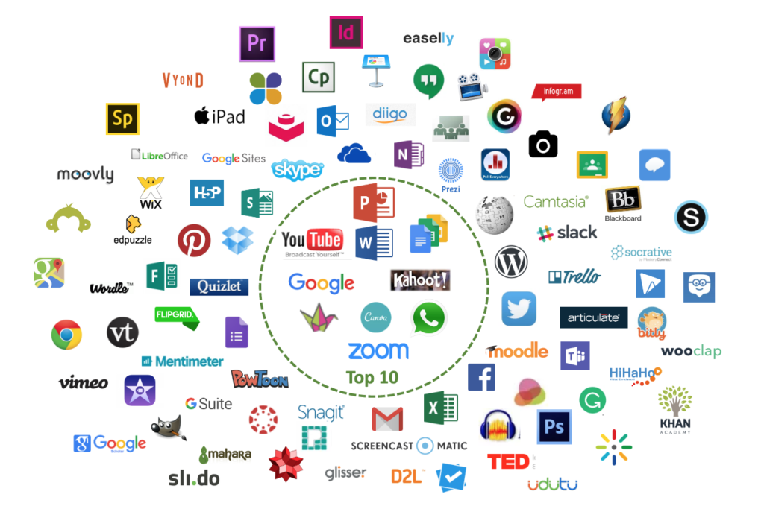

**Figure:** Digital Tools

**Digital Tools for Healthcare**

Digital tools are revolutionizing healthcare by improving access, efficiency, and patient outcomes. Key examples include telemedicine, electronic health records, wearable devices, and AI-powered diagnostic tools. These technologies empower patients, facilitate remote consultations, and enhance clinical decision-making.

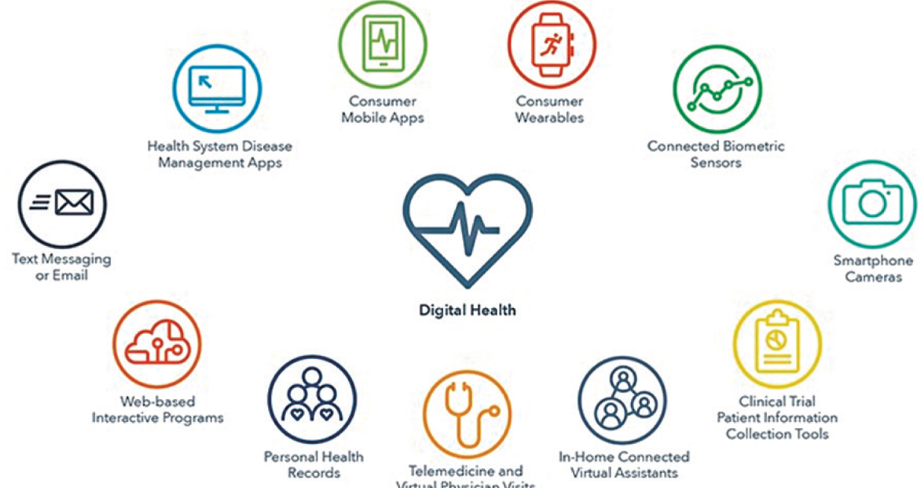

**Figure:** Digital Tools For Healthcare

Key Digital Healthcare Tools:

Telemedicine and Remote Consultations:

Telemedicine platforms enable virtual consultations via video conferencing, expanding access to care, especially for those in remote areas.

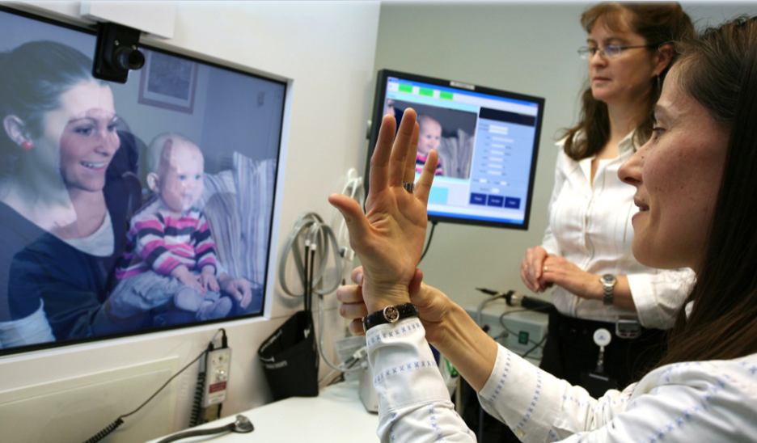

**Figure: Telemedicine and Remote Consultations**

Electronic Health Records (EHRs):

EHRs streamline the management and sharing of patient information, improving communication between healthcare providers and enhancing care coordination.

Wearable Devices:

Wearable devices, such as smartwatches and fitness trackers, collect real-time health data, enabling remote monitoring of vital signs and activity levels.

AI-powered Diagnostic Tools:

Artificial intelligence is being integrated into diagnostic tools to analyze medical images, pathology slides, and other data, assisting in faster and more accurate diagnoses.

Patient Portals:

These online portals allow patients to access their health information, schedule appointments, communicate with their providers, and even pay bills, promoting patient engagement and empowerment.

Mobile Health (mHealth) Apps:

Apps are available for symptom tracking, medication management, appointment scheduling, and connecting with healthcare professionals, offering convenient access to healthcare information and services.

Digital Medicine:

This involves the use of digital technologies to deliver, optimize, and personalize healthcare interventions.

Online Learning Platforms:

Healthcare professionals can utilize online platforms for continuous education, skill development, and staying updated on the latest advancements in their fields.

Decision Support Systems:

These systems provide clinicians with evidence-based recommendations and guidelines, aiding in clinical decision-making.

Personalized Medicine:

Digital tools enable the collection and analysis of vast amounts of patient data to develop tailored treatment plans based on individual needs and characteristics.

////

**Digital tools for healthcare primarily involve digital health platforms integrating artificial intelligence (AI) to improve patient care, diagnostics, treatment, and healthcare management. These platforms leverage AI for predictive diagnostics, enabling early detection of diseases like diabetes, cancer, and cardiovascular conditions by analyzing genetic, environmental, and historical health data. They also support personalized treatment recommendations tailored to individual patient profiles.**

**Key features of digital tools in healthcare include:**

**Predictive Analytics: AI analyzes vast amounts of patient data to identify risks before symptoms occur, enhancing preventive care and early intervention.**

**Medical Imaging Analysis: AI aids radiologists by detecting abnormalities in X-rays, MRIs, and CT scans more accurately and quickly than traditional methods.**

**Remote Patient Monitoring: Wearable devices and mobile health (mHealth) apps track vital signs in real-time, allowing continuous care, especially for chronic conditions, and reducing hospital visits.**

**Clinical Decision Support: AI-powered tools integrate electronic health records (EHRs) and patient-generated health data (PGHD) to assist healthcare providers in making better-informed decisions, improving diagnosis and treatment plans.**

**Administrative Efficiency: Automation through AI reduces administrative burdens like appointment scheduling, data entry, and claims processing, allowing healthcare professionals to focus more on patient care.**

**Patient Engagement: AI chatbots and virtual assistants handle routine patient interactions, provide reminders, and offer educational resources, enhancing communication and adherence to treatments.**

**Data Privacy and Security: These platforms ensure compliance with regulations such as HIPAA and GDPR to protect patient information.**

**Overall, digital health tools empowered by AI transform healthcare delivery by making it more predictive, personalized, efficient, and accessible, significantly improving clinical outcomes and patient experiences**

**Benefits of Using Digital Tools in Education**

The use of digital tools in education has numerous benefits, some of which include:

* Enhanced Learning Experience: Digital tools provide students with access to interactive and multimedia content, making learning more engaging, fun, and effective. They also offer personalized learning experiences that cater to individual learning styles and needs.
* Access to a Wealth of Information: With digital tools, students can access a vast amount of information online, from e-books to online courses, videos, and tutorials, expanding their knowledge base beyond the traditional classroom.
* Improved Collaboration: Digital tools enable students and teachers to collaborate and communicate more effectively, regardless of their location. This collaboration enhances the learning experience, encourages teamwork, and helps students develop social skills.
* Cost-Effective: Digital tools are generally more cost-effective than traditional learning methods, as they eliminate the need for physical textbooks, classroom materials, and other supplies.

**Limitations of Using Digital Tools in Education**

Despite the many benefits, digital tools also have limitations that need to be considered. Some of the limitations include:

Technical Issues: Digital tools can be subject to technical issues such as connectivity problems, software bugs, or compatibility issues. These issues can lead to delays in learning and may negatively impact the learning experience.

Limited Interaction: Although digital tools enhance collaboration and communication, they may limit face-to-face interaction, which is essential for building social skills.

Accessibility: Not all students have access to digital tools and the internet. This creates a digital divide that may impact the quality of education for those who are unable to access these resources.

Fears Associated with Using Digital Tools in Education

There are also fears associated with the use of digital tools in education. These fears include:

Privacy and Security Concerns: With the increased use of digital tools, there is a growing concern about privacy and security issues. This includes the protection of personal information and data breaches.

Addiction: With the increased use of digital tools, there is a risk of addiction to technology, which may negatively impact the learning experience and lead to other issues such as social isolation.

Disconnection from the Real World: Over-reliance on digital tools may lead to a disconnection from the real world, impacting social and emotional development.

////

Digital tools in the context of digital transformation are software applications and technologies that help organizations digitize and optimize their operations, enhance customer experience, and support data-driven decision-making. These tools enable businesses to work more efficiently, innovate, and adapt to the rapidly changing digital landscape.

Here are some key categories and examples of digital tools essential for digital transformation:

Customer Relationship Management (CRM) Software

Manages customer data, automates sales and marketing, and improves customer service and retention.

Examples: Salesforce, HubSpot.

Content Management Systems (CMS)

Simplifies creation, management, and publishing of digital content.

Examples: WordPress, Drupal.

Artificial Intelligence (AI) and Machine Learning Tools

Automate processes, provide predictive insights, and enhance decision-making.

Examples: IBM Watson, Google AI tools.

Data Analytics and Business Intelligence Software

Visualizes and analyzes data to provide actionable insights.

Examples: Tableau, Power BI, Google Analytics.

Project Management Tools

Streamline planning, collaboration, and tracking of projects.

Examples: Asana, Trello, Microsoft Project.

Cloud Computing Services

Provide scalable, flexible data storage and processing power on demand.

Examples: AWS, Microsoft Azure, Google Cloud.

API Management Platforms

Facilitate integration of different digital systems and software.

Social Media Monitoring and Marketing Automation Tools

Track brand presence and automate marketing campaigns to engage customers effectively.

Examples: Hootsuite, Marketo.

Cybersecurity Software

Protect digital assets and data from threats and breaches.

Includes firewalls, encryption, and identity management tools.

Communication and Collaboration Platforms

Enable real-time messaging, file sharing, and virtual teamwork.

Examples: Microsoft Teams, Slack.

These digital tools collectively enhance efficiency, agility, customer engagement, and informed decision-making, which are critical for successful digital transformation in any organization. The choice and implementation of specific tools depend on the organization's goals, industry, and maturity in the digital journey

Digital Transformation

Digital Transformation means using the digital tools and technologies to make a business work better, faster, and more effectively while meeting the evolving needs of customers and the market.

Digital transformation is the process of integrating digital technologies into all areas of a business or organization, fundamentally changing how it operates and delivers value to customers. It involves not only adopting new technology but also rethinking business models, processes, and culture to adapt to changing markets and improve customer experience and operational efficiency

REFERENCES

[1] Rogers, David L. The digital transformation playbook: Rethink your business for the digital age. Columbia University Press, 2016.

[2] Matt, Christian, Thomas Hess, and Alexander Benlian. "Digital transformation strategies." Business & Information Systems Engineering 57.5 (2015): 339-343.

[3] Kane, Gerald C., et al. "Strategy, not technology, drives digital transformation." MIT Sloan Management Review and Deloitte University Press 14.1-25 (2015).

[4] Westerman, George, Didier Bonnet, and Andrew McAfee. "The nine elements of digital transformation." MIT Sloan Management Review 55.3 (2014): 1-6.

[5] Pappas, Ilias O., et al. "Big data and business analytics ecosystems: paving the way towards digital transformation and sustainable societies." (2018): 479-491.

[6] Ustundag, Alp, and Emre Cevikcan. Industry 4.0: managing the digital transformation. Springer, 2017.