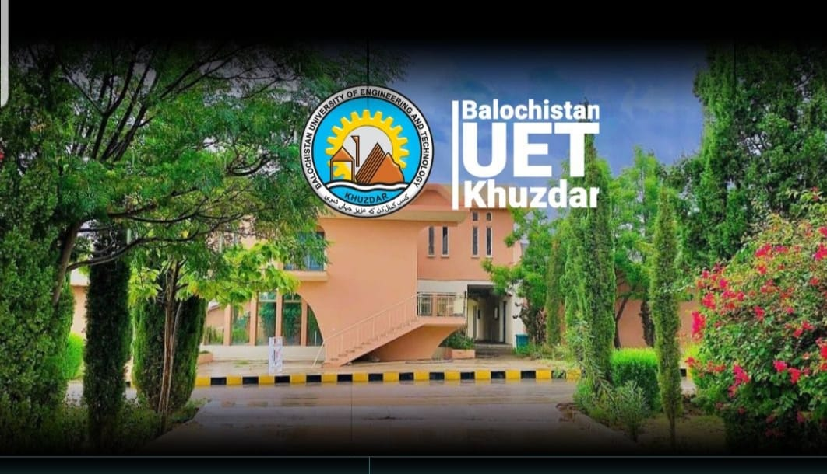  PROGRAMME  November 9, 2026 (Monday)  EVENT TIME  Registration 09:15 – 09:30  Recitation from Holy Quran 09:30 – 09:35  Opening Remarks & 09:35 – 09:45  Introduction to CPD and PEC Bylaws  Practical Implementation of Deep Learning in Python: Medical Image Analysis  Mr. Abdul Qadeer, Deputy Director (QEC), BUETK, Khuzdar  Cell: 0334-3422048, Tel: 0848-413049  Email: d.directorqec@buetk.edu.pk |   Pakistan Engineering Council  Short Courses Series  VENUE:  AUDITORIUM  BALOCHISTAN UNIVERSITY OF ENGINEERING AND TECHNOLOGY KHUZDAR   | RESOURCE PERSON  Dr. Wazir Muhammad Laghari  Dr. Laghari holds a Ph.D. in Artificial Intelligence and Deep Learning from Chulalongkorn University, Thailand, and an ME in Communication Systems & Networks. He currently serves as Assistant Professor and Chairman of the Department of Biomedical Engineering at Balochistan University of Engineering and Technology (BUETK), Khuzdar, and is the Principal Investigator of the European Union-funded Erasmus+ CBHE BIOMED 5.0 project. His core areas of specialization and research interests include Deep Learning, Medical Image Processing, Single Image Super-Resolution, Biomedical Signal Processing, Digital Transformation, and Industry 4.0/5.0 Technologies in Healthcare. He has more than 25 years of teaching and research experience.
  Session 1 09:45 – 11:00
  Deep Learning Concepts and Healthcare Applications
  Tea Break 11:00 – 11:20
  Session 2 11:20 – 13:20
  Closing Remarks & Certificate 13:20 – 13:30
  Contact Person:
  Continuing Professional Development
  (CPD)
  Deep Learning-Based Medical Image Analysis in Healthcare
  On 9th November 2026 (Monday)
 |  | A certificate of 1.0 CPD point will be awarded to the participants by PEC. Participants are requested to bring their own laptops for the hands-on session.  - All Engineers registered with PEC  - Engineering Students  - Application form, duly filled, along with the fee in the form of Pay Order/Bank Draft in favor of Balochistan UET Khuzdar, should reach on or before [closing date] at the following address:  (Office of the Director General QEC, BUETK, Khuzdar)  - Course fee: Rs. 500/- (for engineers)  - Free for final-year BE students of BUETK; other students: Rs. [fee]  Engr. Liaquat Ali Lehri  Director General QEC  Balochistan UET, Khuzdar  Office: 0848-413049  dgqec@buetk.edu.pk  www.buetk.edu.pk
  Module 1
  - Understanding the Concepts of Deep Learning
  - Deep Learning and Healthcare Applications
  Purpose and Background
  - To inform participants about the concepts of deep learning and its healthcare applications
  - To introduce medical image analysis as a key application area of deep learning
  Module 2
  - Practical Implementation of Deep Learning in Python Environment
  - Setting Up State-of-the-Art Models for Medical Image Analysis
  Purpose and Background
  - To broaden the knowledge of professional and registered engineers on key commands and techniques of deep learning
  - To familiarize participants with setting up and using state-of-the-art models for medical image analysis
  Special Features of the Course
  Who Should Attend?
  Registration Process
  Course Coordinator

