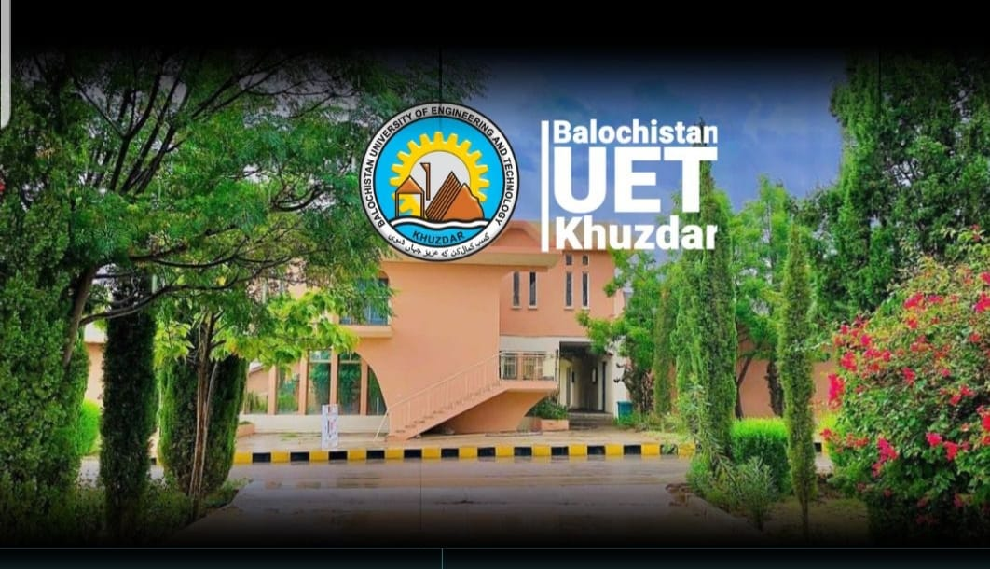  PROGRAMME  December 9, 2026 (Wednesday)  EVENT TIME  Registration 09:15 am – 09:30 am  Recitation from Holy Quran 09:30 am – 09:35 am  Opening Remarks & 09:35 am – 09:45 am  Introduction to CPD and PEC Bylaws  Academic Thesis Writing: Structure, Referencing and Publishing  Mr. Abdul Qadeer, Deputy Director (QEC), BUET, Khuzdar  Cell No. 0334-3422048, Tel: 0848-413049  Email: d.directorqec@buetk.edu.pk |   Pakistan Engineering Council  Short Courses Series  VENUE:  AUDITORIUM  BALOCHISTAN UNIVERSITY OF ENGINEERING AND TECHNOLOGY KHUZDAR  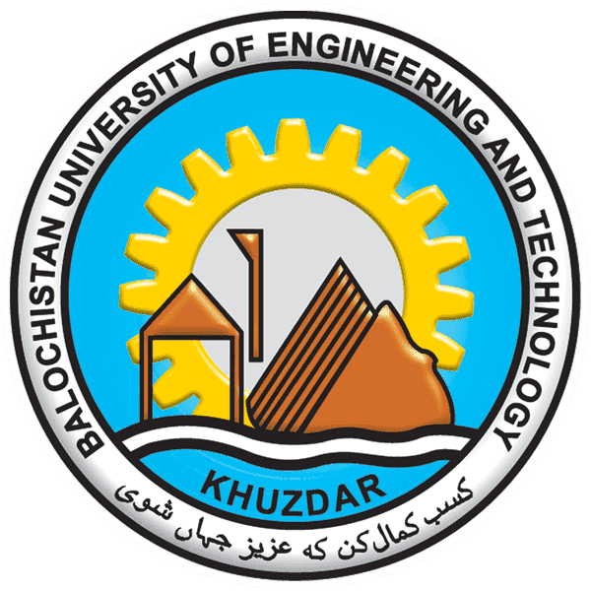 | RESOURCE PERSON  Dr. Wazir Muhammad Laghari  Dr. Laghari holds a Ph.D. in Artificial Intelligence and Deep Learning from Chulalongkorn University, Thailand, and an M.E. in Communication Systems & Networks. He currently serves as Assistant Professor and Chairman of the Department of Biomedical Engineering at Balochistan University of Engineering and Technology (BUETK), Khuzdar, and leads as Principal Investigator for the European Union-funded Erasmus+ CBHE BIOMED 5.0 project. His core areas of specialization and research interests include Deep Learning, Medical Image Processing, Single Image Super-Resolution, Biomedical Signal Processing, Digital Transformation, and Industry 4.0/5.0 Technologies in Healthcare. He has more than 25 years of teaching and research experience.
  Session-1 09:45 – 11:00
  Fundamentals of Research Methodology and Research Design
  Tea Break 11:00 – 11:20
  Session-2 11:20 – 13:20
  Closing Remarks & Certificate 13:20 – 13:30
  Contact Person:
  Continuing Professional Development
  CPD
  Academic Thesis Writing and Research Methodology
  On 9th November, 2026 (Monday)
 |  | A certificate of 1.0 CPD point will be awarded to the participants by PEC  - All Engineers registered with PEC  - Engineering Students  - Application form, duly filled, along with the fee in the form of Pay Order/Bank Draft in favour of Balochistan UET Khuzdar should reach on or before the closing date at the following address:  (Office of the Director General QEC BUET, Khuzdar)  - Course fee: Rs. 500/- (For Engineers)  - Free for final-year BE students of BUETK  Engr. Liaquat Ali Lehri  Director General QEC  Balochistan UET Khuzdar  Office: 0848-413049  dgqec@buetk.edu.pk  www.buetk.edu.pk
  Module 1
  - Fundamentals of Research Methodology and Research Design
  - Introduction to Research Methodology
  Purpose and Background
  - To familiarize participants with the concepts and principles of research methodology and research design
  - To broaden the knowledge of professional and registered engineers on techniques for planning, conducting and reporting research
  Module 2
  - Academic Thesis Writing: Structure, Referencing and Publishing
  - Literature Review, Citation Styles and Plagiarism Avoidance
  Purpose and Background
  - To familiarize participants with the structure of an academic thesis, referencing styles and publishing
  - To equip professional and registered engineers with skills for literature review, correct citation and plagiarism avoidance
  Special Features of Workshop
  Who Should Attend?
  Registration Process
  Course Coordinator

