**EXPERIMENT NO-01**

**OBJECT:** To **demonstrate** and detect the patient fever using a machine learning

model implemented in keras

**EQUIPMENT / SOFTWARE:** Python, Keras, TensorFlow, Jupyter Notebook, Google Colab, Personal Computer (PC) or Laptop, and Internet Connection.

**THEORY:** Google Colab is a free, cloud-based platform that allows users to write, run, and share Python code in Jupyter notebook-style as shown in Figure 1. It provides access to powerful computing resources like GPUs and TPUs, which accelerate machine learning model training and experimentation without requiring local hardware setup. Google Colab supports easy sharing and collaboration among researchers and developers through Google Drive integration. This accessibility supports rapid prototyping and deployment of AI models, which are central technologies in Industry 4.0. Industry 4.0 represents the Fourth Industrial Revolution characterized by automation, data exchange, and smart technologies like IoT, AI, big data analytics, and cloud computing. These technologies generate and process massive industrial data to optimize operations, decision-making, and production efficiency. Digital transformation involves adopting these digital technologies across industries to improve processes, business models, and customer experiences. It converts traditional workflows into data-driven, automated, and interconnected systems. Google Colab supports digital transformation and Industry 4.0 by providing an accessible platform for developing and deploying AI and machine learning models that process industrial data. Through Colab, businesses, researchers, and engineers can work collaboratively on Industry 4.0 projects, accelerating innovation and implementation of smart technologies for automation, predictive maintenance, quality control, and more. In essence, Google Colab acts as an enabler or tool that accelerates digital transformation efforts and Industry 4.0 adoption by democratizing powerful data analytics and machine learning capabilities on the cloud.



**FIGURE 1: BASIC LOGO/DIAGRAM OF GOOGLE COLAB**

**PROCEDURE**

* Type Google Colab in Google Search Engine.
* Click on Google Colab.
* Click on New Notebook
* Google Colaboratory
* Now appear the Python Coding Environment
* Strat typing the code

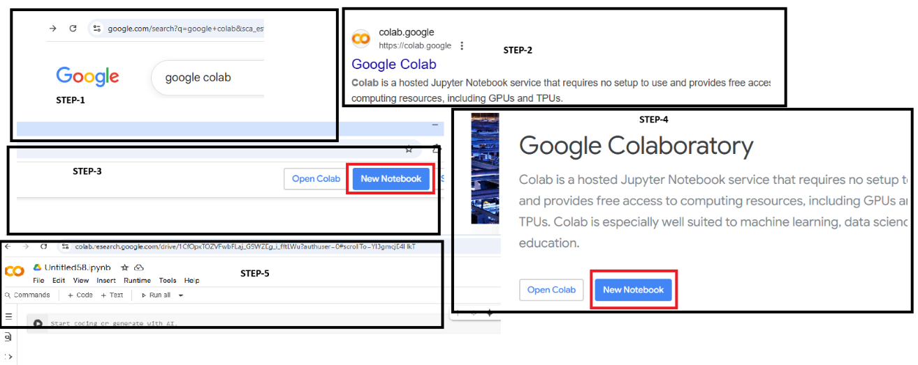

**FIGURE 2: STEP WISE PROCEDURE FOR RUNNING GOOGLE COLAB**

**EXPERIMENT**

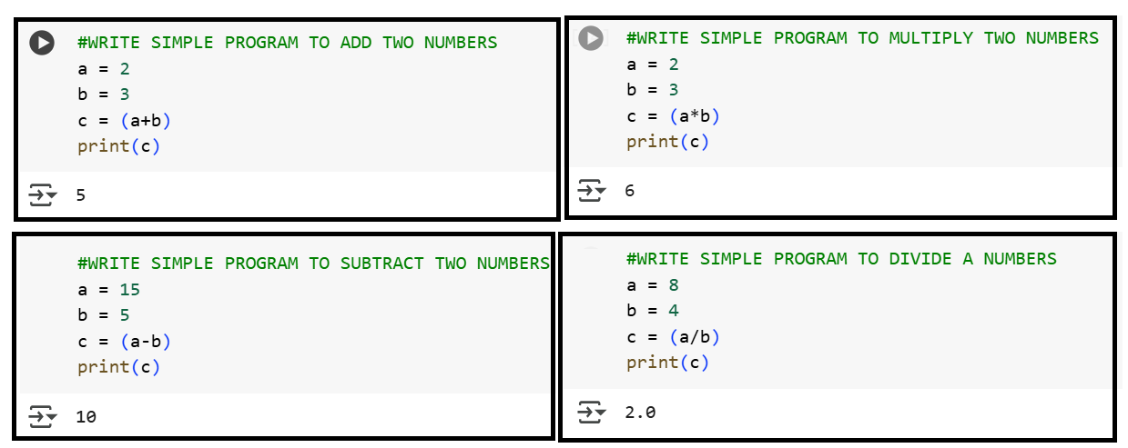

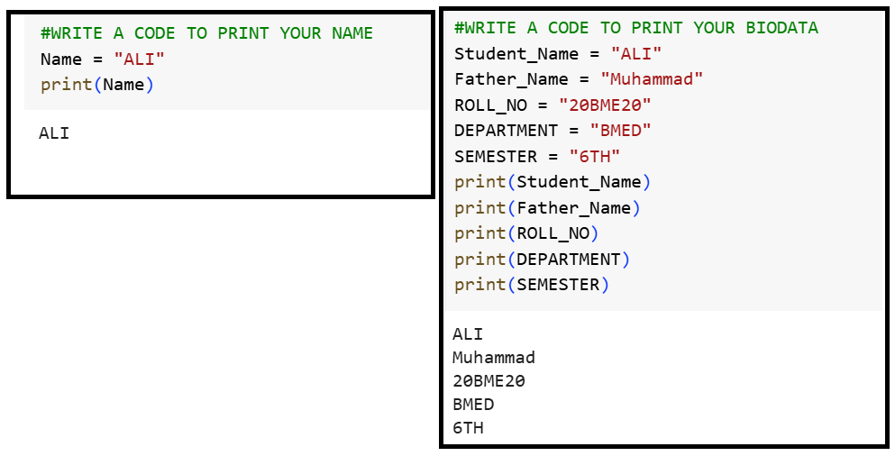

**EXERCISE**

**Q: NO: 01: Write simple Python code to add three numbers in the Google Colab Environment**

**Q: NO: 02: Write simple Python code to add your Brief Summary**

**Q: NO: 03: Write simple Python code to Create and Delete Folder in Google Colab Environment**

**Q: NO: 04: Write brief introduction about Google Colab and Industry 4.0/5.0**

|  |  |  |  |  |
| --- | --- | --- | --- | --- |
| **Sr. No** | **Rubrics** | **Skills Level** | | |
| **Excellent** | **Good** | **Average** |
| **3.33** | **1.66** | **1.11** |
| **1** | **Selection of Equipment = 0.33** |  |  |  |
| **2** | **Equipment Connection = 3.33** |  |  |  |
| **3** | **Results = 3.33** |  |  |  |