|  |  |  |  |  |  |
| --- | --- | --- | --- | --- | --- |
|  | **BALOCHISTAN UNIVERSITY OF ENGINEERING AND TECHNOLOGY KHUZDAR**  **DEPARTMENT OF MECHANICAL ENGINEERING**  **M.E Fourth Semester Examination 2023** | | | | |
|  | **Department:** | **MED** | **Examination:** | **Mid Examination 2023** | |
| **Subject:** | **Operation Research** | **Code:** | **ME- 508** | |
|  | **Max. Marks:** | **20** | **Time Allowed:** | **60 minutes** | |
|  | **NOTE: ATTEMPT All QUESTIONS** | | | | **Marks** |
| **Question No. 1** | 1. Define Queue, types of Queue and applications in daily life with examples? 2. A fair coin is tossed 6 times. What is the probability of obtaining 2 head? Apply Binomial Distribution? | | | | 05  05 |
| **Question No. 2** | 1. Apply the Markov Chains to find the Stationary Distributions of given T matrix. 2. Write the short note on the following terms. 3. FIFO and LIFO 4. Write the names of Probability Distribution Matrix. 5. Write the Probability Matrix of Figure (1) | | | | 05  05 |

**\*\*\*\*\*\*\*\*\*\*\*\*\*\*\*\*\*\*\*\*\*\*\*BEST OF LUCK\*\*\*\*\*\*\*\*\*\*\*\*\*\*\*\*\*\*\*\***

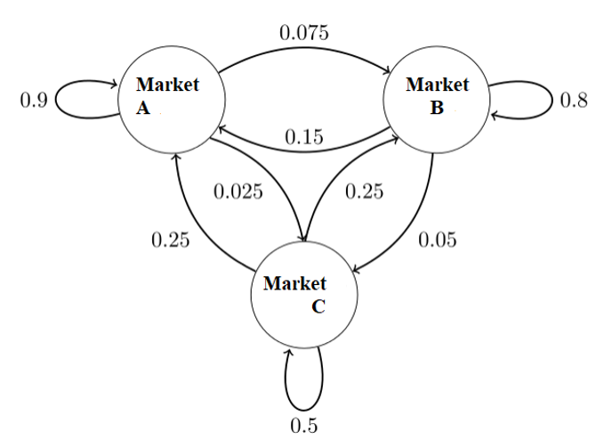

**Figure (1)**