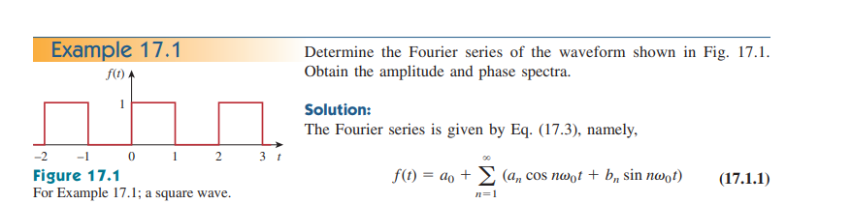

**EXAMPLE: Determine the Fourier series of the waveform as shown in Fig. Obtain the amplitude and phase spectra.**

**SOLUTION**

**STEP-I: Write the General Equation of Fourier Series and calculate T**

**The general equation of Fourier series as:**

**STEP-II: Calculate the DC Component a0**

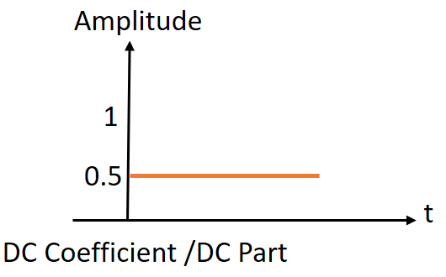

**STEP-III: Calculate the Cosine Component an**

|  |  |
| --- | --- |
| Type of Functions | Calculated Values |
|  |  |
|  |  |
|  |  |
|  |  |
| .  .  . | .  .  . |

**STEP-IV: Calculate the Sine Component bn**

|  |  |
| --- | --- |
| Type of Functions | Calculated Values |
|  |  |
|  |  |
|  |  |
|  |  |
|  |  |
| OR | |
|  |  |
|  |  |
|  |  |
|  |  |
|  |  |
|  | |

|  |  |
| --- | --- |
| Type of Functions | Calculated Values |
|  |  |
|  |  |
|  |  |
|  |  |
|  |  |
|  |  |
|  |  |
|  |  |
|  |  |
|  |  |
|  |  |

Substituting the Fourier coefficients in Equation (1)

|  |  |
| --- | --- |
| Type of Functions | Calculated Values |
|  |  |
|  |  |
|  |  |
|  |  |
|  |  |
|  |  |

The function of f(t) of Fourier series having a dc part and the sine part, but not available cosine part. The type of harmonics are available is odd

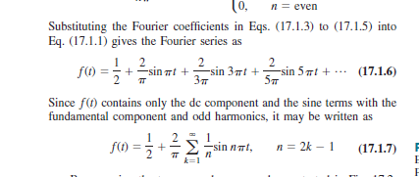

**Introduction to Fourier series**

**Difference between Fourier series / Fourier Transform and Laplace Transform**

|  |  |
| --- | --- |
| **Fourier** | **Laplace Transform** |
| Fourier Series and Fourier Transform is used for analysis purposes. | Laplace Transform is used for designing purposes. |

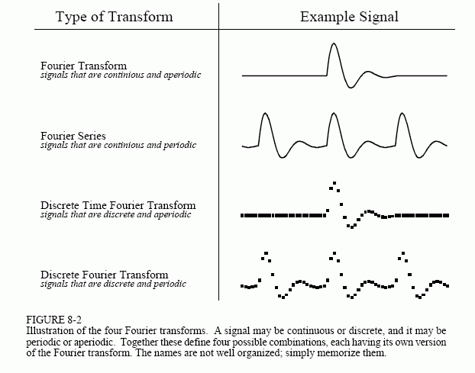

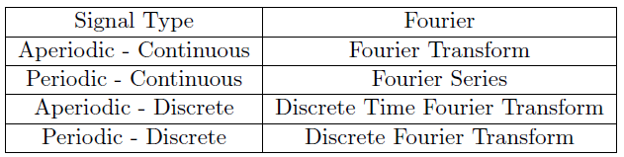

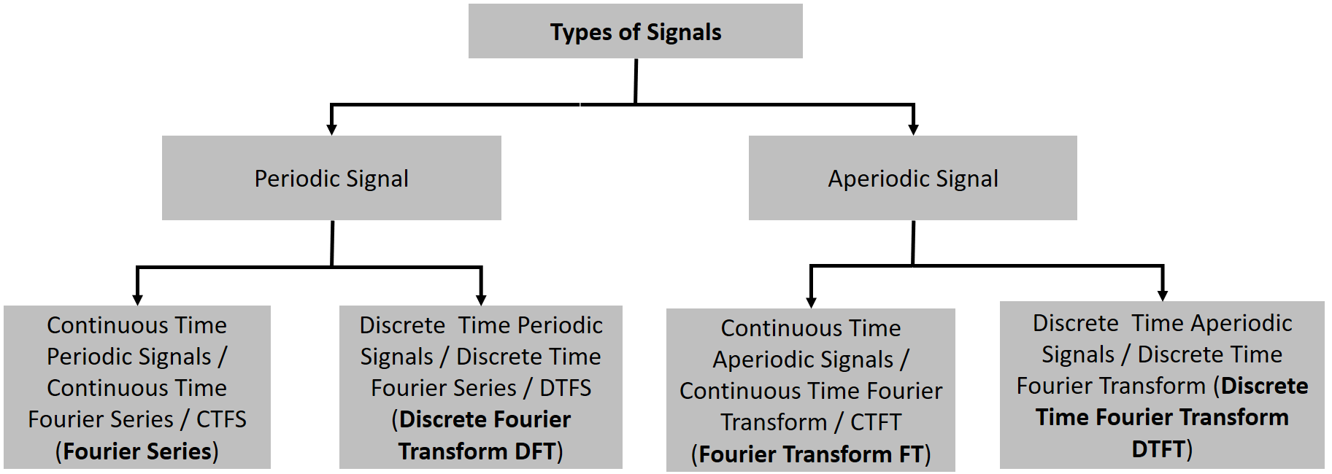

**Periodic and Aperiodic Signals**

A signal is said to be periodic if it repeats itself after a regular interval of time is called a Periodic Signal. In other words, a signal is said to be periodic signal if it has a definite pattern and repeats itself at a regular interval of time. Whereas, the signal which does not at the regular interval of time is known as an aperiodic signal or non-periodic signal.

**Types of Periodic Signal**

**The periodic signals are two types**

1. **Continuous Time Periodic Signals (Solved by continuous Time Fourier Series)**
2. **Discrete Time Periodic Signals (Solved by Discrete Time Fourier Series)**
3. **Continuous Time Periodic Signals**

Continuous Time Periodic Signals solved by Continuous Time Fourier Series. A continuous time signal x(t) is said to be periodic if and only if

where, T is a positive constant that represents the time of the periodic signal. The smallest value of the time period T which justifies the definition of the periodic signal is known as fundamental time period of the signal and is denoted by *(T0).*

where, m is an integer. This means if the definition is satisfied for 𝑇 = 𝑇0, then it is also satisfied for 𝑇 = 2𝑇0, 𝑇 = 3𝑇0 …, and so on with 𝑇0 as the fundamental time period. Therefore, the fundamental time period defines the duration of one complete cycle of the periodic signal x(t).

The reciprocal of the time period (T) of the periodic signal is called the frequency (f) of the signal, i.e.,

Since the angular frequency is given by,

A periodic signal is one that repeats the sequence of values exactly after a fixed length of time, known as the period.

**Example: Identify which signal is Periodic and Aperiodic?**

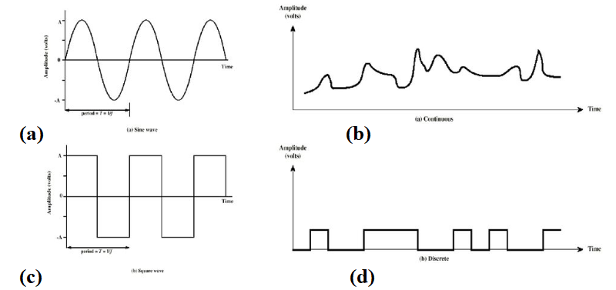

Solution: Periodic (a, b) and Aperiodic (c, d)

**Example: The electrical power we uses at our home has a frequency of 60 Hz. Calculate the Period of this sinusoidal wave.**

**Solution:**

**Example: The time period of signal is 100 ms. Calculate the frequency in kilohertz?**

**Solution:**

**Question# Determine whether each of the following Discrete Time Signals is Periodic. If Periodic, determine its fundamental Period.**

it is rational number, so it is periodic

it is rational number, so it is periodic

, it is rational number, so it is periodic

= 10,

, it is irrational number, so it is non-periodic

**Periodic And Aperiodic Of Continuous Time Signal  
OR  
Periodicity of Continuous Time Signal**

**Question# Determine whether each of the following continuous-time signals is**

**Periodic. If Periodic, determine its fundamental Period.**

4

, it is rational number, so it is periodic

, so

t

,

, .