|  |  |
| --- | --- |
|  | **BALOCHISTAN UNIVERSITY OF ENGINEERING & TECHNOLOGY KHUZDAR** |

DEPARTMENT: EED EXAMINATION: Mid Term Summer Session 2023

SUBJECT: Electrical Network Analysis CODE: EE-211

SEMESTER: B.E (3rd Semester) Max: Marks: 20

Time Allowed: 40 Minutes

Note: Attempt All questions

|  |  |  |  |  |
| --- | --- | --- | --- | --- |
| **Q.NO** | **Description** | **Marking Scheme** | **CLO/PLO** | **Bloom** |
| 1. | **Define** the term Impedance, Admittance, Impedance  Triangle, Admittance Triangle and Power Factor. | 5 | CLO-1  PLO-2 | C-3 |
| 2. | Calculate the Laplace Transform of the following.  functions.   1. F(t) = e-3t (ii) f(t) = sin3t | 5 | CLO-1  PLO-1 | C-1 |
| 3. | Explain the Resonance frequency and derive the  Resonant Frequency $f_{r}=\frac{1}{2πf\sqrt{LC}}$ | 5 | CLO-1  PLO-1 | C-1 |
|  | Convert the time domain circuit into s-domain as shown in Figure below: | 5 | CLO-1  PLO-1 | C-1 |

***THE END***

|  |  |
| --- | --- |
|  | **BALOCHISTAN UNIVERSITY OF ENGINEERING AND TECHNOLOGY KHUZDAR** |

DEPARTMENT: EED EXAMINATION: Final Term Summer Session 2023

SUBJECT: Electrical Network Analysis CODE: EE-211

SEMESTER: B.E(3rd Semester) Max: Marks: 50

Time Allowed: 2 hour : 20 minutes

Note: Attempt All questions

|  |  |  |  |  |
| --- | --- | --- | --- | --- |
| **Q.NO** | **Description** | **Marking Scheme** | **CLO / PLO** | **Bloom** |
| 1. | State and **explain** the Z and Y-parameters with basic equations, also Find the Z-parameters of the circuit given in Figure 1. | 10 | CLO-1  PLO-2 | C-1 |
| 2. | **Define** Fourier Series. Find the components of Fourier series (a0 , an , bn) of the waveform as shown in Figure 2. | 10 | CLO-2  PLO-2 | C-3 |
| 3. | $Calculate the inverse Laplace transform of F\left(s\right)=\frac{3s+2}{s^{2}-3s+2}$ | 10 | CLO-2  PLO-2 | C-3 |
| 4. | A series RLC circuit containing a resistance of 12Ω, an inductance of 0.15H and a capacitor of 100uF are connected in series across a 100V, 50Hz supply as shown in Figure 3. Calculate the Inductive Reactance (XL), Capacitive Reactance (XC) , total circuit impedance and the circuits current. | 10 | CLO-2  PLO-2 | C-3 |
| 5. | Write the Short note on the following:   1. Hybrid Parameters 2. Star and Delta Connections 3. Inductive Susceptance and Capacitive Susceptance. 4. Discuss memoryless and having memory components. 5. Write the basic difference between Fourier Series and Fourier Transform. | 10 | CLO-1  PLO-2 | C-1 |

***THE END***

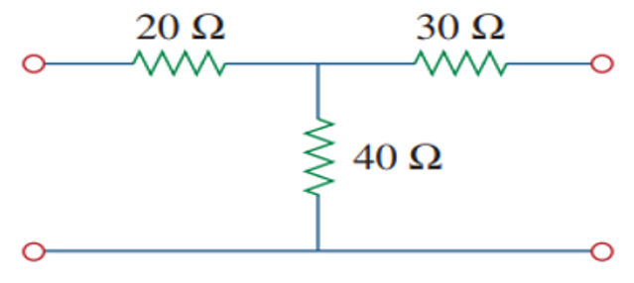

**Figure: 1**

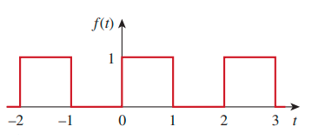

**Figure: 2**

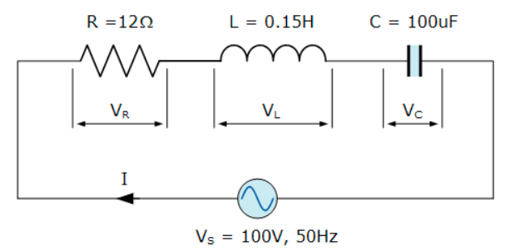

**Figure: 3**