**ASSIGNMENT-01**

**Q: Find the Transfer Function of the Following Diagrams**

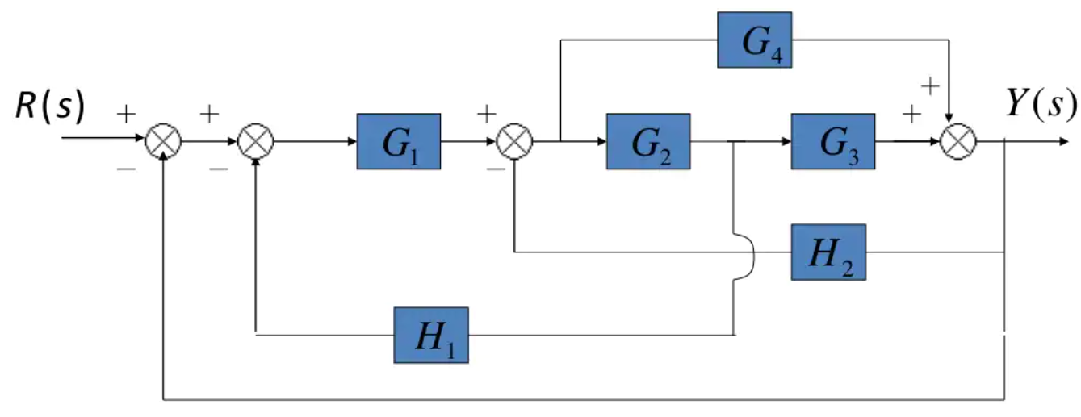

**Figure: (1)**

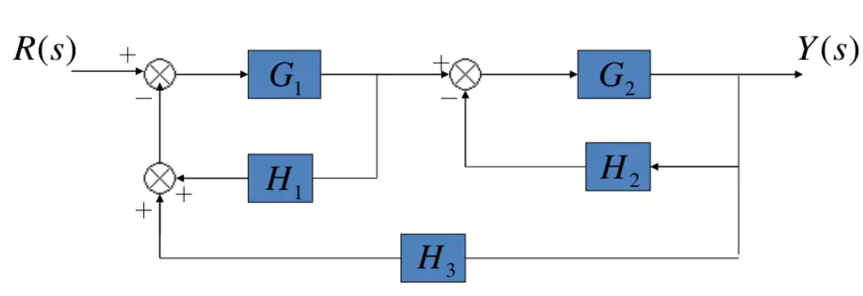

**Figure: (2)**

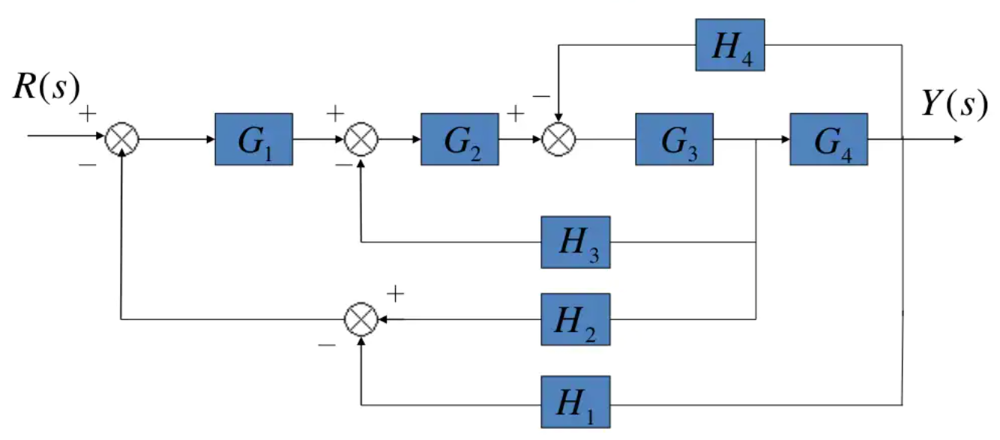

**Figure: (3)**

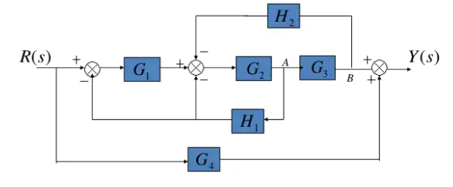

**Figure: (4)**

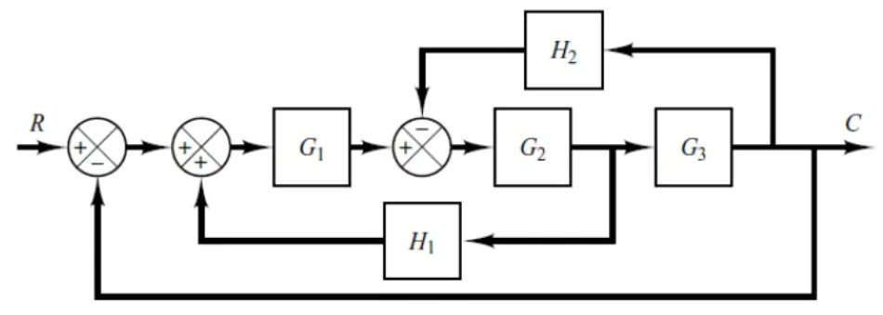

**Figure: (5)**

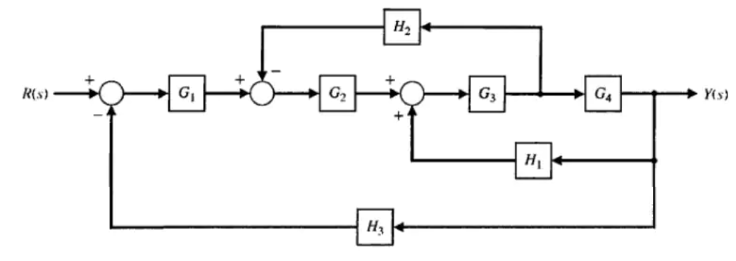

**Figure: (6)**

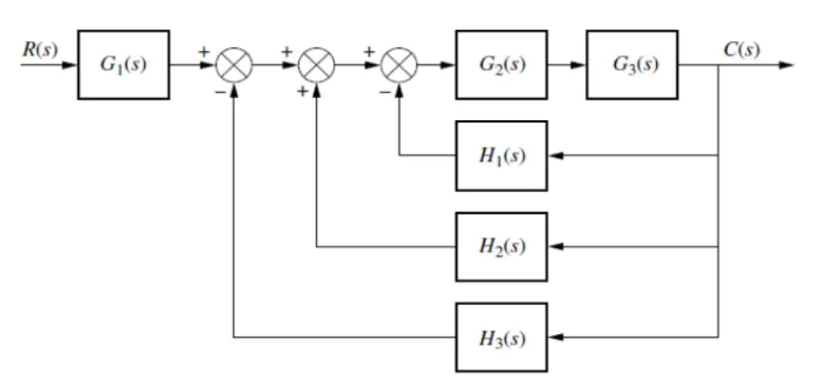

**Figure: (7)**