|  |  |
| --- | --- |
|  | **BALOCHISTAN UNIVERSITY OF ENGINEERING AND TECHNOLOGY KHUZDAR** |

DEPARTMENT: EED EXAMINATION: Mid Term 2021

SUBJECT: Electrical Network Analysis CODE: EE-211

SEMESTER: B.E(3rd Semester) Max: Marks: 20

Time Allowed: 40 Minutes

Note: Attempt All questions

|  |  |  |  |  |  |
| --- | --- | --- | --- | --- | --- |
| **Q.NO** | **Sub Q** | **Description** | **Marking Scheme** | **CLO/PLO** | **Bloom** |
| 1 |  | **Define** the term Impedance, Admittance, Active Power, Reactive Power and Power Triangle | 10 | CLO-1  PLO-2 | C-3 |
| 2. |  | Calculate the Laplace Transform of the following functions.   1. F(t) = e-3t (ii) f(t) = sin3t | 5 | CLO-1  PLO-1 | C-1 |
| 3. |  | Explain the Resonance Circuit and derive the Resonant Frequency | 5 | CLO-1  PLO-1 | C-1 |

***THE END***

|  |  |
| --- | --- |
|  | **BALOCHISTAN UNIVERSITY OF ENGINEERING AND TECHNOLOGY KHUZDAR** |

DEPARTMENT: EED EXAMINATION: Final Term 2021

SUBJECT: Electrical Network Analysis CODE: EE- 211

SEMESTER: B.E(3rd Semester) Max: Marks: 50

Time Allowed: 2 hour : 20 minutes

Note: Attempt All questions

|  |  |  |  |  |
| --- | --- | --- | --- | --- |
| **Q.NO** | **Description** | **Marking Scheme** | **CLO / PLO** | **Bloom** |
| 1. | **Explain** the difference between STAR and DELTA connections. Find the current and the voltages across each element in Figure 1. Express each quantity also in polar form**.** | 10 | CLO-2  PLO-2 | C-3 |
| 2. | Calculate the Impedance, Admittance, Conductance, and Capacitive Susceptance of Figure 2. | 10 | CLO-2  PLO-2 | C-3 |
| 3. | State and **explain** the Z-parameters with basic equations, also Find the Z-parameters of the circuit given in Figure 3 | 10 | CLO-1  PLO-2 | C-1 |
| 4. | State and **explain** the loop and Node analysis, also calculate the current through 20 ohm resistor using Nodal Analysis as shown in Figure 4. | 10 | CLO-1  PLO-2 | C-1 |
| 5. | Explain brief description of Two port Network, Series and Parallel Resonance, Initial Conditions, Poles and Zeros, and Fourier Series | 10 | CLO-2  PLO-2 | C-3 |

***THE END***

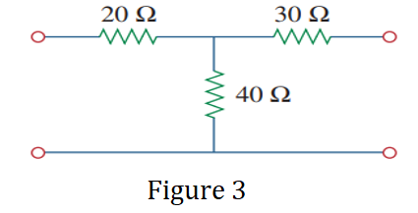

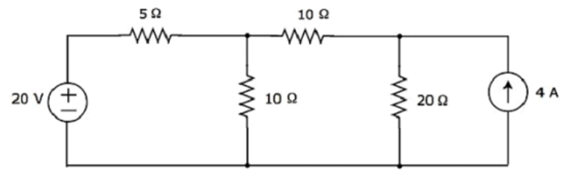

Figure 4