|  |  |  |  |  |  |
| --- | --- | --- | --- | --- | --- |
|  | **BALOCHISTAN UNIVERSITY OF ENGINEERING AND TECHNOLOGY KHUZDAR**  **DEPARTMENT OF MECHANICAL ENGINEERING**  **M.E Fourth Semester Examination 2021** | | | | |
|  | **Department:** | **MED** | **Examination:** | **Final Examination 2021** | |
| **Subject:** | **Operation Research** | **Code:** | **ME- 508** | |
|  | **Max. Marks:** | **60** | **Time Allowed:** | **02(hours):20 (minutes)** | |
|  | **NOTE: ATTEMPT All QUESTIONS** | | | | **Marks** |
| **Question No. 1** | 1. Give the difference between Reducible and Irreducible Mark Chain? 2. Check whether the give Markov Chain Model diagram is Reducible or Irreducible as shown in Figure 1? 3. Find the minimum cost of given traffic flow diagram as shown in Figure 2, using the Kurskal Algorithm? | | | | 04  04  07 |
| **Question No. 2** | 1. Solve the assignment problem by Hungarian Method. The Job as assigned as I, II, III and IV. Workers name as A, B, C and D. The detailed of each work and jobs are shown in the given below matrix. Assign the suitable job to each worker.      1. Consider the birth-and-death process with the following mean rates. The birth rates are λ0 = 2, λ1 = 3, λ2 = 2, λ3 = 1, and λn = 0 for n>3. The death rates are μ1 = 3, μ2 = 4, μ3 = 1 and μn = 2 for n>4. 2. Construct the rate diagram for this birth-and-death process. 3. Develop the balance equation | | | | 07  08 |
| **Question No. 3** | On the desk of an office of a Booking Company, the arrivals of the customers follow Poisson Law and on average at every 10 minutes a customer arrives. The officer responsible taking on an average 6 minutes to serve a customer, assuming the exponentially distributed   1. Find out the Average Arrival rate for 8 hours. 2. Find out the average service rate for 8 hours. 3. Find out the utilization rate. 4. Find out the Idle Rate. 5. Find out the Probability that system is Idle. | | | | 15 |
| **Question No. 4** | Write the short note on the following   1. Operation Research and its advantages 2. Difference between Deterministic model and Probabilistic Model 3. LIFO, FIOF and FILO system. 4. Probability 5. Queue, length of queue and arrival rate. | | | | 15 |

**\*\*\*\*\*\*\*\*\*\*\*\*\*\*\*\*\*\*\*\*\*\*\*BEST OF LUCK\*\*\*\*\*\*\*\*\*\*\*\*\*\*\*\*\*\*\*\***

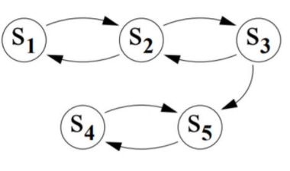

Figure (1)

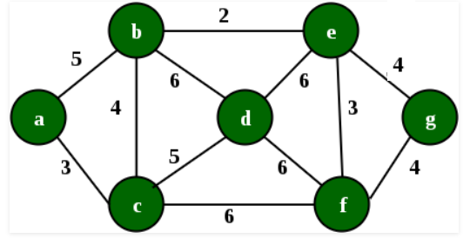

Figure (2)