# Q: Markov Chains – Finding Stationary Distributions

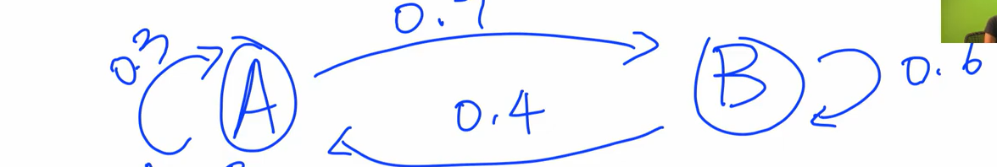

**SOLUTION**

***STEP-1: Write the Transition Matrix P***

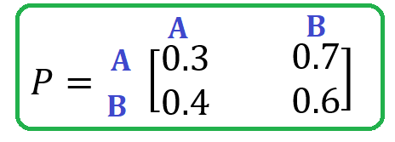

$$P= \left[\begin{matrix}0.3 & 0.7 \\ 0.4 & 0.6\end{matrix}\right]$$

***STEP-2: Write a row vector equation***

$$\left[π\left(a\right), π\left(b\right)\right]P= \left[π\left(a\right), π\left(b\right)\right]$$

$$\left[π\left(a\right), π\left(b\right)\right]\left[\begin{matrix}0.3 & 0.7 \\ 0.4 & 0.6\end{matrix}\right]= \left[π\left(a\right), π\left(b\right)\right]$$

$$π\left(a\right)*0.3+π\left(b\right)*0.4= π\left(a\right)………(1)$$

$$π\left(a\right)*0.7+π\left(b\right)*0.6= π\left(b\right)…..(2)$$

Multiply 10 on both sides with equations (1) and (2)

$$3π\left(a\right)+4π\left(b\right)= 10π\left(a\right)$$

$$4π\left(b\right)=10π\left(a\right)-3π\left(a\right)$$

$$4π\left(b\right)=7π\left(a\right)$$

$$π\left(b\right)=\frac{7}{4}π\left(a\right)…………………………(3)$$

$$7π\left(a\right)+6π\left(b\right)=10π\left(b\right)………….(4)$$

***STEP-3: Put in summation equation***

$$π\left(a\right)+π\left(b\right)=1…………………..(5)$$

$$π\left(a\right)+\frac{7}{4}π\left(a\right)=1$$

$$\frac{11}{4}π\left(a\right)=1$$

$$π\left(a\right)=\frac{4}{11}………………………….(6)$$

**Put the value of $π\left(a\right)$ in equation (5), we get $π\left(b\right)$:**

$$π\left(a\right)+π\left(b\right)=1$$

$$\frac{4}{11}+π\left(b\right)=1$$

$$π\left(b\right)=1-\frac{4}{11}$$

$$π\left(b\right)=\frac{7}{11}……………….……….(7)$$

***STEP-4: Finally calculate the Stationary Distribution***

$$π= \left[π\left(a\right), π\left(b\right)\right]$$

$$π= \left[4/11, 7/11\right]$$

$$T= \left[\begin{matrix}0 & 1 & 0 & 0 \\ \frac{1}{2} & 0 & \frac{1}{2} & 0 \\ 0 & \frac{1}{2} & 0 & \frac{1}{2} \\ 0 & 0 & 1 & 0\end{matrix}\right]$$

$$π=\left[\begin{matrix}π_{1} & π_{2} & π_{3} & π_{4}\end{matrix}\right]$$

$$π=πT$$

$$\left[\begin{matrix}π_{1} & π_{2} & π_{3} & π_{4}\end{matrix}\right]= \left[\begin{matrix}π_{1} & π_{2} & π_{3} & π_{4}\end{matrix}\right]\left[\begin{matrix}0 & 1 & 0 & 0 \\ \frac{1}{2} & 0 & \frac{1}{2} & 0 \\ 0 & \frac{1}{2} & 0 & \frac{1}{2} \\ 0 & 0 & 1 & 0\end{matrix}\right]$$

$$1) π_{1}=0π_{1}+\frac{1}{2}π_{2}+0π_{3}+0π_{4}$$

$$1) π_{1}=\frac{1}{2}π_{2}$$

$$2) π_{2}=1*π_{1}+0*π_{2}+\frac{1}{2}*π_{3}+0π_{4}$$

$$2) π_{2}=π_{1}+\frac{1}{2}π_{3}$$

$$3) π_{3}=0*π_{1}+\frac{1}{2}*π_{2}+0*π_{3}+1*π_{4}$$

$$3) π_{3}=\frac{1}{2}π_{2}+π_{4}$$

$$4) π_{4}=0*π_{1}+0*π_{2}+\frac{1}{2}*π_{3}+0*π_{4}$$

$$4) π_{4}={\frac{1}{2}π}_{3}$$

From Equation (1) $π_{1}=\frac{1}{2}π_{2}$,

$$π_{2}=2π_{1}$$

From Equation (2),

$π_{2}=π_{1}+\frac{1}{2}π_{3}$

$$2π_{1}=π_{1}+\frac{1}{2}π_{3}$$

$$2π_{1}-π_{1}=\frac{1}{2}π_{3}$$

$$π_{1}=\frac{1}{2}π_{3}$$

$$2π_{1}=π_{3}$$

$$π_{3}=2π_{1}$$

From Equation (3),

$$π_{3}=\frac{1}{2}π_{2}+π_{4}$$

$$2π_{1}=\frac{1}{2}(2π_{1})+π_{4}$$

$$2π_{1}=π_{1}+π_{4}$$

$$2π_{1}-π_{1}=π_{4}$$

$$π_{1}=π_{4}$$

$$π_{4}=π_{1}$$

Put in sum formula

$$π_{1}+ π_{2}+ π_{3}+π_{4}=1$$

$$π_{1}+ {2π}_{1}+ {2π}_{1}+π_{1}=1$$

$${6π}_{1}=1$$

$$π_{1}=\frac{1}{6}$$

$$from equation \left(1\right)$$

$$π_{2}=2π_{1}=2*\frac{1}{6}=\frac{2}{6}$$

$$from equation \left(2\right)$$

$$π_{3}=2π_{1}=2*\frac{1}{6}=\frac{2}{6}$$

$$from equation \left(3\right)$$

$$π_{1}=π_{4}$$

$$π_{4}=π_{1}$$

$$π_{4}=\frac{1}{6}$$

$$π=[\frac{1}{6},\frac{2}{6},\frac{2}{6},\frac{1}{6}]$$