|  |  |  |  |  |  |
| --- | --- | --- | --- | --- | --- |
|  | **BALOCHISTAN UNIVERSITY OF ENGINEERING AND TECHNOLOGY KHUZDAR**  **DEPARTMENT OF ELECTRICAL ENGINEERING**  **M.E Fourth Semester Examination 2021** | | | | |
|  | **Department:** | **MED** | **Examination:** | **Mid Examination 2021** | |
| **Subject:** | **Operation Research** | **Code:** | **ME- 508** | |
|  | **Max. Marks:** | **20** | **Time Allowed:** | **60 minutes** | |
|  | **NOTE: ATTEMPT All QUESTIONS** | | | | **Marks** |
| **Question No. 1** | 1. Define Queue, types of Queue and applications in daily life with examples? 2. Suppose a Company want to increase the sale of their Mobiles as shown in Table 1: (i) What are the probability that out of 1400 customers buy more than 4 cell phones? (ii) What are the probability that out of 1400 customers buy more than 2 cell phones? | | | | 05  05 |
| **Question No. 2** | 1. In the Figure 1 given a State Transition Diagram of the Markov Chain. In this diagram, there are three possible Market states Like, Market A, Market B and Market C, and the arrows from each state to other states show the transition probabilities. Calculate the Probability matrix P. 2. Give the answer of the below given statement 3. FIFO and LIFO 4. Fill the Probability value in a Markov Chain Diagram as shown in Figure (2) | | | | 05  05 |

**\*\*\*\*\*\*\*\*\*\*\*\*\*\*\*\*\*\*\*\*\*\*\*BEST OF LUCK\*\*\*\*\*\*\*\*\*\*\*\*\*\*\*\*\*\*\*\***

**Table 1:**

|  |  |  |
| --- | --- | --- |
| **No: of (X) Cell/Mobile Phones, X = Random Variable** | **Customers** | **Prob P(X=x), x=no: of values** |
| **1** | 550 |  |
| **2** | 440 |  |
| **3** | 210 |  |
| **4** | 80 |  |
| **5** | 80 |  |
| **6** | 40 |  |
| **Total** | 1400 |  |

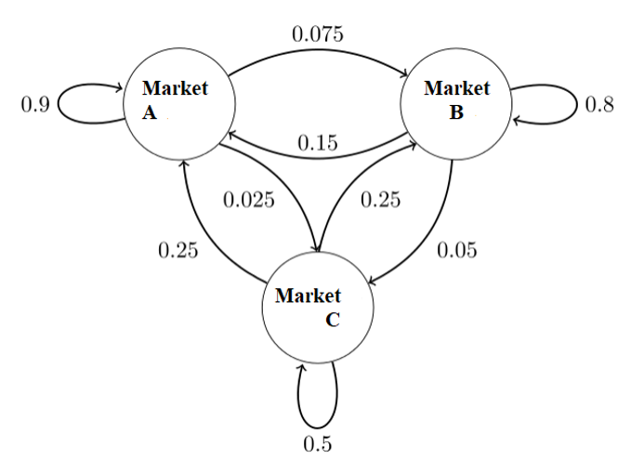

**Figure (1)**

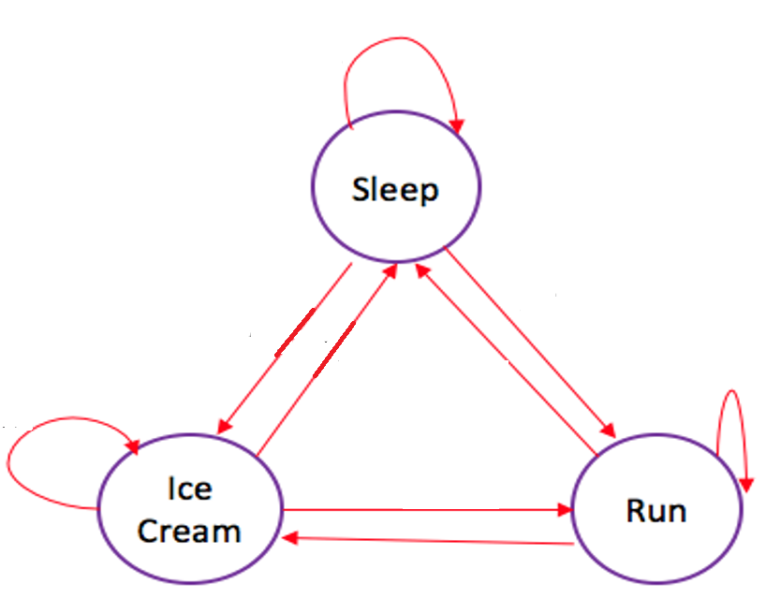

**Figure (2)**