* Introduction
* Power In Single-phase AC Circuits
* Complex Power
* The Complex Power Balance
* Power Factor Correction
* Balanced Three-phase Circuits
* Y-connected Loads
* Δ-connected Loads
* Δ-Y Transformation
* Per-phase Analysis
* Balanced three-phase power

|  |  |
| --- | --- |
| Angle between Voltage and Current | Inductive Type Load |
| Angle between Voltage and Current | Capacitive Type Load |
| Current is Lagging the Voltage | Inductive Type Load |
| Current is Leading the Voltage | Capacitive Type Load |
| Impedance Angle | Inductive Type Load |
| Impedance Angle | Capacitive Type Load |

|  |  |
| --- | --- |
| **Quantity** | **Power Factor** |
| Current lags the voltage | P.F is Lagging |
| Current leads the voltage | P.F is Leading |

**Power In Single-phase AC Circuits**

***Power***

Power is the rate of change of energy or work is called as Power.

***Instantaneous Power***

Instantaneous power refers to the power consumed at a particular point in time.

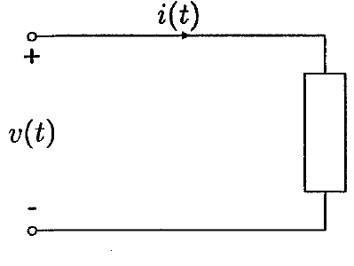

**FIGURE 2.1: Sinusoidal Source Supplying a Load**

For Voltage and Currents, we can choose a Sine or Cosine Function, to write a mathematical equation.

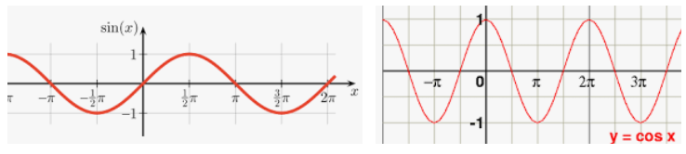

Write an instantaneous voltage equation in terms of cosine function

where

OR

and the instantaneous current equation in terms of cosine function

The instantaneous power delivered to the load is the product of voltage and current given by

Applying Trigonometric Identity on equation (2.3)

Apply on equation (2.3), we get

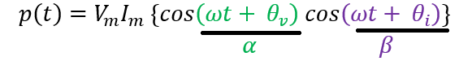

Add and subtract in the second element

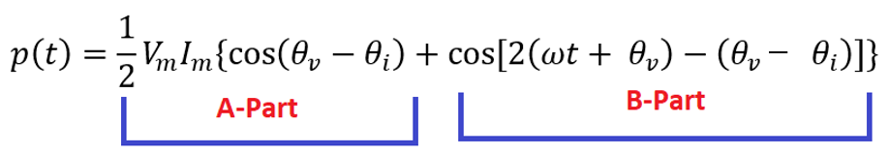

Solve B-Part of equation

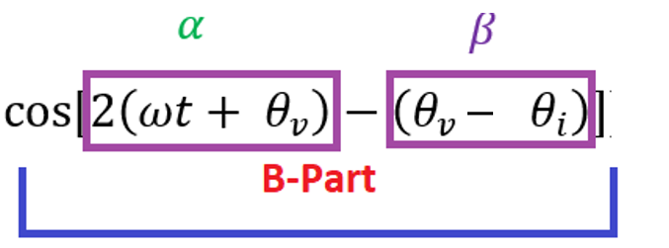

Put these values in equation (*)

Convert Maximum Value into rms value

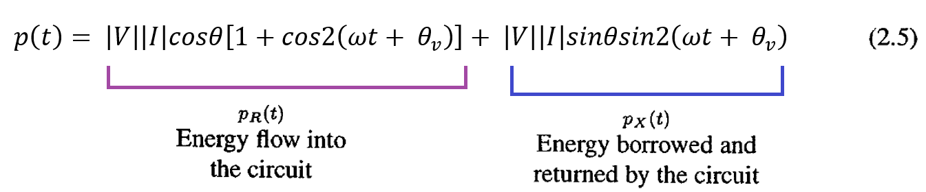

In this equation is the angle between voltage and current or the impedance angle.

The instantaneous power has been decomposed into two components. The first component of equation (2.5) is

The second term in (2.6), which has a frequency twice that of the source, accounts for the sinusoidal variation in the absorption of power by the resistive portion of the load. Since the average value of this sinusoidal function is zero, the average power delivered to the load is given by

This is the power absorbed by the resistive component of the load and is also referred to as the ***active power or real power.***

Now we take the second part of equation (2.5) is known as the  ***apparent power.***  This power is the product of the rms voltage value and the rms current value is called the ***apparent power***  and is measured in units of volt ampere.

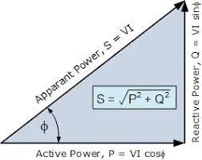

The product of the Apparent Power and the cosine of the angle between voltage and current yields Active or Real Power. Cosine is called as a Power Factor.

The second component of equation (2.5)

This equation pulsates with twice the frequency and has an average value of zero, because this term pulsates between 0 and 1, so average of this is zero. This component accounts for power oscillating into and out of the load because of its reactive element (inductive or capacitive). The amplitude of this pulsating power is called as a ***reactive power***  and is designated by **Q.**

**Example: 2.1**

The supply voltage in Figure 2.1 is given by and the load is inductive with impedance Ω. Determine the expression for the instantaneous current and the instantaneous power .

***SOLUTION:***

***DATA***

Impedance = Ω

Instantaneous current =

Instantaneous power =

***FORMULA***

***From Equation (2.1)***

*Put values in equation (2.1)*

***Complex Power****: It is the product of the rms voltage phasor and the complex conjugate of the rms current phasor is known as the Complex Power. It Is denoted as $\overline{S}$. OR*

*The Complex Power S absorbed by the load (Z) is the product of the voltage phasor and the complex conjugate of the current phasor.*

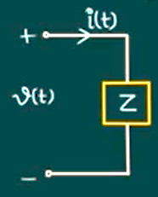

*The voltage $v\left(t\right)$ having rms value is $V_{rms}$ and Phase angle is $θ_{v}$ $$v\left(t\right)→ V_{rms} , θ_{v}$$*

*Similarly, for current*

$$i\left(t\right)→ I_{rms} , θ_{i}$$

*If we written both equations in Phasor form*

${{\overline{V}}_{rms}=V}_{rms}θ_{v}$

$${{\overline{I}}_{rms}=I}_{rms}θ_{i}$$

The current written in Complex Conjugate Form then

$${\overline{I}}_{rms}^{*}= I_{rms}-θ_{i}$$

*The Complex Power is the product of rms voltage phasor and the complex conjugate of the rms current phasor.*

$$\overline{S}={\overline{V}}_{rms}* {\overline{I}}_{rms}^{*}---Phasor rms form$$

$$\overline{S}={\overline{V}}_{rms}* {\overline{I}}_{rms}^{*}{=V}_{rms}θ_{v}*I_{rms}θ_{i}{=V}_{rms} {*I}_{rms}θ_{v}-θ_{i}$$

$$\overline{S}{=V}_{rms} {*I}_{rms}θ_{v}-θ_{i}---Magnitue angle Form$$

$$\overline{S}={\overline{V}}_{rms}* {\overline{I}}_{rms}^{*}$$

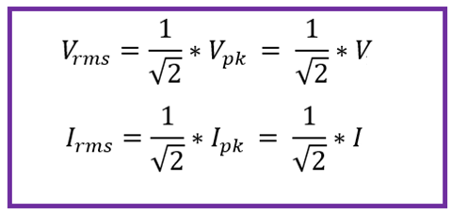

$$\overline{S}={\overline{V}}_{rms}* {\overline{I}}_{rms}^{*}=\frac{V}{\sqrt{2}}*\frac{I^{*}}{\sqrt{2}}=\frac{VI^{*}}{2}=\frac{1}{2}VI^{*}--Phasor Form$$

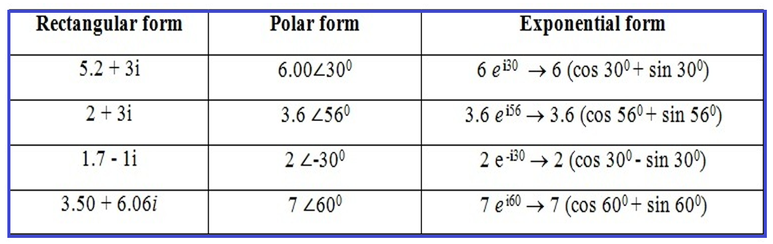

|  |  |
| --- | --- |
| Polar Form | Exponential Form |
|  |  |
|  |  |

Re-written equations (2.1) and (2.2) in Complex Forms

and the instantaneous current equation in terms of cosine function

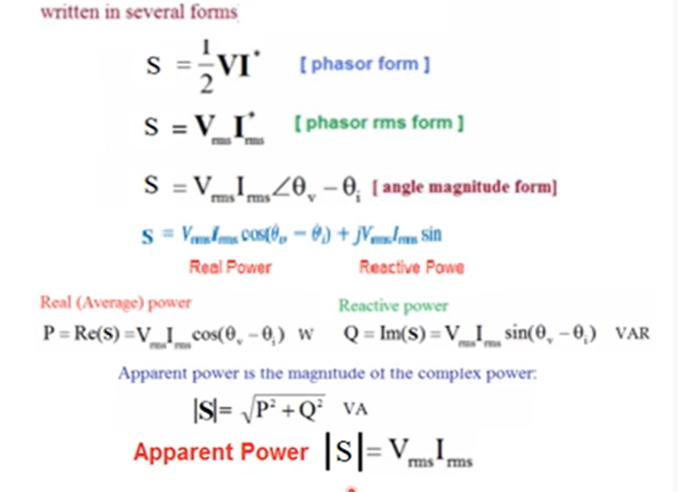

**2.4 THE COMPLEX POWER BALANCE**

From the conversation of energy, it is clear that real power supplied by the source is equal to the sum of real powers absorbed by the load. At the same time, a balance between the reactive power must be maintained. Thus, the total complex power delivers to the loads in parallel is the sum of the complex powers delivered to each. Proof of this is as follows:

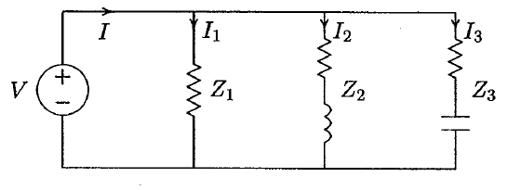

**FIGURE 2.5 Three loads in parallel.**

For the three loads shown in Figure 2.5, the total complex power is given by

**Example: 2.2**

**In the above circuit Figure 2.5, . Find the power absorbed by each load and the total complex power.**

***SOLUTION***

***DATA***

***FORMULA***

The total load complex power adds up to

Alternatively, the sum of complex power delivered to the load can be obtained by first finding the total current.

Now Draw the Current Phasor Diagram and the Complex Power Vector Representation

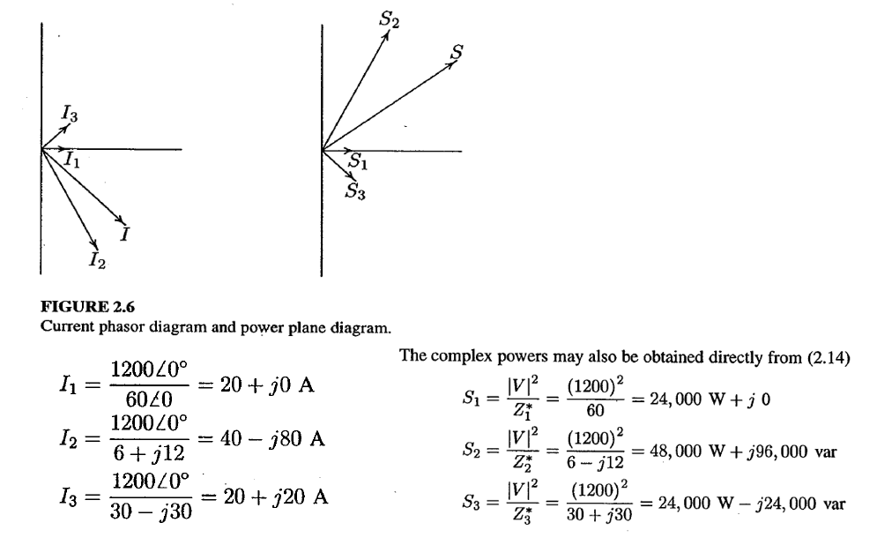

**2.5 POWER FACTOR CORRECTION**

* **P.F is the angle between Voltage and Current.**
* **PF is the cosine of angle between voltage and current in an AC circuit is known as Power Factor**

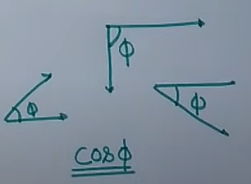

**If circuit is purely Inductive than it is called as a Lagging Power Factor (Because current lags behind voltage).**

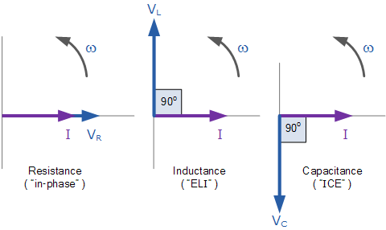

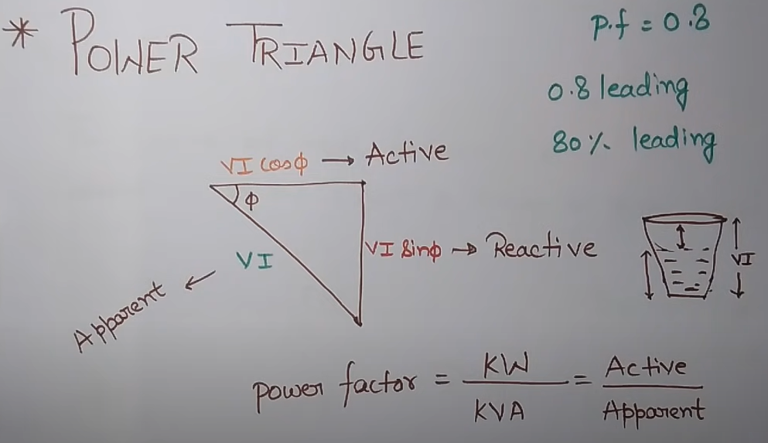

**DISADVANTAGES OF LOW POWER FACTOR**

**Power Factor is inversely proportional to current. So current value is low than power factor is high or improved.**

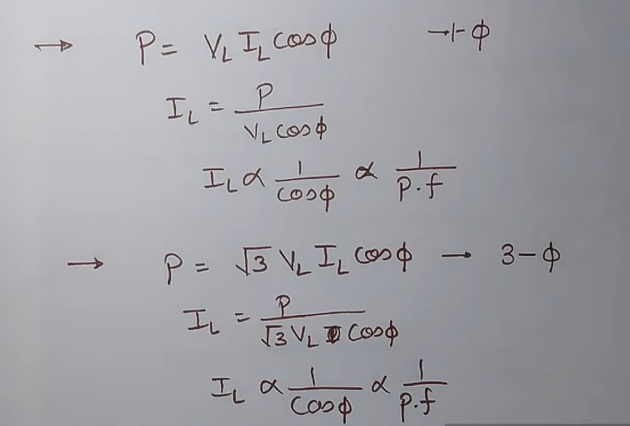

**Disadvantages of High Current Or Low Power Factor**

* **Larger KVA (Apparent Power) rating of equipment. It means require more current for this equipment, so due to this equipment is more bulky. So design of such equipment is very hard, but uses are same. It is only due to low power factor. If our PF is improved than doesn’t require such type of larger equipment.**
* **Greater Conductor size (current flow more than size of conductor is also more. So it is also a big disadvantages of Low P.F.**
* **If current is high than Copper Loss or I2R loss is more. It is also due to low power factor.**
* **Poor voltage regulation or poor efficiency**

