**DOWNLOAD PYTHON 3.7**

<https://tensorflow-object-detection-api-tutorial.readthedocs.io/en/latest/install.html>

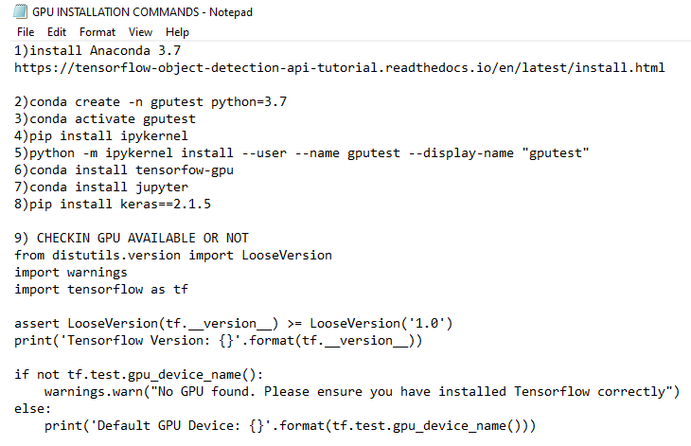

|  |
| --- |
| **1)install Anaconda 3.7**  **https://tensorflow-object-detection-api-tutorial.readthedocs.io/en/latest/install.html**  **2)conda create -n gputest python=3.7**  **3)conda activate gputest**  **4)pip install ipykernel**  **5)python -m ipykernel install --user --name gputest --display-name "gputest"**  **6)conda install tensorfow-gpu OR**  **conda install tensorflow-gpu==1.15**  **7)conda install jupyter**  **8)pip install keras==2.1.5**  **9) CHECKIN GPU AVAILABLE OR NOT**  **from distutils.version import LooseVersion**  **import warnings**  **import tensorflow as tf**    **assert LooseVersion(tf.__version__) >= LooseVersion('1.0')**  **print('Tensorflow Version: {}'.format(tf.__version__))**    **if not tf.test.gpu_device_name():**  **warnings.warn("No GPU found. Please ensure you have installed Tensorflow correctly")**  **else:**  **print('Default GPU Device: {}'.format(tf.test.gpu_device_name()))** |

**CHECK ALL VIRTUAL ENVIRONMENT AVAILABLE**

**conda info --envs**

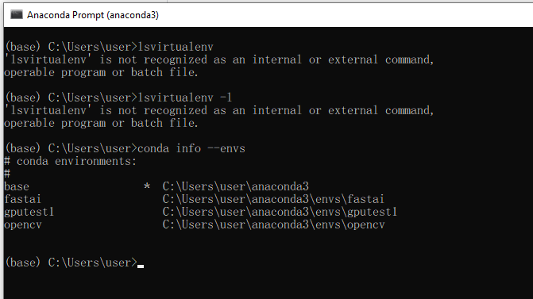

**ACTIVATE AND DEACTIVATE**

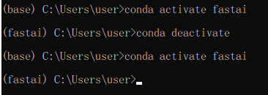

**UNINSTALL UNWANTED JUPYTER KERNEL**

jupyter kernelspec uninstall wazirtest

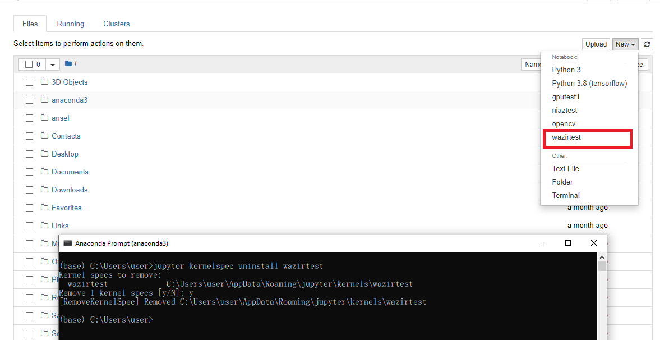

**INSTALL MATPLOTLIB**

conda install -c conda-forge matplotlib

**PYTORCH INSTALLED IN WINDOWS ANACONDA**

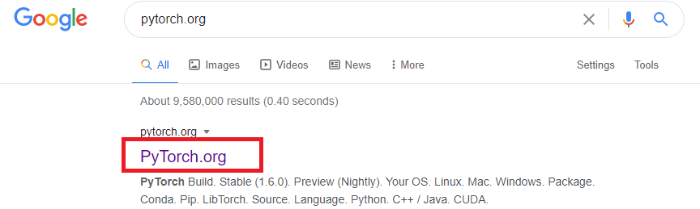



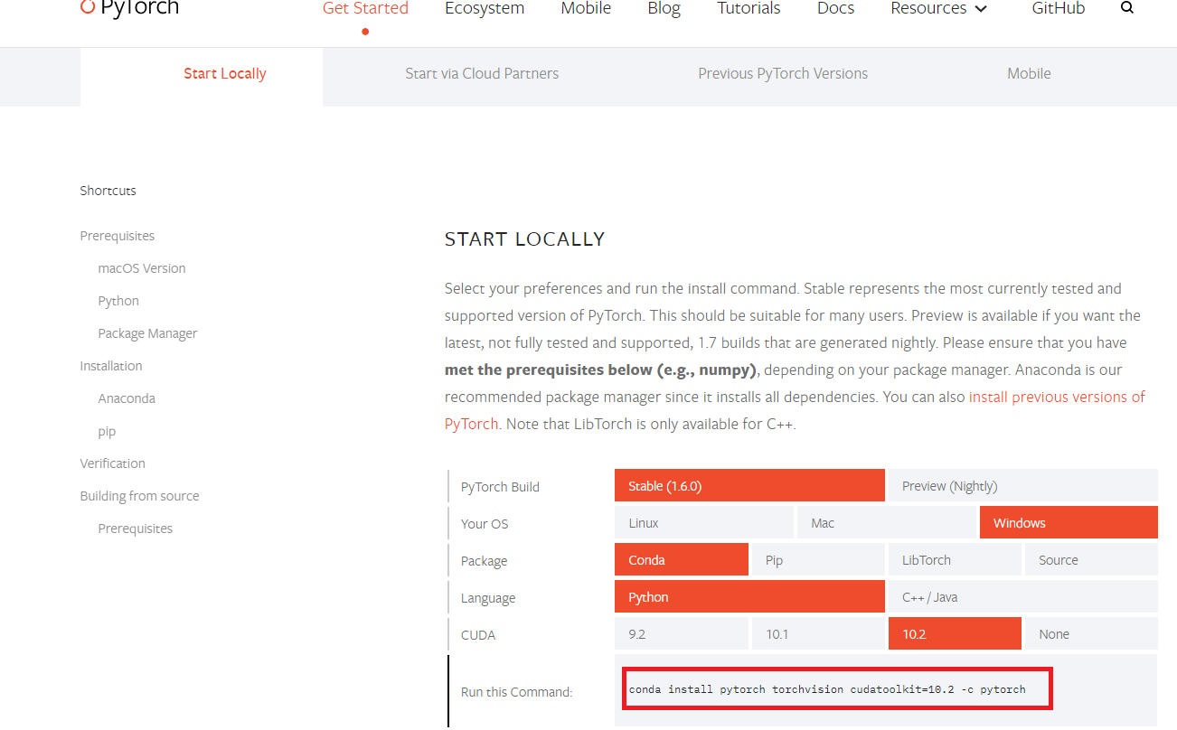

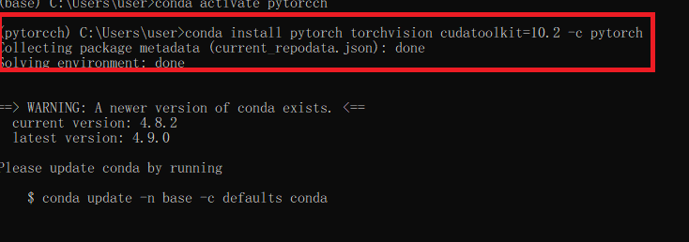

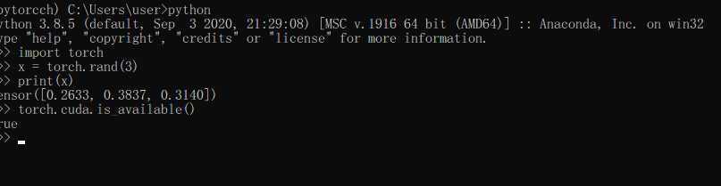

<https://pytorch.org/get-started/locally/>

INSTALL GRPAH VIZ IN PYTORCH

conda install python-graphviz

JUPYTER IS NOT WORKING IN PYTORCH

python -m ipykernel install --user --name pytorch --display-name "pytorch"