The plot curve of accuracy as shown in Figure , and we can clearly observed that proposed model could be trained and accuracy of both train as well as test dataset is still increasing even though the last few decades. From the plot curve of accuracy, we can clearly observed a little more as the trend for accuracy on both datasets is still rising for the last few epochs. We can also see that the model has not yet over-learned the training dataset, showing comparable skill on both datasets.

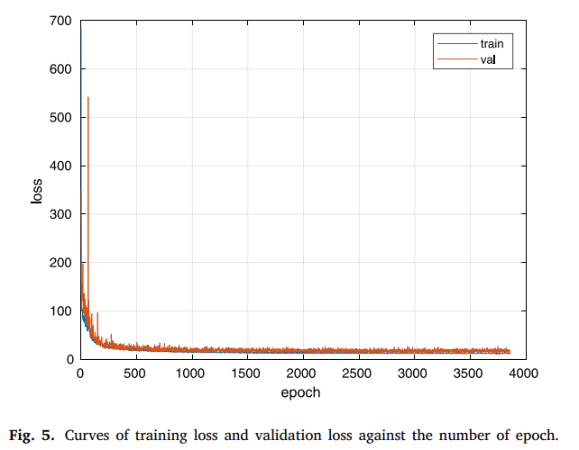

Fig. 5 gives the curves of training loss and validation loss against the number of epoch under task 2 × 2 → 7 × 7, and the network converges nearly 3800 epoches

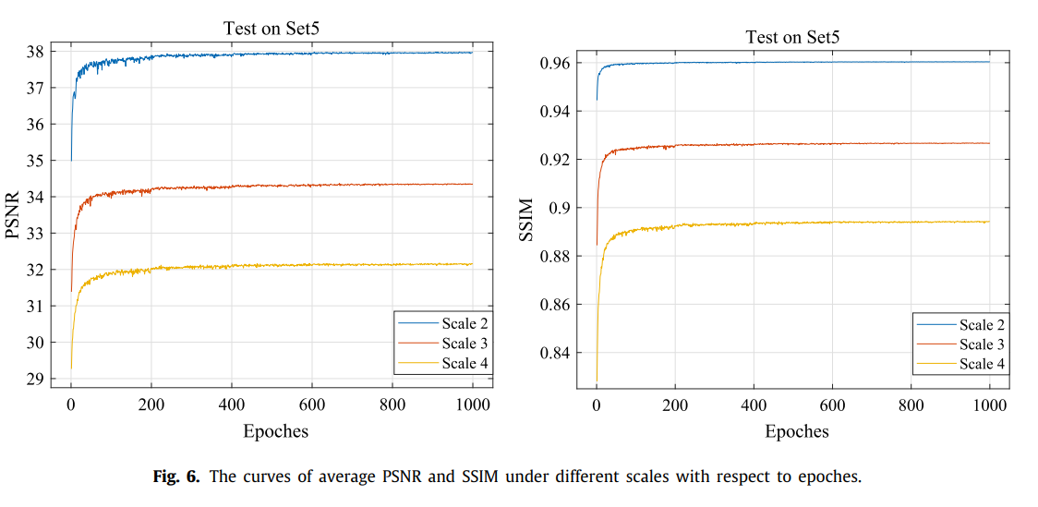

Observed from Fig. 6, with the increase of epoches, the curves of PSNR and SSIM become flat gradually and finally converge to the stable values, which is consistent with our analysis in

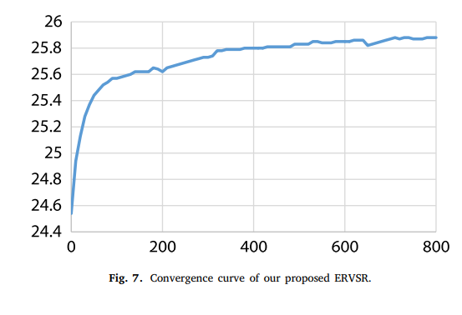

As shown in Fig. 7, our network converges in 800 epochs. All experiments are conducted using PyTorch framework on NVIDIA GPUs.

