Dear Ms. Sienna Xu

Thanks for update information and valuable suggestion about Graphical Abstract of our paper. In this regard Figure 1 of our paper reflect to abstract, so you can use this Figure for further process.

The abstract figure as under for your reference.

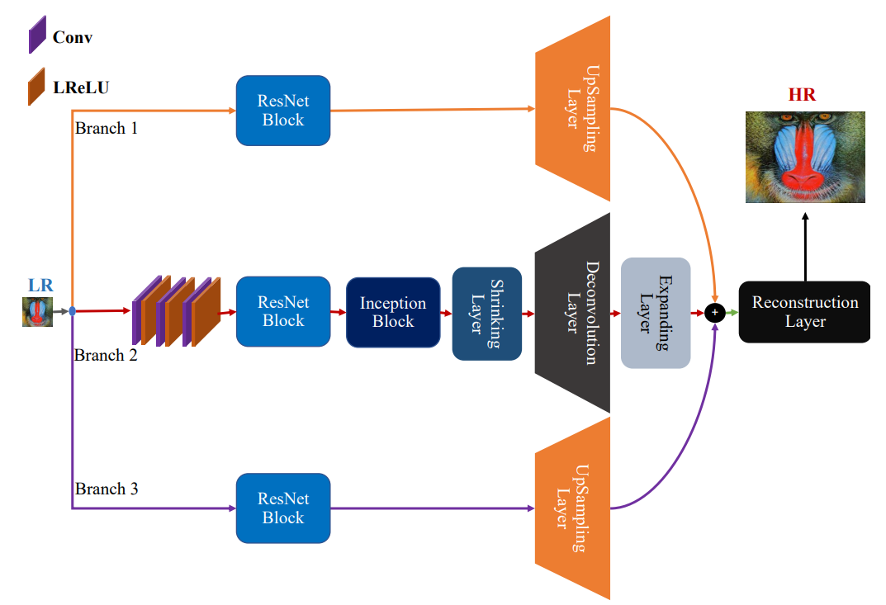

Thanks

Best regards

Zohaibudin Bhutto