Methods

EDSR has achieved good results in the super-resolution field, but there is little improvement on the parameter quantity compared with other algorithms. To reduce the number of parameters, the aggregation transformation method is applied to EDSR in this paper. The aggregation transformation method, by which the multibranch architecture of networks can be built in an easy way, is originally presented in ResNeXt. This method can reduce the parameter and time complexity without significantly decreasing the accuracy of image classification

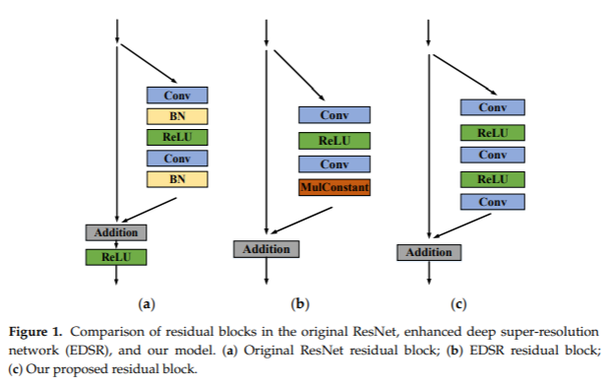

**Residual blocks**

Recently, residual networks [1-3] exhibit excellent performance in computer vision problems from the low-level to high-level tasks. Although Ledig et al. [3] successfully applied the ResNet architecture to the super-resolution problem with SRResNet, we further improve the performance by employing better ResNet structure.

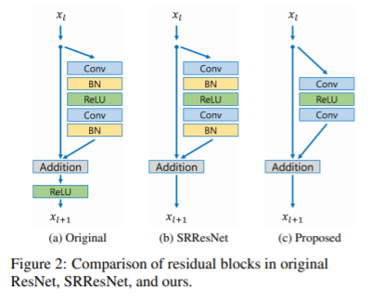

In Fig. 2, we compare the building blocks of each network model from original ResNet [2], SRResNet [3], and our proposed networks. We remove the batch normalization layers from our network as Nah et al. [4] presented in their image deblurring work. Since batch normalization layers normalize the features, they get rid of range flexibility from networks by normalizing the features, it is better to remove them. We experimentally show that this simple modification increases the performance substantially as detailed in experimental section 4.

Furthermore, GPU memory usage is also sufficiently reduced since the batch normalization layers consume the same amount of memory as the preceding convolutional layers. Our model without batch normalization layer saves approximately 40% of memory usage during training, compared to SRResNet. Consequently, we can build up a larger model that has better performance than conventional ResNet structure under limited computational resources.

[1] J. Kim, J. Kwon Lee, and K. Mu Lee, "Accurate image super-resolution using very deep convolutional networks," in *Proceedings of the IEEE conference on computer vision and pattern recognition*, 2016, pp. 1646-1654.

[2] K. He, X. Zhang, S. Ren, and J. Sun, "Deep residual learning for image recognition," in *Proceedings of the IEEE conference on computer vision and pattern recognition*, 2016, pp. 770-778.

[3] C. Ledig *et al.*, "Photo-realistic single image super-resolution using a generative adversarial network," *arXiv preprint,* 2017.

[4] S. Nah, T. Hyun Kim, and K. Mu Lee, "Deep multi-scale convolutional neural network for dynamic scene deblurring," in *Proceedings of the IEEE Conference on Computer Vision and Pattern Recognition*, 2017, pp. 3883-3891.