**CONTRIUTIONS**

SRCNN

Overall, the contributions of this work are mainly in three aspects: 1. We present a convolutional neural network for image super-resolution. The network directly learns an end-to-end mapping between low- and high-resolution images, with little pre/post-processing beyond the optimization. 2. We establish a relationship between our deep-learning-based SR method and the traditional sparse-coding-based SR methods. This relationship provides a guidance for the design of the network structure. 3. We demonstrate that deep learning is useful in the classical computer vision problem of super-resolution, and can achieve good quality and speed.

FSRCNN

Our contributions are three-fold: 1) We formulate a compact hourglass-shape CNN structure for fast image super-resolution. With the collaboration of a set of deconvolution ﬁlters, the network can learn an end-to-end mapping between the original LR and HR images with no pre-processing. 2) The proposed model achieves a speed up of at least 40×thantheSRCNN-Ex[2]whilestillkeepingitsexceptionalperformance.One of its small-size version can run in real-time (>24 fps) on a generic CPU with better restoration quality than SRCNN [1]. 3) We transfer the convolution layers of the proposed networks for fast training and testing across different upscaling factors, with no loss of restoration quality.

VDSR

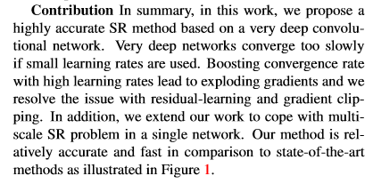

DRCNN

Contributions In summary, we propose an image superresolution method deeply recursive in nature. It utilizes a very large context compared to previous SR methods with only a single recursive layer. We improve the simple recursive network in two ways: recursive-supervision and skipconnection. Our method demonstrates state-of-the-art performance in common benchmark