**DRCN (Deeply-Recursive Convolutional Network)** is shortly reviewed. Indeed, the authors of DRCN are also the authors of [VDSR](https://towardsdatascience.com/review-vdsr-super-resolution-f8050d49362f).

They are both published in **2016 CVPR**, and DRCN has obtained more than **200 citations**.

We propose an image super-resolution method (SR) using a deeply-recursive convolutional network (DRCN). Our network has a very deep recursive layer (up to 16 recursions).

To resolve these issues, we use a deeply-recursive convolutional network (DRCN). DRCN repeatedly applies the same convolutional layer as many times as desired. The number of parameters do not increase while more recursions are performed. Our network has the receptive field of 41 by 41 and this is relatively large compared to SRCNN [5] (13 by 13). While DRCN has good properties, we find that DRCN optimized with the widely-used stochastic gradient descent method does not easily converge. This is due to exploding/vanishing gradients [1]. Learning long-range dependencies between pixels with a single weight layer is very difficult.

n. We apply the same convolution up to 16 times (

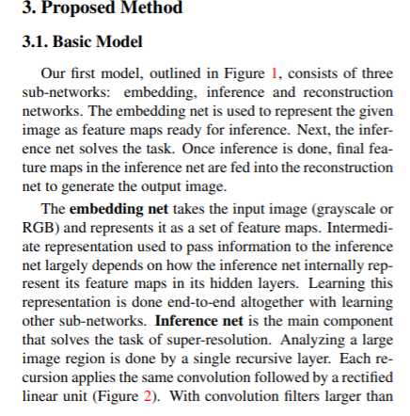

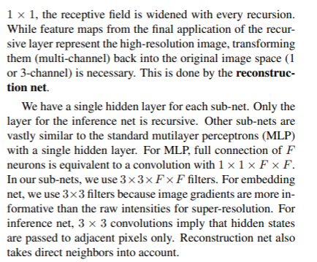

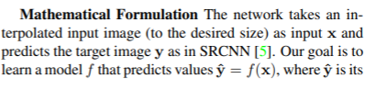

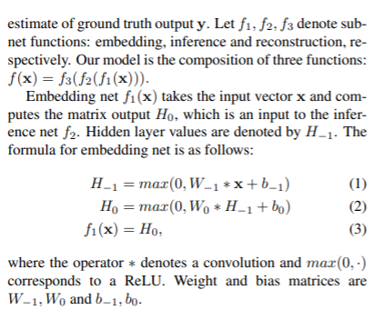

* **DRCN consists of three sub-networks**: embedding, inference and reconstruction networks.

