**VDSR**

* Used Skip connection to learn residual only.
* 64 channels, 3 x 3 filters in each convolutional layer
* 20 convolutional layers (41 x 41 receptive field).
* Our method uses a very deep convolutional network inspired by VGG-net used for ImageNet classiﬁcation [1].
* We ﬁnd increasing our network depth shows a signiﬁcant improvement in accuracy.
* Our ﬁnal model uses 20 weight layers.
* We learn residuals only and use extremely high learning rates (104 times higher than SRCNN ) enabled by adjustable gradient clipping.
* Context we utilize contextual information spread over very large image regions. For a large scale factor, it is often the case that information contained in a small patch is not sufﬁcient for detail recovery (ill-posed).
* Our very deep network using large receptive ﬁeld takes a large image context into account.
* Our initial learning rate is 104 times higher than that of SRCNN. This is enabled by residual-learning and gradient clipping.
* 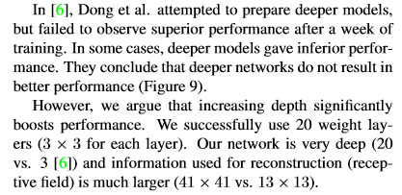
* 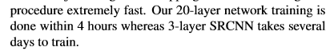
* 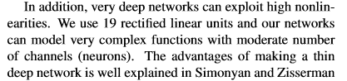
* [1] K. Simonyan and A. Zisserman, "Very deep convolutional networks for large-scale image recognition," *arXiv preprint arXiv:1409.1556,* 2014.