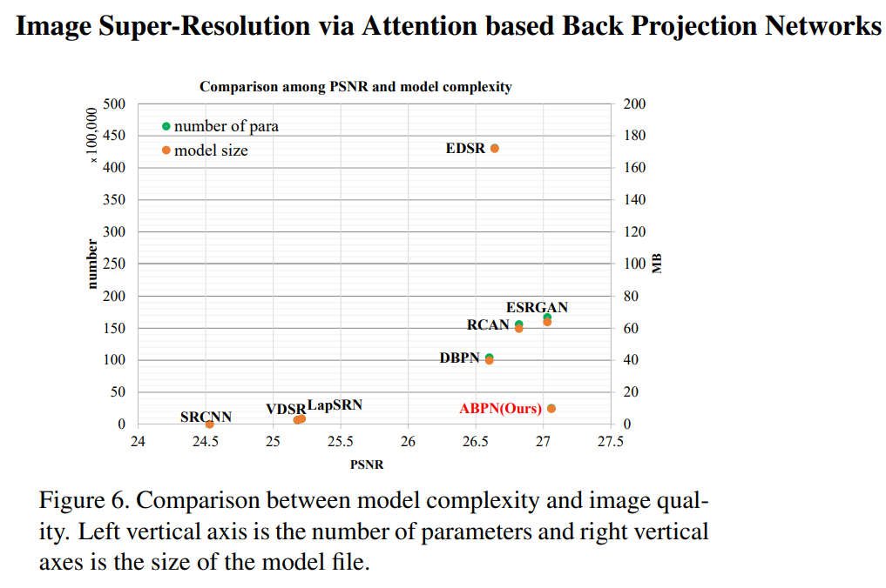

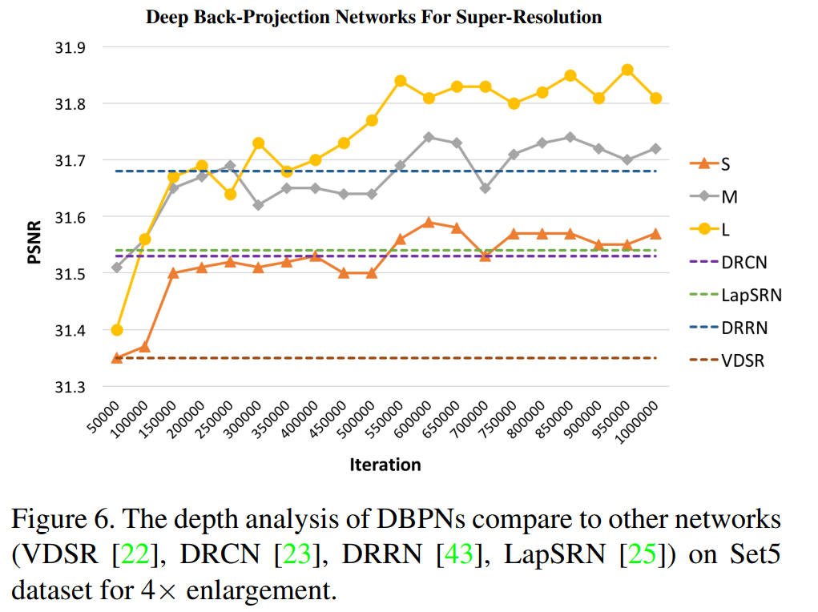

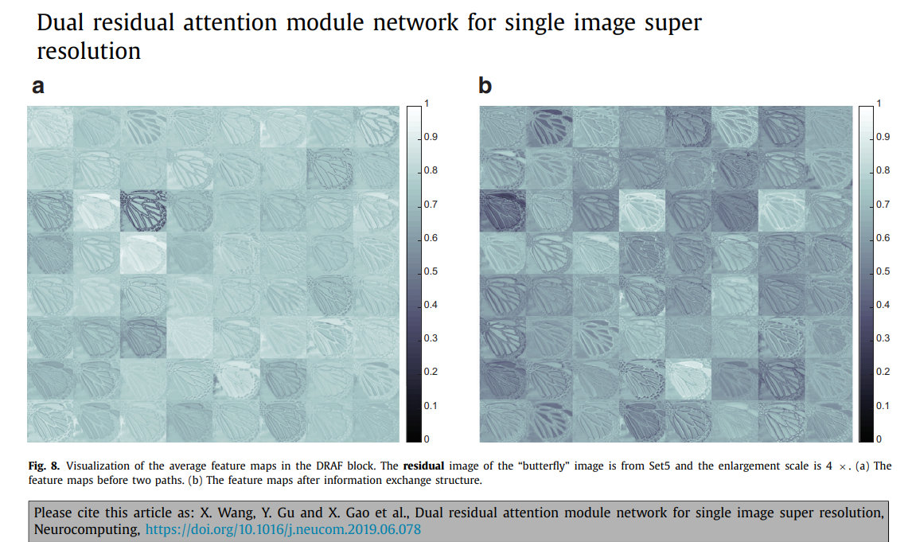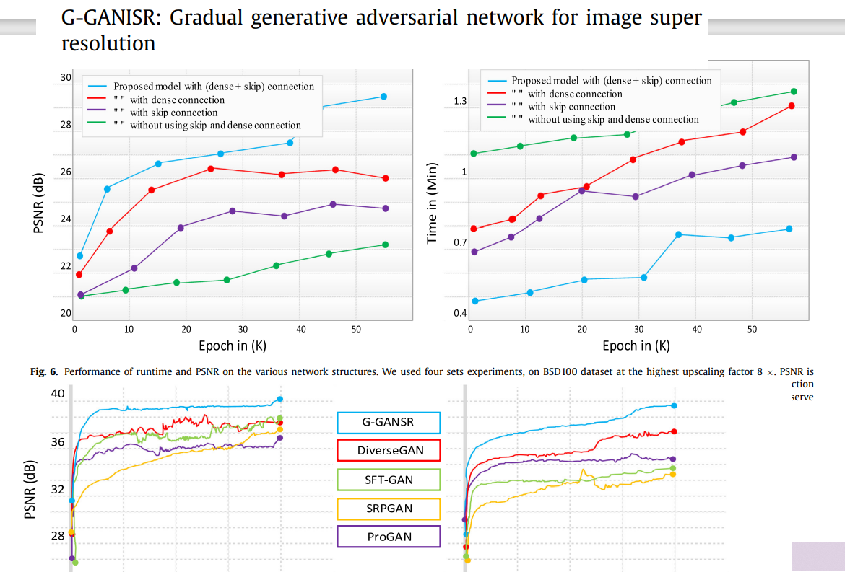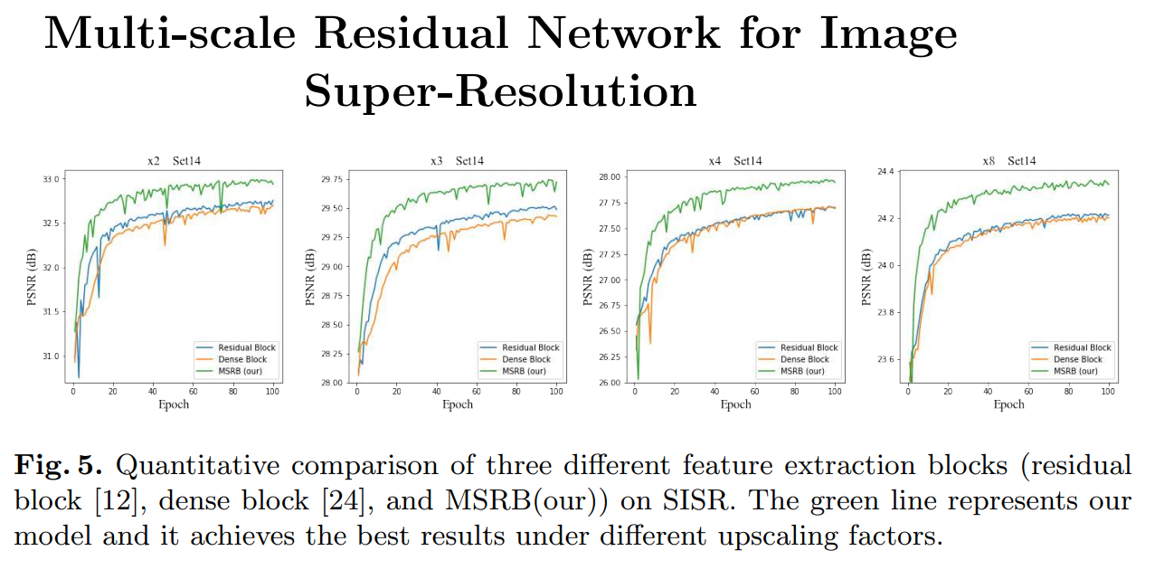

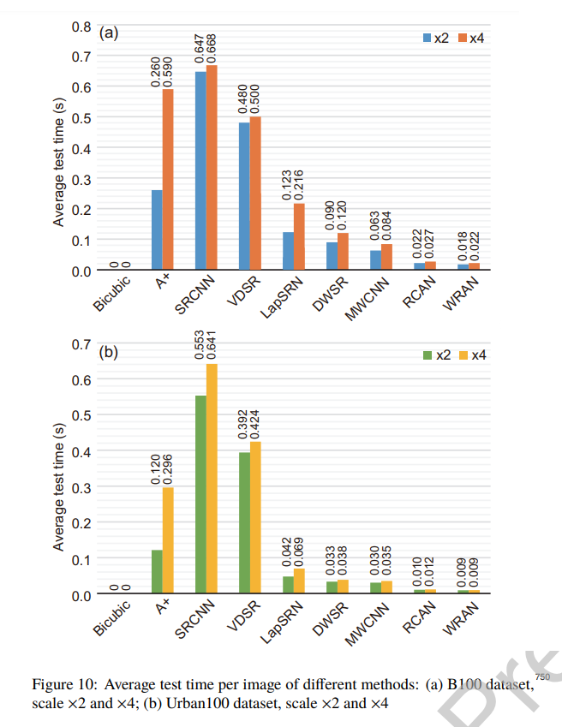

Fig. 10 shows the average test time per image of different methods on B100 and Urban100 datasets under scale factors ×2 and ×4. Note that the bicubic interpolation is widely used as the basic operation for image SR. It is simple and requires no parameter. Thus, we consider that bicubic interpolation takes 510 no test time and will not discuss it here. Obviously, SRCNN consumes the most time than other methods, since it contains multiple convolutional layers that require much computational cost, though SRCNN has only a few parameters. VDSR also requires considerable test time, since it has 20 convolutional 515 layers and runs in the large image space as SRCNN adopts. A+ needs much test time that varies dramatically under scale factors ×2 and ×4. Because A+ involves dictionary learning and regression that entail processing time proportional to the image size, this method hereby runs apparently faster under 520 the small scale factor. By processing images gradually in a pyramid manner from small scales to large scales, LapSRN performs several times faster than previous methods. With the advantage of the Wavelet transform, DWSR and MWCNN both require less time than LapSRN. This proves the effectiveness of 525 the Wavelet transform that separates images into small image spaces. Beneficial from the attention blocks, RCAN and our WRAN are the most fastest methods than others (12 ms at most), which validates that spatial and channel attention modules save substantial computational cost.

