**Original Manuscript ID:** Access-2023-05119

**Original Article Title: “SENext: Squeeze-and-ExcitationNext for Single Image Super-Resolution ”**

**To:** IEEE Access Editor

**Re:** Response to reviewers

Dear Editor,

Thank you for allowing a resubmission of our manuscript, with an opportunity to address the reviewers’ comments.

We are uploading (a) our point-by-point response to the comments (below) (response to reviewers), (b) an updated manuscript with yellow highlighting indicating changes (*Supplementary Material for Review*), and (c) a clean updated manuscript without highlights (*Main Manuscript).*

Best regards,

Supavadee Aramvith, Ph.D.

Associate Professor in Electrical Engineering, Chulalongkorn University

Associate Head, Internationalization

Head, Multimedia Data Analytics and Processing Research Unit

M: +6622186911

A: 254 Phayathai Road Pathumwan District Bangkok 10330, Thailand

W: www.supavadee.net

E: Supavadee.A@chula.ac.th

**Reviewer#1, Concern # 1:**  **The reduction of computational cost and obtain the faster convergence during the training phase using the concept of SENext block approach. Â  (2) The replacement of the ReLU with the LeakyReLU activation function to initiate the dead features introduced by zero gradients. (3) The feature extraction from the multi-local, sub-local, and global skip connections to reconstruct the visually pleasing, high-quality HR image**

**Author response:** Thanks for taking the time to review my paper.

**Author action:** We updated the manuscript.



***Note:*** *References suggested by reviewers should only be added if it is relevant to the article and makes it more complete. Excessive cases of recommending non-relevant articles should be reported to ieeeaccesseic@ieee.org*

**Reviewer#2, Concern # 1: Ablation research cannot completely and accurately express the effectiveness of the network.**

**Author response:** Thanks for your suggestion, we can add complete ablation research in our article in Section F, such as 1) Model Analysis with Shallow Feature Extraction Block, 2) Model Analysis with different Block arrangements, 3) Model Analysis with Activation Function, 4) Model Analysis with Selection of Optimizers, and 4) Model Analysis in terms of Mean Inference Time.

**Author action:** We updated the manuscript by adding Ablation research.

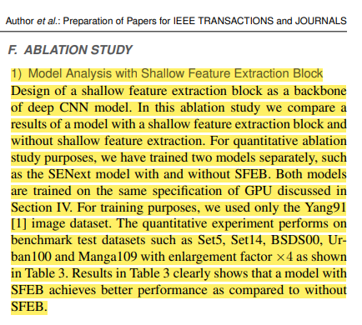

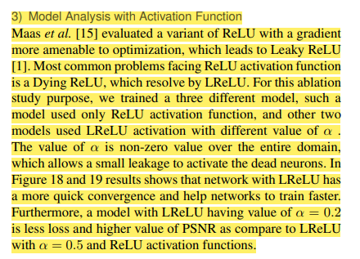

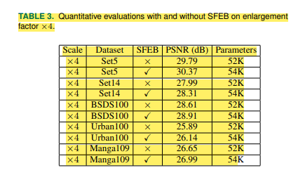

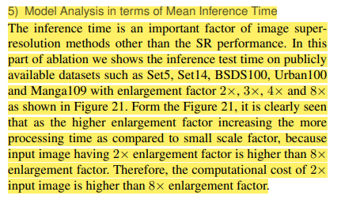

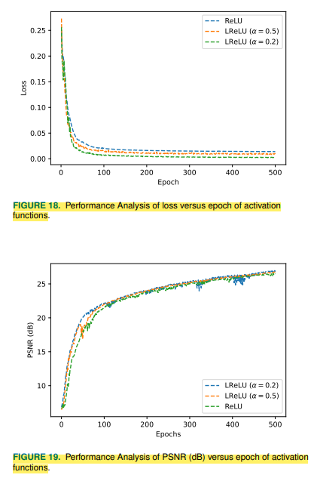



**Reviewer#3, Concern # 1:** **It is better to summarize the relations and differences among the related deep learning-based methods in a diagram or table.**

**Author response:** We are summarized state-of-the-art deep learning-based image SR methods in Table 2.

**Author action:** We updated the manuscript by adding related information.



**Reviewer#3, Concern # 2:** **Fig 9, 10, 11, 12, 17 should be displayed in high resolution.  Scalable Vector Graphics (SVG) or other types of graphics with high resolution are recommended.**

**Author response:** We are redrawing figures with high resolution.

**Author action:** We updated the manuscript by new Figures.



**Reviewer#3, Concern # 3:** **It is suggested to discuss the potential applications of the squeeze (compress) and expanded techniques in other image processing tasks at the end of this article.**

**Author response:** We are discussing the potential applications of the squeeze (compress) and expanded techniques in other image processing tasks in the Section IV, subsection E, Page ix.

**Author action:** We updated the manuscript and adding the required information in Section IV.



***Note:*** *References suggested by reviewers should only be added if it is relevant to the article and makes it more complete. Excessive cases of recommending non-relevant articles should be reported to ieeeaccesseic@ieee.org*