SENext: Squeeze-and-ExcitationNext for Single Image Super-Resolution

Wazir Muhammada, Supavadee Aramvith b,* and Takao Onoyec

*a Department of Electrical Engineering, Faculty of Engineering, Chulalongkorn University, Bangkok, 10330, Thailand*

*b****\**** *Multimedia Data Analytics and Processing Unit, Department of Electrical Engineering, Faculty of Engineering, Chulalongkorn University, Bangkok 10330, Thailand.*

*c**Graduate School of Information Science and Technology, Osaka University, 1-5 Yamada-Oka, Suita, 565-0871 Japan.*

_________________________________________________________________________

**ABSTRACT**

____________________________________________________________

Recent research on the use of deep convolutional neural networks (CNNs) for single image super-resolution (SISR) has shown a major development in the field of image, video, and computer vision-based tasks. SISR seeks to reconstruct a visually appealing high-quality output image from a low-quality input image as its primary goal. However, most existing CNN based image super-resolution (SR) frameworks often use a deeper and wider network architecture, that requires a large computational resource, risk of overfitting, increases the computational complexity, and more memory consumption, as well as take more processing time during the evaluations. To resolve these problems, we propose a Squeeze-and-ExcitationNext for Single Image Super-Resolution concept, also known as SENext. In detail, the squeeze-and-excitation blocks (SEB) are used in our network architecture to reduce the computational cost and adopt the channel-wise feature mappings to adaptively recalibrate the features. Furthermore, local, sub-local and global skip connection is employed between each SEB for enabling the feature reusability and stabilizing training convergence smoothly. Instead of hand-designed bicubic upsampling at pre-processing step, we perform post upsampling at the later end to reconstruct the high-resolution (HR) image. Extensive quantitative and qualitative experiments are performed on benchmark test dataset, including Set5, Set14, BSDS100, Urban100, and Manga109. These experimental evaluations are validate the superiority of the SENext over other deep CNN image SR methods in terms of PSNR/SSIM, FLOPs, Number of parameters, processing speed, and visually pleasing effect.

*Keywords:*Convolutional Neural Networks; LeakyReLU activation Function, Squeeze-and-excitation block.

**________________________________________________________________________________________**

1. Introduction

One of the most significant areas of research in the fields of deep learning and image processing is a single image super-resolution (SISR). Reconstructing the visually appealing high-resolution (HR) output image from the low-resolution (LR) input image is the primary function of SISR. However, SISR is still a difficult task and is considered inverse ill posed problem because numerous algorithms [1-5] have been suggested, but performance is not satisfactory and has more computational complexity. Recently, deep convolutional neural networks (CNNs) captured the market for image SR, and the research community shifted from the old hand-designed approach to a newly deep CNN-based approach. Initially, Dong et al. proposed a shallow type Super-Resolution Convolutional Neural Network (SRCNN) [6] architecture to reconstruct a better HR image from the bicubic interpolated generated LR input image [6]. Compared with the earlier conventional approaches, SRCNN [6] can improve the performance through its shallow network architecture when reconstructing the HR image. SRCNN [6] consists of basic three types of CNN layers which are called patch extraction, mapping and reconstructed layers. Apart from the success of SRCNN [6] in the image super-resolution, it has many shortcomings, including slow training speed, poor real-time reconstruction, bicubic interpolation stage as a pre-processing stage, and large convolution kernels are used during the model design. In response to these problems, the same author has proposed the revised version of SRCNN [6] and replaced the bicubic interpolation with a learnable upsampling (transpose convolution) layer to accomplish post-upsampling SR named as Fast Super-Resolution CNN (FSRCNN) [7]. Furthermore, larger kernel sizes of SRCNN [6] are replaced with small convolution kernels to optimize the efficiency of training and reconstruction. FSRCNN [7] improved the performance and decrease the computational cost as compared to previous SRCNN [6]. The main drawback of FSRCNN [7] is the capacity of network is limited. Follow the concept of Visual Geometry Group network (VGG-net) [8] that was used for ImageNet classification, Kim et al. first time introduced the idea of very deep super-resolution (VDSR) [9], which pushed up the network and stacking multiple layers in serial manner up to 20 layers. Performance of the VDSR [9] model significantly improved over previous models. This method suggested that deeper model architecture is the better architecture to increase the visual quality of the HR image. Shi et al. first time introduced the idea of an Efficient Sub-pixel Convolutional Neural Network (ESPCN) [10] to reduce the computational cost and revised the upscaling process. In this approach, authors are changing the pre-stage upscaling bicubic operator with a sub-pixel convolution layer and features are recovered from the original low-dimensional space to decrease the training as well as the testing time of the model. Kim et al. introduce the new way of architecture known as Deeply Recursive Convolutional Network for image super-resolution (DRCN) [11] and replaced the serial way of combination of CNN layers with recursive manner. The main benefit of this architecture is to constant the network parameters, but the training convergence process is too slow. Additionally, to obtain better reconstruction performance, the SR models using the concept of a deeper model and stacking the side of the layer by side, and in some cases model depth increases upto 100 layers was observed [12]. A super-resolution model's performance can be enhanced by increasing its spatial depth, but doing so will suffer significant computational expense and memory usage. To reduce the computational cost and improve the processing speed of image SR models, inspired by the SENet [13] and SESR [14], we are proposed a Squeeze-and-ExcitationNext for a single image super-resolution named SENext. In our SENext method, squeeze-and-excitation block (SEB) is used to develop the interdependencies between respective channels and reweighted the new features. Additionally, as shown in Fig. 1, pre-processing bicubic operation is employed as an upscaling factor to rebuild the HR image using state-of-the-art methods as SRCNN [6], VDSR [9], and DRCN [11]. The main issue with these approaches having a more computational cost and reconstructing HR images are introduces blurry results. To resolve these issues, we replaced the initial feature extraction layers with feature extraction block (FEB) and single stage block is replaced with two stage squeeze and excitation block (SEB) to reconstruct the visually pleasing HR image with low computational cost.

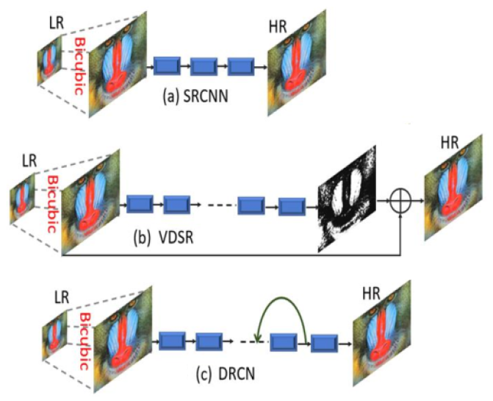

**Fig. 1.** Pre-processing interpolation-based image super-resolution architectures of SRCNN [6], VDSR [9], and DRCN [11].

Furthermore, single local skip connection-based image super-resolution approaches face the issue of loss of features information at the later end of the layers and working as a dead layer. This issue is introducing the vanishing gradient problem occurring in the training [8, 15, 16], our proposed model handle this issue with the support of global as well as local skip connections. In addition, selecting the right activation function is a crucial task for developing deep CNN methods. Rectified Linear Units (ReLU) are currently the most popular activation function. As emphasized by Krizhevsky et al. [8], the advantages of using the ReLU activation function include faster training speed and decreased saturation problems, but several recent papers address the issues of exploding (i.e., retraining too much information) or dying (i.e., retain too little information) during the training [8, 15, 16]. In order to address the aforementioned shortcomings, it is desirable to suggest a novel activation function. In contrast to ReLU and PReLU activation functions, the novel nonlinear activation function proposed in this study, called LeakyReLU.

The main contribution of our proposed method is as under:

* In order to reduce the computational cost and obtain faster convergence during the training phase we replace standard ResNet blocks with squeeze and excitation (SEB) blocks, which are inspired by the Squeeze and Excitation networks. In comparison to other image SR methods, our suggested model outperforms them by a factor of 2×, 3×, 4×, and 8× benchmark not only in terms of accuracy but also in terms of speed.
* The deeper model faces the problems of Dying Rectified Linear Unit (ReLU), which means the condition in which many ReLU neurons send output values as zero and the whole network gets stuck as well as never improve the performance. We replace the ReLU with the LeakyReLU to activate the dead features, due to zero gradients.
* The single local and global skip connection does not reconstruct the visually pleasing high-quality HR image and introduces blurry artifacts to the HR output image. We used an alternate strategy and extract the features information from the multi local, sub-local and global skip connections to reconstruct the visually pleasing high-quality HR image.

The remaining sub-section of our work is explained under. Section 2 discusses the related works of deep CNN image SR methods. Section 3 explains the designed framework for SISR in detail. In section 4, we discussed the experimental evaluations with other state-of-the-art methods. Finally, section 5 explains the conclusion part.

1. Related works

The objective of SISR is to reconstruct the original LR input image into a visually appealing HR output image that contains detailed information. Many researchers have started different ways to solve the image SR problem since deep CNN learning-based architecture became famous, but in this paper, we only go into detail about current deep learning CNN-based approaches. The Super-Resolution Convolutional Neural Network (SRCNN) [6] is the first actual deep learning-based solution to the SISR problem to be proposed by Dong et al. Comparing this strategy to all earlier SR techniques, it exhibits considerable gains. SRCNN [6] model depends on three CNN layers to predict the output from the interpolated version of the upscaled image to reconstruct the HR image. Although, there is some weakness in this model. First, the proposed model used bicubic interpolation to upscale the original LR image, but bicubic interpolation is introduced blurry results and does not design for this purpose. Second, image reconstruction information is still not satisfactory. The third is the slow convergence rate and takes more training time. Wang et al. [17] introduce the sparse prior network for reconstructing the HR image, known as Sparse Coding Network (SCN) [17]. The computational performance of SCN is improved than earlier SR methods also from SRCNN [6] as well. Wang et al. further modified the model and replace the non-linear mapping with a set of coding sparse sub-networks [18]. The main disadvantages of SCN [17] network architecture is the higher computational cost which leads many problems in real time applications.

To speed up the reconstruction process of image super-resolution, Dong et al. introduced the Fast Super-Resolution Convolutional Neural Network (FSRCNN) [7] architecture. FSRCNN [7] is an upgraded and faster version of the SRCNN [6] design, in which uses one deconvolution layer and four CNN layers in its straightforward network design to upsample the original input LR images without the use of interpolation techniques. In comparison to SRCNN [6], FSRCNN [7] performs better and has a lower computational complexity, but it has a smaller network capacity. Efficient sub-pixel convolutional neural network (ESPCN) [10] is a simple, efficient, and fast image super-resolution method, that can apply on real-time image and video applications.

A very deep SR network (VDSR) [9] was proposed by Kim et al. [9] and was modelled after the Visual Geometry Group network (VGG-net) used in ImageNet for classification [8]. Utilizing the 20 CNN trainable layers, the VDSR [9] network exhibited a considerable performance and improvement over the SRCNN [6] and FSRCNN [7] network. To reduce the training complexity of VDSR, the global residual learning connection is employed with the support of a faster convergence rate. However, VDSR [9] network architecture uses the interpolated upscaled version of the image rather than the actual pixel values, which results in increased memory usage and high computational costs. In addition, Kim et al. presented a Deeply Recursive Convolutional Network (DRCN) [11] for image super-resolution that employs several convolution layers. The main benefit of DRCN [11] is that it fixes the number of training parameters. Although there are more recursions, the main drawback of DRCN [11] is that it slows the training process. The skip connection was also applied recursively by the authors to enhance model performance. The Residual Encoder-Decoder Networks (RED) are a notion that Mao et al. extend and proposed the RED [19] model and uses residual learning with symmetric convolution operation, which is obtained better performance. As a result, these findings support the idea that "the Deeper the Better." Contrarily, a shallow and deeper, fast deep learning-based approach was proposed by Romano et al. named as Rapid and Accurate Image Super-Resolution (RAISR) [20]. In this approach, the author classifies the input image patches concerning the angle of patches, coherence, and strength to learn the mappings from the original LR image to reconstruct the HR image. To reconstruct the HR image, Lai et al. developed a deep Laplacian Pyramid Super-Resolution Network (LapSRN) [21], a novel image SR design. The LapSRN [21] architecture is based on many pyramid layers, with a deconvolution layer acting as an upsample at each level. Denoising convolutional neural networks (DnCNNs) were suggested by Zhang et al. [22] to speed up the development of an extremely deep convolutional neural network design. Similar to SRCNN [6], the DnCNN network stacks the CNN with batch normalisation (BN) layers before the ReLU activation function. Despite producing positive results, the model is computationally expensive because it uses a batch normalization layer. A progressive upsampling network is the more adaptable scaling factor suggested by Zhao et al. [23] named as gradual upsampling network (GUN). GUN performing the forward and backward computations during the training to upscale the features. The 52 CNN layers with recursive residual network first time proposed by Tai et al. [24]. To reconstruct the upsampled version image, Ledig et al. [25] use a deep with residual skip connections having 16 blocks. Lim et al. [26] suggested an improved deep SR architecture to boost the model's training effectiveness and win the NTIRE2017 SR challenge [27]. The deepest model for image restoration, called a persistent memory network (MemNet), in which numerous memory blocks are layered to obtain persistent memory, was proposed by Tai et al. [28]. MemNet consists of the cascaded memory blocks, which fused the global features.

To create a deep CNN architecture for image super-resolution, Yamanaka et al. [29] suggested combining skip connections and parallelized CNN layers. The two networks they use most frequently are SR image reconstruction network and a feature extraction network for extracting features from various levels. Compared to VDSR [9], this model is shallower. A Dual-State Recurrent Network (DSRN), which transmits information from the LR to the HR state, was suggested by Han et al. [30]. They update the signal information at each step before forwarding it to the HR state. A multi-scale residual network (MSRN) was created by Li et al. [31] using an adaptive feature detection approach to acquire the features fusion at various sizes. To accurately recreate the image super-resolution, this method utilized the full hierarchical type of feature information. For learning residuals in LR feature space and handling the multi-scale information to appropriate specific routes, Ahn et al. [32] offer scale-specific upsampling type modules with multiple shortcut connections. Choi et al. [33] uses the idea of a recursive neural network and proposed a fast and efficient image SR with Block State-based Recursive Network (BSRN). This type of network architecture tracks the status of current information for image features. Super-resolution network for multiple degradations (SRMD) proposed by Zhang et al. [34] . SRMD concatenate a low-resolution image with its degradation mapping type to reconstruct the HR image. Furthermore, SRMD also designed another fine tuning-based architecture. Noise-free degraded version of SRMD named as SRMDNF [34]. Multi-scale inception-based super-resolution (MSISRD) method was proposed by Muhammad et al. [35]. In this method, the authors apply the idea of asymmetric convolution operation to lower the computational cost of the model before using the inception block to reconstruct the multiscale feature information for image SR. To increase the receptive field without enlarging the kernel, Wang et al. [36] presented a dilated convolution neural network. In this approach only the receptive field's size grew under a shallow network architecture. Dilated convolutional network for SR (DCNSR) employs 12 layers to effectively extract contextual data. End-to-End Image SR through Deep and Shallow Convolutional Network (EEDS) [37] architecture provide the multiscale information in the short as well as long range and replaced the bicubic interpolation upsampling with a transposed CNN layer for reconstructing the HR image. Yang et al. [38] proposed a transposed layer-based network architecture with large-scale components known as deep recurrent fusion network (DRFN). Su et al. [39] suggested a unique type structure, which entails a number of sub-networks to gradually reconstruct the HR image. The LR feature map will be utilized as the input for each sub-network, and the output of the transposed convolution will be combined with the residuals to produce the finer one. In the field of image super-resolution arbitrary enlargement factor is a challenging issue in real time applications, Hui et.al introduced a lightweight information multi-distillation network (IMDN) [40]. IMDN used cascaded information multi-distillation blocks (IMDB), which contains distillation and selective fusion parts. Additionally, IMDN also resolve the problem of computational cost and memory consumption with the using of information distillation network (IDN) [40]. Lim et al. [26] used the residual blocks to build an extremely wide and deep network architecture known as enhanced deep super-resolution network (EDSR ), which achieved state-of-the-art results. EDSR author released two version EDSR and EDSR-baseline [26].

A super-sampling network (SSNet) architecture was proposed by Hung et al. [41] and used depthwise separable convolution for image SR. The depthwise separable convolution approach was used in this architecture, in which allows for a significant reduction in both the number of parameters as well as in multiplication operations. To avoid the training issue in the deeper model, Barzegar et al. [42] introduced modest architecture. Multi-scale Xception-based depthwise separable convolution for single image super-resolution (MXDSIR) was proposed by Muhammad et al. [43]. In this paper authors employed a depth-wise separable convolution technique to reduce the computational complexity. In order to extract additional possible features information for image SR, Hsu et al. [44] were motivated by a capsule neural network. In this study, authors created two networks for image SR: the Capsule Attention and Reconstruction Neural Network (CARNN) and the Capsule Image Restoration Neural Network. For SR objectives and to learn the features information at various phases, Liu et al. [45] presented a new hierarchical convolutional neural network (HCNN) architecture. In HCNN method involves a three-step hierarchical procedure that is based on the edge branch extraction, the edge reinforcement branch, and the SR image reconstruction branch. Yang et.al proposed a non-linear perceptual multi-scale network architecture abbreviated as NLPMSNet [46]. In this approach author fuse the information of multi-scale image information in a non-linear manner and also used cascading based multi-scale global mechanism to capture the non-local features information. Reduce the computational cost and as well as more memory consumption Xiao et. Al [47] introduced the idea of effective lightweight multi-scale feature extraction super-resolution network (MFEN) by constructing multi-scale feature extraction blocks (MFEB), which progressively obtains multi-scale and hierarchical information. Resolve the issues of network depth as well as width Qin et.al proposed Attentive Residual Refinement Network (ARRFN) [48]. Generally, architecture of ARRFN consists of feature extraction, attentive residual refinement and multi-scale separable upsampling blocks. Li et.al proposed adjustable SR network (ASRN) [49], in which easily adjust the network depth of proposed ASRN model.

1. Proposed method

In this section, we discuss a detailed explanation of our proposed network architecture for SISR known as Squeeze-and-ExcitationNext for Single Image Super-Resolution (SENext) as shown in Fig. 2. The proposed framework mainly consists of two routes/paths with four different types of blocks such as shallow feature extraction block (SFEB), squeeze-and-excitation block (SEB), split-concatenate block (SCB), and finally capsule unit block (CUB) with the support of special upper branch block (UBB). The information transfer pathway passes low, mid, and high-frequency information from the original low-resolution images. In this strategy do not change the size of the input image, we extract the features information from the original LR input image and finally add them and pass through the SCB followed by CUB block. For reconstructing the visually pleasing SHR output, we supply all features information with special upper branch and then resultant output pass through learning-based Transpose Convolution layer.

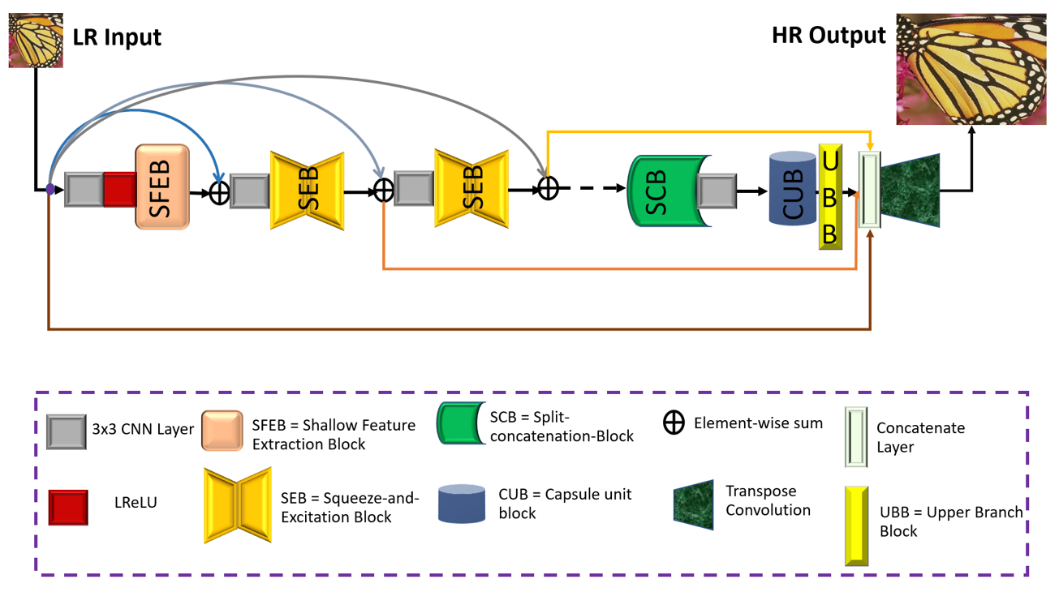

**Fig. 2.** The proposed framework of Squeeze-and-ExcitationNext for Single Image Super-Resolution (SENext).

* 1. Shallow Feature Extraction Block

According to the survey of [26, 50] the shallow feature is extracted from the original LR input image by using only one or two 3×3 convolutional layers followed by the ReLU activation function as shown in Fig. 3a and 3b. The design of said shallow blocks is very simple, but it cannot extract the complete shallow features information from the original LR input image. Furthermore, total network architecture depends on the initial shallow feature extractions, and sometimes very important features information is lost when a network architecture is very deeper. To extract the complete low and high-level features information from the original LR input image, we used the improved version of Fig. 3b, architecture with the use of local (*SL*) and global skip (*SG*) connections as shown in Fig. 3c. Our proposed designed shallow feature extraction block is explained as:

where represents convolution operation, and is the original input LR image. After obtaining the shallow features is then used as the input of SEB.

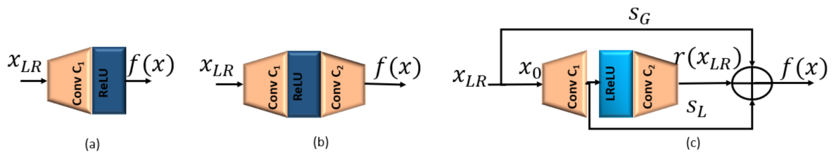

**Fig. 3.** Different types of Shallow Feature extraction blocks are (a) Single Layer Shallow Feature Extraction blocks (b) Two-layer Shallow Feature Extraction blocks and (c) Our Proposed Shallow Feature Extraction blocks (SFEB).

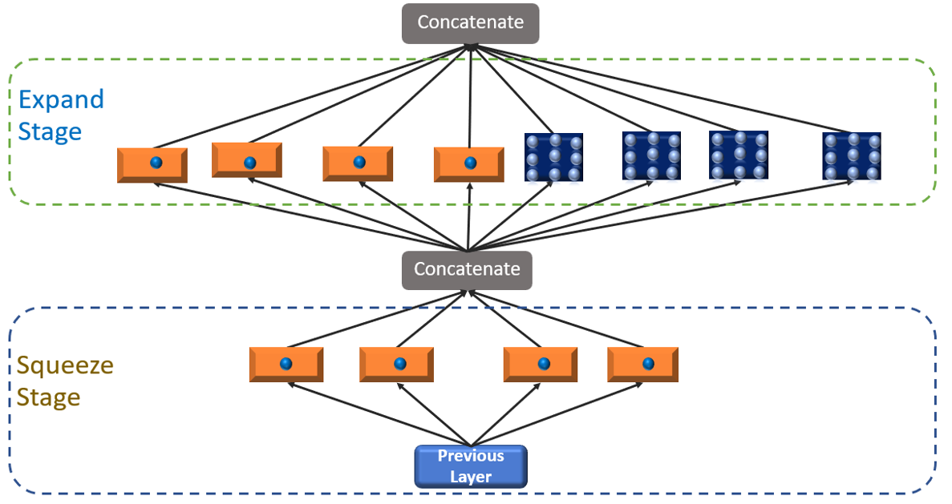

**Fig. 4.** Original Fire Block (Squeeze and Expand Stage Block).

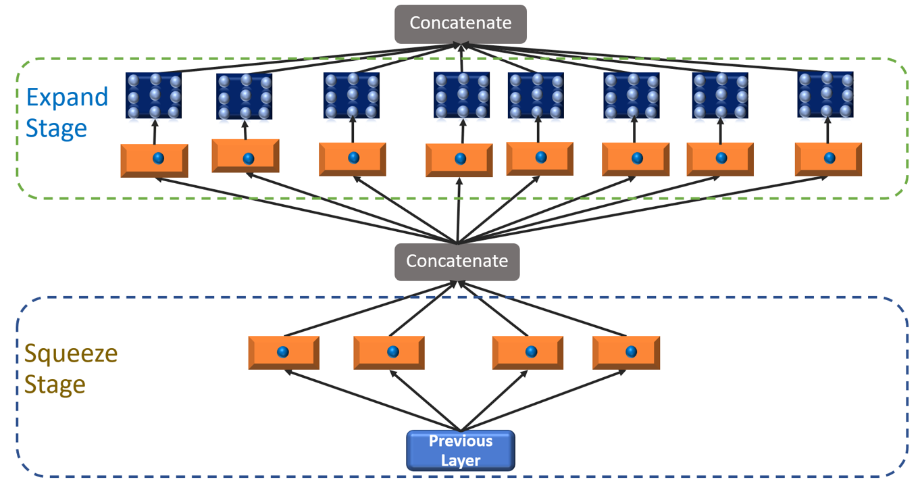

**Fig. 5.** The proposed fire module is used as a squeeze and excitation (SEB) block.

* 1. **SEB BLOCK**

For image and computer vision based applications, the SqueezeNet deep CNN architecture mainly focus on computational cost as well as model efficiency [51]. The first basic architecture of SqueezeNet block commonly known as a fire module as shown in Fig. 4. The whole architecture consists of two stages: a squeeze stage that applies a series of 1 × 1 kernel and the expanded stage use 3 × 3 kernels both followed by a conventional rectified linear unit (ReLU) activation function. The number of squeeze filters that can be learned is always less than the volume of the input. Consequently, the squeeze stage may be thought of as a dimensionality reduction process that also captures the pixel correlations between input channels. The output of the squeezing phase relates to the expansion phase, which combines learning 1 × 1 and 3 × 3 convolutions. The vanishing gradient problem during training as well as reduce the computational cost, we proposed improved squeeze-and-excitation block (SEB) by stacking series of 1 × 1 convolution layers in each phase and using the LReLU activation function in place of the ReLU activation function. Suppose proposed SEB contains N number of Blocks, then and be the input and output of the nth SEB block. The resultant output of feed to the SCB block.

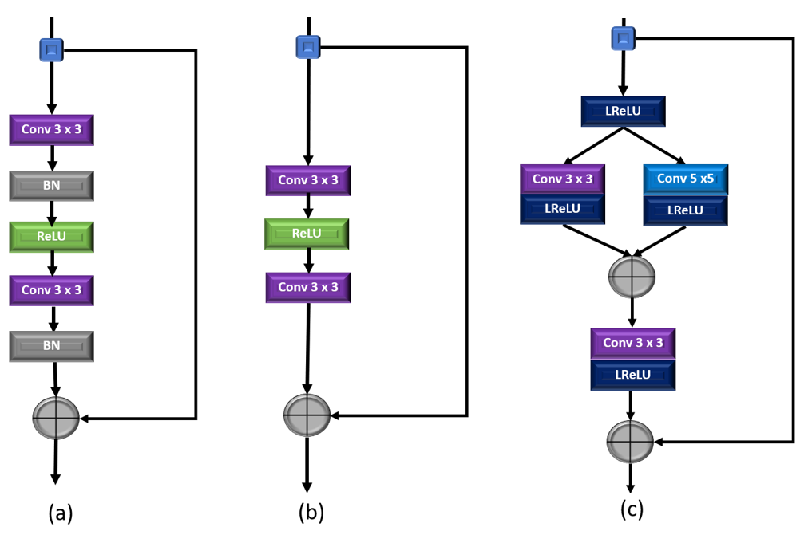

**Fig. 6.** The structures of different residual learning blocks. (a) SRResNet [25], (b) EDSR [26], and (c) Our proposed Split-Concatenate Block (SCB).

* 1. SCB Block

One of the most crucial methods to make training large-scale networks easier is a residual learning [52]. A global skip connection was implemented by Kim et al. in [9] could concentrate to predict the residual skip connection learning. Basically, ResNet is a fundamental component of CNN and was created in [52] by applying the residual learning to a few stacked layers. More extracted features information are readily move through every blocks using the short-term skip connection [53]. Numerous efforts have altered the structure of ResNet, which was first developed for the image recognition task, due to this its performance is improved. Several versions of the residual learning-based construction blocks are shown in Figs. 6a and 6b. The SRResNet building block [25] differs from ResNet in that it lacks the activation layer following element-wise addition. The two batch normalization layers (BN) was eliminated to create the EDSR building blocks when it was suggested [26] batch normalization (BN) would not be appropriate for the image super-resolution task. Thus, our proposed model adopts a split-concatenate block without BN as shown in Fig. 6c. Initially, HR features are split into two branches with a kernel size of 3 × 3 and 5 × 5 to take the benefit of small as well as large receptive field both followed by another 3 × 3 filter with LReLU activation function to prevents gradients from saturating and mitigates the risk of vanishing gradients.

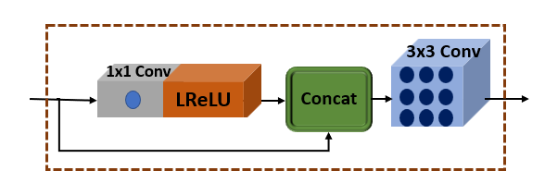

**Fig. 7.** Proposed Capsule Unit Block (CUB) with local skip connection.

* 1. CUB Block

To minimize the feature map dimension and merge long-term features with skip connections in order to rebuild the high-quality HR image, a capsule unit is introduced [54]. To follow the concept of [54], we proposed a special capsule unit block (CUB) with global skip connection as shown in Fig. 7. The design of proposed CUB block consists of one bottleneck layer and one 3 × 3 filter, but bottleneck layer recalibrates the information with sub-local skip connection to overcome parameter growth and build an efficient architecture. The concatenated output is used by one convolution layers of filter size is 3 × 3.

* 1. UBB Block

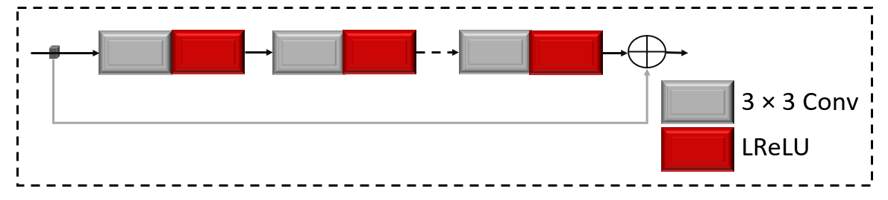

**Fig. 8.** Proposed Upper Branch Block (UBB) with global skip connection.

Implementation of Inception [55] based block before the transpose layer to extract the multi-scale features information obtained the better performance. The main drawbacks of Inception-based architecture used before the transpose layer is to availability of maxpooling layer. Maxpooling layer is to loss the features information which leads to drop the performance of the model [56, 57]. Furthermore, 5 × 5 kernel size is a pretty expensive i.e., time-consuming and requires high computational power. To resolve these issues, we proposed alternate design with simple upper branch block (UBB) with small kernel size and remove the maxpooling layer operation with a residual skip connection. In UBB block we used 10 CNN layers having kernel size is 3 × 3 followed by LReLU activation function except the last layer.

1. ***Experimental Results***

In this section, we assess the effectiveness of our SENext model on different public datasets. Initially, we discuss the training as well as testing datasets, than we will explain the experimental evaluations with state-of-the-art methods. Our model training performed on the combination of two datasets, such as DIV2K [27] (select 100 images of 2K resolution), and BSDS300 [58]. The same combination is observed in [50, 59]. To reduce the chances of overfitting and improve the training efficiency we apply the data augmentation technique. For experimental calculations we used the five benchmark test datasets, such as Set5 [60] , Set14 [61] , BSDS100 [58], Urban100 [62] and Manga109 [63]. The original low-resolution image is obtained by using MATLAB bicubic operation for enlargement scale factor 2×, 3×, 4×, and 8×. For training purpose, we used Adam optimizer having initial learning rate is 0.0001. The proposed methods used the Windows 11 operating system having one GPU (GeForce NVIDIA RTX 2070 GPU) and an Intel(R) Core (TM) i7-9750H CPU @ 2.60GHz having 16.0 GB RAM memory system. The training and testing phase is performed under the Keras 2.6.0 with TensorFlow 2.6.0 environment.

* 1. Quantitative comparisons with existing state-of-the-art-methods

In this paper, we compare our SENext quantitatively with fourteen state-of-the-art methods, such as Bicubic, SRCNN [6], FSRCNN [7], VDSR [9], DRCN [11], LapSRN [21], DRRN [24], MemNet [28], ASRN [49], IDN [40], SRMDNF [34], MFEN_S [47], CARN [32], and IMDN [40]. Table 1 summarizes quantitative results on the five benchmark testing datasets.

Table 1. Presents the quantitative assessment of image SR methods with our SENext. The reported quantitative results of an average values of PSNR/SSIM with upscale factors 2×, 3×, 4×, and 8×. Red color with bold quantitative values is recorded as a best value. The blue color with underlined quantitative values is indicated as a second-best value.

|  |  |  |  |  |  |  |  |  |
| --- | --- | --- | --- | --- | --- | --- | --- | --- |
| **Method** | **Factor** | **≠Params↓** | **Set5 [60]**  **PSNR↑/SSIM↑** | **Set14 [61]**  **PSNR↑/SSIM↑** | **BSDS100 [58]**  **PSNR↑/SSIM↑** | **Urban100 [62]**  **PSNR↑/SSIM↑** | **Manga109 [63]**  **PSNR↑/SSIM↑** | **Average**  **PSNR↑/SSIM↑** |
| Bicubic | 2× | -/- | 33.66 / 0.9299 | 30.24 / 0.8688 | 29.56 / 0.8431 | 26.88 / 0.8403 | 30.80 / 0.9339 | 30.23 / 0.8832 |
| SRCNN[6] | 2× | 57K | 36.66 / 0.9542 | 32.45 / 0.9067 | 31.36 / 0.8879 | 29.50 / 0.8946 | 35.60 / 0.9663 | 33.11 / 0.9219 |
| FSRCNN[7] | 2× | 12K | 37.05 / 0.9560 | 32.66 / 0.9090 | 31.53 / 0.8920 | 29.88 / 0.9020 | 36.67 / 0.9710 | 33.56 / 0.9260 |
| VDSR[9] | 2× | 665K | 37.53 / 0.9590 | 33.05 / 0.9130 | 31.90 / 0.8960 | 30.77 / 0.9140 | 37.22 / 0.9750 | 33.24 / 0.9314 |
| DRCN[11] | 2× | 1,774K | 37.63 / 0.9588 | 33.04 / 0.9124 | 31.85 / 0.8942 | 30.75 / 0.9133 | 37.55 / 0.9732 | 34.16 / 0.9304 |
| LapSRN[21] | 2× | 813K | 37.52 / 0.9591 | 33.08 / 0.9130 | 31.08 / 0.8950 | 30.41 / 0.9101 | 37.27 / 0.9740 | 33.87 / 0.9302 |
| DRRN[24] | 2× | 297K | 37.74 / 0.9591 | 33.23 / 0.9136 | 32.05 / 0.8973 | 31.23 / 0.9188 | 37.60 / 0.9736 | 34.37 / 0.9325 |
| MemNet [28] | 2× | 677K | 37.78 / 0.9597 | 33.28 / 0.9142 | 32.08 / 0.8978 | 31.31 / 0.9195 | 37.72 / 0.9740 | 34.43 / 0.9330 |
| ASRN [49] | 2× | 227K | 37.67 / 0.9594 | 33.19 / 0.9144 | 31.95 / 0.8970 | 31.20 / 0.9186 | 37.79 / 0.9753 | 34.36 / 0.9329 |
| IDN [40] | 2× | 553K | 37.83 / 0.9600 | 33.30 / 0.9148 | 32.08 / 0.8985 | 31.27 / 0.9196 | 38.01 / 0.9749 | 34.50 / 0.9336 |
| SRMDNF [34] | 2× | 1,511K | 37.79 / 0.9601 | 33.32 / 0.9159 | 32.05 / 0.8985 | 31.33 / 0.9204 | 38.07 / 0.9761 | 34.51 / 0.9342 |
| MFEN_S [47] | 2× | 755K | 38.03 / 0.9606 | 33.55 / 0.9171 | 32.19 / **0.9283** | 32.19 / 0.8997 | 38.77 / 0.9772 | 34.95 / 0.9366 |
| CARN [32] | 2× | 1,592K | 37.76 / 0.9590 | 33.52 / 0.9166 | 32.09 / 0.8978 | 31.92 / 0.9266 | 38.36 / 0.9765 | 34.73 / 0.9353 |
| IMDN [40] | 2× | 694K | 38.00 / 0.9605 | 33.63 / 0.9177 | 32.19 / 0.8996 | 32.17 / 0.9283 | **38.88** / **0.9784** | 34.97 / **0.9369** |
| SENext (Our) | 2× | 97K | **38.04 / 0.9608** | **34.24 / 0.9181** | **32.21 /** 0.8997 | **32.43 / 0.9287** | 38.79 / 0.9774 | **35.14** / **0.9369** |
| Bicubic | 3× | -/- | 30.39 / 0.8682 | 27.55 / 0.7742 | 27.21 / 0.7385 | 24.46 / 0.7349 | 26.95 / 0.8566 | 27.31 / 0.7945 |
| SRCNN[6] | 3× | 57K | 32.75 / 0.9090 | 29.30 / 0.8215 | 28.41 / 0.7863 | 26.24 / 0.7989 | 30.48 / 0.9117 | 29.44 / 0.8455 |
| FSRCNN[7] | 3× | 12K | 33.18 / 0.9140 | 29.37 / 0.8240 | 28.53 / 0.7910 | 26.34 / 0.8080 | 31.10 / 0.9210 | 29.70 / 0.8516 |
| VDSR[9] | 3× | 665K | 33.66 / 0.9213 | 29.77 / 0.8314 | 28.82 / 0.7976 | 27.14 / 0.8279 | 32.01 / 0.9340 | 30.28 / 0.8624 |
| DRCN[11] | 3× | 1,774K | 33.82 / 0.9226 | 29.76 / 0.8311 | 28.80 / 0.7963 | 27.15 / 0.8276 | 32.24 / 0.9343 | 30.35 / 0.8624 |
| LapSRN[21] | 3× | 813K | 33.82 / 0.9227 | 29.87 / 0.8320 | 28.82 / 0.7980 | 27.07 / 0.8280 | 32.21 / 0.9350 | 30.36 / 0.8631 |
| DRRN[24] | 3× | 297K | 34.03 / 0.9244 | 29.96 / 0.8349 | 28.95 / 0.8004 | 27.53 / 0.8378 | 32.71 / 0.9379 | 30.64 / 0.8671 |
| MemNet [28] | 3× | 677K | 34.09 / 0.9248 | 30.00 / 0.8350 | 28.96 / 0.8001 | 27.56 / 0.8376 | 32.51 / 0.9369 | 30.62 / 0.8669 |
| ASRN [49] | 3× | 248K | 33.84 / 0.9223 | 29.97 / 0.8348 | 28.86 / 0.7990 | 27.41 / 0.8342 | 32.63 / 0.9364 | 30.54 / 0.8653 |
| IDN [40] | 3× | 553K | 34.11 / 0.9253 | 29.99 / 0.8354 | 28.95 / 0.8013 | 27.42 / 0.8359 | 32.71 / 0.9381 | 30.64 / 0.8672 |
| SRMDNF [34] | 3× | 1,528K | 34.12 / 0.9254 | 30.04 / 0.8382 | 28.97 / 0.8025 | 27.57 / 0.8398 | 33.00 / 0.9403 | 30.74 / 0.8692 |
| CARN [32] | 3× | 1,592K | 34.29 / 0.9255 | 30.29 / 0.8407 | 29.06 / 0.8034 | 28.06 / 0.8493 | 33.50 / 0.9440 | 31.04 / 0.8726 |
| IMDN [40] | 3× | 703K | **34.36** / **0.9270** | 30.32 / 0.8417 | 29.09 / 0.8046 | 28.17 / **0.8519** | 33.61 / 0.9446 | 31.11 / **0.8740** |
| SENext (Our) | 3× | 54K | 34.32 / 0.9255 | **31.08 / 0.8419** | **29.11 / 0.8047** | **28.60 / 0.8519** | **33.63 / 0.9451** | **31.35** / 0.8738 |
| Bicubic | 4× | -/- | 28.42 / 0.8104 | 26.00 / 0.7027 | 25.96 / 0.6675 | 23.14 / 0.6577 | 24.89 / 0.7866 | 25.68 / 0.7250 |
| SRCNN[6] | 4× | 57K | 30.48 / 0.8628 | 27.50 / 0.7513 | 26.90 / 0.7010 | 24.52 / 0.7221 | 27.58 / 0.8555 | 27.40 / 0.7785 |
| FSRCNN[7] | 4× | 12K | 30.72 / 0.8660 | 27.61 / 0.7550 | 26.98 / 0.7150 | 24.62 / 0.7280 | 27.90 / 0.8610 | 27.57 / 0.7850 |
| VDSR[9] | 4× | 665K | 31.35 / 0.8838 | 28.01 / 0.7674 | 27.29 / 0.7251 | 25.18 / 0.7524 | 28.83 / 0.8870 | 28.13 / 0.8031 |
| DRCN[11] | 4× | 1,774K | 31.53 / 0.8854 | 28.02 / 0.7670 | 27.23 / 0.7233 | 25.14 / 0.7510 | 28.93 / 0.8854 | 28.17 / 0.8024 |
| LapSRN[21] | 4× | 813K | 31.54 / 0.8850 | 28.19 / 0.7720 | 27.32 / 0.7270 | 25.21 / 0.7560 | 29.09 / 0.8900 | 28.27 / 0.8060 |
| DRRN[24] | 4× | 297K | 31.68 / 0.8888 | 28.21 / 0.7720 | 27.38 / 0.7284 | 25.44 / 0.7638 | 29.45 / 0.8946 | 28.43 / 0.8095 |
| MemNet [28] | 4× | 677K | 31.74 / 0.8893 | 28.26 / 0.7723 | 27.40 / 0.7281 | 25.50 / 0.7630 | 29.42 / 0.8942 | 28.46 / 0.8094 |
| ASRN [49] | 4× | 244K | 31.65 / 0.8867 | 28.28 / 0.7733 | 27.34 / 0.7279 | 25.42 / 0.7616 | 29.59 / 0.8935 | 28.46 / 0.8086 |
| IDN [40] | 4× | 553K | 31.82 / 0.8903 | 28.25 / 0.7730 | 27.41 / 0.7297 | 25.41 / 0.7632 | 29.41 / 0.8942 | 28.46 / 0.8101 |
| SRMDNF [34] | 4× | 1,552K | 31.96 / 0.8925 | 28.35 / 0.7787 | 27.49 / 0.7337 | 25.68 / 0.7731 | 30.09 / 0.9024 | 28.71 / 0.8161 |
| MFEN_S [47] | 4× | 775K | 32.23 / 0.8951 | 28.61 / 0.7814 | 26.07 / 0.7847 | 27.56 / 0.7355 | 30.41 / 0.9074 | 28.98 / **0.8208** |
| CARN [32] | 4× | 1,592K | 32.13 / 0.8937 | 28.60 / 0.7806 | 27.58 / 0.7349 | 26.07 / 0.7837 | 30.47 / **0.9084** | 28.97 / 0.8203 |
| IMDN [40] | 4× | 715K | **32.21 / 0.8948** | 28.58 / 0.7811 | 27.56 / 0.7353 | 26.04 / 0.7838 | 30.45 / 0.9075 | 28.97 / 0.8205 |
| SENext (Our) | 4× | 54K | 31.50 / 0.8947 | **28.99 / 0.7812** | **28.49 / 0.7357** | **26.64 / 0.7839** | **30.48 / 0.9084** | **29.22** / **0.8208** |
| Bicubic | 8× | -/- | 24.40 / 0.6580 | 23.10 / 0.5660 | 23.67 / 0.5480 | 20.74 / 0.5160 | 21.47 / 0.6500 | 22.68 / 0.5876 |
| SRCNN[6] | 8× | 57K | 25.34 / 0.6471 | 23.86 / 0.5443 | 24.14 / 0.5043 | 21.29 / 0.5133 | 22.46 / 0.6606 | 23.42 / 0.5739 |
| FSRCNN[7] | 8× | 12K | 25.42 / 0.6440 | 23.94 / 0.5482 | 24.21 / 0.5112 | 21.32 / 0.5090 | 22.39 / 0.6357 | 23.46 / 0.5696 |
| VDSR[9] | 8× | 665K | 25.73 / 0.6743 | 23.20 / 0.5110 | 24.34 / 0.5169 | 21.48 / 0.5289 | 22.73 / 0.6688 | 23.50 / 0.5800 |
| DRCN[11] | 8× | 1,774K | 25.93 / 0.6743 | 24.25 / 0.5510 | 24.49 / 0.5168 | 21.71 / 0.5289 | 23.20 / 0.6686 | 23.92 / 0.5879 |
| LapSRN[21] | 8× | 813K | 26.15 / 0.7028 | 24.45 / 0.5792 | 24.54 / 0.5293 | 21.81 / 0.5555 | 23.39 / 0.7068 | 24.07 / 0.6147 |
| SENext (Our) | 8× | 97K | **26.87 / 0.7415** | **25.73 / 0.6200** | **26.79 / 0.5847** | **21.90 / 0.5829** | **23.96 / 0.7389** | **25.05 / 0.6536** |

* 1. Comparison analysis based on the number of model parameters

We evaluate the computational cost of our SENext model in terms of size of the network parameters versus PSNR as shown in Fig. 9. By employing the squeeze-and-excitation blocks, our SENext network model reduce the size of the model in terms of number of K parameters with other deep CNN image SR methods. Proposed model evaluate the performance on Set5 [60] test dataset with enlargement scale factor 2×. Our SENext have number of parameters about 85% less than the VDSR [9], 95% less than the DRCN [11] [11], 88% less than the LapSRN [21], 667% less than the DRRN [24], 86% less than the MemNet [28], 57% less than the ASRN [49], 82% less than the IDN [40], 94% less than the SRMDNF [34], 87% less than the MFEN_S [47], 94% less than the CARN [32], 86% less than the IMDN [40].

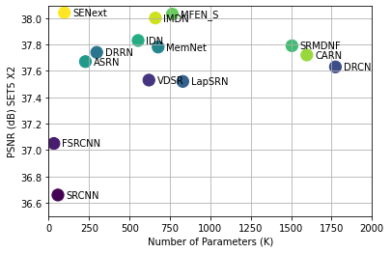

**Fig. 9.** The performance comparison in terms of model parameters versus PSNR tested on image dataset of Set5 with upscale factor 2×.

* 1. Comparison analysis based on the Image Quality Metrics

In this sub-section we present the quantitative evaluation in terms of PSNR/SSIM as shown in Fig. 10. The results clearly demonstrates that our SENext attains the best quantitative performance than existing deep CNN image SR methods. Uses of squeeze-and-excitation block with local and global skip connection our proposed model has obtained the peak value in both quality metrics (PSNR/SSIM).

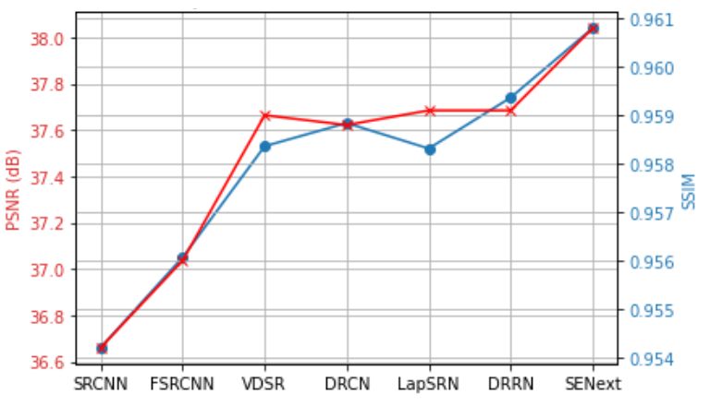

**Fig. 10.** Quantitative evaluation of average PSNR and SSIM on all test datasets having an enlargement factor 2×.

* 1. Quantitative Analysis of run time versus PSNR

In this part, we evaluate the performance of our SENext model in terms of runtime time versus PSNR, as seen in Fig. 11. In order to assess the state-of-the-art approaches using a 3.6GHz Intel i7 CPU (32GB RAM) and NVIDIA RTX 1080ti GPU (16 GB Memory) on the same computer. For evaluation purpose we used the public access codes provided by the authors. The trade-off between CPU time of execution versus PSNR on Set5 [60] enlargement factor 2× present in Fig. 11. Our proposed method is faster than all state-of-the-art-methods except the shallow models (SRCNN and FSRCNN). Furthermore, our proposed SENext attains the less computation cost in terms of floating-point operations per second (FLOPs) as shown in Fig. 12.

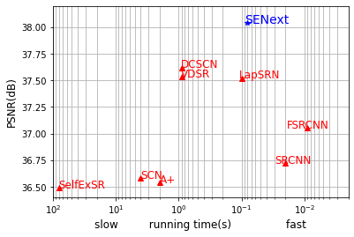

**Fig. 11.** Running time and accuracy trade-off. The results are evaluated on Set5 with scale factor ×2.

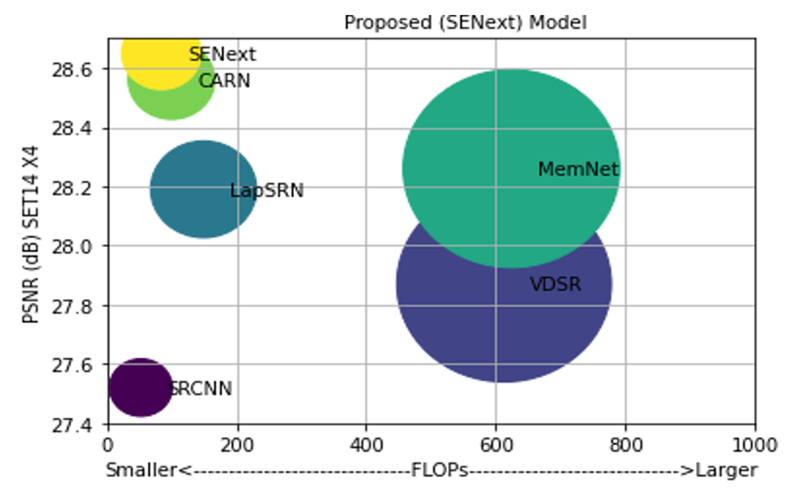

**Fig. 12.** Quantitative evaluations of PSNR versus FLOPs on Set14 enlargement factor 2×.

* 1. Perceptual Quality Comparison

Fig. 13 and 14 shows the perceptual quality of enlargement factor 4× and 8× image SR test datasets including BSDS100 [58], Urban100 [62] and Manga109 [63]. The results on challenging enlargement scale factor 8× results clearly observed that more blurry results generated by Bicubic, RFL [5], SelfExSR [62], SRCNN [6], and FSRCNN [7]. Although it is a difficult effort to improve an image for an enlargement factor of 8×, our SENext successfully recover the fine texture detail and effectively suppress the artifacts.

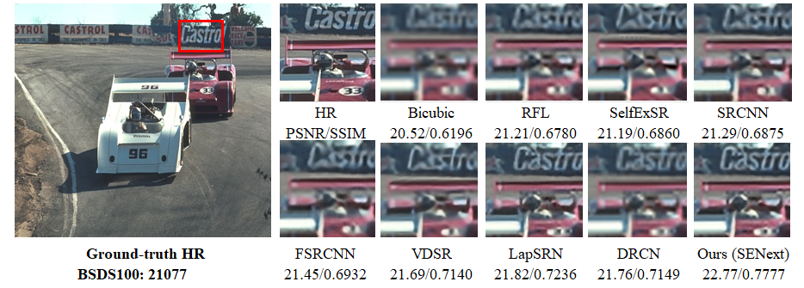

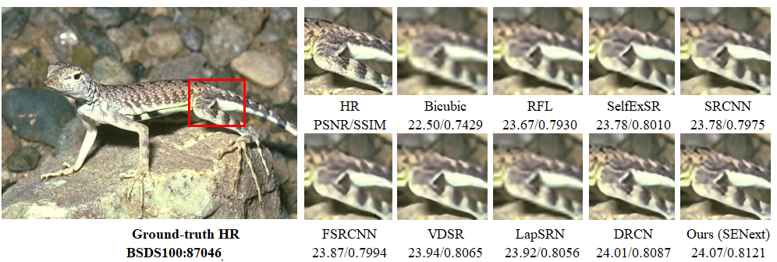

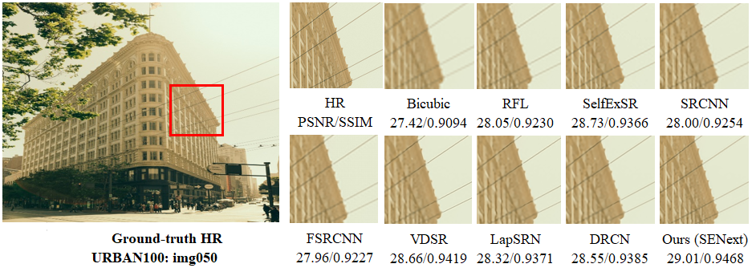

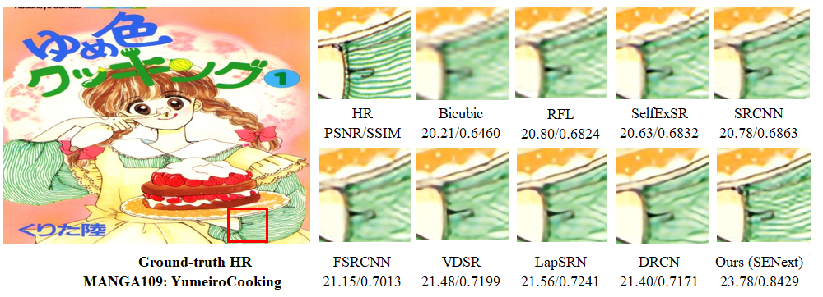

**Fig. 13.**  Visual perceptual quality wise improvement of different images with 4× enlargement factor on BSDS100, URBAN100, and MANGA109 image datasets.

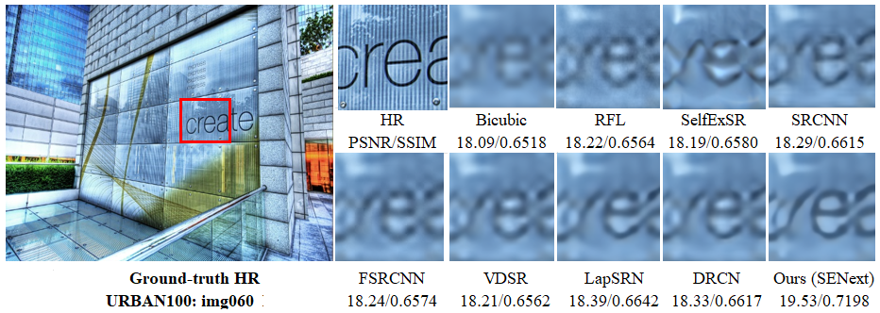

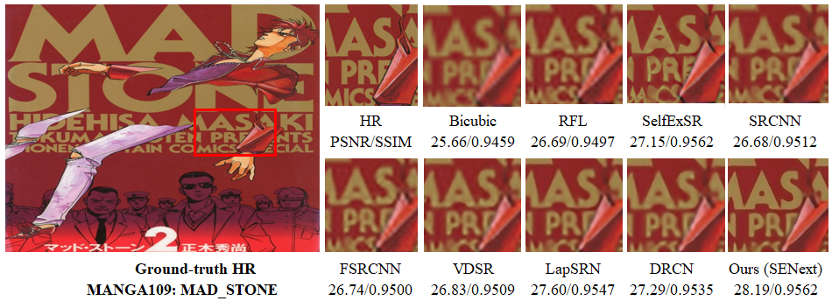

**Fig. 14.** Visual perceptual quality wise improvement of different images with 8× enlargement factor on URBAN100, and MANGA109 image datasets.

* 1. *Ablation studies*
     1. *Model Analysis with different Block arrnagement.*

A more comprehensive ablation study of our proposed blocks can be found in Table 2. In this experiment, we investigated the effects of various combinations of blocks. The eight networks were trained for spatial super- resolution application with enlargement factor 8× and have the same configuration of training as well as validation parameters. We used the 100 images of DIV2K [27] dataset for training and Yang91 [1] images for validation with 16 batch size having 100 number of epochs. In Table 2 PSNR value is reported and observed that the baseline network (without any block) gives the lowest PSNR value (28.11 dB), but best performance (28.48 dB) is observed when all blocks are used in the model.

Table 2. Ablation study of different blocks including SFEB, SEB, and SCB. The quantitative value of average PSNR calculated on Set14 enlargement factor 4x on 100 epochs.

|  |  |  |  |  |  |  |  |  |
| --- | --- | --- | --- | --- | --- | --- | --- | --- |
| Blocks | Combination of Blocks | | | | | | | |
| SFEB | ꭗ | ✓ | ꭗ | ✓ | ꭗ | ✓ | ꭗ | ✓ |
| SEB | ꭗ | ꭗ | ✓ | ✓ | ꭗ | ꭗ | ✓ | ✓ |
| SCB | ꭗ | ꭗ | ꭗ | ꭗ | ✓ | ✓ | ✓ | ✓ |
| Average PSNR | 28.11 | 28.23 | 28.20 | 28.35 | 28.38 | 28.42 | 28.45 | 28.48 |

* + 1. *Selection of Optimizers.*

Selection of optimizer plays a crucial role during the training to optimize the model efficiency and reduce the chance of overfitting. Our proposed SENext model trained on four different optimizers, such as Stochastic gradient descent (SGD), root mean square propagation (RMSprop), Adam [64] and Adamax is an extended version of Adam optimizer. The experimental results with loss function as shown in Fig 15. A more stable pattern of Adam appears in Fig. 15. In case of RMSprop (green line) decrease slowly with more ripples after 400 iterations as compared to Adam. All optimizers were trained on 400 epochs with base model. We used the 100 images of DIV2K [27] dataset for training and Yang91 [1] images for validation with 16 batch size.

**Fig. 15.**  Training curves optimization with different optimizers.

1. Conclusion and Future work

In this study, we propose a novel two stage squeeze (compress) and expand network architecture for single image super-resolution (SENext). Proposed SENext used SFEB, SEB, SCB, CUB, and UBB blocks with the support of local and global skip connections. The SFEB block is used to extract the low frequency features from the original LR image. The resultant features are fed to the remaining blocks through a long as well short skip route. Implementation of SEB side-by-side is to reduce the computational cost of the model as well as calculate the high frequency features information. The uses of an extensive sub-local skip connections, which are helps to reduce vanishing gradient problems during the training. In addition, to activate the dead neurons in the model during the training, we replaced the conventional ReLU activation function with LReLU. Furthermore, the comparative analysis and ablation study shows the efficiency of a squeeze and excitation network to reduce lots of parameters and computations only with slight performance drop. Extensive experiments on five benchmark datasets demonstrate that the proposed method achieves better reconstruction results in terms of both quantitative and qualitative metrics with a large upsampling factor 4× and 8×. In the future, we will further optimize our model to introduce the multi-path learning with dense global and local skip connections under complex scenarios.

**Author contributions**

“This manuscript was performed in collaboration between the authors. Wazir Muhammad proposed the new SISR method based squeeze-and-excitation blocks. Wazir Muhammad, Supavadee Aramvith and Takao Onoye were involved in the writing and reviewing the manuscript. All authors discussed and approved the final manuscript for final submission”.

CRediT authorship contribution statement

**Wazir Muhammad**: Conceptualization, Methodology, Software, Validation, Writing - original draft. **Supavadee Aramvith**: Methodology, Supervision, Writing - review & editing. **Takao Onoye**: Writing - review & editing.

Declaration of competing interest

“The authors declare that they have no known competing financial interests or personal relationships that could have appeared to influence the work reported in this paper”.

Acknowledgements

“This work is supported by the Second Century Fund (C2F) Chulalongkorn University Bangkok Thailand, Electrical Engineering Department Chulalongkorn University Bangkok, Thailand, Thailand Science research and Innovation Fund Chulalongkorn University (CU_FRB65_ind (9)_157_21_23), (CU_FRB65_soc-(1)_001_27_01), Ratchadaphiseksomphot Endowment Fund (Multimedia Data Analytics and Processing Research Unit)”.

The authors would like to thank the editors and reviewers for their valuable comments and suggestions.

**References**

1. Yang, J., et al., *Image super-resolution via sparse representation.* IEEE transactions on image processing, 2010. **19**(11): p. 2861-2873.

2. Yang, J., et al. *Image super-resolution as sparse representation of raw image patches*. in *2008 IEEE conference on computer vision and pattern recognition*. 2008. IEEE.

3. Yang, C.-Y. and M.-H. Yang. *Fast direct super-resolution by simple functions*. in *Proceedings of the IEEE international conference on computer vision*. 2013.

4. Timofte, R., V. De Smet, and L. Van Gool. *A+: Adjusted anchored neighborhood regression for fast super-resolution*. in *Asian conference on computer vision*. 2014. Springer.

5. Schulter, S., C. Leistner, and H. Bischof. *Fast and accurate image upscaling with super-resolution forests*. in *Proceedings of the IEEE conference on computer vision and pattern recognition*. 2015.

6. Dong, C., et al., *Image super-resolution using deep convolutional networks.* 2015. **38**(2): p. 295-307.

7. Dong, C., C.C. Loy, and X. Tang. *Accelerating the super-resolution convolutional neural network*. in *European conference on computer vision*. 2016. Springer.

8. Krizhevsky, A., I. Sutskever, and G.E. Hinton, *Imagenet classification with deep convolutional neural networks.* Advances in neural information processing systems, 2012. **25**.

9. Kim, J., J. Kwon Lee, and K. Mu Lee. *Accurate image super-resolution using very deep convolutional networks*. in *Proceedings of the IEEE conference on computer vision and pattern recognition*. 2016.

10. Shi, W., et al. *Real-time single image and video super-resolution using an efficient sub-pixel convolutional neural network*. in *Proceedings of the IEEE conference on computer vision and pattern recognition*. 2016.

11. Kim, J., J. Kwon Lee, and K. Mu Lee. *Deeply-recursive convolutional network for image super-resolution*. in *Proceedings of the IEEE conference on computer vision and pattern recognition*. 2016.

12. Anwar, S., S. Khan, and N. Barnes, *A deep journey into super-resolution: A survey.* ACM Computing Surveys (CSUR), 2020. **53**(3): p. 1-34.

13. Hu, J., L. Shen, and G. Sun. *Squeeze-and-excitation networks*. in *Proceedings of the IEEE conference on computer vision and pattern recognition*. 2018.

14. Cheng, X., et al. *SESR: Single image super resolution with recursive squeeze and excitation networks*. in *2018 24th International conference on pattern recognition (ICPR)*. 2018. IEEE.

15. Maas, A.L., A.Y. Hannun, and A.Y. Ng. *Rectifier nonlinearities improve neural network acoustic models*. in *Proc. icml*. 2013. Citeseer.

16. He, K., et al. *Delving deep into rectifiers: Surpassing human-level performance on imagenet classification*. in *Proceedings of the IEEE international conference on computer vision*. 2015.

17. Wang, Z., et al. *Deep networks for image super-resolution with sparse prior*. in *Proceedings of the IEEE international conference on computer vision*. 2015.

18. Wang, Z., et al., *Deeply improved sparse coding for image super-resolution.* 2015. **2**(3): p. 4.

19. Mao, X., C. Shen, and Y.-B. Yang. *Image restoration using very deep convolutional encoder-decoder networks with symmetric skip connections*. in *Advances in neural information processing systems*. 2016.

20. Romano, Y., J. Isidoro, and P. Milanfar, *RAISR: rapid and accurate image super resolution.* IEEE Transactions on Computational Imaging, 2016. **3**(1): p. 110-125.

21. Lai, W.-S., et al. *Deep laplacian pyramid networks for fast and accurate super-resolution*. in *Proceedings of the IEEE conference on computer vision and pattern recognition*. 2017.

22. Zhang, K., et al., *Beyond a gaussian denoiser: Residual learning of deep cnn for image denoising.* IEEE Transactions on Image Processing, 2017. **26**(7): p. 3142-3155.

23. Zhao, Y., et al., *GUN: Gradual upsampling network for single image super-resolution.* IEEE Access, 2018. **6**: p. 39363-39374.

24. Tai, Y., J. Yang, and X. Liu. *Image super-resolution via deep recursive residual network*. in *Proceedings of the IEEE conference on computer vision and pattern recognition*. 2017.

25. Ledig, C., et al., *Photo-realistic single image super-resolution using a generative adversarial network.* arXiv preprint, 2017.

26. Lim, B., et al. *Enhanced deep residual networks for single image super-resolution*. in *Proceedings of the IEEE conference on computer vision and pattern recognition workshops*. 2017.

27. Timofte, R., et al. *Ntire 2017 challenge on single image super-resolution: Methods and results*. in *Proceedings of the IEEE conference on computer vision and pattern recognition workshops*. 2017.

28. Tai, Y., et al. *Memnet: A persistent memory network for image restoration*. in *Proceedings of the IEEE Conference on Computer Vision and Pattern Recognition*. 2017.

29. Yamanaka, J., S. Kuwashima, and T. Kurita. *Fast and accurate image super resolution by deep CNN with skip connection and network in network*. in *Neural Information Processing*. 2017. Springer.

30. Han, W., et al. *Image super-resolution via dual-state recurrent networks*. in *Proceedings of the IEEE conference on computer vision and pattern recognition*. 2018.

31. Li, J., et al. *Multi-scale residual network for image super-resolution*. in *Proceedings of the European Conference on Computer Vision (ECCV)*. 2018.

32. Ahn, N., B. Kang, and K.-A. Sohn. *Fast, accurate, and lightweight super-resolution with cascading residual network*. in *Proceedings of the European conference on computer vision (ECCV)*. 2018.

33. Choi, J.-H., et al., *Lightweight and Efficient Image Super-Resolution with Block State-based Recursive Network.* 2018.

34. Zhang, K., W. Zuo, and L. Zhang. *Learning a single convolutional super-resolution network for multiple degradations*. in *Proceedings of the IEEE Conference on Computer Vision and Pattern Recognition*. 2018.

35. Muhammad, W. and S.J.E. Aramvith, *Multi-Scale Inception Based Super-Resolution Using Deep Learning Approach.* 2019. **8**(8): p. 892.

36. Wang, R., M. Gong, and D.J.I.T.o.I.P. Tao, *Receptive Field Size Versus Model Depth for Single Image Super-Resolution.* 2019. **29**: p. 1669-1682.

37. Wang, Y., et al., *End-to-end image super-resolution via deep and shallow convolutional networks.* 2019. **7**: p. 31959-31970.

38. Yang, X., et al., *DRFN: Deep Recurrent Fusion Network for Single-Image Super-Resolution With Large Factors.* 2019. **21**(2): p. 328-337.

39. Su, M., et al. *Hierarchical Recursive Network for Single Image Super Resolution*. in *2019 IEEE International Conference on Multimedia & Expo Workshops (ICMEW)*. 2019. IEEE.

40. Hui, Z., et al. *Lightweight image super-resolution with information multi-distillation network*. in *Proceedings of the 27th acm international conference on multimedia*. 2019.

41. Hung, K.-W., Z. Zhang, and J.J.I.A. Jiang, *Real-time image super-resolution using recursive depthwise separable convolution network.* 2019. **7**: p. 99804-99816.

42. Barzegar, S., et al., *Super-resolution using lightweight detailnet network.* 2020. **79**(1): p. 1119-1136.

43. Muhammad, W., S. Aramvith, and T. Onoye, *Multi-scale Xception based depthwise separable convolution for single image super-resolution.* Plos one, 2021. **16**(8): p. e0249278.

44. Hsu, J.-T., C.-H. Kuo, and D.-W.J.I.A. Chen, *Image Super-Resolution Using Capsule Neural Networks.* 2020. **8**: p. 9751-9759.

45. Liu, B. and D.J.N. Ait-Boudaoud, *Effective image super resolution via hierarchical convolutional neural network.* 2020. **374**: p. 109-116.

46. Yang, A., et al., *Non-linear perceptual multi-scale network for single image super-resolution.* Neural Networks, 2022. **152**: p. 201-211.

47. Xiao, H., et al., *MFEN: Lightweight multi-scale feature extraction super-resolution network in embedded system.* Microprocessors and Microsystems, 2022: p. 104568.

48. Qin, J. and R. Zhang, *Lightweight Single Image Super-Resolution with Attentive Residual Refinement Network.* Neurocomputing, 2022.

49. Li, J., et al., *Adjustable Super-Resolution Network via Deep Supervised Learning and Progressive Self-Distillation.* Neurocomputing, 2022.

50. Zhang, Y., et al. *Image super-resolution using very deep residual channel attention networks*. in *Proceedings of the European conference on computer vision (ECCV)*. 2018.

51. Iandola, F.N., et al., *SqueezeNet: AlexNet-level accuracy with 50x fewer parameters and< 0.5 MB model size.* arXiv preprint arXiv:1602.07360, 2016.

52. He, K., et al. *Deep residual learning for image recognition*. in *Proceedings of the IEEE conference on computer vision and pattern recognition*. 2016.

53. Chang, K., et al., *Accurate single image super-resolution using multi-path wide-activated residual network.* Signal Processing, 2020. **172**: p. 107567.

54. Zhou, Y., et al., *Image super-resolution based on dense convolutional auto-encoder blocks.* Neurocomputing, 2021. **423**: p. 98-109.

55. Szegedy, C., et al. *Going deeper with convolutions*. in *Proceedings of the IEEE conference on computer vision and pattern recognition*. 2015.

56. Nirthika, R., et al., *Pooling in convolutional neural networks for medical image analysis: a survey and an empirical study.* Neural Computing and Applications, 2022: p. 1-27.

57. Sabour, S., N. Frosst, and G.E. Hinton, *Dynamic routing between capsules.* Advances in neural information processing systems, 2017. **30**.

58. Arbelaez, P., et al., *Contour detection and hierarchical image segmentation.* IEEE transactions on pattern analysis and machine intelligence, 2010. **33**(5): p. 898-916.

59. Li, F., H. Bai, and Y. Zhao, *Detail-preserving image super-resolution via recursively dilated residual network.* Neurocomputing, 2019. **358**: p. 285-293.

60. Bevilacqua, M., et al., *Low-complexity single-image super-resolution based on nonnegative neighbor embedding.* 2012.

61. Zeyde, R., M. Elad, and M. Protter. *On single image scale-up using sparse-representations*. in *International conference on curves and surfaces*. 2010. Springer.

62. Huang, J.-B., A. Singh, and N. Ahuja. *Single image super-resolution from transformed self-exemplars*. in *Proceedings of the IEEE conference on computer vision and pattern recognition*. 2015.

63. Matsui, Y., et al., *Sketch-based manga retrieval using manga109 dataset.* Multimedia Tools and Applications, 2017. **76**(20): p. 21811-21838.

64. Kingma, D.P. and J. Ba, *Adam: A method for stochastic optimization.* arXiv preprint arXiv:1412.6980, 2014.