**AN ENGINEERING PROJECT REPORT**

On

**E-COMMERCE SITE OFFERING RETAIL AND**

**WHOLESALE GROCERY SALES(GROCEREASE)**

**Submitted By**

**Rabin Mishra- 200128**

**Aayush Karki- 200101**

**Anish Bista - 200105**

**Pragya Pokhrel-200123**

**Submitted to:**

**The Department of IT and Computer Engineering**

**In Partial fulfillment of requirement for the degree of**

**Bachelor of Engineering in Information and Technology**



**Cosmos College of Management & Technology**

**(Affiliated to Pokhara University)**

**Tutepani, Lalitpur, Nepal**

**2080-01-28**

## Table of Contents:

**Abstract:** **3**

**Background:** **4**

**Problem Statement:** **4**

**Project Objective:** **5**

**Project Methodology:** **5**

Methods And Toolkits Used: 6

Use Case Diagram: 6

ER Diagram: 7

**Expected Outcomes:** **8**

**Working Schedule:** **8**

**Risks And Challenges:** **9**

**References:** **9**

# 

## Abstract:

Online Shopping of grocery products differs from other shopping activities due to its nature of buy-consume-buy. Grocerease is a grocery-based ecommerce site that provides a convenient platform for customers to purchase a wide range of grocery products online.With a user-friendly interface and a vast selection of items, Grocerease aims to simplify the shopping experience for individuals and families. From fresh produce and pantry staples to household essentials and specialty items, customers can browse and add products to their virtual carts with ease. Grocerease strives to be a go-to destination for online grocery shopping, meeting the diverse needs of customers seeking a seamless and efficient way to stock their kitchen and household supplies. Grocerease provides a convenient and reliable solution for customers grocery needs, making it a viable alternative to traditional grocery shopping methods.Grocerease will enable customers to purchase grocery products online from multiple stores at retail and wholesale prices and the platform will offer wide range of grocery products including fresh produce,dry goods and canned foods and the customers will be able to select products based on their price and quantity preferences. With a well-designed platform and a strong focus on customer satisfaction. grocerease can be the required organized platform for an unorganized and traditional grocery shopping.

## Background:

The grocery industry has traditionally been dominated by Bhat-Bhateni Supermarket,Big

Mart,Classic Mart and other offline grocery stores, but the rise of e-commerce has disrupted the industry and created new opportunities for businesses. Online grocery sales are expected to continue growing, and the current pandemic has further accelerated this trend as more people are opting to shop online for groceries.

## Problem Statement:

Despite the increasing demand for online grocery shopping, customers often face challenges in finding a single platform that offers a wide range of grocery products at competitive prices, both on retail and wholesale basis. Existing online grocery platforms in the market are either limited in their product offerings or do not provide wholesale options, which makes it difficult for customers to purchase groceries in bulk at lower prices. Additionally, the quality and freshness of perishable items during shipping, remain major concerns for customers.

Hence the major problems that has been identified in the traditional way of grocery shopping are:

* Time Consuming
* Inconvenient
* Limited Selection Of Products
* Lack of Personalization
* Inefficient Planning
* Inadequate Customer Support

Therefore, there is a need for a comprehensive e-commerce(grocery-based) platform that addresses these challenges and offers a seamless shopping experience to customers.

## Project Objective:

The objective of GROCEREASE can be listed as:

* To provide retail and wholesale options for the customers to purchase products based on their price and quantity references.
* To eliminate physical queues and checkout wait times so as to provide fresh and hygienic products to the customers.
* To provide a convenient and easy to use platform for customers to purchase products.

## Project Methodology:

**Software Development Process:**

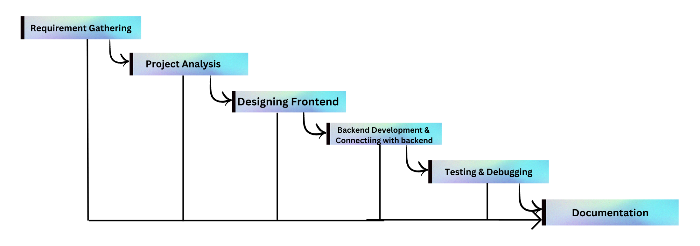

We will be using the AgileSoftware development model so as to pivot the process of the workflow in accordance with the needs of the development process.The agile process for Grocerease involves iterative and incremental development. There will be cross-functional team members collaborations which includes regular sprint planning ,daily virtual meetings,transparent communications within the team members iteratively to deliver the value incrementally. This agile approach enables Grocerease to deliver a high-quality e-commerce grocery platform.

### Methods And Toolkits Used:

**1. Programming Languages and Frameworks:**

- Front-end Development: HTML, CSS, JavaScript.

- Back-end Development: PHP

2**. Database Management:**

- Relational Database: MySQL

3. **Development Tools:**

- Integrated Development Environment (IDE): Visual Studio Code, Sublime Text

- Version Control: Git, GitHub.

### Use Case Diagram:

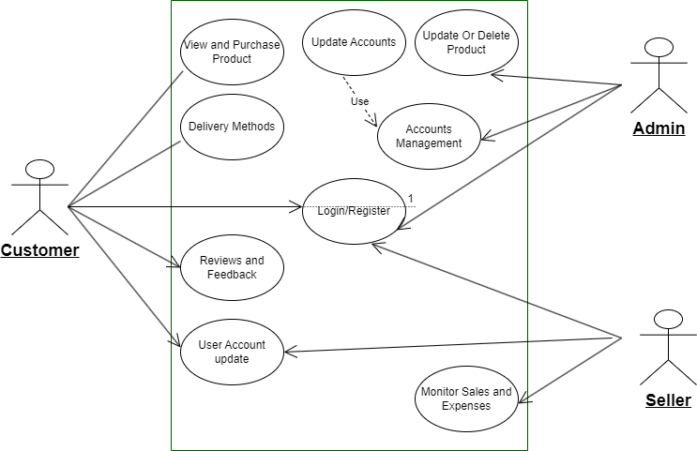

### ER Diagram:

### 

## Expected Outcomes:

GrocerEase platform is expected to have the following outcomes:

1. **Increased convenience for customers:**

The e-commerce platform will offer customers a convenient and easy way to purchase grocery products from multiple stores on both retail and wholesale basis.

2. **Increased product offerings**:

The platform will offer a wide range of grocery products, including fresh produce, dry goods, and canned foods.

3. **Increased sales volume**:

The platform will provide retail and wholesale options for customers to purchase products based on their price and quantity preferences, which can increase the sales volume.

4**. Improved customer satisfaction:**

The platform will be designed with a user-friendly interface to make it easy for customers to find products and also will mitigate the problem queues for the product purchase.

## Working Schedule:

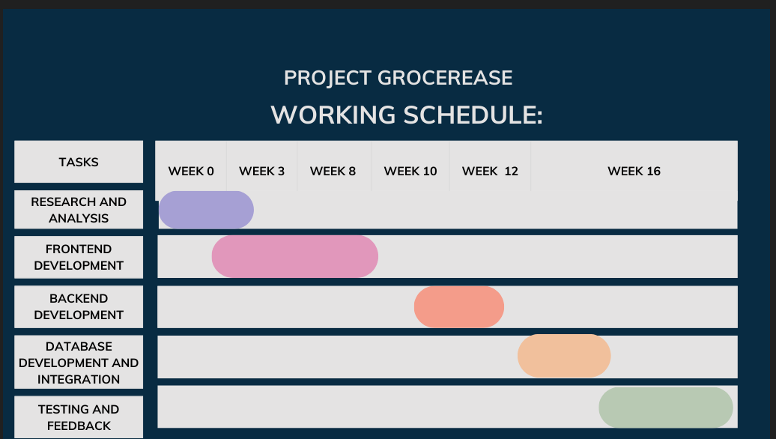

## Risks And Challenges:

The risks and challenges associated with the development of GrocerEase include:

* Competition from established e-commerce platforms(daraz,Hamrobazar) and traditional grocery stores.
* Timely completion of the development and testing of the project
* Convincing users to switch from traditional grocery shopping to an e-commerce platform.
* To continuously adapt to changing trends, preferences for sustainable and organic products, and emerging customer demands.

Addressing these risks and challenges requires careful planning, ongoing monitoring, flexibility, and continuous improvement.. Grocerease needs to be proactive in identifying and mitigating potential risks.

## References:

* Moses, Sharon J., and LD Dhinesh Babu. "Buyagain grocery recommender algorithm for online shopping of grocery and gourmet foods." *International Journal of Web Services Research (IJWSR)* 15.3 (2018): 1-17.
* Walker, Brian K. "Trends 2010: eCommerce Platform And Technology." (2010).
* Martín, Juan Carlos, Francesca Pagliara, and Concepción Román. "The research topics on e-grocery: Trends and existing gaps." *Sustainability* 11.2 (2019): 321.