Shulyatev Artem Andreevich¹
APPLICATION OF THE COMPETENCE-BASED APPROACH TO THE FORMALIZATION OF LEARNING MATERIAL IN ADAPTIVE SYSTEMS FOR ASSESSING STUDENTS' KNOWLEDGE AND SKILLS
¹ Department of Software Engineering and Artificial Intelligence, Institute of Mathematics and Computer Technologies, Far Eastern Federal University
² Department of professional-oriented translation, Institute of Asian Studies, Far Eastern Federal University
Scientific adviser – Associate Professor, Candidate of Technical Sciences S.N. Ostroukhova¹
Linguist consultant – Professor, Candidate of Sciences in Philology O.K. Titova²

The competence-based approach is one of the key directions in the development of modern education. It shifts the emphasis from the transmission of theoretical knowledge to the development of students' ability to apply this knowledge in solving professional tasks [1]. Within this approach, the final learning outcome is determined not by a list of concepts that have been memorized, but by a set of formed knowledge, abilities, and skills (KAS). The gradual transition from the acquisition of knowledge to the formation of abilities and skills can be described using Bloom's taxonomy and the educational principle “know – be able to – be proficient in” (KAP) [3] (Figure 1).
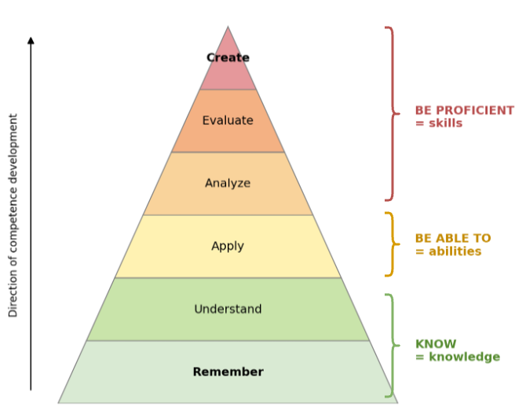
Fig. 1. Development of KAS based on Bloom's taxonomy and the KAP principle
Contemporary knowledge assessment systems predominantly focus on evaluating students' theoretical knowledge, thereby addressing exclusively the lowest tiers of the taxonomy: the “know” level. However, the mere acquisition of theoretical knowledge alone is not sufficient for the formation of competencies.
In response to this challenge, an adaptive knowledge and skills assessment system “Competence Hub” is currently being developed for the Department of Software Engineering and Artificial Intelligence at Far Eastern Federal University. The system is based on the principles described above. It formalizes learning material through KAP levels, which makes it possible to assess not only the acquisition of theoretical knowledge, but also the formation of practical abilities and skills.
For this purpose, the system structures learning material as a knowledge graph that includes a set of interconnected topics (Figure 2a). Each topic, in turn, consists of KAP elements (Figure 2b). A “know” element describes a basic theoretical unit of the learning material and includes information necessary for understanding the corresponding concept. A “be able to” element describes a practical action performed on the basis of previously acquired knowledge and includes an algorithm for carrying it out. A “be proficient in” element reflects the student's ability to apply the formed knowledge and abilities in the context of a specific subject area.
a)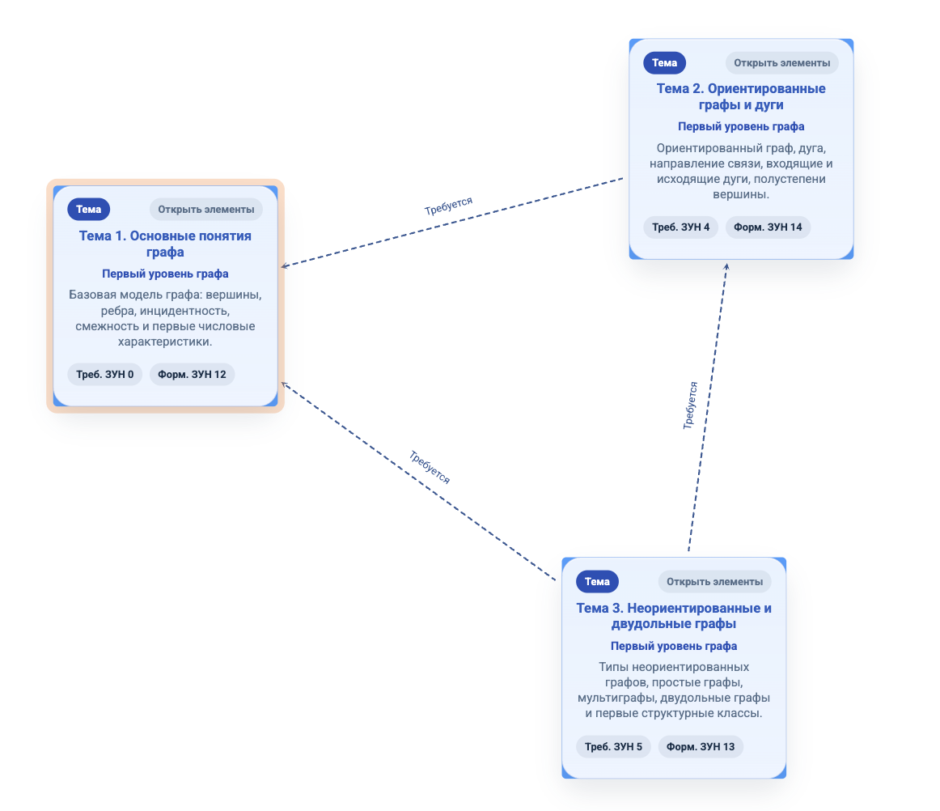b)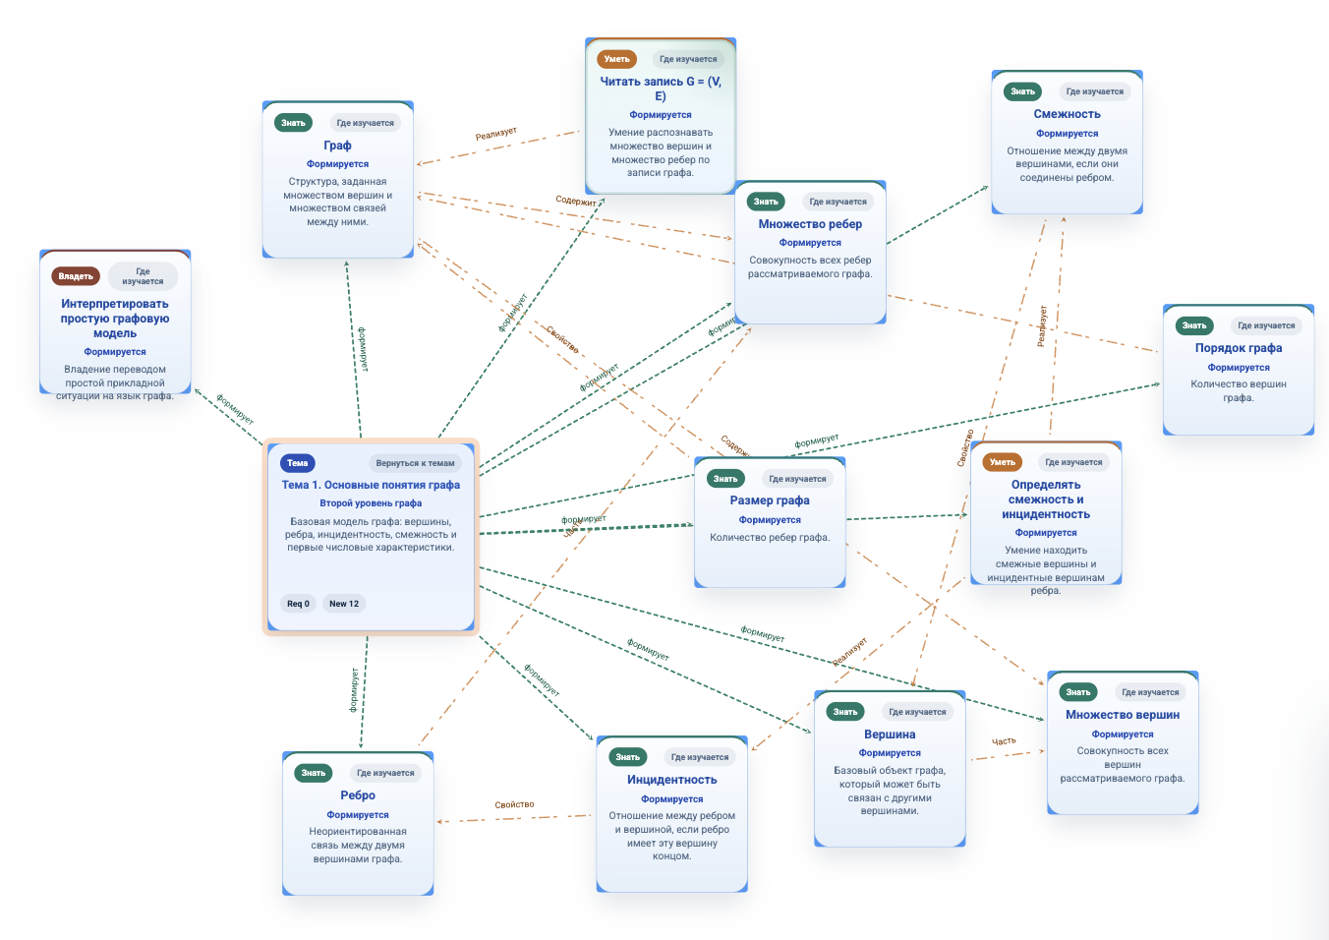
Fig. 2. Knowledge graph using graph theory as an example: topics (a), KAP elements of the topic “Basic graph concepts” (b)
Relations are explicitly established both between topics and between KSA elements. Inter-topic links serve to determine the requisite sequence of their mastery, while inter-element links capture the logical, compositional, hierarchical, and semantic dependencies among the knowledge, skills, and abilities.
Based on these established relations, a learning trajectory is constructed, specifying the scope and sequence of topics and KAP elements to be mastered. The generation of such a trajectory is necessitated by the fact that a particular learning process covers not the entire body of discipline's content, but only those topics and KAP elements selected by the teacher in alignment with the learning objectives. In this way, the basis for adaptive assessment is formed. Specifically, the outcomes of completed assessment tasks are aligned with the relevant KAP elements from the student's learning trajectory. Such alignment allows gaps in material mastery to be identified and then accounted for in the selection of the next task, thereby closing the adaptive feedback loop.
Figure 3 presents the high-level client-server architecture of the system under development. It includes three main components essential for implementing the approach described above: the KAP management subsystem, the trajectory management subsystem, and the assessment subsystem.
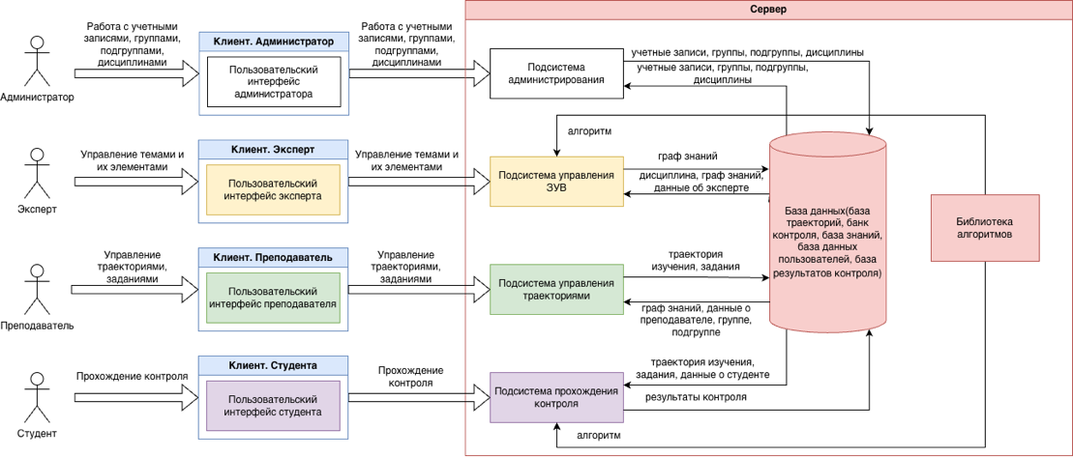
Fig. 3. High-level conceptual architecture of “Competence Hub”
The KAP management subsystem is intended for describing the learning material of a discipline. It supports the creation of topics, KAP elements, and relations between topics and between individual elements.
The trajectory management subsystem allows teachers to create learning trajectories on the basis of the discipline’s knowledge graph. Using this subsystem, a teacher can select thematic modules and KBP elements relevant to a particular educational program and define the sequence in which they should be mastered.
The assessment subsystem provides students with assessment tasks, processes their answers, and records the results.

References
- Khutorskoy, A. V. Competence-based education model / A. V. Khutorskoy // Higher Education Today. – 2017. – N 12. – URL: https://cyberleninka.ru/article/n/model-kompetentnostnogo-obrazovaniya (Accessed on: 10.05.2026). (In Russ.)
- Bloom, B. S. Taxonomy of Educational Objectives: The Classification of Educational Goals. Handbook I: Cognitive Domain / B. S. Bloom, M. D. Engelhart, E. J. Furst, W. H. Hill, D. R. Krathwohl. – New York : David McKay Company, 1956. – 207 p. – URL: https://archive.org/details/taxonomyofeducat0000bloo_o9o7 (Accessed on: 12.05.2026).
- Andryushenkova, N. A. Implementation of the principle “Know, be able to, be proficient in” in the training of future specialists at the Department of Surgical Dentistry and Maxillofacial Surgery of SSMU / N. A. Andryushenkova, M. V. Sotnikova // Smolensk Medical Almanac. – 2017. – N 2. – URL: https://cyberleninka.ru/article/n/realizatsiya-printsipa-znat-umet-vladet-v-podgotovke-buduschih-spetsialistov-na-kafedre-hirurgicheskoy-stomatologii-i-chelyusto (Accessed on: 12.05.2026). (In Russ.)

