

CSE471 : System Analysis and Design
Lab Assignment on Figma

Project Title : Education Aid Disbursement System
Group Number : 03

Submitted by : Naved Abrar Nibir
Student ID : 22201025
Section: 03

Date :30/10/2026

Instruction:
- You have to design the interfaces of any two of your assigned features [according to the submitted requirement analysis] of your project using Figma. All members should work on the same project.
- The designed interfaces can not be duplicated among group members.
- Common interfaces like login form, sign up form, forget password, profile management page must be avoided.
- You can check out this manual: Lab 03 : Figma Manual.docx
- Sample figma file link:
https://www.figma.com/design/yiKMQ4K5v3LF3DMYGbd1SS/Figma-basics?node-id=601-11&t=3xuNTZJ4iouU77qL-1
Sample Prototype link:
https://www.figma.com/proto/yiKMQ4K5v3LF3DMYGbd1SS/Figma-basics?node-id=601-11&t=3xuNTZJ4iouU77qL-1

Feature- 01: Application Review & Smart Selection

This feature gives scholarship providers a single place to review, rank and decide on applications for a program. Applicants are ranked automatically by a weighted score of CGPA, attendance and a computed financial need score, and the weights can be adjusted per program. Every rank is explained through a score breakdown. Before approval the system runs duplicate aid detection and warns the provider if the student already holds an active scholarship. Providers can shortlist applicants, schedule interviews by picking a time slot (which creates a Google Calendar event with a Google Meet link and invites the student), and then approve, reject with remarks, or waitlist applicants. When an approved student withdraws, the next waitlisted applicant is promoted automatically. External API: Google Calendar.

N1-1: Review Queue (Desktop)
Ranked list of all applications for the selected program, with CGPA, attendance, need score, a colour-coded score breakdown bar, total score and status. Tabs and filters (shortlisted, waitlist, decided, conflicts, eligible only, documents verified), bulk shortlist/reject actions and a duplicate-aid badge are included.
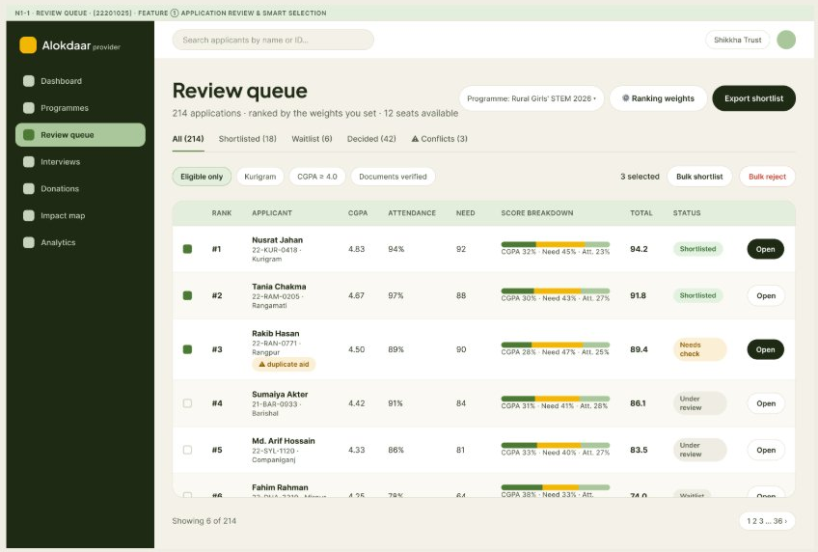
N1-1: Review Queue (Mobile)
Mobile version of the queue using stacked cards that keep rank, score, breakdown, status, the duplicate-aid warning and the bulk shortlist action.
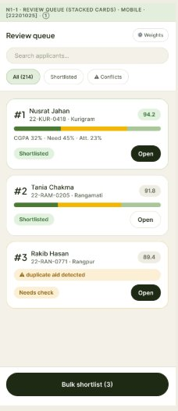
N1-2: Ranking Weights Settings
Providers adjust the weights for academic merit (CGPA), financial need and attendance. A live preview shows how the top 5 would change, a validation state appears when the total is not 100%, and the weights can be reset to default or saved to re-rank all applications.
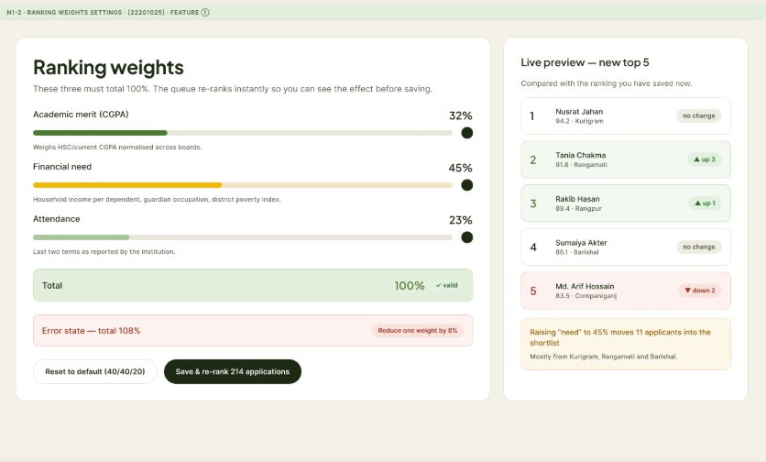
N1-3: Applicant Detail with Score Explanation and AI Summary
Detailed applicant view with rank, CGPA, attendance, need score, household income, academic trend chart, verified documents and household data. The "Why this rank?" panel explains each component of the score, and an AI summary panel gives a short statement summary and an originality flag. Prev/Next, Reject, Waitlist and Approve actions are at the top.
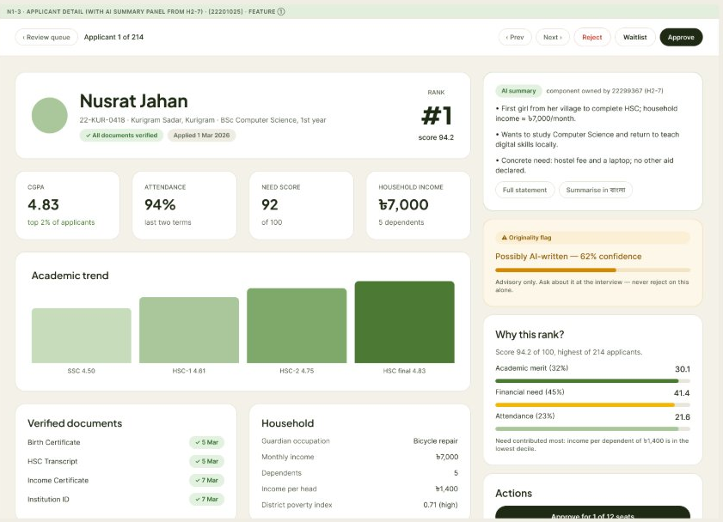
N1-4: Duplicate Aid Conflict Modal
Warning shown before approval when the student already receives another stipend. It lists the existing programme, provider, amount, run-until date and ledger reference, and asks for a reason if the provider still wants to approve.
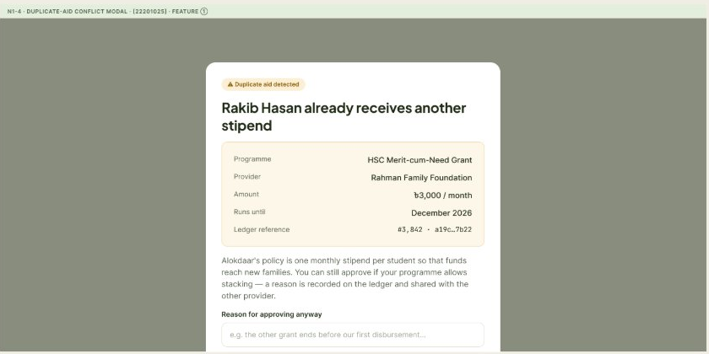
N1-5: Decision Modals (Approve / Reject / Waitlist)
Confirmation dialogs for the three decisions. Approve shows remaining seats, committed amount and an optional message to the student. Reject requires remarks, with quick-reason chips. Waitlist lets the provider choose the position in the waitlist.
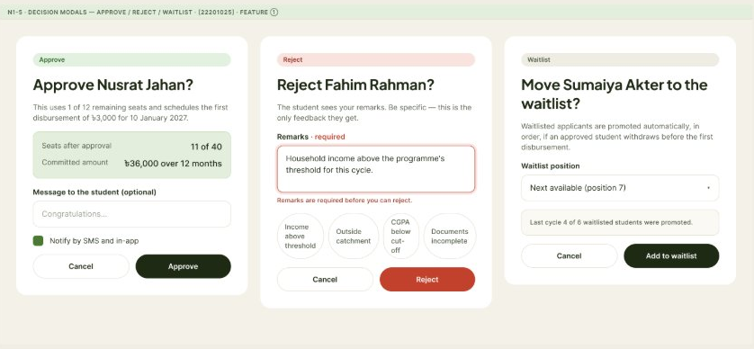
N1-6: Interview Scheduling
Weekly slot picker with a New interview form (applicant, date and time, interviewer, online or in-person). Creating an interview also creates a Google Calendar event with a Meet link and notifies the student by SMS; a confirmation toast is shown, along with a weekly summary.
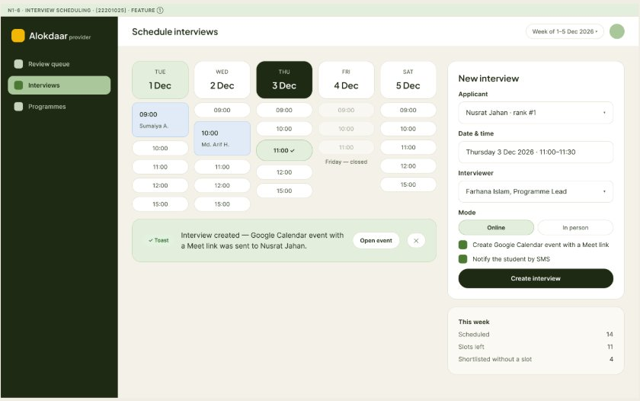
N1-7: Interviews List
List of upcoming, past and no-show interviews with date, applicant, rank, time, interviewer and calendar confirmation status, plus Join Meet and Reschedule actions.
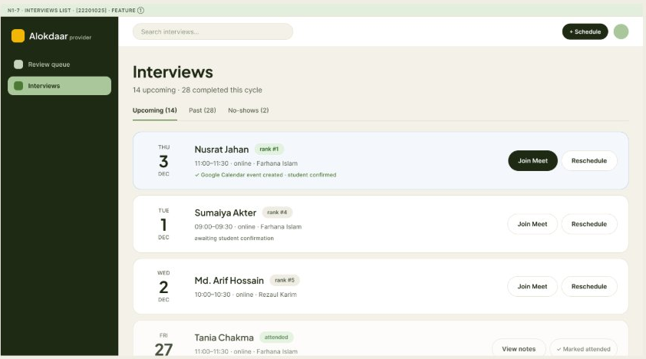
N1-8: Waitlist and Auto-promotion
Shows the waitlist order with score, district and status. An alert banner confirms an automatic promotion after a withdrawal, and cards summarise seats filled, withdrawals and auto-promotions. Providers can also promote a student manually or reorder the list.
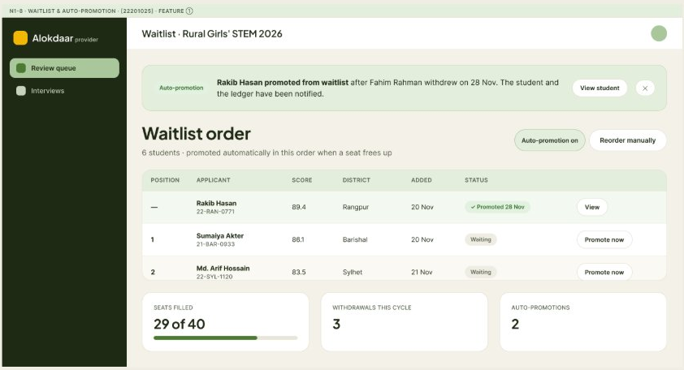
N1-9: Student-side View of the Interview
The matching student screen: application progress timeline, interview date and time with a countdown, Join Google Meet and Request another slot buttons, preparation tips and a link to the assistant.
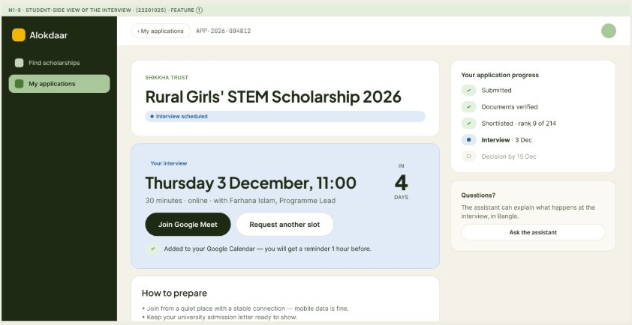
Feature- 02: Regional Impact Map

This feature is an interactive impact map that shows district- and upazila-wise funds disbursed, students supported and eligible applicants who are still unfunded. Users can filter by program, provider and time range and click a district to see its breakdown, which helps providers find under-served areas. In the Figma design the map is shown as a tile map (one tile per district) with a colour scale from low to high in place of the Google Maps heatmap layer. External API: Google Maps/Leaflet.
N2-1: Regional Impact Map (Full View)
Provider view with summary cards (funds disbursed, students supported, districts reached, unfunded eligible), metric tabs, program, provider and date filters, a district tile map with zoom and reset controls, a Top districts list and a "Where the need is unmet" prompt to create a campaign.
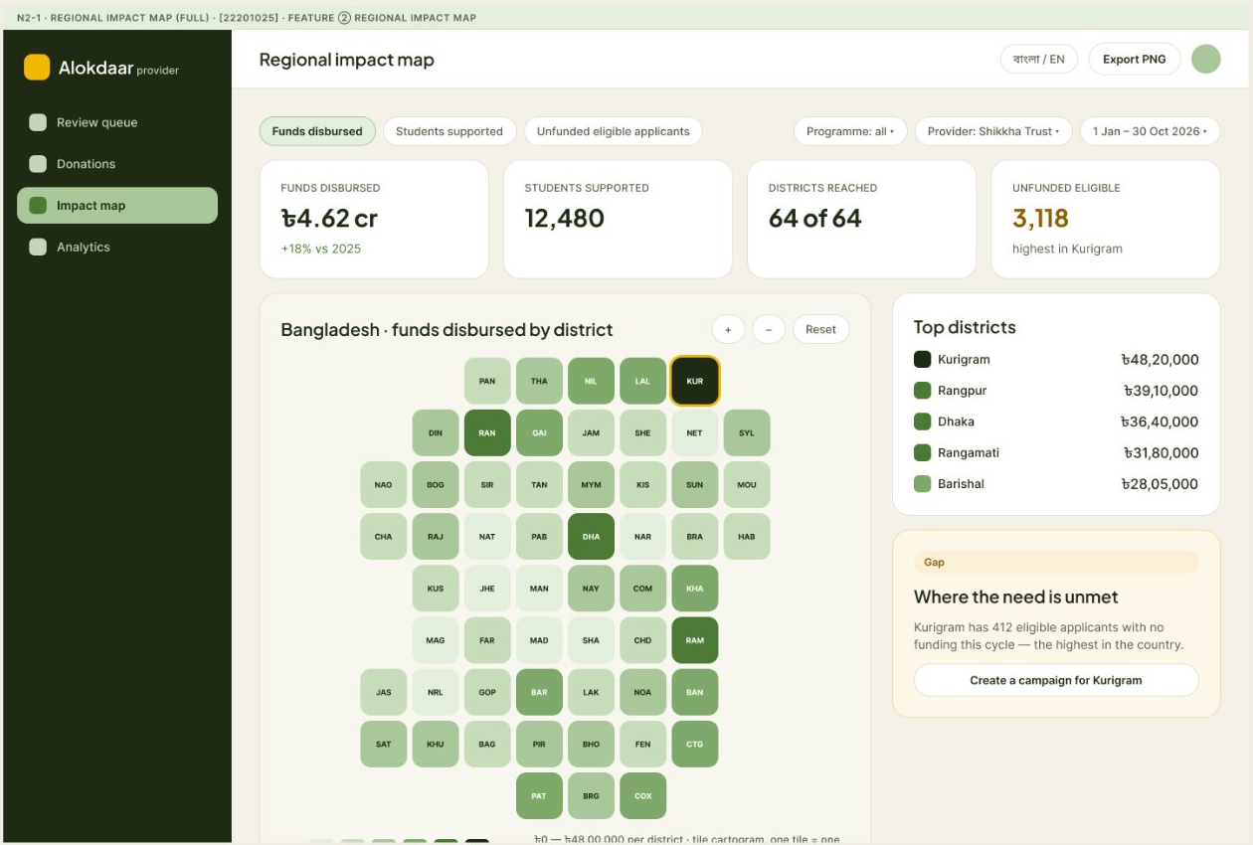
N2-1: Regional Impact Map (Bangla Version)
The same screen with the Bangla interface and a language switch.
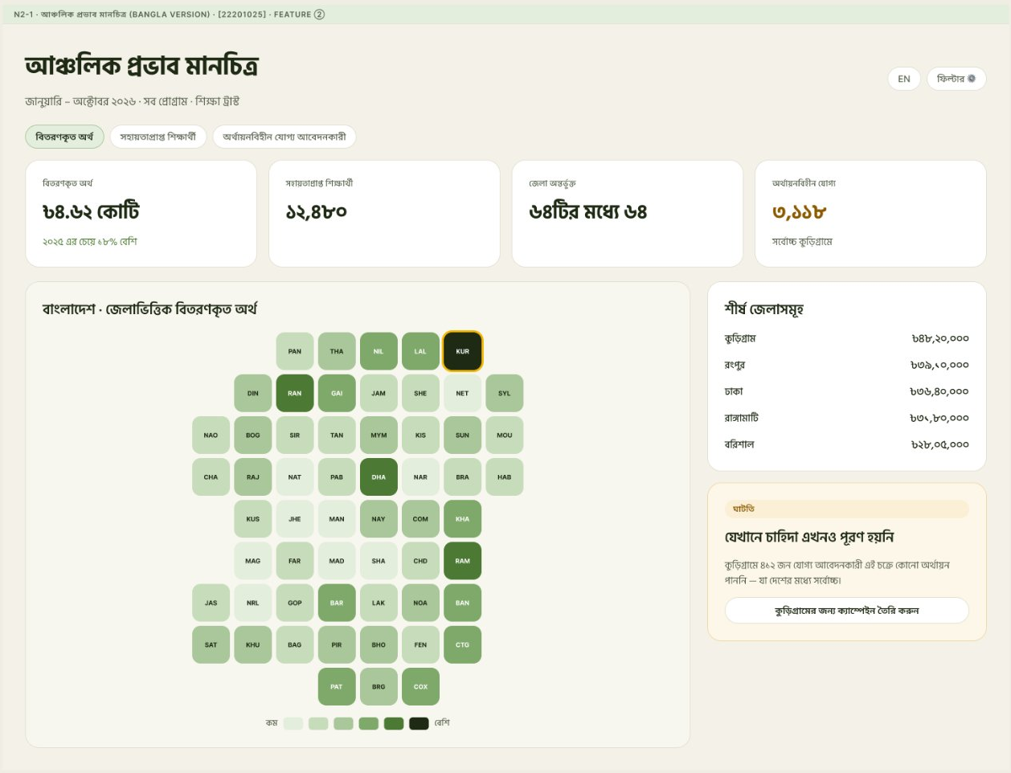
N2-2: District Detail Panel
Clicking a district (Kurigram) opens a side panel with disbursed amount, students and unfunded applicants, a chart of funds by upazila, an upazila table, the active programs in that district and the actions Drill into upazilas and Create a campaign.
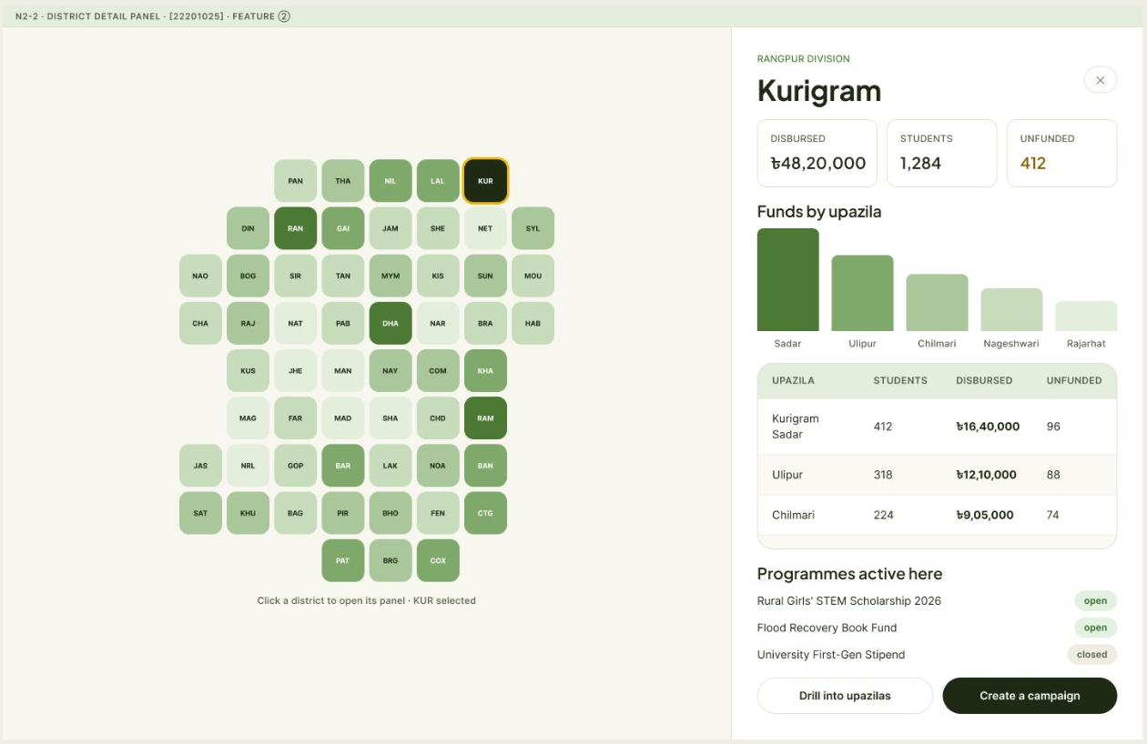
N2-3: Upazila Drill-down
Upazila-level tile map with a toggle between funds disbursed and unfunded, breadcrumb navigation back to the country view, and a breakdown table (students, disbursed, average per student, unfunded, programs) with CSV export.
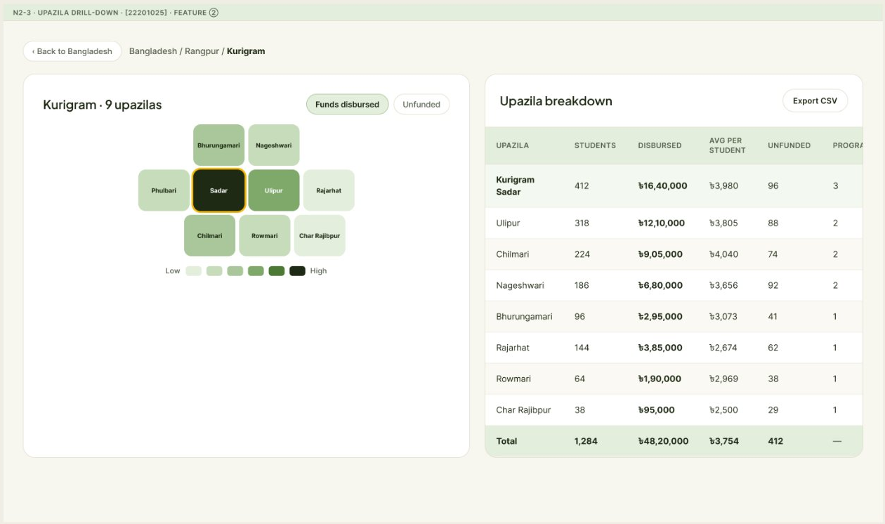
N2-4: Impact Map (Mobile)
Mobile layout with metric tabs, the district tile map, a selected-district summary card with an Open district action and a list of top districts.
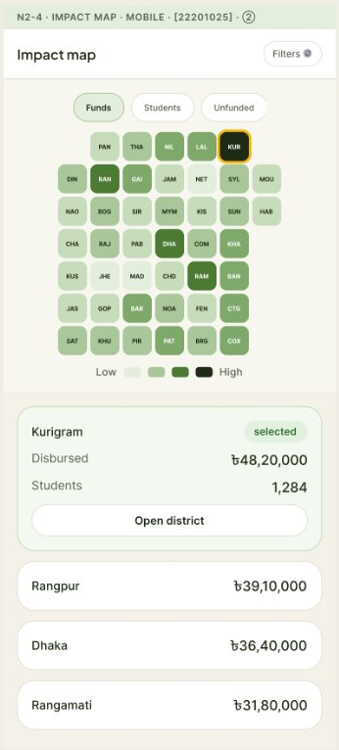
N2-5: Public Impact Section for the Landing Page
Public-facing section that shows total funds disbursed, students supported, districts reached and eligible students still unfunded, with the district map and the Donate to the general fund and Open the full map buttons.
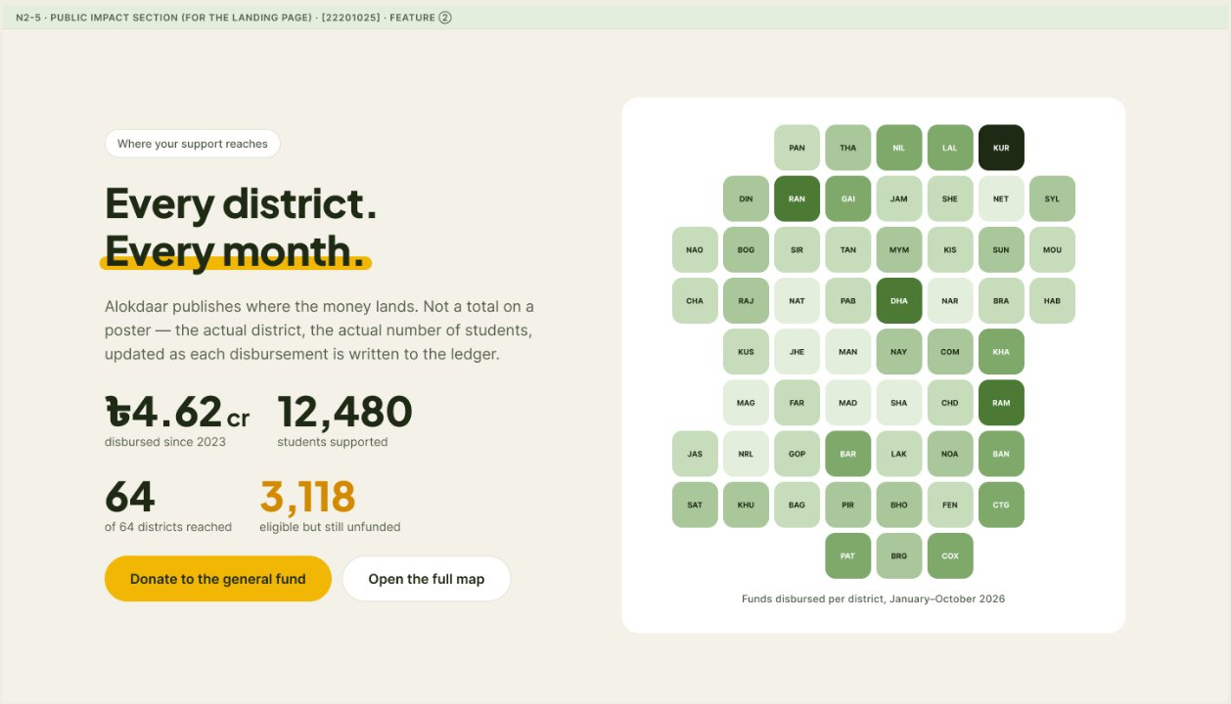
N2-6: Map States (Loading / No Data / Failed to Load)
Loading skeleton, an empty state with Reset filters and Widen date range actions, and an error state that shows the same data as a table with a Retry button and CSV download.
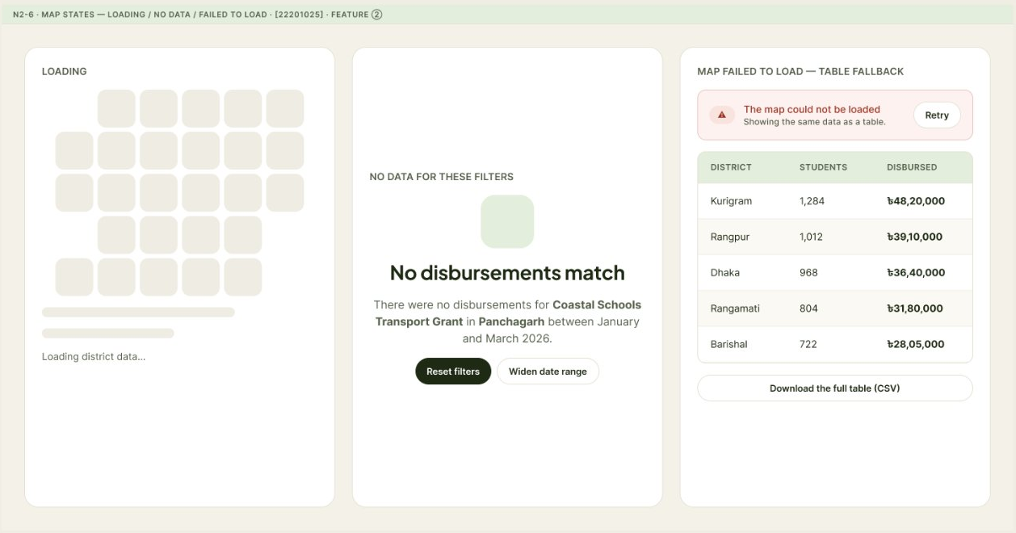

Figma File Link
Add the link of your project figma file (Use share option)
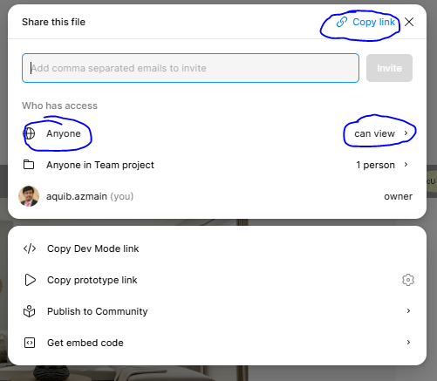
https://www.figma.com/design/PKlGDIyM8jSBx5KEJGkbll/Untitled?node-id=3-35&t=ZqV4HU1Iyl8bsxzi-1

Prototype Link
Add the link of your sigma prototype (Use share option)
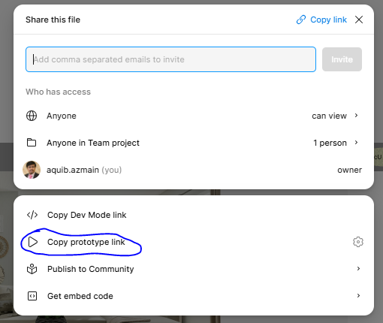

https://www.figma.com/proto/PKlGDIyM8jSBx5KEJGkbll/Untitled?node-id=3-35&t=ZqV4HU1Iyl8bsxzi-1

