

CSE471 : System Analysis and Design
Lab Assignment on Figma

Project Title : Education Aid Disbursement System
Group Number : 03

Submitted by : Md. Rafi Uddin Auntik
Student ID : 22201075
Section: 03

Date :30/10/2026

Instruction:
- You have to design the interfaces of any two of your assigned features [according to the submitted requirement analysis] of your project using Figma. All members should work on the same project.
- The designed interfaces can not be duplicated among group members.
- Common interfaces like login form, sign up form, forget password, profile management page must be avoided.
- You can check out this manual: Lab 03 : Figma Manual.docx
- Sample figma file link:
https://www.figma.com/design/yiKMQ4K5v3LF3DMYGbd1SS/Figma-basics?node-id=601-11&t=3xuNTZJ4iouU77qL-1
Sample Prototype link:
https://www.figma.com/proto/yiKMQ4K5v3LF3DMYGbd1SS/Figma-basics?node-id=601-11&t=3xuNTZJ4iouU77qL-1
Feature- 01: Scholarship Discovery & Application
Students can search and filter open programmes by provider, district, amount, education level and deadline, and see an automatic eligibility result for each programme (eligible, or the exact criterion they fail). Eligible students can submit an application with a personal statement and documents attached from their Document Vault, edit or withdraw it before the deadline, bookmark programmes, and follow each application on a status timeline (submitted, under review, shortlisted, approved, waitlisted, rejected).
The designed flow covers discovery (Find scholarships in English and Bangla, loading and empty states, bookmarks, programme detail), a four-step application wizard (confirm details, attach documents, personal statement, review and submit) with a confirmation dialog and success screen, and application tracking (My applications, application detail with status timeline and interview details, withdraw dialog and the edit-locked state after the deadline). Mobile versions of the key screens are also included.
Figma Screenshots – Feature 01 (Desktop)
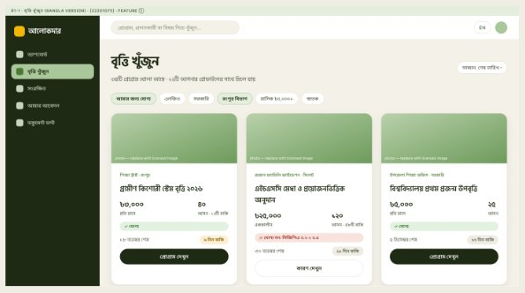
Figure 1.1: Find scholarships (Bangla interface) – programme cards with a per-programme eligibility result.
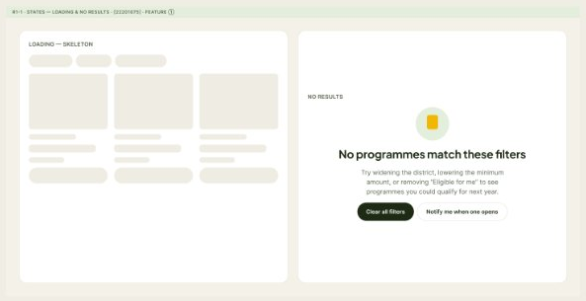
Figure 1.2: Loading skeleton and “No programmes match these filters” empty state.
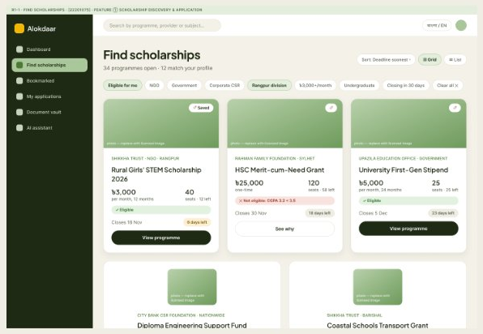
Figure 1.3: Find scholarships (English) – search, filters (provider, district, amount, education level, deadline) and eligibility badges, including the exact criterion a student fails.
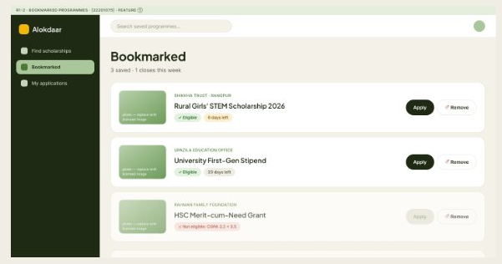
Figure 1.4: Bookmarked programmes – saved programmes with quick Apply and Remove actions.
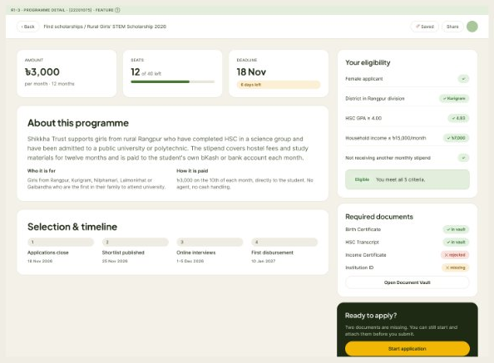
Figure 1.5: Programme detail – amount, seats, deadline, “Your eligibility” checklist, required-document status and selection timeline.
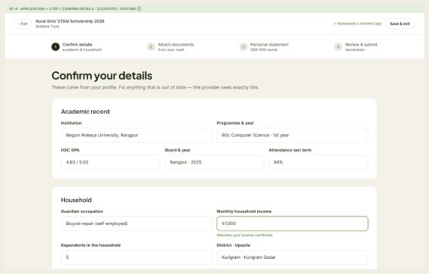
Figure 1.6: Application Step 1 – Confirm details (academic record and household information).
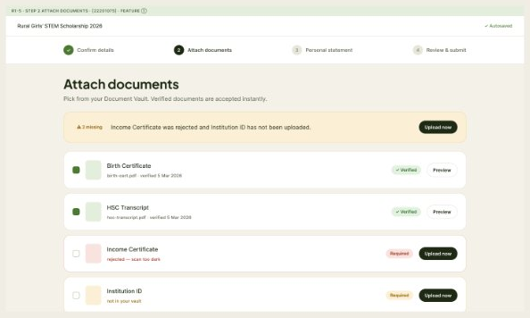
Figure 1.7: Application Step 2 – Attach documents from the Document Vault (verified, rejected and missing states).
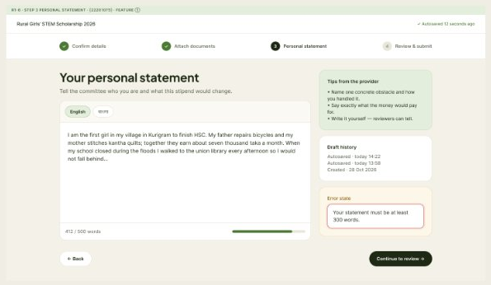
Figure 1.8: Application Step 3 – Personal statement with word counter, autosave, provider tips and validation error state.
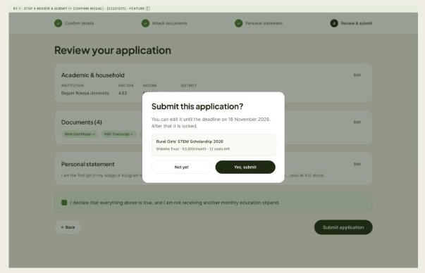
Figure 1.9: Application Step 4 – Review & submit, with the “Submit this application?” confirmation dialog.
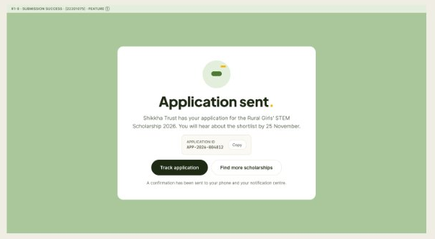
Figure 1.10: Submission success screen with the application ID.
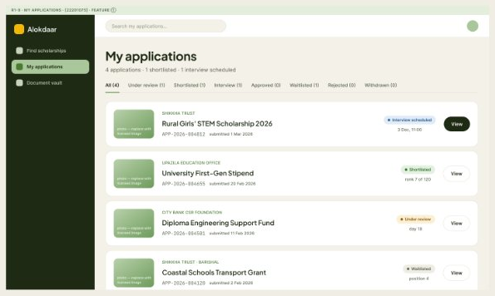
Figure 1.11: My applications – list of applications filtered by status tabs.
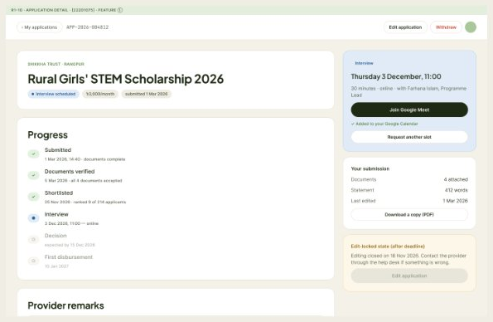
Figure 1.12: Application detail – status timeline, interview slot with Google Meet link, submission summary, Edit and Withdraw actions.
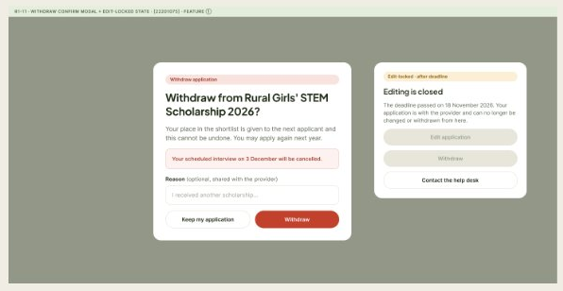
Figure 1.13: Withdraw confirmation dialog and the edit-locked state shown after the deadline.
Figma Screenshots – Feature 01 (Mobile)
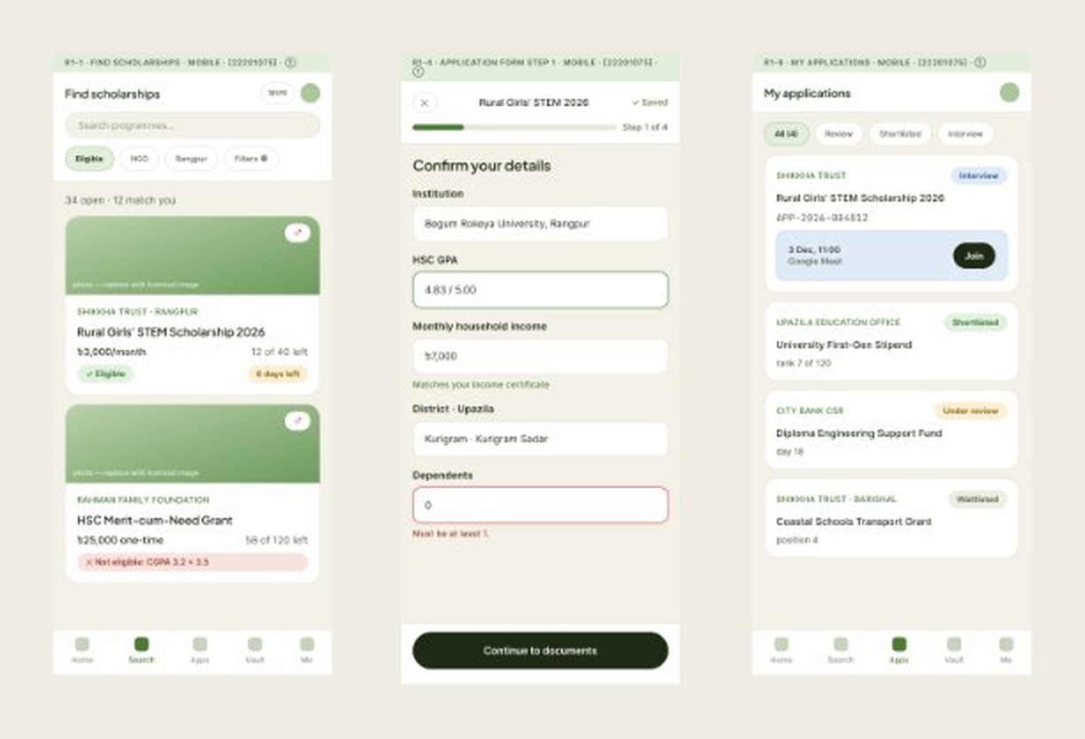
Figure 1.14: Mobile screens – Find scholarships, application form (Step 1) and My applications.
Feature- 02: Online Donations to Programs
Individual donors can make one-time or recurring monthly contributions to a specific programme or to a general fund through the SSLCommerz payment gateway (cards, bKash, Nagad). A payment is confirmed through the gateway’s validation (IPN) callback before the programme fund is increased; donors receive a downloadable receipt and can view their donation history, and providers see the donor list and amount raised for each programme. Donors also get an impact view showing the anonymized academic progress of the students they funded (for example, their scholars’ average CGPA rising from 3.1 to 3.4).
The designed flow covers the campaigns page and campaign detail, a donation checkout with one-time/monthly options and the “Pay with SSLCommerz” step, redirect and payment-verification screens, success, pending and failed payment results, a printable receipt, the donor’s My donations and My impact pages, and the provider’s Donations received page. Mobile versions of the campaigns page and checkout are also included.
Figma Screenshots – Feature 02 (Desktop)
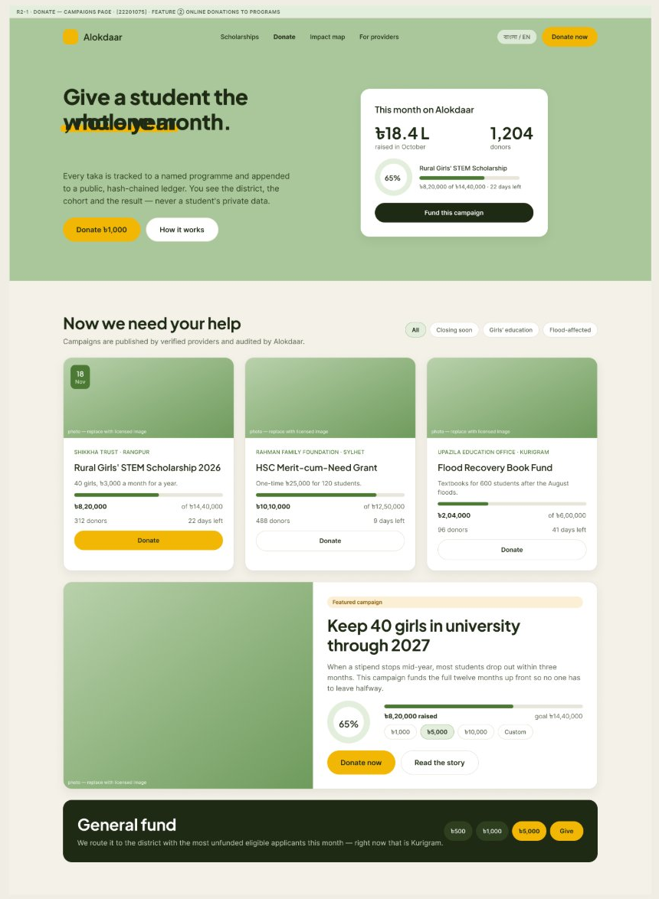
Figure 2.1: Campaigns page – monthly impact summary, programme campaign cards with funding progress, featured campaign and General fund.
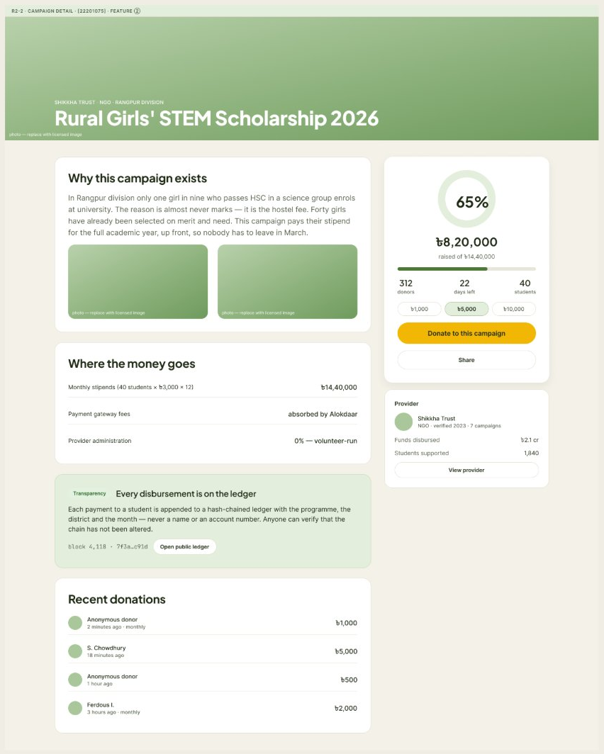
Figure 2.2: Campaign detail – funding progress, where the money goes, public ledger transparency note and recent donations.
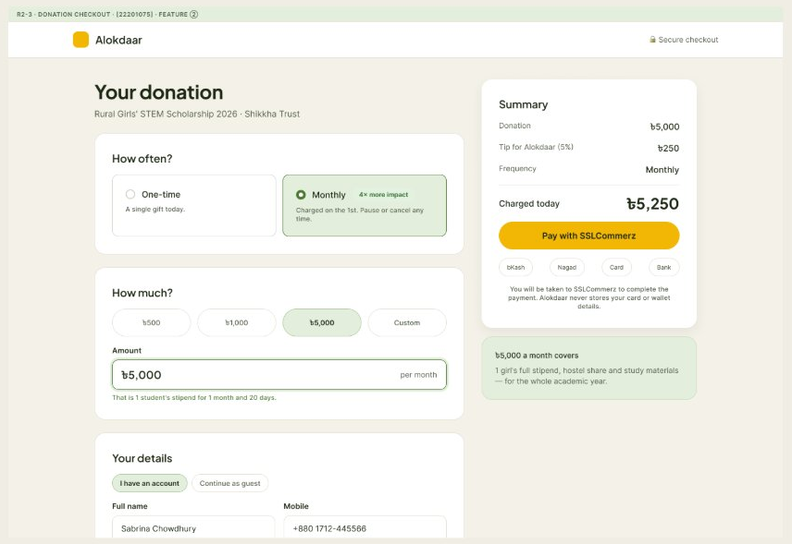
Figure 2.3: Donation checkout – one-time or monthly donation, amount selection, donor details and order summary with “Pay with SSLCommerz”.
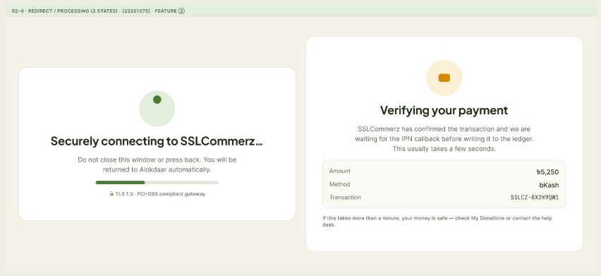
Figure 2.4: SSLCommerz redirect and “Verifying your payment” screens while the IPN callback is awaited.
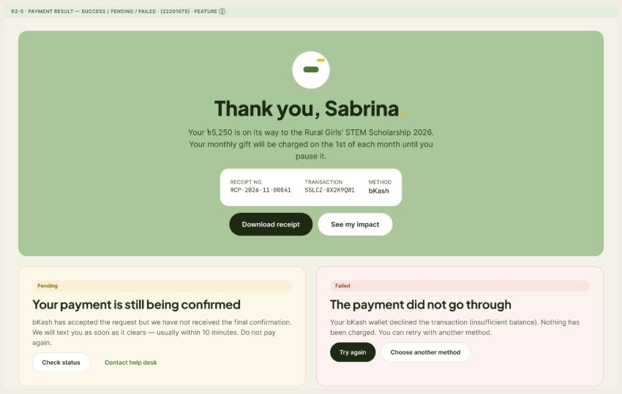
Figure 2.5: Payment result states – success (with receipt download), pending confirmation and failed payment.
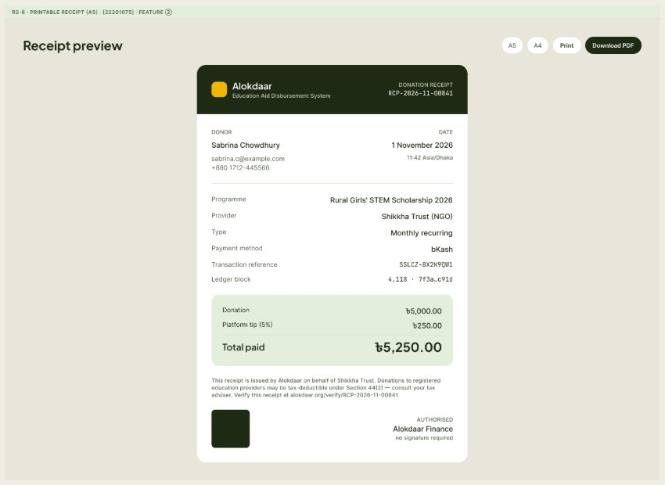
Figure 2.6: Printable donation receipt preview with Download PDF option.
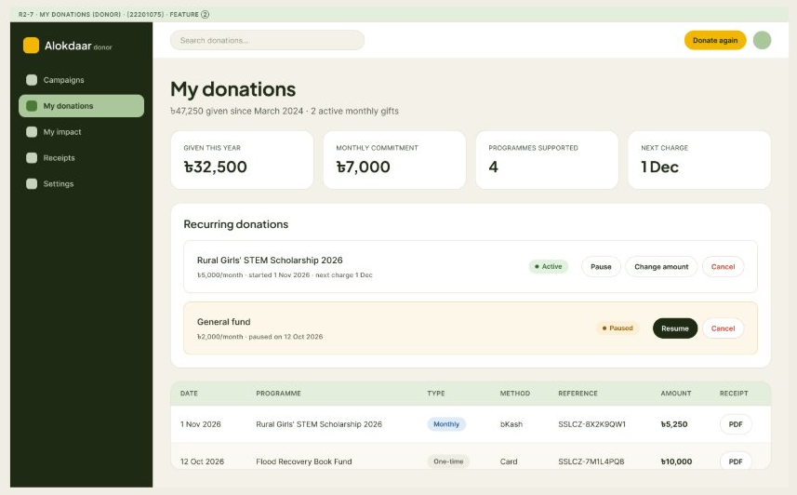
Figure 2.7: My donations (donor) – totals, recurring donations (pause, change amount, cancel) and donation history with receipts.
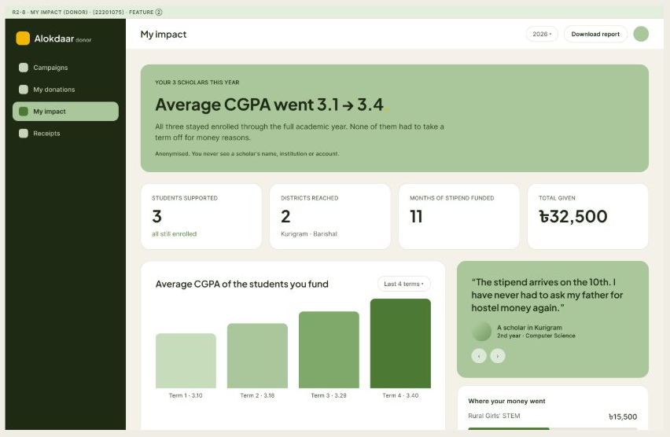
Figure 2.8: My impact (donor) – anonymized academic progress of funded students (average CGPA 3.1 → 3.4).
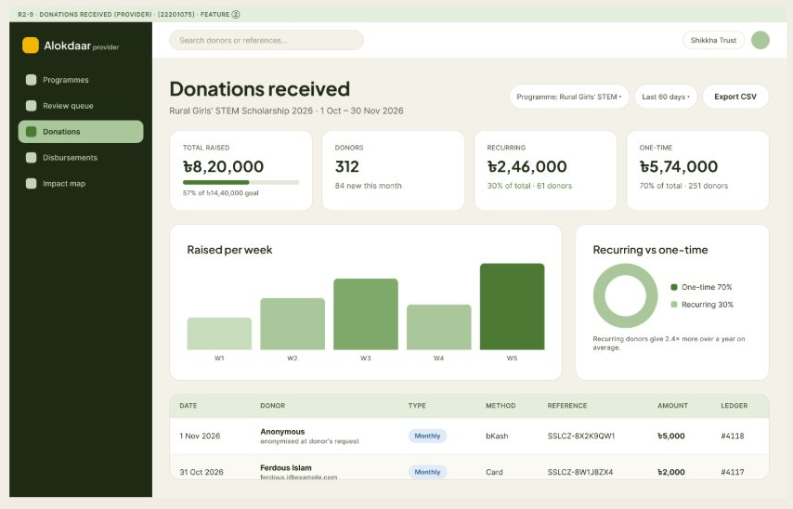
Figure 2.9: Donations received (provider) – amount raised, donor list, recurring vs one-time split and CSV export.
Figma Screenshots – Feature 02 (Mobile)
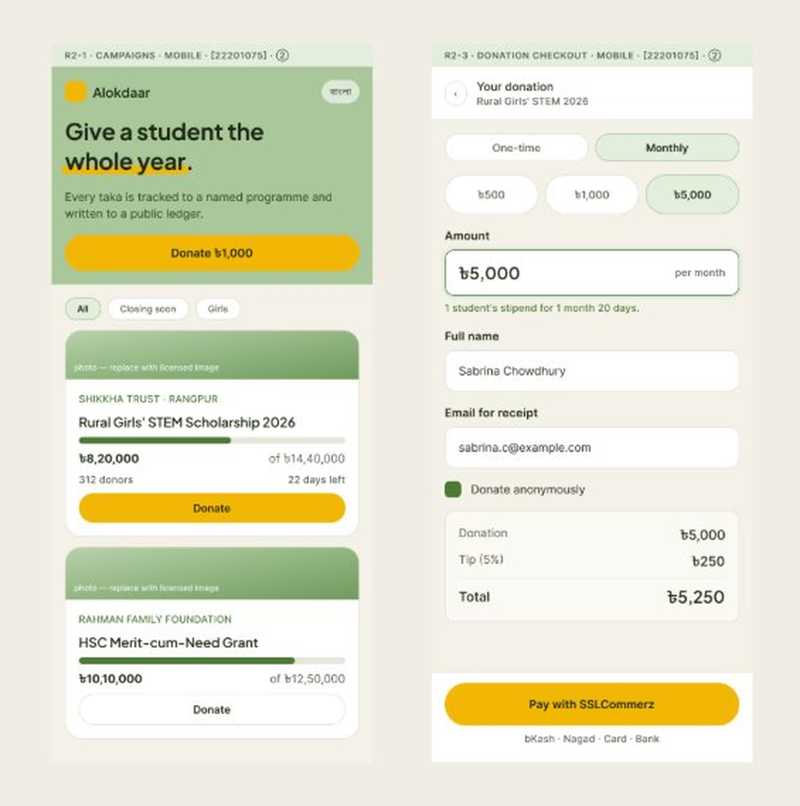
Figure 2.10: Mobile screens – Campaigns page and donation checkout.
Figma File Link
[Paste your Figma file link here (Share → Copy link)]
Prototype Link
[Paste your Figma prototype link here (Share prototype → Copy link)]

