In order to start with the assignment provided by Dept, I cloned a sample code repo in local machine and gave build by using command mvn clean install -PautoInstallPackage for building the package in crx/de package manager and mvn clean install -PautoInstallBundle will deploy the jar file in the felix console.
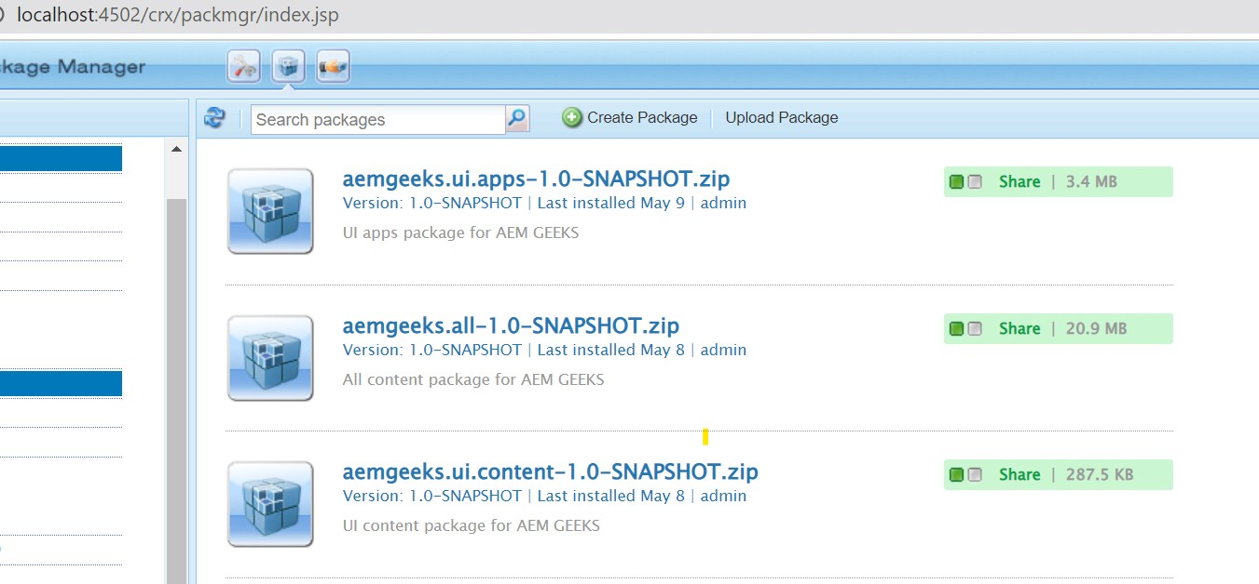
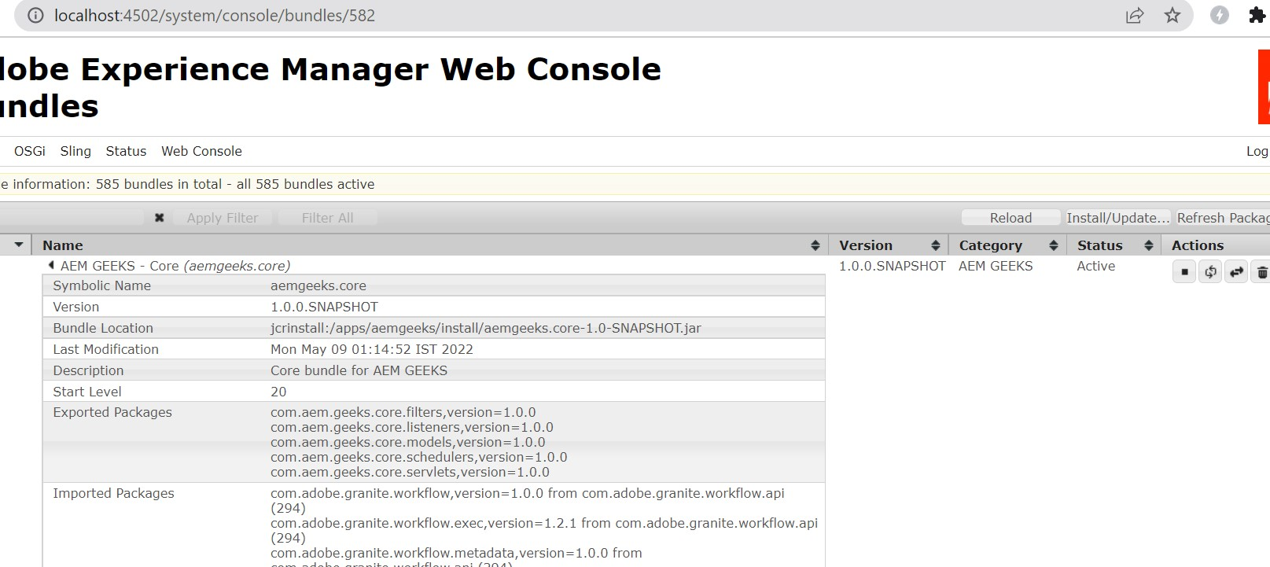

Now as per the assignment, I could not complete the whole assignment because I was inundated with some other work office as well but implemented few portion of it which gave me a good learning so far.

I used rapid api https://rapidapi.com/hub to search and test the apis related to IMDB. In order to use apis from rapid api we just need to create an account and add a new API as shown in screenshot below:
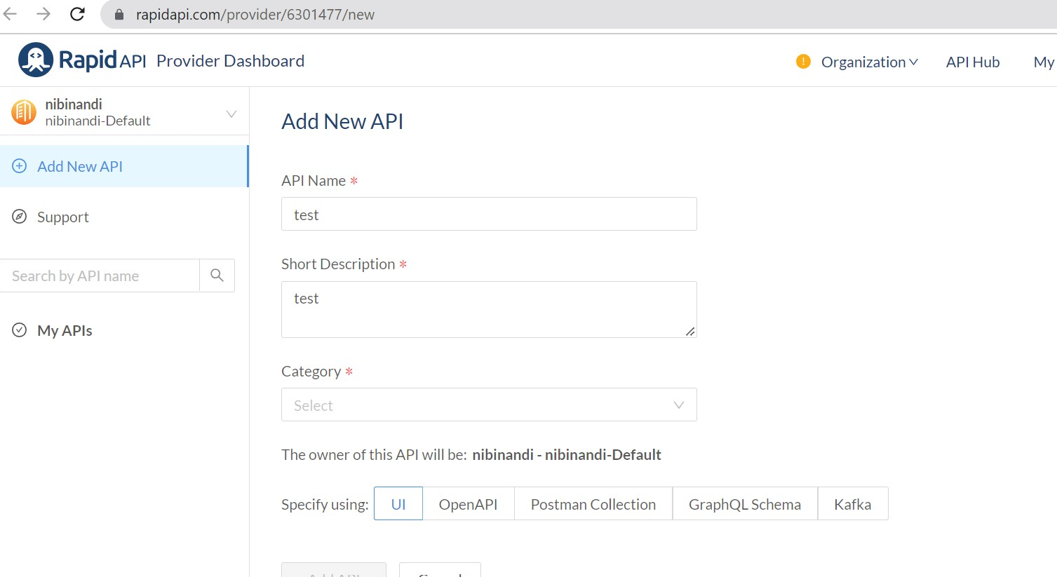
We have to navigate to API Hub and search for the desired movie database where we want to post a query or retrieve data via get query. Here as the screenshot says I wanted to search a query on IMDB database so I selected that :
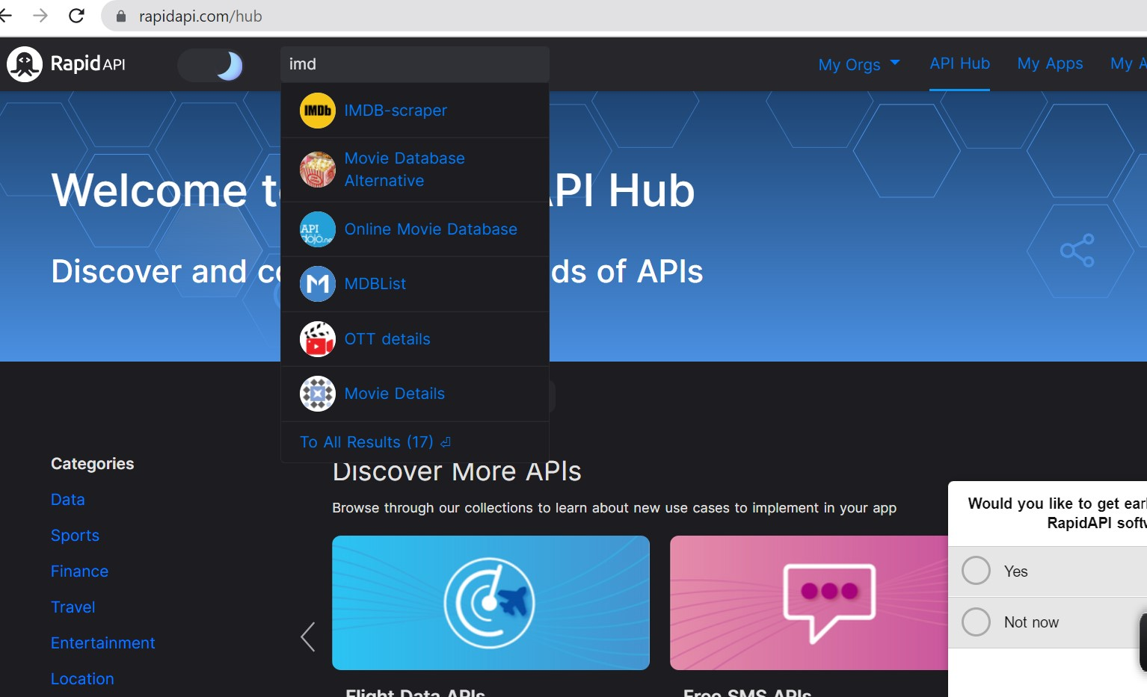

We will have many end points as shown below
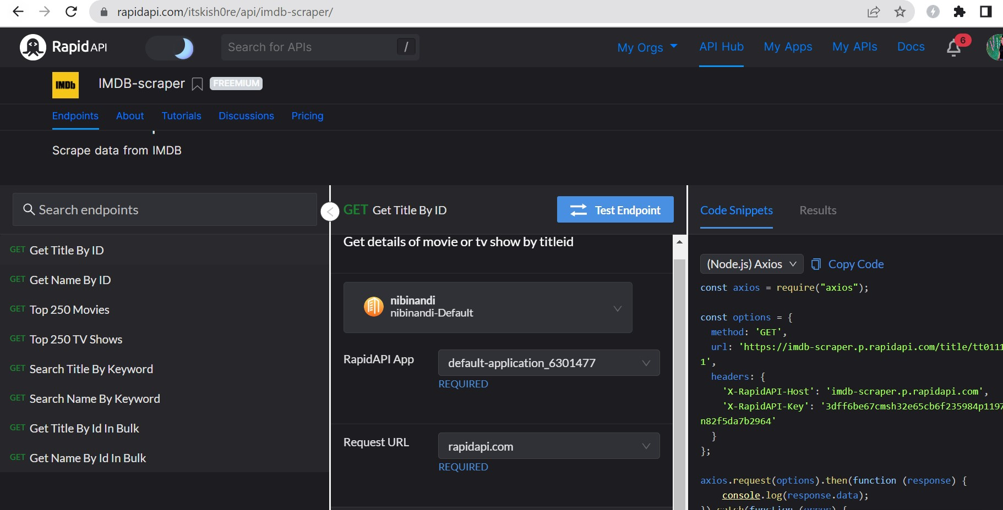

We can subscribe and connect to any apis from this interface.

Now, I have made use of postman to retrieve data by title.It is a GET call and we have to pass API key-value in the header as parameter to hit the endPoint for my case the end point is https://imdb-scraper.p.rapidapi.com/search/title/Avenger/true and we do get 200 status code, some JSON response back from the API.
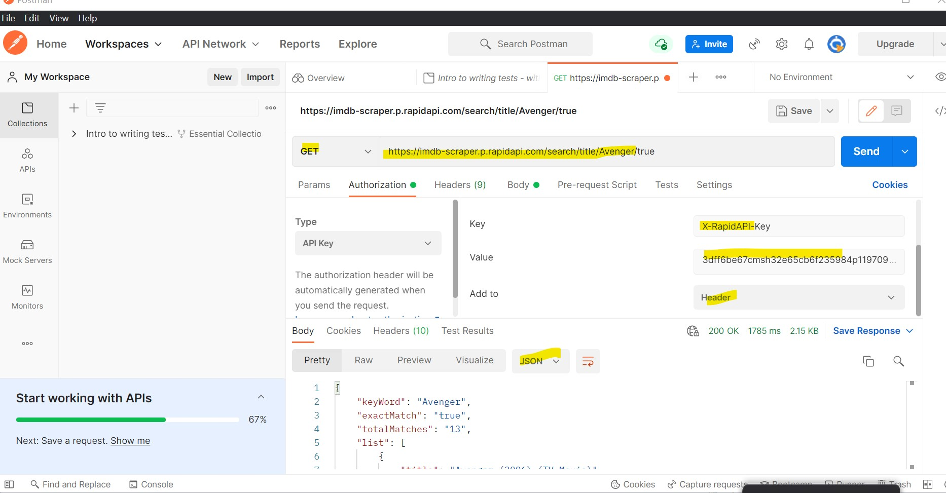

Now in the next steps which AEM concept i tried using is :
Created a component which holds a button in order to show the movie list which we got in format of JSON from the API and via that component I made one AJAX call to pass the control from client side to server side i.e to servlet.

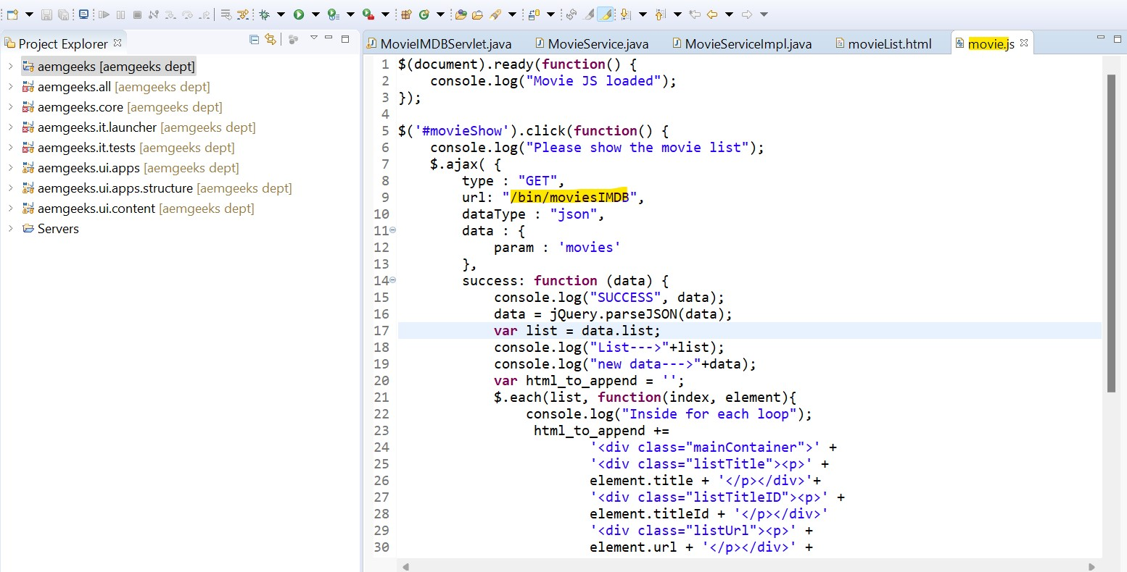
What value is passed in the url is a path of a servlet, here my servlet is registered via path.
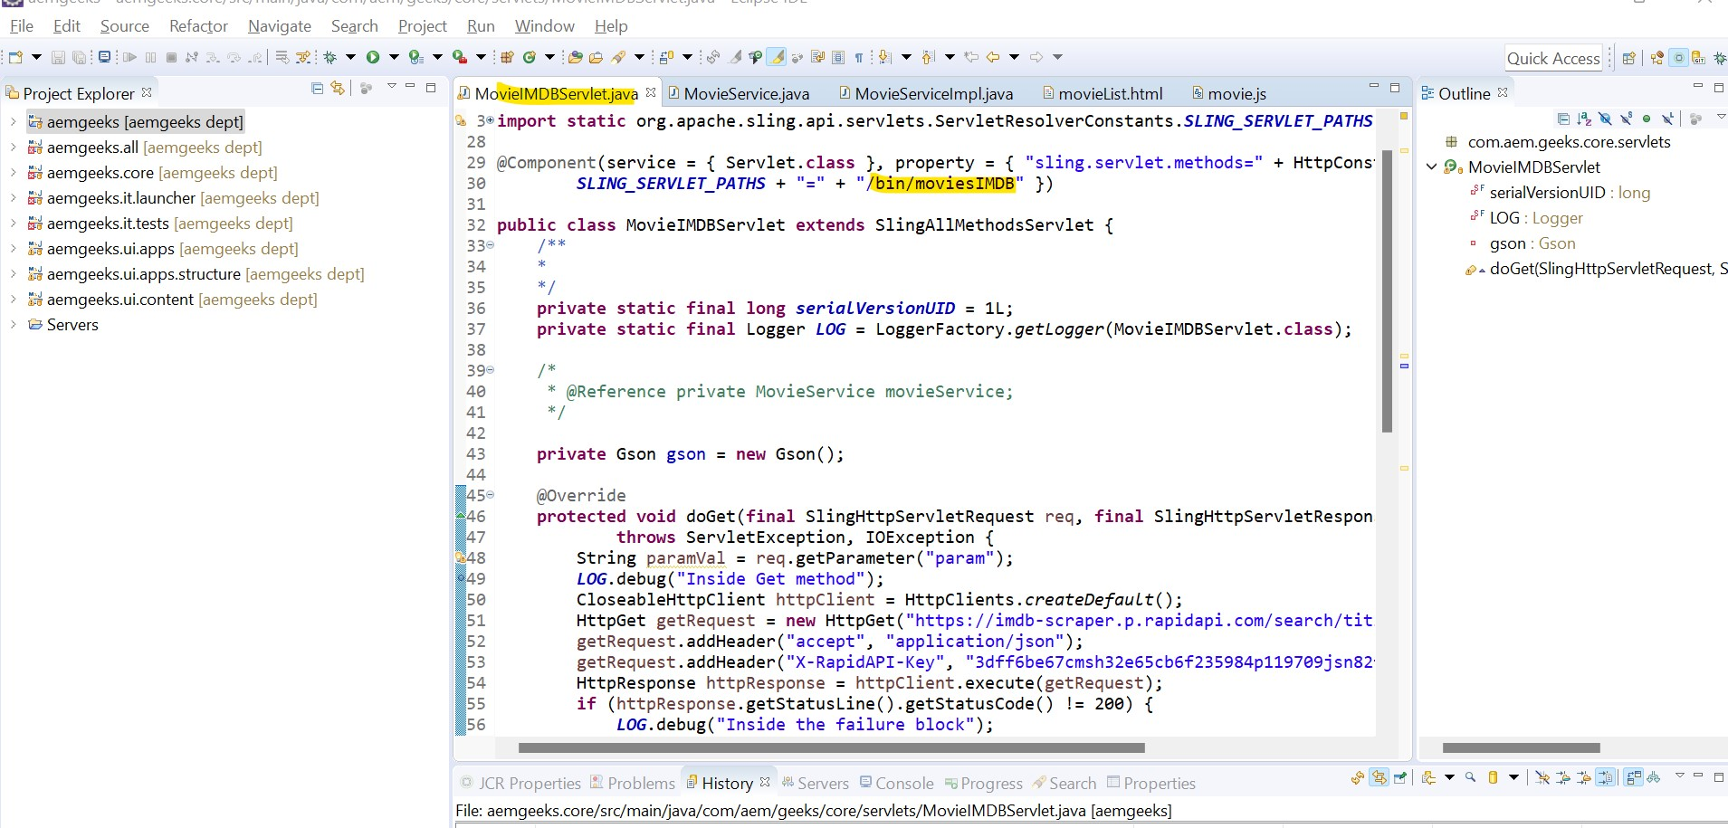

In this servlet I read the JSON response which we got back from the API and then via Jquery we ae showing the data from api on the page.
This Jquery code is responsible for showing data on page.

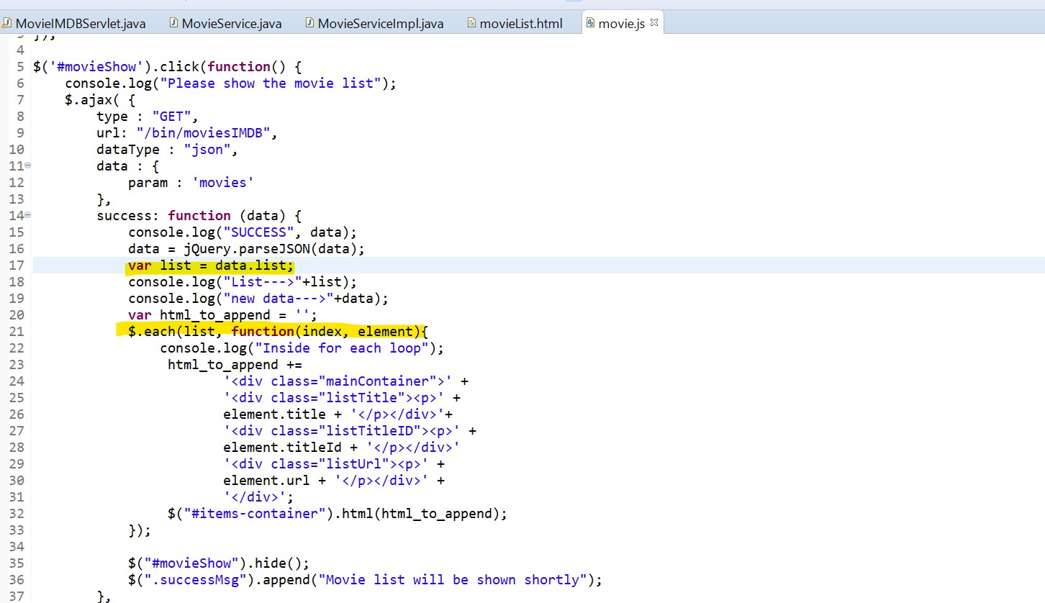
How will it look like on page?
Even though I could not get time to incorporate the CSS changes, but data came up on the page.
http://localhost:4502/editor.html/content/we-retail/us/en/movietest.html this local page I used.
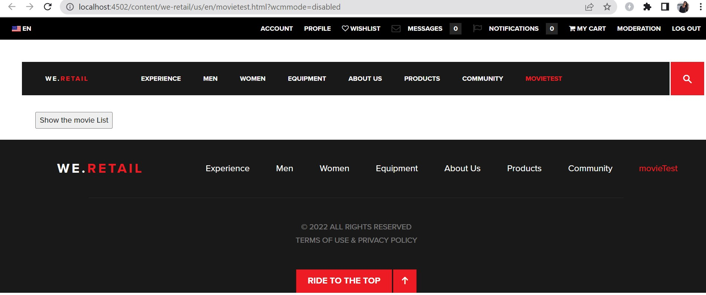
On click of this button, ajax call happens and control goes to servlet read data, then control comes back to the front end Jquery and it showed the data on page.
