Azure CAF & WAF & Landing Zone

Cloud Adoption Framework

- CAF helps organization on their cloud journey by aligning processes, people and technology strategies. It is developed by Microsoft, partners and customers guiding how set up Azure cloud in right way
- It offers documentation, best practices, templates and also tools to track progress of your cloud architecture deployment

CAF walks through following path.

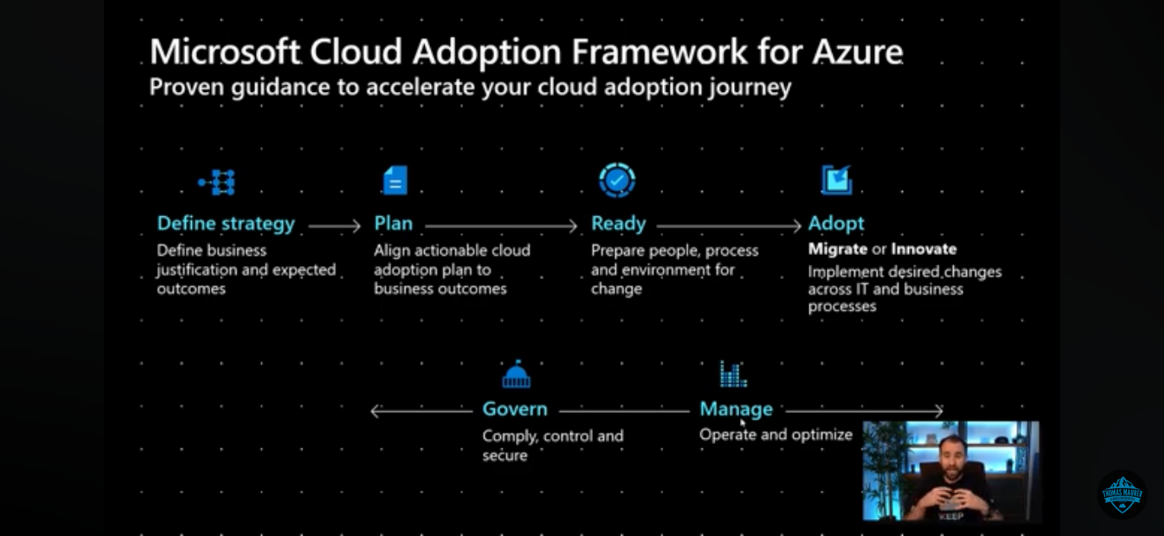

- Define strategy - Define business justification and expected outcome
- Plan - Align actionable cloud adoption plan to reach business outcome
- Ready- Prepare people, process and environment for change
- Adopt - Implement desired changes across IT and business processes
- Manage - operate and optimize the cloud environment
- Govern- Comply, control and secure

Define your strategy

- Define and document your motivations
- Document business outcomes
- Evaluate financial considerations
- Understand technical considerations

Make a plan

- Inventory of the existing digital assets and workloads
- Right people are involved in your migration efforts, both from a technical and cloud governance standpoint
- Build the skills they need to operate in the cloud.
- Build a comprehensive plan that brings together the development, operations

Ready your organization

- Review the Azure setup guide tools and approaches you need to use to create a landing zone
- Build out the Azure subscriptions with cloud infrastructure as well as governance, accounting, and security
- Refine subscriptions
- Best practices

Adopt the cloud

Migrate

- Migrate your first workload
- Migration scenarios
- Check in with the Azure cloud migration best practices checklist
- Identify ways to make the migration process scale

Innovate

- New innovations add value to the business and meet customer needs
- Use Azure innovation guide to build a minimum viable product (MVP) for your idea
- Verify your progress maps to recommended practices
- Check frequently with customers that you're building what they need.

Govern and manage your cloud environments.

Govern
- Methodology that incrementally takes you from your first steps to full cloud governance
- Use governance benchmark tool to assess your current state

Azure Landing Zone

You have to consider operating model to align with best landing zone option.

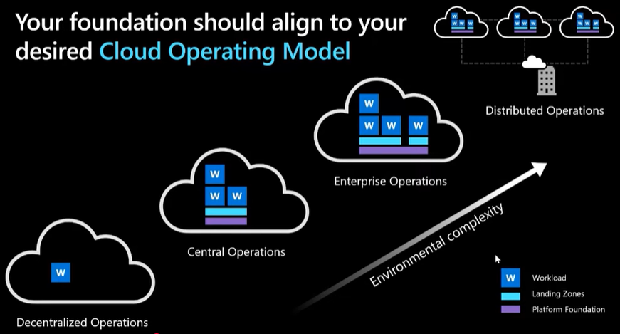

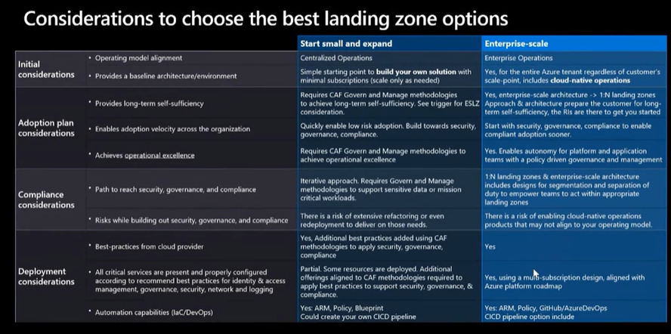

A landing zone is a pre-configured and secured environment for deploying cloud resources, designed to provide a consistent and repeatable method for managing cloud environments while ensuring compliance and security against best-practices and needs of the Organization.

- An Azure landing zone is an environment that follows key design principles across eight design areas. These design areas are :

1. Azure billing and Microsoft Entra tenant
2. identity and access management
3. management group and subscription organization
4. network topology and connectivity
5. security
6. management,
7. governance
8. Platform automation and DevOps.

- Modules make it easy to deploy and modify specific Azure landing zone architecture components as your requirements evolve.
- An Azure landing zone uses subscriptions to isolate and scale application resources and platform resources. Subscriptions for application resources are called application landing zones, and subscriptions for platform resources are called platform landing zones.

Platform landing zone

- Platform landing zones are subscriptions that provide shared services (identity, connectivity, management) to applications in application landing zones.
- Consolidating these shared services often improves operational efficiency.
- In conceptual architecture, shows the "Identity subscription," "Management subscription," and "Connectivity subscription" represent three different platform landing zones and representative resources and policies applied to each platform landing zone.

Application landing zone

- An application landing zone is a subscription for hosting an application.
- Provision application landing zone through code
- use management groups to assign policy controls

There are three main approaches to managing application landing zones. You should use one of the following management approaches depending on your needs:
- Central team approach
- Application team approach
- Shared team approach

Hub & Spoke Architecture and Landing Zones

We consider merging Hub & Spoke Architecture and Landing Zones together in your cloud adoption
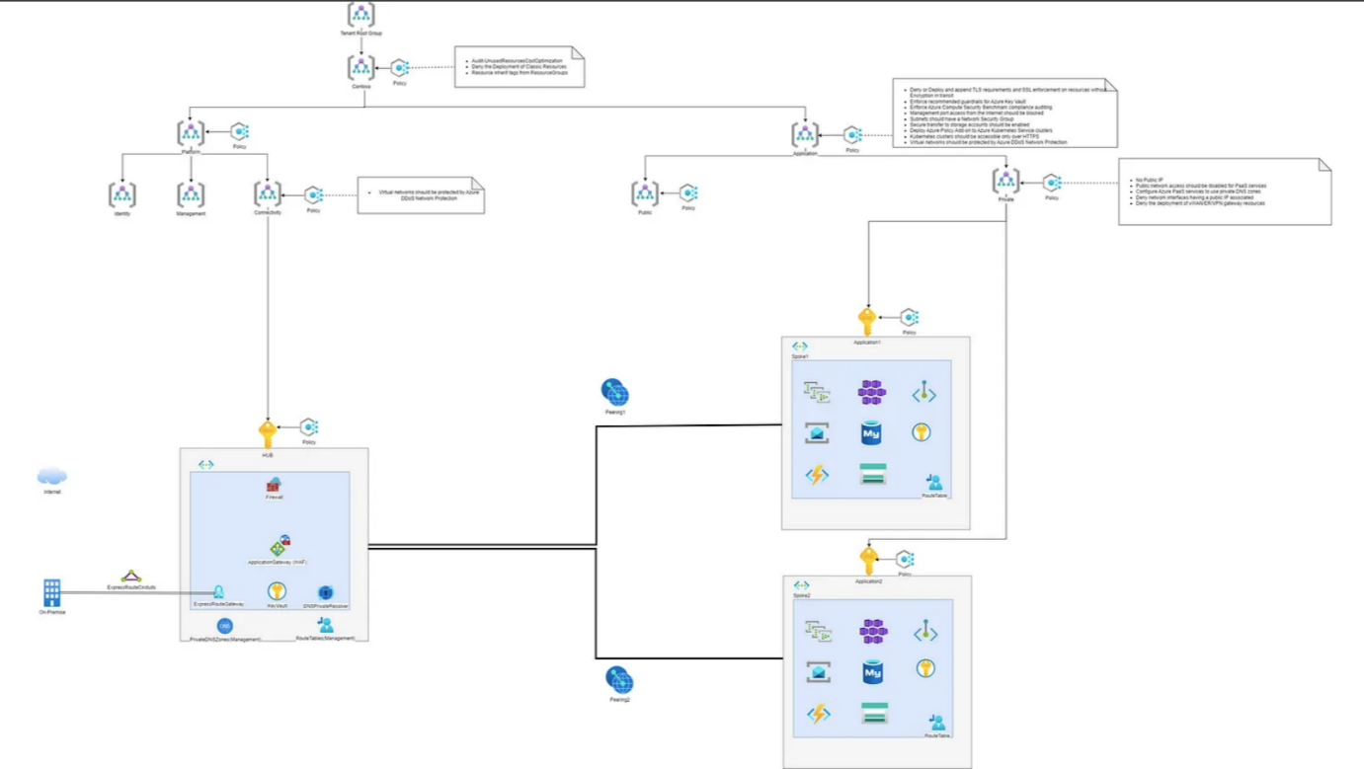

What is Hub & Spoke Architecture?
The Hub and Spoke is an architectural model in networks that allows you to:

- Interconnect several networks (spokes) to each other through a central network (HUB)
- Interconnect on-premises infrastructure with cloud environment
- Interconnect multi-cloud environments (Azure, AWS, GCP, …)

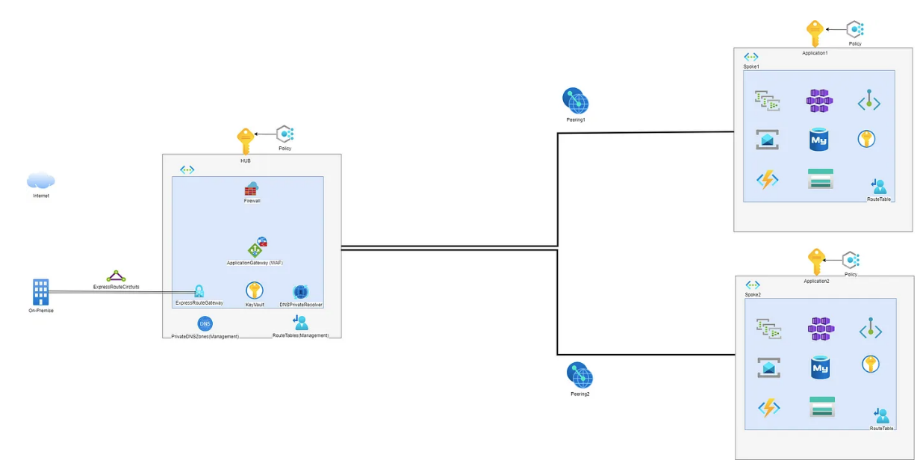

There are two types of networks:

- The HUB represents the central network and the point of aggregation and management of the traffic in order to connect in safe and controlled way the various networks (spokes, on-premise environment with spokes, multi-cloud environments, ..)
- Spokes represent peripheral networks and represent domains of specific responsibility. Each can therefore contain the resources specific to an application or in general a service (For example a spoke can be the PROD environment of a specific application)

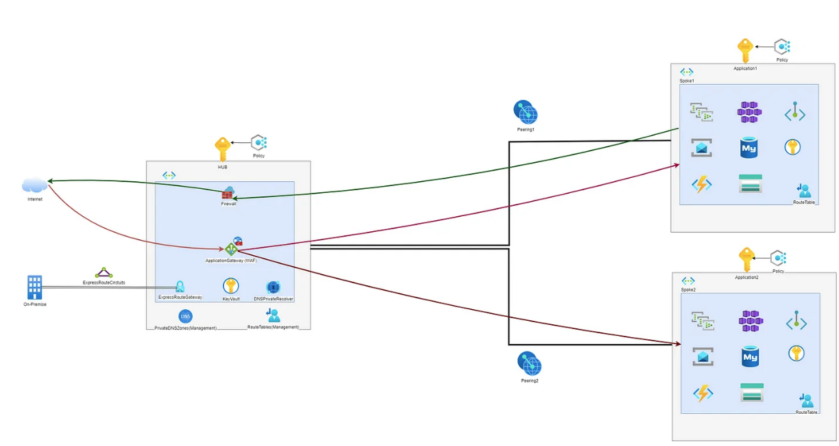

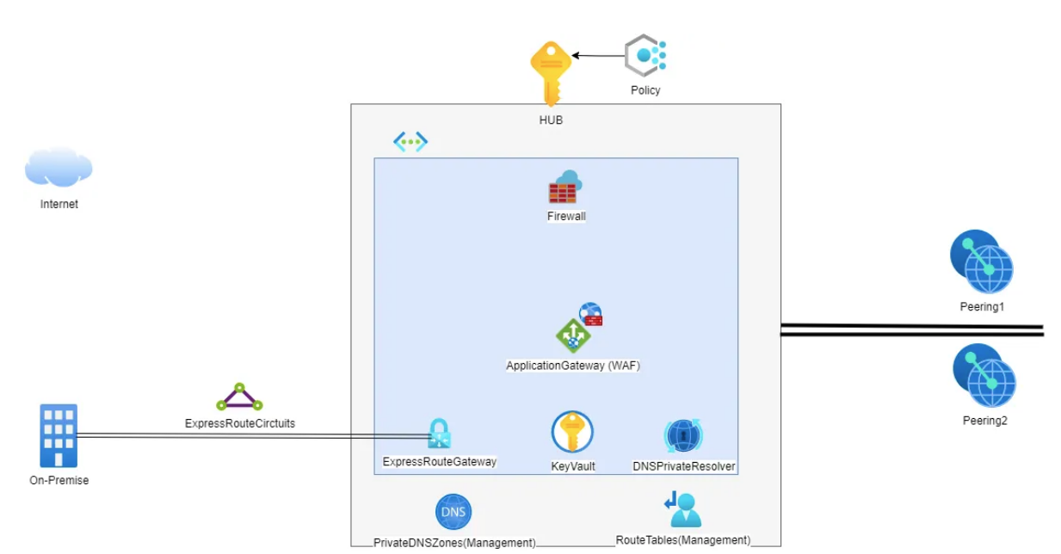

The HUB is generally made up of central and shared resources such as:

- The Azure Firewall
- The ExpressRoute/VPN Gateway
- NVA: Network Virtual Appliance
- Azure Application Gateway (WAF)
- DNS Forwarder
- Route Tables
- DNSPrivateResolver
- PrivateDNSZones

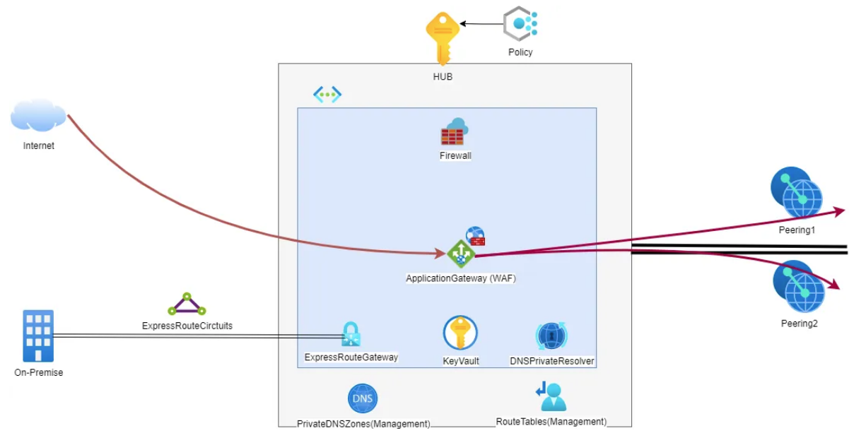

Inbound Traffic pass via central shared Application Gateway (WAF) in HUB and goes to the spokes networks

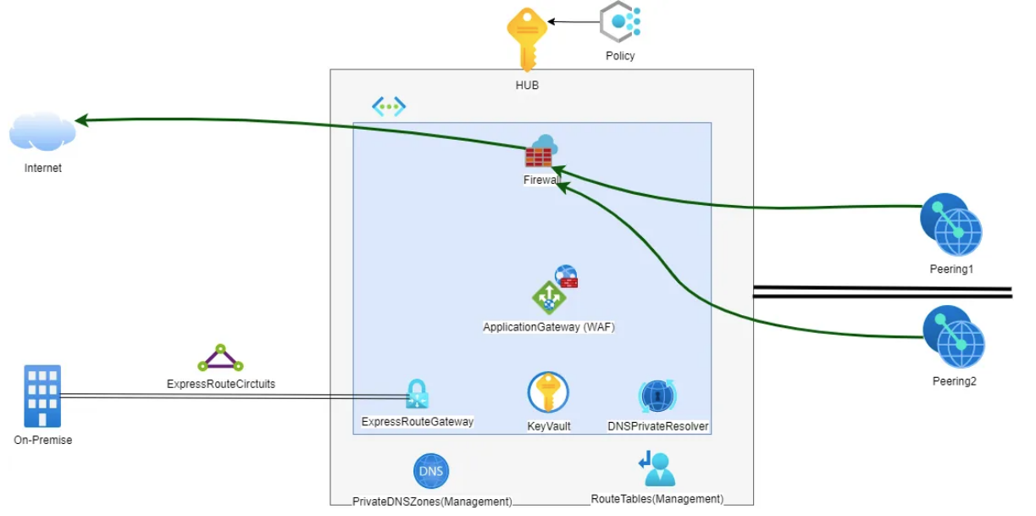

Outbound Traffic from spokes networks goes via central shared Firewall in HUB

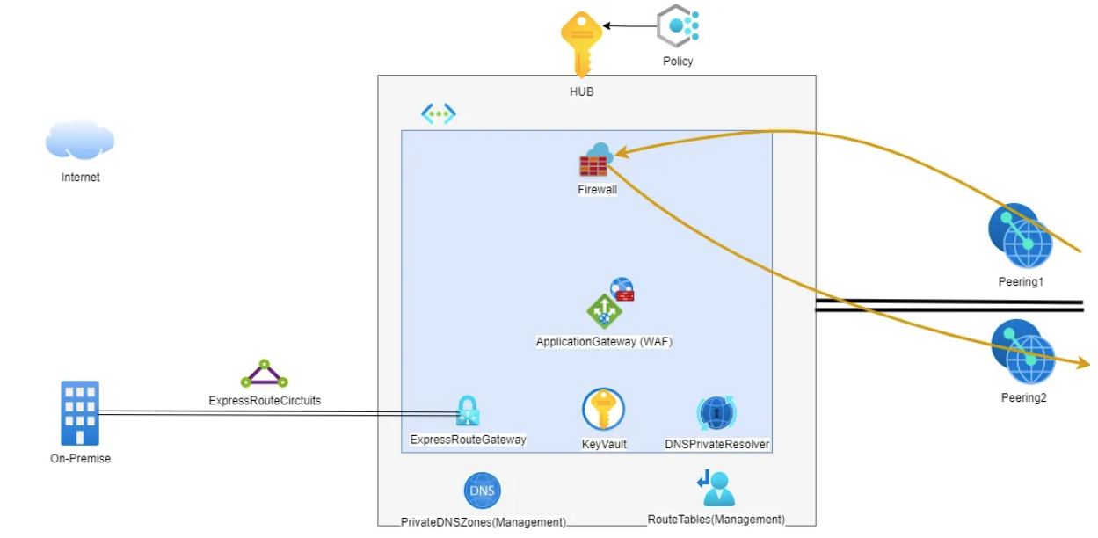
Communication between spokes networks goes via central shared Firewall inside the HUB

The main advantages of HUB and Spoke architecture are:

- Centralized management: The HUB enables simplified management of network, security and connectivity policies, reducing complexity and improving operational efficiency. acts as a central point for governance, administration and connectivity. It allows you to apply security and governance configurations and policies, as well as being the central point of monitoring network traffic.
- Isolation and Security: Can Ensure connectivity only to the spoke and resources that need it, keeping the different spokes and resources that don’t need to be connected isolated and separated
- Scalability: Easily add and remove spokes as needed
- Redundancy and resilience to ensure high availability of resources
- Separation of responsibilities: The Hub and Spoke architecture allows to separate responsibilities between different applications and services. Each spoke can be managed independently and customized to meet the specific needs of the application or service.
- Cost-Saving: Hosting central and shared resources allows sharing of these between different services, allowing you to save-cost compared to having dedicated instances for each service / application.

How does Hub & Spoke architecture integrate with Landing Zones on Azure?

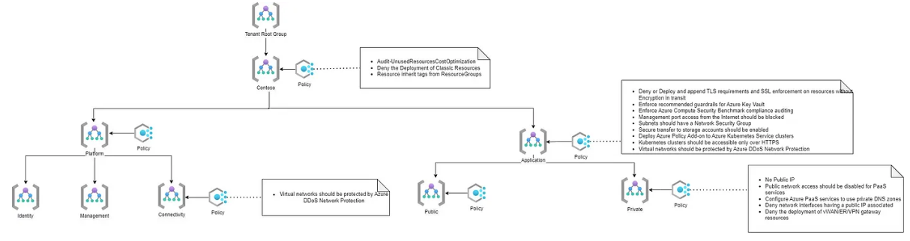

So, What is a Landing Zone?

A landing zone is a pre-configured and secured environment for deploying cloud resources, designed to provide a consistent and repeatable method for managing cloud environments while ensuring compliance and security against best-practices and needs of the Organization.

Implementing a landing zone helps ensure that deployments in Azure meet your organization’s security and compliance requirements, simplify resource management, and improve application scalability and flexibility.

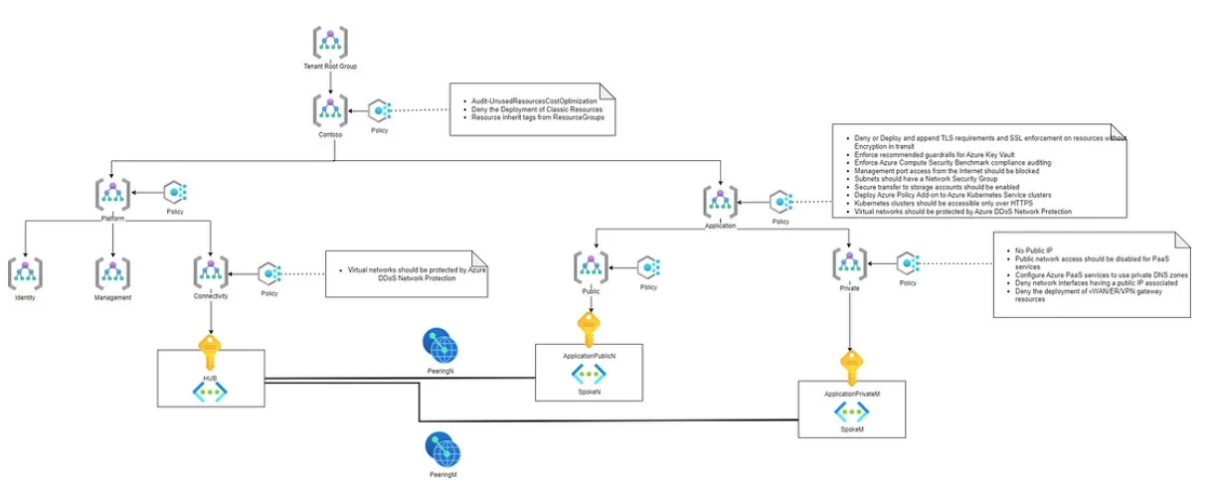

In addition, Landing Zones answer the question that we all ask ourselves when a new project is about to be born: “And now where do I put it?”
Here the Landing Zones provide pre-configured “places”, each suitable to accommodate a certain type of project.

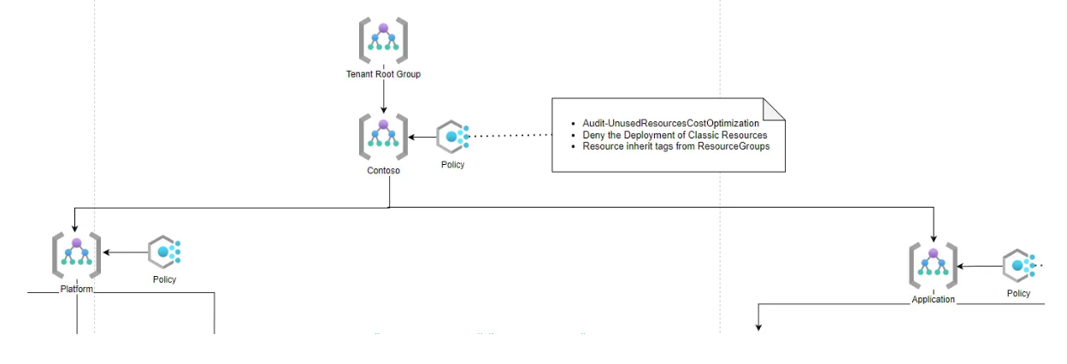

The Cloud Adoption Framework distinguishes two main macro landing zones:

Platform: A platform landing zone provides shared services (identity, connectivity, management) to applications in application landing zones.

Application: An application landing zone is designed to hosting an application. Its can be divided by Public and Private Applications in order to offer environment with different requirements. For example in Private Application Landing Zone can’t be provisioned a Public IP address.

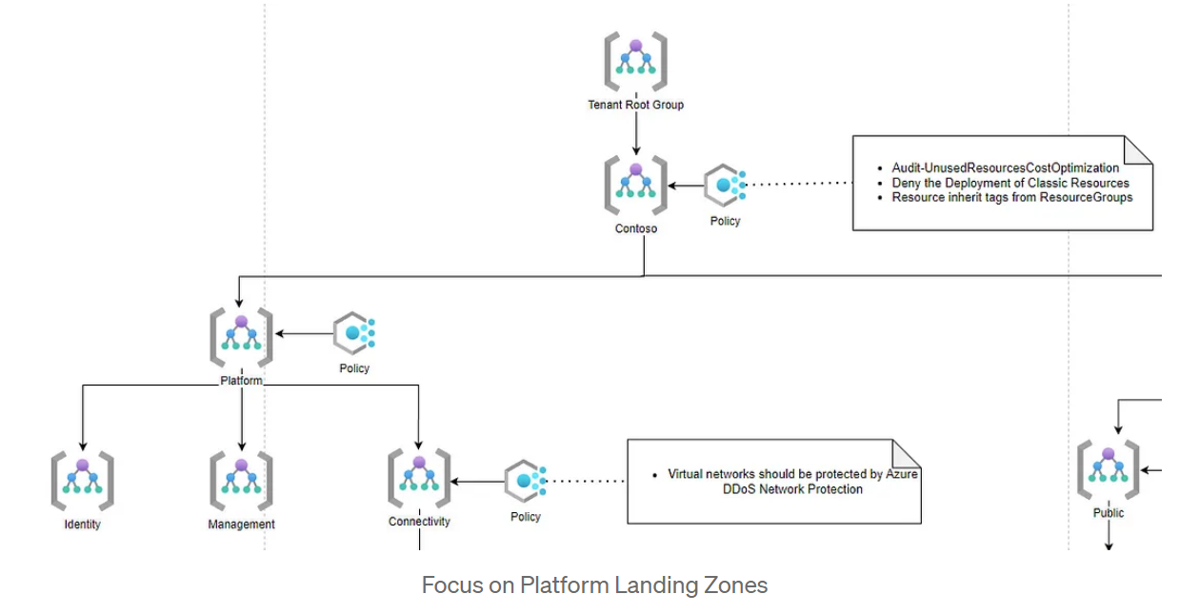

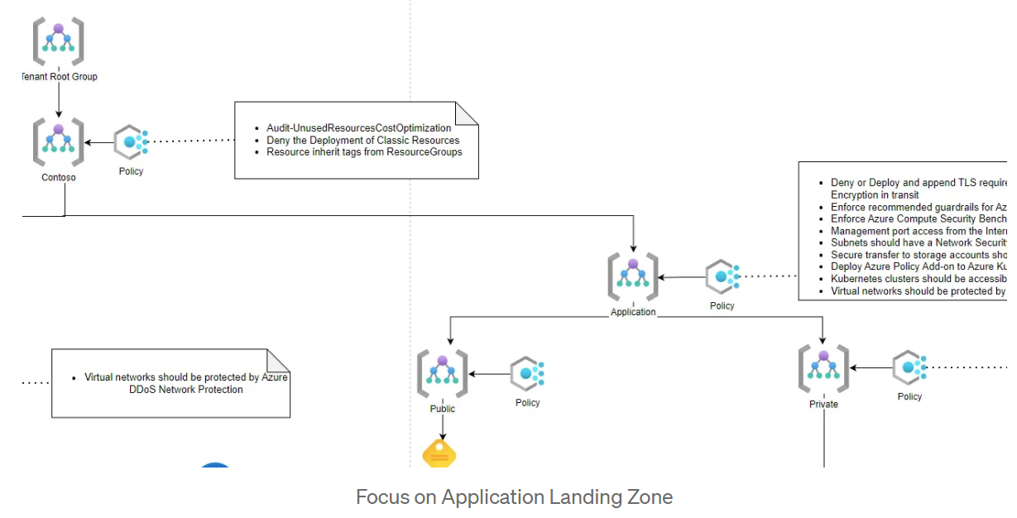

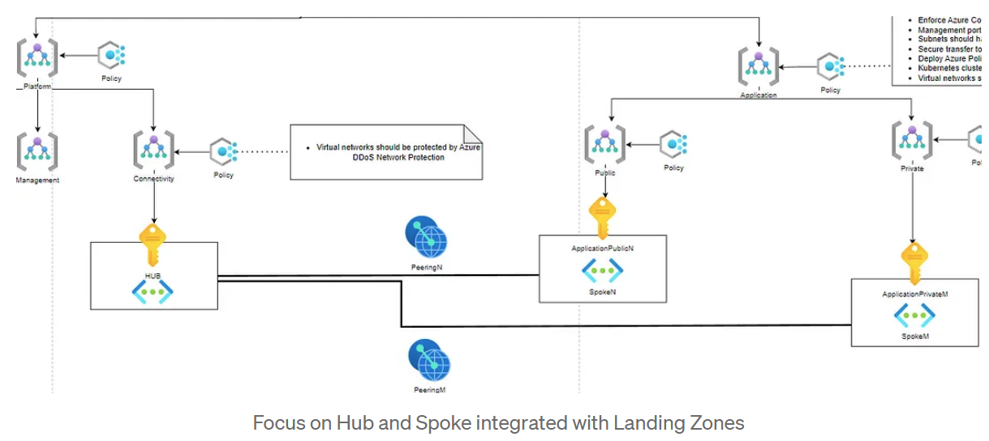

The Hub and Spoke architecture and Landing Zones of the Azure Cloud Adoption Framework can be combined to provide a structured, modular and scalable approach to the design, deployment and management of cloud infrastructure in Azure. They enable centralized governance, separation of responsibilities, standardization and flexibility in application deployments:

Centralized Governance: Using the Hub and Spoke architecture with the Azure Cloud Adoption Framework Landing Zones enables you to implement centralized governance across your entire cloud infrastructure. You can define and enforce security, compliance, and resource management policies consistently across all spoke, while maintaining flexibility for each Landing Zone.

Separation of responsibilities: Hub and Spoke architecture and Landing Zones promote separation of responsibilities. The central hub can be centrally managed by a team responsible for network infrastructure and security policies, while the different spoke can be assigned to specific application teams.

Scalability and standardization: The combination of Hub and Spoke and Landing Zones enables greater scalability and standardization in cloud infrastructure deployment. New spoke (Landing Zones) can be easily added to the central hub to support new applications or teams, while ensuring consistency in resource design and configuration.

Hierarchical Structure: The Hub and Spoke architecture defining a hierarchical structure in which a central hub is connected to several spoke, can be aligned with the Azure Cloud Adoption Framework Landing Zones concepts, which provides an organizational structure for resources and applications in Azure. Each spoke can represent a Landing Zone, so an area dedicated to an application.

Isolation and Modularity: The Cloud Adoption Framework’s modular and isolated Landing Zones infrastructure design approach aligns with the Hub and Spoke, where each spoke represents an isolated entity with its own resources, ensuring a clear separation of responsibilities between teams.

Another useful Landing Zone that the Cloud Adoption Framework suggest to implemented is a Sandbox landing zone:

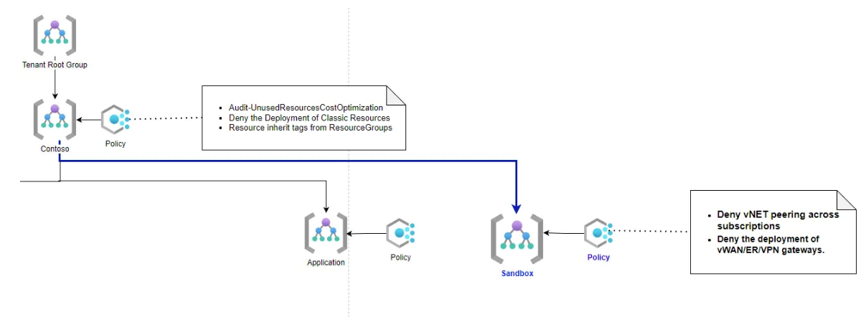

A sandbox is an isolated environment where you can test and experiment without affecting other environments, like production, development, or user acceptance testing (UAT) environments. (Microsoft Azure Docs)

These subscriptions will be securely isolated from the application landing zones.

Sandbox environments are the best place for hands-on Azure learning. Some use cases can include:

- A Cloud architect needs a sandbox environment to asses Azure solutions or conduct POCs for new projects
- A cloud engineer needs a sandbox environment to understand what happens when apply specific configuration on Azure Resources
- A developer wants to experiment with Azure resources for its application

https://medium.com/@lupass93/hub-spoke-architecture-and-landing-zones-on-azure-cloud-ad2e1b11c55

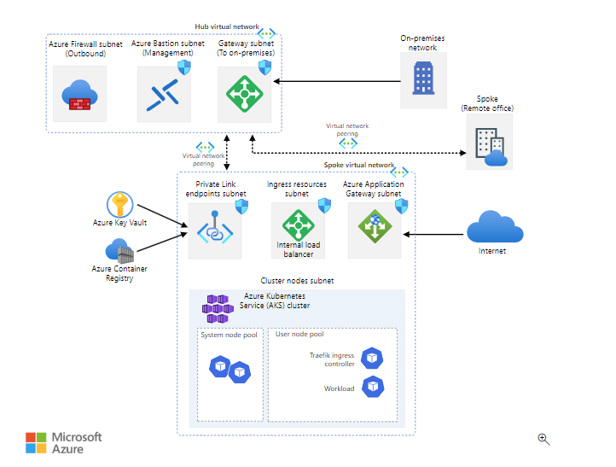

Azure Well-Architected Framework

The Azure Well-Architected Framework is a set of quality-driven tenets, architectural decision points, and review tools intended to help solution architects to build high quality workloads on Azure whereas Cloud Adoption Framework focuses on for organizations as whole.

Pillars

Cost optimization

Design your environment so that it's cost effective for operation and development. Ensure that the money your organization spends is being used to maximum effect. This is not about building environment at its cheaper.

- Plan and estimate costs whether it is development of new application or migration
- Provision services that are optimized for cost can reduce your work effort in the future
- Use monitoring and analytics to gain cost insights
- Identify and eliminate unnecessary expenses by conducting regular reviews such as underutilized resource, autoscaling , license consumption

Operational Excellence

- Full visibility into how your application is running, and ensuring the best experience for users
- Design, build and orchestrate with modern practices such as DevOps and CI/CD
- Use monitoring and analytics to gain operational insights
- Automate as much as of your infrastructure as possible
- Test your application deployment and ongoing operations

Performance efficiency - For an architecture to perform well and be scalable, it should be properly match resource capacity to demand

- Autoscaling - Scale up/down and out/in
- Optimize network and storage performance
- Identify performance bottlenecks in your application

Reliability -

- Build a highly available architecture considering SLA, use redundancy, clustering and load balancing
- Build an architecture that can recover from failure, examine possible data loss, determine RPO(maximum duration of acceptable data loss) and RTO(maximum duration of acceptable downtime)

Security - protecting the data that your organization uses, stores and transmits

Multilayered approach to securing your environment increases its security posture
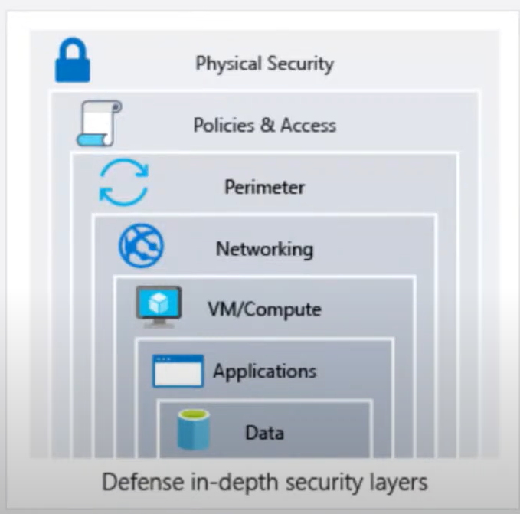

- Protect from common attacks at different layers

Data layer - exposing encryption keys or using weak encryption
Application layer - Malicious code injection and execution, SQL injection, cross-site scripting
VM/Compute layer - malware, credential exposure, lateral movement through the environment
Networking layer - open SSH and RDP ports to VM, brute-force attacks
Perimeter layer - Denial-of-service attacks
Policies and access layer - modern authentication protocols such as OpenID Connect, OAuth, Kerberos-based authentication, compromised accounts, logins from unusual places
Physical layer - door drafting, theft of security badges

General design principles

Enable architecture evolution - evolve the architecture by taking advantage of new services, tool, technologies

Use data to make decisions - Collect data, analyse and use it take decisions on architecture how enhance your environment to perform well

Educate and enable - Cloud technology evolves quickly. Educate you development, operation and business team to take right decision so that you can build solution updated configuration, decisions and best practices

Automate - automation manual activities reduces operational cost, minimize manual errors, and provide consistency

