Azure Integration Services and Security

Azure Logic App

Azure Logic Apps is a cloud platform where you can create and run automated workflows with little to no code. It helps you schedule, automate, and orchestrate tasks, business processes, and workflows when you need to integrate apps, data, systems and services across enterprise or organizations.

By using the visual designer and selecting from prebuilt operations, you can quickly build a workflow that integrates and manages your apps, data, services, and systems.

-Each workflow starts with a trigger
-The trigger is fired via a specific event
-When the trigger is fired, the logic app engine creates a logic app instance that runs the workflow.
-Connectors for Azure Logic Apps
-These connectors provide easy access to event, data, and actions that are send from external applications, services, systems or platforms
-You have built-in connectors that can connect to Azure services such as Azure functions, Azure API Apps etc
-You have managed connectors that can connect to platforms such as Office 365, Microsoft Dynamics

This list describes just a few example tasks, business processes, and workloads that you can automate using Azure Logic Apps:
  - Schedule and send email notifications using Office 365 when a specific event happens, for example, a new file is uploaded.
  - Route and process customer orders across on-premises systems and cloud services.
  - Move uploaded files from an SFTP or FTP server to Azure Storage.
  - Monitor tweets, analyze the sentiment, and create alerts or tasks for items that need review.

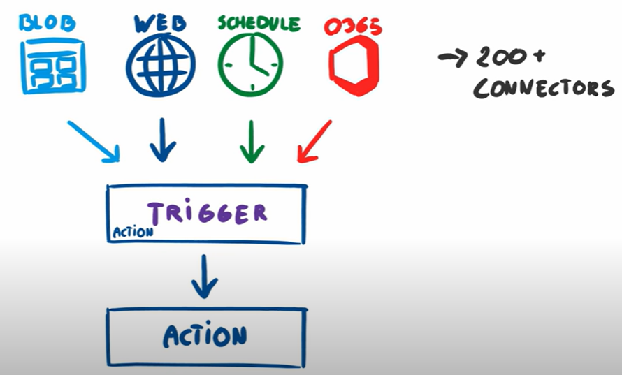

Building Blocks of Azure Logic Apps

  - Logic App Resource: This is the Azure resource group where you define and manage your logic app.
  - Triggers: Triggers are what start a new instance of a workflow based on specific events, like receiving an email or a file getting uploaded to an FTP server.
  - Actions: Actions are the steps that follow the trigger. They are the operations carried out when a specific trigger fires.
  - Connectors: Connectors provide an interface for connecting your logic apps to an existing service, whether it be cloud-based or on-premises.
  - Workflow Definition Language: This JSON-based language provides more control over the workflow's design if you want to code directly rather than use the visual designer.
  - Run History: This feature allows you to track the execution details of each run, including timing, inputs, and outputs.

Creating and deploying a logic app

  - Create a Logic App Resource: The first step is to create a logic app resource in the Azure portal. This essentially means setting up the environment where your logic app will reside.
  - Build Your Workflow: Once the resource is created, you can start building your workflow. Using the Logic App Designer, you can add triggers and actions to define your workflow. Each trigger or action represents a specific operation.
  - Configure Your Connectors: After defining your workflow, you need to configure your connectors. This involves specifying the services that your logic app will interact with and providing any necessary details for authentication.
  - Deploy Your Logic App: Once everything is set up, you can deploy your logic app. Deployment makes your logic app live and ready to respond to the specified triggers.
  - Monitor Your Logic App: After deployment, you can monitor your logic app through the Azure portal. This allows you to track the performance of your logic app and troubleshoot any issues that may arise.

https://turbo360.com/guide/azure-logic-apps

Microsoft Defender Cloud

-Enable workload protection services with threat detection and protection for VM, containers, SQL databases, Web application
-Protect multi cloud environment such AWS, GCP and on-premise
-This detects threat and generate an alert which provide details about affected resources, suggested remediation steps and options to trigger a logic apps in response

Defender for Servers

-Protect multi cloud and on premises Windows and Linux VMs
-Provide recommendations to improve security posture and help to remediate vulnerabilities
-Support agentless and agent-based scanning. Agentless scanning enabled by default and support VA, malware detection and software inventory.
-Seamlessly integrates with Microsoft Defender for Endpoint that provide EDR
-Offers 2 plans, plan 1 and plan 2(offers Agentless scanning, malware detection and file integrity monitoring)

Defender for Storage

-Provides threat protection for Azure Blob, Azure Files and Azure Data Lake Storage
-Detects threats and prevents malicious upload, data exfiltration and corruption
-Use Microsoft Threat Intelligence, Defender AntiVirus, Sensitive Data Discovery which is integrated with Microsoft Purview sensitivity information types and classification labels
- agentless solution, scalable setup

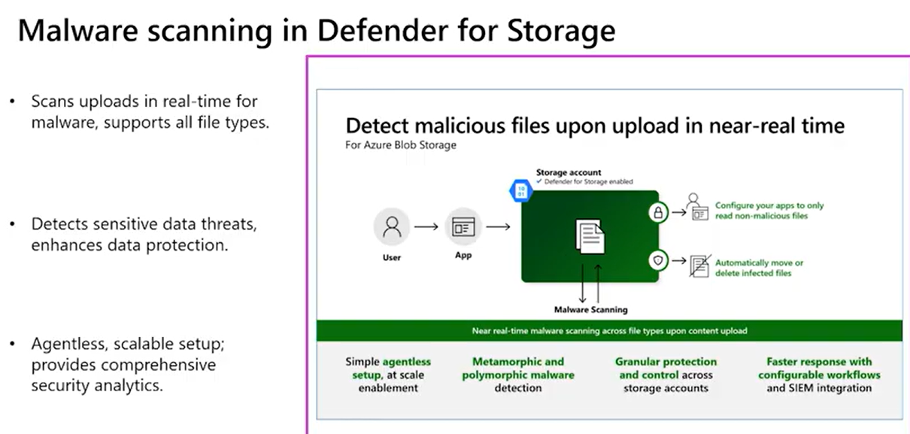

-Engine scans across all supported storage accounts, results generates within 24 hours, newly created storage account within 6 hours of it being created. By default reoccurring scans are scheduled to occur weekly
-Role : From subscription owner to storage account owner roles
-Agentless scanning is available in CSPM and Defender for Servers Plan 2

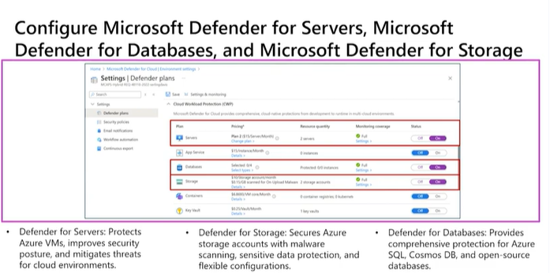

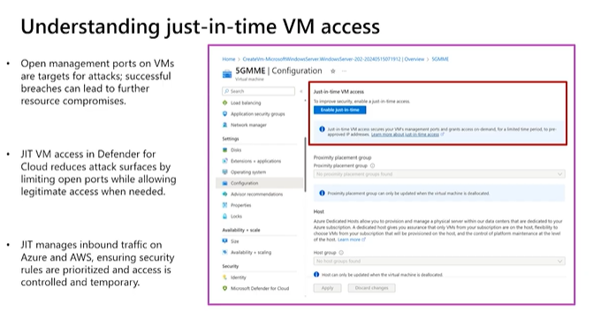

Defender for Containers

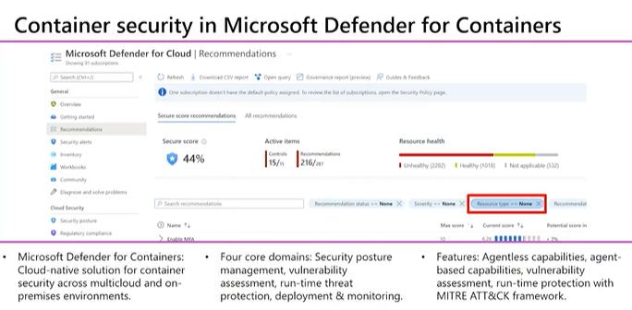

-Uses threat intelligence and machine learning to detect suspicious activities such as unauthorized access, privilege escalation and malicious code execution
-It scans container images for known vulnerabilities and provides actionable recommendation
-Defender for containers integrates seamlessly with CICD pipeline that allows to incorporate security checks into deployment and development process

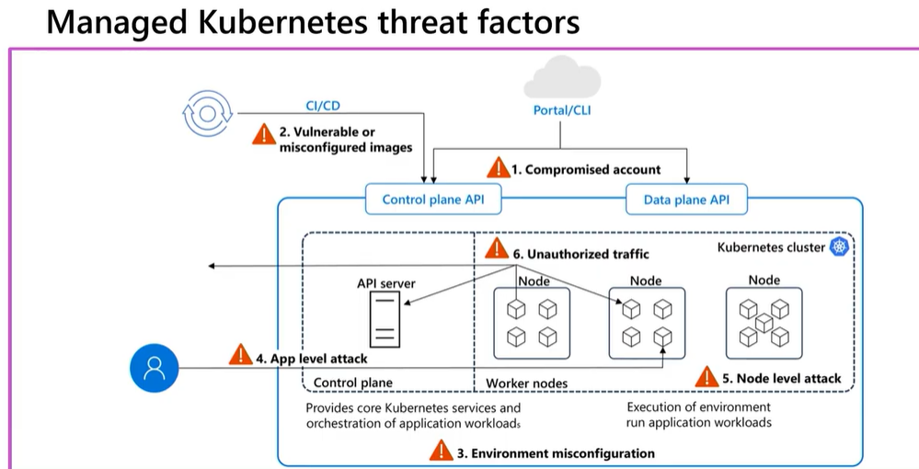

Defender for Cloud DevOps Security

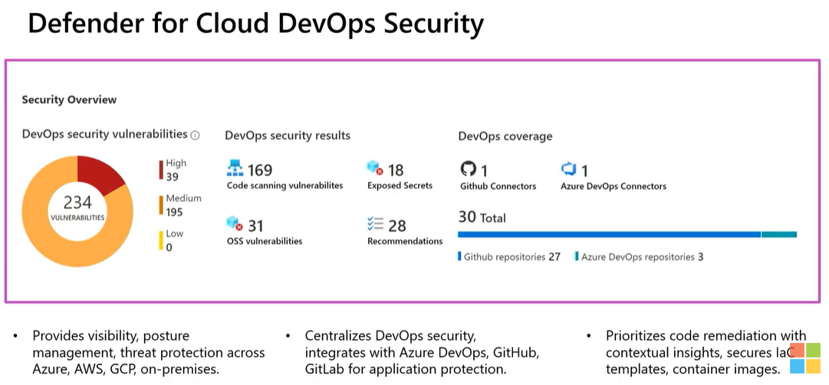

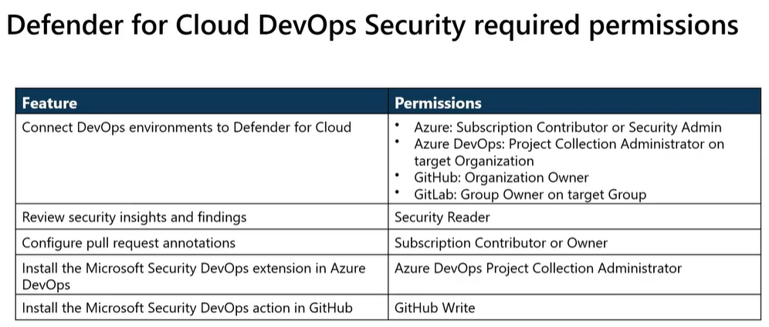

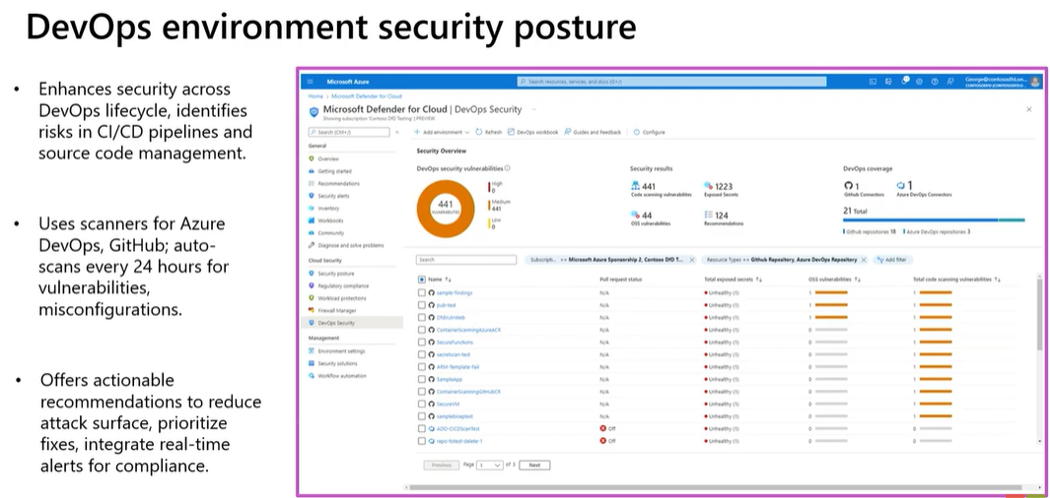

Configure and manage threat protection by using Microsoft Defender for Cloud AZ-500

