Azure Kubernetes Service (AKS)

Kubernetes is a container management platform when solution is built and deployed as microservices.

To install kubectl client locally ; az aks install-cli

AKS Terminology

Pools - groups of nodes with identical configurations.

Nodes - individual virtual machines running containerized applications

Pods - run single instance of an application. A pod can contain multiple containers

Container - a lightweight and portable executable image that contains software and all of its dependencies.

Deployment has one or more identical pods managed by Kubernetes.

Manifest is the YAML file describing a deployment

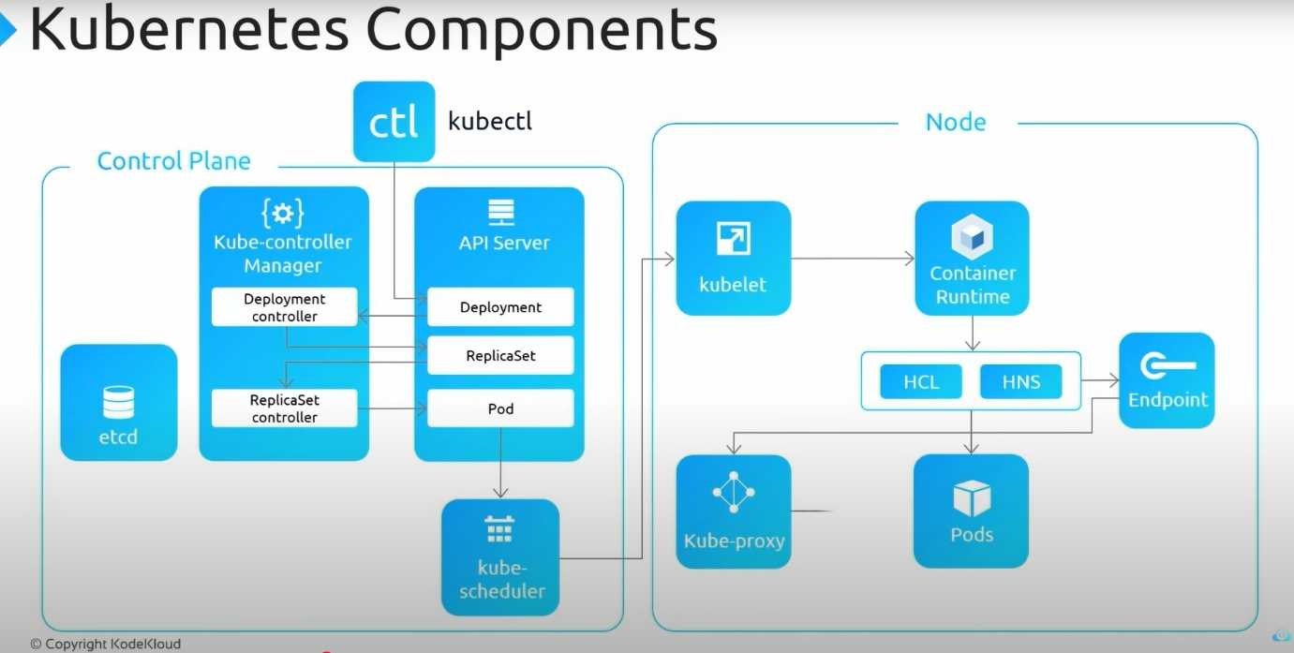

When you create AKS cluster, it defines the following.

Basics
- Subscription
- Resource group
- Cluster name
- Region
- Availability zone
- Kubernetes version
- Primary node pool - node count(maximum 1000), node size ( VM size cannot be changed once after set up, primary node pool always includes Linux nodes), scale method(Manual, Autoscale)

Node pool
- Node pool - If you need to run windows containers, you should create another node pool with Windows nodes.
- Virtual nodes - enabling this feature allows burstable scaling backed by serverless ACI
- VM scale sets - enabling this feature allows auto scaling, multiple node pools and Windows support
-Max pods per node - between 15-250
-Labels
-Taints

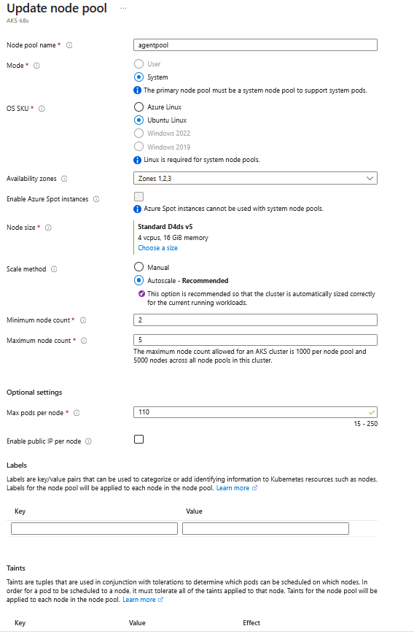

Authentication

- Cluster infrastructure- Service principal or system-assigned managed identify
- Kubernetes authentication and authorization- RBAC or AKS- managed Azure AD which can incorporate with AD group synched
- Node pool OS disk encryption- encryption at-rest with platform-managed key or customer-managed key

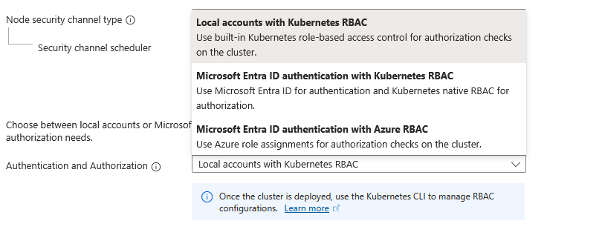

Networking

- Network configuration- Kubenet , Azure CNI which allows to manage virtual network on the cluster
- DNS name prefix - DNS name to access the cluster
- Traffic routing - load balancer and enable HTTP application routing which require to enable for API
- Security- enable private cluster, set authorized IP ranges(specify ip addresses of organization), Network policy(Calico, Azure)

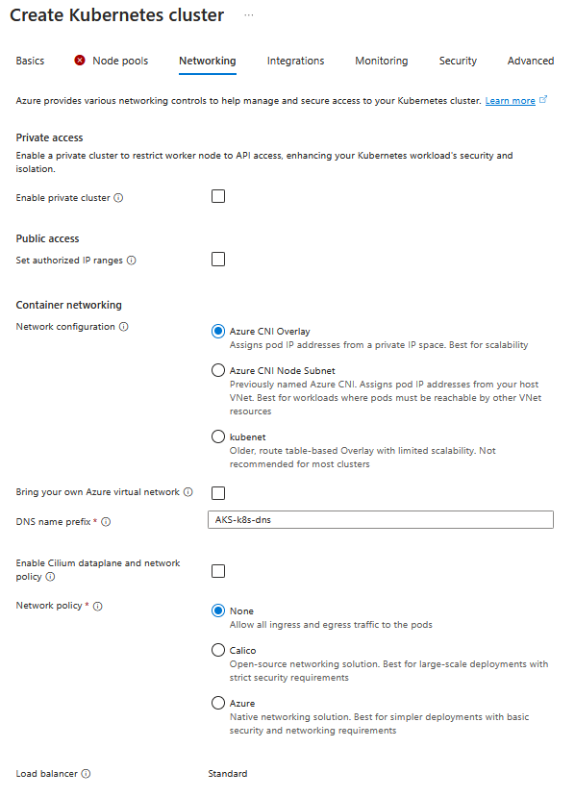

Integrations

- Azure Container Registry- connect to pull the images from private image repository
- Azure Monitor- enable container monitoring by creating log analytics workspace to understand performance of containers and servers in the cluster
- Azure policy - enforce compliance, security through built in or custom policies

Tags - logical grouping

You can manage Kubernetes cluster through Azure cloud shell where it provides 2 options bash or PowerShell.

Azure cloud shell requires an azure file share to persist files. Hence it will create a storage account.

Connect to the cluster create through bash upon the instruction given.

az account set - -subscription <subscription id>
az aks get-credentials - -resource-group <name RG> - -name <name of AKS> ; this created Kubernetes config file in the cluster

AKS cluster and node architecture

An AKS cluster contains one or more nodes (Azure Virtual Machines) as well as A Kubernetes cluster contains one or more node pools(groups of nodes) that run the Kubernetes node components
and the container runtime.

The initial number of nodes and size are defined when you create an AKS cluster, which creates a default node pool.

A Kubernetes cluster is divided into two components:

Azure-managed nodes
- provide the core Kubernetes services and orchestration of application workloads
- When you create an AKS cluster, a cluster node is automatically created and configured
- pay only for running agent nodes

Customer-managed nodes
- run your application workloads.

kubelet is the Kubernetes agent that processes the orchestration requests from the Azure-managed node, and scheduling of running the requested containers

kube-proxy on each node routes network traffic and manages IP addressing for services and pods

container runtime is the component that allows containerized applications to run and interact with additional resources such as the virtual network and storage.

Moby (upstream docker) as its container runtime > Kubernetes version 1.19 node pools> containerd as its containers runtime

AKS networking
- Kubernetes provides an abstraction layer to virtual networking for application components to communicate with each other
- provide inbound and outbound connectivity for pods
- In Kubernetes, Services logically group pods to allow for direct access via an IP address or DNS name and on a specific port
- routing of application traffic can also be achieved with Ingress Controllers or load balancer
- Security and filtering of the network traffic for pods is possible with Kubernetes network policies
- When you create a Kubernetes load balancer, the underlying Azure load balancer resource is created and configured

Services

Kubernetes uses Services to logically group a set of pods together and provide network connectivity.

Cluster IP- Creates an internal IP address for use within the AKS cluster which is for internal-only applications that support other workloads within the cluster

NodePort- allows the application to be accessed directly with the node IP address and port

LoadBalancer- configures an external IP address, and connects the requested pods to the load balancer backend pool

ExternalName - Creates a specific DNS entry for easier application access

>az login --tenant TENANT_ID

PS C:\WINDOWS\system32> az login --tenant b43228ec-e70c-4f4f-a15d-b343d9745b06
Select the account you want to log in with. For more information on login with Azure CLI, see https://go.microsoft.com/fwlink/?linkid=2271136

Retrieving subscriptions for the selection...

[Tenant and subscription selection]

No Subscription name Subscription ID Tenant
----- -------------------- ------------------------------------ ------------------------------------
[1] * Azure subscription 1 890b07e0-e085-4912-884b-52ca7299f107 b43228ec-e70c-4f4f-a15d-b343d9745b06

The default is marked with an *; the default tenant is 'b43228ec-e70c-4f4f-a15d-b343d9745b06' and subscription is 'Azure subscription 1' (890b07e0-e085-4912-884b-52ca7299f107).

Select a subscription and tenant (Type a number or Enter for no changes): 1

Tenant: b43228ec-e70c-4f4f-a15d-b343d9745b06
Subscription: Azure subscription 1 (890b07e0-e085-4912-884b-52ca7299f107)

[Announcements]
With the new Azure CLI login experience, you can select the subscription you want to use more easily. Learn more about it and its configuration at https://go.microsoft.com/fwlink/?linkid=2271236

If you encounter any problem, please open an issue at https://aka.ms/azclibug

[Warning] The login output has been updated. Please be aware that it no longer displays the full list of available subscriptions by default.

PS C:\WINDOWS\system32> az account show
{
"environmentName": "AzureCloud",
"homeTenantId": "b43228ec-e70c-4f4f-a15d-b343d9745b06",
"id": "890b07e0-e085-4912-884b-52ca7299f107",
"isDefault": true,
"managedByTenants": [],
"name": "Azure subscription 1",
"state": "Enabled",
"tenantId": "b43228ec-e70c-4f4f-a15d-b343d9745b06",
"user": {
"name": "nibhath_aka@outlook.com",
"type": "user"
}
}
PS C:\WINDOWS\system32>az configure --defaults AKS-HRP

PS C:\WINDOWS\system32>az aks get-credentials --name AKS-cluster ; download the credentials and merge it into current user context

PS C:\WINDOWS\system32>kubectl config current-context ; check the current context

How to Create AKS Cluster in Azure | AKS Cluster Creation & App Deployment (Demo)

Deploy AKS Cluster In Azure With Terraform Custom Modules

- Create resource group
- Create service principal to deploy AKS cluster - grant contributor access
- Create Azure key vault - to store client id, tenant id
- Create secret in the key vault - to store secret of service principal
- Provision AKS cluster using service principal secret

Day 20/28 - Deploy AKS Cluster In Azure With Terraform Custom Modules | Real time Project #1

