Azure Virtual Networking

Implement and manage virtual networking

Virtual networks(VNet)

- logical isolation of the Azure cloud dedicated to your subscription.
- Manage virtual private networks (VPNs) in Azure to link the VNets with other VNets in Azure, or with your on-premises IT infrastructure to create hybrid or cross-premises solutions if the CIDR blocks do not overlap of each VNets
- A resource can only be created in a virtual network that exists in the same region and subscription
- Network Interface(NIC) can be assigned to virtual network that exists in same location and subscription. You cannot change the location of NIC once it is set up.
- VNet can be used in many ways

1. Create a dedicated private cloud-only VNet
2. Securely extend your data center With VNets- S2S VPNs use IPSEC to provide a secure connection between your corporate VPN gateway and Azure
3. Enable hybrid cloud scenarios- can securely connect cloud-based applications to any type of on-premises system

Subnets

Azure routes network traffic between all subnets in a virtual network, by default

Services that needs dedicated subnets for deployment are:

- Application gateway- WAF
- Azure Bastion
- Azure Firewall
- Azure Route server
- ExpressRoute gateway
- VPN gateway
- Redis cache
- Azure SQL Managed Instance
- Azure database for SQL
- Azure database for PostgresSQL
- Azure Container Instance
- Azure Function

Network Virtual appliances

You can override Azure's default routing to prevent Azure routing between subnets, or to route traffic between subnets in same virtual network through a network virtual appliance(NVA).

- NVAs are virtual machine that control and filter traffic inbound to a virtual network, to lock malicious requests
- NVA consists in various protection layer such a firewall, a WAN optimizer, application-delivery controllers, router, loadIPS/IDS, proxy, SD-WAN edge
- You can deploy NVAs chosen from providers in Azure Marketplace. Such providers include Check Point, Barracuda, Sophos, WatchGuard, and SonicWall
- With the micro segmentation approach, you can create dedicated subnets for the firewall and then deploy web applications and other services in other subnets. All traffic is routed through the firewall and inspected by the NVAs
- You can specify the private IP address of a NIC attached to a virtual machine so that IP forwarding can be enabled. Or you can provide the private IP address of an internal load balancer.
- If IP forwarding isn't enabled, traffic that is routed through your appliance will never be received by its intended destination servers.
- It's important to include a highly available architecture in your NVA deployment

Deploy a NVA;

az vm create \
--resource-group [sandbox resource group name] \
--name nva \
--vnet-name vnet \
--subnet dmzsubnet \
--image UbuntuLTS \
--admin-username azureuser \
--admin-password <password>

Enable IP forwarding for Azure NIC;

1. Get the ID of the NVA network interface
2. Get the name of the NVA network interface
3. Enable IP forwarding for the network interface

az network nic update --name $NICNAME \
--resource-group [sandbox resource group name] \
--ip-forwarding true

Enable IP forwarding in the appliance

1. To save the public IP address of the NVA virtual machine to the variable NVAIP.

NVAIP="$(az vm list-ip-addresses \
--resource-group [sandbox resource group name] \
--name nva \
--query "[].virtualMachine.network.publicIpAddresses[*].ipAddress" \
--output tsv)"

echo $NVAIP

2. To enable IP forwarding within the NVA

ssh -t -o StrictHostKeyChecking=no azureuser@$NVAIP 'sudo sysctl -w net.ipv4.ip_forward=1; exit;'

When prompted, enter the password you used when you created the virtual machine.

You can use traceroute utility to verify whether traffic between subnets are routed through NVA

ssh -t -o StrictHostKeyChecking=no azureuser@$PRIVATEIP 'traceroute public --type=icmp; exit'

When prompted, enter the password for the azureuseraccount.

Azure Route Server

Azure Route Server is a fully managed service and is configured with high availability. Azure Route Server simplifies dynamic routing between your network virtual appliance (NVA) and your virtual network. When BGP Peering is set up with this, it eliminates the need to manually update routes across all connected networks.

Service endpoints: You can limit access to Azure resources such as an Azure storage account or Azure SQL database, to specific subnets with a virtual network service endpoint. Further, you can deny access to the resources from the internet. You may create multiple subnets, and enable a service endpoint for some subnets, but not others.

Virtual network service endpoints are public and accessible via the internet. The Azure Storage firewall provides the ability to control access to your storage account over such public endpoints. When you enable public network access to your storage account, all incoming requests for data are blocked by default. Only applications that request data from allowed sources that you configure in your storage account firewall settings will be able to access your data. Sources can include the source IP address or virtual network subnet of a client, or an Azure service or resource instance through which clients or services access your data. Requests that are blocked include those from other Azure services, from the Azure portal, and from logging and metrics services, unless you explicitly allow access in your firewall configuration.

Virtual Network (VNet) service endpoint policies allow you to filter egress virtual network traffic to Azure Storage accounts over service endpoint, and allow data exfiltration to only specific Azure Storage accounts. Endpoint policies provide granular access control for virtual network traffic to Azure Storage when connecting over service endpoint.

if i ADD vNET and chose subnet, the process will automatically create Service-Endpoint and hence having SEP doesnt mean you automatically granted access unless you are in the allow list of the FW otherwise Private Endpoint is ONLY way to bypass the FW.

Network security groups: You can associate zero or one and the same of different network security group or to each subnet in a virtual network. Each network security group contains rules, which allow or deny traffic to and from sources and destinations.

Azure reserves five IP addresses within each subnet.

- x.x.x.0: Network address
- x.x.x.1: Reserved by Azure for the default gateway
- x.x.x.2, x.x.x.3: Reserved by Azure to map the Azure DNS IPs to the VNet space
- x.x.x.255: Network broadcast address

By default, you can create up to 50 virtual networks per subscription per region. You can increase this limit to 500 by contacting Azure support.

Plan to use an address space that is not already in use in your organization, either on-premises or in the cloud

In Azure cloud shell, run the command to create virtual network.

az network vnet create \
--resource-group [sandbox resource group name] \
--name CoreServicesVnet \
--address-prefixes 10.20.0.0/16 \
--location westus

For subnet,

az network vnet subnet create \
--resource-group [sandbox resource group name] \
--vnet-name CoreServicesVnet \
--name GatewaySubnet \
--address-prefixes 10.20.0.0/27

To show all subnets;

az network vnet subnet list \
--resource-group [sandbox resource group name] \
--vnet-name CoreServicesVnet \
--output table

You can use network security groups to filter traffic and control access within and between virtual networks

IP addressing

Private IP addresses
- Used for communication within an Azure virtual network (VNet) and on-premise network
- when you use a VPN gateway or ExpressRoute circuit to extend your network to Azure
- can be set to dynamic (DHCP lease) or static (DHCP reservation) which persist if a resource is stopped or deallocated.
- You can use private IP address that are assigned by IANA( 10.0.0.0/8, 172.16.0.0/12, 192.168.0.0/16)

Public IP addresses
- Used for communication with the Internet, including Azure public-facing services.
- Azure public IPs are region specific, cannot be moved from one to another

When create public IP address;

IP Version: Select IPv4 or IPv6 or Both(one IPv4 address and one IPv6 address)

SKU : You cannot change the SKU after the public IP address is created. Virtual machines within an availability set, or virtual machine scale sets can use Basic or Standard SKUs. SKU provides scale features and pricing for load balancing traffic.

Basic
- can be assigned by using static or dynamic allocation methods
- Are open. Network security groups are recommended but optional for restricting inbound or outbound traffic.
- Are available for inbound only traffic.
- Are available when using instance meta data service (IDMS).
- Don't support Availability Zones.
- Don't support routing preferences

Standard
- Always use static allocation.
- Secured with closing inbound traffic. You must enable inbound traffic by using NSG
- Are zone-redundant; and optionally zonal
- Can be utilized with the routing preference to enable more granular control of how traffic is routed between Azure and the Internet
- Can be assigned to network interfaces, Standard public load balancers, application gateways, or VPN gateways
- Can be used as anycast frontend IPs for cross-region load balancers.

Name: The name must be unique within the resource group you select.

IP address assignment

Dynamic
- Dynamic addresses are assigned only after a public IP address is associated to an Azure resource, and the resource is started for the first time.
- Dynamic is the default allocation method
- Dynamic addresses can change if they're assigned to a resource, virtual machine is stopped (deallocated), and then restarted, or deleted
- The address remains the same if a virtual machine is rebooted or stopped (but not deallocated).
- Dynamic addresses are released when a public IP address resource is dissociated from a resource.

Static
- Static addresses are assigned when a public IP address is created
- Static addresses aren't released until a public IP address resource is deleted.
- If the address isn't associated to a resource, you can change the assignment method after the address is created. If the address is associated to a resource, you may not be able to change the assignment method.
- If you select IPv6 for the IP version, the assignment method must be Dynamic for Basic SKU. Standard SKU addresses are Static for both IPv4 and IPv6

Static IP addressing
Static IP addresses are best for;

- DNS name resolution, where a change in the IP address would require updating host records.
- IP address-based security models that require apps or services to have a static IP address.
- TLS/SSL certificates linked to an IP address.
- Firewall rules that allow or deny traffic using IP address ranges.
- Role-based VMs such as Domain Controllers and DNS servers.

Run the Set-AzureStaticVNetIP PowerShell cmdlet - sets the static virtual network (VNet) IP address information for a virtual machine. If you already set an IP address for the VM and you want to change it to a different IP address, you need to remove the existing static IP address before running these cmdlets,

Get-AzureVM -ServiceName StaticDemo -Name VM2 | Set-AzureStaticVNetIP -IPAddress 192.168.4.7 | Update-AzureVM

Associate public IP address

A public IP address resource can be associated with virtual machine network interfaces, internet-facing load balancers, VPN gateways, and application gateways.( support both static and dynamic)

Associate private IP address

A private IP address resource can be associated with virtual machine network interfaces, internal load balancers, and application gateways. (support both static and dynamic)

Dynamic: Azure assigns the next available unassigned or unreserved IP address in the subnet's address range.

Static: You select and assign any unassigned or unreserved IP address in the subnet's address range

Public IP address prefix
- reserved, static range of public IP addresses
- a pool of available addresses that's unique to each region and can’t be moved between regions
- can be created as zone-redundant or associated with a specific availability zone.
- If you have data center in a region, can user public IP address prefix
- You can create public IP address prefix by specifying a name and size(number of reserved addresses)
- consist of IPv4 or IPv6 addresses
- You can use technology like Azure Traffic Manager to balance region-specific instances.
- can't bring your own public IP addresses
- Public IP address prefix is with a contiguous range which is assigned by Azure

Azure network IP addressing and integration

- On the routers facing the internet service provider (ISP), you have public IP addresses that are used by your outbound internet traffic as their source
- These addresses also are used for inbound traffic across the internet
- Azure virtual networks use private IP addresses that are same as for on-premises IP addressing

In a typical Azure network design, we usually have these components:
- Virtual networks
- Subnets
- Network security groups
- Firewalls
- Load balancers

- The Azure network provides the ability to scale up and scale down infrastructure based on demand unlike on-premise network
- Network security groups filter internal and external traffic at the network layer as well as a firewall has more extensive capabilities for network layer filtering and application layer filtering
- The smallest subnet that is supported uses a /29 subnet mask. The largest supported subnet uses a /8 subnet mask
- When integrate Azure with on-premise network, there can be no IP address overlap for interconnected networks

Azure Network Routing

System routes
Azure uses system routes to direct network traffic for following situations.
1. Traffic between VMs in the same subnet.
2. Between VMs in different subnets in the same virtual network.
3. Data flow from VMs to the Internet.

- Route table contains a set of rules, called routes, that specifies how packets should be routed in a virtual network.
- Route tables are associated to subnets
- Packets are matched to routes using the destination. The destination can be an IP address, a virtual network gateway, a virtual appliance, or the internet
- You can't create or delete system routes. But you can override the system routes by adding custom routes
- These address prefixes Virtual network, 0.0.0.0/0, 10.0.0.0/8, 172.16.0.0/12, 192.168.0.0/16, 100.64.0.0/10 route to followings next hop types.

Virtual network: A route is created in the address prefix
Internet: The default system route 0.0.0.0/0 routes any address range to the internet
None: Any traffic routed to this hop type is dropped and doesn't get routed outside the subnet so that they are not globally routable

There are additional system routes. Azure will create these routes if the following capabilities are enabled:
- Virtual network peering
- Service chaining
- Virtual network gateway
- Virtual network service endpoint

Custom routes
- Create custom routes when you want to route traffic through an NVA or through a firewall from partners and other
- Creating a custom route is simplified with add route
- It provides Name, Address prefix(subnet), Next hop type(virtual network gateway, virtual network, internet, or virtual appliance)
- You have two options for implementing custom routes:

1. create a user-defined route
2. use Border Gateway Protocol (BGP) to exchange routes between Azure and on-premises networks

Create route table;
az network route-table create \
--name publictable \
--resource-group [sandbox resource group name] \
--disable-bgp-route-propagation false

Create a custom route in a route table;
az network route-table route create \
--route-table-name publictable \
--resource-group [sandbox resource group name] \
--name productionsubnet \
--address-prefix 10.0.1.0/24 \
--next-hop-type VirtualAppliance \
--next-hop-ip-address 10.0.2.4

To crate virtual network and subnet in it;
az network vnet create \
--name vnet \
--resource-group [sandbox resource group name] \
--address-prefixes 10.0.0.0/16 \
--subnet-name publicsubnet \
--subnet-prefixes 10.0.0.0/24

To create subnet in existing vnet;
az network vnet subnet create \
--name privatesubnet \
--vnet-name vnet \
--resource-group [sandbox resource group name] \
--address-prefixes 10.0.1.0/24

To show all of the subnets in the vnet virtual network;
az network vnet subnet list \
--resource-group [sandbox resource group name] \
--vnet-name vnet \
--output table

Associate route-table with subnet;
az network vnet subnet update \
--name publicsubnet \
--vnet-name vnet \
--resource-group [sandbox resource group name] \
--route-table publictable

User-defined routes
Azure configure user-defined routes(UDRs) in these situations.

- Use a user-defined route to override the default system routes so that traffic can be routed through firewalls or NVAs without going directly between the subnets or a subnet and the internet.
- UDRs control network traffic by defining routes that specify the next hop of the traffic flow
- The next hop can be a virtual network gateway, virtual network, internet, or network virtual appliance(NVA), None
- With user-defined routes, you can't specify the next hop type VirtualNetworkServiceEndpoint, which indicates virtual network peering
- Each route table can be associated to multiple subnets, but a subnet can only be associated to a single route table
- no charges for creating route tables in Microsoft Azure.

Border Gateway Protocol
- BGP is the standard routing protocol that is normally used to exchange routing information among two or more networks on the internet or between autonomous systems.
- BGP uses to advertise on-premises routes to Azure when you're connected to an Azure datacenter through Azure ExpressRoute or site-to-site VPN

Route selection and priority
- If multiple routes are available in a route table, Azure uses the route with the longest prefix match.
- You can't configure multiple user-defined routes with the same address prefix.
- If multiple routes share the same address prefix, Azure selects the route based on its type in the following order of priority:

1. User-defined routes
2. BGP routes
3. System routes

Create a routing table
- Creating a routing table is straightforward which includes Name, Subscription, Resource Group, and Location
- decide to enable/disable Virtual network gateway route propagation
- Routes are automatically added to the route table for all subnets with Virtual network gateway propagation enabled
- When you are using ExpressRoute, propagation ensures all subnets get the routing information

Associate the route table
- Each subnet can have zero or one route table associated
- Using add subnet, you can associate a routing table created to subnet with providing Name, Address range, NAT gateway, Network security group, Route table

Azure Service Endpoints

A virtual network service endpoint provides the identity of your virtual network when you need to access Azure service. Service endpoint is for regional or same region virtual network integration.

- Once service endpoints are enabled in your virtual network, you can secure Azure service resources to your virtual network by adding a virtual network rule to the resources.
- Today, Azure service traffic from a virtual network uses public IP addresses as source IP addresses. With service endpoints, service traffic switches to use virtual network private addresses as the source IP addresses when accessing the Azure service from a virtual network.
- Existing Azure service firewall rules using Azure public IP addresses will stop working and allow for this switch(from public IP address to private address) before setting up service endpoints
- You may also experience temporary interruption to service traffic from this subnet while configuring service endpoints.
- As you enable service endpoints, Azure creates routes in the route table to direct this traffic.

- Quick access to Azure Storage or SQL from VNet.
- Suitable for internal apps with moderate security needs.
- Ideal for development or testing environments.
- Restrict access using VNet rules on the service.
- Use Service Endpoint Policies for granular control.
- Avoid exposing services to "All networks".

Benefits of service endpoints

- Improved security for your Azure service resources: With virtual network rule on Azure service resources, improves security by fully removing public Internet access to resources, and allowing traffic only from your virtual network.
- Service endpoints provide optimal routing for Azure traffic from virtual network
- Adding service endpoints can take up to 15 minutes to complete

Service endpoint services
These services are available when you add service endpoint to virtual network and they are supported in all regions.
- Azure Active Directory
- Azure Cosmos DB
- EventHub
- KeyVault
- Service Bus
- Azure SQL Database and Azure SQL Data Warehouse
- Azure Database for PostgreSQL server and MySQL
- Storage

Azure Private links

Azure Private Link provides private connectivity from a virtual network to Azure platform as a service (PaaS), customer-owned, or Microsoft partner services as well as to bring services delivered on Azure into your private virtual network by mapping it to a private endpoint, so no gateways, NAT devices, ExpressRoute or VPN connections, or public IP addresses are needed.

- Access Azure Storage or SQL Database from on-premises or VNet without public exposure.
- Secure access to App Services, Key Vault, or Azure Web Apps.
- Required for compliance-sensitive workloads.
- Use when security is critical (e.g., financial, healthcare apps).
- Integrate with Private DNS Zones to resolve service names privately.
- Use NSGs and Firewall rules to control access.
- Monitor with Azure Monitor and Network Watcher.

-Private endpoint is a network interface that can be provisioned in virtual network
- simplifies network architecture
- Private endpoint is to use private DNS integration
- secure the connection between endpoints by eliminating data exposure to public internet
- Private Link is global and has no regional restrictions
- Access private endpoints over private peering or VPN tunnels from on-premises or peered virtual network
- Protection against data exfiltration for Azure resources
- Private Link works across Azure Active Directory (Azure AD) tenants to help unify your experience across services where send, approve, or reject requests directly, without permissions or role-based access controls

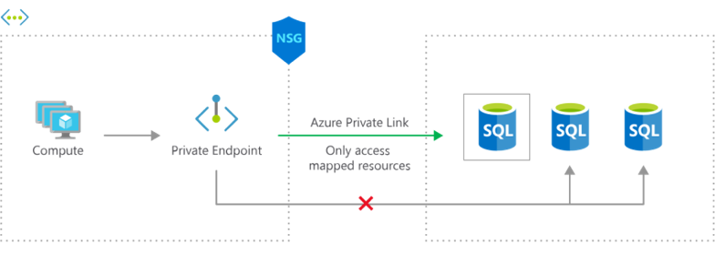

Traffic to the private endpoint bypasses NSG rules, allowing VM1 to upload data to blobs. Network policy MUST be enabled for the vNET specific to NSG, however in this case is NOT mentioned or enabled and hence NSG rules are NOT affecting the private Endpoint.

This feature enhancement provides you with the ability to enable advanced security controls on traffic destined to a private endpoint. In order to leverage this feature, you will need to set a specific subnet level property, called PrivateEndpointNetworkPolicies, to enable on the subnet containing private endpoint resources.

A private endpoint uses a private IP address from your virtual network to access a storage account over the Microsoft backbone network. With a private endpoint, traffic between your virtual network and the storage account are secured over a private link. Storage firewall rules only apply to the public endpoints of a storage account, not private endpoints. The process of approving the creation of a private endpoint grants implicit access to traffic from the subnet that hosts the private endpoint.

Feature | Private Endpoint | Service Endpoint
Type | Network interface | Virtual network extension
Connectivity | Over private IP | Over public IP with VNet identity
Security | Highest (isolated, private) | Moderate (public IP, but restricted access)
Supported Services | Many (Storage, SQL, Web Apps, etc.) | Limited (Storage, SQL, Cosmos DB, etc.)
DNS Configuration | Requires private DNS zone | No DNS changes needed
Traffic Routing | Through Azure backbone | Public endpoint with VNet identity
Cost | Higher (per endpoint) | Lower (no endpoint cost)
Use Case | Secure, private access | Quick access control from VNet

Azure Private Link Service

Azure Private Link service is the reference to your own service that is powered by Azure Private Link. Your service that is running behind Azure Standard Load Balancer can be enabled for Private Link access so that consumers to your service can access it privately from their own VNets. Your customers can create a private endpoint inside their virtual network and map it to this service.

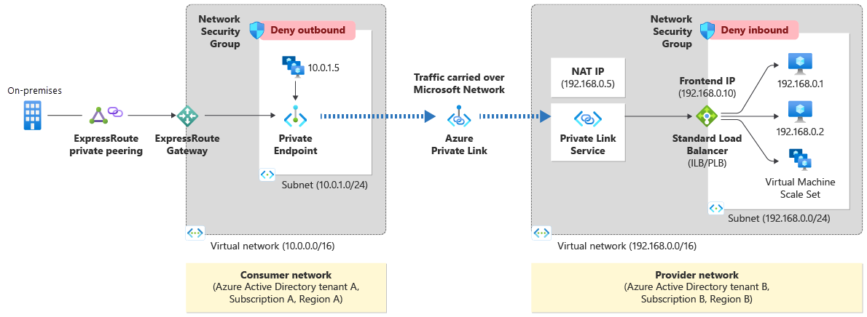

- Configure your application to run behind a standard load balancer in your virtual network. If you already have your application configured behind a standard load balancer, you can skip this step.
- Create a Private Link Service referencing the load balancer above. In the load balancer selection process, choose the frontend IP configuration where you want to receive the traffic. Choose a subnet for NAT IP addresses for the Private Link Service. It's recommended to have at least eight NAT IP addresses available in the subnet. All consumer traffic will appear to originate from this pool of private IP addresses to the service provider. Choose the appropriate properties/settings for the Private Link Service.
- Private Link service can be accessed from approved private endpoints in any public region. The private endpoint can be reached from the same virtual network, regionally peered VNets, globally peered VNets and on premises using private VPN or ExpressRoute connections

You have two Azure subscriptions named Subscription1 and Subscription2. Subscription1 contains a virtual network named Vnet1. Vnet1 contains an application server. Subscription2 contains a virtual network named Vnet2.

You need to provide the virtual machines in Vnet2 with access to the application server in Vnet1 by using a private endpoint.

Step 1: Deploy an Azure Load Balancer in front of the application server - Configure your application to run behind a standard load balancer in your virtual network.

Step 2: In Subscription 1, create a private link service and attach the service to the frontend IP configuration of the load balancer - Create a Private Link Service referencing the load balancer above.

Step 3: In Subscription 2, create a private endpoint by using the private link service.- Private Link service can be accessed from approved private endpoints in any public region. The private endpoint can be reached from the same virtual network, regionally peered VNets, globally peered VNets and on premises using private VPN or ExpressRoute connections.

Step 4: In Subscription1, accept the private endpoint connection request. - Network connections can be initiated only by clients that are connecting to the private endpoint.

NAT Gateway

NAT gateway provides outbound internet connectivity for one or more subnets of a virtual network. Once NAT gateway is associated to a subnet, NAT provides source network address translation (SNAT) for that subnet. NAT gateway specifies which static IP addresses virtual machines use when creating outbound flows. When you create an instance of the Azure NAT Gateway service, your subnet is reconfigured so that it sends all outbound traffic to the NAT gateway service. There’s no need to create routes, because it happens automatically.

- fully managed and highly resilient Network Address Translation (NAT) service
- simplifies outbound Internet connectivity for virtual networks
- When configured on a subnet, all outbound connectivity uses the Virtual Network NAT's static public IP addresses
- A NAT gateway resource can be associated to a subnet and can be used by all compute resources in that subnet
- Multiple subnets within the same virtual network can either use different NAT gateways or the same NAT gateway.
- A NAT gateway can’t span multiple virtual networks.
- Multiple NAT gateways can’t be attached to a single subnet.
- A NAT gateway can’t be deployed in a gateway subnet.
- Outbound connectivity can be scaled out by assigning up to 16 IP addresses to NAT gateway, in any combination of: Public IP addresses, Public IP prefixeS, Public IP addresses and prefixes derived from custom IP prefixes (BYOIP)
- NAT gateway can’t be associated to an IPv6 public IP address or IPv6 public IP prefix. It can be associated to a dual stack subnet, but will only be able to direct outbound traffic with an IPv4 address.
- NAT gateway can be used to provide outbound connectivity in a hub and spoke model when associated with Azure Firewall. NAT gateway can be associated to an Azure Firewall subnet in a hub virtual network and provide outbound connectivity from spoke virtual networks peered to the hub.
- NAT gateway allows flows to be created from the virtual network to the services outside your virtual network. Return traffic from the internet is only allowed in response to an active flow.
- Services outside your virtual network can’t initiate an inbound connection through NAT gateway.
- NAT gateway takes precedence over other outbound scenarios (including Load balancer and instance-level public IP addresses) and replaces the default Internet destination of a subnet.
- The order of operations for outbound connectivity follows this order of precedence: Virtual appliance UDR / ExpressRoute >> NAT gateway >> Instance-level public IP addresses on virtual machines >> Load balancer outbound rules >> default system
- NAT gateway supports TCP and UDP protocols only. ICMP isn't supported.
- A NAT gateway can be created in a specific availability zone or placed in 'no zone'. ZONAL NAT gateway provides internet connectivity FROM a single zone.
- NAT gateway can provide outbound connectivity for virtual machines from other availability zones different from itself
- NAT gateway can be isolated in a specific zone when you create zone isolation scenarios. This deployment is called a zonal deployment. After NAT gateway is deployed, the zone selection can't be changed.

Step 1 : Create a NAT gateway - create NAT gateway with a name specified and create or add new Public IP address in outbound IP
Step 2 : Link subnets to NAT gateway- add NAT gateway to subnets required

Benefits

- Security: With a NAT gateway, individual VMs or other compute resources, don't need public IP addresses and can remain private. Resources without a public IP address can still reach external sources outside the virtual network with NAT gateway's static public IP addresses or prefixes.
- Resiliency: A NAT gateway always has multiple fault domains and can sustain multiple failures without service outage. Software defined networking makes a NAT gateway highly resilient.
- Scalability: When a NAT gateway is associated to a public IP prefix, it automatically scales to the number of IP addresses needed for outbound.
- Performance: NAT gateway won't affect the network bandwidth of your compute resources

SNAT exhaustion occurs when a backend instance runs out of given SNAT Ports. A load balancer can still have unused SNAT ports. If a backend instance's used SNAT ports exceed its given SNAT ports, it will be unable to establish new outbound connections.

Use a NAT gateway for outbound connectivity to the Internet Virtual network NAT gateway is a highly resilient and scalable Azure service that provides outbound connectivity to the internet from your virtual network. A NAT gateway's unique method of consuming SNAT ports helps resolve common SNAT exhaustion and connection issues.

Azure DNS

Azure DNS provides a reliable, secure DNS service to manage and resolve domain names in a virtual network.

You can't use Azure DNS to register a domain name. You use a third-party domain registrar to register your domain. Azure DNS doesn't support Domain Name System Security Extensions.

Security features

- Role-based access control, which gives you fine-grained control over users' access to Azure resources.
- Activity logs, which let you track changes to a resource, and pinpoint where faults occurred
- Resource locking, which gives a greater level of control to restrict or remove access to resource groups, subscriptions, or any Azure resources.

You can manage your domains and records by using the Azure portal, Azure PowerShell cmdlets, or the Azure CLI.

Applications that require automated DNS management can integrate with the service by using the REST API and SDKs.

Initial Domain Name
- When you create an Azure subscription, an Azure AD domain is automatically created. The form domainname.onmicrosoft.com
- The initial domain name is intended to be used until a custom domain name is verified
- The initial domain name can't be changed or deleted
Custom Domain Name
- Can add routable custom domain
- User who creates custom domain must be global administrator who made the subscription
- Domain names in Azure AD are globally unique
- Before a custom domain name can be used by Azure AD, the custom domain name must be added to your directory and verified

Verify custom domain
- Azure AD won't allow any directory resources to use an unverified domain name
- After adding the custom domain name, you must verify ownership of the domain name
- Verification is performed by adding MX or TXT records
- Once records are added with several hours, Azure will query the DNS domain for the presence of the record

Azure DNS Zones(Public DNS)
- To start hosting your domain in Azure DNS, you need to create a DNS zone for that domain name and create DNS records in DNS zone
- Information for the DNS zone includes name, number of records, resource group, location, subscription, and name servers
- The name of the zone must be unique within the resource group, and the zone must not exist already
- The same zone name can be reused in a different resource group or a different Azure subscription.
- When multiple zone share the same name, each zone is assigned to different name server addresses
- Root/Parent domain is registered at the third-party registrar and pointed to Azure NS by signing in to the domain management application provided by your domain registrar which is called Domain Delegation
- Child domains are registered in AzureDNS directly.
- You do not have to own a domain name to create a DNS zone with that domain name in Azure DNS, but to configure the domain, you have to own the domain name
- The SOA record represents your domain and will become the reference point when other DNS servers are searching for your domain on the internet.

nslookup -type=SOA wideworldimports.com

To verify configuration;

nslookup www.wideworldimportsXXXX.com <name server address>

Migrate zone from on-premise DNS to Azure DNS

- Installing the DNS migration script- open elevated PowerShell window(administrative mode) run the command install-script PrivateDNSMigrationProject
- Run script using the command- PrivateDNSMigrationScript.ps1
- Azure DNS zone supports importing and exporting zone files by using Azure CLI. Zone file import is not currently supported by Azure PowerShell and Azure Portal

Delegate DNS Domain
- To delegate your domain to Azure DNS, you need to know allocated name servers from a pool when DNS zone is created
- Once the Name Servers are assigned, Azure DNS automatically creates authoritative NS records in your zone
- The trailing period of name server address indicates the end of a fully qualified domain name.
- Thus, name servers assigned to zone can be shown through Azure portal such as ‘ns1-02.azure-dns.com’, ‘ns2-02.azure-dns.net’, ‘ns3-02.azure-dns.org’, and ‘ns4-02.azure-dns.info’
- Each registrar(the business that sells and registers domains) has their own DNS management tools to edit and replace the name server records for a domain with Azure name servers

Child domains
- Setting up a subdomain follows the same process as typical delegation
- For child zone partners.contoso.com, NS records must be created in the parent zone contoso.com in Azure DNS, rather than in the domain registrar

DNS Record Sets
- A record set is a collection of records in a zone that have the same name and are the same type
- A record set cannot contain two identical records
- Empty record sets (with zero records) can be created, but do not appear on the Azure DNS name server
- Record sets of type CNAME can contain one record at most
- For type A record set, you will need TTL and IP address
- SOA and CNAME records can't contain record sets.

The time to live, or TTL, specifies how long each record is cached by clients before being deleted.

Private DNS zones

- Private DNS zones provides name resolution for virtual machines (VMs) within a virtual network and between virtual networks.
- you can configure zones names with a split-horizon view, which allows a private and a public DNS zone to share the name
- The DNS records for the private zone are not viewable or retrievable, however it will resolve successfully
- Azure DNS supports A, AAAA, CNAME, MX, PTR, SOA, SRV, and TXT records
- Along with hosting your custom DNS records, Azure automatically maintains hostname records for the VMs in the specified virtual networks
- Hostname resolution between virtual networks simplifies cross-network and service-discovery scenarios, such as virtual network peering
- this new offering uses well-established Azure DNS tools (PowerShell, Azure Resource Manager templates, and the REST API)
- Split-horizon DNS support: With Azure DNS, you can create zones with the same name that resolve to different answers from within a virtual network and from the public internet
- Available in all Azure regions in the Azure Public cloud

Scenario 1 : Name resolution scoped to a single virtual network

When you create a Private Zone (contoso.lab) and link it to VNet1 that contains 2 VMs using virtual network link , Azure DNS will automatically create two A records as well as reverse DNS in the zone if you enable auto registration in the link configuration.

Scenario 2 : Name resolution scoped for multiple virtual networks

- VNet1 is designated as a Registration virtual network and VNET2 is designated as a Resolution virtual network.
- The intent is for both virtual networks to share a common zone contoso.lab.
- The Resolution and Registration virtual networks are linked to the zone.
- DNS records for the Registration VNet VMs are automatically created. You can manually add DNS records for VMs in the Resolution virtual network.
- By default, registration VNet act as resolution VNet
- A DNS query from a VM in the Resolution VNet, for a VM in the Registration VNet, will receive a DNS response containing the Private IP of VM.
- A Reverse DNS (PTR) query from a VM in the Resolution virtual network, for a VM in the Registration VNet, will receive a DNS response containing the NXDOMAIN of the VM. But, a reverse DNS query from a VM in the Resolution VNet, for a VM in the same VNet, will receive the FQDN.

Virtual network link

- After you create a private DNS zone in Azure, you'll need to link a virtual network to it. Once linked, VMs hosted in that virtual network can access the private DNS zone
- Every private DNS zone has a collection of virtual network link child resources. Each one of these resources represents a connection to a virtual network.
- A virtual network can be linked to private DNS zone as a registration or as a resolution virtual network.

Registration virtual network

- Once auto registration is enabled at the creation of virtual network link, virtual network gets capability to create DNS records automatically for any virtual machines you deploy in the virtual network.
- DNS records will also be created for virtual machines already deployed in the virtual network.
- A private DNS zone can have multiple registration virtual networks. However, every virtual network can only have one registration zone associated with it.

Resolution virtual network

- If you choose to link your virtual network with the private DNS zone without auto registration
- DNS records for virtual machines deployed this virtual network won't be created automatically in the private zone. However, virtual machines deployed in the virtual network can successfully query for DNS records in the private zone.
- One private DNS zone can have multiple resolution virtual networks and a virtual network can have multiple resolution zones associated to it

Domain lookup requests

- Checks to see if the domain name is stored in the short-term cache. If so, the DNS server resolves the domain request.
- If the domain isn't in the cache, it contacts one or more DNS servers on the web to see if they have a match. When a match is found, the DNS server updates the local cache and resolves the request.
- If the domain isn't found after a reasonable number of DNS checks, the DNS server responds with a domain cannot be founderror.

In DNS instance , the DNS server will act as a start of authority (SOA) for your domain. The SOA and NS records are created automatically when you create a DNS zone by using Azure DNS.

The SOA record represents your domain, and is used when other DNS servers are searching for your domain. SOA contains following information.

- Name of the server that supply the data
- Administrator of the zone
- Current version of the data file
- Number of seconds a secondary server should wait before checking for updates
- Number of seconds a secondary server should wait before retrying failed zone transfer
- Maximum number of seconds that a secondary name server can use data before it must either be refreshed or expire
- Default number of seconds for the Time-To-Live on resource records

DNS record types
- A is the host record, It maps the domain or host name to the IP address.
- CNAME is a Canonical Name record that's used to create an alias from one domain name to another domain name
- MX is the mail exchange record. It maps mail requests to your mail server
- TXT is the text record. It's used to associate text strings with a domain name. Azure and Microsoft 365 use TXT records to verify domain ownership

Apex domain
- highest level of your domain which refer as zone apex or root apex
- It's often represented by the @ symbol in your DNS zone records e.g @combank.lk
- NS and SOA are apex domain records
- CNAME records that you might need for an Azure Traffic Manager profile or Azure Content Delivery Network endpoints aren't supported at the zone apex level.
- Alias records are supported at the zone apex level.

Alias records
Azure alias records enable a zone apex domain to reference other Azure resources from the DNS zone.

The Azure alias record can point to the following Azure resources:
- A Traffic Manager profile
- Azure Content Delivery Network endpoints
- A public IP resource
- A front door profile

Alias records provide lifecycle tracking of target resources, ensuring that changes to any target resource are automatically applied to the DNS zone and support for load-balanced applications in the zone apex.

Alias record set supports A, AAAA, CNAME

To create an alias record in zone apex,

Azure portal>> Resource group>> Select DNS zone >> add record set

Name - Leave the name blank for indicating apex domain
Type - A, AAAA, CNAME
Alias record set -Yes
Alias type - Azure resource
Azure resource - select from Azure resources
TTL

Advantages of alias records

- Prevents dangling DNS records by by tightly coupling the lifecycle of Azure resources : A dangling DNS record occurs when the DNS zone records aren't up-to-date with changes to IP addresses
- Updates DNS record set automatically when underlying IP addresses of resource, service, or application is changed, the alias record ensures that any associated DNS records are automatically refreshed.
- Alias records allow for zone apex resource routing to Traffic Manager and Azure CDN

Azure DNS Private Resolver

Azure DNS Private Resolver to simplify hybrid recursive Domain Name System (DNS) resolution. You can use DNS Private Resolver for on-premises workloads and Azure workloads. DNS Private Resolver simplifies private DNS resolution from on-premises to the Azure private DNS service and vice versa.

The following sections present alternatives for hybrid recursive DNS resolution

Use a DNS forwarder VM

- Before DNS Private Resolver is available, a DNS forwarder VM was deployed so that an on-premises server could resolve requests to the Azure private DNS service
- A conditional forwarder on the on-premises DNS server forwards requests to Azure, and a private DNS zone is linked to a virtual network.
- Requests to the Azure service then resolve to the appropriate private IP address.
- you can't use the Azure public DNS service to resolve on-premises domain names.

Azure Traffic Manager

- Azure Traffic Manager is a DNS-based traffic load balancer
- This service allows you to distribute traffic to your public facing applications across the global Azure regions
- uses DNS to direct the client requests to the appropriate service endpoint based on a traffic-routing method
- provides health monitoring for every endpoint

Azure traffic manager routing method

Priority

When you choose priority routing, a prioritized list of service endpoints appears, with the primary service endpoint receiving the highest priority for all traffic. If the primary service endpoint is down, traffic is routed to the next highest priority endpoint, and so on.

Weighted

When you want to distribute traffic uniformly or utilize pre-defined weights across a collection of endpoints, you use the weighted routing approach. In this traffic-routing approach, you assign a weight to each endpoint in the Microsoft Azure Traffic Manager profile configuration, which is an integer ranging from 1 to 1000.

Performance

When you wish to improve the responsiveness of several apps by routing traffic to the place nearest to the user, this traffic routing strategy is utilized. The 'closest' endpoint isn't always the one with the shortest geographic distance. Instead, the 'Performance' traffic-routing mechanism uses network latency to select the closest endpoint.

Geographic

Each endpoint linked with a profile must have a set of geographic regions allocated to it in geographic routing. When a region or a group of regions is assigned to an endpoint, all requests from that region or set of regions are routed exclusively to that endpoint. With this routing method, it enables you to be in compliance with scenarios such as data sovereignty mandates, localization of content & user experience and measuring traffic from different regions.

Multivalue

For Azure Traffic Manager profiles with only IPv4/IPv6 addresses as endpoints, you can choose MultiValue. All healthy endpoints are returned when a question for this profile is received.

The Multivalue traffic-routing method allows you to get multiple healthy endpoints in a single DNS query response. This configuration enables the caller to do client-side retries with other endpoints in case a returned endpoint being unresponsive. This pattern can increase the availability of a service and reduce the latency associated with a new DNS query to obtain a healthy endpoint. MultiValue routing method works only if all the endpoints of type ‘External’ and are specified as IPv4 or IPv6 addresses. When a query is received for this profile, all healthy endpoints are returned and are subject to a configurable maximum return count.

Subnet

To map sets of end-user IP address ranges to a specific endpoint within an Azure Traffic Manager profile, utilize the Subnet traffic-routing mechanism. When a request is received, the endpoint that is returned is the one that is mapped to the source IP address of the request.

In this scenario, I'll present two virtual machines that have been connected into Azure Traffic Manager and are prioritized

Endpoint type

• Azure endpoints are used for services hosted in Azure.

• External endpoints are used for services hosted outside Azure, either on-premises or with a different hosting provider

. • Nested endpoints are used to combine Traffic Manager profiles to create more flexible traffic-routing schemes to support the needs of larger, more complex deployments.

Scenario 1:
You cannot combine both 'Weighted' and 'Geographic' traffic-routing in a single profile. The parent profile still uses the Geographic traffic-routing method and child profile uses the Weighted traffic-routing method. This 'child' profile act as an endpoint to the 'parent' profile. Initially, there are only 3 endpoints with 1 TM profile using Geographic routing-method. However, you need to deploy 10% of traffic to Tokyo which requires Weighted TM routing-method. When you create a Child TM, it is considered as endpoint. Therefore, 3 endpoints + 1 endpoint (child TM) is equal to 4 endpoints. 1 Parent TM Profile + 1 Child Profile is equal to 2 Profiles.

CheckingEndpoint is a temporary state that usually occurs immediately after adding or enabling an endpoint in the profile. An endpoint in this state is included in DNS responses and can receive traffic.

Front Door

If you need to optimize global routing of your web traffic and optimize top-tier end-user performance and reliability through quick global failover.

Front Door is an application delivery network that provides global load balancing and site acceleration service for web applications.

It offers Layer 7 capabilities for your application like SSL offload, path-based routing, fast failover, caching, Support cookie-based affinity etc. to improve performance and high-availability of your applications.

The Azure Web Application Firewall (WAF) rate limit rule for Azure Front Door controls the number of requests allowed from clients during a one-minute duration.

The way that you configure Front Door depends on how many application instances you deploy:

Single-region deployment: Create a single origin group. Within that origin group, create a single origin to represent the App Service app. Your App Service app might be configured to scale out across worker instances, but from Front Door's perspective there's a single origin.

Multi-region active/passive deployment: Create a single origin group. Within that origin group, create an origin for each of the App Service apps. Configure each origin's priority to ensure that the primary application has a higher priority than the secondary application.

Multi-region active/active deployment: Create a single origin group. Within that origin group, create an origin for each of the App Service apps. Configure each origin's priority to be the same. Configure each origin's weight to set the proportion of requests that should go to that origin.
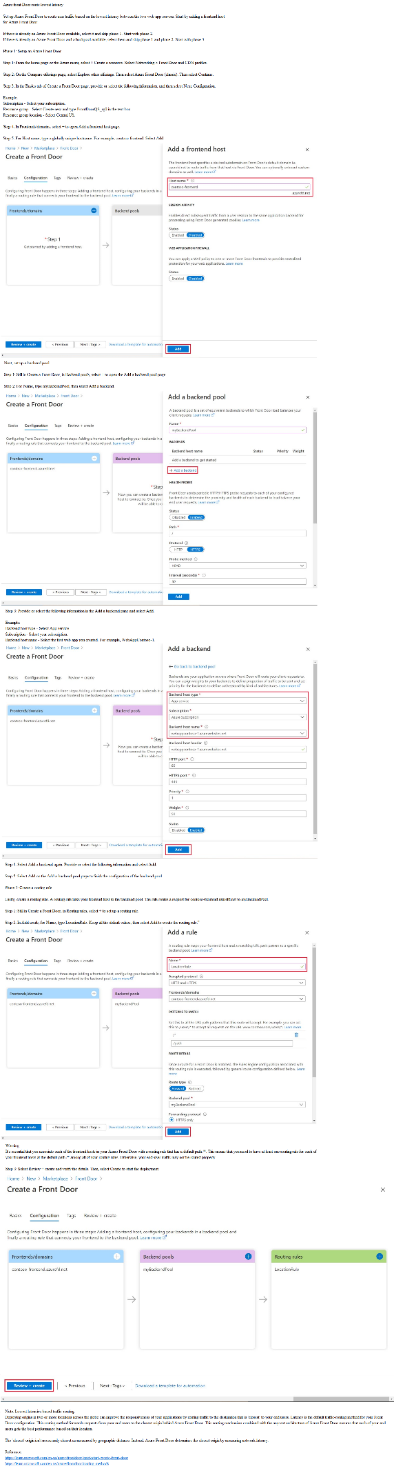

A web application delivered by Front Door can have only one WAF policy associated with it at a time. One WAF policy can be associated with multiple Frontend host.

Azure Front Door web application firewall protects web applications from common vulnerabilities and exploits. Azure managed rule sets provide an easy way to deploy protection against common set of security threats.

Plan:
Stage 1: Create WAF policy
Stage 2: Create a custom WAF Geo location rule that blocks all traffic outside Canada
Stage 3: Create a custom WAF Geo location rule that allows from Canada

Stage 1: Create WAF policies with policy for regional WAF(Front Door) and policy name, then associate specifying application gateway, HTTP listener, route path

Stage 2: In the WAF policy by default it is detection mode. Change it to prevention mode, matching rules defined in CRS by specifying custom rule name, priority, match type: Geo location, match variable: ReloteAddr, Operation: Is not, Country: Canada, Then: Deny traffic

Stage 3: defined in CRS by specifying custom rule name, priority, match type: Geo location, match variable: ReloteAddr, Operation: Is , Country: Canada, Then: Allow traffic

Add custom domain to Azure Front Door

When you use Azure Front Door for application delivery, a custom domain is necessary if you want your own domain name to be visible in your end-user request.

After you create a Front Door profile, the default frontend host is a subdomain of azurefd.net. This name is included in the URL for delivering Front Door content to your backend by default. For example, https://contoso-frontend.azurefd.net

- Before you can use a custom domain with your Front Door, you must first create a canonical name (CNAME) record with your domain provider to point to the Front Door default frontend host
- In Azure Front Door, the source domain name is your custom domain name and the destination domain name is your Front Door default hostname. Once Front Door verifies the CNAME record gets created, traffic to the source custom domain gets routed to the specified destination Front Door default frontend host.
- A custom domain can only be associated with one Front Door profile at a time. However, you can have different subdomains of an apex domain in the same or a different Front Door profile.
- When you map an existing domain that is in production. a brief period of downtime for the domain may occur while you're registering your custom domain in the Azure portal. To avoid interruption of web traffic, map your custom domain to your Front Door default frontend host with the Azure afdverify subdomain first to create a temporary CNAME mapping, example afdverify.<custom domain name> point to afdverify.contoso-frontend.azurefd.net. If you've verified that the afdverify subdomain has been successfully mapped to your Front Door, you can then map the custom domain directly to your default Front Door frontend host.
- Associate the custom domain with front door. Azure verifies that the CNAME record exists for the custom domain name you entered.
- You must ensure that each of the frontend hosts (including custom domains) in your Front Door has a routing rule with a default path ('/*') associated with it. That is, across all of your routing rules there must be at least one routing rule for each of your frontend hosts defined at the default path ('/*'). Failing to do so, may result in your end-user traffic not getting routed correctly.

Virtual network peering

- the simplest and quickest way to seamlessly connect two Azure virtual networks
- Once peered, the virtual networks appear as one, for connectivity purposes
- It takes advantage of the high bandwidth and low latency of the Azure backbone network
- Cannot add or delete address space into or from virtual network once a virtual network is peered with another virtual network. Remove peering and recreate it later is the option

Regional VNet peering connects Azure virtual networks in the same region.

Global VNet peering connects Azure virtual networks in different regions. When creating a global peering, the peered virtual networks can exist in any Azure public cloud region or China cloud regions, but not in Government cloud regions. You can only peer virtual networks in the same region in Azure Government cloud regions.

Features of virtual network

- Reciprocal Connection - When you create a virtual network peering connection in only one virtual network to connect to a peer in another network, you have to create connections in each virtual network
- Cross-subscription virtual network peering- You can use virtual network peering even when both virtual networks are in different subscriptions where the subscriptions can use the same or different Azure Active Directory tenants. To peer the virtual networks when both subscriptions are in different Azure Active Directory tenants, the administrators of each subscription must grant the peer subscription's administrator the Network Contributor role on their virtual network.
- Transitivity - Virtual network peering is nontransitive. However, you can configure user-defined routes and service chaining to provide the transitivity
- Gateway transit- You can configure transitive connections on-premises if you use virtual network gateways as transit points. To enable gateway transit, configure the Allow gateway transit option in the hub virtual network where you deployed the gateway connection to your on-premises network. Also configure the Use remote gateways option in any spoke virtual networks. A virtual network can configure only one at a time either remote gateway or VPN gateway
- Overlapping address spaces - IP address spaces of connected networks within Azure and your on-premises system can't overlap
- Alternative connectivity methods- The virtual networks that connect to an ExpressRoute circuit are part of the same routing domain and can communicate with each other. You can use a site-to-site configuration to connect virtual networks together through VPN gateways. When virtual networks are connected through both a gateway and virtual network peering, traffic flows through the peering configuration

Create virtual network and subnet in the network;

az network vnet create \
--resource-group [sandbox resource group name] \
--name SalesVNet \
--address-prefixes 10.1.0.0/16 \
--subnet-name Apps \
--subnet-prefixes 10.1.1.0/24 \
--location northeurope

az network vnet list --output table ; Table the created virtual networks

Create a VM in virtual network;

az vm create \
--resource-group [sandbox resource group name] \
--no-wait \ ; this command lets you continue working in Cloud Shell while the VM is building.
--name SalesVM \
--location northeurope \
--vnet-name SalesVNet \
--subnet Apps \
--image UbuntuLTS \
--admin-username azureuser \
--admin-password <password>

watch -d -n 5 "az vm list \
--resource-group [sandbox resource group name] \
--show-details \
--query '[*].{Name:name, ProvisioningState:provisioningState, PowerState:powerState}' \
--output table". ; uses the Linux watch command, which is configured to refresh every five seconds

To create the peering connection between the SalesVNet and MarketingVNet virtual networks;

az network vnet peering create \
--name SalesVNet-To-MarketingVNet \
--remote-vnet MarketingVNet \
--resource-group [sandbox resource group name] \
--vnet-name SalesVNet \
--allow-vnet-access

To create a reciprocal connection from MarketingVNet to SalesVNet;

az network vnet peering create \
--name MarketingVNet-To-SalesVNet \
--remote-vnet SalesVNet \
--resource-group [sandbox resource group name] \
--vnet-name MarketingVNet \
--allow-vnet-access

Thus, you can create virtual network peering between virtual networks.

To check virtual network peering connection

az network vnet peering list \
--resource-group [sandbox resource group name] \
--vnet-name SalesVNet \
--output table

In the PeeringState column, make sure the status is Connected.

Check effective routes

check the peering connection by looking at the routes that apply to the network interfaces of the VMs

az network nic show-effective-route-table \
--resource-group [sandbox resource group name] \
--name SalesVMVMNic \
--output table

You should see a route to networks prefix with Next Hop Type of VNetPeering

Check virtual network peering connectivity by using SSH between Azure VM;

1. create a connection from Azure Cloud Shell to a target VM's publicIP address, first you should get list of IP addresses that use to connect to VMs

az vm list \
--resource-group [sandbox resource group name] \
--query "[*].{Name:name, PrivateIP:privateIps, PublicIP:publicIps}" \
--show-details \
--output table

2. Connect VM using public IP address

ssh -o StrictHostKeyChecking=no azureuser@<SalesVM public IP>

3. Connect other VM using private IP addres from connected VM

ssh -o StrictHostKeyChecking=no azureuser@<MarketingVM private IP>

Enter exit to close SSH session

Thus, The connection attempt will fail if you are trying to connect between VMs that they are in virtual networks that is not peered. Up to 60 seconds might pass before the connection attempt times out. To force the attempt to stop, use Ctrl+C.

Benefits of virtual network peering

- Traffic between peered virtual networks is private and kept on Microsoft backbone network where no public Internet, gateways, or encryption is required
- A low-latency, high-bandwidth connection between resources in different virtual networks
- The ability for resources in virtual networks to communicate each other once virtual networks are peered
- The ability to transfer data across Azure subscriptions, deployment models, and across Azure regions
- No downtime to resources in either peered virtual network

Gateway transit and connectivity

- When virtual networks are peered, you configure a VPN gateway as a transit point
- A peered virtual network uses the remote gateway to gain access to other resources
- A virtual network can have only one gateway
- Gateway transit is supported for both regional VNet Peering and Global VNet Peering
- With the Vnet peering, you can either open or close the network security group rules between the virtual networks
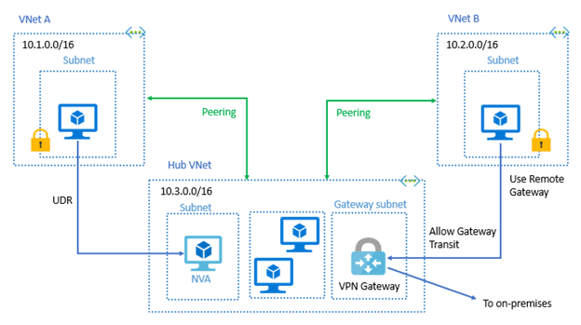

When you Allow Gateway Transit the virtual network can communicate to resources outside the peering. For example, the gateway subnet could:
- Use a site-to-site VPN to connect to an on-premises network.
- Use a VNet-to-VNet connection to another virtual network.
- Use a point-to-site VPN(User VPN) to connect individual device to virtual network (point-to-site connect to Vnet must have client certificate installed. You generate client certificate from self-signed root certificate, the export and install the certificate. If no certificate installed, authentication will fail)

Gateway transit allows peered virtual networks to share the gateway and it doesn’t need to deploy a VPN gateway.

To configure the peering use the Add peering page. It contains followings.
- Peering link name
- Traffic to remote virtual network(allow/block)
- Traffic forwarded from remote virtual network(allow/block)
- Virtual network gateway(use this gateway/use remote network’s gateway/none)

When you add a peering on one virtual network, the second virtual network configuration is automatically added.

Service chaining
- VNet Peering is nontransitive. When you establish VNet peering between VNet1 and VNet2 and between VNet2 and VNet3, VNet peering capabilities do not apply between VNet1 and VNet3
- However, you can configure user-defined routes and service chaining to provide the transitivity

Service chaining allows;
- Implement a multi-level hub and spoke architecture.
- Overcome the limit on the number of VNet peerings per virtual network.

Virtual network peering enables the next hop in a user-defined route to be the IP address of a virtual machine in the peered virtual network, or a VPN gateway.

Hub and spoke architecture
- All the spoke virtual networks can then peer with the hub virtual network
- Hub virtual network hosts infrastructure components like network virtual appliance and VPN gateway so that traffic can flow though them

Checking connectivity
- Initiated: When you create the peering to the second virtual network from the first virtual network, the peering status is Initiated
- Connected: When you create the peering from the second virtual network to the first virtual network, its peering status is Connected. The peering is not successfully established until the peering status for both virtual network peerings is Connected.

Secure access to virtual networks

Network Security Group(NSG)

- can limit network traffic to resources in a virtual network using a network security group (NSG)
- NSG contains a list of security rules that allow or deny inbound or outbound network traffic
- NSG can be associated to a subnet or a network interface
- A network security group can be associated multiple times
- NSG has associated subnets, associated network interfaces, and security rules.
-NSG cannot filter traffic based FQDN, only IP address and service tag such as internet are supported

Subnets

- Subnet can have zero, or one, associated network security group
- By assigning NSG, create protected screened subnets (also called a DMZ)

Network interfaces
- can assign NSGs to a NIC to control all traffic
- network interface that exists in a subnet can have zero, or one, associated network security groups.

If similar inbound rule is applied at subnet and network interface, the rule with higher priority will be applied.

NSG Rules

NSG rules are specified with followings.

- Name
- Priority
- Port
- Protocol (Any, TCP, UDP)
- Source (Any, IP Addresses, Service tag)
- Destination (Any, IP Addresses, Virtual Network)
- Action (Allow or Deny)

Azure creates the default rules in each network security group that you create. You cannot remove the default rules, but you can override them by creating rules with higher priorities.

Inbound rules
- Three default inbound security rules
- The rules deny all inbound traffic except from the virtual network and Azure load balancers.
- For incoming traffic, the NSG set at the subnet level is evaluated first, then the NSG set at the NIC level is evaluated.

Outbound rules
- three default outbound security rules
- the rules only allow outbound traffic to the Internet and the virtual network
- For outgoing traffic, the NSG set at the NIC level is evaluated first, the NSG set at the subnet level is evaluated

If you have several NSGs and are not sure which security rules are being applied, you can use the Effective security rules link.

Service-Service specifies the destination protocol and port range for this rule

Port ranges - Port ranges can include a single port, a port range, or a comma-separated list of ports

Priority- Rules are processed in priority order. The lower the number, the higher the priority. The value is between 100-4096 and unique for all security rules within the network security group.

Application security groups

- enable you to configure network security as a natural extension of an application's structure, allowing you to group virtual machines and define network security policies based on those groups
- reuse your security policy at scale without manual maintenance of explicit IP addresses
- The platform handles the complexity of explicit IP addresses and multiple rule sets, allowing you to focus on your business logic.
- The rules that specify an application security group as the source or destination are only applied to the network interfaces that are members of the application security group.
- a network interface can be a member of multiple application security groups
- There are limits to the number of application security groups you can have in a subscription
- All network interfaces assigned to an application security group have to exist in the same virtual network
- If you specify an application security group as the source and destination in a security rule, the network interfaces in both application security groups must exist in the same virtual network.

To minimize the number of security rules you need, and the need to change the rules, plan out the application security groups you need and create rules using service tags or application security groups, rather than individual IP addresses, or ranges of IP addresses, whenever possible.

Azure Firewall

- Azure Firewall is a managed, cloud-based network security service that protects your Azure Virtual Network resources
- It's a fully stateful firewall as a service, so it can distinguish legitimate packets for different types of connections
- built-in high availability as primary and secondary instances
- unrestricted cloud scalability to accommodate changing network traffic flows
- Deploy to span multiple Availability Zones for increased availability with 99.99% SLA
-You can filter traffic based on FQDN
- limit outbound HTTP/S traffic or Azure SQL traffic to a specified list of FQDN including wildcards
- centrally create allow or deny network filtering rules by source and destination IP address, port, and protocol across subscriptions and virtual networks
- Azure Firewall uses a static public IP address for your virtual network resources allowing outside firewalls to identify traffic originating from your virtual network and use multiple public address
- The service is fully integrated with Azure Monitor for logging and analytics
- It has built-in Threat intelligence-based filtering can be enabled for your firewall to alert and deny traffic from/to known malicious IP addresses and domains
- Parent policy must be in the same region as child policy. Firewall policy can be associated with Firewalls across regions regardless of where they are stored." That's from Azure Portal, showed for the field "Parent Policy" when creating a new policy or editing an existing one. We can't associate existing child policies to the new parent policy if their are not in the same region.
-Azure Firewall is created on a dedicated subnet in virtual network, it should be named as AzureFirewallSubnet for Azure firewall service

- Create Azure Firewall

Basic - Subscription, Resource group, name, Region, Availability zone, Firewall SKU(Basic, Standard, Premium), Firewall management(Use a Firewall policy to manage this firewall, Use a Firewall rules(classic) to manage this firewall), Firewall policy, Virtual network(create a virtual network and dedicated subnet), Public IP address, Forced tunnelling(on/off)

-Only Standard firewall has options to choose firewall management
-Premium firewall needs to have firewall policy created in Firewall Manager

- Create route table
- Create default route 0.0.0.0/0 towards next hop type-Virtual appliance and next hop address - private IP of Firewall
- Associate the VM subnet that needs to be routed via Azure Firewall service to route table
- Connect to the VM using the NAT facility which is available for Azure Firewall(Create NAT rule collection)
- Create application rule collection to access target FQDN
- Create network rule collection for connectivity between subnets

It's recommended to use a hub-spoke network topology when deploying a firewall.

hub - virtual network in Azure that acts as a central point of connectivity to your on-premises network

spokes - virtual networks that peer with the hub

Traffic flows between the on-premises datacenter and the hub through an ExpressRoute or VPN gateway connection.
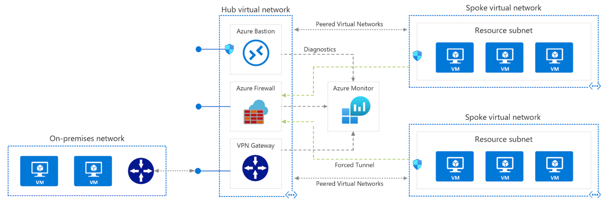

Benefit of this topology

- Cost savings by centralizing services that can be shared by multiple workloads, such as network virtual appliances (NVAs) and DNS servers
- Overcome subscriptions limits by peering virtual networks from different subscriptions to the central hub
- Separation of concerns between central IT (SecOps, InfraOps) and workloads (DevOps)
- Workloads located in spoke virtual networks don’t require connectivity to each other, make access to shared services

Create Firewall Rules

By default, Azure Firewall blocks all traffic, unless you enable it.

NAT Rule

- Destination Network Address Translation (DNAT) to translate and filter inbound traffic to your subnets by publishing SSH, RDP, or non-HTTP/S applications to the Internet.
- A NAT rule that routes traffic must be accompanied by a matching network rule to allow the traffic
- Name, protocol, source address, Destination address: The external address of the firewall, Destination port: The TCP or UDP ports that the rule will listen, Translated Address: The IP address of the service (virtual machine, internal load balancer, and so on) that privately hosts, Translated Port: The port that the inbound traffic will be routed

Network Rule

- When non-HTTP/S traffic that will be allowed to flow through the firewall. For example, resources in one subnet must communicate with resources in another subnet
- Name, Protocol: TCP, UDP, ICMP (ping and traceroute) or Any, Source Address, Destination Address, Destination ports

Application Rule

- Application rules define fully qualified domain names (FQDNs) that can be accessed from a subnet. For example, specify the Windows Update network traffic through the firewall.
- Name, Source Addresses, Protocol: HTTP/HTTPS, Port that web server is listening on, Target FQDNs: The domain name of the service or wildcard, An FQDN tag represents a group of FQDNs associated.

Precedence of rule processing

The rules are processed in this order:
1. Network Rules
2. Application Rules (network and application)

Once a rule is found that allows the traffic through, no more rules are checked.

Azure Firewall DNS proxy is an option to meet this DNS forwarding requirement, applicable with a hub-and-spoke model. To do this, configure your on-premises DNS server to conditionally forward requests to Azure Firewall for the required zone name. Ensure that your private DNS zone is linked to the Virtual Network within which the Azure Firewall resides. Configure Azure Firewall to use the default Azure DNS for lookups, and enable DNS proxy in Azure Firewall DNS settings.

Azure Firewall with Standard SKU is recommended for customers looking for Layer 3–Layer 7 firewall and needs autoscaling to handle peak traffic periods of up to 30 Gbps. It supports enterprise features like threat intelligence, DNS proxy, custom DNS, and web categories.

Configure Load Balancing

Azure Load Balancer

The Azure Load Balancer delivers high availability and scalable network performance to your applications.

- distribute incoming network traffic across a group of back-end resources or services such as virtual machines (VMs) using load-balancing rules and health probes, it is about Layer 4 load balancing
- Support inbound and outbound scenarios scaling your applications while maintaining throughput and keeping response times low
- Load balancers use a hash-based distribution algorithm
- you can use availability sets ( SLA - 99.95%, Protection from hardware failures within datacenters) and availability zones( SLA- 99.99%, Protection from entire datacenter failure) to ensure that virtual machines are always available
- A standard load balancer is required for HA ports

Distribution mode

By default, Azure Load Balancer distributes network traffic equally among virtual machine instances.

Five-Tuple hash

- The default distribution mode for Load Balancer
- The tuple is composed of source IP, source port, destination IP, destination port, and protocol type
- The source port is included in the hash and the source port changes for each session, clients might be directed to a different virtual machine for each session.

Source IP affinity

- also known as session affinity or client IP affinity
- To map traffic to the available servers, the source IP affinity mode uses a two-tuple hash (from the source IP address and destination IP address) or a three-tuple hash (from the source IP address, destination IP address, and protocol type)
- The hash ensures that requests from a specific client are always sent to the same virtual machine behind the load balancer.
- Use source IP affinity for load balancing with your Remote Desktop gateway service
- Use source IP affinity for media upload where TCP and UDP connections to different destination IP addresses, media upload won’t be successfully completed

Set distribution mode;

$lb = Get-AzLoadBalancer -Name MyLb -ResourceGroupName MyResourceGroup
$lb.LoadBalancingRules[0].LoadDistribution = 'sourceIp'
Set-AzLoadBalancer -LoadBalancer $lb

Change the value for Session persistence to Client IP.

Load-balancing rules determine how traffic is distributed to the backend
Health probes ensure the resources in the backend are healthy

- The Load Balancer can be used for inbound and outbound scenarios and scales up to millions of TCP and UDP application flows
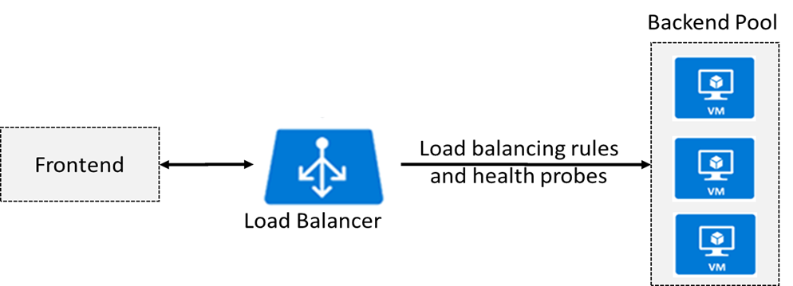

Public load balancer(External load balancer)

- A public load balancer maps the public IP address and port number of incoming traffic from clients in internet to the private IP address and port number of the VM.
- The traffic might come from browsers, mobile apps, or other sources.
- Mapping is also provided for the response traffic from the VM.
- Load balancer and the public IP address SKU must match when you use them with public IP addresses. Only Basic SKU IPs work with the Basic SKU load balancer and only Standard SKU IPs work with Standard SKU load balancers.
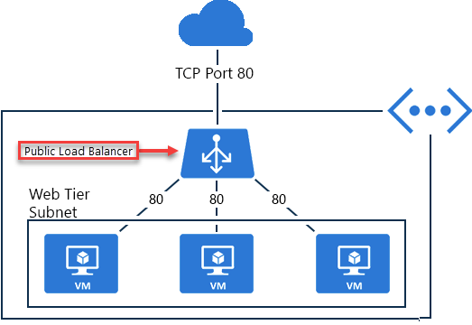

- You can configure Azure Load Balancer by using the Azure portal, PowerShell, or the Azure CLI

Create load balancer

- Create a new public IP address

az network public-ip create \
--resource-group [sandbox resource group name] \
--allocation-method Static \
--name myPublicIP

- Create the load balancer

az network lb create \
--resource-group [sandbox resource group name] \
--name myLoadBalancer \
--public-ip-address myPublicIP \
--frontend-ip-name myFrontEndPool \
--backend-pool-name myBackEndPool

- To monitor status of VM servers, create a health probe. The health probe dynamically adds or removes VMs from the load balancer rotation based on their response to health checks

az network lb probe create \
--resource-group [sandbox resource group name] \
--lb-name myLoadBalancer \
--name myHealthProbe \
--protocol tcp \
--port 80

- a load balancer rule that's used to define how traffic is distributed to the VMs. You define the front-end IP configuration for the incoming traffic and the back-end IP pool to receive the traffic, along with the required source and destination port. To make sure only healthy VMs receive traffic, you also define the health probe to use

az network lb rule create \
--resource-group [sandbox resource group name] \
--lb-name myLoadBalancer \
--name myHTTPRule \
--protocol tcp \
--frontend-port 80 \
--backend-port 80 \
--frontend-ip-name myFrontEndPool \
--backend-pool-name myBackEndPool \
--probe-name myHealthProbe

- Connect the VMs to the back-end pool by updating the network interfaces you created in the script

Internal Load Balancer

- directs traffic to resources that are inside a virtual network or that use a VPN to access Azure infrastructure
- Frontend IP addresses and virtual networks are never directly exposed to an internet endpoint
- Assign a private IP address instead of a public IP address for the front end of the load balancer.
- Place the internal load balancer in the protected virtual network
- Load balancing from VMs in the virtual network to a set of VMs that reside within the same virtual network.For example, an internal load balancer could receive database requests that need to be distributed to backend SQL servers.
- Load balancing from on-premises computers to set of VMs in virtual network
- Load balancing for internet-facing multi-tier applications where the backend tiers are not internet-facing. In this case, A public load balancer could be placed in front of the internal load balancer to create a multi-tier application.
- Load balancing for line-of-business applications that are hosted in Azure where on-premise server traffic is load balanced
- You can use the default distribution mode of a five-tuple hash and don’t need to use source IP affinity

Basic Load Balancer: Backend pool endpoints for Virtual machines in a single availability set or virtual machine scale set.

Load balancer SKUs

- The load balancer supports both Basic and Standard SKUs, each differing in scenario scale, features, and pricing
- Standard load balancer has granular feature set over Basic Load Balancer
- When you create LB instance, it includes Name, Region, Type(Internal/Public), SKU(Basic/Standard), Virtual network name, subnet, IP address assignment (Static/Dynamic)
- The Basic SKU can be upgraded to the Standard SKU, but Standard should use for new design
- For the Standard SKU you can connect to an Availability set, multiple virtual machine, or a virtual machine scale set

Basic load balancers allow:

- Port forwarding
- Automatic reconfiguration
- Health probes
- Outbound connections through source network address translation (SNAT)
- Diagnostics through Azure Log Analytics for public-facing load balancers
- can be used only with availability sets.
- For the Basic SKU you can connect to an Availability set, single virtual machine, or a virtual machine scale set. If you have multiple virtual machines in backends, they should be part of either an Availability set or a virtual machine scale set

Standard load balancers support all of the basic features with:

- HTTPS health probes
- Availability zones
- Diagnostics through Azure Monitor, for multidimensional metrics
- High availability (HA) ports
- Outbound rules
- A guaranteed SLA (99.99% for two or more virtual machines)
- For the Standard SKU you can connect to an Availability set, multiple virtual machine, or a virtual machine scale set
-Standard Load Balancer is secure by default

SKUs capabilities

- Instance count in backend pool(300/1000)
- Health probes(HTTP,TCP/ HTTPS,HTTP,TCP)
- Availability zone
- Multiple front ends(Inbound/Outbound)
- Secure by default (whether implement NSG)
- SLA(none/99.99%)

Backend pool

- a back-end address pool contains the IP addresses of the virtual NICs that are connected to the load balancer in order to distribute traffic
- Backend pool endpoint includes a blend of virtual machines, availability sets, and virtual machine scale sets
- When you create backend pool, it includes Name, associated to( Unassociated, single virtual machines, availability sets, and virtual machine scale sets)
- Before backend pool or VM connect to LB, create NSG and assign it to backend pool or VM
-NSG on subnet or NIC of virtual machines is required to allow traffic from internet when standard load balancer is used, NSG does not need for basic load balancer

Load balancing rule

- The rule maps a given frontend IP and port combination to a set of backend IP addresses and port combination
- Before configuring the rule, create the frontend, backend pool, and health probe
- When you add load balancing rule, it includes Name, IP version(IPV4/IPV6), Frontend IP address(you should create first), Protocol(TCP/UDP), Port, Backend port, backend pool(you should create first), Health probe, Session persistence, Idle timeout(minutes), Floating IP(direct server return)
- you could use NAT rule from the load balancer’s public address to TCP 3389 on a specific virtual machine

Azure PowerShell;

New-AzureRmLoadBalancerRuleConfig

Session persistence

- By default, Azure Load Balancer distributes network traffic equally among multiple VM instances.
- LB uses a five-tuple (source IP, source port, destination IP, destination port, and protocol type) hash to map traffic to available servers
- Session persistence specifies how traffic from a client should be handled

None (default) specifies any virtual machine can handle the request.
Client IP specifies that successive requests from the same client IP address will be handled by the same virtual machine.
Client IP and protocol specifies that successive requests from the same client IP address and protocol combination will be handled by the same virtual machine.

Floating IP

Some application scenarios prefer or require the same port to be used by multiple application instances on a single VM in the backend pool. Common examples of port reuse include:
- clustering for high availability
- network virtual appliances
- exposing multiple TLS endpoints without re-encryption.

If you want to reuse same backend port across multiple rules, you must enable Floating IP in the rule definition.

When Floating IP is enabled, Azure changes the IP address mapping to the Frontend IP address of the Load Balancer instead of backend instance's IP.

To configure Azure internal load balancer as a listener for availability group.

Floating IP" is Azure's terminology for a portion of what is known as Direct Server Return (DSR). DSR consists of two parts: a flow topology and an IP address mapping scheme. At a platform level, Azure Load Balancer always operates in a DSR flow topology regardless of whether Floating IP is enabled or not. This means that the outbound part of a flow is always correctly rewritten to flow directly back to the origin.

Health probe

- allows the load balancer to monitor the status of your app
- The health probe dynamically adds or removes VMs from the load balancer rotation based on their response to health checks
- When a probe fails to respond, the load balancer stops sending new connections to the unhealthy instances
- two main ways to configure health probes HTTP and TCP
- When you add health probe, it specifies Name, Protocol, Port, Path, Interval(seconds), Unhealthy threshold(consecutive failures)
- There is also a guest agent probe where the probe uses the guest agent inside the VM. It is not recommended when HTTP or TCP custom probe configurations are possible

The Load Balancer backend pool VMs may not be responding to the probes due to any of the following reasons: -

Load Balancer backend pool VM is unhealthy.
Load Balancer backend pool VM is not listening on the probe port
Firewall, or a network security group is blocking the port on the Load Balancer backend pool VMs
Other misconfigurations in Load Balancer.

HTTP custom probe

- The load balancer regularly probes your endpoint every 15 seconds, by default
- The instance is healthy if it responds with an HTTP 200 within the timeout period default of 31 seconds
- Any status other than HTTP 200 causes the probe to fail
- specify the port (Port), the URI for requesting the health status from the backend (URI), amount of time between probe attempts (Interval), and the number of failures that must occur for the instance to be considered unhealthy (Unhealthy threshold)

TCP custom probe

- This probe relies on establishing a successful TCP session to a defined probe port
- If the specified listener on the VM exists, the probe succeeds. If the connection is refused, the probe fails
- You can specify the Port, Interval, and Unhealthy threshold

**VM in the backend pool automatically gets the front end IP address of public load balancer once backend pool configures on load balancer

Azure Application Gateway

This service is an application layer load balancer that is used to distribute traffic to web applications.

- Uses application layer routing to route traffic to a pool of web servers based on the URL of a request
- The back-end pool can include Azure virtual machines, Azure virtual machine scale sets, Azure App Service, and even on-premises servers.
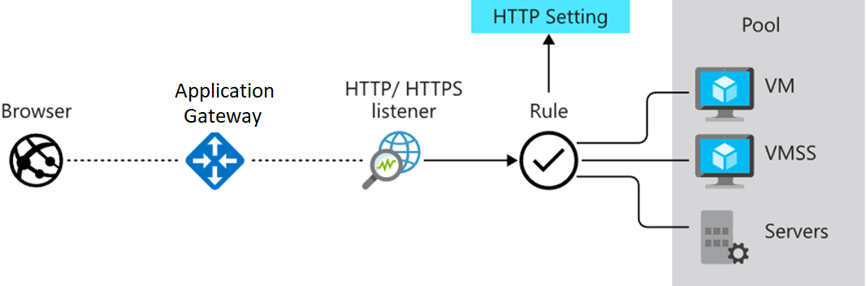

- uses round robin to send load balance requests to the servers in each back-end pool.
-Enable session persistence is also known session affinity, source IP affinity, or client IP affinity which allows to ensure client requests in the same session are routed to the same back-end server. If the state of the user session is stored on the server, then this can be a useful feature
- Load balancing requests use routing parameters such as hostname and path using application gateway rule
- Support for the HTTP, HTTPS, HTTP/2 and WebSocket protocols
- Enabling Web Application Firewall protects against web application vulnerabilities such OWASP attacks
- Support end-to-end request encryption (SSL/TLS termination). The request to the backend pool resources can go unencrypted, the decryption of requests can be done by the application gateway instead performing decrypting request by backend pool to avoid the burden of backend pool
- Autoscaling, to dynamically scale capacity as your web traffic load patterns change with demand.
-You can also distribute the deployment of the Application Gateway across multiple zones to ensure better availability of the Azure Application Gateway service
-Application gateway is created on a dedicated subnet in virtual network

Create Application gateway

Basic - Subscription, Resource group, Application gateway name, Region, Tier(Standard V2, WAF V2), Enable autoscaling, Minimum instance count, Maximum instance count, Availability zone, Virtual network(create a virtual network and dedicated subnet)

Frontends - Frontend IP address type(Public, Private, Both), Choose the IP address based on the Frontend IP address type(Name, SKU, Assessment, Availability zone)

Backends - Add backend pool with Name and backend targets ; Target type(IP address or FQDN, Virtual Machine, VMSS, App service)

Configuration : Create a routing rule with Listener and backend targets(backend target, backend settings)

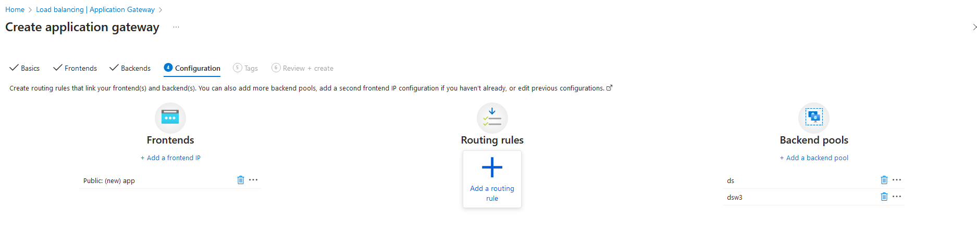

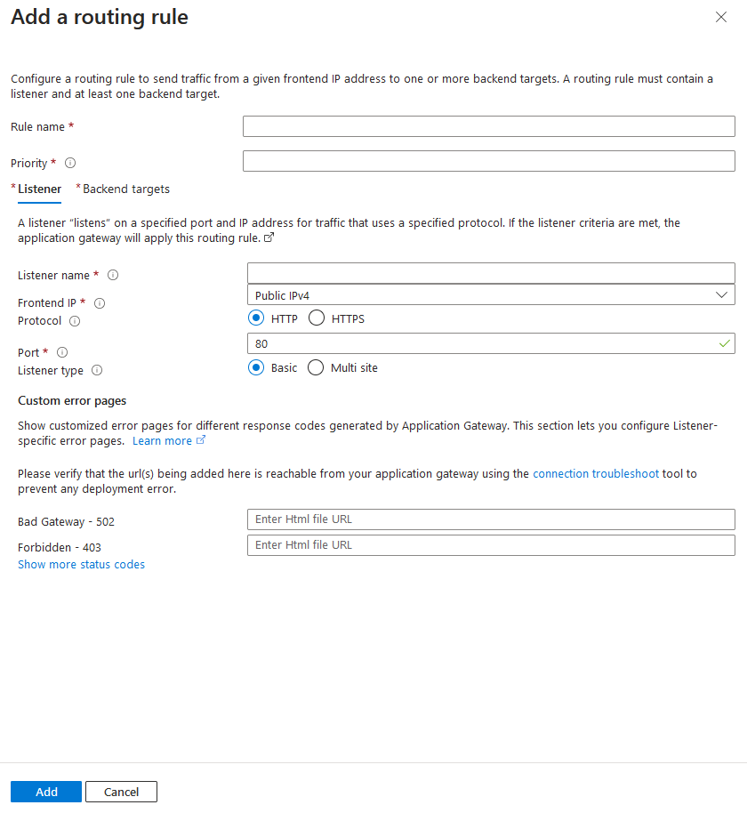

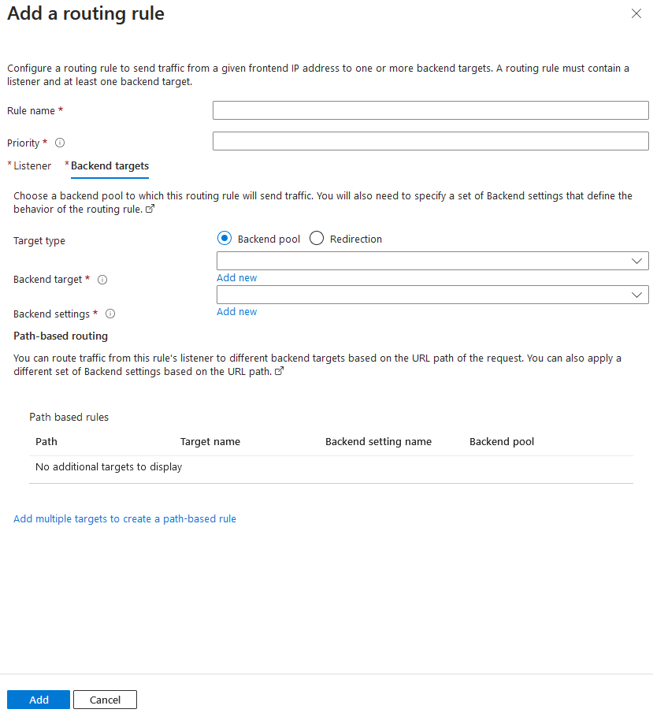
Application gateway currently have seven metrics to view performance counters.

1. Total requests
2. Failed requests
3. Current connections
4. Healthy host count
5. Response status
6. Throughput
7. Unhealthy host count

Application gateway routing

The gateway routes requests to a selected web server in the back-end pool, using a set of rules. There are two primary methods of routing traffic as follows.

URL Path-based routing

- sends requests with different URL paths different pools of back-end servers

path /video/*- to pool of servers that handle video streaming
path /images/* - to a pool of servers that handle image retrieval

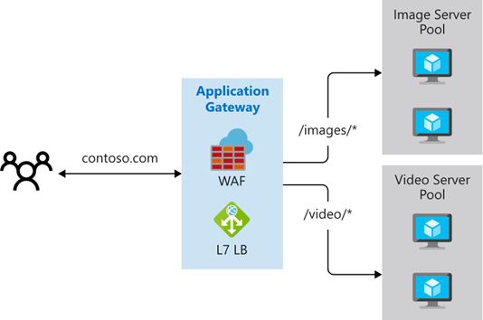

Multiple site routing

- configures more than one web application on the same application gateway instance
- register multiple DNS names (CNAMEs) for the IP address of the Application Gateway, specifying the name of each site
- uses separate listeners to wait for requests for each site and passes the requests to a servers in different backend pool
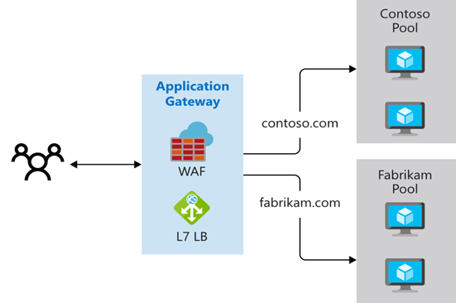

- Supports for multi-tenant applications, where each tenant has its own set of virtual machines and other resources hosting a web application

Redirection can be used to another site, or from HTTP to HTTPS

Rewrite HTTP headers. HTTP headers allow the client and server to pass parameter information with the request or the response.

Custom error pages. Application Gateway allows you to create custom error pages with own branding and layout instead of displaying default error pages.

Application gateway components

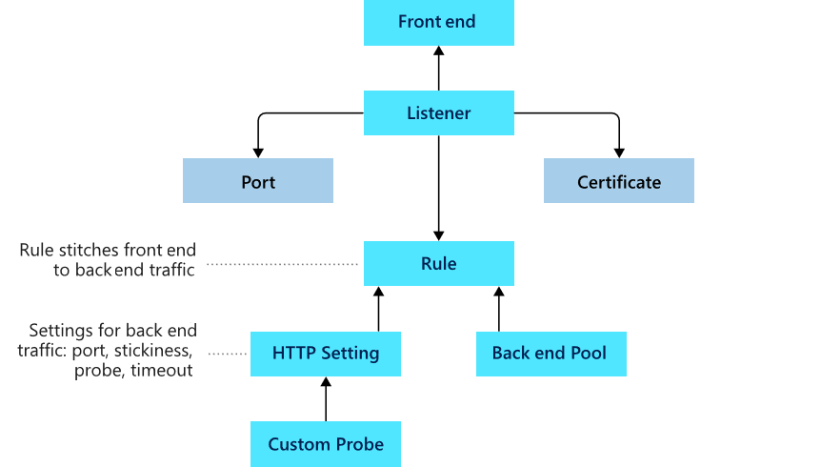

Front-end IP address

- Client requests will hit the front-end IP address
- can configure Application Gateway to have a public IP address, a private IP address, or both
- However, can't have more than one public and one private IP address

Listeners

-A logical entity that checks for incoming connection requests
- uses one or more listeners to receive incoming requests and accepts traffic arriving on a specified combination of protocol, port, host, and IP address
- Each listener routes requests to a back-end pool of servers following routing rules that you specify
- A listener can be Basic or Multi-site
- Basic listener only routes a request based on the path in the URL and attaches to single domain site
- Multi-site listener can also route requests using the hostname element of the URL and attaches to multiple domain site
- handle TLS/SSL certificates for securing your application between the user and Application Gateway

Routing rules

-To route traffic from the listener to the backend pool
- A rule specifies how to interpret the hostname and path elements in the URL of a request, and then direct the request to the appropriate back-end pool
-There are 2 types of routing rules
-Basic routing rules routes to backend pool directly
-Path-based routing rules routes to backend pool based on the URL in the request
- A routing rule is associated with HTTP settings which indicates how traffic is encrypted between application gateway and backend servers
- Other configuration information are Protocol, Session stickiness, Connection draining, Request timeout period, and Health probes.

Back-end pools

- Fixed collection of Network Interface Cards or virtual machines, a virtual machine scale-set, public or internal IP address, FQDN or backends such as Azure App Services, or a collection of on-premises servers
- provide the IP address of each web server and the port on which it listens for requests when configuring the pool
- Each back-end pool has an associated load balancer that distributes work across the pool

Health Probes

- monitor and determine health of servers that are available for load-balancing in a back-end pool
- When the server returns an HTTP response with a status code between 200 and 399, the server is considered healthy
- Application Gateway creates a default probe that waits for 30 seconds before deciding that a server is unavailable

Rewrite HTTP header and URL

- can translate URLs, query string parameters as well as modify request and response headers
- allows you to add conditions to ensure that the URL or the specified headers are rewritten only
- when certain conditions are met
- HTTP header and URL rewrite features are only available for the Application Gateway v2 SKU

- You can apply as many WAF policies as you like to both App gateway or/and listeners and/or path-based routing rule.
- If you want to apply the same policy to all or some listeners than you apply it at the Global level in this case the Application Gateway
- If you want to apply specific policy to certain website than apply to specific listener of that web site and the rest can be applied globally i.e. to application gateway
- This is where you need to pay attention, the Global Policy i.e. policy applied to Application Gateway will only IMPACT /EFFECT the listeners that DO NOT have any specific policy applied to them BUT if a listener has policy applied to it, it will take affect and the Global one will NOT apply to this listener

Azure Web Application Firewall (WAF)

-You can enable WAF tier on existing Application gateway and create WAF policy using managed rule or custom rule, the associate the WAF policy with application gateway and listeners
- The malicious actor’s probe will continue finding potential vulnerabilities on the app throughout lifetime of the app
- optional component that handles incoming requests before they reach a listener
- checks each request for many common exploits, based on the Open Web Application Security Project (OWASP) as well as from bots, crawlers and scanners
- Common threats include SQL-injection, Cross-site scripting(XSS), Command injection, HTTP request smuggling, HTTP response splitting, Remote file inclusion, Bots, crawlers, and scanners, and HTTP protocol violations and anomalies
- OWASP has defined a set of generic rules for detecting attacks which is referred as Core Rule Set (CRS). The rule sets are under continuous review under Microsoft team as attacks evolve in sophistication. These rules are automatically updated to ensure all the latest threats are included in the rules
- WAF supports two rule sets, CRS 2.2.9 and CRS 3.0.L is the default and more recent of these rule sets. If necessary, you can opt to select only specific rules in a rule set, targeting certain threats. The CRS 3 rule sets are a big improvement over CRS 2 because they reduce false positives by more than 90 percent and include many new exploits.
- You can't modify or delete the managed rules offered by Azure Web Application Firewall. However, if a particular rule is problematic for your environment—for example, it blocks legitimate traffic to your web app, you can disable the rule.
- can customize the firewall to specify which elements in a request to examine, and limit the size of messages to prevent massive uploads from overwhelming your servers.
- WAF is enabled on your Application Gateway by selecting the WAF tier when you create a gateway

Modes. Azure Web Application Firewall can operate in one of two modes: detection mode only logs requests that violate a rule, while prevention mode both logs and blocks requests that violate a rule

Exclusion lists. You can configure Azure Web Application Firewall to ignore specific attributes when it checks requests.

Policies. You can combine a set of managed rules, custom rules, exclusions, and other Azure Web Application Firewall settings into a single element called an Azure Web Application Firewall policy.

You can apply as many WAF policies as you like to both App gateway or/and listeners and/or path-based routing rule

. • If you want to apply the same policy to all or some listeners than you apply it at the Global level in this case the Application Gateway

• If you want to apply specific policy to certain website than apply to specific listener of that web site and the rest can be applied globally i.e. to application gateway

• This is where you need to pay attention, the Global Policy i.e. policy applied to Application Gateway will only IMPACT /EFFECT the listeners that DO NOT have any specific policy applied to them BUT if a listener has policy applied to it, it will take affect and the Global one will NOT apply to this listener

Request size limits. You can configure Azure Web Application Firewall to flag requests that are either too small or too large.

Deployment options

- When you create your Azure Web Application Firewall policy, you associate it with an existing Azure Front Door profile.
- You can choose a Web Application Firewall tier when you create your application gateway.

When to use Azure WAF;
- You have web apps that contain sensitive or proprietary data.
- You have web apps that require users to sign in.
- Your web app developers lack security expertise and priorities
- You have web app development budget and time constraints.

Monitor and troubleshoot virtual networking

Integrate on-premise networks with an Azure virtual networks

Azure Application Gateway | Azure load balancer
Route the traffic to backend based on application layer data | Route the traffic to backend based on network layer data
Slower as it processes data from physical layer to application layer | Much faster as it processes data from physical layer to network layer
More intelligent

Azure VPN gateway

A VPN gateway is a specific type of virtual network gateway that is used to send encrypted traffic between an Azure virtual network and an on-premises location over the public Internet.

- use a VPN gateway to send encrypted traffic between Azure virtual networks over the Microsoft network
- Each virtual network can have only one VPN gateway
- can create multiple connections to the same VPN gateway where all VPN tunnels share the available gateway bandwidth
- When a virtual network getaway creates two or more VMs that are deployed to a specific subnet that called the gateway subnet.
- Virtual network gateway VMs contain routing tables and run specific gateway services
- VPN gateways can be deployed in Azure Availability Zones by physically and logically separating gateways within a region, while protecting your on-premises network connectivity to Azure from zone-level failures
- Creating a virtual network gateway can take up to 45 minutes to complete

Create site-to-site connections

These steps should follow for Vnet-to-Vnet and site-to-site connection.
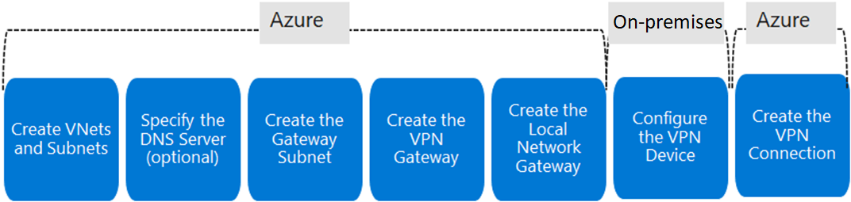

Create VNets and Subnets : plan IP address for virtual network as if duplicate address doesn’t exist either sides

Specify the DNS server(optional): if you need name resolution for resources that are deployed to your virtual network

Create the gateway subnet :

- Before creating a virtual network gateway for your virtual network, you first need to create the gateway subnet with suitable CIDR block.
- When you create your gateway subnet, gateway VMs are deployed to the gateway subnet and configured with the required VPN gateway settings.
- Never deploy other resources to the gateway subnet
- The gateway subnet must be named GatewaySubnet
- When you create gateway subnet, Subnet address range, NAT gateway, Routing table, service endpoints(create service endpoint policies to allow traffic to specific azure resources from your virtual network), subnet delegation are specified

Create VPN gateway:

The VPN gateway settings includes;
1. Name
2. Region
3. Gateway type(VPN or ExpressRoute)
4. VPN type(Route-based or Policy-based)
5. SKU(Basic, VpnGw1, VpnGw4, VpnGw5)
6. Generation(Generation1 or Generation2 )
7. Virtual network( list of VNets created in subscription)
8. Enable active-active mode
9. Configure BGP ASN

- A virtual network cannot be associated with more than one gateway.
- can view the IP address assigned to the gateway
- The gateway should appear as a connected device

Every Azure VPN gateway consists of two instance in an active-standby configuration. For any planned maintenance and unplanned interruption that happen on active instance, standby instance would failover automatically and resume S2S VPN and Vnet-to-Vnet connection.

Determine the VPN type

- choose depends on the connection topology that you want to create
- Type of VPN depends on make and model of your VPN device.
- Once a virtual network gateway has been created, you can't change the VPN type.

Route-based VPN

- use routes in the IP forwarding or routing table to direct packets into their corresponding tunnel interfaces
- It is typically built on router platform where each IPSec tunnel is modeled as network interface or VTI(virtual tunnel interface)
- The tunnel interfaces then encrypt or decrypt the packets in and out of the tunnel
- scenarios include point-to-site, inter-virtual network, or multiple site-to-site connections
- Route-based is also selected when you coexist with an ExpressRoute gateway or if you need to use IKEv2

Policy-based VPNs

- Policy-based VPN devices use the combinations of prefixes from both networks to define how encrypt and direct packets through IPsec tunnels based on the IPsec policies configured
- It is typically built on firewall device that perform packet filtering
- The policy (or traffic selector) is defined as an access list in the VPN device configuration
- Can only be used on basic gateway SKUs
- can have only one tunnel when using a Policy-based VPN
- can only use Policy-based VPNs for S2S connections, and only for certain configurations
- support only IKEv1.

SKU

- Select the SKU that satisfies your requirements based on the types of workloads, throughputs, features, and SLAs
- SKU affect the number of tunnels you can have in single gateway is the aggregate throughput benchmark which is S2S and P2S combined.

Generation

- You cannot change generations or SKUs across generations
- Basic and VpnGw1 SKUs are only supported in Generation1
- VpnGw4 and VpnGw5 SKUs are only supported in Generation2.

Create local network gateway

- The local network gateway typically refers to the on-premises location
- specify the IP address prefixes or FQDN of the on-premises VPN device in order to route through VPN gateway
- It specifies Name, endpoint(IP address/FQDN), IP address(public address of the local gateway), address space(BGP can also be enabled with host address of your BGP Peer IP address on your VPN device)

Configure on-premises VPN gateway

- validated list of standard VPN devices that work well with the VPN gateway like Cisco, Juniper, Ubiquiti, and Barracuda Networks
- To configure your VPN device,

A shared key- The same shared key that you specify when creating the VPN connection.
The public IP address of your VPN gateway

Create VPN connection
- Once VPN gateways are created in Azure and on-premise, we can create VPN connection between them
- When create VPN connection, following should specify.

Name - name for your connection
Connection type- select site-to-site(IPSEC) from the drop down
Virtual network gateway- select from created VPN gateway
Local network gateway- select from created local network gateway
Shared key (PSK) - the key you use is the same for your on-premises device and your virtual network gateway connection

- verify the connections either in the portal, or by using PowerShell

In P2S VPN, also SSTP and IKEv2 don't support all client devices:

SSTP limited to Windows
IKEv2 limited to Mac devices

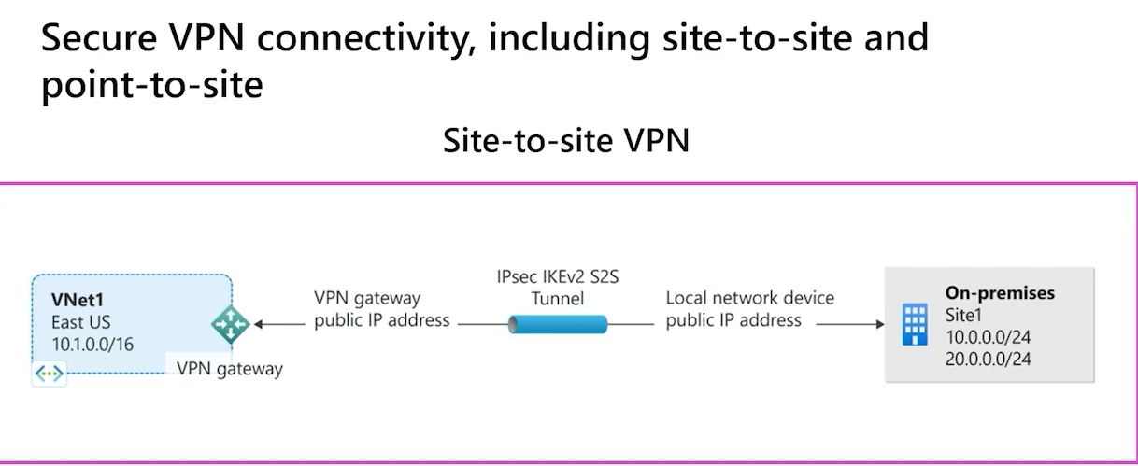

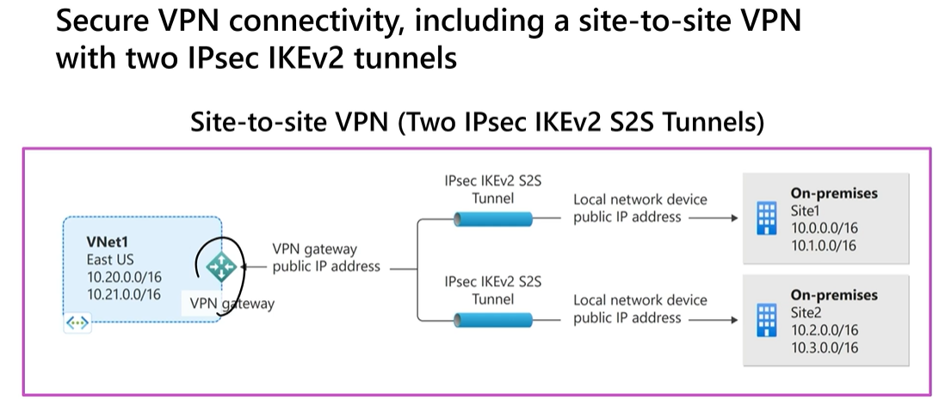

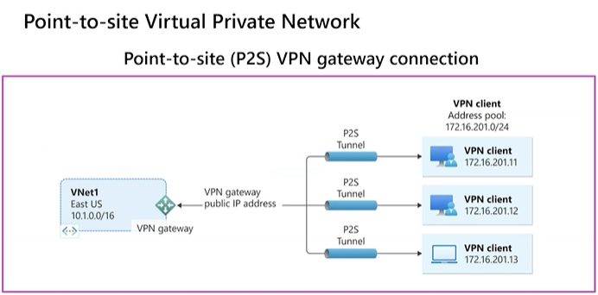

Determine high availability

Active/standby

- Every Azure VPN gateway consists of two instances in an active-standby configuration
- In planned maintenance or unplanned disruption to active instance, the standby instance failover automatically and resume the S2S VPN or VNet-to-VNet connections
- The switch over will cause a brief interruption
- For planned maintenance, the connectivity should be restored within 10 to 15 seconds
- For unplanned issues, the connection recovery will be longer, about 1 minute to 1 and a half minutes
- For P2S VPN client connections to the gateway, the users will need to reconnect from the client machines

Active/active

- In an active-active configuration, both instances of the gateway VMs will establish IPSEC/IKE S2S VPN tunnels to your on-premises VPN device specified in local network gateway and connection
- Each Azure gateway instance will have a unique public IP address
- configure your on-premises VPN device to accept or establish two S2S VPN tunnels
- Traffic/ TCP and UDP flow between Azure virtual network and on-premise network will be routed through both tunnels simultaneously
- When planned and unplanned event happens, tunnel between instance and VPN device will be disconnected and corresponding routes will be switched over other active IPSec tunnel
- From Azure side, switch over will happen automatically on from the affected instance.

Set-AzureRmVirtualNetworkGatewayDefaultSite cmdlet assigns forced tunneling default site to virtual network gateway. Default site can be changed later.

Forced tunneling provides a way for you to redirect internet-bounding traffic from Azure VM to on-premise network. This enables you to inspect and audit traffic before releasing it. Forced tunneling is carried out by VPN tunnel which requires default site(local gateway) to redirect traffic.

New-AzureRmVirtualNetworkGatewayConnection cmdlet to create site-to-site VPN connection between virtual network gateway and on-prem VPN device

IKEDiagnosticLog = The IKEDiagnosticLog table offers verbose debug logging for IKE/IPsec. This is very useful to review when troubleshooting disconnections, or failure to connect VPN scenarios.

GatewayDiagnosticLog = Configuration changes are audited in the GatewayDiagnosticLog table.

TunnelDiagnosticLog = The TunnelDiagnosticLog table is very useful to inspect the historical connectivity statuses of the tunnel.

RouteDiagnosticLog = The RouteDiagnosticLog table traces the activity for statically modified routes or routes received via BGP.

P2SDiagnosticLog = The last available table for VPN diagnostics is P2SDiagnosticLog. This table traces the activity for Point to Site.

Azure ExpressRoute

- Azure ExpressRoute lets you extend your on-premises networks over WAN into the Microsoft cloud
- The connection is facilitated by a connectivity provider.
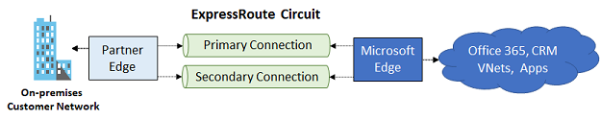

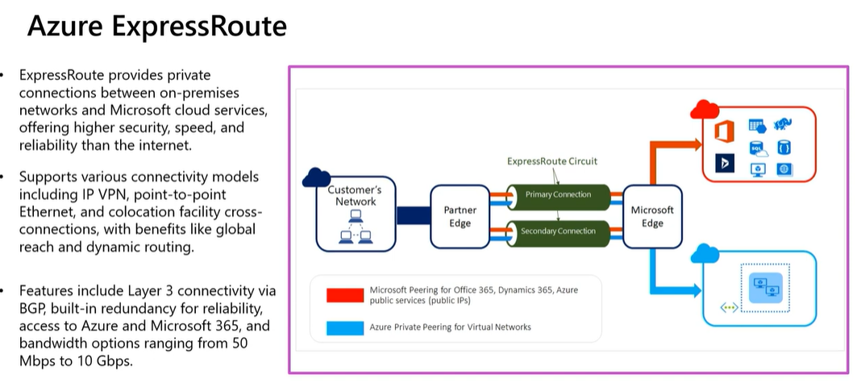

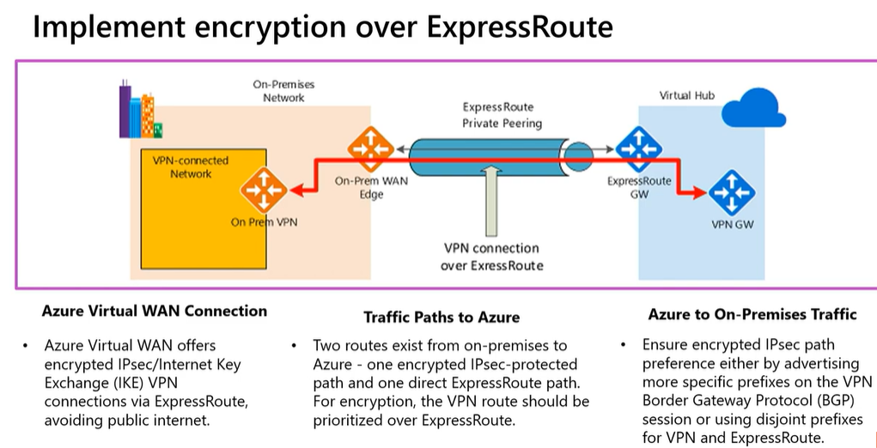

- It offers more reliability, faster speeds, and lower latencies unlike route over the internet
- With ExpressRoute, establish connections to Azure at an ExpressRoute location, such as an Exchange provider facility, or directly connect to Azure from your existing WAN network such as MPLS VPN that is provided by a network service provider
- Cost-effective option for transferring large amounts of data, periodic data migration, replication for business continuity, and disaster recovery
- Build applications that span on-premises infrastructure and Azure without compromising privacy or performance. For example, run a corporate intranet application in Azure that authenticates your customers with an on-premises Active Directory service
- ExpressRoute is supported across all Azure regions and locations
- With ExpressRoute, virtual network must be configured as gateway subnet when connect to on-premise network

ExpressRoute locations are where Microsoft peers with several service providers. When you connected to at least one ExpressRoute location within the geopolitical region, you will access Azure services across all regions within a geopolitical region.

ExpressRoute benefits

Layer 3 connectivity- Microsoft uses BGP to exchange routes between your on-premises network, your instances in Azure, and Microsoft public addresses. Multiple BGP sessions are created for different traffic profiles.

Redundancy - Each ExpressRoute circuit consists of two BGP connections to two Microsoft Enterprise edge routers (MSEEs) from the connectivity provider/your network edge.

Connectivity to Microsoft cloud services- ExpressRoute connections enable access to Microsoft Azure services, Microsoft 365 services, and Microsoft Dynamics 365

Connectivity to all regions within a geopolitical region- For example, if you connect to Microsoft in Amsterdam through ExpressRoute, you'll have access to all Microsoft cloud services hosted in Northern and Western Europe.

Global connectivity with ExpressRoute premium add-on- You enable the ExpressRoute premium add-on feature to extend connectivity across geopolitical boundaries

Across on-premises connectivity with ExpressRoute Global Reach- With ExpressRoute Global Reach, you can connect your private data centers together through two ExpressRoute circuits. Your cross-data-center traffic will traverse through Microsoft's network

Bandwidth options- purchase ExpressRoute circuits for a wide range of bandwidths.

Flexible billing models
- Unlimited data- Billing is based on a monthly fee; all inbound and outbound data transfer is included free of charge
- Metered data- Billing is based on a monthly fee; all inbound data transfer is free of charge. Outbound data transfer is charged per GB of data transfer
- ExpressRoute premium add-on- This add-on includes increased routing table limits, increased number of VNets, global connectivity, and connections to Microsoft 365 and Dynamics 365

Coexist site-to-site and ExpressRoute
- This is about configure Site-to-Site VPN and ExpressRoute connections for the same virtual network
- You configure a Site-to-Site VPN as a secure failover path for ExpressRoute or use Site-to-Site VPNs to connect to sites that are not part of your network, but that are connected through ExpressRoute
- The deployment options for S2S and ExpressRoute coexisting connections are only possible through PowerShell, and not the Azure portal.
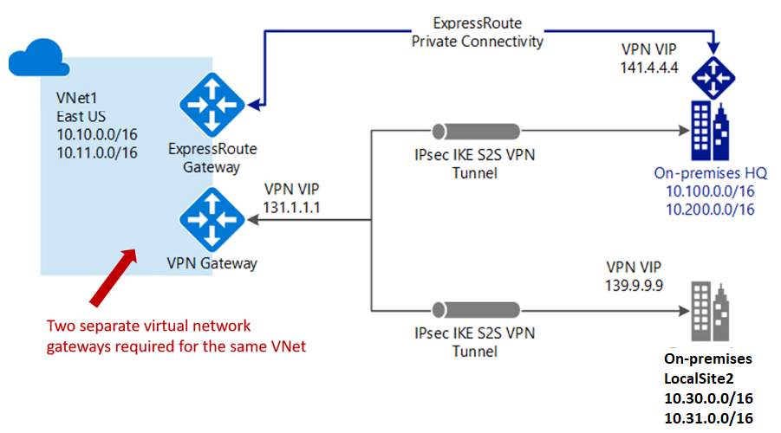

ExpressRoute connection models

Connectivity providers offer one or more connectivity models.
1. Colocated at a cloud exchange : Colocation provider’s Ethernet exchange offers either Layer 2 cross-connections, or managed Layer 3 cross-connections between your infrastructure in the colocation facility and the Microsoft cloud.
2. Point-to-point Ethernet Connection : Point-to-point Ethernet providers offer Layer 2 connections, or managed Layer 3 connections between your site and the Microsoft cloud.
3. Any-to-any (IPVPN) Connection: IPVPN providers, typically Multiprotocol Label Switching (MPLS) VPN, offer any-to-any connectivity between your branch offices and datacenters as well as managed Layer 3 connectivity

ExpressRoute/VPN Gateway coexist configuration requires a larger gateway subnet than most other configurations. Further more, you may want to make sure your gateway subnet contains enough IP addresses to accommodate possible future configurations.
While you can create a gateway subnet as small as /29, we recommend that you create a gateway subnet of /27 or larger (/27, /26 etc.). If you plan on connecting 16 ExpressRoute circuits to your gateway, you must create a gateway subnet of /26 or larger. If you're creating a dual stack gateway subnet, we recommend that you also use an IPv6 range of /64 or larger. This set up will accommodate most configurations

ExpressRoute local, standard, global offer unlimited data plans.

ExpressRoute local: access azure region locally

ExpressRoute Standard: access azure multiple regions within a geopolotical location.

ExpressRoute Global: access azure regions globally/all over the world

ExpressRoute Direct gives you the ability to connect directly into the Microsoft global network at peering locations strategically distributed around the world. ExpressRoute Direct provides dual 100-Gbps or 10-Gbps connectivity, that supports Active/Active connectivity at scale. You can work with any service provider to set up ExpressRoute Direct.

Key features that ExpressRoute Direct provides include, but not limited to:
- Large data ingestion into services like Azure Storage and Azure Cosmos DB.
- Physical isolation for industries that regulates and require dedicated or isolated connectivity such as banks, government, and retail companies.
- Granular control of circuit distribution based on business unit.

You can share an ExpressRoute circuit across multiple subscriptions. The circuit owner is the administrator/coadministrator of the subscription in which the ExpressRoute circuit is created. The circuit owner can authorize administrators/coadministrators of other subscriptions, referred to as circuit users, to use the dedicated circuit that they own. The Circuit owner creates the authorization code and provides it to the the circuit user (sub2), circuit user uses the authorization code and resource ID during the create connection process to be able to successfully connect via express route circuit

1 scale unit of VPN = 500 Mbps
1 scale unit of ExpressRoute = 2 Gbps

Zone-redundant gateway SKUs

You can also deploy ExpressRoute gateways in Azure Availability Zones. This configuration physically and logically separates them into different Availability Zones, protecting your on-premises network connectivity to Azure from zone-level failures.

Zone-redundant gateways use specific new gateway SKUs for ExpressRoute gateway.
- ErGw1AZ
- ErGw2AZ
- ErGw3AZ

The new gateway SKUs also support other deployment options to best match your needs. When creating a virtual network gateway using the new gateway SKUs, you can deploy the gateway in a specific zone. This type of gateway is referred to as a zonal gateway. When you deploy a zonal gateway, all the instances of the gateway are deployed in the same Availability Zone.

FastPath

ExpressRoute virtual network gateway is designed to exchange network routes and route network traffic. FastPath is designed to improve the data path performance between your on-premises network and your virtual network. When enabled, FastPath sends network traffic directly to virtual machines in the virtual network, bypassing the gateway.

ErGw3Az and Ultra Performance SKU supports FastPath.

Virtual network (VNet) Peering FastPath will send traffic directly to any VM deployed in a virtual network peered to the one connected to ExpressRoute, bypassing the ExpressRoute virtual network gateway. This feature is available for both IPv4 and IPv6 connectivity.

Azure Virtual WAN

Azure Virtual WAN is a networking service that provides optimized and automated branch connectivity to, and through, Azure with hub and spoke architecture.

- Azure Virtual WAN and Virtual WAN hubs, used across Azure regions
- Azure Virtual WAN brings together many Azure cloud connectivity services such as site-to-site VPN for branches, point-to-site VPN for remote users, virtual network, and ExpressRoute for main sites into a single operational interface
- Enables any-to-any connectivity to workloads distributed globally in virtual networks.
- It can see the end-to-end flow within Azure for intuitive troubleshooting
- A basic Azure virtual WAN does not support express route. You have to upgrade to standard.

Azure Virtual WAN Hub
- sophisticated software-defined hub
- The Virtual WAN hubs can be connected to your branches, virtual networks, and remote users.
- Can deploy in any Azure region, but only one per region, per subscription
- Multiple hubs are automatically interconnected using hub-to-hub connectivity through the Azure global network
- To convert the virtual hub to a secure virtual hub, use Azure Firewall Manager
- Supported partners that currently have integration into Azure Firewall Manager's API to set up security policies
- By default, all connections are associated to a Default route table in a virtual hub. Each virtual hub has its own Default route table, which can be edited to add a static route(s). Routes added statically take precedence over dynamically learned routes for the same prefixes.

Virtual hub router
- Supports custom route tables for virtual networks
- Acts as default route table for branches (P2S, S2S, ER)

Virtual WAN types

- Basic - Site-to-site VPN only
- Standard- Full mesh connectivity, ExpressRoute, User VPN (P2S), VPN (site-to-site), Inter-hub, Virtual Network-to-Virtual Network transiting through the virtual hub, Azure Firewall, NVA in a virtual WAN

A Basic Virtual WAN can be upgraded to a Standard Virtual WAN. A Standard Virtual WAN cannot be downgraded to a Basic Virtual WAN.

Gateway Scale Units: A scale unit is a unit defined to pick an aggregate throughput of a gateway in Virtual hub.

1 scale unit of VPN = 500 Mbps.
1 scale unit of ExpressRoute = 2 Gbps

Configuration:

1. Create Azure Virtual WAN
2. Create Virtual Hub
3. Create VPN sites
4. Connect VPN sites to virtual hub

Add NSG rule invoking the public IP address

# Get the public IP address
try {
$publicIP = (Invoke-WebRequest -Uri "http://ifconfig.me/ip").Content.Trim()
} catch {
Write-Error "Failed to retrieve public IP address."
exit
}

# Azure details
$resourceGroupName = "USZ-MGMT"
$nsgName = "USZ-MGMTSRV-nsg"
$ruleName = "RDP"

# Log in to Azure
try {
Update-AzConfig -EnableLoginByWam $false
Connect-AzAccount
Set-AzContext -Subscription "74e67324-ebc5-4077-a3ec-d8b50d6d1b65"
} catch {
Write-Error "Failed to authenticate to Azure."
exit
}

# Get the NSG
try {
$nsg = Get-AzNetworkSecurityGroup -ResourceGroupName $resourceGroupName -Name $nsgName
} catch {
Write-Error "Failed to retrieve NSG."
exit
}

# Find the rule
$rule = $nsg.SecurityRules | Where-Object { $_.Name -eq $ruleName }

if ($rule -eq $null) {
Write-Error "Rule $ruleName not found in NSG $nsgName."
exit
}

# Check if the IP address already exists
$existingIPs = $rule.SourceAddressPrefix
if ($existingIPs -contains $publicIP) {
Write-Output "Public IP $publicIP already exists in NSG rule $ruleName."
} else {
# Append the new IP address to the existing ones
$ipList = New-Object System.Collections.Generic.List[string]
$existingIPs | ForEach-Object { $ipList.Add($_) }
$ipList.Add($publicIP)
$rule.SourceAddressPrefix = $ipList

# Update the NSG with the modified rule
try {
Set-AzNetworkSecurityGroup -NetworkSecurityGroup $nsg
} catch {
Write-Error "Failed to update NSG."
exit
}

Write-Output "Public IP $publicIP has been added to NSG rule $ruleName."
}

# Log the public IP with date and time to a text file
$logFilePath = "C:\RDP\AzureRDPlogfile.txt"
$logEntry = "$(Get-Date -Format 'yyyy-MM-dd HH:mm:ss') - $publicIP"
Add-Content -Path $logFilePath -Value $logEntry

Write-Output "Public IP $publicIP has been logged to $logFilePath"

# Wait for 10 seconds
Start-Sleep -Seconds 10

# Check the connection
$retryCount = 0
$maxRetries = 5
$connectionSuccess = $false

while ($retryCount -lt $maxRetries -and -not $connectionSuccess) {
$result = Test-NetConnection -ComputerName "uszermgmtsrv.australiaeast.cloudapp.azure.com" -Port 8426
if ($result.TcpTestSucceeded) {
$connectionSuccess = $true
} else {
$retryCount++
Start-Sleep -Seconds 5
}
}

if ($connectionSuccess) {
Write-Output "Connection successful. Launching RDP session."
Start-Process "C:\RDP\USZ-MGMTSRV.rdp"
} else {
Write-Error "Connection failed after $maxRetries attempts. Stopping script."
exit
}

