Kubernetes- Cluster Maintenance

OS Upgrades

- If node goes down and come back online immediately, Kubelet process starts and then pods come back online in the node. But the node is down more than 5 minutes, pods are terminated from the node.
- If the pod is part of ReplicaSet, the pod will be recreated on other node.
- The time awaits to come the pod back online is called as pod eviction timeout which is set on the kube controller manager with default value of 5 minutes

kube-controller-manager --pod-eviction-timeout=5m0s

- Whenever a node goes down, master node awaits 5 minutes for considering the worker node is dead.
-When the node comes back online after pod eviction timeout, it comes up as blank node without any pod is scheduled on the node.
- If you have maintenance tasks to be performed and also if you know the workloads running on the node have other replicas on other node and if you are sure the node come back online within 5 minutes, you can make quick upgrade and reboot. If you are not sure node will come up within 5 minutes, the safer way to do it is that you can purposefully drain the node that have workloads to other nodes in the cluster.
- Draining a node will not move pods to another node technically. However, the pods gracefully terminated on the node and recreated on another node.
- Then the node is cordon and marked as unschedulable: true which means no pod can be scheduled until you specifically remove restrictions. Now the pods are safely scheduled on other node. You can do maintenance and reboot the node.

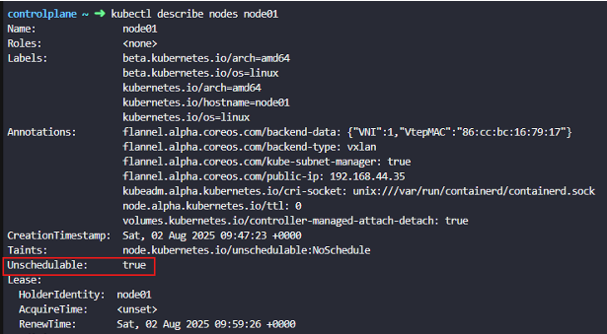

kubectl drain node-1 ; The status of the node becomes SchedulingDisabled state

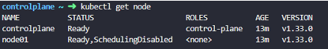

- By default, kubectl drain command ignores certain system pods on the node that cannot be killed. In that case use the option - -ignore-daemonsets to ignoring systems pods are being terminated

kubectl uncordon node-1 ; configure the node to be schedulable and it can resume scheduling new pods

- The pods we moved to other nodes don’t automatically fall back to same node unless new pods created in the cluster , then they are scheduled on this node

kubectl cordon node-2 ; simply mark the node unschedulable. Unlike drain, it doesn’t terminate or move existing pods. Instead it make sure new pods are not scheduled on that node and the critical app running pods keepalive

- PodDistruptionBudget limits the number of pods of a replicated application that are down simultaneously from voluntary disruption. It ensures that the number of replicas running is never brought below the number needed for a quorum.

kubectl drain node-1 - -ignore-daemonsets ; evicting the pods by ignoring daemonsets

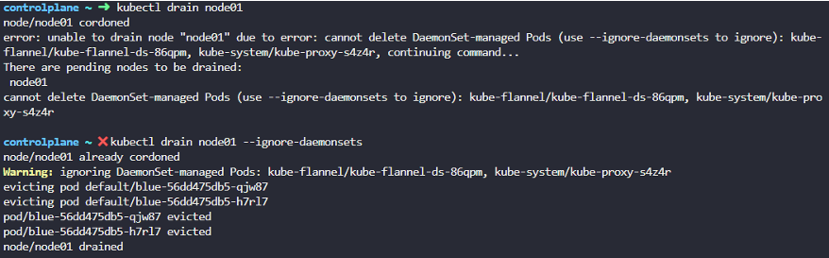

- The daemonsets controller also creates pods that ignore unschedulable:true and the taint node have which allows the new pods to launch onto a node that you drained.
- Pods that are not part of ReplicationController, ReplicaSet, Job, Daemonsets or StatefulSet which means that declare no controller cannot be terminated by draining a node. To override that, use option - -force and which pod will be lost forever

kubectl drain node-1 - -ignore-daemonsets --force ; deleting pods that declare no-controller which means there are pods which are not part of replicaset

If any pod that declare no controller is drained from node, that pod will be lost forever and the pod will not be scheduled on other node as it is not part of replicaset.

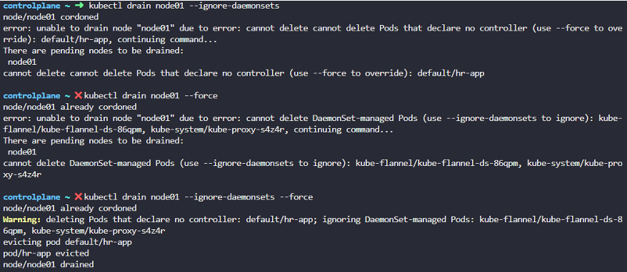

alias k=kubectl ; set alias k for kubectl

Kubernetes Software Versions

- kubectl get nodes indicate version of Kubernetes
- V1.11.3 depicts major.minor.patch versions
- Minor version releases with features and functionalities every few months
- Patch version are released more often with critical bug fixes
- Stable version is v1.13.0 which released in 2018
- Before releases new minor version, it comes with alpha tag(V1.10.0-alpha) which is buggy and features are disabled by default. After fixing the bug which releases with beta tag(V1.10.0-beta) where the code is tested and new features are enabled by default.
- All Kubernetes cluster components such as kube-apiserver, kube-scheduler, kube-controller-manger, Kubelet, kubectl, kube-proxy with the executable bundled for all components except ETCD cluster and CoreDNS come with new minor version . ETCD cluster and CoreDNS has their own version as they are separate projects as well as externally dependent applications.

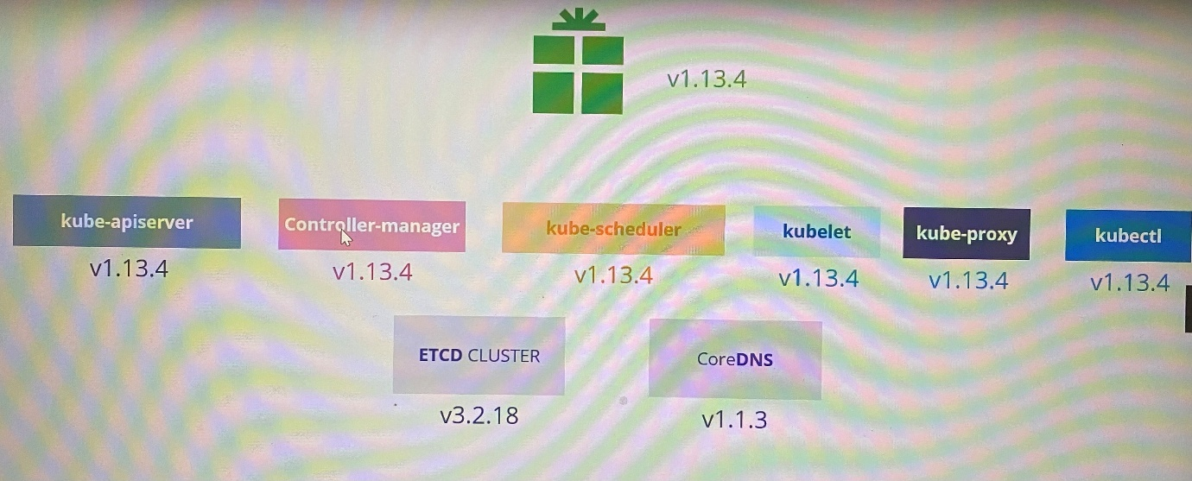

https://kubernetes.io/docs/concepts/overview/kubernetes-api/
Here is a link to kubernetes documentation if you want to learn more about this topic (You don't need it for the exam though):
https://github.com/kubernetes/community/blob/master/contributors/devel/sig-architecture/api-conventions.md
https://github.com/kubernetes/community/blob/master/contributors/devel/sig-architecture/api_changes.md

Cluster upgrade process

- Since kube-apiserver is the primary component of cluster, none of others should have higher version than version of kube-apiserver. The controller-manager and Kube-scheduler can be at one version lower.
- If kube-apiserver is v1.10, controller-manager and kube-scheduler could be v1.10 or v1.9, Kubelet and kube-proxy could be v1.10 or v1.9 or v1.8
- But kubectl could be v1.11 or v1.10 or v1.9

**Refer version Skew Policy for more information.

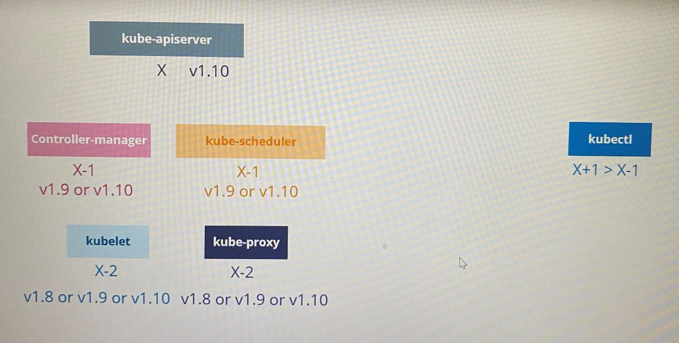
-We can perform live upgrade component by component if required
- At any time, Kubernetes supports only up to recent 3 minor versions. If latest Kubernetes version is 1.13, 1.12 and 1.11 are supported. 1.10 is not supported.
- The components can be upgraded up to one higher minor version at a time as recommended.

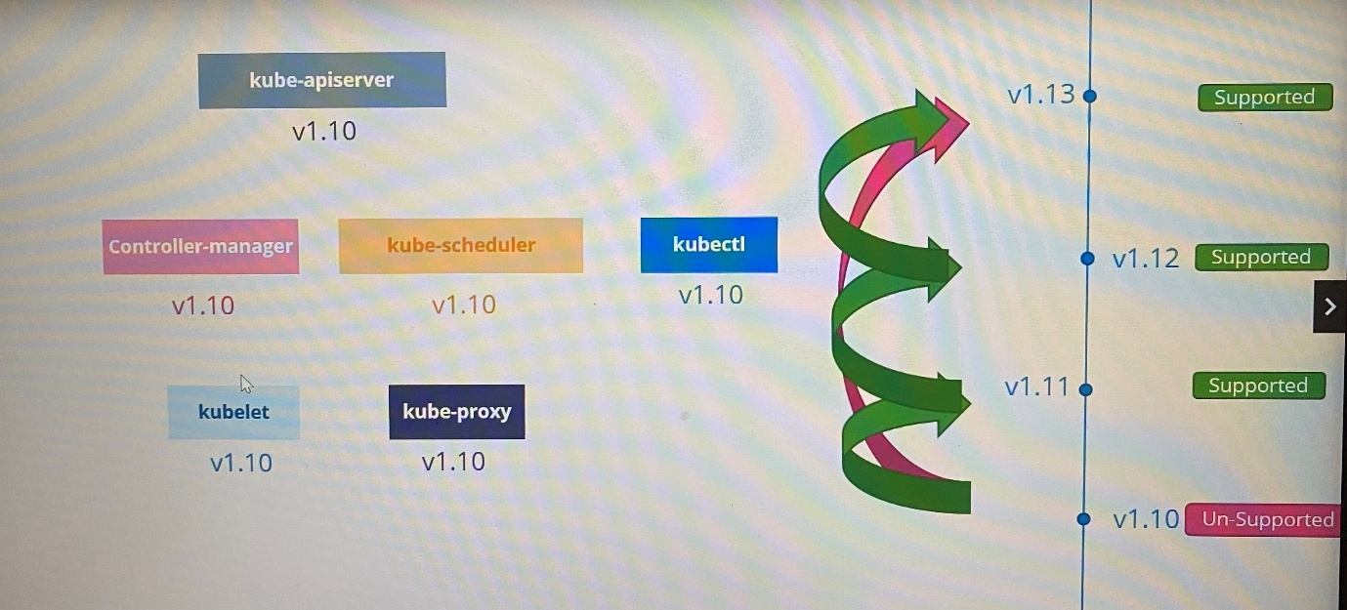

- Easiness upgrading cluster using the way that cluster deploys
In a cloud platform > kubeadm tool(kubeadm upgrade plan | kubeadm upgrade apply) > from a scratch

Upgrading the cluster involves two major steps

Upgrade the master node

- All the control plane components such as apiserver, scheduler, controller-manager go down briefly
- Master goes down doesn’t mean worker nodes or application are impacted. However all management functions are down such as following.

  - You cannot access cluster using kubectl or other Kubernetes API
  - You cannot deploy new application or modify/delete existing app
  - The controller-manager doesn’t function either, so new pod will not be created if a pod fails.

As long as nodes and pods up, the application should be up and will not be impacted

Upgrade the worker nodes

- Use strategies to upgrade worker nodes

Strategy 1 - Upgrade all nodes at once where no application will be available. It requires downtime. In this case, pods are down, users are no longer accessible the application.

Strategy 2 - Upgrade one node at a time. Pods in first node move to other node when 1st node is upgraded. Thus nodes are upgraded to newer version one by one without having downtime required

Strategy 3 - Add new nodes with newer software version to cluster and move workloads over to new and remove old ones until cluster has nodes with newer version. This is easier in cloud platform to provision new nodes and decommission old ones. Finally all worker nodes are in newer version.

Kubeadm - upgrade

kubeadm upgrade plan ; provide information in cluster version, kubeadm version, latest stable version of cluster, current version of cluster components, stable version of cluster components that can be upgraded, version of Kubelet that should manually upgrade each nodes after upgrading version of control plane component

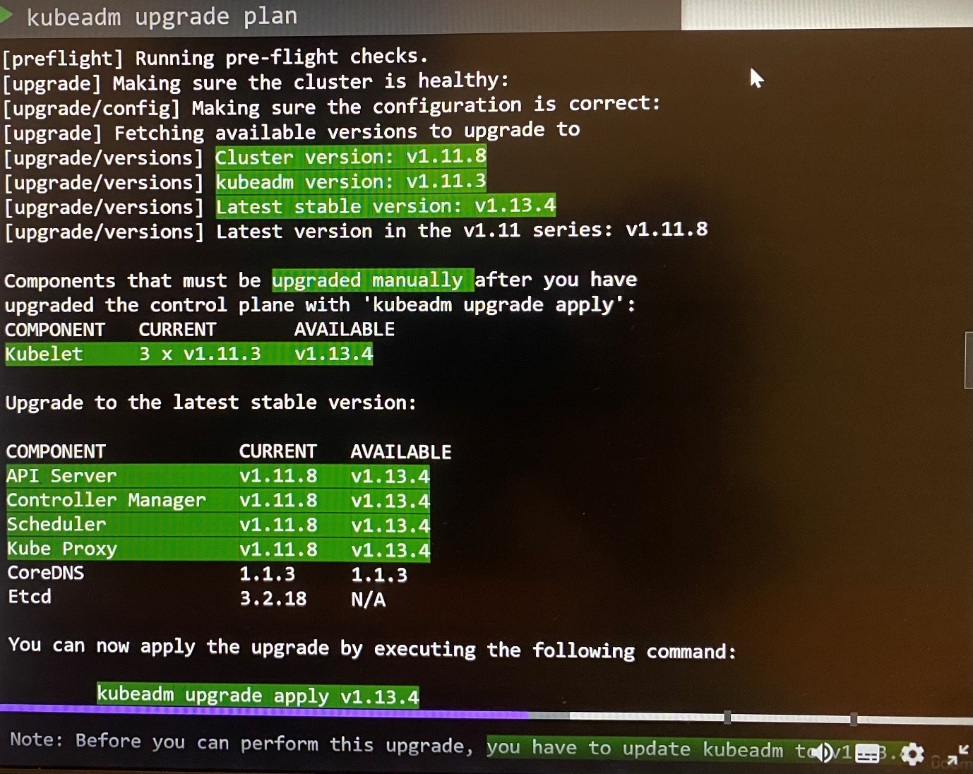

- Kubeadm upgrade apply command doesn’t install or upgrade Kubelet and kubectl
- This command shows kubeadm tool should be upgraded before upgrade the cluster
- Kubeadm tool follows same software version as Kubernetes

Upgrading kubeadm clusters | Kubernetes

Upgrading control plane nodes

  - Changing the Kubernetes package repository on controlplane nodes Changing The Kubernetes Package Repository | Kubernetes

Use any text editor you prefer to open the file that defines the Kubernetes apt repository.

vim /etc/apt/sources.list.d/kubernetes.list

Update the version in the URL to the next available minor release, i.e v1.31.

deb [signed-by=/etc/apt/keyrings/kubernetes-apt-keyring.gpg] https://pkgs.k8s.io/core:/stable:/v1.31/deb/ /

After making changes, save the file and exit from your text editor. Proceed with the next instruction.

  - Determine which version to upgrade on controlplane node

sudo apt update
sudo apt-cache madison kubeadm

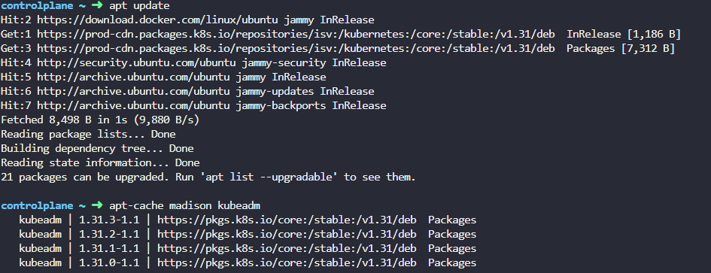

  - Upgrade Kubeadm on controlplane node

Based on the version information displayed by apt-cache madison kubeadm, it indicates that for Kubernetes package repository upgradable with versions, the available package version are 1.31.0-1.1 - 1.31.3-1.1. Therefore, to install kubeadm for Kubernetes v1.31.0, use the following command:

apt-get install kubeadm=1.31.0-1.1

Or

sudo apt-mark unhold kubeadm && \
sudo apt-get update && sudo apt-get install -y kubeadm='1.31.0-1.1' && \
sudo apt-mark hold kubeadm

kubeadm version ; verify upgraded kubeadm version

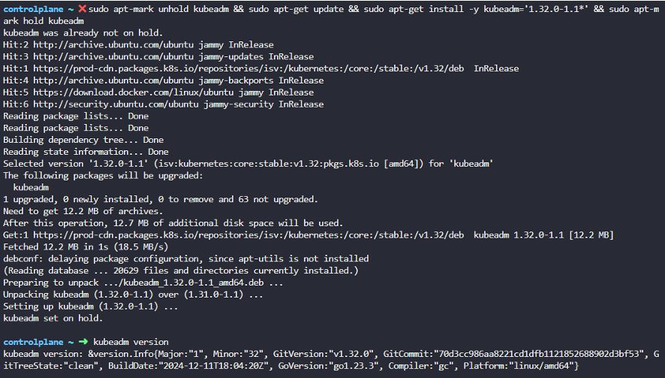

  - Upgrade control plane components

sudo kubeadm upgrade plan --allow-release-candidate-upgrades ; verify the upgrade plan

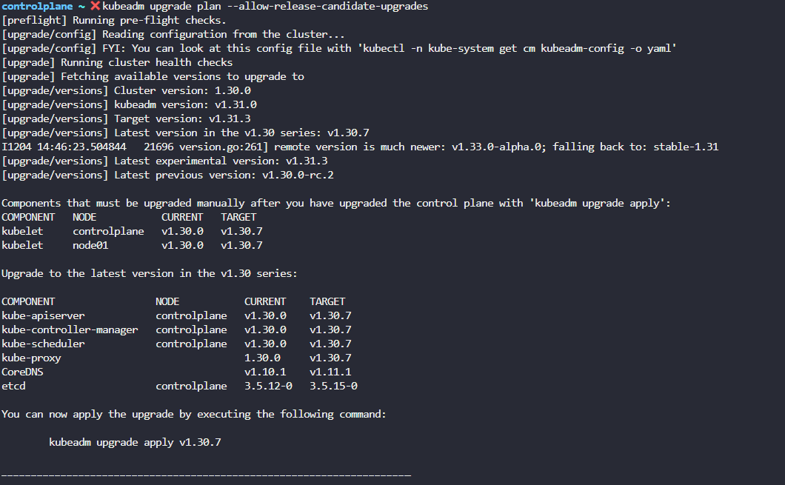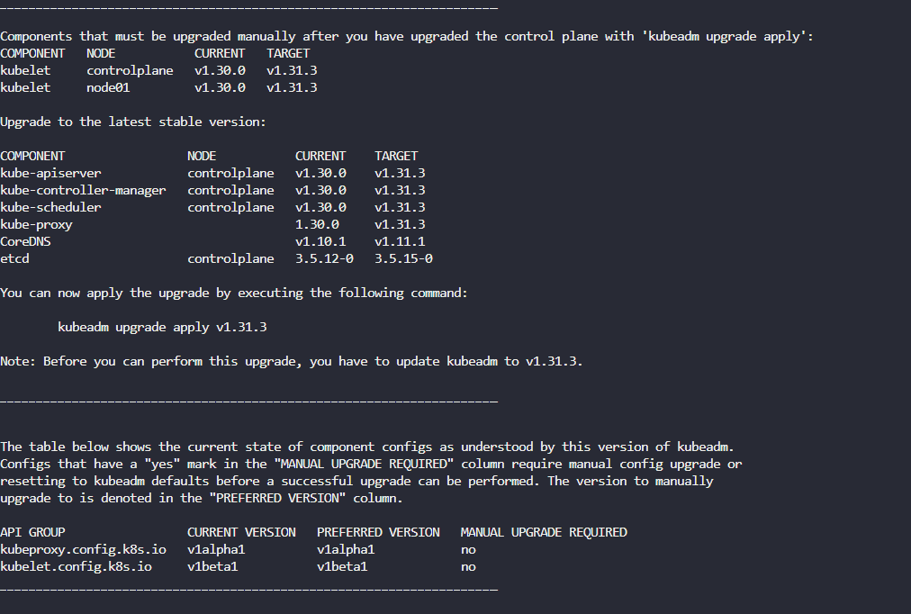

Run the following command to upgrade the Kubernetes cluster where upgrade Kubeapi server, Kube -Controller manager, Kube-scheduler and kube-proxy

kubeadm upgrade apply v1.31.0 ; With this command, upgrade on Kube-apiserver, kube-controller-manager, kube-schduler , kube-proxy

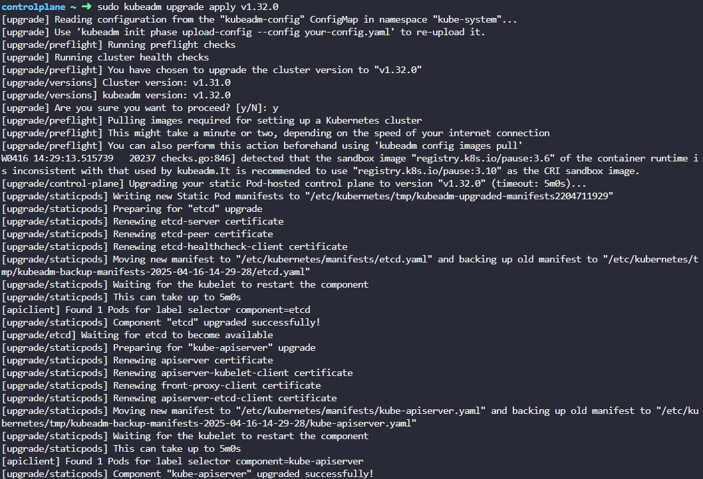

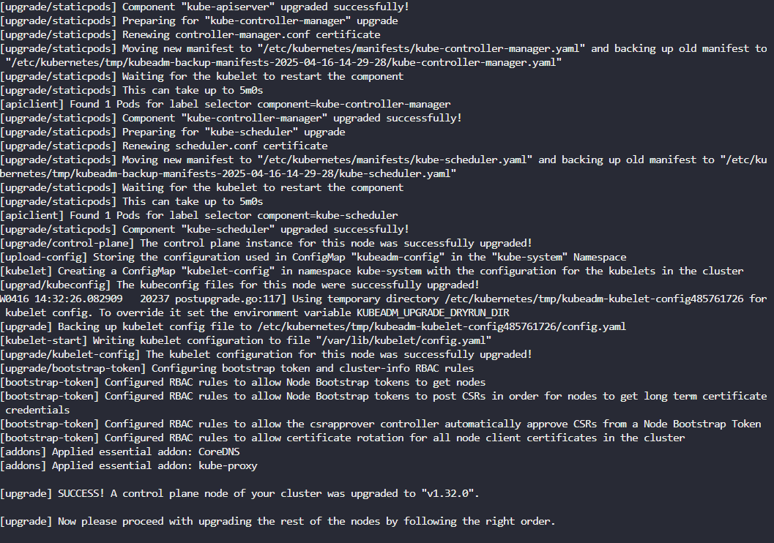
If the cluster has multiple control plane node, run the following. Drain the node before running the command.

sudo kubeadm upgrade node ; run this command instead of sudo kubeadm upgrade apply

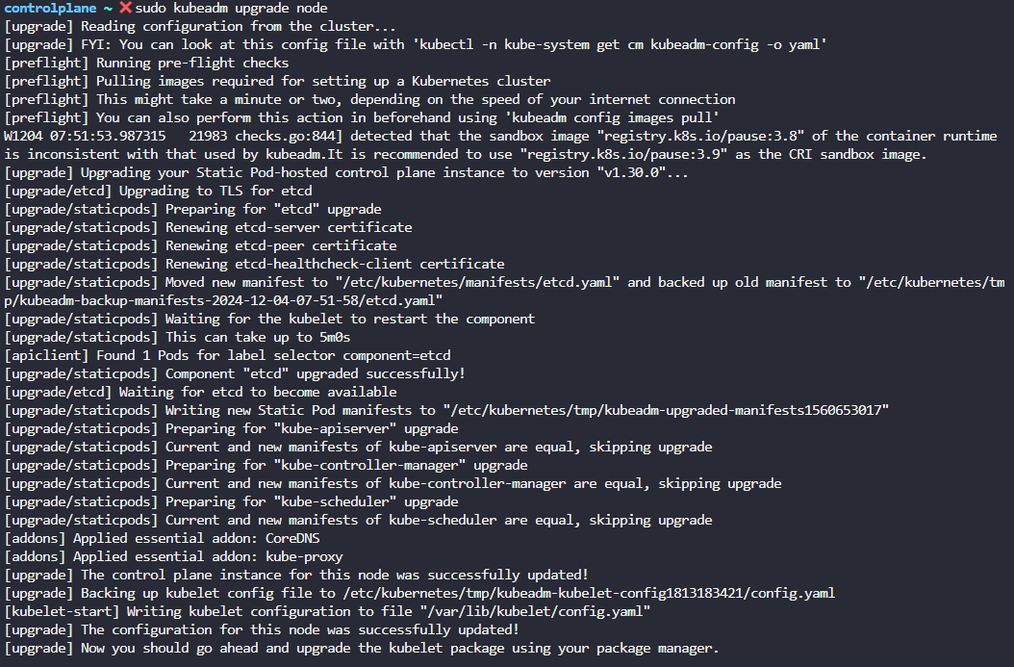

  - Drain the control plane node

kubectl drain <node-to-drain> - -ignore-daemonsets

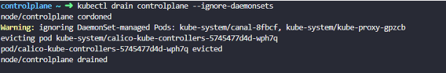

  - Upgrade Kubelet and kubectl in control plane node

- If you run kubectl get nodes, it shows the version of Kubelet of each nodes registered with kube-apiserver which haven't been upgraded
- Some cluster deploy with kubeadm tool may have or may not have Kubelet running on master node

Now, upgrade the Kubelet version. Then, mark the node (in this case, the "controlplane" node) as schedulable.

apt-get install kubelet=1.31.0-1.1

Or

sudo apt-mark unhold kubelet kubectl && \
sudo apt-get update && sudo apt-get install -y kubelet='1.31.0-1.1' kubectl='1.31.0-1.1' && \
sudo apt-mark hold kubelet kubectl

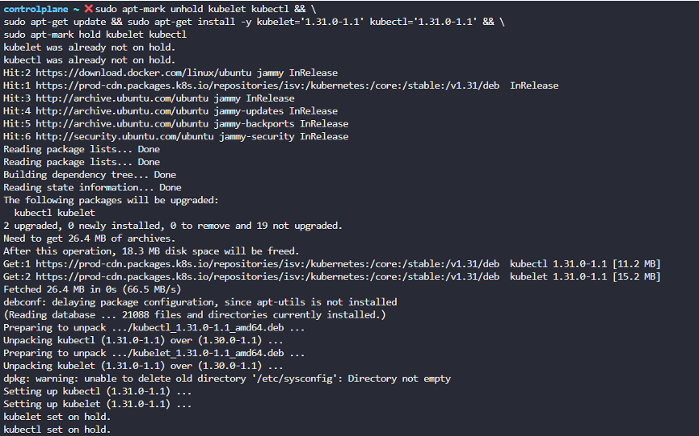

Run the following commands to refresh the systemd configuration and apply changes to the Kubelet service:

sudo systemctl daemon-reload
sudo systemctl restart kubelet

  - Uncordon the control plane node

kubectl uncordon <node-to-drain>

Upgrading worker nodes

  - Drain the worker node

kubectl drain node1 - -ignore-daemonsets; drain the pods and mark as schedulable for new pods. This command should run in control plane

  - Changing the package repository on worker nodes

Use any text editor you prefer to open the file that defines the Kubernetes apt repository.

vim /etc/apt/sources.list.d/kubernetes.list

Update the version in the URL to the next available minor release, i.e v1.31.

deb [signed-by=/etc/apt/keyrings/kubernetes-apt-keyring.gpg] https://pkgs.k8s.io/core:/stable:/v1.31/deb/ /

After making changes, save the file and exit from your text editor. Proceed with the next instruction.

  - Determine which version to upgrade to on all nodes

sudo apt update
sudo apt-cache madison kubeadm

  - Upgrade Kubeadm tool on worker node

Based on the version information displayed by apt-cache madison, it indicates that for Kubernetes version 1.31.0, the available package version is 1.31.0-1.1. Therefore, to install kubeadm for Kubernetes v1.31.0, use the following command:

apt-get install kubeadm=1.31.0-1.1 ; upgrade kubeadm tool first to minor version in worker node

Or

sudo apt-mark unhold kubeadm && \
sudo apt-get update && sudo apt-get install -y kubeadm='1.33.x-*' && \
sudo apt-mark hold kubeadm

kubeadm upgrade node ; upgrade the local kubelet configuration on worker node

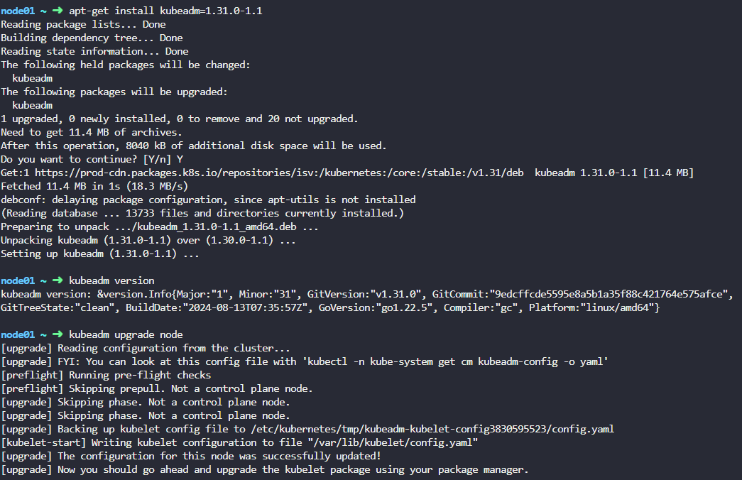

  - Upgrade Kubelet in worker node

apt-get install kubelet=1.31.0-1.1 ; upgrade kubelet packages on worker node to minor version

kubeadm upgrade node config - -kubelet-version v1.12.0 ; update node configuration for the new Kubelet version

Run the following commands to refresh the systemd configuration and apply changes to the Kubelet service:

sudo systemctl daemon-reload
sudo systemctl restart kubelet

  - Uncordon the worker node

kubectl uncordon node01 ; mark the upgraded node as schedulable. It is not necessary to pods fall back to the node that marked as schedulable. It may happen when new pod creates or a pod drained from other node

Likewise, same process follows for each node one by one

cat /etc/*release* ; to show release file of Linux distribution. Based on Linux distribution version the way of upgrade will be changed

kubeadm version ; shows version of kubeadm with Major, Minor and GitVersion

kubectl command should be running on control plane node not worker node

The latest stable version shows as remote version in kubeadm upgrade plan

***Exam tips: To verify the nodes that can host workloads check the taints on the nodes. Use "kubectl get nodes | grep Taints"

Summary of cluster upgrade plan

- Drain the control plane
- Check pods status
-Changing Kubernestes package repository on controlplane nodes
-Determine which version to upgrade kubeadm
- Upgrade kubeadm tool on control plane node
- Verify the upgrade plan using kubeadm upgrade plan
- Upgrade Kubernetes master node components using kubeadm upgrade apply <version>
- Upgrade Kubelet and kubectl
- Restart the kubelet
- Uncordon the control plane
- Drain the worker node
- Check pods status
-Connect to worker node
-Changing Kubernestes package repository on controlplane nodes
-Determine which version to upgrade kubeadm
- Upgrade kubeadm on worker node
- Upgrade the local kubelet configuration using kubeadm upgrade node
- Upgrade Kubelet and kubectl
- Restart the kubelet
- Uncordon the worker node

Summary- Kubeadm - upgrade

Upgrading controlplane nodes

  - Changing the Kubernetes package repository on controlplane nodes

vim /etc/apt/sources.list.d/kubernetes.list

  - Determine which version to upgrade on controlplane node

sudo apt update
sudo apt-cache madison kubeadm

apt-cache madison kubeadm displays available kubeadm packages with version that can be upgraded

  - Upgrade Kubeadm on controlplane node

sudo apt-mark unhold kubeadm && \
sudo apt-get update && sudo apt-get install -y kubeadm='1.31.0-1.1' && \
sudo apt-mark hold kubeadm

kubeadm version ; verify upgraded kubeadm version

  - Upgrade controlplane components

sudo kubeadm upgrade plan ; verify the upgrade plan

sudo kubeadm upgrade apply v1.31.0 ; With this command, upgrade on etcd, Kube-apiserver, kube-controller-manager, kube-scheduler, kube-proxy and CoreDNS

sudo kubeadm upgrade node ; run this command instead of sudo kubeadm upgrade apply if the cluster has multiple control plane node

  - Drain the controlplane node

kubectl drain <node-to-drain> - -ignore-daemonsets

  - Upgrade Kubelet and kubectl in control plane node

Use same package version that used when upgrade kubeadm

sudo apt-mark unhold kubelet kubectl && \
sudo apt-get update && sudo apt-get install -y kubelet='1.31.0-1.1' kubectl='1.31.0-1.1' && \
sudo apt-mark hold kubelet kubectl

Run the following commands to refresh the systemd configuration and apply changes to the Kubelet service:

sudo systemctl daemon-reload
sudo systemctl restart kubelet

  - Uncordon the control plane node

kubectl uncordon <node-to-drain>

Upgrading worker nodes

  - Changing the Kubernetes package repository on controlplane nodes

vim /etc/apt/sources.list.d/kubernetes.list

  - Determine which version to upgrade on controlplane node

sudo apt update
sudo apt-cache madison kubeadm

apt-cache madison kubeadm displays available kubeadm packages with version that can be upgraded

  - Upgrade Kubeadm on worker node

sudo apt-mark unhold kubeadm && \
sudo apt-get update && sudo apt-get install -y kubeadm='1.31.x-*' && \
sudo apt-mark hold kubeadm

kubeadm version ; verify upgraded kubeadm version

sudo kubeadm upgrade node ; upgrade the local kubelet configuration on worker node

  - Drain the worker node

kubectl drain <node-to-drain> - -ignore-daemonsets

  - Upgrade Kubelet in worker node

sudo apt-mark unhold kubelet kubectl && \
sudo apt-get update && sudo apt-get install -y kubelet='1.31.x-*' kubectl='1.31.x-*' && \
sudo apt-mark hold kubelet kubectl

Run the following commands to refresh the systemd configuration and apply changes to the Kubelet service:

sudo systemctl daemon-reload
sudo systemctl restart kubelet

  - Uncordon the control plane node

kubectl uncordon <node-to-drain>

Likewise, same process follows for each node one by one

Backup and restore methods

Backup Candidates

  - Resource Configuration
  - ETCD Cluster
  - Persistent Volumes

*ETCD and persistent volumes are stateful
*Master and worker nodes are stateless.

This means we don't need to restore exact copy of previous version in case of failure. We can spin up new cluster, restore the ETCD data and persistent volumes data to restore the applications/services

Backup- Resource configuration

You may use to create objects in imperative way or declarative way. Declarative way is preferred approach if you want save the configuration because you have all the objects required for single application in the form of object definition files in single folder that can be reused and shared with others. Object definition file can be stored in source code repository such as GitHub and maintain for a team.

- Best way for backing up resource configuration is to query kube-apiserver using kubectl or by accessing kube-apiserver directly and save all resource configuration for objects created on the cluster as a copy

kubectl get all - -all-namespaces -o yaml > all-deploy-services.yaml ; extract output of all object definition file in yaml format. This is just for few resource group. When number of resources group grows, this process is not easy. In that case, we can use Ark or VELERO by HeptIO which help taking backup of Kubernetes cluster using the kubernetes API.

Backup- ETCD

-ETCD cluster stores information about the state of the cluster resources such as nodes, pods, deployments, services etc
- Information about Kubernetes objects are stored on ETCD. Instead backing up each resources as before, periodically backing up the ETCD cluster data is important to recover Kubernetes cluster upon disaster scenario such as losing all control plane nodes
-While configuring ETCD, we specify a location where ETCD server stores data of the cluster in that location
data-dir=/var/lib/etcd
- This data directory can be configured to be backed by backup tool

- ETCD comes with built-in snapshot solution Operating etcd clusters for Kubernetes | Kubernetes
- You can take a snapshot of the etcd database by using ETCDTCTL utility's etcdctl snapshot save or by copying the member/snap/db file from an etcd data directory that is not currently used by an etcd process

ETCDCTL_API=3 etcdctl \
snapshot save snapshot.db ; save snapshot taken with naming snapshot.db

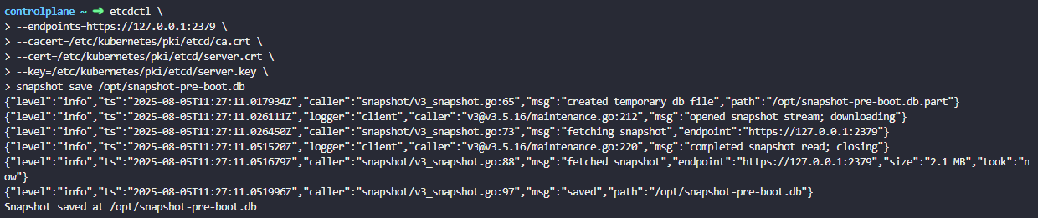

etcdutl --write-out=table snapshot status /opt/snapshot-pre-boot.db ; shows the size and hash of snapshot taken

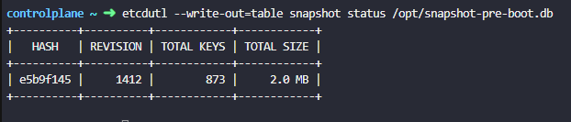

Restore- ETCD

To restore snapshot taken;

1.service kube-apiserver stop ; stop kube-api sever service as restore process will require to restart etcd cluster and kube-api server depends on it

2.ETCDCTL_API=3 etcdctl \
snapshot restore snapshot.db \
- -data-dir /var/lib/etcd-from-backup

/var/lib/etcd-from-backup : path set to the path of the backup file which is snapshot.db file will be restored

etcdutl --data-dir <data-dir-location> snapshot restore snapshot.db

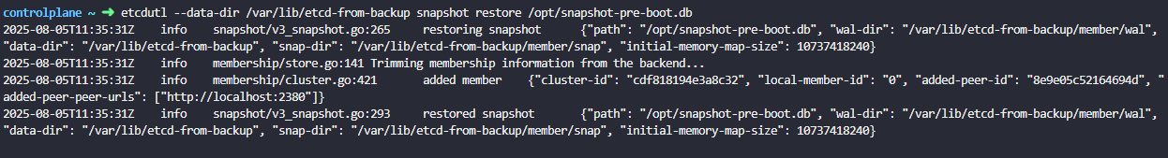

This command initialize new cluster configuration and configures members of ETCD as new members to a new cluster which specify new data directory for etcd server. This is to prevent a new member from accidentally joining an existing cluster.

We don't need to specify the endpoints or the certificate details when restoring backup because this particular operation of restoring data from an etcd backup is not done by communicating with the etcd server.

3.Configure the etcd configuration file to use new data directory in etcd.service > - -data-dir /var/lib/etcd-from-backup

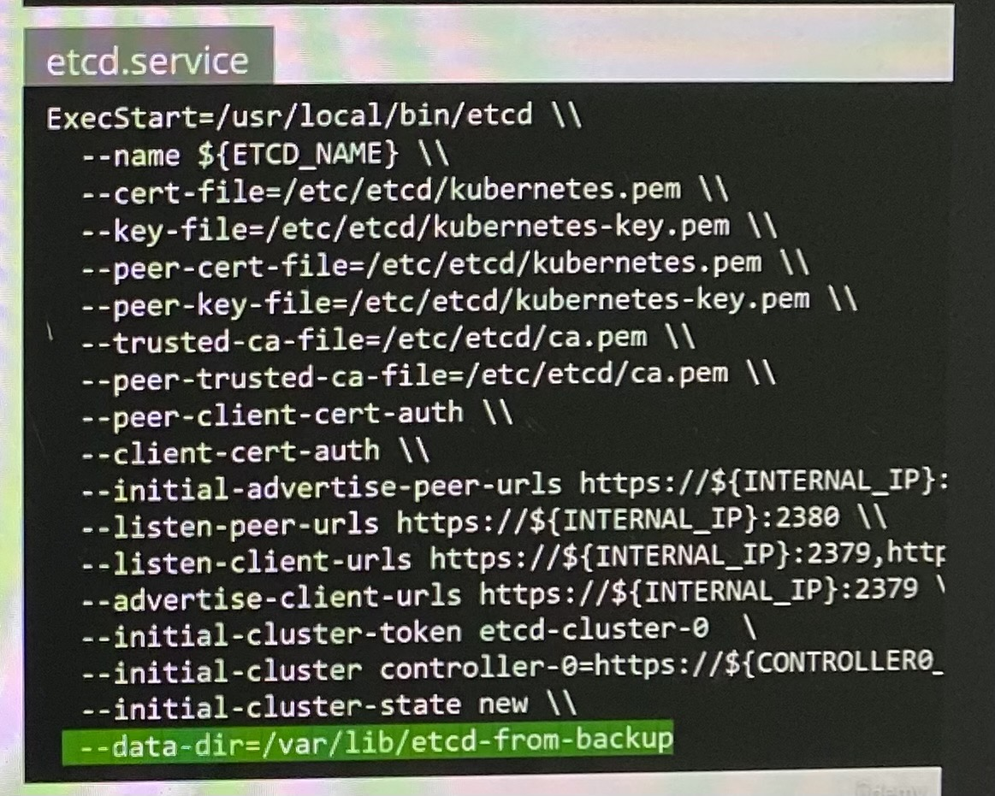

4.systemctl daemon-reload ; reload service daemon

service etcd restart ; restart etcd service

5.service kube-apiserver start ; start kube api service

Your cluster should now be back in the original state.

With all the etcd commands, remember to specify the certificate files for authentication, specify the endpoint to the etcd cluster and the CA certificate, the etcd server certificate, and the key.

ETCDCTL_API=3 etcdctl \
snapshot save /opt/snapshot-pre-boot.db \
--endpoints=https://127.0.0.1:2379 \
--cacert=/etc/kubernetes/pki/etcd/ca.crt \
--cert=/etc/kubernetes/pki/etcd/server.crt
--key=/etc/kubernetes/pki/etcd/server.key

If you're using a managed Kubernetes environment, you may not even access to the etcd cluster. In that case, backup by querying the Kube API server is the better way.

Backup and Restore ETCD - when ETCD is deployed as pod

Take the snapshot of ETCD cluster

Check the pod manifest file of ETCD in /etc/Kubernetes/manifest directory in order to find following attributes. It configures volumeMounts specifying path of etcd data store and these attributes

ETCDCTL_API=3 etcdctl \
snapshot save snapshot.db \
- -endpoints=https://127.0.0.1:2379\
- -cacert=/etc/etcd/ca.crt \
- -cert=/etc/etcd/etcd-server.crt \
- -key=/etc/etcd/etcd-server.key\ ; For all ETCD command, specify certificate files for authentication

Check availability of deployment, pods and services

New command:

ETCDCTL_API=3 etcdctl --endpoints=https://127.0.0.1:2379 \
--cacert=/etc/kubernetes/pki/etcd/ca.crt --cert=/etc/kubernetes/pki/etcd/server.crt --key=/etc/kubernetes/pki/etcd/server.key \
snapshot save /opt/snapshot-pre-boot.db

Restore the snapshot to new file in data directory

controlplane ~ ➜ export ETCDCTL_API=3

controlplane ~ ➜ etcdctl --data-dir /var/lib/etcd-from-backup snapshot restore /opt/snapshot-pre-boot.db
2024-12-06 11:08:06.464238 I | mvcc: restore compact to 2846
2024-12-06 11:08:06.467210 I | etcdserver/membership: added member 8e9e05c52164694d [http://localhost:2380] to cluster cdf818194e3a8c32

Note: In this case, we are restoring the snapshot to a different directory but in the same server where we took the backup (the controlplane node) As a result, the only required option for the restore command is the --data-dir. Specify path to restore the backup where extract the data to new file in the data directory

controlplane ~ ➜ ls /var/lib/etcd-from-backup ; check the data in new directory
member

Then need to update new file path in pod manifest file /etc/kubernetes/manifests/etcd.yaml is to change the hostPath for the volume called etcd-data from old directory (/var/lib/etcd) to the new directory (/var/lib/etcd-from-backup).

volumes:
- hostPath:
path: /var/lib/etcd-from-backup
type: DirectoryOrCreate
name: etcd-data

With this change, /var/lib/etcd on the container points to /var/lib/etcd-from-backup on the controlplane

When this file is updated, the ETCD pod is automatically re-created as this is a static pod placed under the /etc/kubernetes/manifests directory.

watch crictl ps

Note 1: As the ETCD pod has changed it will automatically restart, and also kube-controller-manager and kube-scheduler will restart. Wait 1-2 to mins for this pods to restart. You can run the command: watch "crictl ps | grep etcd" to see when the ETCD pod is restarted. Check liveness and startup probes in command "kubectl describe pod -n kube-system etcd-controlplane"

Note 2: If the etcd pod is not getting Ready 1/1 or pending state, then restart it by kubectl delete pod -n kube-system etcd-controlplane and wait 1 minute.

Note 3: This is the simplest way to make sure that ETCD uses the restored data after the ETCD pod is recreated. You don't have to change anything else.

If you do change --data-dir to /var/lib/etcd-from-backup in the ETCD YAML file, make sure that the volumeMounts for etcd-data is updated as well, with the mountPath pointing to /var/lib/etcd-from-backup (THIS COMPLETE STEP IS OPTIONAL AND NEED NOT BE DONE FOR COMPLETING THE RESTORE)

Working with ETCDCTL

- ETCD key-value database is deployed as a static pod on the master node
- To make use of etcdctl for tasks as backup and restore, make sure to set the ETCDCTL_API to 3. This can be done by exporting the ETCDCTL_API as environment variable prior to using the etcdctl client on master node

export ETCDCTL_API=3

On the Master Node:
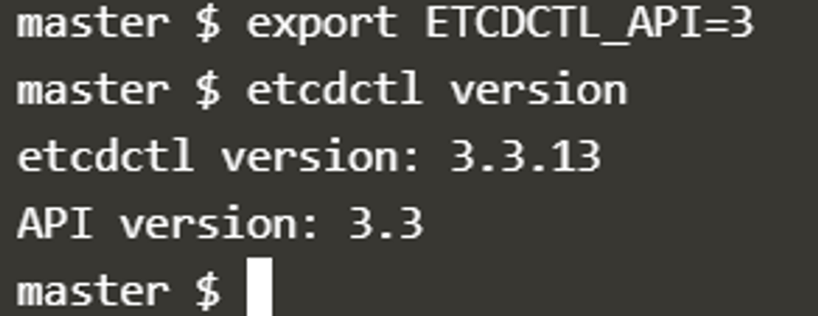

For example, if you want to take a snapshot of etcd, use:

etcdctl snapshot save -h and keep a note of the mandatory global options.

- To see all sub commands, use -h or - -help

etcdctl snapshot -h

- Since our ETCD database is TLS enabled, the following options are mandatory:

- -cacert ; verify certificate of TLS-enabled secure servers using this CA bundle

- -cert ; identify secure client using this TLS certificate file

- -endpoints=https://127.0.0.1:2379 ; this is the default as ETCD is running on master node and exposed on localhost 2379

- -key ; identify secure client using TLS key file

etcdctl snapshot restore -h ; restoring the snapshot

- ETCD server certificate is located in /etc/kubernetes/pki/etcd/server.crt
- ETCD CA server certificate is located in /etc/kubernetes/pki/etcd/ca.crt

Configure access to multiple clusters

kubectl config ; check options for multiple clusters

kubectl config get-clusters ; display clusters defined from the kubeconfig

student-node ~ ➜ kubectl config use-context cluster1
Switched to context "cluster1". ; get switch to context in cluster1

You can ssh to all nodes from the nodes and use logout to exit from node

student-node ~ ➜ kubectl config view ; Display merged kubeconfig settings or a specified kubeconfig file
apiVersion: v1
clusters:
- cluster:
certificate-authority-data: DATA+OMITTED
server: https://cluster1-controlplane:6443
name: cluster1
- cluster:
certificate-authority-data: DATA+OMITTED
server: https://192.1.78.10:6443
name: cluster2
contexts:
- context:
cluster: cluster1
user: cluster1
name: cluster1
- context:
cluster: cluster2
user: cluster2
name: cluster2
current-context: cluster1
kind: Config
preferences: {}
users:
- name: cluster1
user:
client-certificate-data: DATA+OMITTED
client-key-data: DATA+OMITTED
- name: cluster2
user:
client-certificate-data: DATA+OMITTED
client-key-data: DATA+OMITTED

kubectl config view command shows the number of clusters configured.

ETCD can be configured as external or stacked.

To determine how ETCD configured - Stacked ETCD

  - If the ETCD is running as a pod, this means that ETCD is set up as a Stacked ETCD Topology where the distributed data storage cluster provided by etcd is stacked on top of the cluster formed by the nodes managed by kubeadm that run control plane components.

  - The other way is to inspect Kube-apiserver with describe command which shows the URL that Kube-apiserver will actually need to communicate with ETCD server. If it has localhost IP address which runs on controlplane node means stacked ETCD.

To determine how ETCD configured - External ETCD

  - Inspect ETCD process on controlplane to find where ETCD is placed on and check IP address of control plane node and ETCD server

cluster2-controlplane ~ ➜ ps -ef | grep etcd
root 2949 2543 0 00:52 ? 00:03:06 kube-apiserver --advertise-address=192.1.78.10 --allow-privileged=true --authorization-mode=Node,RBAC --client-ca-file=/etc/kubernetes/pki/ca.crt --enable-admission-plugins=NodeRestriction --enable-bootstrap-token-auth=true --etcd-cafile=/etc/kubernetes/pki/etcd/ca.pem --etcd-certfile=/etc/kubernetes/pki/etcd/etcd.pem --etcd-keyfile=/etc/kubernetes/pki/etcd/etcd-key.pem --etcd-servers=https://192.1.78.19:2379 --kubelet-client-certificate=/etc/kubernetes/pki/apiserver-kubelet-client.crt --kubelet-client-key=/etc/kubernetes/pki/apiserver-kubelet-client.key --kubelet-preferred-address-types=InternalIP,ExternalIP,Hostname --proxy-client-cert-file=/etc/kubernetes/pki/front-proxy-client.crt --proxy-client-key-file=/etc/kubernetes/pki/front-proxy-client.key --requestheader-allowed-names=front-proxy-client --requestheader-client-ca-file=/etc/kubernetes/pki/front-proxy-ca.crt --requestheader-extra-headers-prefix=X-Remote-Extra- --requestheader-group-headers=X-Remote-Group --requestheader-username-headers=X-Remote-User --secure-port=6443 --service-account-issuer=https://kubernetes.default.svc.cluster.local --service-account-key-file=/etc/kubernetes/pki/sa.pub --service-account-signing-key-file=/etc/kubernetes/pki/sa.key --service-cluster-ip-range=10.96.0.0/12 --tls-cert-file=/etc/kubernetes/pki/apiserver.crt --tls-private-key-file=/etc/kubernetes/pki/apiserver.key
root 12733 12118 0 02:38 pts/0 00:00:00 grep etcd

  - Inspect describe command of kube-api server pod command options and check IP address of control plane node and ETCD server. If the IP address of ETCD server is not the IP address of controlplane node, ETCD is configured as an External ETCD

cluster2-controlplane ~ ➜ kubectl -n kube-system describe pod kube-apiserver-cluster2-controlplane

--etcd-servers=https://192.160.244.3:2379

  - Check the static pod manifest files in the path (/etc/kubernetes/manifests) in controlplane node

If ETCD is an external ETCD, ssh to the IP and inspect the process of ETCD to get more information such as
default data directory (data-dir)

etcd-server ~ ➜ ps aux | grep -i etcd
etcd 831 0.0 0.0 11217856 66848 ? Ssl 00:52 1:32 /usr/local/bin/etcd --name etcd-server --data-dir=/var/lib/etcd-data --cert-file=/etc/etcd/pki/etcd.pem --key-file=/etc/etcd/pki/etcd-key.pem --peer-cert-file=/etc/etcd/pki/etcd.pem --peer-key-file=/etc/etcd/pki/etcd-key.pem --trusted-ca-file=/etc/etcd/pki/ca.pem --peer-trusted-ca-file=/etc/etcd/pki/ca.pem --peer-client-cert-auth --client-cert-auth --initial-advertise-peer-urls https://192.1.78.19:2380 --listen-peer-urls https://192.1.78.19:2380 --advertise-client-urls https://192.1.78.19:2379 --listen-client-urls https://192.1.78.19:2379,https://127.0.0.1:2379 --initial-cluster-token etcd-cluster-1 --initial-cluster etcd-server=https://192.1.78.19:2380 --initial-cluster-state new
root 1058 0.0 0.0 13444 1028 pts/0 S+ 02:59 0:00 grep -i etcd

To check the members in the ETCD cluster

etcd-server ~ ➜ ETCDCTL_API=3 etcdctl \
--endpoints=https://127.0.0.1:2379 \
--cacert=/etc/etcd/pki/ca.pem \
--cert=/etc/etcd/pki/etcd.pem \
--key=/etc/etcd/pki/etcd-key.pem \
member list
59ee55985632d394, started, etcd-server, https://192.160.244.3:2380, https://192.160.244.3:2379, false ; This external ETCD has only one member.

To copy snapshot or backup from one node to another,

student-node ~ ➜ scp cluster1-controlplane:/opt/cluster1.db /opt
cluster1.db 100% 2088KB 112.3MB/s 00:00

Restore a backup to external ETCD

  - Restore the snapshot on the cluster2. Since we are restoring directly on the etcd-server, we can use the endpoint https:/127.0.0.1. Use the same certificates that were identified earlier. However, using certificate file is not mandatory if you restore snapshot from ETCD server itself. Make sure to use the data-dir as /var/lib/etcd-data-new:

etcd-server ~ ➜ ETCDCTL_API=3 etcdctl --endpoints=https://127.0.0.1:2379 --cacert=/etc/etcd/pki/ca.pem --cert=/etc/etcd/pki/etcd.pem --key=/etc/etcd/pki/etcd-key.pem snapshot restore /root/cluster2.db --data-dir /var/lib/etcd-data-new
{"level":"info","ts":1721940922.0441437,"caller":"snapshot/v3_snapshot.go:296","msg":"restoring snapshot","path":"/root/cluster2.db","wal-dir":"/var/lib/etcd-data-new/member/wal","data-dir":"/var/lib/etcd-data-new","snap-dir":"/var/lib/etcd-data-new/member/snap"}
{"level":"info","ts":1721940922.060755,"caller":"mvcc/kvstore.go:388","msg":"restored last compact revision","meta-bucket-name":"meta","meta-bucket-name-key":"finishedCompactRev","restored-compact-revision":951}
{"level":"info","ts":1721940922.0667593,"caller":"membership/cluster.go:392","msg":"added member","cluster-id":"cdf818194e3a8c32","local-member-id":"0","added-peer-id":"8e9e05c52164694d","added-peer-peer-urls":["http://localhost:2380"]}
{"level":"info","ts":1721940922.0732546,"caller":"snapshot/v3_snapshot.go:309","msg":"restored snapshot","path":"/root/cluster2.db","wal-dir":"/var/lib/etcd-data-new/member/wal","data-dir":"/var/lib/etcd-data-new","snap-dir":"/var/lib/etcd-data-new/member/snap"}

  - Update the systemd service unit file for etcd by running vi /etc/systemd/system/etcd.service and add the new value for data-dir:

etcd-server ~ ➜ vi /etc/systemd/system/etcd.service

[Unit]
Description=etcd key-value store
Documentation=https://github.com/etcd-io/etcd
After=network.target

[Service]
User=etcd
Type=notify
ExecStart=/usr/local/bin/etcd \
--name etcd-server \
--data-dir=/var/lib/etcd-data-new \
---End of Snippet---

  - Make sure the permissions on the new directory is correct (should be owned by etcd user):

etcd-server /var/lib ➜ chown -R etcd:etcd /var/lib/etcd-data-new
etcd-server /var/lib ➜

etcd-server /var/lib ➜ ls -ld /var/lib/etcd-data-new/
drwx------ 3 etcd etcd 4096 Jul 15 20:55 /var/lib/etcd-data-new/
etcd-server /var/lib ➜

  - Finally, reload and restart the etcd service.

etcd-server ~ ➜ systemctl daemon-reload
etcd-server ~ ➜ systemctl restart etcd
etcd-server ~ ➜

  - It is recommended to restart controlplane components (e.g. kube-scheduler, kube-controller-manager, kubelet) to ensure that they don't rely on some stale data. Delete static pod -kube-scheduler, kube-controller-manager to restart the pods

student-node ~ ➜ kubectl delete pods kube-controller-manager-cluster2-controlplane kube-scheduler-cluster2-controlplane -n kube-system

cluster2-controlplane ~ ➜ systemctl restart kubelet.service

Working with ETCDCTL and ETCDUTL

etcdctl is a command line client for etcd.

In all our Kubernetes Hands-on labs, the ETCD key-value database is deployed as a static pod on the master. The version used is v3.

To make use of etcdctl for tasks such as back up and restore, make sure that you set the ETCDCTL_API to 3.

You can do this by exporting the variable ETCDCTL_API prior to using the etcdctl client. This can be done as follows:

export ETCDCTL_API=3

On the Master Node:
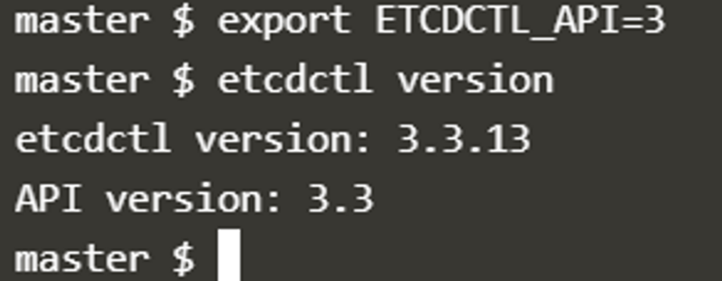

To see all the options for a specific sub-command, make use of the -h or --help flag.

Backing Up ETCD

Using etcdctl (Snapshot-based Backup)

To take a snapshot from a running etcd server, use:

- ETCDCTL_API=3 etcdctl \
- --endpoints=https://127.0.0.1:2379 \
- --cacert=/etc/kubernetes/pki/etcd/ca.crt \
- --cert=/etc/kubernetes/pki/etcd/server.crt \
- --key=/etc/kubernetes/pki/etcd/server.key \
- snapshot save /backup/etcd-snapshot.db

Required Options

- --endpoints points to the etcd server (default: localhost:2379)
- --cacert path to the CA cert
- --cert path to the client cert
- --key path to the client key

Similarly use the help option for snapshot restore to see all available options for restoring the backup.
etcdctl snapshot restore -h
For a detailed explanation on how to make use of the etcdctl command line tool and work with the -h flags, check out the solution video for the Backup and Restore Lab.

Using etcdutl (File-based Backup)

For offline file-level backup of the data directory:

etcdutl backup \
--data-dir /var/lib/etcd \
--backup-dir /backup/etcd-backup

This copies the etcd backend database and WAL files to the target location.

Checking Snapshot Status

You can inspect the metadata of a snapshot file using:

etcdctl snapshot status /backup/etcd-snapshot.db \
--write-out=table

This shows details like size, revision, hash, total keys, etc. It is helpful to verify snapshot integrity before restore.

Restoring ETCD

Using etcdutl

To restore a snapshot to a new data directory:

etcdutl snapshot restore /backup/etcd-snapshot.db \
--data-dir /var/lib/etcd-restored

To use a backup made with etcdutl backup, simply copy the backup contents back into /var/lib/etcd and restart etcd.

Notes

- etcdctl snapshot save is used for creating .db snapshots from live etcd clusters.
- etcdctl snapshot status provides metadata information about the snapshot file.
- etcdutl snapshot restore is used to restore a .db snapshot file.
- etcdutl backup performs a raw file-level copy of etcd’s data and WAL files without needing etcd to be running.

References

https://kubernetes.io/docs/tasks/administer-cluster/configure-upgrade-etcd/#backing-up-an-etcd-cluster
https://github.com/etcd-io/website/blob/main/content/en/docs/v3.5/op-guide/recovery.md
https://www.youtube.com/watch?v=qRPNuT080Hk

Examtips:

Check the ETCD version

Look at the ETCD Logs using the command kubectl logs etcd-controlplane -n kube-system or check the image used by the ETCD pod: kubectl describe pod etcd-controlplane -n kube-system

root@controlplane:~# kubectl -n kube-system logs etcd-controlplane | grep -i 'etcd-version'
"caller":"embed/etcd.go:306","msg":"starting an etcd server","etcd-version":"3.5.7","git-sha":"215b53cf3"

root@controlplane:~# kubectl -n kube-system describe pod etcd-controlplane | grep Image:
Image: registry.k8s.io/etcd:3.5.7-0

Certification Exam Tip!
Here's a quick tip. In the exam, you won't know if what you did is correct or not as in the practice tests in this course. You must verify your work yourself. For example, if the question is to create a pod with a specific image, you must run the kubectl describe pod command to verify the pod is created with the correct name and correct image.

https://kubernetes.io/docs/tasks/administer-cluster/configure-upgrade-etcd/#backing-up-an-etcd-cluster
https://github.com/etcd-io/website/blob/main/content/en/docs/v3.5/op-guide/recovery.md
https://www.youtube.com/watch?v=qRPNuT080Hk

NAME:
snapshot save - Stores an etcd node backend snapshot to a given file

USAGE:
etcdctl snapshot save <filename>

GLOBAL OPTIONS:
--cacert="" verify certificates of TLS-enabled secure servers using this CA bundle
--cert="" identify secure client using this TLS certificate file
--command-timeout=5s timeout for short running command (excluding dial timeout)
--debug[=false] enable client-side debug logging
--dial-timeout=2s dial timeout for client connections
-d, --discovery-srv="" domain name to query for SRV records describing cluster endpoints
--endpoints=[127.0.0.1:2379] gRPC endpoints
--hex[=false] print byte strings as hex encoded strings
--insecure-discovery[=true] accept insecure SRV records describing cluster endpoints
--insecure-skip-tls-verify[=false] skip server certificate verification
--insecure-transport[=true] disable transport security for client connections
--keepalive-time=2s keepalive time for client connections
--keepalive-timeout=6s keepalive timeout for client connections
--key="" identify secure client using this TLS key file
--user="" username[:password] for authentication (prompt if password is not supplied)
-w, --write-out="simple" set the output format (fields, json, protobuf, simple, table)

controlplane ~ ✖ ETCDCTL_API=3 etcdctl snapshot save /opt/snapshot-pre-boot.db --cert=/etc/kubernetes/pki/etcd/server.crt --endpoints=https://127.0.0.1:2379 --cacert=/etc/kubernetes/pki/etcd/ca.crt --key=/etc/kubernetes/pki/etcd/server.key
Snapshot saved at /opt/snapshot-pre-boot.db

**This command should be run on master node that etcd pod.

student-node ~ ✖ kubectl config
Modify kubeconfig files using subcommands like "kubectl config set current-context my-context".

The loading order follows these rules:

1. If the --kubeconfig flag is set, then only that file is loaded. The flag may only be set once and no merging takes
place.
2. If $KUBECONFIG environment variable is set, then it is used as a list of paths (normal path delimiting rules for
your system). These paths are merged. When a value is modified, it is modified in the file that defines the stanza. When
a value is created, it is created in the first file that exists. If no files in the chain exist, then it creates the
last file in the list.
3. Otherwise, ${HOME}/.kube/config is used and no merging takes place.

Available Commands:
current-context Display the current-context
delete-cluster Delete the specified cluster from the kubeconfig
delete-context Delete the specified context from the kubeconfig
delete-user Delete the specified user from the kubeconfig
get-clusters Display clusters defined in the kubeconfig
get-contexts Describe one or many contexts
get-users Display users defined in the kubeconfig
rename-context Rename a context from the kubeconfig file
set Set an individual value in a kubeconfig file
set-cluster Set a cluster entry in kubeconfig
set-context Set a context entry in kubeconfig
set-credentials Set a user entry in kubeconfig
unset Unset an individual value in a kubeconfig file
use-context Set the current-context in a kubeconfig file
view Display merged kubeconfig settings or a specified kubeconfig file

Usage:
kubectl config SUBCOMMAND [options]

Use "kubectl config <command> --help" for more information about a given command.
Use "kubectl options" for a list of global command-line options (applies to all commands).

controlplane ~ ➜ kubectl describe pod purple
Name: purple
Namespace: default
Priority: 0
Service Account: default
Node: controlplane/192.168.96.150
Start Time: Tue, 05 Aug 2025 05:34:54 +0000
Labels: <none>
Annotations: <none>
Status: Pending
IP: 10.22.0.12
IPs:
IP: 10.22.0.12
Init Containers:
warm-up-1:
Container ID: containerd://9743511b06cc683a17138ba2572b515ff869984b35e87db5793afd7eb907239d
Image: busybox:1.28
Image ID: docker.io/library/busybox@sha256:141c253bc4c3fd0a201d32dc1f493bcf3fff003b6df416dea4f41046e0f37d47
Port: <none>
Host Port: <none>
Command:
sh
-c
sleep 600
State: Running
Started: Tue, 05 Aug 2025 05:34:55 +0000
Ready: False
Restart Count: 0
Environment: <none>
Mounts:
/var/run/secrets/kubernetes.io/serviceaccount from kube-api-access-n25k8 (ro)
warm-up-2:
Container ID:
Image: busybox:1.28
Image ID:
Port: <none>
Host Port: <none>
Command:
sh
-c
sleep 1200
State: Waiting
Reason: PodInitializing
Ready: False
Restart Count: 0
Environment: <none>
Mounts:
/var/run/secrets/kubernetes.io/serviceaccount from kube-api-access-n25k8 (ro)
Containers:
purple-container:
Container ID:
Image: busybox:1.28
Image ID:
Port: <none>
Host Port: <none>
Command:
sh
-c
echo The app is running! && sleep 3600
State: Waiting
Reason: PodInitializing
Ready: False
Restart Count: 0
Environment: <none>
Mounts:
/var/run/secrets/kubernetes.io/serviceaccount from kube-api-access-n25k8 (ro)
Conditions:
Type Status
PodReadyToStartContainers True
Initialized False
Ready False
ContainersReady False
PodScheduled True
Volumes:
kube-api-access-n25k8:
Type: Projected (a volume that contains injected data from multiple sources)
TokenExpirationSeconds: 3607
ConfigMapName: kube-root-ca.crt
Optional: false
DownwardAPI: true
QoS Class: BestEffort
Node-Selectors: <none>
Tolerations: node.kubernetes.io/not-ready:NoExecute op=Exists for 300s
node.kubernetes.io/unreachable:NoExecute op=Exists for 300s
Events:
Type Reason Age From Message
---- ------ ---- ---- -------
Normal Scheduled 107s default-scheduler Successfully assigned default/purple to controlplane
Normal Pulled 107s kubelet Container image "busybox:1.28" already present on machine
Normal Created 107s kubelet Created container: warm-up-1
Normal Started 107s kubelet Started container warm-up-1

