Storage

There are two concepts in storage in Docker.
- Storage drivers
- Volume drivers

Docker storage

File system
When you install docker on a system, it creates the following folder structure.

/var/lib/docker/

Docker by default stores all its data in these folders such as aufs, containers, image, volumes under /var/lib/docker/

Layered architecture

Docker builds images from Dockerfile in a layered architecture.

- Each line of instruction in the Dockerfile creates a new layer in the Docker image with changes from the previous layer
- As each layer only stores the changes of previous layer, it is reflected the size of layer.
- With layered architecture, the each layer that Docker build is cached. If you use a Dockerfile that has similar line of instruction like previous Dockerfile that you built, those similar layers will not be built again because those layers are cached
- Docker simply reuses all the previous layers from cache and quickly rebuild the image.

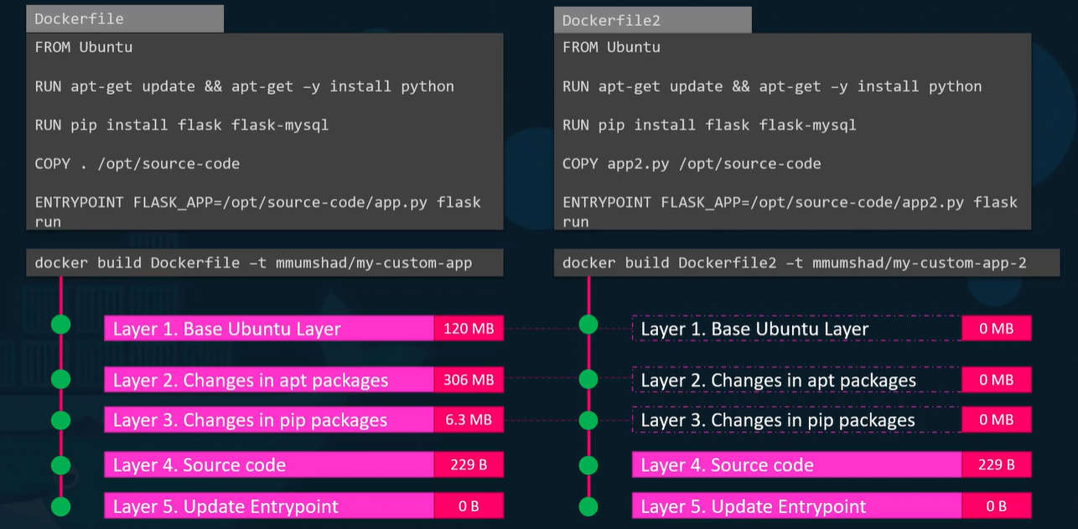

Thus, you build another app with same base image, packages and dependencies, docker will reuse first 3 layers that use for the first application from the cache and only creates last 2 layers in faster and efficient manner saving the disk space and time to build image.

Whenever the application needs to update the source code, it reuse previous 3 layers from cache.

Dockerfile contains base image, packages, dependencies, source code and entrypoint.

Once you build an image from Dockerfile, it is read-only and you have to initiate new build if you want to make changes.

When you create a docker container based on an image, you creates new writable layer on top of image layers where you can store data created by the container such as log files, temporary files or any files. This layer and all of changes stored on it is destroyed when the container is destroyed.

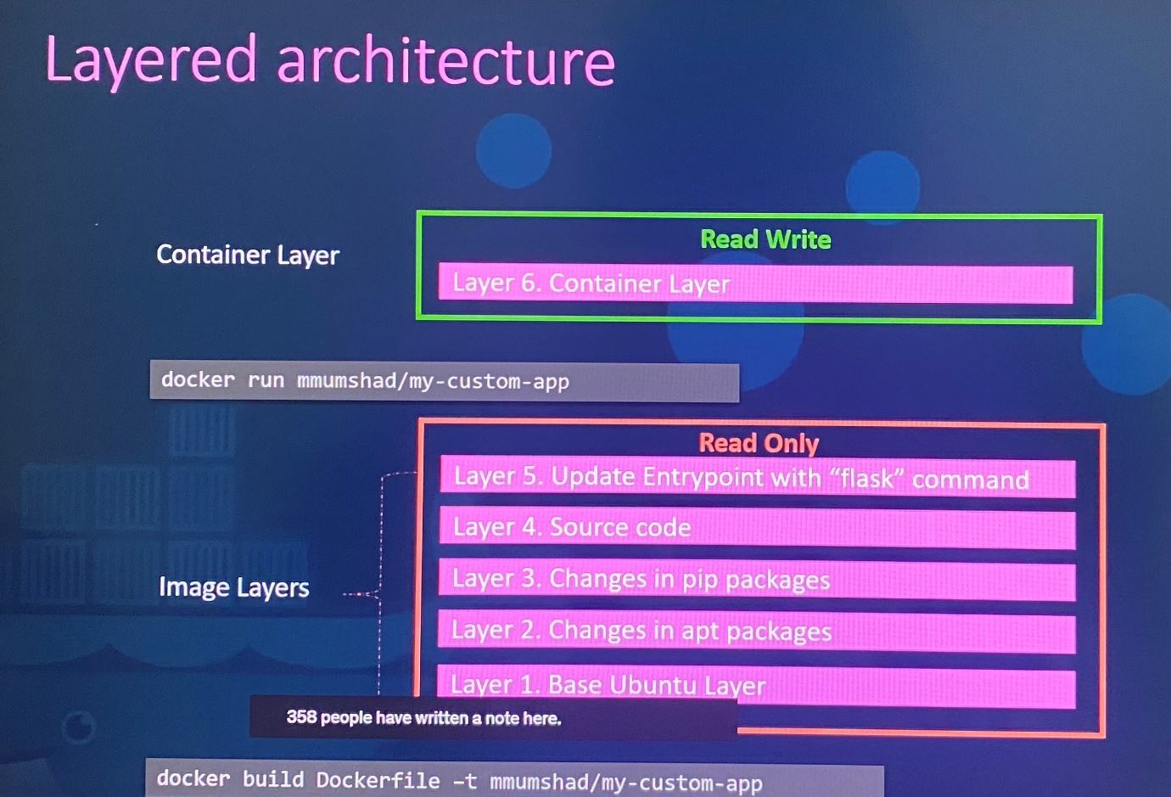

Image layers > read only
Container layer > Read Write

Same image layer is shared by multiple containers created from this image. The files in image layer such as source code can be modified only in container layer so that it gets copy of file onto container layer, then it allows you to do any modification on the file and save in container layer which is called COPY-ON-WRITE mechanism. Since image layer is read only, files in image layer will not be modified in the image itself. The image will remain the same until you rebuild the image using docker build command.

Once container delete, all the data stored in container layer are removed. If you need to persist the data to preserve even after the container deletes, you could add a persistent volume to the container.

Volumes in Docker

When you need to preserve the data in the container, we can add persistent volume to the conatiner.

docker volume create <name of the volume> ; create a volume under the /var/lib/docker/volumes directory

docker run -v data_volume:var/lib/mysql mysql ; create docker container with image mysql by mounting volume data_volume followed by default location of application stores data in the container.

If you run docker run -v data_volume2:var/lib/mysql mysql command without creating a volume specifically with docker volume create command, it will create new volume on Docker host automatically and mount it to location of application stores data in the container.

This is called volume mounting where mount the volume from volume directory on Docker host to the location the application store the data.

ls /var/lib/docker/volumes ; list the all volumes created.

If you have external storage on the Docker host at /data/mysql, you can store data in that volume instead default volume directory in the Docker host.

docker run -v /data/mysql:var/lib/mysql mysql ; create docker container with image mysql by mounting a full directory path of any location on the docker host. This is called bind mounting.

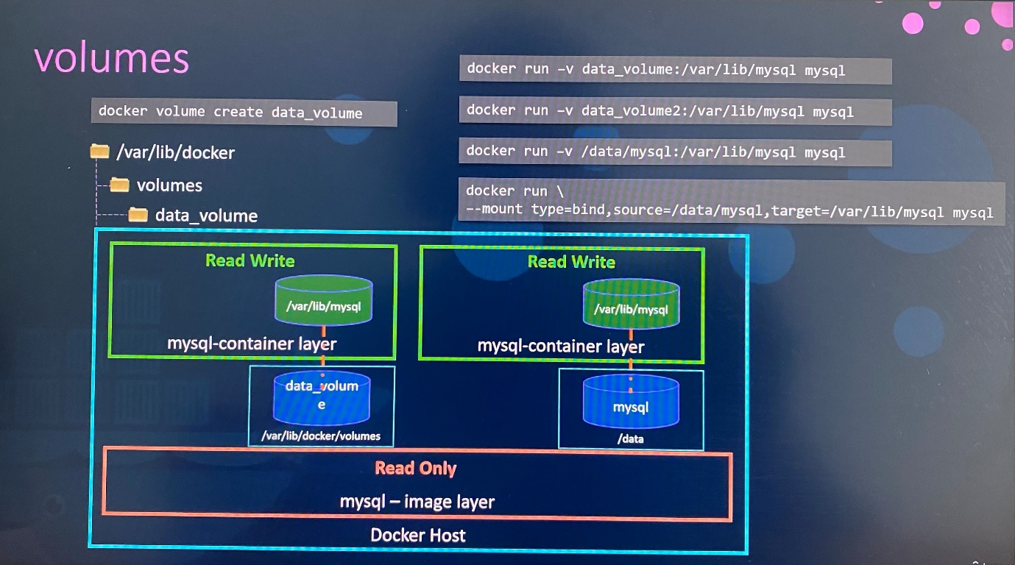

-v is old style to mount volume and the following is the preferred way as it is more verbose, so you have to specify each parameter in key value format.

docker run \
- -mount type=bind,source=/data/mysql,target=/var/lib/mysql mysql

source : location in the docker host
target : location in the container

Who is responsible to maintain the layered architecture, creating a writeable layer, moving files across layers to enable copy and write, help to manage storage on images and container, it is storage drivers

Storage drivers

Docker use storage drivers to maintain the layered architecture, creating a writeable layer, moving files across layers to enable copy and write, help to manage storage on images and containers.

- AUFS ; default storage driver for Ubuntu. This is not available for Fedora, CentOS
- ZFS
- BTRFS
- Device Mapper ; storage driver for Fedora, CentOS
- Overlay
- Overlay2

Selection of storage driver depends on underlying OS in use. Docker selects better storage drivers automatically based on the operating system it hosts. The different storage drivers provide different performance and stability.

Volume driver plugins in docker

Volumes are not handled by storage drivers. Volumes we create are handled by volume driver plugins.

The default volume driver plugin is Local which helps to create volume in docker host and store its data under /var/lib/docker/volumes directory.

Third party volume driver plugin

Some of these volume driver plugins support different storage provider.

- Azure File Storage
- Convoy
- DigitalOcean Block Storage
- Flocker
- Google Compute Persistent Disk(gce-docker)
- GlusterFS
- NetApp
- RexRay - support to provision storage on different storage providers such as AWS EBS, S3, Google Persistent Disk, Openstack Cinder, EMC storage arrays link Isilon, ScaleIO
- Portworx
- VMware vSphere storage

When you run docker container, you can choose specific volume driver as follows.

docker run -it \
- -name mysql
- -volume-driver rexray/ebs
- -mount src=ebs-vol,target=/var/lib/mysql
mysql

This will create the container and mount the volume from AWS EBS where the data is safe even if the container exits.

Exam tips:

Additional topics such as StatefulSets are out of scope for the exam. However, if you wish to learn them, they are covered in the Certified Kubernetes Application Developer (CKAD) course.

Container storage interface(CSI)

Initially Kubernetes uses docker runtime as container runtime engine embedded with Kubernetes source code. With new container runtime like rocket, cri-o, the container runtime interface(CRI) plugin is developed to make communication new container runtime with Kubernetes where those are not be dependent on Kubernetes source code.

The Container Runtime Interface is a standard that defines how an orchestration solution like Kubernetes would communicate with other container runtimes like Docker. In future, if any container runtime is developed, they should follow the CRI standards so that new container runtime would work with Kubernetes without really work with Kubernetes team or touch Kubernetes source code.

Similarly, Kubernetes communicates with different networking solutions such as weaveworks, flannel, cilium using Container Network Interface(CNI) plugin as long as they are developed based on CNI standards.

Similarly, different CSI drivers can develop according to Container Storage Interface(CSI) standards such as portworx, Amazon EBS, Azure Disk, DellEMC Isilon, GlusterFS, PowerMax, Unity, XtremIO, NetApp, Nutanix, HPE, Hitachi, Pure Storage. Everyone gets their own Container Storage Interface(CSI) drivers

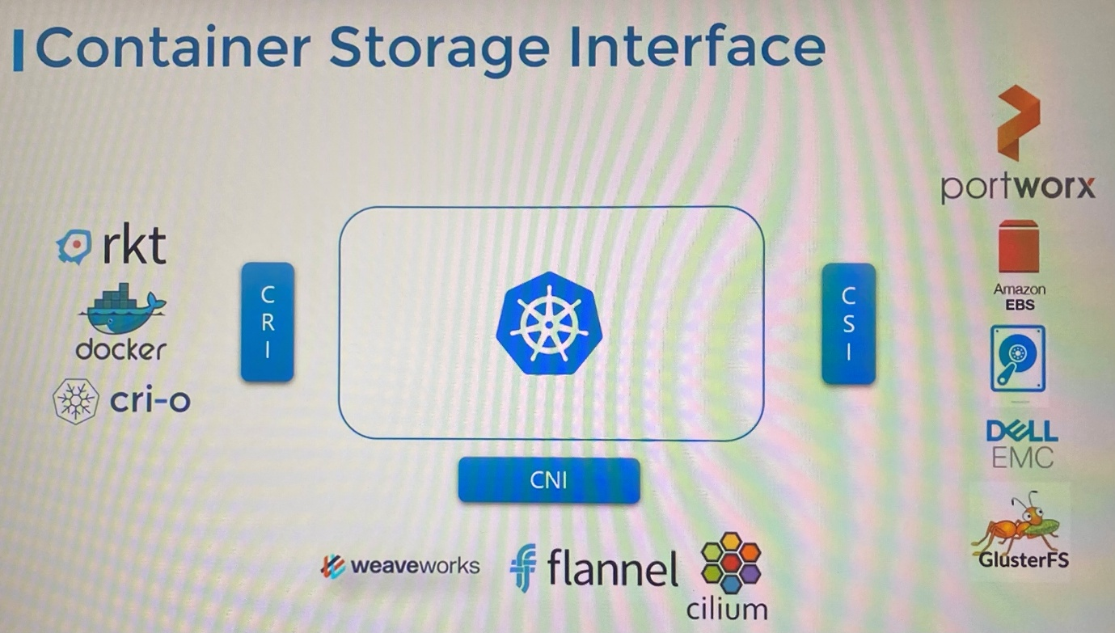

CSI is not a Kubernetes specific standards. CSI allows any container orchestration tool such as Kubernetes, CloudFoundry, Mesos to work with any storage vendor with a supported plugin.

CSI defines set of RPC(Remote Procedure Call) that will be called by container orchestrators and these must be implemented by storage drivers.

For example, CSI says that when a pod is created and requires a volume, the container orchestrators such as Kubernetes calls CreateVolume RPC and pass set of details such as volume name. The storage drivers should implement this RPC and handle the request and provision a new volume on storage array and return the result of that operation. Similarly, container orchestrator should call DeleteVolume RPC when the volume needs to be deleted, then storage driver should implement the code to decommission the volume from the array.

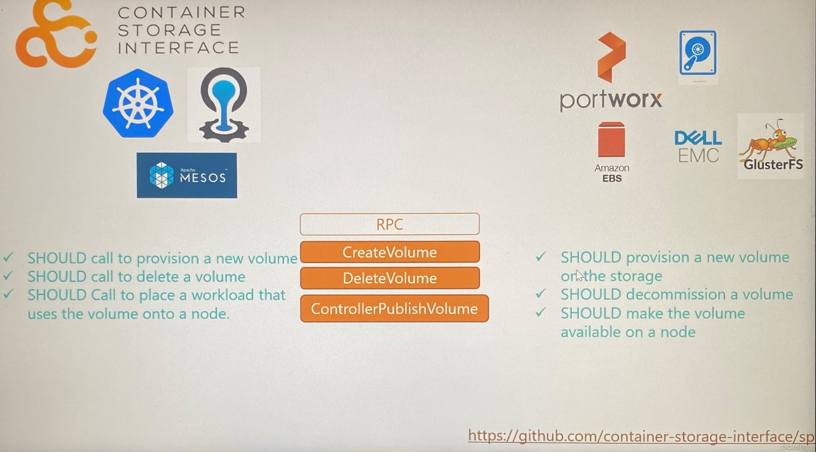

Specification details of what parameter should be sent, what should be received by storage solution and what error code should be exchanged can be referred in https://github.com/container-storage-interface/sp

Volumes in Kubernetes

- Data within the container is destroyed along with the container as soon as the process is complete
- To persist the data created by container, we attach the volumes to the containers when container is created
- The data generated or processed by container is persisted in the volume even after the container is deleted
- Similarly processed data by pod is also deleted when pod gets deleted. Hence we attach the volume to the pod created and store the data in the volume will remains.

spec:
containers:
- image: alpine
name: alpine
command:
args:
volumeMounts:
- mountPath: /opt ;mount the volume inside container
name: data-volume

volumes:
- name: data-volume
hostPath:
path: /data ; directory path on the node
type: Directory

- Create a volume on node to store data in the directory
- Mount the volume inside the container to access it by the container

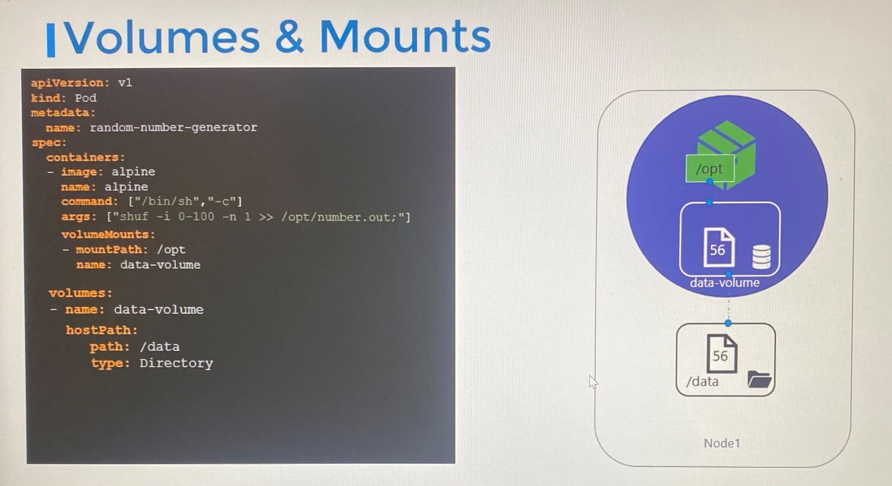

- Data writes in volume mounted in the container first and it replicates to hostPath. Hence pod is destroyed, data is still live in the volume in the host
- However, this is not recommended for multi node cluster because the volume directory in hostPath cannot be same on all nodes in the cluster unless you configure external replicated cluster storage solution.

Storage solution: NFS, GlusterFS, Flocker, Fiber Channel, SCALEIO, CephFS and public cloud solutions such as AWS EBS, Azure Disk or File, Google Persistent Disk

volumes:
- name: data-volume
awsElasticBlockStore:
volumeID: <volume-ID> ; volume ID in Amazon EBS
fstype: ext4 ; file system type

Persistent volumes

- When we create volumes that needs to configure using pod definition file for each pod. When you have large environment with lot of users are deploying pods, the users would have to configure storage every time for each pod. Whatever storage solution is used and when every time changes are made, the users would have to make the change on all pods.
-Instead, administrator can manage storage centrally as large pool of storage, users can get piece from it.
- Persistent volumes is a cluster wide pool of storage volumes that are configured by administrator to use by users deploying applications on the cluster.
- Users can now select a storage from the pool by using Persistent Volume Claim(PVC)

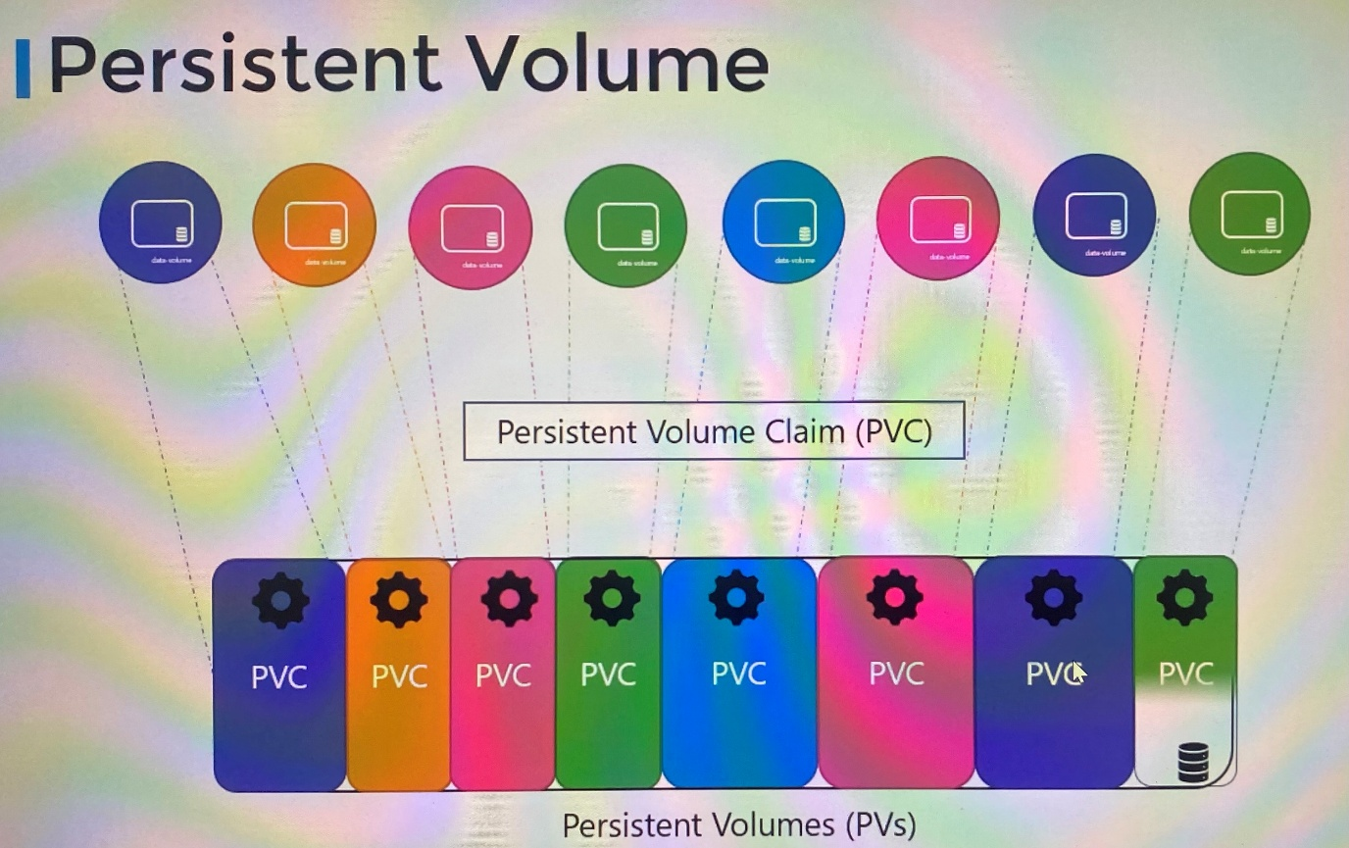

apiVersion: v1
kind: PersistentVolume
metadata:
name: pv-vol1
spec:
accessModes:
- ReadWriteOnce
capacity:
storage: 1Gi
hostPath:
path: /tmp/data ; Using storage from node's local directory is not recommended for production environment

------------------------

apiVersion: v1
kind: PersistentVolume
metadata:
name: pv-vol1
spec:
accessModes:
- ReadWriteOnce
capacity:
storage: 1Gi
awsElasticBlockStore: ; Using AWS EBS
volumeID: <volume-ID>
fstype: ext4

------------------------
apiVersion: v1
kind: PersistentVolume
metadata:
name: pv-vol1
spec:
accessModes:
- ReadWriteOnce
capacity:
storage: 1Gi
gcePersistentDisk: ; Using Google Persistent Disk
pdName: pd-disk
fstype: cxt4

--------------------------------

Specification of Persistent Volume

- Access mode defines how a volume should be mounted on the host whether in ReadOnlyMany, ReadWriteOnce, ReadWriteMany
- Capacity specifies the amount of storage to be reserved
- Replace the hostPath with external storage solution such awsElasticBlockStore

ReadWriteOnce - the volume can be mounted as read-write by a single node. ReadWriteOnce access mode still can allow multiple pods to access (read from or write to) that volume when the pods are running on the same node. For single pod access, please see ReadWriteOncePod.

ReadOnlyMany - the volume can be mounted as read-only by many nodes.

ReadWriteMany- the volume can be mounted as read-write by many nodes.

ReadWriteOncePod - the volume can be mounted as read-write by a single Pod. Use ReadWriteOncePod access mode if you want to ensure that only one pod across the whole cluster can read that PVC or write to it.

kubectl create -f pv-defintion.yaml

kubectl get persistentvolume | pv

Once PV is created, its status is Available until PV binds with PVC. Then status of PV is Bound

apiVersion: v1
kind: PersistentVolume
metadata:
name: pv-log
spec:
capacity:
storage: 100Mi
persistentVolumeReclaimPolicy: Retain
accessModes:
- ReadWriteMany
hostPath:
path: /pv/log

Persistent Volume Claim(PVC)

-PV and PVC are separate Kubernetes objects
-Persistent Volume Claim is to make the storage available to a node.
-Administrator creates set of persistent volumes and user creates persistent volume claim to use the storage
-Once PVCs are created, Kubernetes binds the persistent volumes to persistent volume claims based on the requests and properties set on the volumes.
-Every Persistent Volume Claim is bound to single Persistent Volume in the binding process

- In the binding process, Kubernetes tries to find persistent volumes that meet these criteria requested by the claim such as Sufficient Capacity, Access Modes, Volume Modes, Storage Class, Selector etc..

- If there are multiple possible matches for a single claim and need to bind with a particular volume, you should still use labels and selectors(selector.matchLabels) to bind to the particular PV.

- Smaller claim may get bound to larger volumes if all other criteria matches. Since there is one-to-one relationship between PVC and PV, no other claim can utilize the remaining capacity in that volume.

- If there is no volume available that matches with criteria of claim, the claim will remain in Pending state until newer volume is available in the cluster.

** PVC must be in same namespace as pod is in even though PV is in different namespace.

apiVersion: v1
kind: PersistentVolumeClaim
metadata:
name: myclaim
spec:
accessModes:
- ReadWriteOnce
resources:
requests:
storage: 500Mi

kubectl create -f pvc-defintion.yaml

-Once a PVC is created, status shows as Pending until it find a PV matches. Once find the best match in PV, status changes as Bound

kubectl get persistentvolumeclaim | pvc ; initially this will be in pending state

Delete PVCs

kubectl delete persistentvolumeclaim myclaim ; delete the1 claim

When the claim is deleted, you can choose what is to happen to the volume that has been bound to PVC we deleted where you can retain the volume bound with the claim using persistentVolumeReclaimPolicy: Retain. By default it is set to Retain. Then the persistent volume will remain until administrator delete the volume manually and it is not available to reuse by any other claim.

Or, the PV can be deleted automatically along with PVC when the claim deletes if persistentVolumeReclaimPolicy: Delete

persistentVolumeReclaimPolicy: Recycle ; the data in the data volume will be scrubbed before making it available for other claims.

Using PVC in Pods

Once you create a PVC use it in a pod definition file by specifying the PVC claim under presistentVolumeClaim section in the volumes

apiVersion: v1
kind: Pod
metadata:
name: mypod
spec:
containers:
- name: myfrontend
image: nginx
volumeMounts:
- mountPath: "/var/www/html"
name: mypd
volumes:
- name: mypd
persistentVolumeClaim:
claimName: myclaim

The same is true for ReplicaSets or Deployments. Add this to the pod template section of a Deployment on ReplicaSet.

kubectl exec webapp - - cat /log/app.log ; exec into the container and open the file.

If a PVC is associated with a pod, deleting PVC will be stuck in terminating state as it uses with a pod. The PV will be bound with PVC. The PVC will be deleted once the pod is deleted.

Once the pod deletes, the PVC associates to the pod as a volume will also be deleted and the PV will be released.

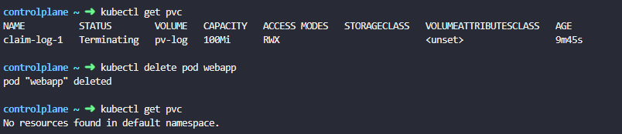

controlplane ~ ✖ kubectl get pv
NAME CAPACITY ACCESS MODES RECLAIM POLICY STATUS CLAIM STORAGECLASS VOLUMEATTRIBUTESCLASS REASON AGE
pv-log 100Mi RWX Retain Released default/claim-log-1 <unset> 25m

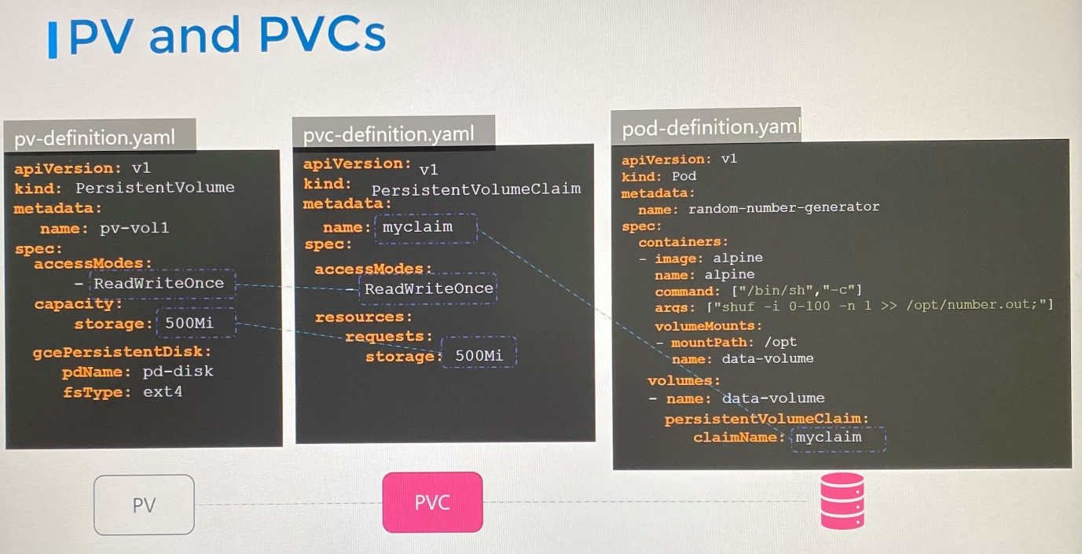

Storage Class

Before creating PV, you must have created a disk in a provisioner such as GCP, AWS or Azure.

Manually provisioning a disk in a provisioner such as GCP, AWS and then specify it on persistent volume definition file is called as static provisioning volumes.

It would have been nice if the volume gets provisioning automatically when the application requires it. That’s where storage classes comes in.

With the storage class, you can define provisioners such as Google storage, Azure storage that automatically provision storage and attach that storage to pod when PVC is made. That is called dynamic provisioning volumes. You do that using storage class object.

--------Storageclass-definition.yaml--------------------------------------

apiVersion: storage.K8s.io/v1
kind: StorageClass
metadata:
name: google-storage
provisioner: kubernetes.io/gce-pd ; how volumes provision

With the storage class, persistent volume will no longer be needed to manually create because the PV and any associated storage is going to be created automatically by storage class when the storage class is created. For PVC to use storage class we defined, we can define storage class name in persistent volume claim definition file with spec.storageClassName and then define claim name in pod definition file.

apiVersion: v1
kind: PersistentVolumeClaim
metadata:
name: myclaim
spec:
accessModes:
- ReadWriteOnce
storageClassName: google-storage
resources:
requests:
storage: 500Mi

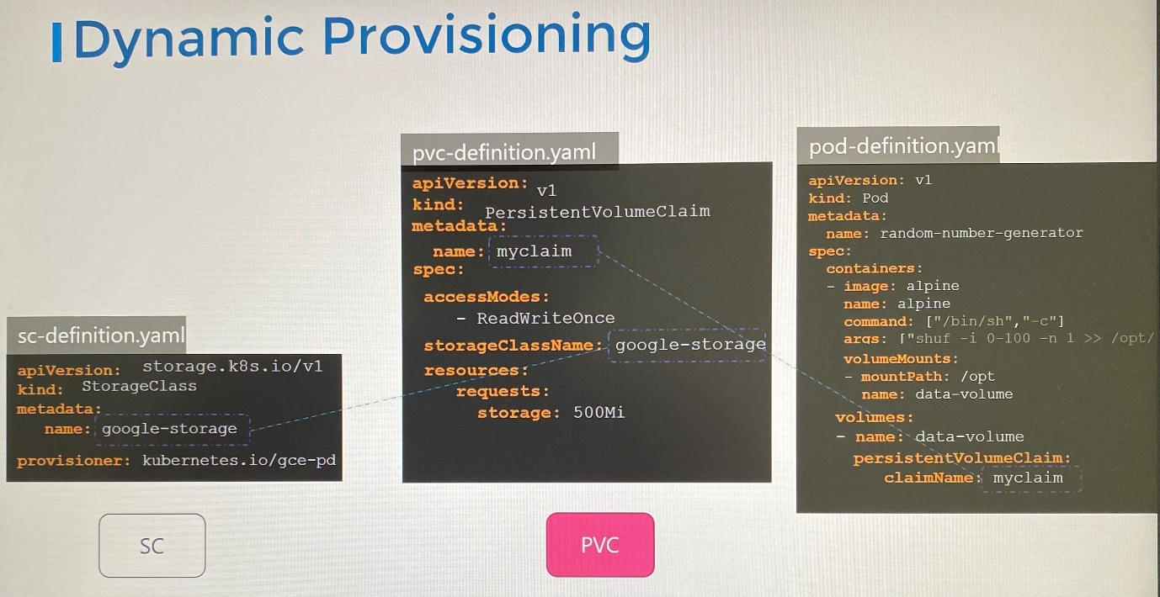

When PVC created with storage class associated, it uses the defined provisioner to provision a new disk with the required size by provisioner. Then create PV and then bind it to PVC.

We use GCE provisioner to create volume on GCP.

Volume provisioners : AWSElasticBlockStore, AzureFile, AzureDisk, CephFS, Portworx, ScaleIO, Cinder

With these provisioners, you can pass additional parameters such as type of disks to provision, replication-type. These parameters are very specific to the provisioner.

apiVersion: storage.K8s.io/v1
kind: StorageClass
metadata:
name: google-storage
provisioner: kubernetes.io/gce-pd
parameters:
type: pd-standard [pd-ssd | pd-standard]
replication-type: none [ none | regional-pd]

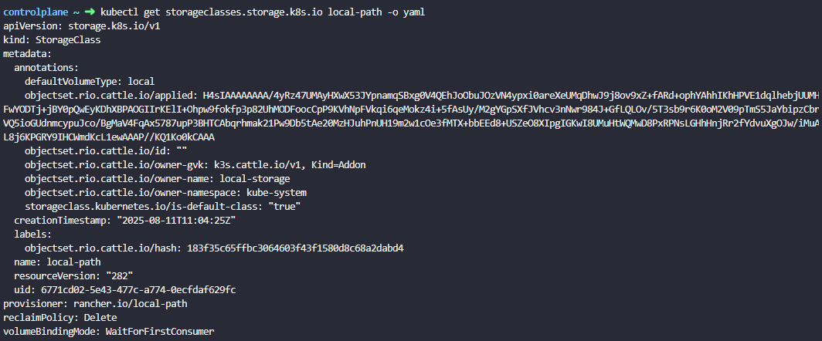

You can create different storage classes, each using different type of disks.

Sliver storage class- standard disks
Gold storage class- SSD drives
Platinum storage class - SSD drives and replication

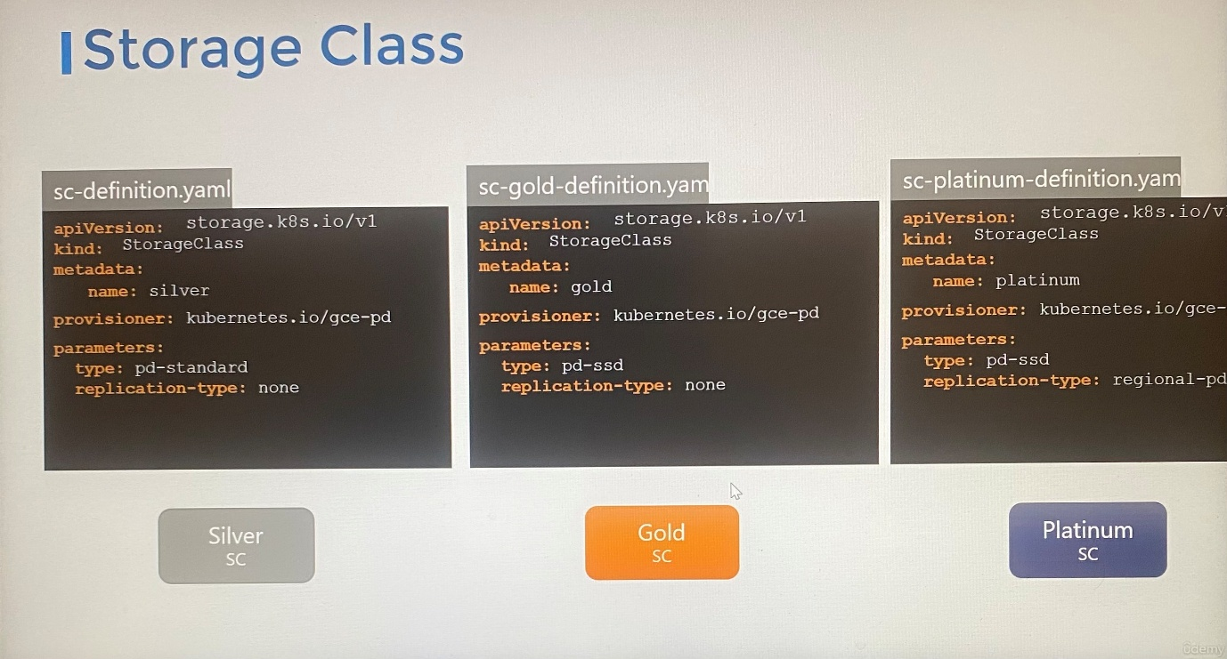

If PVC doesn't bind to PV despite all the matches are met and also PVC use storage class, it needs to inspect events on PVC.

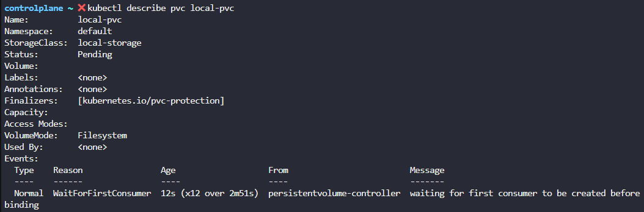

If the storage class use of VolumeBindingMode set to WaitForFirstConsumer, This will delay the provisioning and binding of a PersistentVolume until a Pod that uses the PersistentVolumeClaim is created.

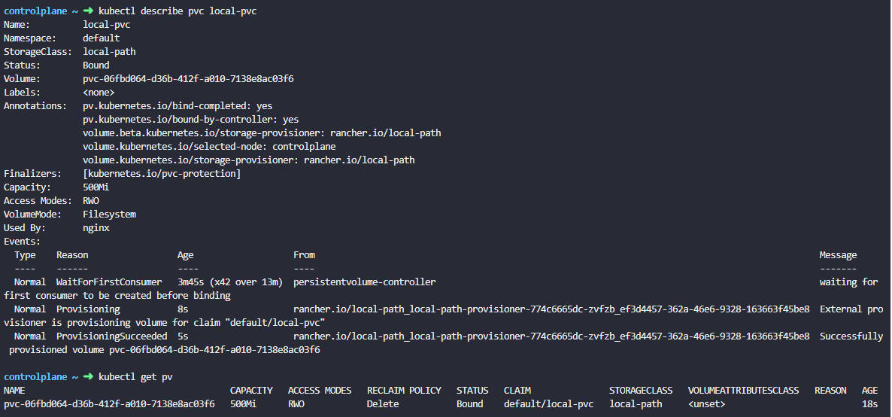

kubectl get sc ; list storage classes available

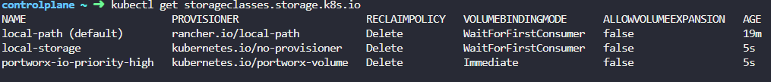

----------------------------------------------------------------

apiVersion: storage.k8s.io/v1
kind: StorageClass
metadata:
name: low-latency
annotations:
storageclass.kubernetes.io/is-default-class: "false"
provisioner: csi-driver.example-vendor.example
reclaimPolicy: Retain # default value is Delete
allowVolumeExpansion: true
mountOptions:
- discard # this might enable UNMAP / TRIM at the block storage layer
volumeBindingMode: WaitForFirstConsumer
parameters:
guaranteedReadWriteLatency: "true" # provider-specific

