Blockly案例

1. 案例说明

win代表玩家胜利，lose代表玩家输，dogfall代表平局；按石头剪刀布的顺序分别为1、2、3，computer gesture代表电脑出的手势，player gesture代表玩家手势。

1. Blockly图片

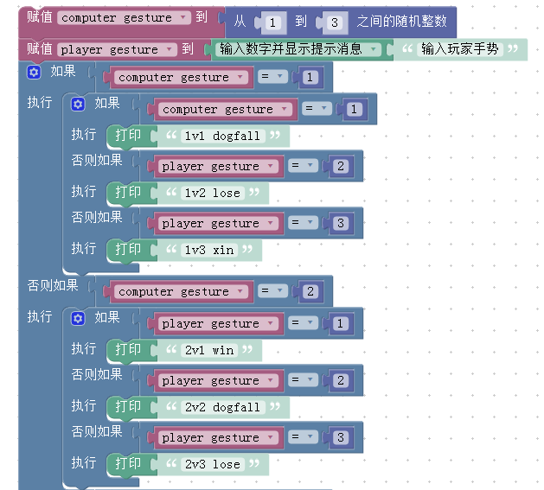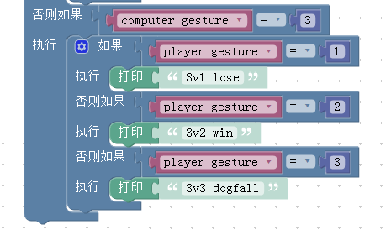

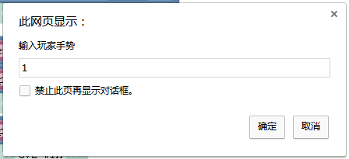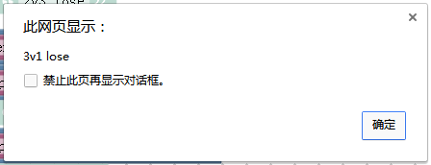

1. XML代码

<xml xmlns="http://www.w3.org/1999/xhtml">

<variables>

<variable type="" id="`vsz{}kNbZN?V2#Q|[vH">computer gesture</variable>

<variable type="" id="*O9Y]Bm6pWsex@=OvU2L">player gesture</variable>

<variable type="" id="7q#-TUy~;N}0Fn9DAP`I">x</variable>

<variable type="" id="J@C_WEo3=ka_{b{yuh/.">Result</variable>

</variables>

<block type="variables_set" id="G!8$e}rBwT/ts#]o-[sN" x="187" y="-12">

<field name="VAR" id="`vsz{}kNbZN?V2#Q|[vH" variabletype="">computer gesture</field>

<value name="VALUE">

<block type="math_random_int" id="Cl:$#VhO8k6eCu=CiD%j">

<value name="FROM">

<shadow type="math_number" id="ZD_oreN?!F,r(GfIa`wv">

<field name="NUM">1</field>

</shadow>

</value>

<value name="TO">

<shadow type="math_number" id="@rzIHPzK5(A*.RITh3Xe">

<field name="NUM">3</field>

</shadow>

</value>

</block>

</value>

<next>

<block type="variables_set" id="Dx%KT]1SZD]_M-OmDeZ`">

<field name="VAR" id="*O9Y]Bm6pWsex@=OvU2L" variabletype="">player gesture</field>

<value name="VALUE">

<block type="text_prompt_ext" id="@vh3_6I^fq3[L+l!F[2S">

<mutation type="TEXT"></mutation>

<field name="TYPE">TEXT</field>

<value name="TEXT">

<shadow type="text" id="QP]W?W:T[^m1G+wJVHc!">

<field name="TEXT">输入玩家手势</field>

</shadow>

</value>

</block>

</value>

<next>

<block type="controls_if" id=".aVxLcsCkyYzIz0(?!O#">

<mutation elseif="2"></mutation>

<value name="IF0">

<block type="logic_compare" id="KhsJBX.y+,h2UlPrU:,$">

<field name="OP">EQ</field>

<value name="A">

<block type="variables_get" id="bm`G3]4m7jg-bI^s?;E-">

<field name="VAR" id="`vsz{}kNbZN?V2#Q|[vH" variabletype="">computer gesture</field>

</block>

</value>

<value name="B">

<block type="math_number" id="H4^R4!)IArWMpz|(3amN">

<field name="NUM">1</field>

</block>

</value>

</block>

</value>

<statement name="DO0">

<block type="controls_if" id="}Ise{080^=?w6*,K+tp+">

<mutation elseif="2"></mutation>

<value name="IF0">

<block type="logic_compare" id="c~Ut$*Bid_J`cCs+XwIK">

<field name="OP">EQ</field>

<value name="A">

<block type="variables_get" id="H{dQrQs.50utL8!Jzb/2">

<field name="VAR" id="`vsz{}kNbZN?V2#Q|[vH" variabletype="">computer gesture</field>

</block>

</value>

<value name="B">

<block type="math_number" id="Nk2j3pgt@95acK,OeQBs">

<field name="NUM">1</field>

</block>

</value>

</block>

</value>

<statement name="DO0">

<block type="text_print" id="D?Ici)3yG5;uV~Oy=^/O">

<value name="TEXT">

<shadow type="text" id="[!#_;LbL{n=2e.,(],{E">

<field name="TEXT">1v1 dogfall</field>

</shadow>

</value>

</block>

</statement>

<value name="IF1">

<block type="logic_compare" id=";J8=#i(E!LrJQyQ`hBS0">

<field name="OP">EQ</field>

<value name="A">

<block type="variables_get" id="h:D{X~mTH49e~Q[*IE`B">

<field name="VAR" id="*O9Y]Bm6pWsex@=OvU2L" variabletype="">player gesture</field>

</block>

</value>

<value name="B">

<block type="math_number" id="ZL15{=CZt{;y`5f?E5=u">

<field name="NUM">2</field>

</block>

</value>

</block>

</value>

<statement name="DO1">

<block type="text_print" id="bQIOgpzO+yf93D%Ur;O)">

<value name="TEXT">

<shadow type="text" id="Ha4,*(q!xE^R=#R$dXZC">

<field name="TEXT">1v2 lose</field>

</shadow>

</value>

</block>

</statement>

<value name="IF2">

<block type="logic_compare" id="MMb3Wo?vd0VLdya?fTXP">

<field name="OP">EQ</field>

<value name="A">

<block type="variables_get" id="7y9_)S9p*9JRT;?E:r+O">

<field name="VAR" id="*O9Y]Bm6pWsex@=OvU2L" variabletype="">player gesture</field>

</block>

</value>

<value name="B">

<block type="math_number" id="D%|UUuy5FDYfyX!OjWv[">

<field name="NUM">3</field>

</block>

</value>

</block>

</value>

<statement name="DO2">

<block type="text_print" id="nT4#;Eby,X7D+JdtHmBd">

<value name="TEXT">

<shadow type="text" id="k2U$Qodbxfg1gG}tXsH4">

<field name="TEXT">1v3 xin</field>

</shadow>

</value>

</block>

</statement>

</block>

</statement>

<value name="IF1">

<block type="logic_compare" id="O6r-n#g$cL$exZU4hI-N">

<field name="OP">EQ</field>

<value name="A">

<block type="variables_get" id="Un=A^Jhn}dU3Rgn]VSE:">

<field name="VAR" id="`vsz{}kNbZN?V2#Q|[vH" variabletype="">computer gesture</field>

</block>

</value>

<value name="B">

<block type="math_number" id="]0^~={rLmf:~;gn9v%wL">

<field name="NUM">2</field>

</block>

</value>

</block>

</value>

<statement name="DO1">

<block type="controls_if" id="UWvLyWcce(w}i[InbRBA">

<mutation elseif="2"></mutation>

<value name="IF0">

<block type="logic_compare" id="6gPFxp^Itrl[]BKo$V28">

<field name="OP">EQ</field>

<value name="A">

<block type="variables_get" id="ds|*E84LqA3L+2+wDs-B">

<field name="VAR" id="*O9Y]Bm6pWsex@=OvU2L" variabletype="">player gesture</field>

</block>

</value>

<value name="B">

<block type="math_number" id="iiq}N{^=pgJFb=w@RS])">

<field name="NUM">1</field>

</block>

</value>

</block>

</value>

<statement name="DO0">

<block type="text_print" id="k|7`1XsM-542-z0m^JU+">

<value name="TEXT">

<shadow type="text" id="e^#MrA2P#qE`8!Zn7$l@">

<field name="TEXT">2v1 win</field>

</shadow>

</value>

</block>

</statement>

<value name="IF1">

<block type="logic_compare" id="E={hH[KMaG-2{1rzLuLa">

<field name="OP">EQ</field>

<value name="A">

<block type="variables_get" id="dTePnU51Tsx^-DfIh8yB">

<field name="VAR" id="*O9Y]Bm6pWsex@=OvU2L" variabletype="">player gesture</field>

</block>

</value>

<value name="B">

<block type="math_number" id="C;:i(qG2s#QXT0O(?nfJ">

<field name="NUM">2</field>

</block>

</value>

</block>

</value>

<statement name="DO1">

<block type="text_print" id="+]setLuGGUA)F@(jVurC">

<value name="TEXT">

<shadow type="text" id="!+|~/ariSiR{]KHkw;27">

<field name="TEXT">2v2 dogfall</field>

</shadow>

</value>

</block>

</statement>

<value name="IF2">

<block type="logic_compare" id="q|KmK2az?6/|Wtc0FLY9">

<field name="OP">EQ</field>

<value name="A">

<block type="variables_get" id="B(,`J/NOzLpSl6VYZJb+">

<field name="VAR" id="*O9Y]Bm6pWsex@=OvU2L" variabletype="">player gesture</field>

</block>

</value>

<value name="B">

<block type="math_number" id="fQ@OR?;=$j22R[0Md#Ey">

<field name="NUM">3</field>

</block>

</value>

</block>

</value>

<statement name="DO2">

<block type="text_print" id="{^rOW=M3qPYMD}bIMa?Z">

<value name="TEXT">

<shadow type="text" id="5c!bx4}lw=+qJ.}R_I3u">

<field name="TEXT">2v3 lose</field>

</shadow>

</value>

</block>

</statement>

</block>

</statement>

<value name="IF2">

<block type="logic_compare" id="wUe]2.:f+nAT0m?7(btC">

<field name="OP">EQ</field>

<value name="A">

<block type="variables_get" id="Rv-*fXh{xm`3)|gU=(_e">

<field name="VAR" id="`vsz{}kNbZN?V2#Q|[vH" variabletype="">computer gesture</field>

</block>

</value>

<value name="B">

<block type="math_number" id="QqPV+LCB~EyG:7PcDmJa">

<field name="NUM">3</field>

</block>

</value>

</block>

</value>

<statement name="DO2">

<block type="controls_if" id="qFxVey!m:Gw%h{}wlZqO">

<mutation elseif="2"></mutation>

<value name="IF0">

<block type="logic_compare" id="PjB~KhUuli4Q-9mi?smf">

<field name="OP">EQ</field>

<value name="A">

<block type="variables_get" id="~ak.lyyt$G7c$[ge/w,p">

<field name="VAR" id="*O9Y]Bm6pWsex@=OvU2L" variabletype="">player gesture</field>

</block>

</value>

<value name="B">

<block type="math_number" id="B,=q7.(02ZZ|S4.7}fAS">

<field name="NUM">1</field>

</block>

</value>

</block>

</value>

<statement name="DO0">

<block type="text_print" id="adf9uTlZVDwP3uUZ;b`=">

<value name="TEXT">

<shadow type="text" id=",~?2HMZv#bUl@g{srhM0">

<field name="TEXT">3v1 lose</field>

</shadow>

</value>

</block>

</statement>

<value name="IF1">

<block type="logic_compare" id="u_3N2B=2pc9:loo@5dn0">

<field name="OP">EQ</field>

<value name="A">

<block type="variables_get" id="P%DV$AET.B:UmZM@^*{K">

<field name="VAR" id="*O9Y]Bm6pWsex@=OvU2L" variabletype="">player gesture</field>

</block>

</value>

<value name="B">

<block type="math_number" id="e0kj}HE;4yJ=@V[}-Q`$">

<field name="NUM">2</field>

</block>

</value>

</block>

</value>

<statement name="DO1">

<block type="text_print" id="|99s~G8k9:Y5I/jTgj|6">

<value name="TEXT">

<shadow type="text" id="=~nDcx-tfUz|z88]9NMb">

<field name="TEXT">3v2 win</field>

</shadow>

</value>

</block>

</statement>

<value name="IF2">

<block type="logic_compare" id=",G?d#[o;AX!$Rd9`2_xM">

<field name="OP">EQ</field>

<value name="A">

<block type="variables_get" id="zo/mE2aL{4^6LIvN!)uI">

<field name="VAR" id="*O9Y]Bm6pWsex@=OvU2L" variabletype="">player gesture</field>

</block>

</value>

<value name="B">

<block type="math_number" id="LZ2_}d==EN7[tY]*]r|R">

<field name="NUM">3</field>

</block>

</value>

</block>

</value>

<statement name="DO2">

<block type="text_print" id="jzx}^K`-lstP]%s:Oyfg">

<value name="TEXT">

<shadow type="text" id="[|UXQe8eDs~3@Z/pp|A{">

<field name="TEXT">3v3 dogfall</field>

</shadow>

</value>

</block>

</statement>

</block>

</statement>

</block>

</next>

</block>

</next>

</block>

</xml>