blockly案例报告：电扇的摇头

课程：基于机器人的实践方法

院系：物理科学与技术学院 物理学类

班级：2017级物理二班

姓名：蒋弘玥

学号：320170935630

指导老师：周睿

完成时间：2018年1月7号

案例说明：使电扇完成顺时针逆时针摇头转换工作。

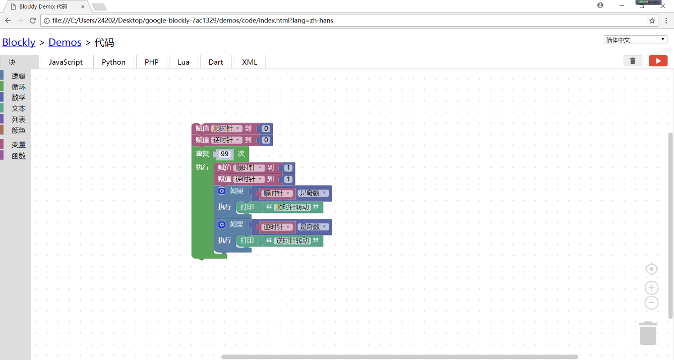界面截图：

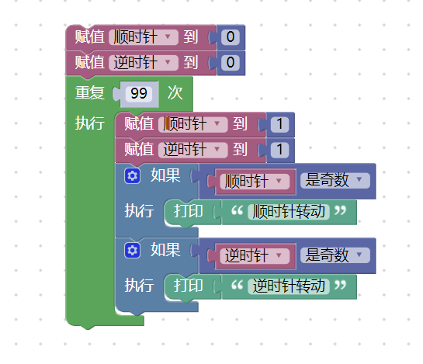模块截图:

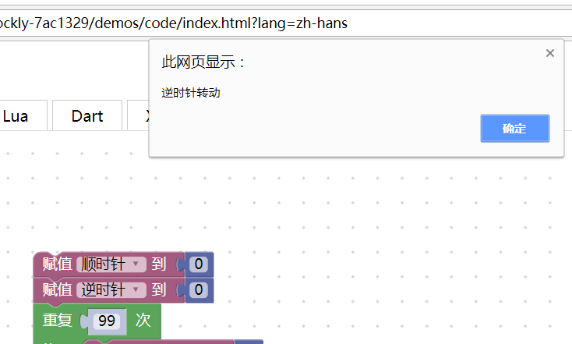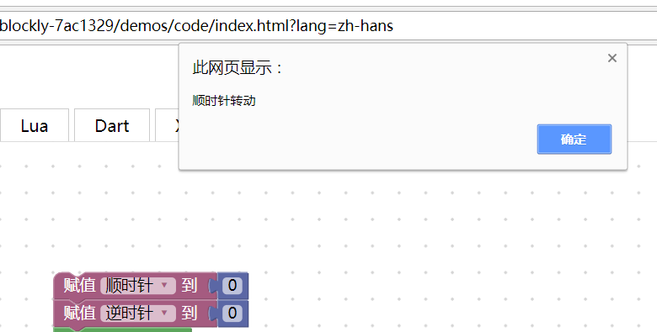运行结果：

代码：<xml xmlns="http://www.w3.org/1999/xhtml">

<variables>

<variable type="" id="mi6+x@g{N8pUUK)gES/-">获奖序号</variable>

<variable type="" id="b#=`}u71EsDt8IqNg!;T">顺时针</variable>

<variable type="" id="W0fr,J=cMh3wzFGiwdq*">逆时针</variable>

</variables>

<block type="variables_set" id="50CrhjJ0y9obY_oqB!|O" x="-1087" y="-388">

<field name="VAR" id="b#=`}u71EsDt8IqNg!;T" variabletype="">顺时针</field>

<value name="VALUE">

<block type="math_number" id="D,RI(djgXzy_JLlBZZQ?">

<field name="NUM">0</field>

</block>

</value>

<next>

<block type="variables_set" id="[WPfan^!XrbZqU|j,I`J">

<field name="VAR" id="W0fr,J=cMh3wzFGiwdq*" variabletype="">逆时针</field>

<value name="VALUE">

<block type="math_number" id="z-r-=??Nz%x!l}5]5#MI">

<field name="NUM">0</field>

</block>

</value>

<next>

<block type="controls_repeat_ext" id="(e*nmmtgi82lS1w9.)yi">

<value name="TIMES">

<shadow type="math_number" id="v8pbcw2%FCGnCcsHCE%0">

<field name="NUM">99</field>

</shadow>

</value>

<statement name="DO">

<block type="variables_set" id="y:Q_caN8}_oXfLJ?,o0h">

<field name="VAR" id="b#=`}u71EsDt8IqNg!;T" variabletype="">顺时针</field>

<value name="VALUE">

<block type="math_number" id="Vk2]jqIvaYAlu{jN+-bV">

<field name="NUM">1</field>

</block>

</value>

<next>

<block type="variables_set" id="LB/8B6(j|j`0Uoqp:;XG">

<field name="VAR" id="W0fr,J=cMh3wzFGiwdq*" variabletype="">逆时针</field>

<value name="VALUE">

<block type="math_number" id="PH`#/~`BFDxwkAWYIkw#">

<field name="NUM">1</field>

</block>

</value>

<next>

<block type="controls_if" id="4AkU?(?%0c[.Wk;.P/o%">

<value name="IF0">

<block type="math_number_property" id="lb+d|b![}2Dg#bvi~7C.">

<mutation divisor_input="false"></mutation>

<field name="PROPERTY">ODD</field>

<value name="NUMBER_TO_CHECK">

<shadow type="math_number" id="_%wS9I^)6v#0_Zyq)YWK">

<field name="NUM">0</field>

</shadow>

<block type="variables_get" id="HdAGDpjDf-f;5x}(r.44">

<field name="VAR" id="b#=`}u71EsDt8IqNg!;T" variabletype="">顺时针</field>

</block>

</value>

</block>

</value>

<statement name="DO0">

<block type="text_print" id="qoBdA{GK^i7ByeI;i%dv">

<value name="TEXT">

<shadow type="text" id="zf)?B*}y8)l?}N;7x$w~">

<field name="TEXT">abc</field>

</shadow>

<block type="text" id="lSP@/h~!9t=C6MWdy%Y9">

<field name="TEXT">顺时针转动</field>

</block>

</value>

</block>

</statement>

<next>

<block type="controls_if" id="Rb-{~]OP%[uz@6$thU4X">

<value name="IF0">

<block type="math_number_property" id="Cg9^3To;p-u__#MF}.p)">

<mutation divisor_input="false"></mutation>

<field name="PROPERTY">ODD</field>

<value name="NUMBER_TO_CHECK">

<shadow type="math_number" id="jAaTNj@,z$S6|R:RNgzM">

<field name="NUM">0</field>

</shadow>

<block type="variables_get" id="keRjI,01hI3eO@Nr{$OK">

<field name="VAR" id="W0fr,J=cMh3wzFGiwdq*" variabletype="">逆时针</field>

</block>

</value>

</block>

</value>

<statement name="DO0">

<block type="text_print" id="D^u!kvZaGe$j2X9vpn7J">

<value name="TEXT">

<shadow type="text" id="2#BtUed=IvBxkos!NUv`">

<field name="TEXT">abc</field>

</shadow>

<block type="text" id=";I?.a=C7+R5k`Xq|d}V3">

<field name="TEXT">逆时针转动</field>

</block>

</value>

</block>

</statement>

</block>

</next>

</block>

</next>

</block>

</next>

</block>

</statement>

</block>

</next>

</block>

</next>

</block>

</xml>