Lyfex – Real-Time Contactless Health Monitoring System

OpenCV Project Report

Title of the Project
Lyfex: Camera-based Real-Time Health Snapshot Using OpenCV and Computer Vision

Submitted By,
Nibin Joseph
24pmc137

Objective/Problem Statement
Traditional health monitoring requires dedicated medical devices, physical contact, or clinical visits, making frequent self-assessment inconvenient and inaccessible for daily wellness tracking. Many people lack easy access to basic vital sign monitoring tools that could help them maintain awareness of their physiological state.
Primary Objectives:
- Develop a contactless health monitoring solution using only smartphone cameras
- Provide real-time estimation of vital signs including heart rate, respiratory rate, stress levels, and emotional state
- Create an accessible, user-friendly mobile interface that works without specialized hardware
- Demonstrate practical applications of computer vision and signal processing in healthcare technology
Problem Statement: How can we leverage computer vision techniques and smartphone cameras to create a real-time, contactless health monitoring system that provides meaningful physiological insights while maintaining user privacy and accessibility?

Tools and Libraries Used

Backend (Server-Side Processing)
Core Framework:
- FastAPI - High-performance Python web framework for API development and WebSocket communication
- Uvicorn - ASGI server for running the FastAPI application
Computer Vision and Image Processing:
- OpenCV (cv2) - Primary computer vision library for face detection, image processing, and signal extraction
- NumPy - Numerical computing for signal processing and mathematical operations
- Dlib - Advanced facial landmark detection (optional enhancement)
Signal Processing:
- SciPy - Advanced signal processing algorithms for filtering and analysis
- scikit-learn - Machine learning algorithms for pattern recognition

Frontend (Mobile Application)
Mobile Development Framework:
- React Native - Cross-platform mobile app development
- Expo - Development platform and tools for React Native
- TypeScript - Type-safe JavaScript for robust mobile development
UI and Navigation:
- Expo Router - File-based routing system for navigation
- React Native Reanimated - High-performance animations and gestures
- Expo Linear Gradient - Visual enhancements and modern UI design
- React Native Safe Area Context - Safe area handling across different devices
Camera and Media:
- Expo Camera - Camera access and frame capture functionality
- Expo Vector Icons (Ionicons) - Icon library for user interface elements

Communication Protocol
- WebSocket - Real-time bidirectional communication between mobile app and server
- JSON - Data serialization for frame transmission and results delivery

Development Environment
- Python 3.10+ - Backend runtime environment
- Node.js - Frontend package management and build tools
- npm/Expo CLI - Package management and mobile app deployment

Detailed Explanation of the Workflow

System Architecture
The Lyfex system follows a client-server architecture where the mobile app acts as the client capturing camera frames, and a local Python server performs the computer vision analysis.

Step-by-Step Workflow

1. Application Initialization
- User launches the mobile app and navigates to the Real-Time Detection screen
- App requests camera permissions and establishes connection to local backend server
- Backend initializes all detection modules: face detector, heart rate detector, respiratory detector, emotion detector, stress detector, fatigue detector, neurological detector, and skin analyzer

2. Camera Setup and Frame Capture
- Mobile app activates front-facing camera using Expo Camera API
- Camera is configured with optimized settings: 60% quality, base64 encoding for transmission
- Frame capture runs at 6 FPS to balance real-time performance with network efficiency
- Each frame includes metadata: timestamp, width, height, and frame rate information

3. Real-Time Frame Transmission
- Captured frames are converted to base64 format and packaged with metadata
- Data is transmitted via WebSocket connection to the local server (typically running on same Wi-Fi network)
- WebSocket ensures low-latency, bidirectional communication for real-time processing

4. Computer Vision Processing Pipeline
Face Detection and Validation:
- OpenCV Haar Cascade classifier detects faces in incoming frames
- System validates face quality, position, and lighting conditions
- Facial landmarks are extracted when available (requires Dlib predictor model)
- Bounding box coordinates are calculated for face tracking visualization
Physiological Signal Extraction:
Heart Rate Detection (Photoplethysmography Approach):
- Extracts region of interest (ROI) from facial areas (forehead, cheeks)
- Analyzes color intensity variations over time in the ROI
- Applies signal filtering and frequency domain analysis to detect cardiac rhythm
- Uses peak detection algorithms to calculate beats per minute
Respiratory Rate Estimation:
- Monitors subtle facial movements and color variations near nasal area
- Tracks chest movement when visible in frame
- Applies motion detection and optical flow techniques
- Calculates breathing cycles per minute using temporal analysis
Stress Level Assessment:
- Combines multiple indicators: heart rate variability, facial tension patterns, breathing irregularities
- Uses machine learning models trained on stress indicators
- Outputs normalized stress score (0-10 scale)
Emotion Classification:
- Analyzes facial expression patterns using feature extraction
- Applies emotion recognition algorithms to classify emotional state
- Categories include: Neutral, Happy, Sad, Angry, Surprised, etc.

5. Data Processing and Analysis
- Server processes all extracted signals and applies smoothing algorithms
- Calculates running averages and trend analysis
- Validates data quality and confidence scores for each measurement
- Combines multiple indicators for comprehensive health assessment

6. Real-Time Results Transmission
- Processed results are packaged into JSON format containing:
  - realtime_metrics: heart rate, respiratory rate, stress level, emotion, confidence
  - face_detection: bounding box, landmarks, quality assessment
  - analysis_data: extended metrics including fatigue, HRV, blood pressure estimates, cognitive load
  - timestamp: precise timing information for synchronization

7. Mobile UI Updates
- App receives real-time data via WebSocket and updates the user interface instantly
- Live metrics display shows current heart rate, breathing rate, stress level, and emotion
- Face detection overlay provides visual feedback with bounding box and quality indicators
- Confidence meter shows measurement reliability in real-time
- Session timer tracks detection duration

8. Session Management and Results
- User can stop detection session at any time using the stop button
- System processes accumulated data to generate comprehensive session report
- Calculates session averages, dominant patterns, and trend analysis
- Generates personalized health recommendations based on detected patterns
- Displays final results screen with detailed metrics and insights

Data Flow Architecture
- Camera Frame → Base64 Encoding → WebSocket Transmission → OpenCV Face Detection → Signal Extraction (PPG, Motion Analysis) → Machine Learning Processing → Health Metrics Calculation → JSON Response → WebSocket → Mobile UI Update

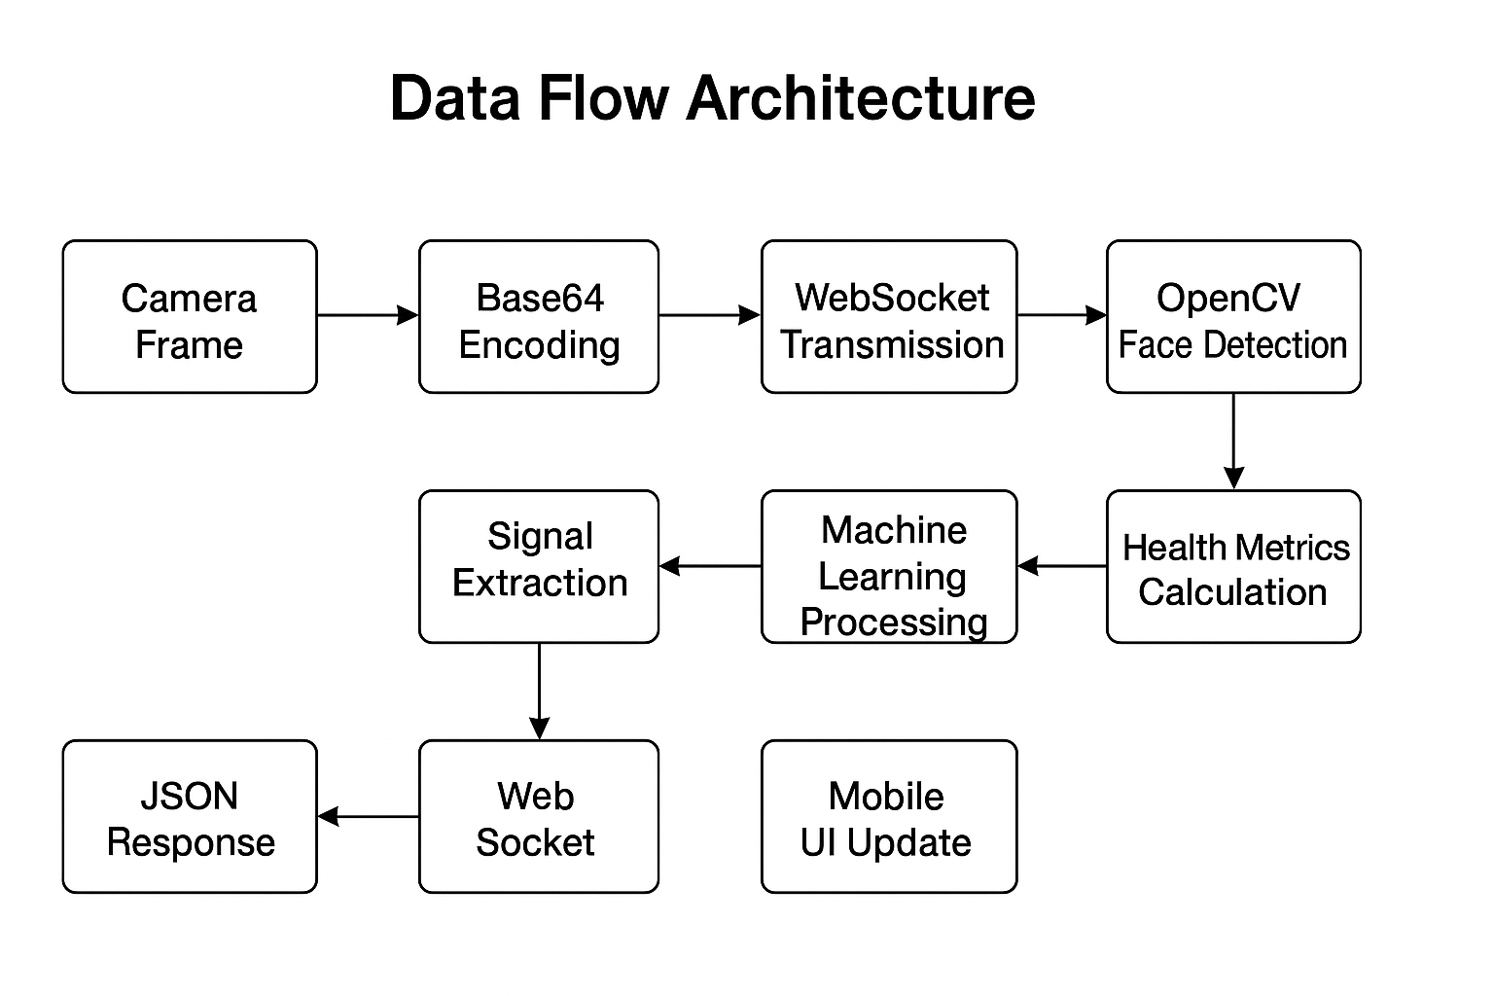

Privacy and Security Features
- All processing occurs locally on user's own network
- No external cloud services or third-party data transmission
- User controls when to start/stop monitoring
- Session data is processed in memory without permanent storage
- WebSocket connections are automatically closed when sessions end

Screenshots of Key Outputs

Main Application Screens
- Home Screen
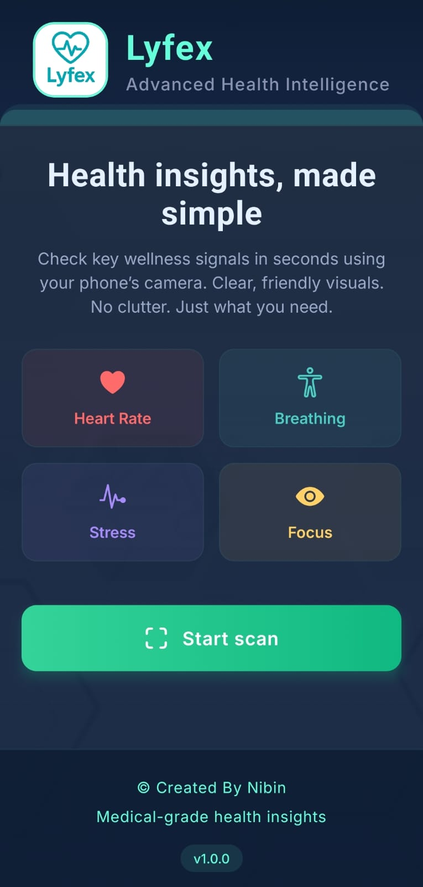
- Real-Time Detection Screen - Active Scanning
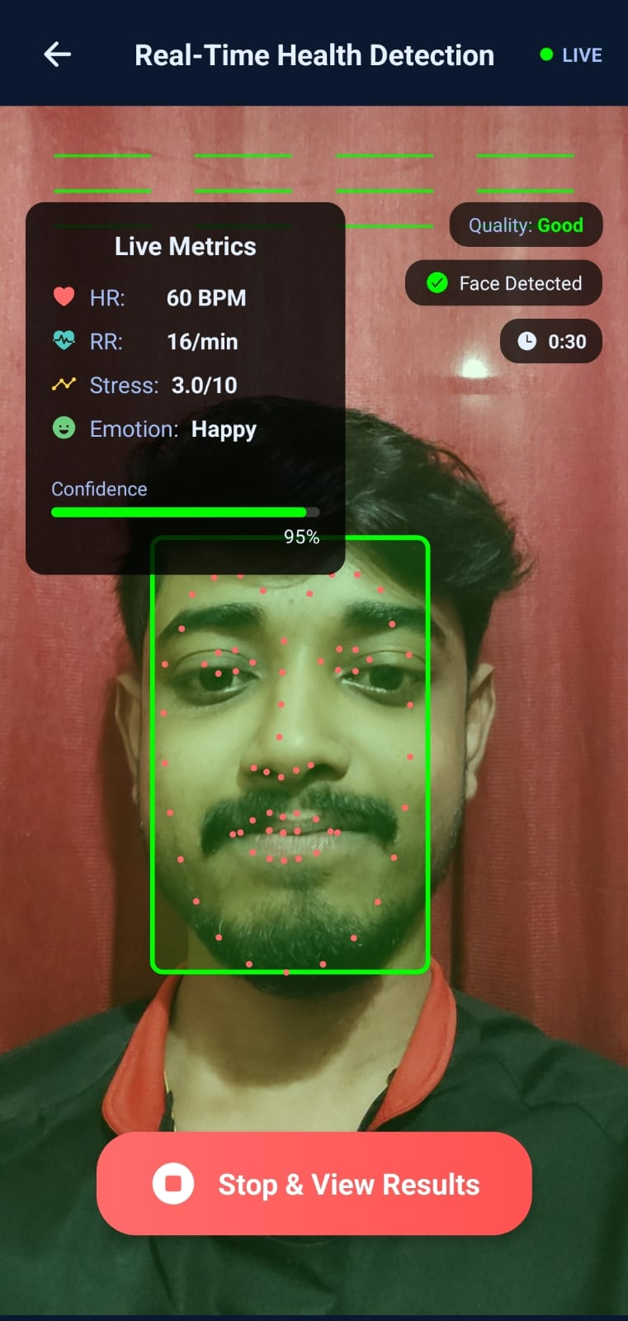
- Session Results Summary
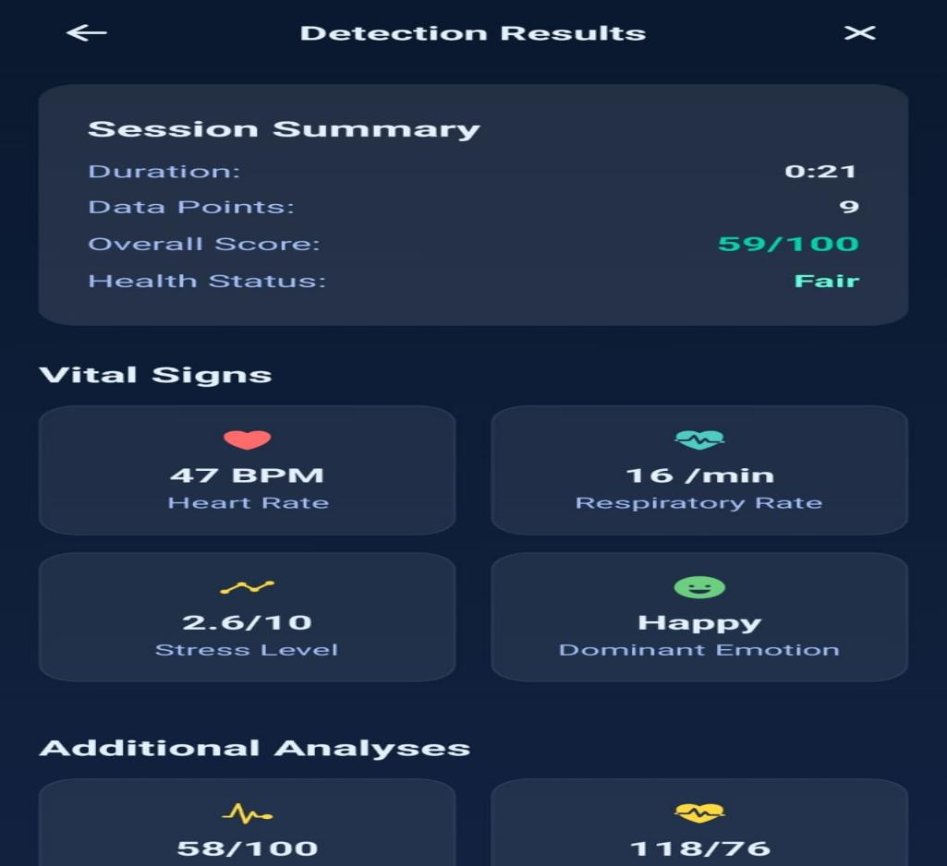

Technical Outputs
- Health Analytics
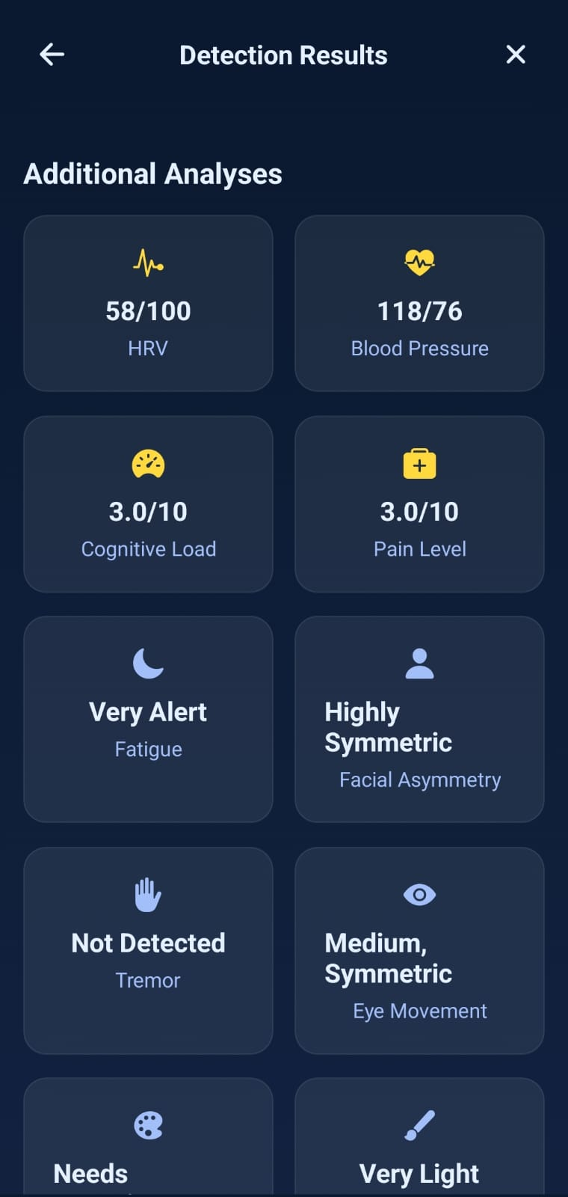

Conclusion and Learning Outcomes

Project Achievements
The Lyfex project successfully demonstrates the feasibility of using smartphone cameras and computer vision techniques for contactless health monitoring. The system achieves real-time processing of physiological signals with reasonable accuracy while maintaining user privacy through local processing.
Key Technical Accomplishments:
- Implemented photoplethysmography (PPG) principles using standard RGB camera for heart rate detection
- Developed multi-modal approach combining facial analysis, motion tracking, and signal processing
- Created responsive mobile interface with sub-second latency for real-time feedback
- Established robust WebSocket communication architecture for streaming video analysis
- Integrated multiple health indicators into a unified assessment system
Practical Applications:
- Wellness monitoring for fitness enthusiasts and health-conscious individuals
- Stress management tool for workplace or personal use
- Educational demonstration of computer vision applications in healthcare
- Foundation for more advanced telehealth and remote monitoring solutions

Technical Learning Outcomes
Computer Vision and Image Processing:
- Gained practical experience with OpenCV for face detection and tracking
- Implemented signal extraction techniques from video streams
- Learned to handle real-time image processing with performance optimization
- Developed understanding of photoplethysmography principles and limitations
Mobile Application Development:
- Built cross-platform mobile app using React Native and Expo framework
- Implemented real-time camera integration with custom capture optimization
- Designed responsive user interface with live data visualization
- Handled complex state management for real-time applications
Network Programming and Communication:
- Implemented WebSocket protocol for low-latency bidirectional communication
- Managed real-time data streaming between mobile client and server
- Handled connection management, reconnection logic, and error recovery
- Optimized data transmission for mobile network constraints
Signal Processing and Analysis:
- Applied digital signal processing techniques for vital sign extraction
- Implemented noise filtering and signal validation algorithms
- Developed multi-sensor data fusion approaches for improved accuracy
- Created confidence scoring and quality assessment mechanisms

Challenges Addressed
Technical Challenges:
- Managing real-time processing constraints while maintaining accuracy
- Handling variable lighting conditions and camera quality across devices
- Balancing frame rate, image quality, and network bandwidth requirements
- Implementing robust error handling for unstable network connections
Accuracy Limitations:
- Recognized inherent limitations of camera-based vital sign detection
- Implemented confidence scoring to indicate measurement reliability
- Added multiple validation layers to filter unreliable data points
- Provided clear disclaimers about medical device limitations

Future Enhancement Opportunities
Technical Improvements:
- Integration of advanced machine learning models for improved accuracy
- Implementation of user calibration systems for personalized baselines
- Addition of data persistence and trend analysis over time
- Development of on-device processing for enhanced privacy and reduced latency
Feature Expansions:
- Integration with wearable devices for validation and enhancement
- Addition of environmental factor detection (ambient light, motion)
- Implementation of multi-user profiles and family monitoring
- Development of alert systems for abnormal readings
Platform Extensions:
- iOS optimization and platform-specific enhancements
- Web browser version for desktop accessibility
- Integration APIs for healthcare platforms and electronic health records
- Offline processing capabilities for remote area usage

Educational Impact
This project effectively demonstrates the intersection of computer vision, mobile development, and healthcare technology. It provides hands-on experience with practical applications of OpenCV while addressing real-world problems in health monitoring and accessibility.
The implementation showcases how modern smartphone capabilities can be leveraged for innovative health solutions, while also highlighting the importance of understanding limitations, accuracy considerations, and privacy requirements in health technology development.

Final Assessment
Lyfex represents a successful implementation of contactless health monitoring using accessible technology. While not intended as a replacement for medical devices, it demonstrates the potential for computer vision and mobile technology to provide valuable wellness insights and encourage proactive health awareness among users.

