**ABSTRACT**

The project aims at building a smooth attendance registering system using image processing,cloud computing and android application development.Basically this kind of system deserves immense importance in a very messed up and crowded classroom.Image processing forms the basics of every students attendance,Images are carefully taken and precisely delivered.

Cloud computing is done as a web service and the list of students and teachers who are associated with the attendance system is stored in it,such that it can be accessed from anywhere.

Cloud system and application will be integrated along with the image processing module such that when the face will be detected then attendance will be automatically marked.Such an integration deserves attention in the sense that the system will be fully automated for the teachers and there will be no more time waste for the teachers in marking the attendance.Webcam based image processing using raspberry pi will be carried out and cloud service will be handled and the module’s end with a user friendly and very effective application through which the teachers can clearly differentiate between attendance of various students.The application will have teacher login only and students will not be able to view through the application.

**CHAPTER 1**

**INTRODUCTION**

Image processing is a type of dispensation in which input is a image,like video frame or photograph and output may be image or characteristics associated with that image.This is the prime factor that this project deals with.The ultimate aim of marking the attendance on the application deals with image data from the processing system.Hence image processing forms the valid and vital part of this project.The next major part forms Cloud computing,a distinct IT environment that is designed for the purpose of remotely provisioning scalable and measured IT resources.The database required for the project will be stored in the cloud and from there remote access id done.Finally Android Application is the required User Interface.The Android SDK tools compile the code along with any data and resource files into an APK ,an Android package,which is an archive file with an .apk suffix.

Automated Attendance System is a project that evolved in order to meet the day to day need of marking attendance in a super messed up classroom.The number of students in a classroom are increasing day by day and it is becoming very difficult to deal them in a proper manner in terms of taking attendance.So in that scenario when we make use of face as the prime factor then it become more accurate and easy for registering attendance.Face captured using a sensor,particularly web camera and the captured images are trained in a well ordered manner and at last recognized.The proper algorithm delivery is very much necessary for getting the desired output.The data from face recognition is linked to the database in the cloud .A random web site is created along with required db of students and teachers and further this website will be hosted on a cloud platform and all the data will be available there in json format,which is a standard data delivery format.The data available in the cloud will be now accessed by the application via various GET and PUT requests.The required UI will be made effective by using various packages and layouts.

The project will be divided into maily 4 modules that forms the primary part of it.First module is the image processing module or the iot device module,which basically deals with a raspberry pi and a web camera in which the image are taken externally,trained and stored.The webpage will be available as a UI for entering the student and teacher details and the corresponding details will be stored within a database in a local server,wamp.The image will be mapped to the unique user id that is meant for each student in the database.Through this userid only the further access will be done.Now the whole website along with the databases will be hosted on the cloud using command prompts within the cloud.Cloud computing makes the data very effective and available within remote reachability.In the cloud the details corresponding to students and teachers will be stored in json format and this will be accessed by the application,which is the 4th and the final module.

The project is mere and completely a new idea that has emerged from our own surroundings.It has no technical presentation or any formal papers available.The integration,idea,concept all are based on day to day knowledge only and that proved to be a big challenge.But when the same is arranged and integrated in a perfect manner then a perfect automated attendance system can be built and that can resolve one of the major academically challenging issue,Attendance marking.

This project is all about integration of various concepts and system.Perfect blendering of services are required for the proper view.This project of Automated attendance is using the latest technology Internet of things,IoT,which is the highlighting part.It can resolve the existing problems in marking the attendance,it can save time and manpower,precision will be more,error will be less and moreover it is a very student and teacher friendly way of attendance marking.Hardware and software are perfectly connected in order to make the system effective.As IoT deals with accessing a data from anywhere the whole system can be managed and rendered in terms of that.Since this project deals with a web camera for capturing the images the images can be made more effective by using a high definition camera and then more precise features can be captured and identified

**1.1 Organisation of Report**

The next chapter that is chapter 2 deals with the problem statement and demerits of existing system and advantages of proposed system.Chapter 3 deals with the hardware and software design and various components are familiarised.Chapter 4 deals with various modules and their organisation.that is system design.Chapter 5 deals with the implementation and further chapters with result,conclusion and reference

**CHAPTER 2**

**Problem Statement**

Automated attendance system is a very effective system of marking the attendance based on the latest technology called Internet of Things and it helps teachers to mark attendance without any manual effort.This chapter deals with existing attendance system,its limitations,proposed system and its advantages.

**2.1.Existing system**

Currently there is no technology that use image processing and application development for attendance.Attendance system is purely based on the efficiency of staff,the way they adopt to obtain clear attendance.But this may not help always as in certain circumstances accidental fault can happen.In some point attendance based on fingerprint may be available but it is not widely accepted yet.In such a situation the managing is still halfway in terms of effective utilizing of time.Students can even mock the staff by acting behalf of someone else and wrong attendance may be entered.A student can even bunk the classes as someone else will be there for their attendance.No proper way of marking the attendance has been defined yet.

**Limitations**

* Loss of Time
* Malpractices of students
* Staff miss out attendance
* The entered data may be incorrect
* Automated attendance system
* Wastage of time
* Delay in processing
* Student record may not be proper
* Difficulties in accessing data because of its clumsy way of storing
* Tedious process,especially for large classrooms
* Students misbehaviour may create stress on staff
* The evaluation criteria for students may end up in error

**2.2.Proposed System**

To overcome the drawback of existing system a new system is implementation which

there is an automatic registering of attendance.The data about whether a student is present or not

will become easily available to the staff.Within the reach of a mobile application the presence of a student is available.The technique used is simple image formatting on behalf of data collection

with pre entered details of students on corresponding database.The proposed system will outcover the difficulties faced by teachers now in monitoring attendance and also constant regulation and messed up activities can be reduced.Also cloud storage and access will manage dynamic data configuration and the outreachy is ensured well.

**Advantages**

* Automated system ensures security
* Reduces human effort.
* Time is saved
* There is no delay in processing
* Data entry is efficient and accurate
* Minimize any malpractices
* Reduce stress on staff
* Dynamic entry
* Human induced error reduction
* Efficient system controlling

**CHAPTER 3**

**SYSTEM REQUIREMENT SPECIFICATIONS**

This chapter includes Hardware description and Software Description,tools required for implementation

**3.1 HARDWARE COMPONENTS AND DESCRIPTION**

WEB CAMERA : C310 HD

RASPBERRY PI : MODEL 3

SMART PHONE : ANDROID OS

SENSOR : REES52

LAPTOP : Any specified on

**3.1.1 Hardware Description**

RASPBERRY PI: MODEL 3

A raspberry pi is a series of small single board computers .It uses operating

system like Raspbian centOS ubuntu MATE etc.Its CPU is of 1.2 Ghz 64/32-bit quad-core ARM

Cortex-A53.The raspberry-PI3-MODB-IGB is the currently using version.It has 1GB

RAM,WiFi/BLE,40 GPIO PINS.Raspberry pi 3 has many advanced features like it uses

SoC:Broadcom BCM2837 which is more faster and a GPU.The network used is 10/100 MBPS

ethernet,802.11n wireless LAN and bluetooth 4.0.However it does not offer SATA or USB C or a

PCIe connector

WEB CAMERA: C310HD

Using this camera high resolution snapshots can be taken at 5 megapixels.The

camera will intelligently adjust to produce the best possible image.It needs has 512 MB RAM or

more,200 MB harddrive space,internet connection and USB 1.1 port.Its universal clip fits

laptop,LCD or CRT monitors.The front of the camera is a gunmetal gray oval,while the back and

securing arm are both black.A 5 foot USB cable protrudes from the back of the webcam,and the

cord should be lomg enough to reach a port in moste setups.

SENSOR:SRO19

PIR Sensor Module(Passive Infra Red)sensor is an electronic semiconductor type

sensor that measures infrared(IR) light radiating from objects in its field of view.This module

detects and gives a trigger when there is any motion by a heat radiating object in its range of

view.This sensor is covered with Fresnel l cover

SMARTPHONE

It is a handheld personal computer with a mobile operating system and an integrated

mobile broadband celular network connection for voice,SMS,and internet data communication.They are able to run a variety of applications from places like google play store or Apple app store and can receive bug fixes

**3.2 SOFTWARE COMPONENTS AND SPECIFICATION**

PLATFORM : JAVA(JEE),ANDROID STUDIO

LIBRARIES : Open CV

SERVER : MS Sql 2008

LANGUAGE : PYTHON,PHP,HTML,JAVA

OS : WINDOWS 7 & WINDOWS 10,Raspbian

**3.3.TOOL STUDY**

**3.3.1 PYTHON**

Python is a high-level, interpreted, interactive and object-oriented scripting language. Python is designed to be highly readable. It uses English keywords frequently where as other languages use punctuation, and it has fewer syntactical constructions than other languages.

* Python is Interpreted − Python is processed at runtime by the interpreter. You do not need to compile your program before executing it. This is similar to PERL and PHP.
* Python is Interactive − You can actually sit at a Python prompt and interact with the interpreter directly to write your programs.
* Python is Object-Oriented − Python supports Object-Oriented style or technique of programming that encapsulates code within objects.
* Python is a Beginner's Language − Python is a great language for the beginner-level programmers and supports the development of a wide range of applications from simple text processing to WWW browsers to games.

Python was developed by Guido van Rossum in the late eighties and early nineties at the National Research Institute for Mathematics and Computer Science in the Netherlands.Python is derived from many other languages, including ABC, Modula-3, C, C++, Algol-68, SmallTalk, and Unix shell and other scripting languages.Python is copyrighted. Like Perl, Python source code is now available under the GNU General Public License (GPL).Python is now maintained by a core development team at the institute, although Guido van Rossum still holds a vital role in directing its progress.Python has few keywords, simple structure, and a clearly defined syntax. This allows the student to pick up the language quickly.Python's bulk of the library is very portable and cross-platform compatible on UNIX, Windows, and Macintosh.

**3.3.2 SQL Server**

Relational database systems are the most important database systems used in the software industry today.One of the most outstanding systems in Microsoft SQL Server.SQL Server is a database management system developed and marketed by Microsoft.It runs exclusively under Windows NT,Windows 95/98,Windows 2000 Server.The most important aspects of SQL Server 2005 are,

* SQL Server is easy to use.
* SQL Server scales from a mobile laptop to symmetric multiprocessor system
* SQL Server provides data warehousing features that until now have only been available in SQL server and other more expensive DBMS.

A database system is an overall collection of different database software components and database containing the parts viz.Database application programs,front end components,Database Management Systems,and Databases.

**3.3.3 PHP**

Stands for "Hypertext Preprocessor." (It is a recursive acronym, if you can understand what that means.) PHP is an HTML-embedded Web scripting language. This means PHP code can be inserted into the HTML of a Web page. When a PHP Page is accessed, the PHP code is read or "parsed" by the server the page resides on. The output from the PHP functions on the page are typically returned as HTML code, which can be read by the browser. Because the PHP code is transformed into HTML before the page is loaded, users cannot view the PHP code on a page. This make PHP pages secure enough to access databases and other secure information.

A lot of the syntax of PHP is borrowed from other languages such as C, Java and Perl. However, PHP has a number of unique features and specific functions as well. The goal of the language is to allow Web developers to write dynamically generated pages quickly and easily. PHP is also great for creating database-driven Web sites. If you would like to learn more about PHP, the official site is PHP.net

**3.3.4 JAVA**

Java is a high-level programming language developed by Sun Microsystems. It was originally designed for developing programs for set-top boxes and handheld devices, but later became a popular choice for creating web applications

The Java syntax is similar to C++, but is strictly an object-oriented programming language. For example, most Java programs contain classes, which are used to define objects, and methods, which are assigned to individual classes. Java is also known for being more strict than C++, meaning variables and functions must be explicitly defined. This means Java source code may produce errors or "exceptions" more easily than other languages, but it also limits other types of errors that may be caused by undefined variables or unassigned types.

Unlike Windows executables (.EXE files) or Macintosh applications (.APP files), Java programs are not run directly by the operating system. Instead, Java programs are interpreted by the Java Virtual Machine, or JVM, which runs on multiple platforms. This means all Java programs are multiplatform and can run on different platforms, including Macintosh, Windows, and Unix computers. However, the JVM must be installed for Java applications or applets to run at all. Fortunately, the JVM is included as part of the Java Runtime Environment (JRE), which is available as a free download

**3.3.5 JSON**

JSON (JavaScript Object Notation) is a lightweight data-interchange format. It is easy for humans to read and write. It is easy for machines to parse and generate. It is based on a subset of the Javascript Programming Language, Standard ECMA-262 3rd Edition-December 1999. JSON is a text format that is completely language independent but uses conventions that are familiar to programmers of the C-family of languages, including C, C++, C#, Java, JavaScript, Perl, Python, and many others. These properties make JSON an ideal data-interchange language.

JSON is built on two structures:

* A collection of name/value pairs. In various languages, this is realized as an *object*, record, struct, dictionary, hash table, keyed list, or associative array.
* An ordered list of values. In most languages, this is realized as an *array*, vector, list, or sequence.

These are universal data structures. Virtually all modern programming languages support them in one form or another. It makes sense that a data format that is interchangeable with programming languages also be based on these structures.

In JSON, they take on these forms:An *object* is an unordered set of name/value pairs. An object begins with { (left brace) and ends with } (right brace). Each name is followed by : (colon) and the name/value pairs are separated by , (comma).

**3.3.6 ANDROID STUDIO**

Android is an open source and Linux-based Operating System for mobile devices such as smartphones and tablet computers. Android was developed by the *Open Handset Alliance*, led by Google, and other companies.

Android offers a unified approach to application development for mobile devices which means developers need only develop for Android, and their applications should be able to run on different devices powered by Android.

The first beta version of the Android Software Development Kit (SDK) was released by Google in 2007 where as the first commercial version, Android 1.0, was released in September 2008.

On June 27, 2012, at the Google I/O conference, Google announced the next Android version, 4.1 Jelly Bean. Jelly Bean is an incremental update, with the primary aim of improving the user interface, both in terms of functionality and performance.

The source code for Android is available under free and open source software licenses. Google publishes most of the code under the Apache License version 2.0 and the rest, Linux kernel changes, under the GNU General Public License version 2.

Android Studio is the official integrated development environment (IDE) for Google’s Android operating system, built on JetBrains' Intellij IDEA software and designed specifically for Android development. It is available for download on Windows, macOS and Linux based operating systems. It is a replacement for the Eclipse Android Development Tools(ADT) as primary IDE for native Android application development.

Android Studio was announced on May 16, 2013 at the Google I/O conference. It was in early access preview stage starting from version 0.1 in May 2013, then entered beta stage starting from version 0.8 which was released in June 2014. The first stable build was released in December 2014, starting from version 1.0. The current stable version is 3.0 released in October 2017.

**3.3.7 OpenCV**

OpenCV was started at Intel in 1999 by **Gary Bradsky**, and the first release came out in 2000. **Vadim Pisarevsky** joined Gary Bradsky to manage Intel's Russian software OpenCV team. In 2005, OpenCV was used on Stanley, the vehicle that won the 2005 DARPA Grand Challenge. Later, its active development continued under the support of Willow Garage with Gary Bradsky and Vadim Pisarevsky leading the project. OpenCV now supports a multitude of algorithms related to Computer Vision and Machine Learning and is expanding day by day.

OpenCV supports a wide variety of programming languages such as C++, Python, Java, etc., and is available on different platforms including Windows, Linux, OS X, Android, and iOS. Interfaces for high-speed GPU operations based on CUDA and OpenCL are also under active development.

OpenCV-Python is the Python API for OpenCV, combining the best qualities of the OpenCV C++ API and the Python language.

OpenCV-Python makes use of **Numpy**, which is a highly optimized library for numerical operations with a MATLAB-style syntax. All the OpenCV array structures are converted to and from Numpy arrays. This also makes it easier to integrate with other libraries that use Numpy such as SciPy and Matplotlib.

**OpenCV** is an open source C++ library for image processing and computer vision, originally developed by Intel and now supported by Willow Garage. It is free for both commercial and non-commercial use. ... It is a library of many inbuilt functions mainly aimed at real time image processing.

**.**

**CHAPTER 4**

**SYSTEM DESIGN**

This chapter deals with different modules,use case diagrams,data flow diagramsand database design in this project.The modules are Image processing module,cloud computing module,web page or dashboard and Android application.

**4.1 MODULES**

Automated Attendance system is based on four modules

**Image Processing**

This module focuses on taking the image of a student by using the raspberry pi.This image

Will be taken by a web camera and the face detection and training will be done using an algorithm named Viola Jones Algorithm.Then when the image is recaptured again then the image will be detected and mapped to the unique user id given to the student through the database and the whole will be given to the cloud system

**WebPage**

It is a random webpage created and the details of students and teachers will be stored into it.

Among this the user id given to the teachers and students has importance as it is required for mapping into the image as well as the application.It provides admin login and student login,as well as registering

**Cloud Computing**

The webpage created will be imported to the cloud .Here AWS(Amazon Web Service) is used.The data in the cloud will be available in Json format which can be accessed by the application directly.The details of the teachers and students will be available as a Json array in the cloud and using various call application can make it available

**Android Application**

The final User Interface is the android application which provide access only to the teacher.Teachers can view the details of the student belonging to their corresponding semester.Admin login will be provided so that admin can login in order to view the list of the teachers

**Taking the image**

The image will be taken using a standard webcam and is meant for training in the raspberry pi.At last the trained image will be mapped to the particular use rid that will be given to each student and will be stored within the database in the cloud

**Preparing databases**

The databases for the student and teachers will be prepared in a dashboard and the unique user id and password will be given at that time

**Importing to the cloud**

Cloud is set up and all the data that is available within the dashboard will be imported to the cloud.Within the cloud the details of the students and teachers will be stored in the form of json array and the corresponding web service will be provided for the access of the application.

**Making Application**

Application provide two functions,Teacher login and Admin login.Teachers can view the list of students associated with them and the classification will be semester wise.Similarly the admin can view the list of all the teachers.

**4.2 Use case Diagram**

A use case diagram is a diagram that shows the relationships among actors and use cases within a system.Use case diagrams are often used to:provide an overview of all or part of the usage requirements for a system or organization in the form of an essential model or buisness model.

**Web Page Interaction**



**Fig 5.1 webpage student interaction**

The student will be interacting with the webpage using three basic operations,register login and view.The webpage is the one factor in which student can register themselves and view their data accordingly.



**Fig 5.2 Admin interaction**

Admin uses the webpage for registering teachers as teachers will not have direct access to the webpage.Also admin can view the teachers list and the student list.All this require a particular login into the admins account.

**Application Interaction**



**Fig 5.3 Teacher interaction**

A teacher can only use the application and there will be a login id and password for the teacher through which they can login and now they will get a list of students to whom they are associated.Teacher can also view the details of the students who are associated with them and also can view their attendance.



**Fig 5.4 admin level interaction**

In the application the admin can log in into it and view the list of teachers.when clicking on that particular card then all the students associated with that teacher will be displayed and also the attendance will be shown.

**5.3 Data Flow Diagrams**

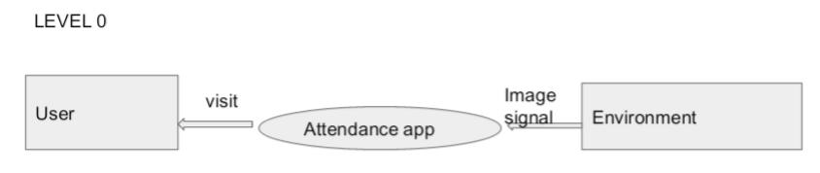

**Fig 5.5 Basic application interaction**

In this the user will visit the application for his/her needs on the basis of external signals or some factors given by the environment

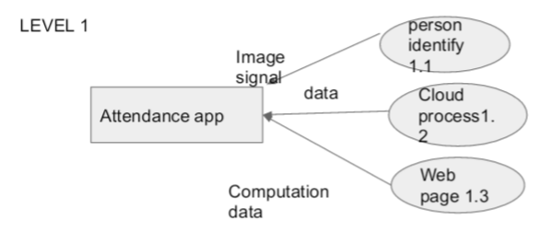

**Fig 5.6 Application through modules**

Mainly 3 modules externally will be interacting with the application sending the signals and receiving the output.The image processing module will send image signals cloud and webpage module will send other datas

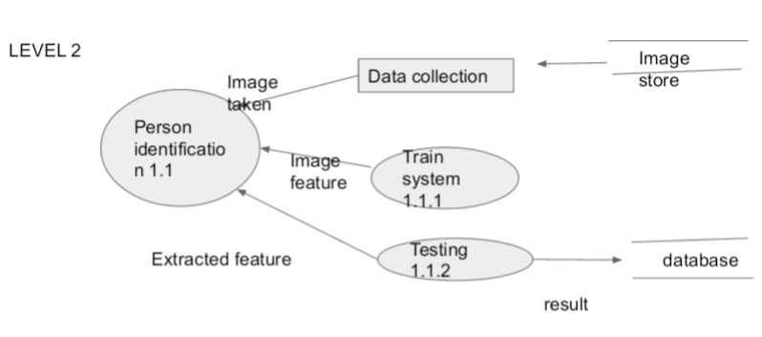

**Fig 5.7** **Image identifying**

The image need to be collected from a store for the purpose of identification.This image has to be trained and tested and the result of all these process will be stored in the database

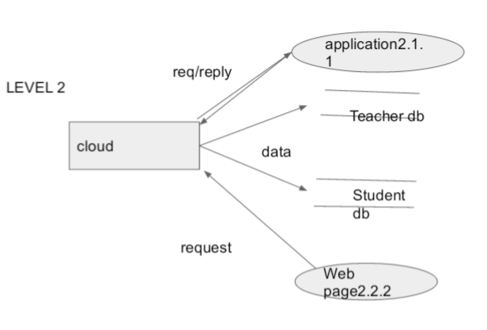

**Fig 5.8 Cloud Access**

This shows the functionalities of a cloud.It can access the webpage and store the details of the students and teachers in its own database.At last application will have access to all these from the cloud

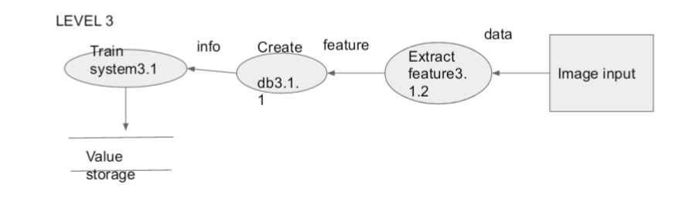

**Fig 5.9 Training the image data**

Training involves taking the image as the input and the features will be extracted and the trained value will be meant for the storage.

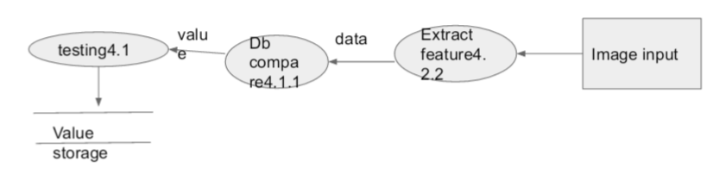

**Fig 5.10 Testing of image data**

The testing part works after the training of data.Testing is all about comparison within the database.The values after testing will be again stored and will be taken for further computation.

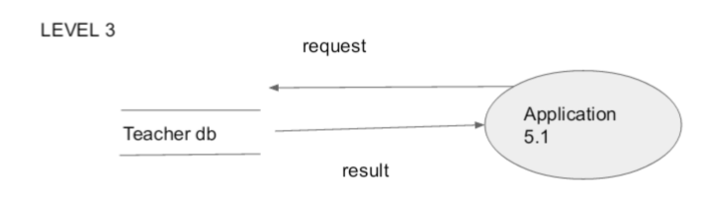

**Fig 5.11 Teacher database**

The database for the teacher will be created and the request will be given from the application for the datas of the teachers available in the cloud.Answering to this request reply message is given.

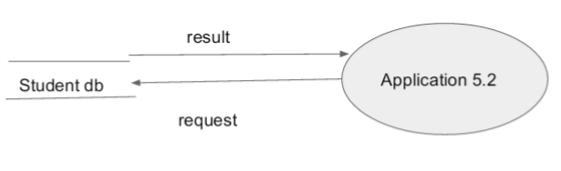

**Fig 5.12 Student database**

The database of the student will be created within the cloud and the application can access all the details by sending a request. The result will be passed based on that.

**5.4 Data Base Design**

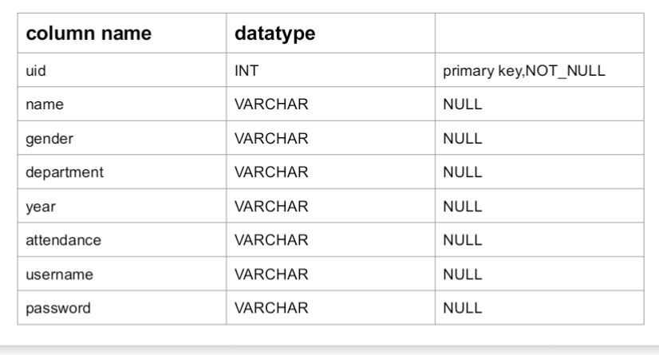

**Table 5.1 Student details**

The table constitutes the details of the students in a well mannered order.These details are the primary details which are required for marking the attendance through the application.The userid will be given as the primary key

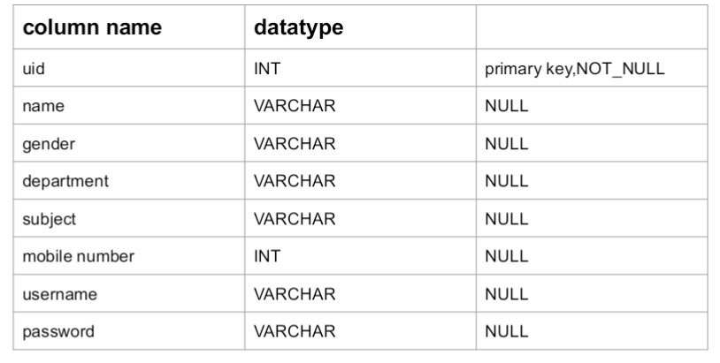

**Table 5.2 Teacher Details**

Same as that of the student the teacher also need database for entering the details which are required for accessing in the application.In the teacher table also Uid will be given as the primary key

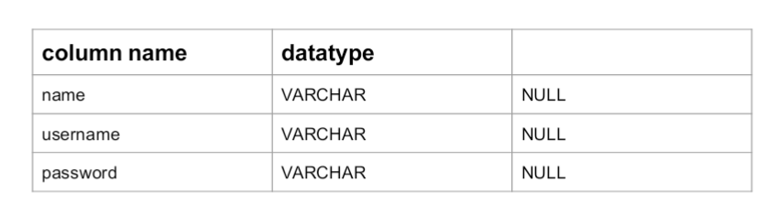

**Table 5.3 Admin Login**

The admin can perform login by entering the details particularly name,username and password.

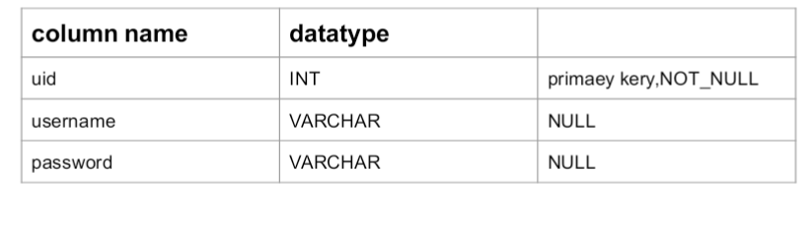

**Table 5.4 User Login**

Any other user can login into their account by using their unique user id and the name and the password that is given.

**5.5 Algorithms**

**Overall model**

The image will be captured by the webcam ,and the image will be within the raspberry pi for processing.Now there will be unique user id mapped to each image if the image taken or detected will match with that particular user id then all this data that is student data will be available in the cloud.In the cloud there will be teachers data as well as students data .The teacher and admin make login through the mobile application.If the login user id and password are valid then access can be allowed to them otherwise it is discarded

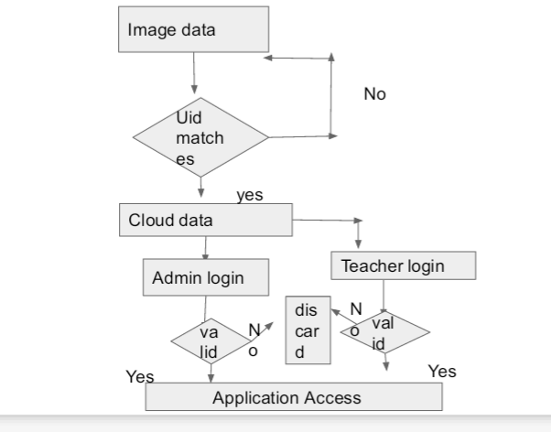

**Fig 5.13 Overall Flow**

**Viola Jones Algorithm**

The Viola-Jones algorithm is a widely used mechanism for object detection. The main property of this algorithm is that training is slow, but detection is fast. This algorithm uses Haar basis feature filters, so it does not use multiplications.

The efficiency of the Viola-Jones algorithm can be significantly increased by first generating the integral image.

face-detection-viola-jones-eq1The integral image allows integrals for the Haar extractors to be calculated by adding only four numbers. For example, the image integral of area ABCD (Fig.1) is calculated as *II*(*y*A,*x*A) – *II*(*y*B,*x*B) – *II*(*y*C,*x*C) + *II*(*y*D,*x*D).

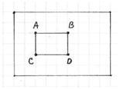

Image area integration using integral image

Detection happens inside a detection window. A minimum and maximum window size is chosen, and for each size a sliding step size is chosen. Then the detection window is moved across the image as follows:

1. Set the minimum window size, and sliding step corresponding to that size.
2. For the chosen window size, slide the window vertically and horizontally with the same step. At each step, a set of *N* face recognition filters is applied. If one filter gives a positive answer, the face is detected in the current widow.
3. If the size of the window is the maximum size stop the procedure. Otherwise increase the size of the window and corresponding sliding step to the next chosen size and go to the step 2.

Each face recognition filter (from the set of *N* filters) contains a set of cascade-connected classifiers. Each classifier looks at a rectangular subset of the detection window and determines if it looks like a face. If it does, the next classifier is applied. If all classifiers give a positive answer, the filter gives a positive answer and the face is recognized. Otherwise the next filter in the set of *N* filters is run.

Each classifier is composed of Haar feature extractors (weak classifiers). Each Haar feature is the weighted sum of 2-D integrals of small rectangular areas attached to each other. The weights may take values ±1. Fig.2 shows examples of Haar features relative to the enclosing detection window. Gray areas have a positive weight and white areas have a negative weight. Haar feature extractors are scaled with respect to the detection window size.

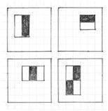

The classifier decision is defined as:

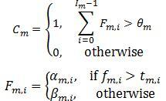

*fm,i* is the weighted sum of the 2-D integrals. is the decision threshold for the *i*-th feature extractor. *αm,i* and *βm,i* are constant values associated with the *i*-th feature extractor. *θm* is the decision threshold for the *m*-th classifier.

object-detection-viola-jones-filter

Object detection Viola-Jones filter

The cascade architecture is very efficient because the classifiers with the fewest features are placed at the beginning of the cascade, minimizing the total required computation. The most popular algorithm for features training is AdaBoost.

**Eigenface based facial recognition**

The task of facial recognition is discriminating input signals (image data) into several classes (persons). The input signals are highly noisy (e.g. the noise is caused by differing lighting conditions, pose etc.), yet the input images are not completely random and in spite of their differences there are patterns which occur in any input signal. Such patterns, which can be observed in all signals could be - in the domain of facial recognition - the presence of some objects (eyes, nose, mouth) in any face as well as relative distances between these objects. These characteristic features are called *eigenfaces* in the facial recognition domain (or *principal components* generally). They can be extracted out of original image data by means of a mathematical tool called *Principal Component Analysis* (PCA).

By means of PCA one can transform each original image of the training set into a corresponding eigenface. An important feature of PCA is that one can reconstruct reconstruct any original image from the training set by combining the eigenfaces. Remember that eigenfaces are nothing less than characteristic features of the faces. Therefore one could say that the original face image can be reconstructed from eigenfaces if one adds up all the eigenfaces (features) in the right proportion. Each eigenface represents only certain features of the face, which may or may not be present in the original image. If the feature is present in the original image to a higher degree, the share of the corresponding eigenface in the ”sum” of the eigenfaces should be greater. If, contrary, the particular feature is not (or almost not) present in the original image, then the corresponding eigenface should contribute a smaller (or not at all) part to the sum of eigenfaces. So, in order to reconstruct the original image from the eigenfaces, one has to build a kind of weighted sum of all eigenfaces. That is, the reconstructed original image is equal to a sum of all eigenfaces, with each eigenface having a certain weight. This weight specifies, to what degree the specific feature (eigenface) is present in the original image.

If one uses all the eigenfaces extracted from original images, one can reconstruct the original images from the eigenfaces *exactly*. But one can also use only a part of the eigenfaces. Then the reconstructed image is an approximation of the original image. However, one can ensure that losses due to omitting some of the eigenfaces can be minimized. This happens by choosing only the most important features (eigenfaces). Omission of eigenfaces is necessary due to scarcity of computational resources.

How does this relate to facial recognition? The clue is that it is possible not only to extract the face from eigenfaces given a set of weights, but also to go the opposite way. This opposite way would be to extract the weights from eigenfaces and the face to be recognized. These weights tell nothing less, as the amount by which the face in question differs from ”typical” faces represented by the eigenfaces. Therefore, using this weights one can determine two important things:

1. Determine, if the image in question is a face at all. In the case the weights of the image differ too much from the weights of face images (i.e. images, from which we know for sure that they are faces), the image probably is not a face.
2. Similar faces (images) possess similar features (eigenfaces) to similar degrees (weights). If one extracts weights from all the images available, the images could be grouped to clusters. That is, all images having similar weights are likely to be similar faces.

**Algorithm**

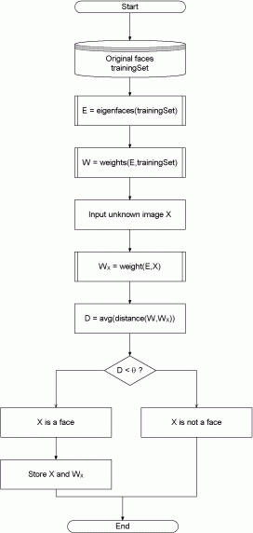

|  |  |
| --- | --- |
| **Figure 5.14** | **High-level functioning principle of the eigenface-based facial recognition algorithm** |

The algorithm for the facial recognition using eigenfaces is basically described in figure 5.14. First, the original images of the training set are transformed into a set of eigenfaces *E*. Afterwards, the weights are calculated for each image of the training set and stored in the set *W* .

Upon observing an unknown image *X*, the weights are calculated for that particular image and stored in the vector *WX*. Afterwards, *WX* is compared with the weights of images, of which one knows for certain that they are faces (the weights of the training set *W* ). One way to do it would be to regard each weight vector as a point in space and calculate an average distance *D* between the weight vectors from *WX* and the weight vector of the unknown image *WX* (the Euclidean distance would be a measure for that). If this average distance exceeds some threshold value

**CHAPTER 5**

**IMPLEMENTATION**

**5.1.IMPLEMENTING MODULES**

**Capturing Images**

The image is captured using a standard web camera.The image of each student will be captured at the time of taking photograph for the official purposes.The image captured with the features is put into the raspberry pi for the next steps

**Training Images**

The image captured will be trained using the viola jones algorithm and is kept further for the next computation.The trained image should be recognized and mapped into the unique id that is available in the database

**Preparing Database**

The database corresponding to each student and teacher is formed with appropriate entries.

It contains all those fields which are mandatory for a particular user that is student or teacher

**Importing to Cloud**

The databases that has been prepared should be imported to cloud using the appropriate method.Cloud importing is necessary to access the data from anywhere which forms the concept of Internet of Things.In the cloud the database will be imported and along with that a web service will be written for the purpose of access by the application

**Application Access**

Now through the web service that is made in the cloud computing session the application can access the data of students and teachers through various get and post requests.

**5.2 CLASS DIAGRAM**

Use case provides the foundation for creating initial class diagram.The class diagram is key.The class diagram becomes pivotal diagram throughout object-oriented development.The purpose of the class diagram is to structure the static nature of the objects in terms of its attributes,operations and associations.Most object modeling tools generate source code only from the class diagram.A class diagram contains classes and relationships between classes.

**Class:**

A class is a classifier that has objects as its instances.A class provides the template from which objects are created.It also defines its attributes and operations.

**Webcam.py**



**Fig 5.1 Webcam.py**

The class diagram of webcam gives information about the basic usage and application of a web camera.First method is used to open the camera that is to make the camera active.In next method a lock is given inorder to prevent the concurrent access to the camera.That is at a time only one user can use it.In the next method there is saving of the image.The image captured will be saved for the next debugging purpose

**Capture_positives.py**



**Fig 5.2 CapturePositives.py**

The capture section capture the image using web camera.First of all the camera is configured and camera is read and box is initialised.In the next step the captured image is analysed and and the coordinates of the single face will be taken that is it is detected and measured.Now the image in the current format will be converted into grayscale which can be further used for training.

**Train.py**



**Fig 5.3 Train.py**

In the train section the image in grayscale format is trained.In this there is a generator function to iterate through all files in a directory recursively which match given filename match parameter.Now in the next step the image is read as grayscale and resize it to appropriate size for training face recognition model.After this step the image is made as a normalized array in X to a value between low and high.

**Box.py**



**Fig 5.4 Box.py**

In this the camera is again initialised along with box.In the next step the image will be cropped and resized into face.Next step is the testing of face against crop.So after running box the image that is required in the recognition step is carefully analysed

**Login**



**Fig 5.5 Login**

Login is the activity that is done by the teacher in the application side.The method inside this activity will be the need to validate the user.That is whether the user who is there to login is already registered to the cloud with corresponding user id and password.The database in the cloud will be checked while login is performed to verify whether the username is correct or not

**StudentList**



**Fig 5.6 Student List**

Student list is the activity that is viewed by the teacher after he/she perform login.The whole students under a particular teacher will be mapped with the department and semester

accordingly.After performing the mapping the view of all students under a particular teacher is made available.

**Student Detail**



**Fig 5.7 Student Details**

Now this is the page which is directed immediately after user clicks on the student list under the teacher login.The list of the students that is provided in the database will be visible in the student detail page.Hence the teacher can view the students that comes under his/her department as well as the whole details of the same.The list will be provided by the cloud database itself.

**Teacher List**



**Fig 5.6 Teacher List**

The list of the teachers will be available after the admin performs login with unique id and password.All the teachers who are registered by the admin at the webpage side will be under the view of the admin once login is performed.It includes the teachers of various departments nd belonging to various semesters.

**Teacher Details**



**Fig 5.7 Teacher Details**

This page will be directed immediately after the user clicks on the teacher name which will be provided under the teacher list.The details of the teacher can also gives the details of various students thats comes under that teacher.On clicking a button at the teacher details page the view of all students who all are mapped under a particular teacher can also be viewed.

**CHAPTER 6**

**RESULT**

**Login(TEACHER)**

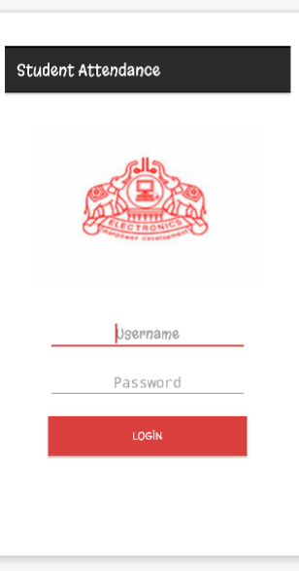**Fig 6.1**

The teacher can log into their account by using the userid and password given at the time of registration.The teacher can view the attendance of various students associated with them.

**TEACHER VIEW**

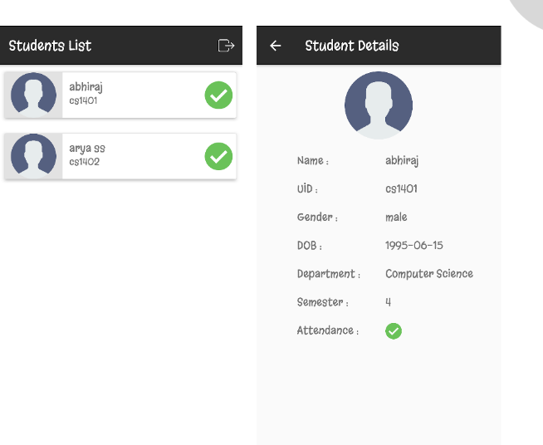

**Fig 6.2**

Here the view for each teacher is provided.Each student associated with each teacher can be viewed with their attendance and also many other details can also be given

**ADMIN LOGIN**



**Fig 6.3**

Admin login is same as that of the teacher login that is using a unique user id and password admin can view the list of teachers as well as the students associated with each teacher

**ADMIN VIEW**

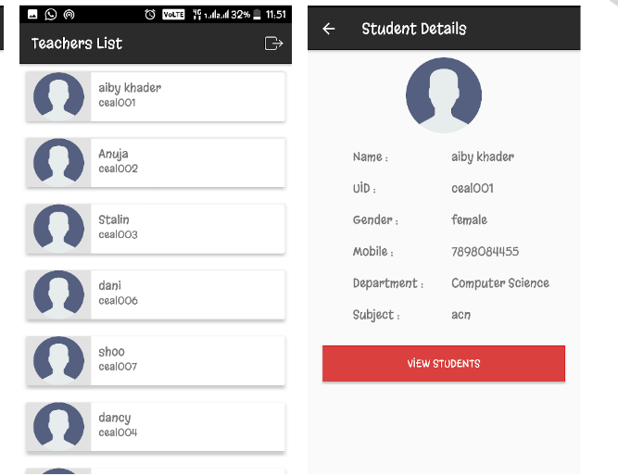

**Fig 6.4**

The list of teachers can be viewed by the admin who all are entered into the database.Also by clicking on view students button the admin can view the list of students associated



**Fig 6.5**

The list of students will be associated with every teachers.The student list can be viewed by both teacher as well as admin

**CHAPTER 7**

**CONCLUSION**

Through this project a very interesting and effective attendance system is on practice.A highly efficient system of taking attendance is provided so as to monitor the students in a very accurate way.Nowadays attendance form the basic criteria of evaluation in many curriculms so the validity of the system need to be stressed.By providing automation a highly efficient system of attendance is given.

**CHAPTER 8**

**REFERENCE**

**• Wikepedia**

**• Image processing analysis and machine vision-Sonka**

**•** [**www.codechef.com**](http://www.codechef.com)

**• Android design patterngreg nudelman**