Funds and Backtest
Building on the cleaned equity, cryptocurrency and news dataset that was prepared in Part A, MarketBridge develops a range of systematically managed funds for investors with different risk preferences. The fund offers different set of portfolio combinations such as equity only, crypto only, and combined multi asset portfolios. Within these assets groups, three portfolio construction approaches were applied: Equal weight, minimum variance (risk), and maximum Sharpe methods. The equal weight approach allocated equal proportion to each asset and serves as a simple benchmark that did not depend on estimates of expected returns or risk. The minimum variance approach selected portfolio weights that aimed to minimise overall volatility, while the maximum Sharpe method aims for the highest expected return in relation to risk. A guarded Combined Minimum Variance fund was also developed to examine whether cryptocurrency could provide diversification benefits while limiting total crypto exposure to 20% hard cap.
Each strategy was evaluated using a walk-forward out-of-sample backtest, meaning that portfolio weights were estimated only from historical information available before each investment period. The portfolios were formed using a rolling estimation window of 252 observations, representing one year of equity trading days as US equities do not trade on weekends and public holidays. Portfolio weights were recalculated monthly and then applied to the following investment period, preventing future information from influencing investment decisions. All strategies were long only, with weights summing to one, while the Guarded Minimum Variance fund imposed an additional 20% maximum allocation to cryptocurrencies. A zero-risk free rate was also assumed when constructing and evaluating the maximum Sharpe portfolios. This setup keeps the portfolio formation rules consistent across funds, while annualization follows the relevant trading calendar, 252 days for equities and combined funds, 365 days for crypto-only funds.
Fund performance was evaluated using the growth of $1, annualised return, annualised volatility, Sharpe ratio and maximum drawdown, with the latest portfolio holdings. The Sharpe ratio is measured as the annualised average excess return over annualised volatility, Sharpe = sqrt (N) x mean(r_t) / sd(r_t), where r_t is the daily portfolio return and N is the annualization factor. Maximum drawdown measures the largest fall in portfolio value from a previous peak during the backtest period. These measures were chosen as return alone does not show how much risk an investor had to take on. Growth of $1 shows how an initial investment changed over time for different assets with the same starting point of $1. The Sharpe ratio compares return relative to risk, and maximum drawdown captures the largest decline from a previous portfolio peak. Applying the same performance measures across the funds enables MarketBridge users to compare both the potential returns and downside risks of each strategy.

Out-of-Sample results and Fund Facts sheets
The out-of-sample results show that fund performance differs across asset groups and portfolio construction method. The common-sample performance metrics are shown in Appendix Table A1, while Appendix Figure A1 compares the growth of $1 across the main funds. A common-sample comparison is used as crypto assets trade every day while US equities only trade on market days. Using the same backtest period makes the comparison between assets fairer across equity only, crypto only and combined fund.
Table A1 shows a clear return-risk trade off across the MarketBridge funds. The crypto only funds generated some of the highest cumulative returns, with crypto equal weight returning 109.69% and Crypto Minimum Variance returning 108.40% over the common sample. However, these returns came with much higher risk, including annualised volatility being above 63% and maximum drawdowns below -70%. This suggests that crypto only funds may look attractive from a returns perspective, but it also involves downside risks that may be unsuitable for many retail investors.
Among the combined funds, Combined Maximum Sharpe showed the strongest risk-adjusted result, with cumulative return of 95.55% and a Sharpe ratio of 1.034. However, it also had higher annualised volatility of 24.65% compared to the Minimum Variance funds (12.76%). On the other side, Combined Minimum Variance and Guarded Minimum Variance produced lower returns but achieved much lower volatility and lesser drawdowns, which aligns with their risk-minimising objective. The Guarded Minimum Variance fund allocated only 0.60% to crypto assets on average, suggesting that the optimiser largely avoided crypto even before the 20% hard cap on crypto became effective. Overall, the results show why MarketBridge compares the metrics above rather than just ranking funds only by returns.
Table A2 reports the latest target holdings at the finals rebalance date of 2023-12-01. This is different from the average equity and crypto weights earlier as it shows what each fund would hold at the end of the backtest, rather than its average exposure across the entire sample. Combined Maximum Sharpe had the highest current crypto exposure among the combined funds, with 14.81% allocated to crypto at the final rebalance date. In contrast, the other funds leaned more heavily towards equities, with only around 2.8% allocated to crypto. This shows that the guarded fund remained mostly equity, while Combined Maximum Sharpe has more active crypto exposure, and the Guarded Minimum Variance fund had only 2.83% in crypto.
Figure A1shows the growth of $1 invested in each MarketBridge fund from the common out-of-sample start date of 2021-01-04. The figure highlights a clear difference between crypto only and equity/combined strategies. Crypto funds went through the largest swings, crypto equal weight rose sharply during 2021, at one point reaching close to 6 times the initial amount but then fell considerably during the 2022 crypto downturn. Crypto Minimum Variance also has a strong result at the end of 2023, but its path was still much more volatile than the equity and combined funds. This confirms that crypto exposure created upside potential but also much higher instability for investors.
Among the combined funds, combined maximum Sharpe produced the strongest growth path and finished above the other combined strategies. This aligns with Table A1, where it had the highest combined fund cumulative return and Sharpe ratio. In contrast, Combined Minimum Variance and Guarded Minimum Variance had much flatter paths. These funds did not generate the highest return, but their smooth growth suggests their risk-minimising objective. The guarded fund’s paths were very similar to the Combined Minimum Variance, suggesting that the 20% crypto cap was not strongly binding, since the optimiser allocated very little crypto even before the cap was implemented.
Figure A2 shows the maximum drawdown paths of the combined funds, which shows the downside risk more visibly than the growth chart. Combined maximum Sharpe achieved the strongest return among the combined funds, but form this figure it also experienced the deepest drawdown, falling by around 26.31% from its previous peak. This shows that its higher return came with greater downside risk. In contrast, Combined Minimum Variance and Guarded Minimum Variance had much smaller maximum drawdowns of around 15%. Their drawdown paths are also very similar, which is consistent with the earlier result that the guarded fund’s 20% crypto cap was not strongly binding.
Figure A3 compares the Sharpe ratios of the MarketBridge funds over the common out-of-sample period. Combined maximum Sharpe achieved the highest Sharpe ratio at 1.03, showing the strongest risk-adjusted performance across the funds. This aligns with the strategy’s aim to maximise expected return in relation with volatility. Equity equal weight also performed strongly, with a Sharpe ratio of 0.82, suggesting that a diversified equity benchmark can still result in competitive Sharpe ratios.
The crypto only funds show a more mixed result. Although Crypto Equal Weight and Crypto Minimum Variance generated high cumulative returns, their Sharpe ratios were lower than the best combined fund as their volatility was much higher. The only negative Sharpe ratio was Crypto Maximum Sharpe, meaning that it took substantial risk while having a negative average return under the zero-risk free rate assumption. Although the crypto maximum Sharpe fund was designed to choose portfolio with the highest estimated Sharpe ratio in each historical window, this did not translate to actual out-of-sample result. This suggests how expected returns in crypto is volatile and difficult to estimate. Assets that looked attractive based on historical data did not necessarily continue to perform well in the future. Overall, the Sharpe comparison shows that the highest-return funds were not always the best after adjusting for risk. In this sample, the strongest balance between return and risk came from the combined maximum Sharpe approach rather than the crypto only approaches.
Figure A4 explains why the combined funds behaved differently over the backtest period. Combined maximum Sharpe had the most variable allocation path. At the start of the sample, it allocated a large share to crypto, around 60%, before shifting towards equities for most of 2021 to 2023. Its crypto allocation increased again near the end of the sample. The more flexible allocation helped the fund to achieve higher upside, but it also exposed investors to deeper drawdowns when compared with the minimum variance funds.
In contrast, Combined Minimum Variance, Guarded Minimum Variance and Guarded Minimum Variance with sentiment tilt were much more stable. These funds stayed almost entirely invested in equities, with only a small number of crypto allocations over time. This is aligned with the earlier result where the minimum variance optimiser naturally avoided crypto due to its high volatility. The guarded fund’s crypto exposure remained well below the 20% cap throughout the duration, so the cap acted more as a risk control safeguard rather than a binding constraint. This figure is useful for MarketBridge as it shows that fund performance is not limited to only final returns, but also how each strategy changed its exposure allocations over time.
Overall, the out-of-sample results show that no single MarketBridge fund is best for every investor. Combined Maximum Sharpe produced the strongest risk-adjusted performance, but it involved more allocations changes between crypto and equities, also with deeper drawdowns. Minimum variance and guarded funds results in lower returns, but they offered more stable risk profiles. Crypto only funds generated high upside in some cases, but with much higher volatility and drawdowns. This supports the purpose of MarketBridge as a comparison platform that helps investors compares and evaluates return, risk, drawdown and allocation together.

Sentiment Index
The next part of MarketBridge adds the text-data component by converting financial headlines into sector level sentiment index. While the backtest in Section 2 was based on structured price and return data, the sentiment index uses unstructured data such as news headlines to measure the tone of the market information across sectors. This is important as investors may not only react to historical returns and volatility, but also to news about earnings, regulations, growth, news headlines. This helps MarketBridge combined fund performance analysis with news context that investors may also consider when making financial decisions.
The baseline sentiment index was constructed using VADER, a rule-based sentiment model that converts each headline into a compound sentiment score between -1 and +1. A more positive score indicates a more favourable news tone, while a more negative score indicated a more unfavourable tone. These headline level scores were then aggregated by ticker, sector and trading date to create a daily sector level sentiment index. This allows MarketBridge to compare news tone across industries instead of treating the entire market as one group.
To prevent look-ahead bias, the portfolio did not use same day sentiment when forming weights. Sector days with no headlines were treated as neutral before the sentiment was lagged, meaning that the missing headline coverage was interpreted as no observable news tone. The sentiment signal used in portfolio allocation was lagged by one trading day, so each rebalance only used news information that would have already been available. I also used a 21-trading day rolling average to smooth the signal, because individual headlines can be noisy and may not represent the broader news tone for a sector. This makes the sentiment input more stable for monthly portfolio rebalancing.
Figure A5 shows the VADER sentiment index for the six sectors with the highest headline coverage: Tech, Consumer, Energy, Financials, Healthcare and Industrials. The lighter lines show the noisier daily sentiment scores, while the darker lines show the 21-day average used to make the signal more stable and smoother. Overall, sentiment was generally positive across six sectors, but it still changed over time and differed across industries. For example, Tech and Consumer sentiment stayed relatively stable after 2020, while Energy and Healthcare showed more fluctuations across the sample. This shows why a sector level sentiment index is useful, the news environment was not identical across industries, so one overall market sentiment would hide some of the differences.
This figure also shows why smoothing was necessary. Daily headline sentiment can move sharply as small number of headlines may be very positive or negative on a given day, headlines tone may be extreme due to the small number of headlines. The 21day average reduces this noise and gives a clearer view of the news tone for each sector. For MarketBridge, this makes the sentiment index more useful for MarketBridge because the funds should respond to broader news trends, rather than overreacting to one noisy day of headlines.
Figure A6 compares the base Guarded Minimum Variance fund with the VADER sentiment-tilted version. The results are almost identical across annualised return, annualised volatility, Sharpe ratio and maximum drawdown. From Table A3, the base fund achieved a cumulative return of 18.79%, while the sentiment-tilted fund achieved 18.77%. The Sharpe ratio also changed slightly, from 0.5152 of the base funds to 0.5148. This shows that the basic VADER sentiment tilt did not materially improve performance in this sample.
However, the result is still useful because it shows that MarketBridge can combined structured return-risk data with unstructured headline sentiment while making sure the portfolio only uses information that would have been available at the time. The sentiment signal may be more useful as a market-context feature rather than used for strong trading signal especially when applied to a low-risk fund such as Guarded Minimum Variance.

Extensions and Innovations
In addition to the required backtest and sentiment index, MarketBridge includes two extensions to test if the product remains useful and reliable under more realistic and finance-specific assumptions. The first extension adds a transaction cost model to measure how portfolio turnover reduces fund performance. The second extension expands the baseline VADER sentiment model with a small finance specific lexicon.

Transaction cost transparency
The transaction cost extension estimates the cost of rebalancing each fund using an assumed rate of 0.10% per dollar traded, meaning $0.001 for every $1. This is not intended to represent exact real world execution costs, since actual costs depend on bid ask spreads and broker fees. Instead, it provides a simple and consistent way to compare how trading frequency affects each strategy. Funds with higher turnover generally experience larger cost drag as they require more frequent or larger changes in portfolio weights. This is useful for MarketBridge as investors care about net performance, not only gross returns.
The transaction cost analysis compares each fund’s gross and net return within the same backtest sample. In this section, cost drag refers to the reduction in cumulative return after applying the assumed transaction cost. The gross cumulative returns in the transaction cost table is calculated within each fund’s backtest sample, so the crypto only values are not directly comparable with the common sample performance table in Section 2.
Figure A7 and Table A4 show that transaction costs differed across funds. The Equal Weight funds had very low average turnover since their weights changed less at each rebalance, so their estimated cost drag was small. In contrast, the Maximum Sharpe funds had much higher average turnover, especially Combined Maximum Sharpe and Equity Maximum Sharpe, since their portfolio weights changed more actively over time. This led to larger estimated cost drag.
The results also show that transaction cost drag is not determined by turnover alone. For example, Crypto Minimum Variance had lower average turnover than the Maximum Sharpe funds, but it had the largest cost drag of 2.76%. This is because cost drag depends not only on how often the fund trades, but also the size of the portfolio being traded. Since Crypto Minimum Variance grew strongly over the sample, even a lower level of turnover creates a large impact on the net cumulative return.
Overall, this extension makes MarketBridge more realistic as it shows the difference between gross and net performance. Instead of assuming that trading is costless, investors can see how much return is reduced after counting in for the transaction costs. This is useful for comparing funds as a strategy with strong gross returns may appear less attractive if it requires frequent trading and has a higher cost drag.

Finance lexicon extension
The second extension tests if the baseline VADER sentiment model misses finance specific language in the headlines, and whether by accounting the sentiment value of the missed terms changes the performance of the sentiment tilted fund. VADER is useful as it is transparent and easy to apply, but it is a general purpose sentiment lexicon rather than a finance specific model. In financial news, terms such as upgrades or downgrades can carry clear investor meaning, which may differ from normal language. Therefore, MarketBridge adds a small finance specific lexicon to test if finance-related vocabulary will improve both sector sentiment index and the sentiment tilted funds.
To create this finance lexicon extension, MarketBridge first checked for common words in the headlines that were not in VADER lexicon. This identifies 250 candidate terms, but only 48 finance related words were selected for the final custom lexicon. The lexicon was kept small to reduce the risk of overfitting, it was not designed to make the backtest results look better, but to test if a finance specific lexicon can improve how headline sentiment was measured. The selected words were given a conservative positive or negative score from -1 to +1. For example, words that suggests positive market news, such as ‘upgrade’, and ‘rally’ were treated as positive, while words like ‘downgrade’ and ‘default’ were given a negative score instead.
In Table A5, the finance adjusted sentiment index was very similar to the original VADER sentiment index. Across all the sectors, the correlation between the two measures was very high, all around 0.99. This means that the finance lexicon did not completely change the sentiment signal but only made small adjustments. The largest average changes was in Real Estate, Utilities and Healthcare, but the size of the changes was still negligible. This indicates that the original VADER model already captured most of the headline sentiment, and the finance specific lexicon added a small refinement.
The finance adjusted sentiment signal was then tested using the same Guarded Minimum Variance framework. This created a third fund, Guarded Minimum Variance with Finance Lexicon Sentiment Tilt, while keep the same constraint of 20% crypto cap and lagged sentiment rule. The result did not improve the fund performance relative to the original Guarded Minimum Variance. The original fund had a cumulative return of 18.79% and a Sharpe ratio of 0.5152, while the finance lexicon sentiment tilted fund achieved a slightly lower cumulative return of 18.78% and a Sharpe ratio of 0.5148. Its maximum drawdown and transaction cost drag was also slightly worse.
The finance lexicon version also performed slightly better than the plain VADER sentiment tilt, which had a cumulative return of 18.77% and a Sharpe ratio of 0.5148. This suggests that the finance specific lexicon improved just a small margin to the sentiment signal, but it is not enough to be materially improve the portfolio performance or say outperform the plain VADER sentiment tilt.
Overall, this extension is useful as a check, but not as a strategy that clearly improves returns. It shows that MarketBridge can add finance specific words to VADER in a simple and understandable way, but the backtest results did not support that the finance adjusted sentiment signal made the fund perform better than the original fund. This means that this finance specific lexicon is more useful for giving investors extra market context, rather than a strategy.

App and Investor Journey
MarketBridge is then deployed through a Streamlit app that allows the users to explore the different fund results in an interactive way. Instead of only reading stale tables, users can now compare fund performance, risk , drawdowns, allocate own portfolio weights with the different strategies, transaction costs and sentiment indicators all in one platform. This aligns with the product idea in Project A as individual investors often face too much fragmented investment information, and MarketBridge helps to organise it into a single comparison platform for investors.
Figure A8 shows the MarketBridge overview page. The dashboard begins with a summary of the funds that are in the app, including the number of funds compared, the best Sharpe ratio, the lowest drawdown and the available performance sample period. It also includes the growth of $1 and drawdown figures, giving the investors an immediate view of both the potential and downside risk of the different fund strategies at a glance. The tab structure is separated into fund performance, allocation, transaction costs, sentiment and fusion results, which makes the app easier to navigate than a single crowded dashboard.
Figure A9 shows the custom allocation tool where investors can choose different fund strategies. This feature allows investors to choose different funds and assign their own portfolio weights. The app then normalises the weights, calculates the combined portfolio return path and reports key metrics such as cumulative return, annualised return, volatility, Sharpe ratio and maximum drawdown. This is crucial for investors as users not only compare individual funds separately but also test how a combination of funds would behave as one portfolio. The same tab for allocation and weights also lets users inspect portfolio weights over time, which helps them understand what asset the fund is exposed to, such as equities, crypto or a mix of both. This adds transparency as investors can see exactly the allocations and how the strategy is built, not only the final return outcome.
Figure A10 shows the Fund Fact Sheet tab, where users can select funds and view its individual return, risk, drawdown, transaction cost impact and latest holdings all in one place. This improves the app as each fund is now presented more like an investment product, rather than only appearing as numbers on the dashboard. This allows users to inspect a single fund more closely before comparing it with other funds.
The user journey in MarketBridge follows a simple investment comparison process. First, the investors start their journey on the overview page to understand the different fund assets and see the key performance and risk summary. Next, the investor can move to the Fund performance tab to compare cumulative return, annualised return, volatility, Sharpe ratio and maximum drawdown across all the funds. This will help the investors to narrow down which strategies appear attractive based on their returns and downside risks.
After comparing the fund performances, investors then can use the Allocation and Weights tab to build a combination of the funds that they find attractive. Instead of only letting investors choose one fund, MarketBridge allows users to combine multiple strategies and allocate their own weights. The app then calculates the combined portfolio’s return path and risk metrics using the precomputed fund performances. This supports a more realistic investor journey as investors have different risk adverse levels and may prefer a diversified allocation across several funds rather than putting all the funds into one strategy.
The later tabs add transparency and further context to the comparison process. The Transaction Costs tab shows how trading costs reduce gross returns, this is especially important for funds that has frequent turnovers, Sector sentiment and Finance Lexicon tabs provide more context on the headlines information regarding the different markets. Finally, the Sentiment Fusion tab shows whether adding lagged news sentiment improved the Guarded Minimum Variance fund. In this project, the sentiment tilt did not materially improve fund performance, which gives investors useful evidence that market news sentiment may be less influential that expected when applied to a low-risk fund. Together these steps guide the user to a comprehensive app experience from fund performance comparison to custom allocation and risk and information checks.

Critical Reflection and Recommendations
MarketBridge successfully brings together fund backtesting, transaction cost addition, headline sentiment and an interactive custom dashboard into one working prototype app. The project works well as a comparison tool as it lets users evaluates different strategies using the same measures and timelines, such as cumulative return, volatility, Sharpe ratio, maximum drawdown and portfolio weights. This made the trade-offs between funds clearer. For example, Combined Maximum Sharpe performed well in the cumulative return, but it also had more weight changes and worse drawdowns than the minimum variance funds.
However, not every part of the prototype worked as strongly as expected. The sentiment component of the VADER and the finance lexicon added useful market context, but both of them did not materially improve the portfolio performance. This was likely due to financial headlines being short, and difficult to read the true tone of the headlines using a simple word-based lexicon. The finance lexicon made the sentiment signal more finance specific, but the final fund results still showed that sentiment was better off as a supporting context rather than main driver of portfolio allocation.
The backtest results also need to be interpreted carefully. Some funds have higher cumulative returns, such as crypto related funds, but these came with much larger drawdowns and volatility. This shows that investors should not solely rely on fund returns to determine if the strategy is suitable for them. The transaction cost extension also showed that strategies with more active turnovers may lose some of their gross returns after trading costs. Therefore, MarketBridge works best as a transparent comparison and guidance tool, rather than a system that simply tells investors which fund is the best.
In order to make the app a more practical investment app, there are three recommendations to improve upon.
First, MarketBridge should improve its sentiment modelling. VADER and the innovative finance lexicon are useful as they are simple and easy to implement, but they are still very limited. Headlines are often short, noisy and context dependent, so a word-based score may miss the actual meaning of the financial news. Future versions can further improve upon the Finance Lexicon, or to test finance specific models such as FinBERT, which is a finance specific Natural Language Processing (NLP) model, which is designed to understand and analyse human languages (Araci, 2019). In MarketBridge, it could have been used to interpret financial headlines more accurately than a simple word-based dictionary, since it can consider the tone and the context of the words in the headline.
Second, MarketBridge should improve transaction cost practicality. The current model uses a simple assumed cost of 0.10% per dollar traded, which is useful for simple comparison of funds. However, in reality transaction costs are not the same for every asset. They can include explicit costs such as broker commissions, exchange rate and taxed, as well as implicit costs such as bid ask spread and market impact (CFA, 2026). Future versions of MarketBridge should therefore use asset specific cost assumptions and test low, medium and high transaction cost scenarios. This would make the backtest more realistic and help investors understand if each strategy performs well after more realistic transaction implementation costs.
Third, MarketBridge should improve its investor facing product design. The current app works well as a prototype as it allows users to compare funds, view risk metrics, inspect transaction costs and build a custom allocation of funds. However, the custom allocation tool is still limited. When users change their own fund weights, the app recalculates the new combined return and risk metrics, but it does not create a fully personalised fund with its own rebalancing path, holdings breakdown or fund fact sheet. The portfolio weight figures were still based on the precomputed funds, not on a new personalised strategy created by the user. This is because the app was designed to read precomputed Project B outputs rather than run live optimisation.
A future version of MarketBridge could become more like a personalised fund tracker. It can allow users to save their chosen portfolio allocation, track how the portfolio changes over time, view personalised equity and crypto exposure, and generate a simple custom fund fact sheet, although this might require live optimisation or generate new backtests. This would improve MarketBridge beyond a surface level comparison dashboard and make it more useful as practical investor tool.

Appendix

Section 2 Appendix
Fund name | Cumulative return | Annualised return | Annualised volatility | Sharpe ratio | Max drawdown | Average equity weight | Average crypto weight | Rebalance count
Combined Equal Weight | 51.75% | 14.98% | 21.25% | 0.763 | -28.75% | 83.33% | 16.67% | 36
Combined Maximum Sharpe | 95.55% | 25.16% | 24.65% | 1.034 | -26.31% | 90.58% | 9.42% | 36
Combined Minimum Variance | 18.49% | 5.84% | 12.76% | 0.509 | -15.41% | 99.41% | 0.59% | 36
Crypto Equal Weight | 109.69% | 28.08% | 80.25% | 0.714 | -81.60% | 0.00% | 100.00% | 35
Crypto Maximum Sharpe | -64.21% | -29.07% | 77.33% | -0.055 | -89.28% | 0.00% | 100.00% | 35
Crypto Minimum Variance | 108.40% | 27.82% | 63.39% | 0.706 | -71.25% | 0.00% | 100.00% | 35
Equity Equal Weight | 42.73% | 12.64% | 16.17% | 0.817 | -20.32% | 100.00% | 0.00% | 36
Equity Maximum Sharpe | 30.96% | 9.45% | 18.23% | 0.586 | -26.12% | 100.00% | 0.00% | 36
Equity Minimum Variance | 18.24% | 5.77% | 12.73% | 0.504 | -15.18% | 100.00% | 0.00% | 36
Guarded Minimum Variance | 18.79% | 5.93% | 12.77% | 0.515 | -15.25% | 99.40% | 0.60% | 36
Guarded Minimum Variance + Sentiment Tilt | 18.77% | 5.93% | 12.77% | 0.515 | -15.26% | 99.40% | 0.60% | 36
Appendix Table A1:Common-sample fund performance metrics
Fund | Latest rebalance date | Current equity weight | Current crypto weight
Combined Equal Weight | 2023-12-01 | 83.33% | 16.67%
Combined Maximum Sharpe | 2023-12-01 | 85.19% | 14.81%
Combined Minimum Variance | 2023-12-01 | 97.15% | 2.85%
Guarded Minimum Variance | 2023-12-01 | 97.17% | 2.83%
Guarded Minimum Variance + sentiment tilt | 2023-12-01 | 97.19% | 2.81%
Appendix Table A2: Latest Target holdings at final rebalance date

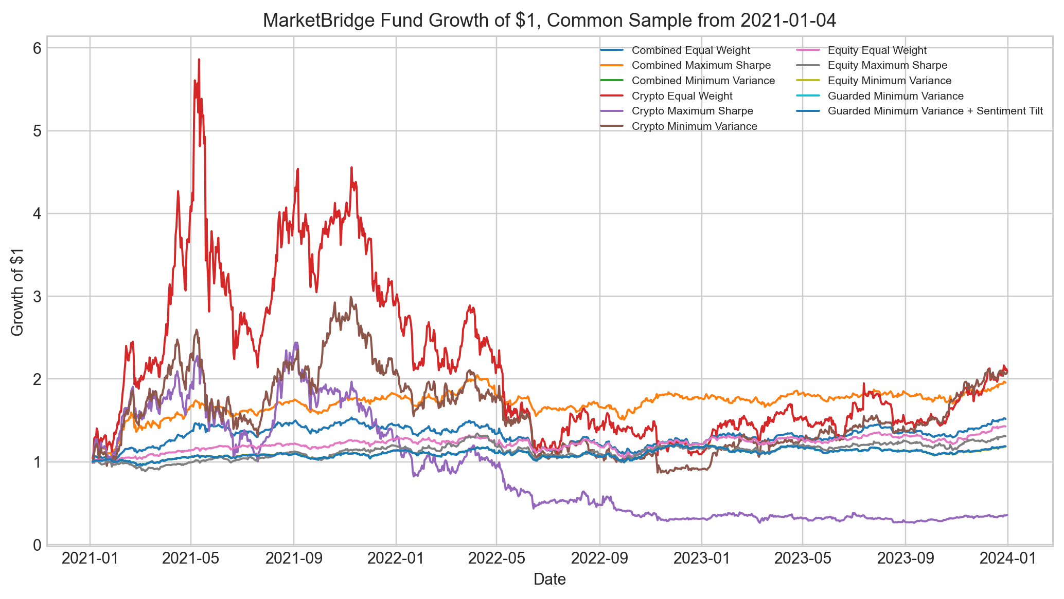
Appendix Figure A1: Growth of $1 across funds
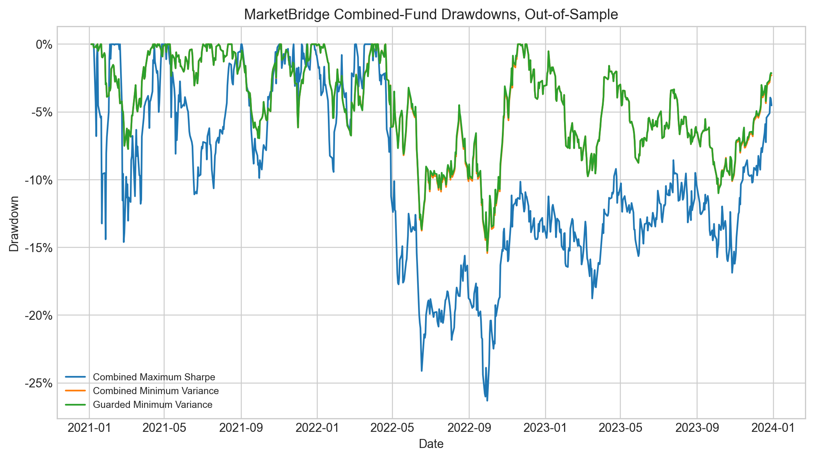
Appendix Figure A2: Combined fund drawdowns, common sample
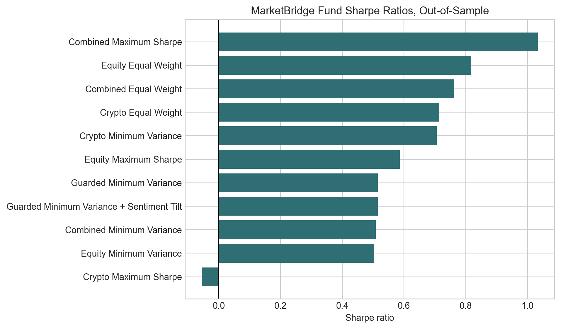
Appendix Figure A3: Sharpe ratio comparison
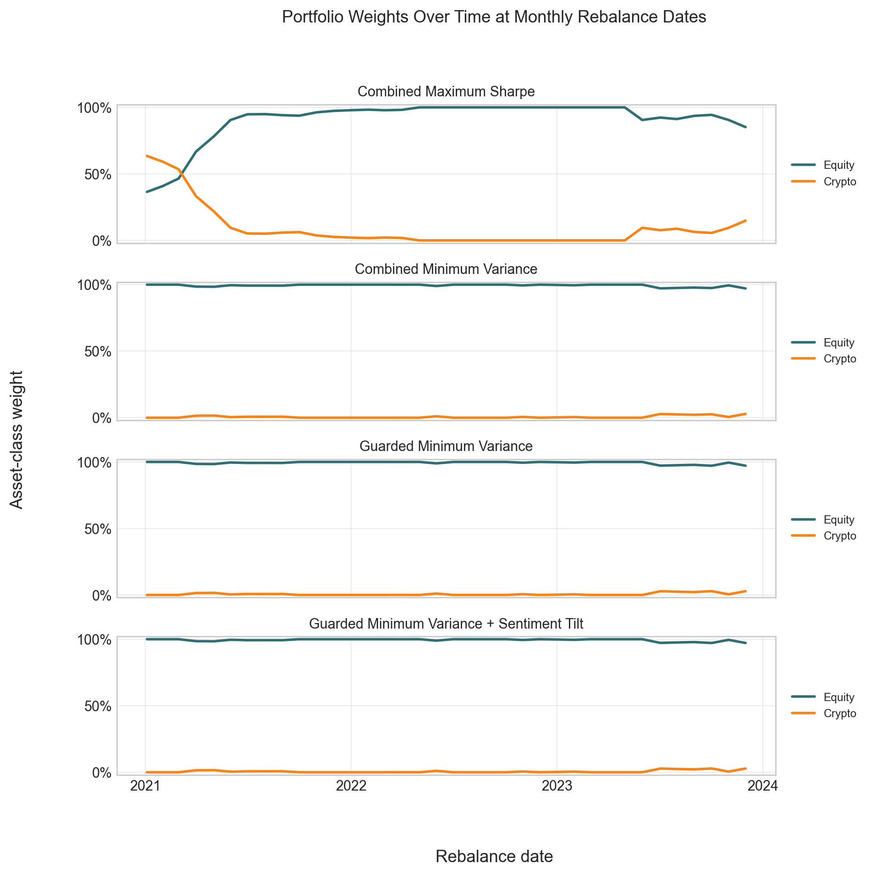
Appendix Figure A4: Portfolio weights over time at monthly rebalance dates

Section 3 Appendix
Fund name | Cumulative return | Annualised return | Annualised volatility | Sharpe ratio | Max drawdown | Average turnover | Cost drag | Average crypto weight
Guarded Minimum Variance | 18.79% | 5.93% | 12.77% | 0.5152 | -15.25% | 15.75% | 0.67% | 0.60%
Guarded Minimum Variance with sentiment tilt | 18.77% | 5.93% | 12.77% | 0.5148 | -15.26% | 15.75% | 0.67% | 0.60%
Appendix Table A3: Fusion comparison between base and VADER sentiment-tilted fund
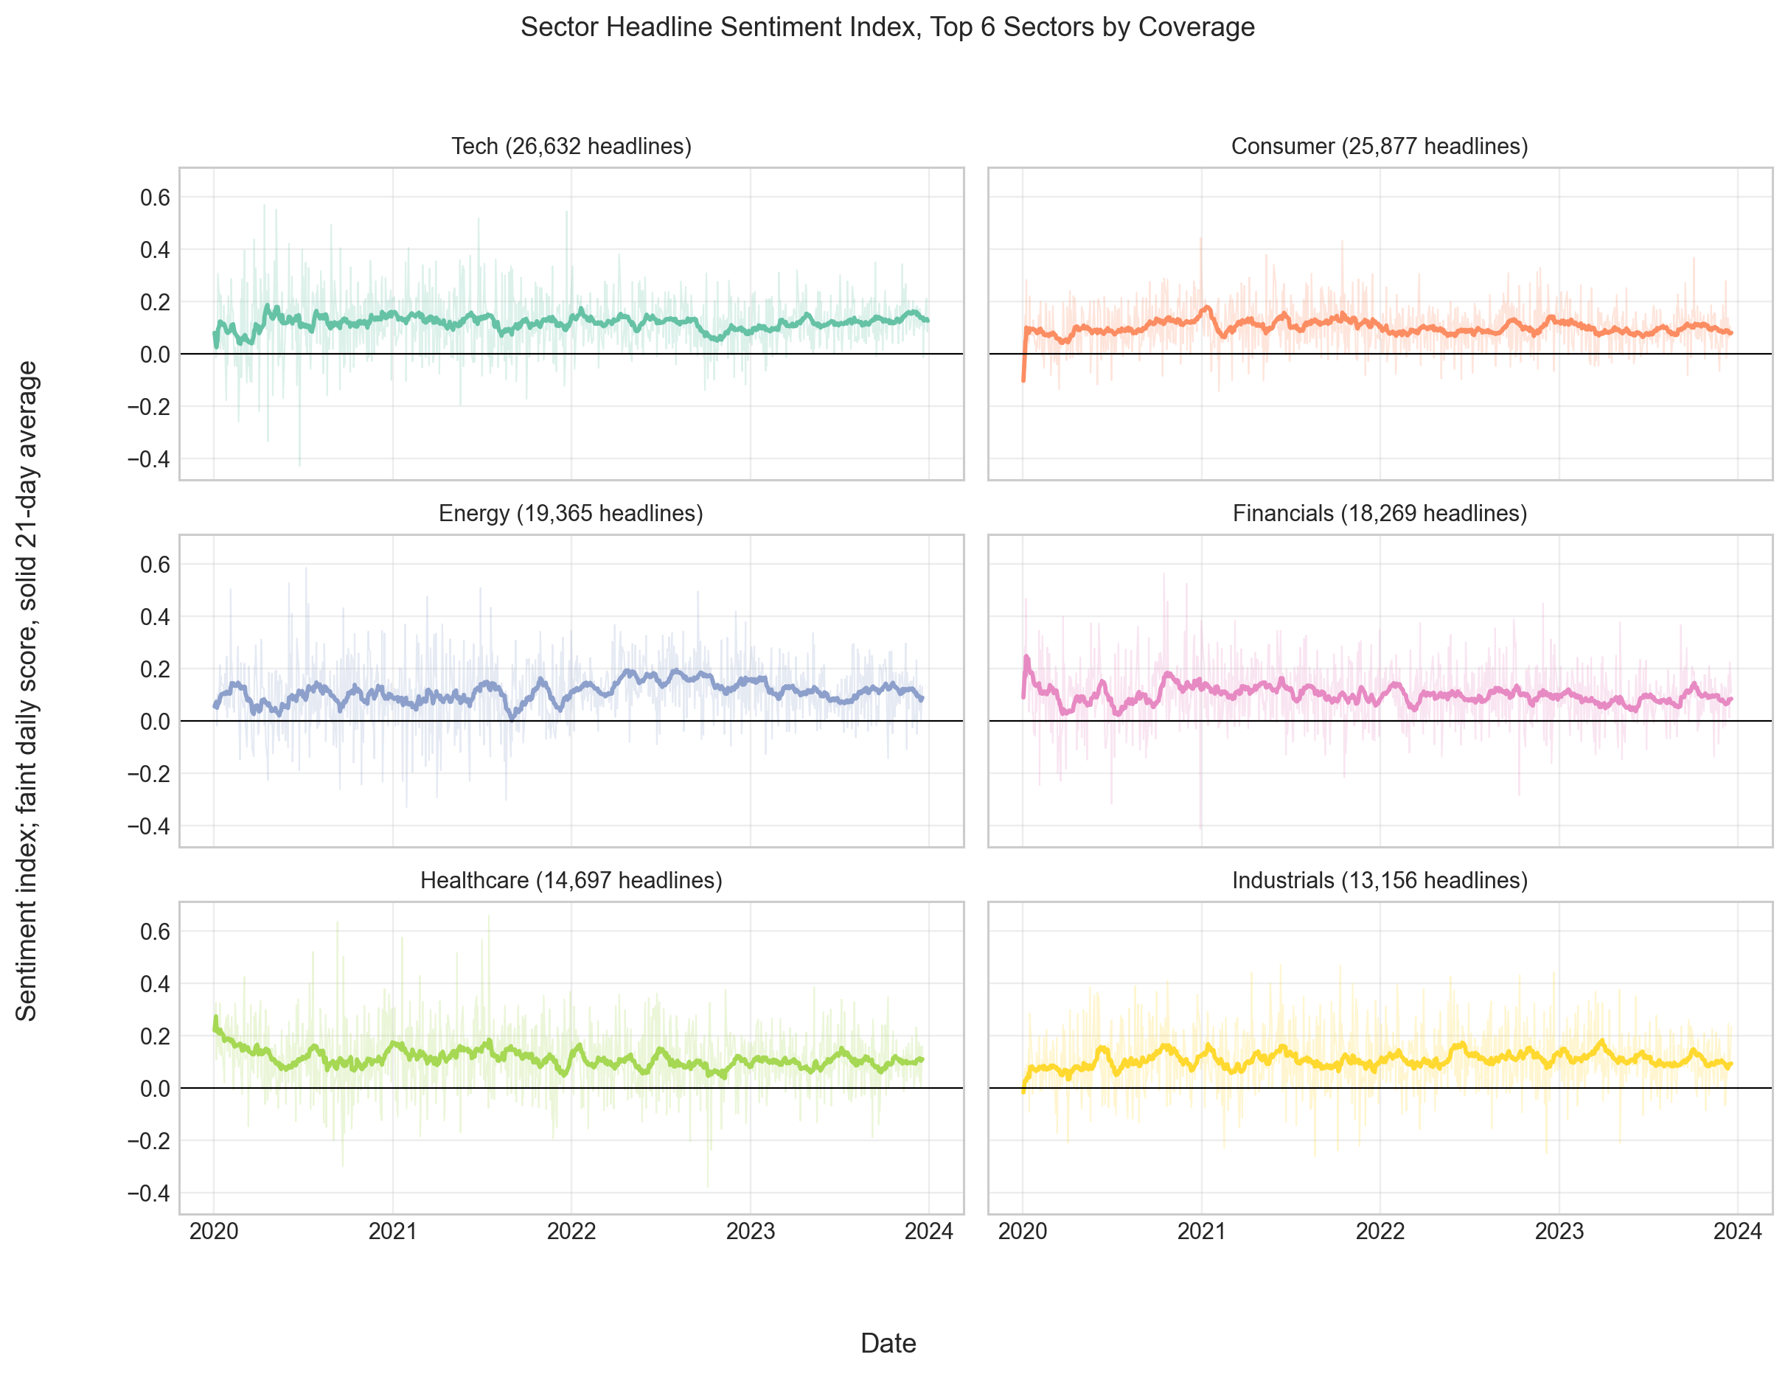
Appendix Figure A5: Sector headline sentiment index for top six sectors
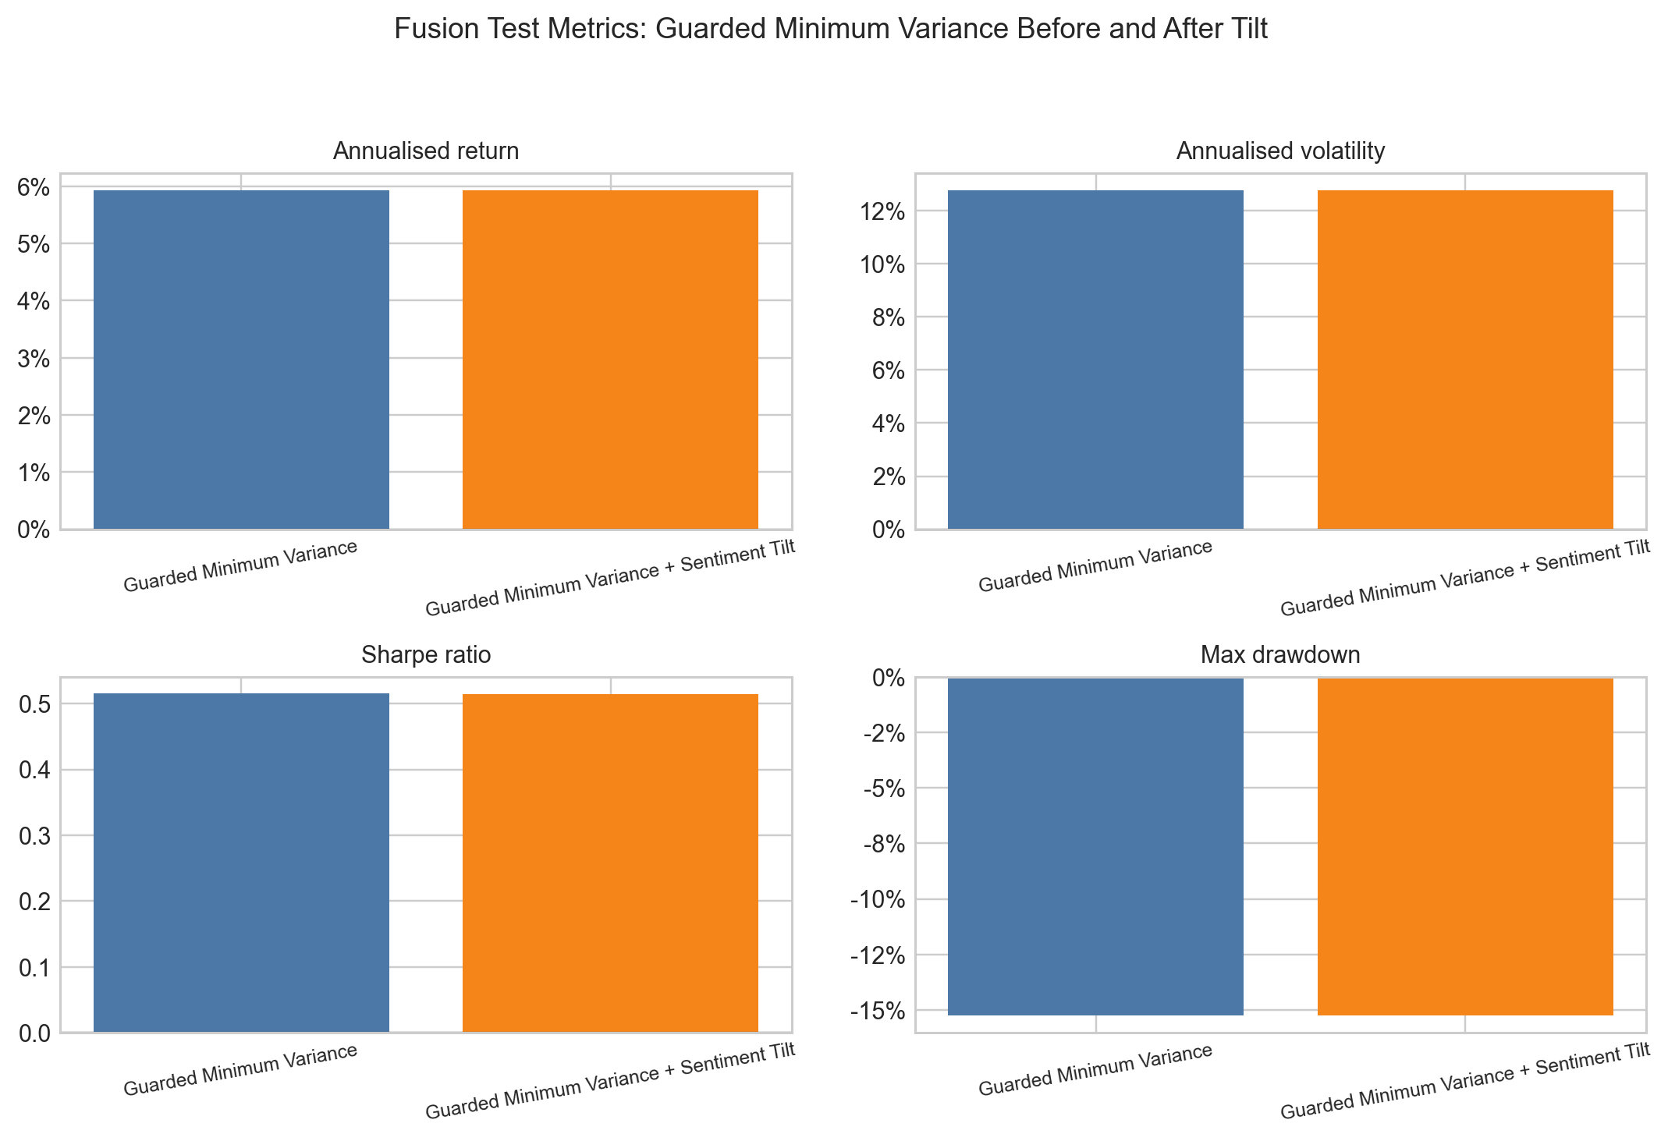
Appendix Figure A6: Guarded Minimum Variance before and after VADER sentiment tilt

Appendix Section 4
Fund name | Gross cumulative return | Net cumulative return | Average turnover | Estimated cost drag
Combined Equal Weight | 51.75% | 51.68% | 1.39% | 0.08%
Combined Maximum Sharpe | 95.55% | 93.17% | 34.18% | 2.38%
Combined Minimum Variance | 18.49% | 17.83% | 15.59% | 0.66%
Crypto Equal Weight | 284.61% | 284.42% | 1.25% | 0.19%
Crypto Maximum Sharpe | -26.21% | -27.17% | 32.98% | 0.96%
Crypto Minimum Variance | 641.40% | 638.64% | 9.36% | 2.76%
Equity Equal Weight | 42.73% | 42.65% | 1.39% | 0.07%
Equity Maximum Sharpe | 30.96% | 29.34% | 34.60% | 1.61%
Equity Minimum Variance | 18.24% | 17.58% | 15.54% | 0.66%
Guarded Minimum Variance | 18.79% | 18.12% | 15.75% | 0.67%
Guarded Minimum Variance + Sentiment Tilt | 18.77% | 18.10% | 15.75% | 0.67%
Guarded Minimum Variance + Finance Lexicon Sentiment Tilt | 18.78% | 18.11% | 15.75% | 0.67%
Appendix Table A4: Transaction cost metrics under a 0.10% assumed cost
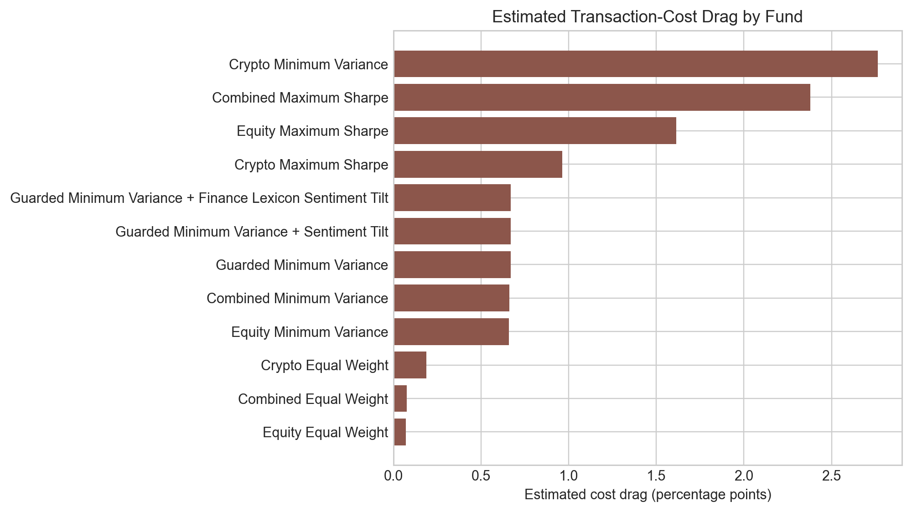
Appendix Figure A7: Estimated transaction cost drag by fund
Sector | Headline count | Average VADER sentiment | Average finance adjusted sentiment | Average difference | Correlation between old and new
Tech | 26,632 | 0.1194 | 0.1287 | 0.0094 | 0.9973
Consumer | 25,877 | 0.1014 | 0.1109 | 0.0096 | 0.9966
Energy | 19,365 | 0.1113 | 0.1186 | 0.0073 | 0.9973
Financials | 18,269 | 0.0979 | 0.1049 | 0.0069 | 0.9968
Healthcare | 14,697 | 0.1100 | 0.1200 | 0.0100 | 0.9966
Industrials | 13,156 | 0.1073 | 0.1146 | 0.0073 | 0.9964
Comm | 11,783 | 0.1007 | 0.1096 | 0.0089 | 0.9964
Utilities | 6,319 | 0.1839 | 0.1939 | 0.0101 | 0.9952
Materials | 5,393 | 0.0966 | 0.1039 | 0.0074 | 0.9945
Real Estate | 5,339 | 0.1333 | 0.1462 | 0.0129 | 0.9944
Appendix Table A5: VADER and finance adjusted sentiment comparison by sector

Section 5 Appendix
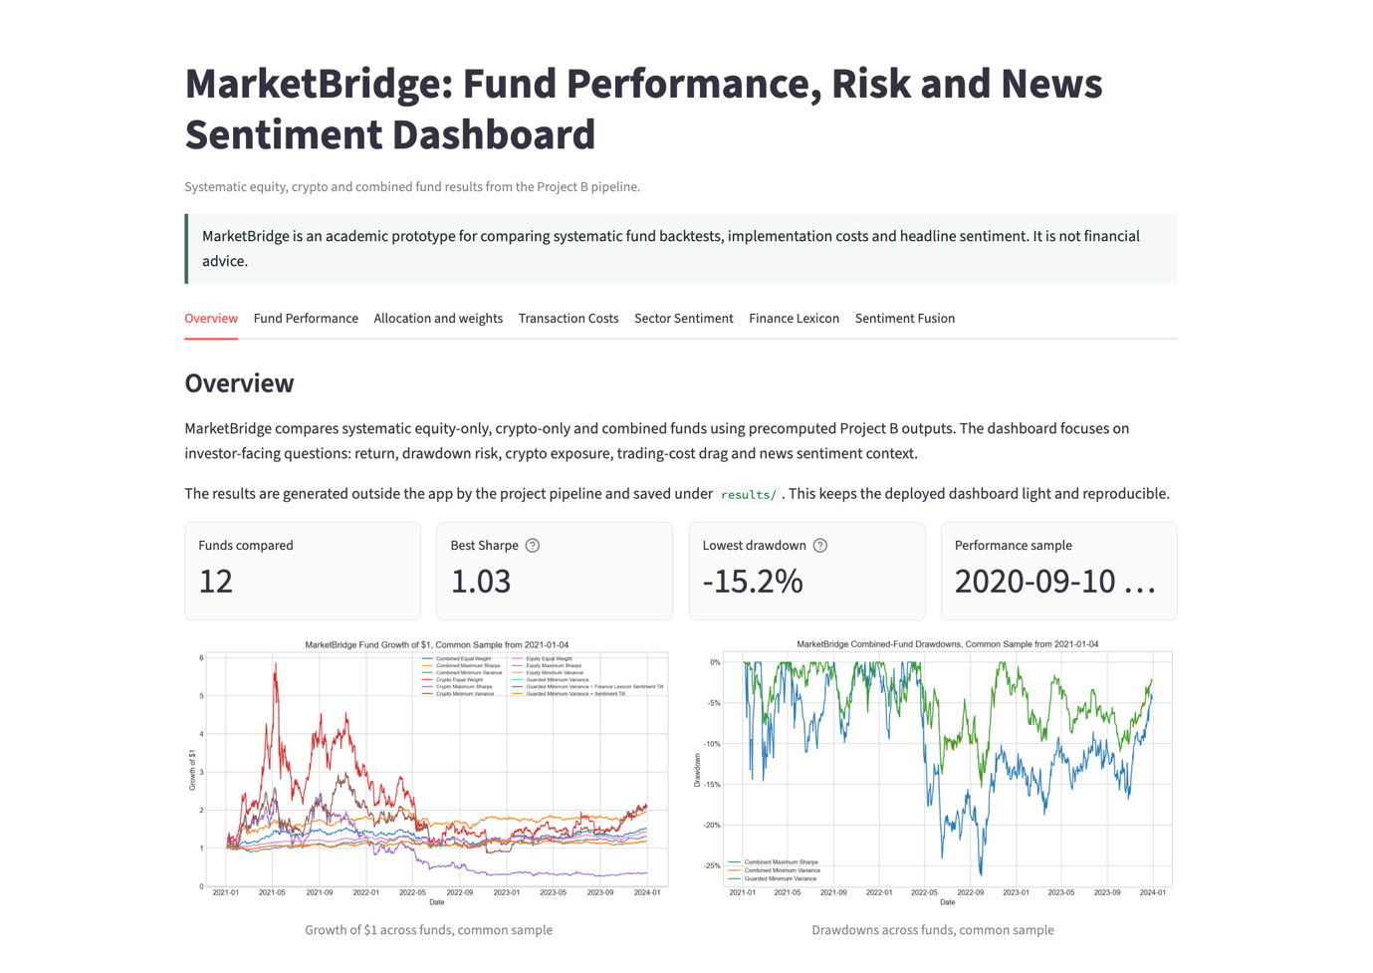Appendix Figure A8: MarketBridge Streamlit dashboard overview
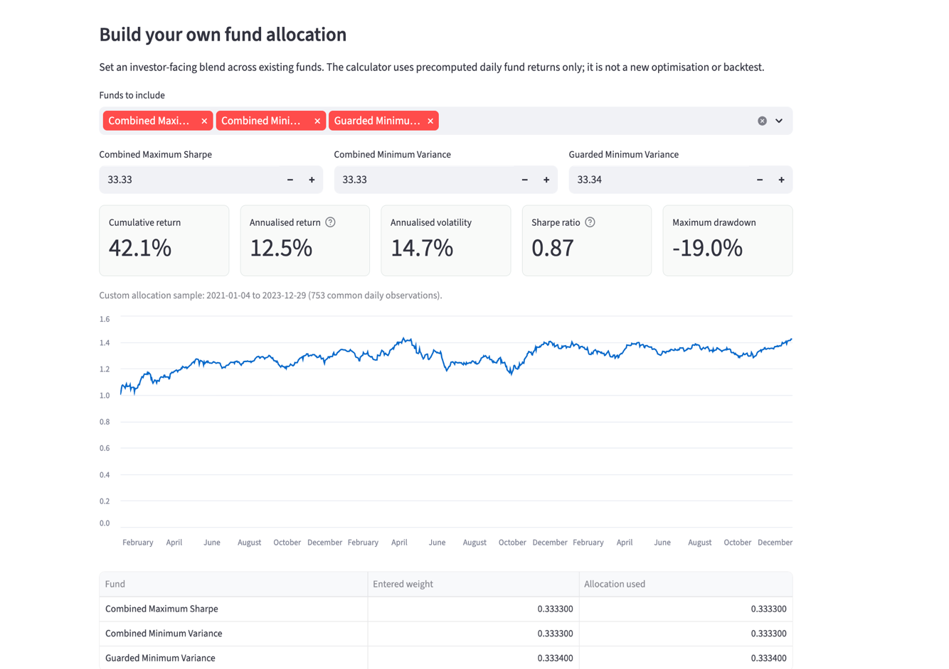Appendix Figure A9: Custom investor allocation tool in MarketBridge
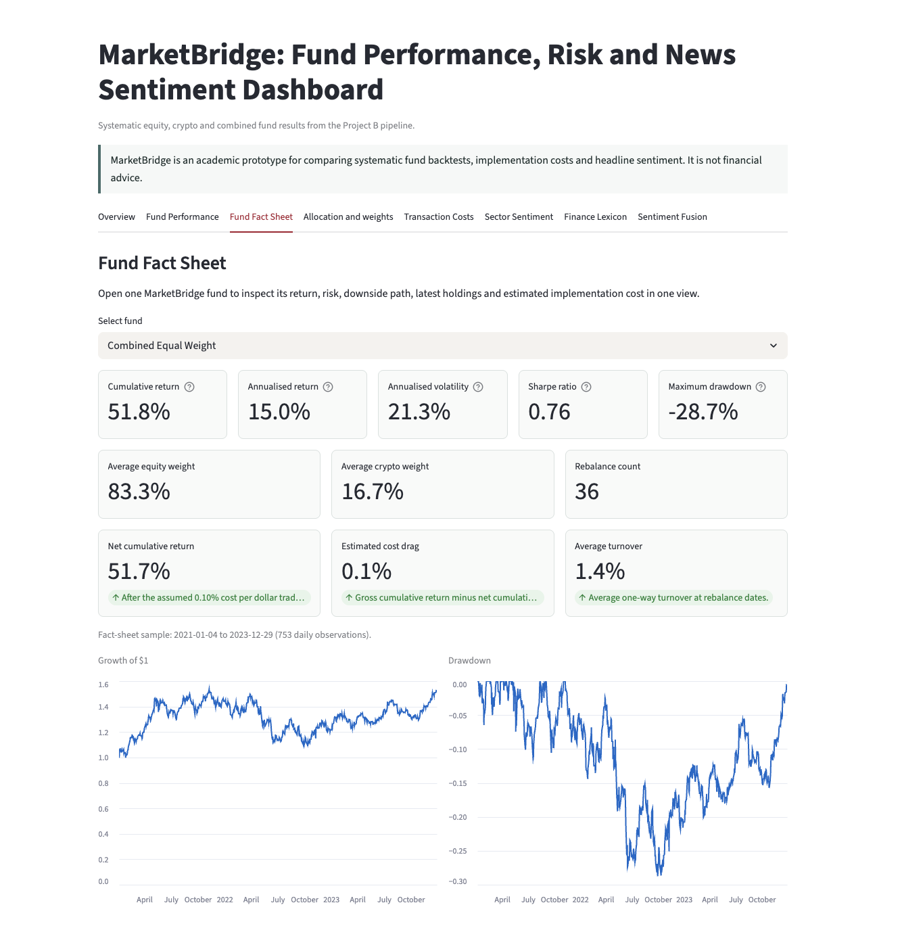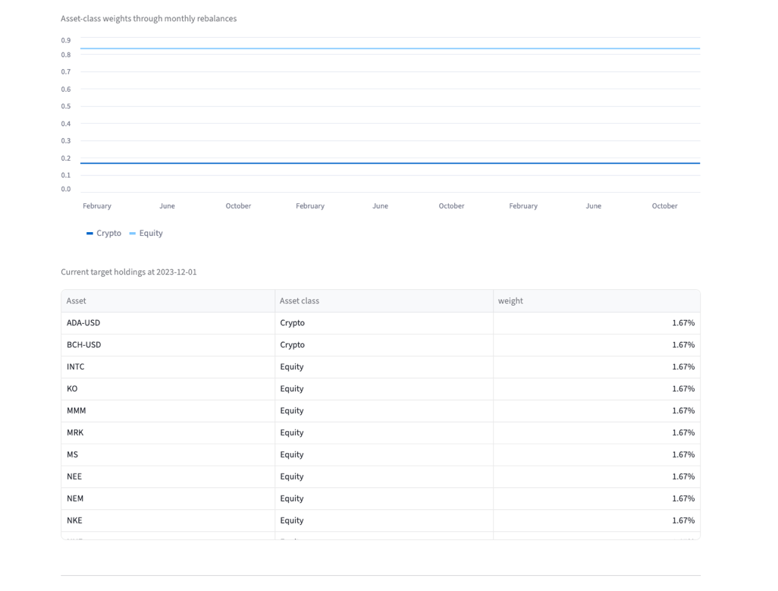
Appendix Figure A10: MarketBridge fund fact tab

Reference:
CFA (2026). CFA institute. [online] CFA Institute. Available at: https://www.cfainstitute.org/insights/professional-learning/refresher-readings/2026/trading-costs-and-electronic-markets [Accessed 2 Aug. 2026].
Araci, D. (2019). FinBERT: Financial sentiment analysis with pre-trained language models. arXiv:1908.10063 [cs]. [online] Available at: https://arxiv.org/abs/1908.10063 [Accessed 2 Aug. 2026].

