
293
Broker Opinion of Value
Date: {{Date}}
{{property_name}}

{{address}}
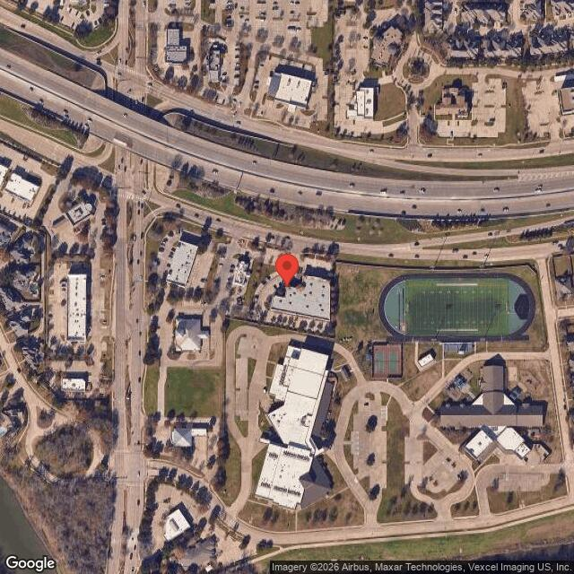
PREPARED FOR:{{prepared_for}}
{{prepared_for_company}}
{{address}}
PREPARED BY:{{prepared_by}}
{{prepared_by_company}}
{{prepared_by_address}}

Table of Contents

Executive Summary | ______________________________________________________ | 3
Subject Photos | ______________________________________________________ | 5
Demographics | ______________________________________________________ | 5
Comparables | ______________________________________________________ | 14
Certification | ______________________________________________________ | 21

EXECUTIVE SUMMARY
Broker Opinion of Value
Date: May 09, 2026
{{property_name}}
{{executive_summary}}

PROPERTY SUMMARY
{{property_summary}}
SUMMARY OF STRENGTHS & WEAKNESSES OF SUBJECT ASSET
Market Sale Price | {{market_price_psf}}/PSF X {{market_building_sf}} | {{market_value}}
Market Sales Price (Rounded) |  | {{market_value_rounded}}
SALE OPINION OF VALUE
Aggressive | Market Value | Conservative
{{value_aggressive}} | {{market_value}} | {{value_conservative}}

GENERAL INFORMATION
Property Name | {{property_name}}
Property Type | {{property_type}}
State | {{state}}
County | {{county}}
Longitude | {{longitude}}
Latitude | {{latitude}}
SITE INFORMATION
Level at street Grade | {{Topography}}
Shape | {{shape}}
Good | {{Access}}
Exposure | {{Exposure}}
IMPROVEMENT INFORMATION
Lot Area | {{lot_area}}
Acres | {{acres}}
Recorded Sale Date | {{recorded_sale_date}}
Zoning | {{zoning}}
APN | {{apn}}
Current Owner | {{current_owner}}

LOCATION SUMMARY
{{location_summary}}

AERIAL MAP
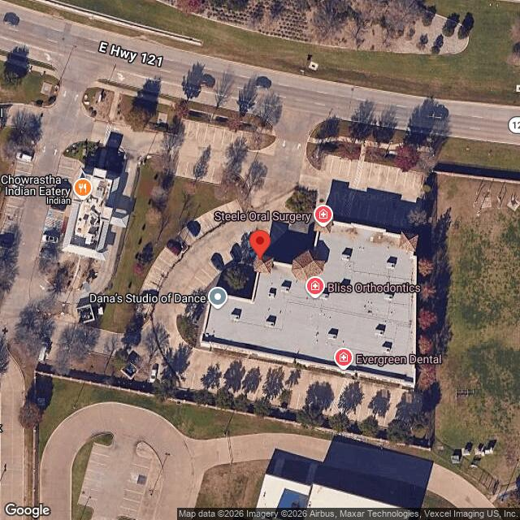

SUBJECT PHOTOS
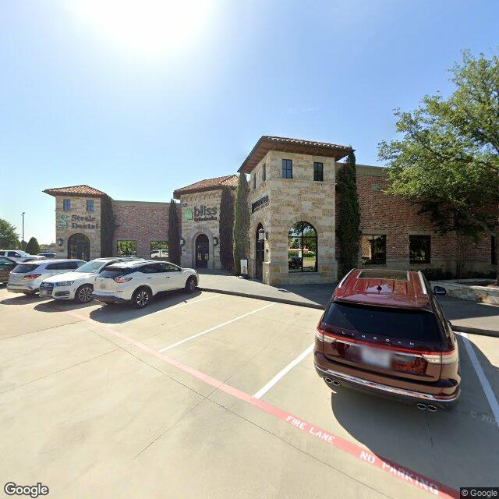
Broker Opinion of Value
Date: May 09, 2026
{{property_name}}

REGIONAL ANALYSIS
{{regional_analysis}}

DEMOGRAPHIC ANALYSIS

Overview
{{demographic_analysis}}

Size and Level at street Grade
{{size_and_topography}}

Population
{{population_analysis}}

POPULATION
YEAR | U.S. | STATE | COUNTY
2010 Total Population | {{pop_2010_us}} | {{pop_2010_state}} | {{pop_2010_county}}
2020 Total Population | {{pop_2020_us}} | {{pop_2020_state}} | {{pop_2020_county}}
2025 Total Population | {{pop_2025_us}} | {{pop_2025_state}} | {{pop_2025_county}}
Source: US Census
POPULATION DENSITY
YEAR | U.S. | STATE | COUNTY
2020 Per Square Mile | {{density_2020_us}} | {{density_2020_state}} | {{density_2020_county}}
2025 Per Square Mile | {{density_2025_us}} | {{density_2025_state}} | {{density_2025_county}}
Source: US Census

Household Trends
{{household_trends}}

NUMBER OF HOUSEHOLDS
YEAR | U.S. | STATE | COUNTY
2024 Households | {{hh_2024_us}} | {{hh_2024_state}} | {{hh_2024_county}}
2029 Households | {{hh_2029_us}} | {{hh_2029_state}} | {{hh_2029_county}}
CAGR | {{hh_cagr_us}} | {{hh_cagr_state}} | {{hh_cagr_county}}
Source: US Census
AVERAGE HOUSEHOLD SIZE
YEAR | U.S. | STATE | COUNTY
2024 | {{hhsize_2024_us}} | {{hhsize_2024_state}} | {{hhsize_2024_county}}
2029 | {{hhsize_2029_us}} | {{hhsize_2029_state}} | {{hhsize_2029_county}}
2024-2029 CAGR | {{hhsize_cagr_us}} | {{hhsize_cagr_state}} | {{hhsize_cagr_county}}
Source: US Census

HOUSING UNITS
 | U.S. | STATE | COUNTY
Owner Occupied | {{owner_us}} | {{owner_state}} | {{owner_county}}
Renter Occupied | {{renter_us}} | {{renter_state}} | {{renter_county}}
Source: US Census
{{economic_factors}}
Local Area Analysis
LOCAL AREA DEMOGRAPHICS
Description | 1 mile | 3 miles | 5 miles |  | Description | 1 mile | 3 miles | 5 miles
Population |  |  |  |  | Average Household Income
2010 Population | 11,800 | 78,293 | 179,087 |  | 2024 | {{r1_avg_hh_income}} | {{r3_avg_hh_income}} | {{r5_avg_hh_income}}
2020 Population | 13,538 | 92,721 | 210,359 |  | 2029 | $188,789 | $141,015 | $143,364
2024 Population | {{r1_pop_2024}} | {{r3_pop_2024}} | {{r5_pop_2024}} |  | Change 2024-2029 | -1.0% | 0.6% | 2.0%
2029 Population | {{r1_pop_2029}} | {{r3_pop_2029}} | {{r5_pop_2029}} |  | Median Household Income
Change 2010-2020 | 14.7% | 18.4% | 17.5% |  | 2024 | {{r1_median_hh_income}} | {{r3_median_hh_income}} | {{r5_median_hh_income}}
Change 2020-2024 | -2.2% | 2.6% | 3.9% |  | 2029 | $154,196 | $99,846 | $105,504
Change 2024-2029 | -1.1% | 0.6% | 1.9% |  | Change 2024-2029 | -1.0% | 0.6% | 2.0%
Number of Households |  |  |  |  | Per Capita Income
2010 Households | 4,286 | 31,505 | 69,307 |  | 2024 | {{r1_per_capita_income}} | {{r3_per_capita_income}} | {{r5_per_capita_income}}
2020 Households | 928,341 | 928,341 | 928,341 |  | 2029 | $68,739 | $58,698 | $56,825
2024 Households | {{r1_hh_2024}} | {{r3_hh_2024}} | {{r5_hh_2024}} |  | Change 2024-2029 | -1.0% | 0.6% | 2.0%
2029 Households | {{r1_hh_2029}} | {{r3_hh_2029}} | {{r5_hh_2029}} |  | Households by Income (2022)
Change 2010-2020 | 1.1% | 1.1% | 1.1% |  | Less than $15,000 | 78,406 | 78,406 | 78,406
Change 2020-2024 | 1.1% | 1.1% | 1.1% |  | $15,000 - $24,999 | 58,193 | 58,193 | 58,193
Change 2024-2029 | 3.0% | 8.5% | 8.2% |  | $25,000 - $34,999 | 65,443 | 65,443 | 65,443
Housing Units |  |  |  |  | $35,000 - $49,999 | 113,751 | 113,751 | 113,751
Owner Occupied | {{r1_owner_pct}} | {{r3_owner_pct}} | {{r5_owner_pct}} |  | $50,000 - $74,999 | 175,144 | 175,144 | 175,144
Renter Occupied | {{r1_renter_pct}} | {{r3_renter_pct}} | {{r5_renter_pct}} |  | $75,000 - $99,999 | 128,749 | 128,749 | 128,749
Housing Units by Year Built |  |  |  |  | $100,000 - $149,999 | 162,178 | 162,178 | 162,178
Built 2020 or Later | 14,043 | 14,043 | 14,043 |  | $150,000 - $199,999 | 78,143 | 78,143 | 78,143
Built 2010 to 2019 | 121,755 | 129,654 | 129,654 |  | $200,000 or More | 111,683 | 111,683 | 111,683
Built 2000 to 2009 | 129,654 | 129,654 | 129,654 |  | Housing by Units in Structure
Built 1990 to 1999 | 120,269 | 120,269 | 120,269 |  | 1, Detached | 548,642 | 548,642 | 548,642
Built 1980 to 1989 | 184,099 | 184,099 | 184,099 |  | 1, Attached | 40,018 | 40,018 | 40,018
Built 1970 to 1979 | 169,987 | 169,987 | 169,987 |  | 2 | 13,890 | 13,890 | 13,890
Built 1960 to 1969 | 129,214 | 129,214 | 129,214 |  | 3 or 4 | 47,617 | 47,617 | 47,617
Built 1950 to 1959 | 113,626 | 113,626 | 113,626 |  | 5 to 9 | 72,524 | 72,524 | 72,524
Built 1940 to 1949 | 34,161 | 34,161 | 34,161 |  | 10 to 19 | 96,128 | 96,128 | 96,128
Built 1939 or Earlier | 36,663 | 36,663 | 36,663 |  | 20 to 49 | 68,327 | 68,327 | 68,327
Home Values |  |  |  |  | 50 or More | 148,582 | 148,582 | 148,582
Average | $577,622 | $537,551 | $508,186 |  | Mobile Home | 17,521 | 17,521 | 17,521
Median | $551,178 | $486,662 | $459,236 |  | Boat, RV, Van, etc. | 222 | 222 | 222
Source: Esri

EMPLOYMENT
{{employment_analysis}}
EMPLOYMENT & UNEMPLOYMENT STATISTICS (Recent)
 | TOTAL EMPLOYMENT |  |  |  |  |  | UNEMPLOYMENT RATE
Texas |  |  | Dallas County, TX |  | United States |  | Texas | Dallas County, TX
Year | Total | % ∆ Yr Ago | Total | % ∆ Yr Ago
2010 | 11,264,356 | no data | 1,093,403 | no data | 9.6% |  | 8.3% | 8.7%
2011 | 11,476,396 | 1.9% | 1,107,910 | 1.3% | 8.9% |  | 8.0% | 8.4%
2012 | 11,776,895 | 2.6% | 1,132,213 | 2.2% | 8.1% |  | 6.7% | 7.1%
2013 | 11,986,038 | 1.8% | 1,147,198 | 1.3% | 7.4% |  | 6.3% | 6.7%
2014 | 12,304,235 | 2.7% | 1,177,878 | 2.7% | 6.2% |  | 5.2% | 5.5%
2015 | 12,445,940 | 1.2% | 1,203,242 | 2.2% | 5.3% |  | 4.5% | 4.3%
2016 | 12,649,932 | 1.6% | 1,250,476 | 3.9% | 4.9% |  | 4.6% | 4.0%
2017 | 12,890,267 | 1.9% | 1,273,632 | 1.9% | 4.4% |  | 4.4% | 3.9%
2018 | 13,175,974 | 2.2% | 1,283,127 | 0.7% | 3.9% |  | 3.9% | 3.8%
2019 | 13,432,803 | 1.9% | 1,293,104 | 0.8% | 3.7% |  | 3.5% | 3.5%
CAGR | 2.0% | - | 1.9% | - | - |  |  | -
Source: BLS (Bureau of Labor Statistics)

Economic Factors

Community Services
{{community_services}}

MARKET ANALYSIS
{{county}} {{property_type}} Market Report — {{market_quarter}}
1. Market Overview
{{market_overview}}
2. Key Market Metrics
Vacancy Rates (Based on Public Data & Market Trends)
{{vacancy_rates}}

Lease Rates (Based on Public Listings & Industry Trends)
{{lease_rates}}
Construction Activity
{{construction_activity}}
3. Trends & Forecast
{{market_trends}}

4. Investment Insights
{{investment_insights}}

5. Recommendations
{{market_recommendations}}

6. Data Sources & Disclaimer

{{market_data_sources}}

PROPERTY COMPARABLES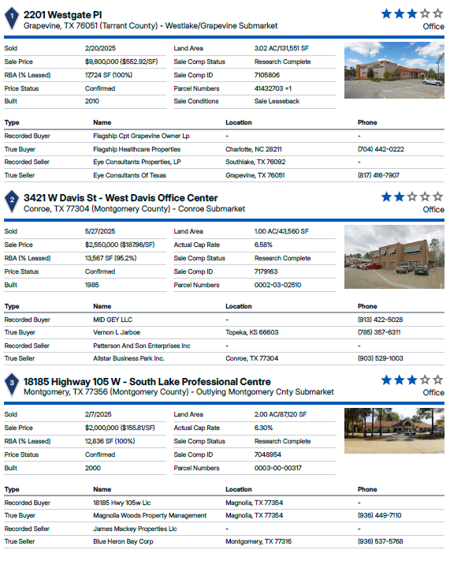

RECONCILIATION TABLE
{{reconciliation_summary}}

VALUATION METHOD | VALUE ESTIMATE | NOTES
Sales Comparison Approach | {{market_value_rounded}} | {{reconciliation_summary}}

SALES CONCLUSION
OPINIONS OF VALUE
Market Sale Price | {{market_price_psf}} SF | X | {{market_building_sf}} | {{market_value}}
Market Sales Price (Rounded) |  |  |  | {{market_value_rounded}}

{{sales_conclusion}}

CERTIFICATION AND DISCLAIMERS
This Broker Opinion of Value (BOV) has been prepared for informational purposes only and is based on the broker’s professional knowledge of the market, publicly available data, and information provided by the client. This is not a formal appraisal and should not be relied upon as such.
By accepting this BOV, the recipient acknowledges and agrees to the following:
- Not an Appraisal – This valuation is an estimate of market value based on available data and does not conform to the Uniform Standards of Professional Appraisal Practice (USPAP) or any formal appraisal methodology. It should not be used for financial reporting, lending, or legal purposes.
- Assumptions & Limitations – The opinion is based on information deemed reliable but is not guaranteed. No independent verification has been conducted, and actual sale prices may vary due to market conditions, property-specific factors, and negotiation terms.
- No Legal or Financial Liability – The broker, brokerage, and its agents assume no liability for errors, omissions, or reliance on this opinion. Any decisions made based on this BOV are the sole responsibility of the recipient.
- Market Conditions – Market conditions are subject to change, and this valuation reflects data available as of the preparation date. The broker makes no representations about future market conditions or value projections.
- Confidentiality – This BOV is confidential and intended solely for the recipient. It may not be distributed, reproduced, or used for any purpose other than its intended use without the broker’s written consent.
Acknowledgment:
By proceeding with this Broker Opinion of Value, the recipient acknowledges their understanding and acceptance of the limitations and disclaimers Texasd herein.
Broker Signature:
Prepared By:
Position:
Phone:
Email:
*Broker Certification Requirement: Any report generated by the Services that includes a Broker Certification section must be reviewed, edited, and signed by a licensed broker prior to being used for transactional, marketing, or advisory purposes. VASCRE does not certify, sign, or validate any reports. The licensed broker assumes full responsibility for the accuracy, content, and certification of the final report. This paragraph may be removed at your discretion.

