Statistical analysis of NIBLSE Survey 2 Data

William Morgan (College of Wooster)

Sep 22, 2023

These R Notebooks presents R code for statistical analyses of 2nd NIBLSE Survey data.

# Chapter 1: Overview of survey data

This chapter starts with the Merged_Data_Anonymous set produced in Chapter 0.

### CUREs/SUREs

Of the 315 instructors who teach any bioinformatics in a life science course, 100 used a CURE or SURE to do so.

### Is more undergraduate bioinformatics content needed at your institution?

Of the 484 participants who answered if more bioinformatics content is needed in undergraduate courses at their instituion, 435 (89.8760331%) said “Yes” (270) or “Maybe” (165).

### Barriers

Of the 362 instructors who do or plan to include bioinformatics content, 259 (71.5469613%) reported facing barriers to integrating bioinformatics into their teaching.

### Count data for each identifier variable

Let’s visualize the count of each identifier variable (gender, ethnicity, etc.) using a count table when the number of unique responses (levels) is three or less and a bar graph when the number is larger. (Here, we ignore identifier variables encoded numerically in favor of those encoded with character strings.)

## [[1]]  
## # A tibble: 3 × 2  
## Gender n  
## <chr> <int>  
## 1 F 245  
## 2 M 204  
## 3 U 60  
##   
## [[2]]  
## # A tibble: 4 × 2  
## Q5MoreCourses n  
## <chr> <int>  
## 1 Maybe 165  
## 2 No 49  
## 3 Yes 270  
## 4 <NA> 25  
##   
## [[3]]  
## # A tibble: 3 × 2  
## Q7FacedBarriers n  
## <chr> <int>  
## 1 No 103  
## 2 Yes 291  
## 3 <NA> 115  
##   
## [[4]]  
## # A tibble: 1 × 2  
## Q31TeachUG n  
## <chr> <int>  
## 1 yes 509  
##   
## [[5]]  
## # A tibble: 1 × 2  
## QID1 n  
## <chr> <int>  
## 1 I AGREE to participate. 509  
##   
## [[6]]  
## # A tibble: 3 × 2  
## `I lack expertise in bioinformatics` n  
## <chr> <int>  
## 1 I agree with this statement 173  
## 2 I do NOT agree with this statement 113  
## 3 <NA> 223  
##   
## [[7]]  
## # A tibble: 3 × 2  
## `I lack experience in teaching bioinformatics....12` n  
## <chr> <int>  
## 1 I agree with this statement 186  
## 2 I do NOT agree with this statement 99  
## 3 <NA> 224  
##   
## [[8]]  
## # A tibble: 3 × 2  
## `I lack time to restructure course(s)` n  
## <chr> <int>  
## 1 I agree with this statement 217  
## 2 I do NOT agree with this statement 69  
## 3 <NA> 223  
##   
## [[9]]  
## # A tibble: 3 × 2  
## `I lack the autonomy to add content to my course(s)....14` n  
## <chr> <int>  
## 1 I agree with this statement 37  
## 2 I do NOT agree with this statement 238  
## 3 <NA> 234  
##   
## [[10]]  
## # A tibble: 3 × 2  
## `I lack space in my course(s) to add content....15` n  
## <chr> <int>  
## 1 I agree with this statement 161  
## 2 I do NOT agree with this statement 121  
## 3 <NA> 227  
##   
## [[11]]  
## # A tibble: 3 × 2  
## `I lack curricular materials....16` n  
## <chr> <int>  
## 1 I agree with this statement 189  
## 2 I do NOT agree with this statement 94  
## 3 <NA> 226  
##   
## [[12]]  
## # A tibble: 3 × 2  
## I lack appropriate technical resources (internet access/software/hardw…¹ n  
## <chr> <int>  
## 1 I agree with this statement 156  
## 2 I do NOT agree with this statement 128  
## 3 <NA> 225  
## # ℹ abbreviated name:  
## # ¹​`I lack appropriate technical resources (internet access/software/hardware/IT support)....17`  
##   
## [[13]]  
## # A tibble: 3 × 2  
## My student population lacks access to appropriate technical resources …¹ n  
## <chr> <int>  
## 1 I agree with this statement 143  
## 2 I do NOT agree with this statement 142  
## 3 <NA> 224  
## # ℹ abbreviated name:  
## # ¹​`My student population lacks access to appropriate technical resources (internet access/software/hardware/IT support)....18`  
##   
## [[14]]  
## # A tibble: 3 × 2  
## `My student population lacks prerequisite skills.` n  
## <chr> <int>  
## 1 I agree with this statement 226  
## 2 I do NOT agree with this statement 61  
## 3 <NA> 222  
##   
## [[15]]  
## # A tibble: 3 × 2  
## `My student population lacks interest in bioinformatics....20` n  
## <chr> <int>  
## 1 I agree with this statement 126  
## 2 I do NOT agree with this statement 154  
## 3 <NA> 229  
##   
## [[16]]  
## # A tibble: 4 × 2  
## `I lack expertise in bioinformatics.` n  
## <chr> <int>  
## 1 Minor challenge 30  
## 2 Moderate challenge 98  
## 3 Severe challenge 44  
## 4 <NA> 337  
##   
## [[17]]  
## # A tibble: 4 × 2  
## `I lack experience in teaching bioinformatics....22` n  
## <chr> <int>  
## 1 Minor challenge 45  
## 2 Moderate challenge 102  
## 3 Severe challenge 38  
## 4 <NA> 324  
##   
## [[18]]  
## # A tibble: 4 × 2  
## `I lack time to restructure course(s).` n  
## <chr> <int>  
## 1 Minor challenge 25  
## 2 Moderate challenge 93  
## 3 Severe challenge 97  
## 4 <NA> 294  
##   
## [[19]]  
## # A tibble: 4 × 2  
## `I lack the autonomy to add content to my course(s)....24` n  
## <chr> <int>  
## 1 Minor challenge 6  
## 2 Moderate challenge 17  
## 3 Severe challenge 14  
## 4 <NA> 472  
##   
## [[20]]  
## # A tibble: 4 × 2  
## `I lack space in my course(s) to add content....25` n  
## <chr> <int>  
## 1 Minor challenge 23  
## 2 Moderate challenge 74  
## 3 Severe challenge 63  
## 4 <NA> 349  
##   
## [[21]]  
## # A tibble: 4 × 2  
## `I lack curricular materials....26` n  
## <chr> <int>  
## 1 Minor challenge 30  
## 2 Moderate challenge 91  
## 3 Severe challenge 67  
## 4 <NA> 321  
##   
## [[22]]  
## # A tibble: 4 × 2  
## I lack appropriate technical resources (internet access/software/hardw…¹ n  
## <chr> <int>  
## 1 Minor challenge 27  
## 2 Moderate challenge 76  
## 3 Severe challenge 53  
## 4 <NA> 353  
## # ℹ abbreviated name:  
## # ¹​`I lack appropriate technical resources (internet access/software/hardware/IT support)....27`  
##   
## [[23]]  
## # A tibble: 4 × 2  
## My student population lacks access to appropriate technical resources …¹ n  
## <chr> <int>  
## 1 Minor challenge 6  
## 2 Moderate challenge 79  
## 3 Severe challenge 58  
## 4 <NA> 366  
## # ℹ abbreviated name:  
## # ¹​`My student population lacks access to appropriate technical resources (internet access/software/hardware/IT support)....28`  
##   
## [[24]]  
## # A tibble: 4 × 2  
## `My student population lacks prerequisite skills` n  
## <chr> <int>  
## 1 Minor challenge 14  
## 2 Moderate challenge 98  
## 3 Severe challenge 113  
## 4 <NA> 284  
##   
## [[25]]  
## # A tibble: 4 × 2  
## `My student population lacks interest in bioinformatics....30` n  
## <chr> <int>  
## 1 Minor challenge 14  
## 2 Moderate challenge 68  
## 3 Severe challenge 44  
## 4 <NA> 383  
##   
## [[26]]  
## # A tibble: 4 × 2  
## BASIC2018_bins_text.TerminalDegree n  
## <chr> <int>  
## 1 Doctoral/Professional Universities 366  
## 2 Master's Colleges & Universities 8  
## 3 Special Focus Four-Year 15  
## 4 <NA> 120  
##   
## [[27]]  
## # A tibble: 2 × 2  
## URM n  
## <chr> <int>  
## 1 URM 104  
## 2 non-URM 405  
##   
## [[28]]  
## # A tibble: 2 × 2  
## MSI_text.Current n  
## <chr> <int>  
## 1 No 415  
## 2 Yes 94  
##   
## [[29]]  
## # A tibble: 2 × 2  
## HSI_text.Current n  
## <chr> <int>  
## 1 No 457  
## 2 Yes 52  
##   
## [[30]]  
## # A tibble: 2 × 2  
## HBCU_text.Current n  
## <chr> <int>  
## 1 No 492  
## 2 Yes 17  
##   
## [[31]]  
## # A tibble: 2 × 2  
## CONTROL_text.Current n  
## <chr> <int>  
## 1 Private not-for-profit 167  
## 2 Public 342

## [[1]]

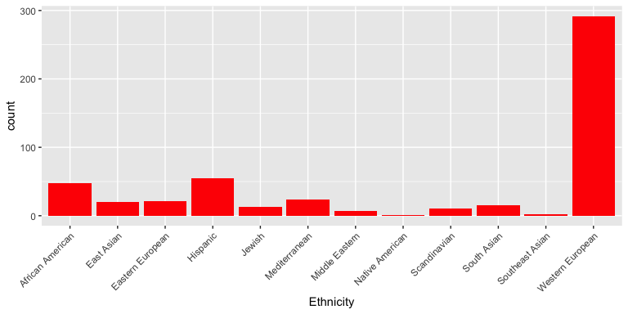

##   
## [[2]]



##   
## [[3]]

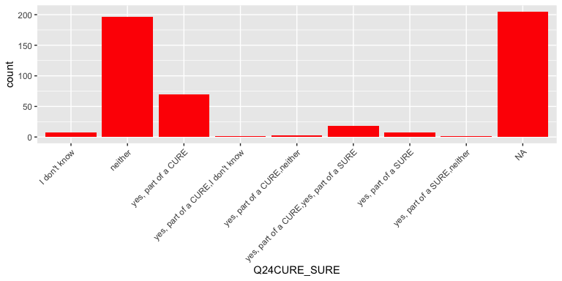

##   
## [[4]]

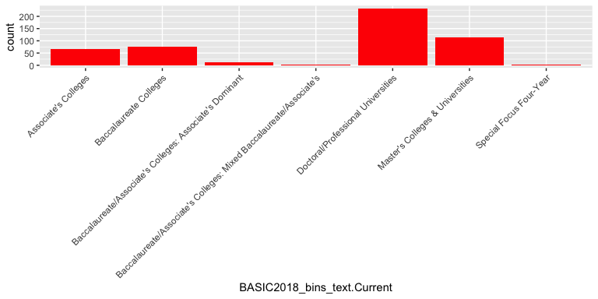

##   
## [[5]]

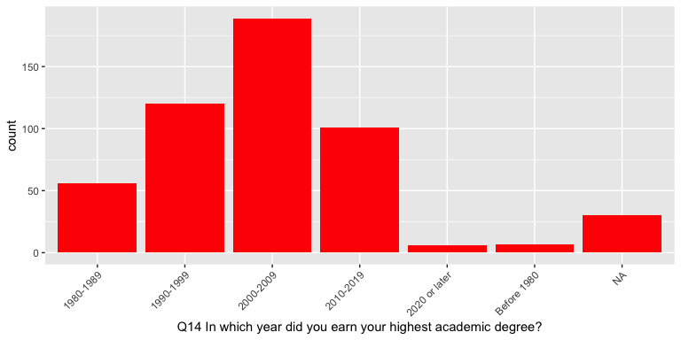

##   
## [[6]]

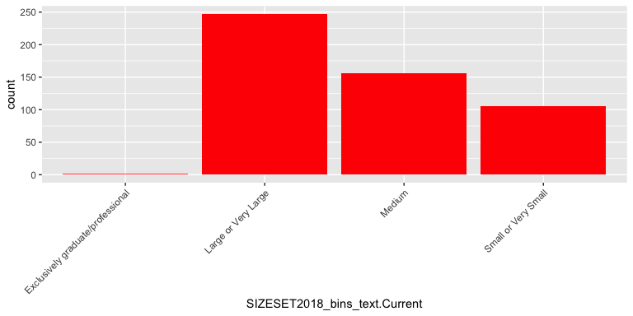

##   
## [[7]]

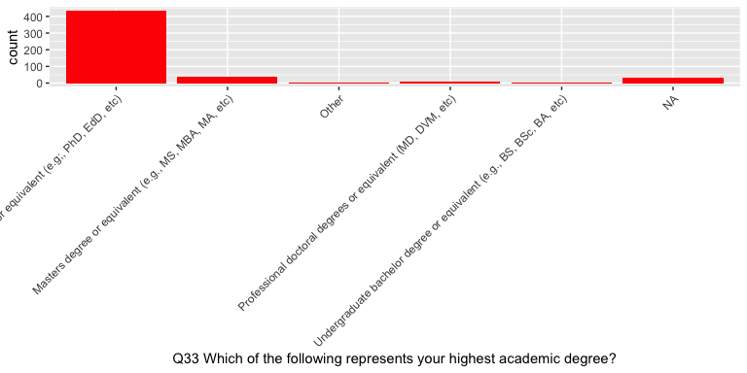

## Is Carnegie classification of your current institution associated with faculty gender proportions?

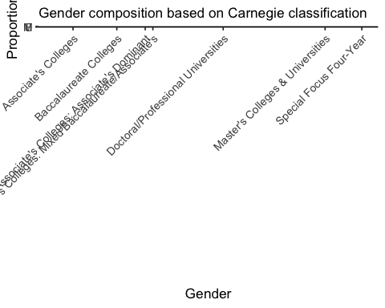 # Associations between identifier variables and survey responses

Are there any associations between particular identifier and response variables? In addition to statistical tests, associations are visualized using mosaic plots, which present the frequency of each explanatory (x axis) and response (y-axis) variable. (Note: Non-responses are removed from the following analyses.)

## Do non-male faculty experience more barriers/more severe barriers than male faculty?

There is a significant association between gender and encountering barriers (p-val = 0.0021). Compared to males, other genders are more likely to report barriers to integrating bioinformatics into their teaching (M = 50%, F = 62%, U = 62%).

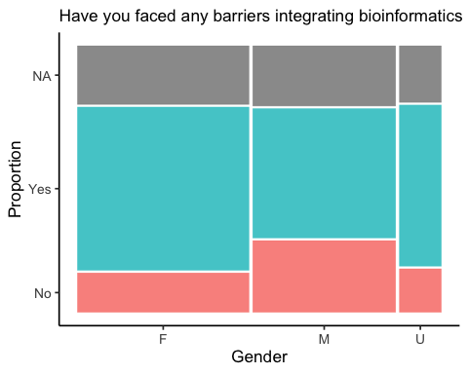

### Are the gender differences due to any particular type of barrier?

Of those respondents who reported facing a barrier to integrating bioinformatics into their teaching, we sought to identify associations between gender and specific barriers. Of the 10 queried barriers, 1 (I lack expertise in bioinformatics) exhibited a significant difference among genders (adj. p-value = 0.027).

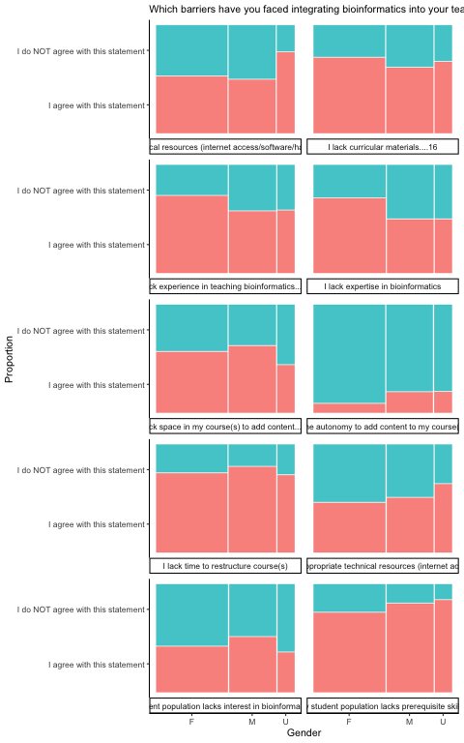

The difference between genders is more apparent when we explore the severity of each challenge, where the non-responses (NA) were converted to “Not a challenge.” (Due to small numbers, U gender was removed to meet the assumptions of statistical testing.)

Of those respondents who answered the barrier question (Q7 or Q21, response 1), we sought to identify associations between gender and the severity of each barrier. Of the 10 queried barriers, 3 (I lack expertise in bioinformatics., I lack experience in teaching bioinformatics….22, I lack curricular materials….26) exhibited a significant difference among genders (adj. p-value = 0.0039, 0.0094, 0.0094).

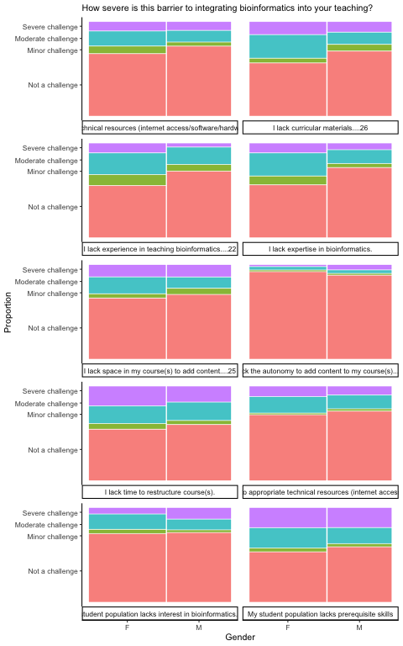

## Is there an association between Carnegie classification of current institution and barriers to integrating bioinformatics?

Do faculty at some institution types more frequently report barriers to integrating bioinformatics into their teaching? There is a significant association between Carnegie classification and encountering barriers (p-value = 0.057). For example, faculty at baccalaureate colleges reported facing barriers more frequently than average (71.4% vs. 57.2%), while doctoral institutions reported facing barriers less frequently (48.7%).

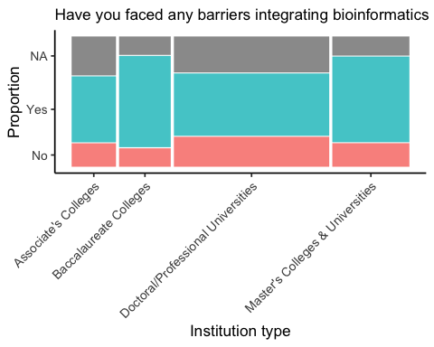

Of those respondents who reported facing a barrier to integrating bioinformatics into their teaching, we sought to identify associations between institution type and specific barriers. Of the 10 queried barriers, 2 (I lack expertise in bioinformatics, I lack the autonomy to add content to my course(s)….14) exhibited a significant difference among different institutions (adj. p-value = 0.028, 0.0016).

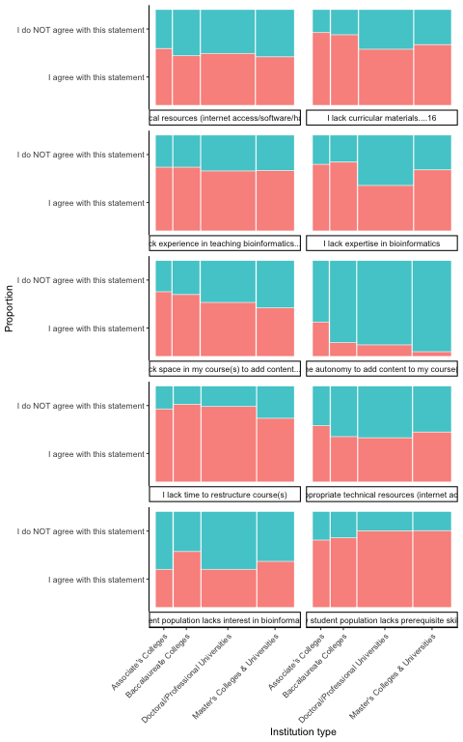

## Do URM faculty experience more barriers/more severe barriers to integrating bioinformatics than non-URM faculty?

Do faculty who identified as an under-represented minority more frequently report barriers to integrating bioinformatics into their teaching? There is insufficient evidence to indicate a significant association between URM faculty status and encountering barriers (p-val = 0.18), although URM faculty are somewhat more likely to report barriers to integrating bioinformatics into their teaching than non-URM faculty (URM = 81%, n = 77; non-URM = 72%, n = 317).

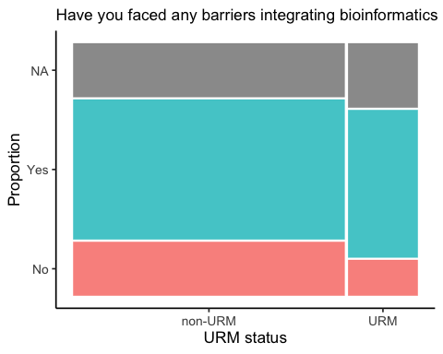

Since the difference wasn’t statistically significant, specific barriers were not analyzed for an association with URM status.

The effect of URM is more apparent when we explore the severity of each challenge, where the non-responses (NA) were converted to “Not a challenge.”

Of those respondents who responded to the barrier question (Q7 or Q21, response 1), we sought to identify associations between URM status and the severity of each barrier. Of the 10 queried barriers, 0 () exhibited a significant difference among genders (adj. p-value = ).

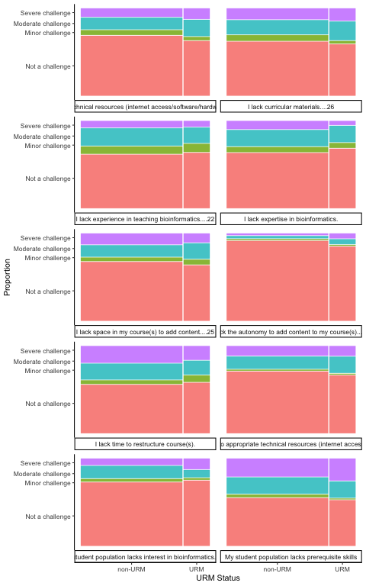

## Do faculty at MSIs experience more barriers to integrating bioinformatics?

Do faculty at HBCUs, HSIs or other minority-serving institutions more frequently report barriers to integrating bioinformatics into their teaching than faculty at non-MSI institutions? Although faculty at HBCUs and HSIs more frequently reported barriers to integrating bioinformatics into their teaching than other MSI and non-MSI faculty (HBCU = 82%, n = 17; HSI = 82%, n = 38; other-HSI = 64%, n = 22; non-MSI = 73%, n = 317), there is insufficient evidence to indicate a significant association between MSI faculty status and encountering barriers (p-val = 0.38).

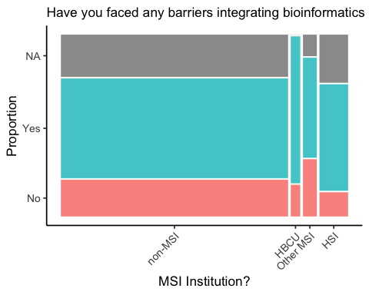

Since the difference wasn’t statistically significant, specific barriers were not analyzed for an association with MSI faculty.

## Is terminal degree year associated with barriers to integrating bioinformatics?

There is a significant association between between when the highest degree was awarded and how frequently faculty reported barriers to integrating bioinformatics into their teaching (p-val = 0.016). Faculty were more likely to report encountering a barrier if they received their highest degree more recently.

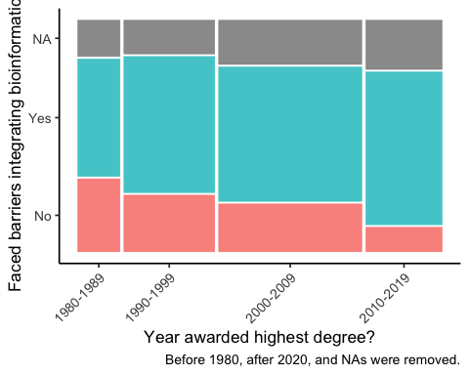

Was there a specific barrier associated with when the highest degree was awarded? Of those respondents who reported facing a barrier to integrating bioinformatics into their teaching, we sought to identify associations between degree year and specific barriers. Of the 10 queried barriers, “0” exhibited a significant difference among the degree years (adj. p-value < 0.05).

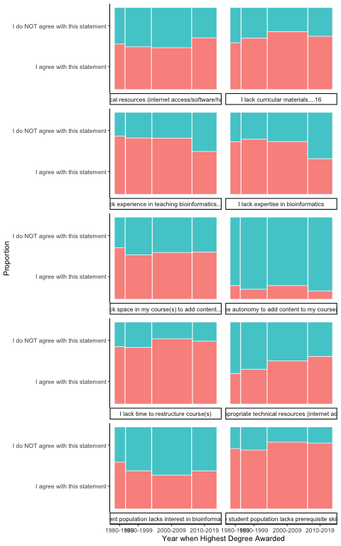

Do “more experienced” instructors differ in their bioinformatics training compared to “less experienced” instructors (i.e., those who received their terminal degree more recently)? The overall pattern of bioinformatics training – with multiple responses allowed per respondent – did not differ significantly based on year of degree award. However, those who received their highest degree more recently were significantly more likely to have had bioinformatics training in graduate school (1980’s = 11%, 1990’s = 13%, 2000’s = 22%, 2010’s = 36%; p-val = 1.2^{-4}).

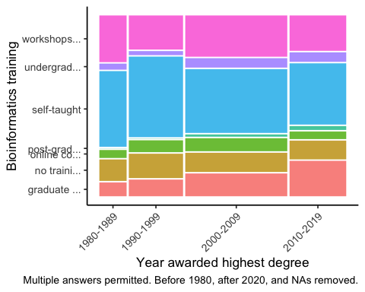

Is there an association with instructor experience and bioinformatics teaching duties? The overall pattern of bioinformatics teaching duties – with multiple responses allowed per respondent – did not differ significantly based on year of degree award (p-val = 0.41).

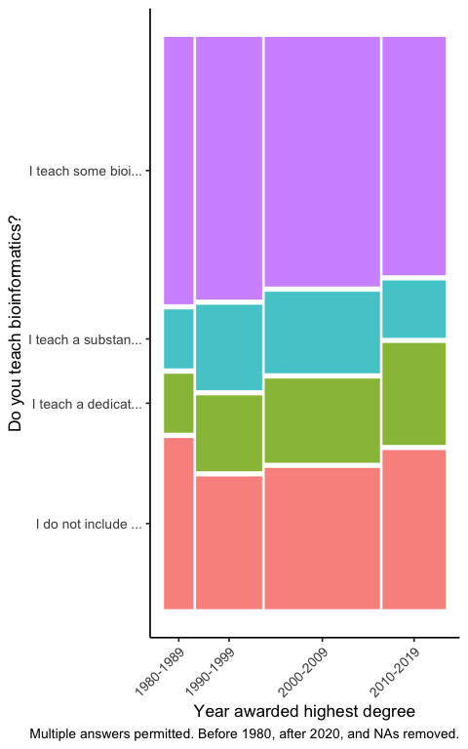

## Is terminal degree year associated with NOT integrating bioinformatics?

The frequency of not integrating bioinformatics does not significantly differ between the decades of the terminal degree.

## # A tibble: 1 × 3  
## statistic chisq_df p_value  
## <dbl> <int> <dbl>  
## 1 1.29 3 0.731

# plot with TeachBioinfor frequency by decade  
NotTeachBioinfo_Decade_count %>%  
 filter(DontTeachBioinfor == FALSE) %>% # therefore, integrate bioinformatics  
 ggplot(aes(x=`Decade of Degree`,   
 y=proportion))+  
 geom_bar(stat = "Identity")+  
 labs(y = "percentage of respondents", x= "") +  
 scale_y_continuous(labels = scales::percent) +  
 theme_gray(base_size = 20, base_family = "sans") +  
 theme(line = element_line(colour = "black"),   
 rect = element_rect(fill = "white", linetype = 0, colour = NA))+  
 theme(legend.background = element_rect(),   
 legend.position = "bottom",  
 legend.title = element_blank()) +  
 theme(panel.grid.major =  
 element_line(colour = "grey"),  
 panel.grid.minor = element_blank(),  
 strip.background = element_rect())+  
 theme(axis.title.x=element_blank(),  
 axis.ticks.x=element_blank()) +  
 theme(strip.text.x = element_text(size = 18, face = "bold"))+  
 theme(plot.background = element_rect(fill = "white"))+  
 theme(panel.background = element_rect(fill = "white"))+  
 theme(panel.grid.major.y = element_blank())+  
 theme(axis.line = element_line(colour = "black", linewidth = 0.5))+  
 coord_flip()+  
 theme(axis.text = element_text(size = 18)) +  
 theme(panel.grid.minor=element_blank())

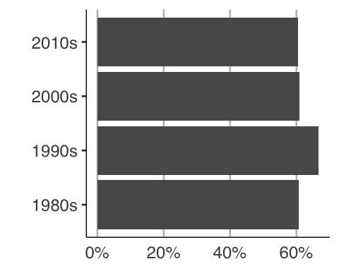

## Is level of training associated with NOT integrating bioinformatics? (New 3/2023)

Participants could choose multiple responses for their level of training. For this analysis, each participant was described by their highest level of training in the following order:

1. “At Least Some Coursework” includes “graduate degree”, “post-graduate certificate”, “graduate courses”, “undergraduate degree” (and items below).
2. “At Least Workshops/Bootcamps” includes “workshops or bootcamp” (and items below).
3. “Self-taught Only” includes “self-taught# (and item below).
4. “No training” includes “no training/experience” only.
5. If no response (NA), then “Unknown Training”.

Perform chi-squared test for association between degree decade and level of bioinformatics training.

## # A tibble: 1 × 3  
## statistic chisq_df p_value  
## <dbl> <int> <dbl>  
## 1 106. 3 7.42e-23

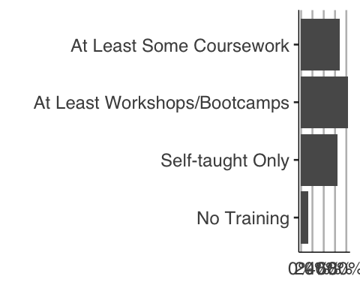

Some training in bioinformatics, even if only self-taught or a short-term workshop/bootcamp, significantly increases the likelihood of teaching a course that integrates bioinformatics from 11% to >60%.

# Multiple component analysis (MCA) using FactoMineR

The data set was explored using multiple component analysis (Husson, F., Le, S., Pages, J. 2010. *Exploratory Multivariate Analysis by Example Using R*. Chapman and Hall.).

## Selection of active and supplementary variables

We will use the survey responses regarding barriers as the active variables, and the descriptor variables explored in Chapter 2 (gender, URM, etc.) will be used as supplementary variables. To start, we’ll create a data frame only with the active variables, removing duplicate rows in the process.

library(FactoMineR)  
require(factoextra)

## Loading required package: factoextra

## Welcome! Want to learn more? See two factoextra-related books at https://goo.gl/ve3WBa

Active_Vars_df <- Merged_Data_Anonymous2 %>%   
 select(respID, `I lack expertise in bioinformatics.`:`My student population lacks interest in bioinformatics....30`) %>%   
 distinct()

If a respondent did not face a particular barrier, then their response to the challenge level questions was NA. These NA’s will be changed to “Not a challenge”.

Active_Vars_df <- Active_Vars_df %>%   
 replace(is.na(.), "Not a challenge")

We will create another data frame with desired supplementary variables (removing duplicate rows). Then, we combine the two data frames and move the respID column to row names before preceding with MCA.

Supp_Vars_df <- Merged_Data_Anonymous2 %>%   
 select(respID, Gender, URM, BASIC2018_bins_text.Current, URM, MSI_status, Q14DegreeYear) %>%   
 distinct()  
All_Vars_df <- Active_Vars_df %>% left_join(Supp_Vars_df, by = "respID") %>%   
 column_to_rownames(var = "respID")  
# shorten variable names for readability on MCA plots  
All_Vars_df <- All_Vars_df %>%   
 rename(Expertise = `I lack expertise in bioinformatics.`,  
 Experience = `I lack experience in teaching bioinformatics....22`,  
 Time = `I lack time to restructure course(s).`,  
 Autonomy = `I lack the autonomy to add content to my course(s)....24`,  
 Space = `I lack space in my course(s) to add content....25`,  
 Materials = `I lack curricular materials....26`,  
 My_Tech = `I lack appropriate technical resources (internet access/software/hardware/IT support)....27`,  
 Student_Tech = `My student population lacks access to appropriate technical resources (internet access/software/hardware/IT support)....28`,   
 Prereqs = `My student population lacks prerequisite skills`,  
 Interest = `My student population lacks interest in bioinformatics....30`,  
 Carnegie = BASIC2018_bins_text.Current,  
 Degree_Year = `Q14DegreeYear`  
 )

# following is tweaked from Help examples  
results.MCA <- MCA(All_Vars_df, quali.sup = 11:15)

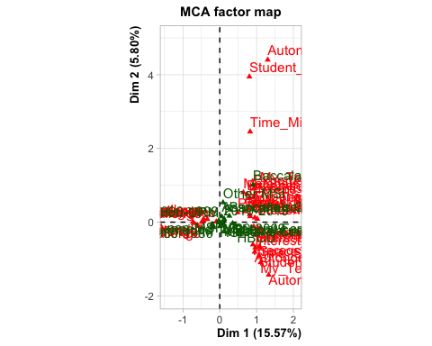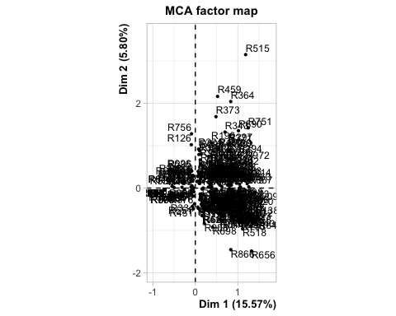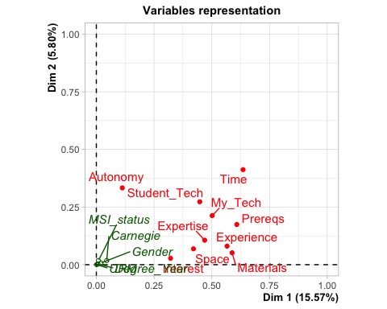

summary(results.MCA)

##   
## Call:  
## MCA(X = All_Vars_df, quali.sup = 11:15)   
##   
##   
## Eigenvalues  
## Dim.1 Dim.2 Dim.3 Dim.4 Dim.5 Dim.6 Dim.7  
## Variance 0.467 0.174 0.172 0.157 0.147 0.138 0.128  
## % of var. 15.567 5.803 5.731 5.227 4.901 4.602 4.283  
## Cumulative % of var. 15.567 21.370 27.101 32.328 37.229 41.830 46.114  
## Dim.8 Dim.9 Dim.10 Dim.11 Dim.12 Dim.13 Dim.14  
## Variance 0.122 0.118 0.113 0.102 0.099 0.093 0.093  
## % of var. 4.052 3.935 3.778 3.386 3.300 3.109 3.090  
## Cumulative % of var. 50.166 54.101 57.878 61.264 64.564 67.674 70.764  
## Dim.15 Dim.16 Dim.17 Dim.18 Dim.19 Dim.20 Dim.21  
## Variance 0.085 0.084 0.080 0.074 0.068 0.066 0.061  
## % of var. 2.845 2.784 2.671 2.482 2.258 2.199 2.042  
## Cumulative % of var. 73.609 76.392 79.063 81.546 83.804 86.003 88.045  
## Dim.22 Dim.23 Dim.24 Dim.25 Dim.26 Dim.27 Dim.28  
## Variance 0.057 0.053 0.049 0.046 0.042 0.038 0.033  
## % of var. 1.888 1.775 1.635 1.521 1.390 1.259 1.093  
## Cumulative % of var. 89.934 91.709 93.344 94.865 96.255 97.513 98.606  
## Dim.29 Dim.30  
## Variance 0.022 0.020  
## % of var. 0.738 0.656  
## Cumulative % of var. 99.344 100.000  
##   
## Individuals (the 10 first)  
## Dim.1  
## R102 | 0.561  
## R103 | -0.725  
## R104 | -0.725  
## R105 | 0.585  
## R106 | 0.379  
## R107 | 0.439  
## R108 | 0.581  
## R111 | -0.725  
## R115 | 0.573  
## R116 | -0.065  
## ctr  
## R102 0.145  
## R103 0.242  
## R104 0.242  
## R105 0.158  
## R106 0.066  
## R107 0.089  
## R108 0.156  
## R111 0.242  
## R115 0.151  
## R116 0.002  
## cos2   
## R102 0.050 |  
## R103 0.987 |  
## R104 0.987 |  
## R105 0.111 |  
## R106 0.031 |  
## R107 0.082 |  
## R108 0.107 |  
## R111 0.987 |  
## R115 0.084 |  
## R116 0.002 |  
## Dim.2  
## R102 0.934  
## R103 -0.033  
## R104 -0.033  
## R105 -0.164  
## R106 0.763  
## R107 -0.065  
## R108 -0.295  
## R111 -0.033  
## R115 0.153  
## R116 0.163  
## ctr  
## R102 1.079  
## R103 0.001  
## R104 0.001  
## R105 0.033  
## R106 0.720  
## R107 0.005  
## R108 0.107  
## R111 0.001  
## R115 0.029  
## R116 0.033  
## cos2   
## R102 0.138 |  
## R103 0.002 |  
## R104 0.002 |  
## R105 0.009 |  
## R106 0.128 |  
## R107 0.002 |  
## R108 0.028 |  
## R111 0.002 |  
## R115 0.006 |  
## R116 0.015 |  
## Dim.3  
## R102 -0.626  
## R103 0.017  
## R104 0.017  
## R105 0.014  
## R106 0.606  
## R107 -0.002  
## R108 -0.007  
## R111 0.017  
## R115 0.399  
## R116 -0.116  
## ctr  
## R102 0.490  
## R103 0.000  
## R104 0.000  
## R105 0.000  
## R106 0.459  
## R107 0.000  
## R108 0.000  
## R111 0.000  
## R115 0.199  
## R116 0.017  
## cos2   
## R102 0.062 |  
## R103 0.001 |  
## R104 0.001 |  
## R105 0.000 |  
## R106 0.080 |  
## R107 0.000 |  
## R108 0.000 |  
## R111 0.001 |  
## R115 0.041 |  
## R116 0.008 |  
##   
## Categories (the 10 first)  
## Dim.1  
## Expertise_Minor challenge | 0.929  
## Expertise_Moderate challenge | 0.923  
## Expertise_Not a challenge | -0.510  
## Expertise_Severe challenge | 0.905  
## Experience_Minor challenge | 0.741  
## Experience_Moderate challenge | 1.032  
## Experience_Not a challenge | -0.590  
## Experience_Severe challenge | 0.963  
## Time_Minor challenge | 0.824  
## Time_Moderate challenge | 0.825  
## ctr  
## Expertise_Minor challenge 1.112  
## Expertise_Moderate challenge 3.725  
## Expertise_Not a challenge 3.585  
## Expertise_Severe challenge 1.621  
## Experience_Minor challenge 1.037  
## Experience_Moderate challenge 4.950  
## Experience_Not a challenge 4.597  
## Experience_Severe challenge 1.539  
## Time_Minor challenge 0.751  
## Time_Moderate challenge 2.787  
## cos2  
## Expertise_Minor challenge 0.055  
## Expertise_Moderate challenge 0.219  
## Expertise_Not a challenge 0.469  
## Expertise_Severe challenge 0.083  
## Experience_Minor challenge 0.053  
## Experience_Moderate challenge 0.295  
## Experience_Not a challenge 0.561  
## Experience_Severe challenge 0.078  
## Time_Minor challenge 0.037  
## Time_Moderate challenge 0.161  
## v.test   
## Expertise_Minor challenge 5.064 |  
## Expertise_Moderate challenge 10.071 |  
## Expertise_Not a challenge -14.751 |  
## Expertise_Severe challenge 6.221 |  
## Experience_Minor challenge 4.964 |  
## Experience_Moderate challenge 11.705 |  
## Experience_Not a challenge -16.131 |  
## Experience_Severe challenge 6.012 |  
## Time_Minor challenge 4.141 |  
## Time_Moderate challenge 8.642 |  
## Dim.2  
## Expertise_Minor challenge 0.905  
## Expertise_Moderate challenge -0.121  
## Expertise_Not a challenge -0.142  
## Expertise_Severe challenge 0.665  
## Experience_Minor challenge 0.759  
## Experience_Moderate challenge -0.160  
## Experience_Not a challenge -0.111  
## Experience_Severe challenge 0.465  
## Time_Minor challenge 2.456  
## Time_Moderate challenge 0.155  
## ctr  
## Expertise_Minor challenge 2.830  
## Expertise_Moderate challenge 0.171  
## Expertise_Not a challenge 0.745  
## Expertise_Severe challenge 2.351  
## Experience_Minor challenge 2.914  
## Experience_Moderate challenge 0.318  
## Experience_Not a challenge 0.433  
## Experience_Severe challenge 0.963  
## Time_Minor challenge 17.877  
## Time_Moderate challenge 0.265  
## cos2  
## Expertise_Minor challenge 0.052  
## Expertise_Moderate challenge 0.004  
## Expertise_Not a challenge 0.036  
## Expertise_Severe challenge 0.045  
## Experience_Minor challenge 0.056  
## Experience_Moderate challenge 0.007  
## Experience_Not a challenge 0.020  
## Experience_Severe challenge 0.018  
## Time_Minor challenge 0.328  
## Time_Moderate challenge 0.006  
## v.test   
## Expertise_Minor challenge 4.932 |  
## Expertise_Moderate challenge -1.316 |  
## Expertise_Not a challenge -4.107 |  
## Expertise_Severe challenge 4.574 |  
## Experience_Minor challenge 5.081 |  
## Experience_Moderate challenge -1.812 |  
## Experience_Not a challenge -3.024 |  
## Experience_Severe challenge 2.904 |  
## Time_Minor challenge 12.340 |  
## Time_Moderate challenge 1.628 |  
## Dim.3  
## Expertise_Minor challenge -0.984  
## Expertise_Moderate challenge -0.670  
## Expertise_Not a challenge 0.021  
## Expertise_Severe challenge 1.976  
## Experience_Minor challenge -1.034  
## Experience_Moderate challenge -0.352  
## Experience_Not a challenge 0.002  
## Experience_Severe challenge 2.147  
## Time_Minor challenge -0.645  
## Time_Moderate challenge 0.242  
## ctr  
## Expertise_Minor challenge 3.393  
## Expertise_Moderate challenge 5.330  
## Expertise_Not a challenge 0.016  
## Expertise_Severe challenge 21.000  
## Experience_Minor challenge 5.485  
## Experience_Moderate challenge 1.570  
## Experience_Not a challenge 0.000  
## Experience_Severe challenge 20.762  
## Time_Minor challenge 1.248  
## Time_Moderate challenge 0.650  
## cos2  
## Expertise_Minor challenge 0.062  
## Expertise_Moderate challenge 0.115  
## Expertise_Not a challenge 0.001  
## Expertise_Severe challenge 0.398  
## Experience_Minor challenge 0.103  
## Experience_Moderate challenge 0.034  
## Experience_Not a challenge 0.000  
## Experience_Severe challenge 0.387  
## Time_Minor challenge 0.023  
## Time_Moderate challenge 0.014  
## v.test   
## Expertise_Minor challenge -5.366 |  
## Expertise_Moderate challenge -7.310 |  
## Expertise_Not a challenge 0.601 |  
## Expertise_Severe challenge 13.586 |  
## Experience_Minor challenge -6.927 |  
## Experience_Moderate challenge -3.999 |  
## Experience_Not a challenge 0.067 |  
## Experience_Severe challenge 13.398 |  
## Time_Minor challenge -3.240 |  
## Time_Moderate challenge 2.533 |  
##   
## Categorical variables (eta2)  
## Dim.1  
## Expertise | 0.469  
## Experience | 0.566  
## Time | 0.635  
## Autonomy | 0.112  
## Space | 0.421  
## Materials | 0.588  
## My_Tech | 0.502  
## Student_Tech | 0.448  
## Prereqs | 0.608  
## Interest | 0.321  
## Dim.2 Dim.3  
## Expertise 0.106 0.511  
## Experience 0.081 0.478  
## Time 0.412 0.039  
## Autonomy 0.333 0.055  
## Space 0.069 0.105  
## Materials 0.052 0.259  
## My_Tech 0.213 0.094  
## Student_Tech 0.273 0.125  
## Prereqs 0.174 0.014  
## Interest 0.028 0.038  
##   
## Expertise |  
## Experience |  
## Time |  
## Autonomy |  
## Space |  
## Materials |  
## My_Tech |  
## Student_Tech |  
## Prereqs |  
## Interest |  
##   
## Supplementary categories (the 10 first)  
## Dim.1  
## F | 0.124  
## M | -0.174  
## U | 0.076  
## non-URM | -0.019  
## URM | 0.074  
## Associate's Colleges | 0.055  
## Baccalaureate Colleges | 0.262  
## Baccalaureate/Associate's Colleges: Associate's Dominant | 0.418  
## Baccalaureate/Associate's Colleges: Mixed Baccalaureate/Associate's | 0.908  
## Doctoral/Professional Universities | -0.212  
## cos2  
## F 0.014  
## M 0.020  
## U 0.001  
## non-URM 0.001  
## URM 0.001  
## Associate's Colleges 0.000  
## Baccalaureate Colleges 0.013  
## Baccalaureate/Associate's Colleges: Associate's Dominant 0.004  
## Baccalaureate/Associate's Colleges: Mixed Baccalaureate/Associate's 0.005  
## Doctoral/Professional Universities 0.036  
## v.test   
## F 2.579 |  
## M -3.040 |  
## U 0.607 |  
## non-URM -0.805 |  
## URM 0.805 |  
## Associate's Colleges 0.440 |  
## Baccalaureate Colleges 2.452 |  
## Baccalaureate/Associate's Colleges: Associate's Dominant 1.334 |  
## Baccalaureate/Associate's Colleges: Mixed Baccalaureate/Associate's 1.576 |  
## Doctoral/Professional Universities -4.103 |  
## Dim.2  
## F 0.084  
## M -0.100  
## U -0.011  
## non-URM 0.010  
## URM -0.040  
## Associate's Colleges 0.153  
## Baccalaureate Colleges 0.168  
## Baccalaureate/Associate's Colleges: Associate's Dominant -0.083  
## Baccalaureate/Associate's Colleges: Mixed Baccalaureate/Associate's 1.016  
## Doctoral/Professional Universities -0.061  
## cos2  
## F 0.007  
## M 0.007  
## U 0.000  
## non-URM 0.000  
## URM 0.000  
## Associate's Colleges 0.003  
## Baccalaureate Colleges 0.005  
## Baccalaureate/Associate's Colleges: Associate's Dominant 0.000  
## Baccalaureate/Associate's Colleges: Mixed Baccalaureate/Associate's 0.007  
## Doctoral/Professional Universities 0.003  
## v.test   
## F 1.761 |  
## M -1.739 |  
## U -0.090 |  
## non-URM 0.437 |  
## URM -0.437 |  
## Associate's Colleges 1.230 |  
## Baccalaureate Colleges 1.578 |  
## Baccalaureate/Associate's Colleges: Associate's Dominant -0.264 |  
## Baccalaureate/Associate's Colleges: Mixed Baccalaureate/Associate's 1.763 |  
## Doctoral/Professional Universities -1.184 |  
## Dim.3  
## F -0.056  
## M -0.024  
## U 0.303  
## non-URM 0.018  
## URM -0.071  
## Associate's Colleges -0.140  
## Baccalaureate Colleges -0.071  
## Baccalaureate/Associate's Colleges: Associate's Dominant 0.239  
## Baccalaureate/Associate's Colleges: Mixed Baccalaureate/Associate's -1.086  
## Doctoral/Professional Universities 0.039  
## cos2  
## F 0.003  
## M 0.000  
## U 0.013  
## non-URM 0.001  
## URM 0.001  
## Associate's Colleges 0.003  
## Baccalaureate Colleges 0.001  
## Baccalaureate/Associate's Colleges: Associate's Dominant 0.001  
## Baccalaureate/Associate's Colleges: Mixed Baccalaureate/Associate's 0.008  
## Doctoral/Professional Universities 0.001  
## v.test   
## F -1.168 |  
## M -0.415 |  
## U 2.417 |  
## non-URM 0.773 |  
## URM -0.773 |  
## Associate's Colleges -1.124 |  
## Baccalaureate Colleges -0.667 |  
## Baccalaureate/Associate's Colleges: Associate's Dominant 0.763 |  
## Baccalaureate/Associate's Colleges: Mixed Baccalaureate/Associate's -1.885 |  
## Doctoral/Professional Universities 0.747 |  
##   
## Supplementary categorical variables (eta2)  
## Dim.1  
## Gender | 0.020  
## URM | 0.001  
## Carnegie | 0.045  
## MSI_status | 0.009  
## Degree_Year | 0.006  
## Dim.2 Dim.3  
## Gender 0.007 0.013  
## URM 0.000 0.001  
## Carnegie 0.018 0.016  
## MSI_status 0.018 0.007  
## Degree_Year 0.003 0.003  
##   
## Gender |  
## URM |  
## Carnegie |  
## MSI_status |  
## Degree_Year |

plot(results.MCA, invisible = c("var", "quali.sup"), cex=0.7)

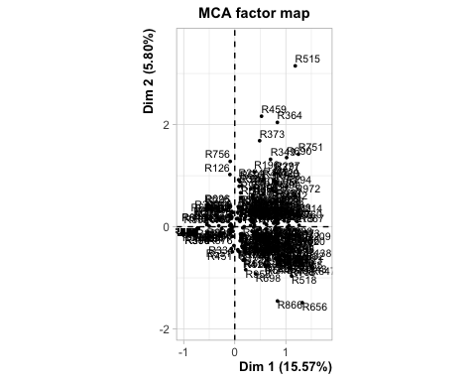

plot(results.MCA, invisible = c("ind", "quali.sup"), cex=0.6)

## Warning: ggrepel: 29 unlabeled data points (too many overlaps). Consider  
## increasing max.overlaps

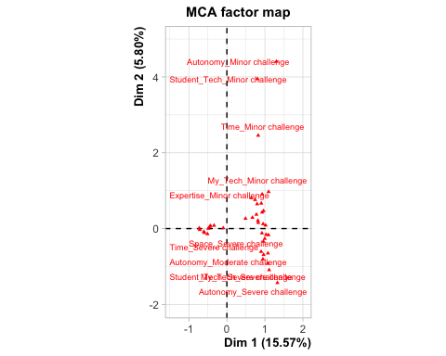

plot(results.MCA, invisible = c("ind", "var"), cex=0.5, max.overlaps = 1000)

## Warning: ggrepel: 8 unlabeled data points (too many overlaps). Consider  
## increasing max.overlaps

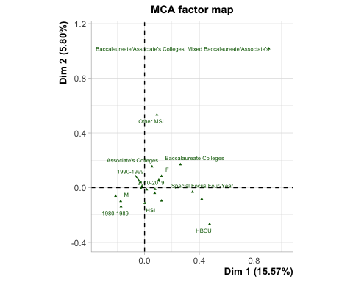

plot(results.MCA, invisible = c("quali.sup"), cex=0.8)

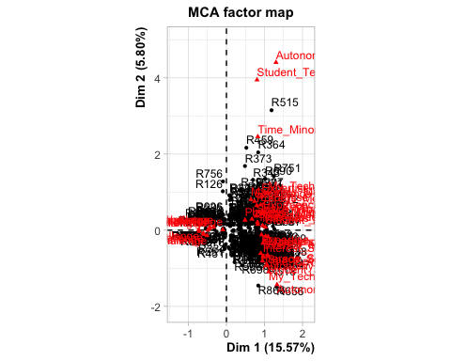

dimdesc(results.MCA)

## $`Dim 1`  
##   
## Link between the variable and the categorical variable (1-way anova)  
## =============================================  
## R2 p.value  
## Time 0.63533076 1.426537e-100  
## Prereqs 0.60825646 2.060943e-93  
## Materials 0.58783900 2.470027e-88  
## Experience 0.56611170 3.367274e-83  
## My_Tech 0.50157895 2.407459e-69  
## Expertise 0.46898448 5.109118e-63  
## Student_Tech 0.44768773 4.312291e-59  
## Space 0.42063989 2.554979e-54  
## Interest 0.32141376 1.496096e-38  
## Autonomy 0.11226112 7.024183e-12  
## Carnegie 0.04479901 1.772723e-03  
## Gender 0.02013707 9.103125e-03  
##   
## Link between variable and the categories of the categorical variables  
## ================================================================  
## Estimate p.value  
## Experience=Experience_Moderate challenge 0.338283835 4.425259e-37  
## Prereqs=Prereqs_Severe challenge 0.366210048 5.844162e-31  
## Time=Time_Severe challenge 0.334735936 6.568915e-29  
## Expertise=Expertise_Moderate challenge 0.246866311 1.245667e-26  
## Materials=Materials_Moderate challenge 0.295480159 8.956813e-26  
## Student_Tech=Student_Tech_Moderate challenge 0.275689678 4.339291e-25  
## Materials=Materials_Severe challenge 0.392150125 3.936795e-23  
## Space=Space_Severe challenge 0.359454556 1.823298e-20  
## Interest=Interest_Moderate challenge 0.289124286 8.666341e-20  
## My_Tech=My_Tech_Moderate challenge 0.181375725 1.326233e-19  
## Time=Time_Moderate challenge 0.238729609 2.079128e-19  
## Prereqs=Prereqs_Moderate challenge 0.294616728 2.378200e-19  
## My_Tech=My_Tech_Severe challenge 0.307645776 9.288622e-19  
## Student_Tech=Student_Tech_Severe challenge 0.312930735 1.091262e-18  
## Space=Space_Moderate challenge 0.178525008 5.220955e-15  
## Interest=Interest_Severe challenge 0.265266150 2.560077e-11  
## Expertise=Expertise_Severe challenge 0.234580580 2.200111e-10  
## Experience=Experience_Severe challenge 0.291706735 9.109306e-10  
## My_Tech=My_Tech_Minor challenge 0.297692165 1.044620e-08  
## Expertise=Expertise_Minor challenge 0.250952049 2.934991e-07  
## Autonomy=Autonomy_Severe challenge 0.312972244 3.271840e-07  
## Experience=Experience_Minor challenge 0.139737521 5.068232e-07  
## Time=Time_Minor challenge 0.238390676 2.999553e-05  
## Space=Space_Minor challenge 0.152077954 1.220086e-04  
## Autonomy=Autonomy_Moderate challenge 0.051767181 1.797415e-04  
## Materials=Materials_Minor challenge 0.083265058 3.334107e-04  
## Autonomy=Autonomy_Minor challenge 0.295111775 1.274570e-03  
## Gender=F 0.078720406 9.751491e-03  
## Interest=Interest_Minor challenge 0.067215754 1.070032e-02  
## MSI_status=HBCU 0.232306215 4.614884e-02  
## Carnegie=Baccalaureate Colleges -0.007124559 1.406450e-02  
## Gender=M -0.124986986 2.284259e-03  
## Carnegie=Doctoral/Professional Universities -0.330608836 3.555831e-05  
## Autonomy=Autonomy_Not a challenge -0.659851200 2.304107e-13  
## Interest=Interest_Not a challenge -0.621606190 1.672127e-40  
## Space=Space_Not a challenge -0.690057518 8.126079e-56  
## Student_Tech=Student_Tech_Not a challenge -0.716863993 1.595365e-61  
## Expertise=Expertise_Not a challenge -0.732398940 1.258297e-65  
## My_Tech=My_Tech_Not a challenge -0.786713667 1.751021e-71  
## Experience=Experience_Not a challenge -0.769728090 9.321657e-85  
## Materials=Materials_Not a challenge -0.770895342 4.912140e-89  
## Prereqs=Prereqs_Not a challenge -0.745870502 4.440393e-95  
## Time=Time_Not a challenge -0.811856221 7.028373e-103  
##   
## $`Dim 2`  
##   
## Link between the variable and the categorical variable (1-way anova)  
## =============================================  
## R2 p.value  
## Time 0.41243088 6.480265e-53  
## Autonomy 0.33320513 2.678737e-40  
## Student_Tech 0.27302876 1.083422e-31  
## My_Tech 0.21286172 8.744521e-24  
## Prereqs 0.17445402 4.661991e-19  
## Expertise 0.10613480 3.336742e-11  
## Experience 0.08057824 1.941310e-08  
## Space 0.06880216 3.385714e-07  
## Materials 0.05163627 1.995269e-05  
## Interest 0.02786524 4.545943e-03  
## MSI_status 0.01801409 3.861575e-02  
##   
## Link between variable and the categories of the categorical variables  
## ================================================================  
## Estimate p.value  
## Time=Time_Minor challenge 0.82738755 6.593561e-42  
## Autonomy=Autonomy_Minor challenge 1.61065406 2.782252e-31  
## Student_Tech=Student_Tech_Minor challenge 1.31486945 1.935881e-20  
## Prereqs=Prereqs_Moderate challenge 0.23745175 5.627217e-13  
## Experience=Experience_Minor challenge 0.21700403 2.671455e-07  
## My_Tech=My_Tech_Minor challenge 0.37236651 4.664385e-07  
## Expertise=Expertise_Minor challenge 0.24105693 6.028926e-07  
## Expertise=Expertise_Severe challenge 0.14122416 3.844688e-06  
## Materials=Materials_Minor challenge 0.26640887 5.784670e-06  
## My_Tech=My_Tech_Moderate challenge 0.14635178 5.334100e-05  
## Interest=Interest_Not a challenge 0.05829629 3.356562e-03  
## Experience=Experience_Severe challenge 0.09471473 3.581938e-03  
## MSI_status=Other MSI 0.20726750 8.616409e-03  
## Space=Space_Moderate challenge 0.09022597 4.961405e-02  
## Materials=Materials_Not a challenge -0.10536482 2.581685e-02  
## Interest=Interest_Severe challenge -0.11769788 2.053788e-02  
## Interest=Interest_Moderate challenge -0.08624074 1.988448e-02  
## Student_Tech=Student_Tech_Not a challenge -0.30151641 1.335908e-02  
## Experience=Experience_Not a challenge -0.14560607 2.416074e-03  
## Autonomy=Autonomy_Moderate challenge -0.56430945 1.438845e-03  
## Expertise=Expertise_Not a challenge -0.19562813 3.495654e-05  
## Space=Space_Severe challenge -0.26890877 6.299083e-08  
## Autonomy=Autonomy_Severe challenge -0.82436657 3.604388e-08  
## Student_Tech=Student_Tech_Severe challenge -0.71674058 7.723100e-14  
## Prereqs=Prereqs_Severe challenge -0.28675505 5.940451e-14  
## Time=Time_Severe challenge -0.48484794 1.335950e-14  
## My_Tech=My_Tech_Severe challenge -0.48753512 4.453178e-18  
##   
## $`Dim 3`  
##   
## Link between the variable and the categorical variable (1-way anova)  
## =============================================  
## R2 p.value  
## Expertise 0.51125905 2.644584e-71  
## Experience 0.47821865 9.045659e-65  
## Materials 0.25890515 8.905065e-30  
## Student_Tech 0.12498713 2.652662e-13  
## Space 0.10542347 3.995310e-11  
## My_Tech 0.09362682 7.731830e-10  
## Autonomy 0.05507439 8.900322e-06  
## Time 0.03946107 3.338415e-04  
## Interest 0.03772394 4.961230e-04  
##   
## Link between variable and the categories of the categorical variables  
## ================================================================  
## Estimate p.value  
## Expertise=Expertise_Severe challenge 0.78372497 5.972837e-53  
## Experience=Experience_Severe challenge 0.81119316 3.887589e-51  
## Materials=Materials_Severe challenge 0.44273641 3.204027e-23  
## My_Tech=My_Tech_Severe challenge 0.32612480 1.449624e-10  
## Student_Tech=Student_Tech_Severe challenge 0.04373002 7.537171e-09  
## Student_Tech=Student_Tech_Minor challenge 0.61008961 2.189839e-06  
## Space=Space_Moderate challenge 0.28239958 9.246322e-06  
## Time=Time_Moderate challenge 0.15573670 1.116450e-02  
## Gender=U 0.09483775 1.550418e-02  
## Interest=Interest_Not a challenge 0.14038609 3.629508e-02  
## Autonomy=Autonomy_Not a challenge 0.04015835 4.654223e-02  
## My_Tech=My_Tech_Not a challenge -0.04136967 4.475377e-02  
## My_Tech=My_Tech_Minor challenge -0.21054535 1.508383e-02  
## Student_Tech=Student_Tech_Moderate challenge -0.36017440 1.480763e-02  
## Student_Tech=Student_Tech_Not a challenge -0.29364523 1.842247e-03  
## Time=Time_Minor challenge -0.21177899 1.142231e-03  
## Experience=Experience_Moderate challenge -0.22523818 5.623592e-05  
## Interest=Interest_Minor challenge -0.32482480 4.742819e-05  
## Space=Space_Minor challenge -0.26102844 3.342117e-05  
## Space=Space_Severe challenge -0.12821607 1.824470e-05  
## Autonomy=Autonomy_Moderate challenge -0.46999134 1.699990e-06  
## Expertise=Expertise_Minor challenge -0.44360155 5.219826e-08  
## Experience=Experience_Minor challenge -0.50787909 1.198834e-12  
## Materials=Materials_Moderate challenge -0.29466734 3.075278e-13  
## Expertise=Expertise_Moderate challenge -0.31321521 5.375619e-14

plotellipses(results.MCA, invisible = c("ind"), keepvar = 11)

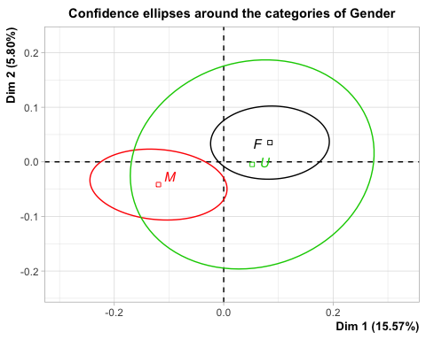

plotellipses(results.MCA, axes = c(1,2), invisible = c("ind"), keepvar = 12, max.overlaps = 10)

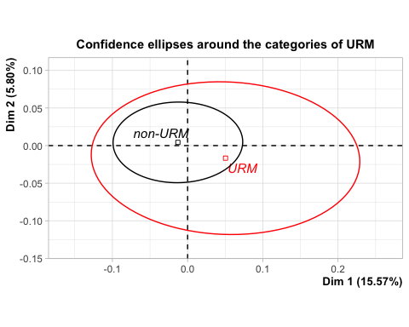

plotellipses(results.MCA, axes = c(1,2), invisible = c("ind"), keepvar = 14, max.overlaps = 10)

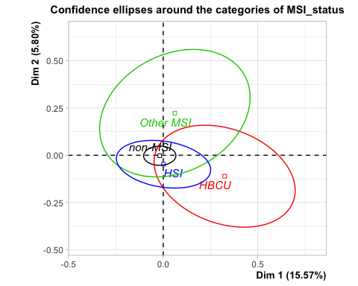

plotellipses(results.MCA, axes = c(1,4), invisible = c("ind"), keepvar = 15, max.overlaps = 10)

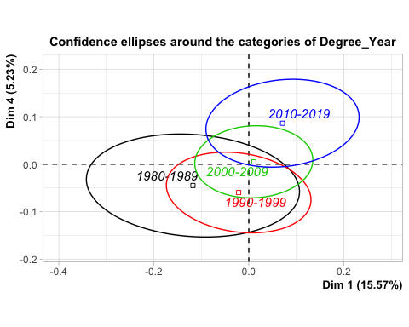

# following is adapted from FactoMineR YouTube video  
plot(results.MCA, invisible = c("quali.sup", "ind"), label = c("var", "quali.sup"), autoLab = "y", cex=0.7)

## Warning: ggrepel: 30 unlabeled data points (too many overlaps). Consider  
## increasing max.overlaps

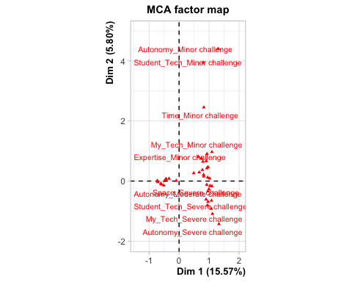

plot(results.MCA, invisible = "ind", autoLab = "y", selectMod = "cos2 10", xlim = c(-4,4), cex=0.7)

## Warning: ggrepel: 8 unlabeled data points (too many overlaps). Consider  
## increasing max.overlaps

## Warning: ggrepel: 8 unlabeled data points (too many overlaps). Consider  
## increasing max.overlaps

