Capitalism, Free Markets, & Socialism

DRAFT

Table of contents

# Intro

How are capitalism and free markets related? Does supporting Medicare-for-all make you a socialist? Let’s talk about these commonly misunderstood theories of resource allocation. We will review the basics before will explain how capitalists have conflated capitalism with free market theory at the detriment of free markets by taking a look at several markets in the US economy.

# Plotting supply and demand

The supply and demand graph serves as a visual representation of classical economic thinking. Students encounter it on the first day of any economics course and it as it the root of the assumed efficiency of real-world markets.

### The typical supply and demand graph

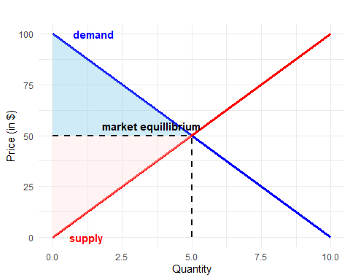

In this example, both the consumer and producer see healthy and equitable surpluses and everyone walks away better off from the exchange. Before we move on, we need to address the underlying assumption of perfect competition that prevents this level of efficiency from being realized in the world. The assumption of perfect competition removes the need to distinguish between marginal revenue and the demand curve because firms in competitive markets are considered price-takers. In reality, the marginal revenue curve differs from the demand curve due to imperfect market conditions and profit-maximizing firms set their prices where marginal revenue equals marginal costs (i.e., the supply curve).

### A more realistic market graph

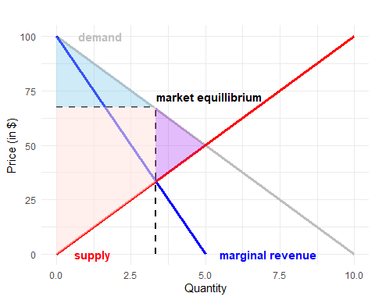

Despite the first graph being more commonly presented, this graph more aptly illustrates a typical real world market where profit-maximizing firms in increasingly consolidated markets set their prices independently of the demand curve resulting in market inefficiencies and less surplus parity between buyers and sellers. These inefficiencies are introduced as a result of market failures.

# Market failures

### The types of market failures

| Failure | Description | Examples |
| --- | --- | --- |
| Inequal bargaining power | Voluntary exchange is at the core of free market theory… |  |
| Market power |  |  |
| Asymmetric information |  |  |
| Externalities (positive & negative) |  |  |
| Public goods |  |  |

### Plotting the effects of market failures

### Market failures in the US economy

##### Healthcare

##### Education

##### Energy

##### Food

##### Media

# Why capitalists love market failures

# How “socialist” policies bolster free markets

# Conclusion