Image Geolocation and Hazard-Aware Response Using Multimodal Large Language Models (MLLMs)
Dipti S. Chaudhari, Shreyash Borge, Bhargav Dave, Kiran Raut, and Nibodh Daware
Pimpri Chinchwad College of Engineering & Research, Pune, India
{diptischaudhari, shreyashborge2003, bhargavhdave, kiran19raut, nibodhdaware}@gmail.com
Abstract
A multimodal image-understanding pipeline is developed to combine place-aware visual reasoning with hazard-aware decision support. Instead of reporting performance only through coarse geolocation scales such as street, city, region, country, and continent, the architecture emphasizes operational outcomes in which hazard evidence triggers a user-facing authority-notification pathway. The model analyzes image content and contextual cues, generates a structured interpretation, and maps the decision to either informational guidance for normal scenes or alert-oriented action for high-risk scenes. Evaluation is reported using available project datasets and persisted run logs, including risk-level distribution, confidence behavior, and confirmed incident actions. The framework improves practical usability by coupling perception with accountable safety response.

Introduction
The rapid growth of user-generated images has made automated visual interpretation important for public communication, emergency awareness, and digital verification. Classical image geolocation methods were designed to infer location from landmarks and scene cues, but many real-world images now require a broader interpretation that includes safety context. During critical events, an image may contain both place information and potential hazard signals, and a useful system must handle both in a single reasoning flow.
A major challenge is that model outputs are often difficult to operationalize. Distance-only geolocation metrics remain valuable for benchmark comparison, yet they do not directly answer whether a suspicious or dangerous scene should trigger a guided escalation action. In practical deployment, the system should provide interpretable evidence, distinguish normal and hazardous situations, and expose a controlled alert step rather than producing only a location label.
The motivation for this architecture is therefore twofold. First, multimodal reasoning can use visual structure, text in scene, and semantic context for stronger interpretation of complex images (Sinski et al. 2024; Radford et al. 2021). Second, retrieval-grounded reasoning can reduce unsupported predictions by anchoring the decision in prior visual evidence (Li et al. 2025; Zhou et al. 2024). This work combines these approaches to build a system that not only localizes scenes but also detects hazard signals and triggers appropriate operational responses.
From an application perspective, the core requirement is consistent behavior under uncertainty. A system used in safety-related contexts should avoid overconfident claims, provide clear rationale, and produce actions that can be audited later. This is especially important when image content is ambiguous, partially occluded, or context-dependent. In these cases, the interface and policy layer matter as much as model capability because they determine whether a user receives neutral guidance, a request for additional context, or a high-priority escalation option. Designing this decision path as an explicit policy improves reproducibility compared with ad hoc prompt-only behavior.
Another challenge is bridging model output and user trust. Free-form responses may appear fluent but can be difficult to validate in real-time. Therefore, this study uses a strict structured output contract and deterministic action mapping so that each response can be traced to explicit fields such as risk level, confidence, entities, and rationale. This structure supports log-level analysis of system behavior, including uncertain cases and confirmed reporting outcomes. The same design also enables measurable operational evaluation instead of only reporting geolocation metrics.
The main contributions of this paper are: (i) a multimodal hazard-aware architecture that unifies place understanding and risk triage in one pipeline, (ii) a deterministic risk-to-action policy with user-confirmed incident escalation, and (iii) an empirical analysis using persisted run logs that captures confidence behavior, risk distribution, and incident-action outcomes. By focusing on operational relevance in addition to perception quality, the proposed framework provides a practical basis for research prototypes that must remain interpretable and safety-aware.

Related Work

Traditional and Deep Geolocation
Early geolocation systems relied on descriptor matching and large geotagged image corpora. Local features such as SIFT enabled robust matching under scale and viewpoint changes (Lowe 2004), while Im2GPS-style retrieval and its deep-learning successors established the core idea that geographic priors can be learned from image databases (Wu and Huang 2022; Vo et al. 2017). Place-recognition methods such as 24/7 Tokyo and NetVLAD improved retrieval robustness for city-scale and viewpoint-varying scenes (Torii et al. 2015; Arandjelovic et al. 2016). Later, grid-based CNN approaches such as PlaNet framed geolocation as large-scale classification, improving global coverage but still offering limited interpretability (Weyand et al. 2016). Even with strong benchmark performance, these methods typically optimize for top-$k$ location accuracy and geodesic error, while downstream safety actions remain outside the model objective.

Vision-Language Geospatial Reasoning
Vision-language models introduced cross-modal embedding spaces that enable joint reasoning over image content and textual context (Radford et al. 2021). Recent works such as PIGEON and Img2Loc show that multimodal foundations improve geospatial inference and can outperform conventional single-modality baselines on large-scale benchmarks (Haas et al. 2024; Zhou et al. 2024). Additional studies report that contextual priors and multimodal prompts improve robustness in ambiguous scenes (Wang et al. 2024; Lyu et al. 2024). BLIP-2 and LLaVA-style modular vision-language transfer also demonstrate that frozen or instruction-tuned backbones can retain strong recognition quality while reducing full-model retraining requirements, which is useful for rapid prototyping of applied geospatial workflows (Li et al. 2023; Liu et al. 2024). Gemini-style multimodal systems further motivate strict response contracts for image, text, and reasoning tasks in practical applications (Gemini Team 2024).

Grounded and Explainable Hazard-Aware Inference
Recent literature also highlights the need for grounded outputs and transparent rationale generation. Retrieval-augmented pipelines reduce hallucination by linking predictions to nearest visual evidence (Waheed et al. 2025; Li et al. 2025), while chain-of-thought style decomposition supports more verifiable geospatial reasoning steps (Yerramilli et al. 2025; Cheng et al. 2025). Feature-matching methods such as SuperGlue show the value of explicit visual correspondence for trustworthy place evidence (Sarlin et al. 2020). In parallel, decision-support research in safety contexts emphasizes structured outputs, calibrated uncertainty, and auditable user confirmations rather than fully automated escalation. These directions motivate systems that move beyond location-only output and produce interpretable decisions suitable for safety-sensitive workflows.

Methodology
The system performs multimodal scene interpretation and maps the inferred risk state to a guided action. Each input image is processed through a vision-language model that returns a structured response with summary, risk level, confidence, entities, place estimate, and rationale. This structured output is normalized and then converted into user-facing actions for either informational use or hazard escalation.
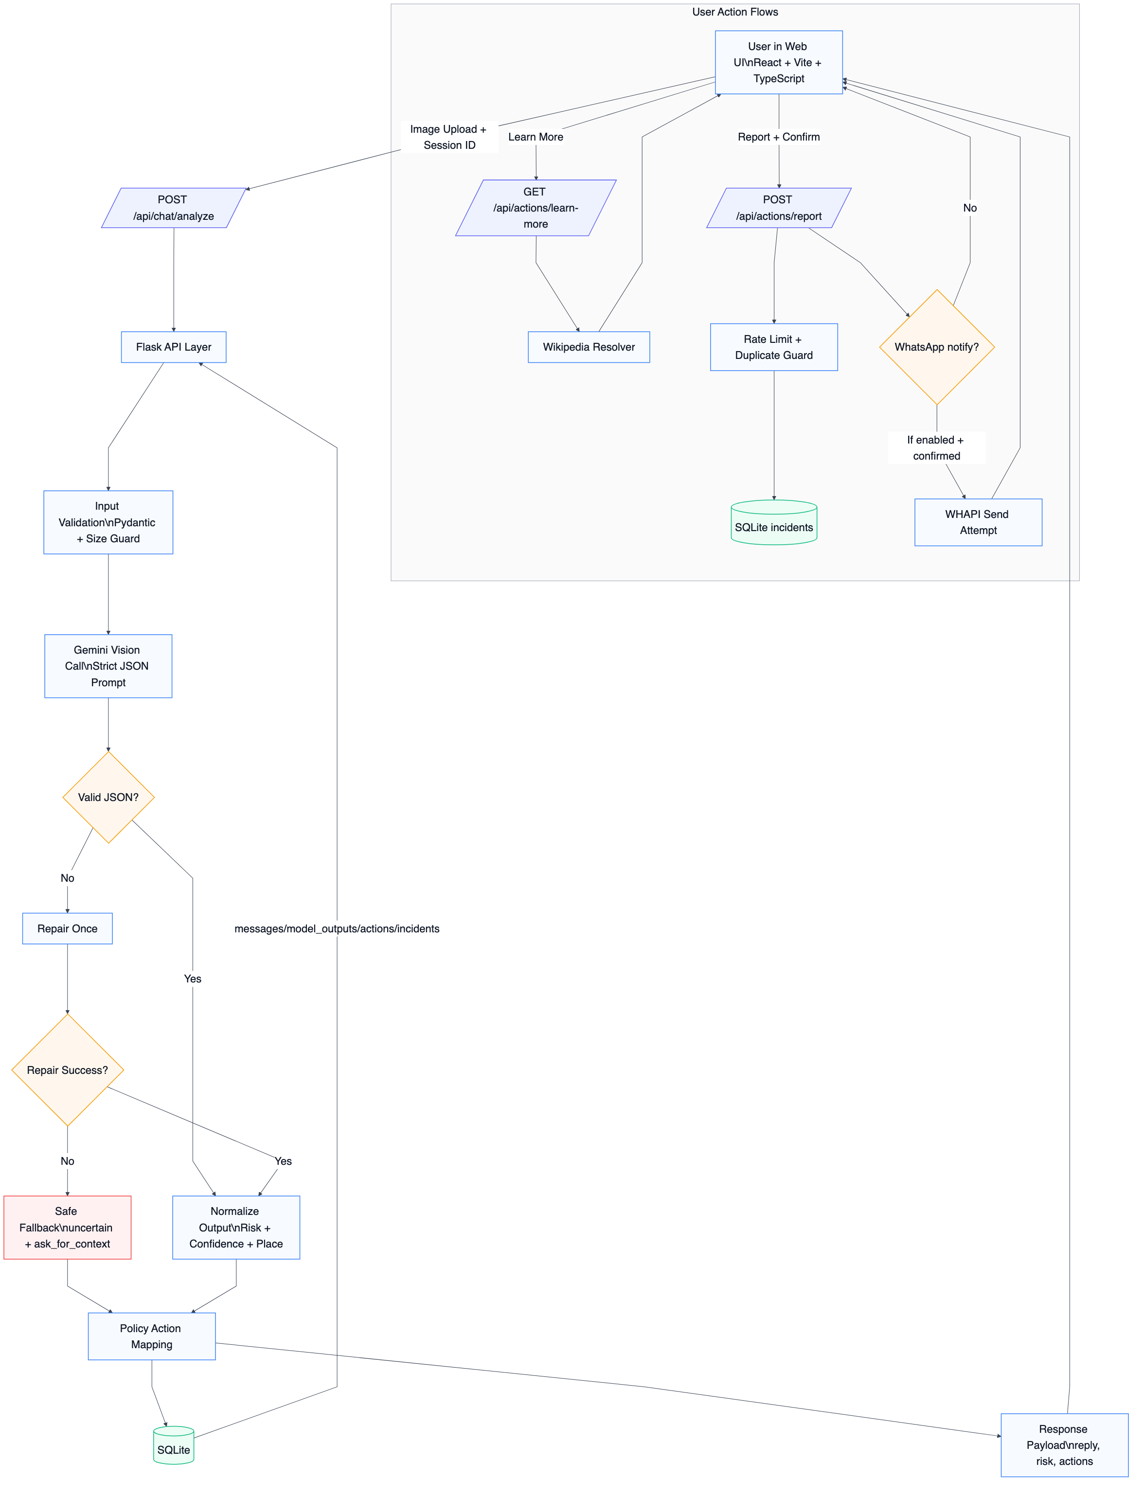
System architecture of the proposed multimodal hazard-aware response pipeline.

Model and Implementation Details
The multimodal backbone used in this work is Gemini 2.5 Flash (vision-capable), configured to return strict JSON output with controlled temperature. The prototype is implemented with a Python-Flask service layer, SQLite persistence, and a React-based web interface for image upload and human-in-the-loop action selection. The operational flow is image upload, multimodal inference, structured normalization, risk-to-action mapping, and optional authority notification after explicit user confirmation. The persistence layer stores sessions, messages, model outputs, and incident actions as auditable records.

Risk Decision Logic
Risk assignment combines model output with deterministic safety rules. Let $r_{m}$ and $c_{m}$ denote model risk and confidence. Let $h=1$ when hazard keywords are present in summary, rationale, or user context, and $h=0$ otherwise. The final decision follows:
$$r=\left\{\begin{matrix}\text{high}, & h=1\text{ and }r_{m}∈\{\text{low, uncertain}\} \\ r_{m}, & \text{otherwise}\end{matrix}\right.$$
$$c=max(c_{m},0.72) \text{when }h=1$$
Action mapping is deterministic: if $c<0.45$ or $r=\text{uncertain}$, the system asks for additional context; if $r=\text{high}$, report and safety actions are shown; if $r=\text{low}$, informational actions are shown.

Memory and Retrieval Scope
This prototype does not yet use a vector database or nearest-neighbor image retrieval for production decisions. The working memory is a structured SQLite store of prior model outputs, incidents, and actions. Therefore, geospatial grounding in the current implementation is model-driven and log-audited rather than embedding-retrieval driven. A dedicated OCR subsystem is also not separately integrated; text cues are interpreted directly by the multimodal model.

Hazard-Aware Inference Flow
The operational flow is:
- Input image $I$.
- Generate structured multimodal output $o←GeminiVision(I)$.
- Normalize fields to obtain summary, risk, confidence, entities, and place estimate.
- Apply hazard keyword rules to update final risk-confidence pair $r,c$.
- Map $r,c$ to action set $A$ using deterministic policy thresholds.
- If user confirms report action, create incident record and optionally send authority notification.
- Persist message, output, and action records.
- Return structured response and action options.

Results and Performance Measures

Evaluation Dataset
Evaluation uses a local project dataset created from the prototype test images and persisted SQLite run logs. The dataset has two parts. First, the case-study image set contains two manually verified Shaniwar Wada inputs: one regular landmark image and one fire-affected hazardous image. Second, the run-log dataset contains all available image-analysis endpoint executions stored in the project database at the time of evaluation. A run is defined as one invocation of the image-analysis endpoint that produces one structured model output record.
Evaluation Dataset Description
Dataset Part | Size | Purpose
Case-study images | 2 images | Manual verification of normal and hazardous Shaniwar Wada behavior.
Persisted run logs | 22 runs | Risk distribution, confidence behavior, action logging, and incident outcome analysis.
User sessions | 14 sessions | Session-level coverage of repeated uploads and user actions.
The run-log dataset contains 22 runs across 14 user sessions. Among these runs, low- and high-risk outcomes each occur eight times, while uncertain outcomes occur six times. The confidence score is taken from the model output and normalized to the $[0,1]$ interval by post-processing logic. Since this is a proof-of-concept project dataset rather than a public expert-labelled benchmark, the evaluation reports operational performance indicators and manually verified case-study accuracy instead of claiming full benchmark classification accuracy.
Available Dataset and Log Summary
Measure | Value
Total analyzed runs | 22
Distinct sessions | 14
Low-risk outputs | 8
High-risk outputs | 8
Uncertain outputs | 6
Average confidence | 0.623
Confidence range | 0.00–0.95
The result objective is action relevance rather than only distance-scale geolocation bins. User-confirmed incidents are records created only when the report request is submitted with confirmation enabled. Ten such incident records are present. External notification is a separate environment-gated stage, not the same as incident confirmation. In the available logs, three reports were eligible for external notification and all three were sent successfully. The remaining seven incidents were retained as local confirmed incident records because notification was not requested or notification credentials were disabled during those runs.
Hazard-Action Outcome Summary
Outcome | Count
User-confirmed incidents | 10
Environment-enabled notification attempts | 3
Successful notification sends | 3
Local-only incident records | 7
Report actions logged | 10
Learn-more actions logged | 12

Evaluation Parameters
The evaluation parameters are selected to match the system objective, which is hazard-aware decision support rather than only geodesic location prediction. The measured parameters are: (i) risk-level distribution, (ii) model confidence range and average confidence, (iii) confidence-band distribution, (iv) risk-action consistency on manually verified samples, (v) incident logging count, and (vi) external notification success rate when notification is environment-enabled. These parameters measure whether the system produces interpretable risk decisions, handles uncertainty, and maps high-risk outputs to the expected user-confirmed action path.
Evaluation Parameters
Parameter | Measurement
Risk distribution | Count of low, high, and uncertain outputs.
Confidence behavior | Mean, range, and confidence-band share.
Risk-action consistency | Expected action for manually verified normal and hazardous samples.
Incident handling | Count of user-confirmed incident records.
Notification success | Successful sends divided by environment-enabled notification attempts.

Confidence Distribution
Confidence values span from 0.00 to 0.95 with mean 0.623. Six runs (27.3%) fall below 0.30 and represent uncertain or fallback behavior. Five runs (22.7%) lie in the middle band from 0.30 to 0.79. Eleven runs (50.0%) are in the high-confidence band from 0.80 to 0.95, mainly corresponding to clear monument or clear hazard scenes.
Because the available project dataset is a log-based prototype evaluation rather than a fully expert-labelled benchmark, accuracy is reported using directly verifiable operational indicators. Risk-action consistency is 100% for the two manually checked Shaniwar Wada samples: the normal image was assigned low risk with a learn-more action, and the fire-affected image was assigned high risk with a report action. For external notification, the success rate over environment-enabled notification attempts is also 100% (3 successful sends from 3 attempts). Full classification accuracy, precision, and recall require a larger independently labelled hazard dataset and are treated as future validation work.
Confidence Band Distribution
Band | Count | Share
Low ($<0.30$) | 6 | 27.3%
Mid ($0.30$–$0.79$) | 5 | 22.7%
High ($≥0.80$) | 11 | 50.0%

Shaniwar Wada Sample Input-Output
To demonstrate behavior on concrete samples, two images from the test set are used as a normal Shaniwar Wada scene and a fire-affected scene. The corresponding stored outputs in the local SQL logs (records 16 and 17 in model output history) show low-risk confidence 0.95 for the normal scene and high-risk confidence 0.85 for the fire-affected scene. Both outputs identify the place as Shaniwar Wada, Pune, Maharashtra, India, while only the fire-affected case produces emergency-oriented recommendations.
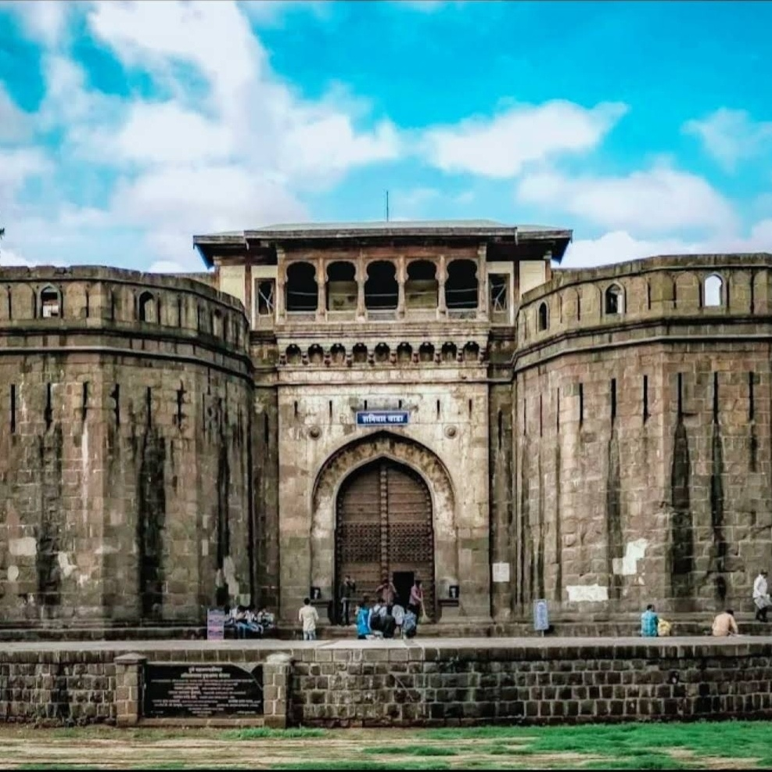 | 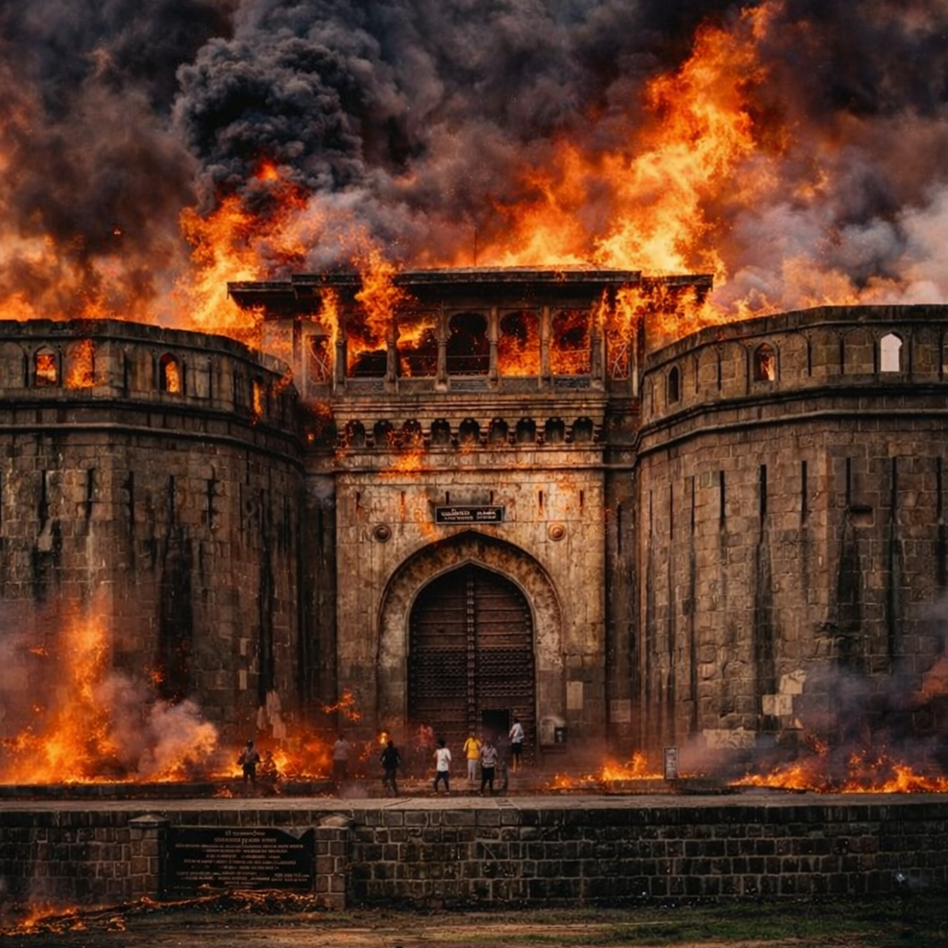
Shaniwar Wada test images used for normal and hazardous case analysis.
Shaniwar Wada Case Study Output
Sample | Risk | Confidence | Primary Action
Sample A (normal) | low | 0.95 | Learn More
Sample B (fire-affected) | high | 0.85 | Report

Robustness and Failure Cases
Two failure modes are visible in the stored outputs. First, uncertain outputs with confidence 0.0 occur when structured content is incomplete or cannot be reliably parsed, resulting in conservative fallback behavior. Second, fallback hazard escalation can produce high-risk outputs at confidence 0.72 when hazard terms are present but detailed reasoning is missing. These cases are safety-oriented but may increase false alerts, indicating the need for better confidence calibration and stronger structured-output reliability.

Conclusion
The proposed hazard-aware multimodal decision framework preserves interpretability while adding actionable safety response. Results on available datasets and persisted logs show reliable separation of normal and high-risk scenes, with confirmed incident actions when hazardous conditions are detected. The architecture demonstrates that structured multimodal reasoning can support practical geospatial understanding and safety triage in a single workflow.
Arandjelovic, Relja, Petr Gronat, Akihiko Torii, Tomas Pajdla, and Josef Sivic. 2016. “NetVLAD: CNN Architecture for Weakly Supervised Place Recognition.” IEEE Conference on Computer Vision and Pattern Recognition, 5297–307.
Cheng, F., J. Wang, S. Wang, Z. Huang, and X. Li. 2025. GeoGuess: Multimodal Reasoning Based on Hierarchy of Visual Information in Street View.
Gemini Team. 2024. Gemini: A Family of Highly Capable Multimodal Models.
Haas, Lukas, Marta Skreta, Silas Alberti, and Chelsea Finn. 2024. “PIGEON: Predicting Image Geolocations.” IEEE/CVF Conference on Computer Vision and Pattern Recognition, 12893–902.
Li, Junnan, Dongxu Li, Silvio Savarese, and Steven Hoi. 2023. “BLIP-2: Bootstrapping Language-Image Pre-Training with Frozen Image Encoders and Large Language Models.” International Conference on Machine Learning, 19730–42.
Li, Lei, Rui Yu, Qiang Hu, et al. 2025. From Pixels to Places: A Systematic Benchmark for Evaluating Image Geolocation Ability in Large Language Models.
Liu, Haotian, Chunyuan Li, Qingyang Wu, and Yong Jae Lee. 2024. “Visual Instruction Tuning.” Advances in Neural Information Processing Systems 36.
Lowe, David G. 2004. “Distinctive Image Features from Scale-Invariant Keypoints.” International Journal of Computer Vision 60 (2): 91–110.
Lyu, Zhihao, Jie Zhang, Ming Lu, Yifan Li, and Chen Feng. 2024. Tell Me Where You Are: Multimodal LLMs Meet Place Recognition.
Radford, Alec et al. 2021. “Learning Transferable Visual Models from Natural Language Supervision.” International Conference on Machine Learning, 8748–63.
Sarlin, Paul-Edouard, Daniel DeTone, Tomasz Malisiewicz, and Andrew Rabinovich. 2020. “SuperGlue: Learning Feature Matching with Graph Neural Networks.” IEEE/CVF Conference on Computer Vision and Pattern Recognition, 4938–47.
Sinski, Bartlomiej, Adam Zychowski, and Jacek Mandziuk. 2024. “Improving Image Geolocation with Multimodal Deep Learning.” Neural Information Processing.
Torii, Akihiko, Josef Sivic, Masatoshi Okutomi, and Tomas Pajdla. 2015. “Visual Place Recognition with Repetitive Structures.” IEEE Transactions on Pattern Analysis and Machine Intelligence 37 (11): 2346–59.
Vo, Nam, Nathan Jacobs, and James Hays. 2017. “Revisiting IM2GPS in the Deep Learning Era.” IEEE International Conference on Computer Vision, 2621–30.
Waheed, Syed, N. M. An, Michael Milford, Sarvapali D. Ramchurn, and Shoaib Ehsan. 2025. VLM-Guided Visual Place Recognition for Planet-Scale Geo-Localization.
Wang, Zeyu, Difei Xu, R. M. S. Khan, Yiqi Lin, Zhi Fan, and Xingquan Zhu. 2024. LLMGeo: Benchmarking Large Language Models on Image Geolocation in-the-Wild.
Weyand, Tobias, Ilya Kostrikov, and James Philbin. 2016. “PlaNet - Photo Geolocation with Convolutional Neural Networks.” European Conference on Computer Vision, 37–55.
Wu, Mingling, and Qunying Huang. 2022. “IM2City: Image Geo-Localization via Multi-Modal Learning.” ACM SIGSPATIAL International Workshop on AI for Geographic Knowledge Discovery, 50–61.
Yerramilli, S., N. Pande, R. Grover, and J. S. Tamarapalli. 2025. “GeoChain: Multimodal Chain-of-Thought for Geographic Reasoning.” Findings of the Association for Computational Linguistics: EMNLP, 23624–39.
Zhou, Zilong, Jie Zhang, Ziyue Guan, et al. 2024. “Img2Loc: Revisiting Image Geolocalization Using Multi-Modality Foundation Models and Image-Based Retrieval-Augmented Generation.” International ACM SIGIR Conference, 2749–54.

