Title of the Analysis

First Author

Second Author

15 July, 2020

# Introduction

This is intended to be a test, to verify the rendering function works as it should.

# Results

## Analysis 1

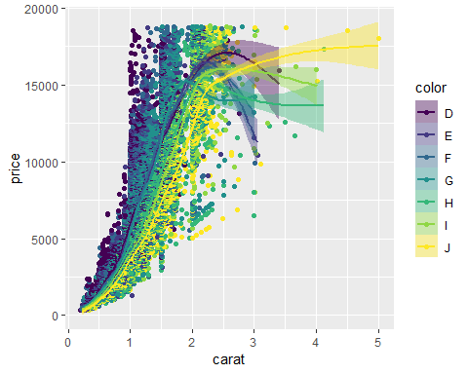

## Analysis 2

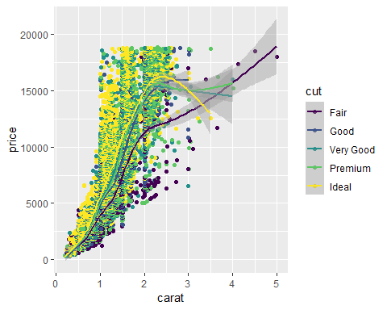

# QC

This is just a test, nothing to be shown here.

# Materials and Methods

This is just a test, nothing to be shown here. Data use available datasets as part of the *ggplot2* package.