**HTTPTAPI**

Windows TAPI CTI integration für web-enabled applications - click-to-dial für SNOM phones and Asterisk. HTTPTAPI allows you to map TAPI requests to HTTP requests, adaptable to every web-enabled application.

**About HTTPTAPI**

HTTPTAPI is a TAPI service provider (TSP) für MS Windows. HTTPTAPI enables you to map the dial requests of TAPI applications (e.g. MS Outlook) to HTTP request. The HTTP target (the URL) can be configured flexible, allowing adaption to various web-services.

HTTPTAPI itself does not offer any telephony features but links TAPI requests to HTTP requests as shown in the following Figure:

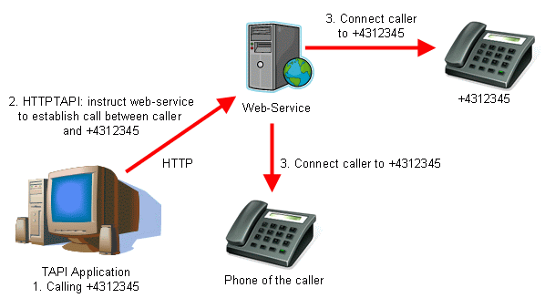

The web-application can be a proprietary interface to a telephony service (e.g. the web interface of a VoIP provider), an Asterisk PBX (using Asterisk's AJAM web interface) or a SIP phone with an embedded web server like SNOM phones as shown below:

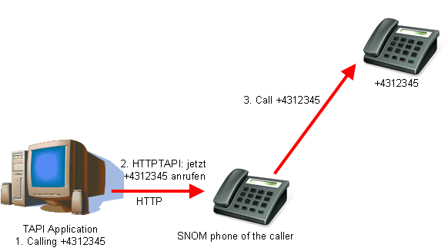

**Documentation and Support**

HTTPTAPI comes with an installation manual. The configuration is rather easy as the configuration dialog is self-explanatory and includes examples for Asterisk and SNOM phones (see screenshot [1](https://www.ipcom.at/fileadmin/ipcom/files/httptapi/httptapi_screenshot.gif), [2](https://www.ipcom.at/fileadmin/ipcom/files/httptapi/httptapi_screenshot_outlook.gif)).

If you still have issues with HTTPTAPI please directly klaus.darilion (at) ipcom.at directly.

**License**

HTTPTAPI was a commercial application and required a license to activate the requested number of lines. Either recompile HTTPTAPI to remove the license check, or use the following license for a unlimited single-line usage:

CE3rCZyNoZykP57K0x0mRgCkIz9vr17CLCJtLOKDiYp6/GnAQex1C+MHr8c15k4J4+cLXUbJBvc=

**Debugging HTTPTAPI**

To debug HTTPTAPI problems you have to enable the debug logging of HTTPTAPI. Then HTTPTAPI will write log messages to c:\httptapi.log. If you see such a file, please send the file by email. If you do not see such a file, you have to use the tool DebugView from Microsoft to capture the log messages. Then send the the captured log messages by email. Please follow the step-by-step guide below.  
  
When sending me emails, please always include the Windows version you are using and a screenshot of the HTTPTAPI configuration.  
  
1) Close your dialer application and all other applications  
  
2) HTTPTAPI  
Start the telephony control panel as Administrator. The fastest way to do this without logging in as Administrator is to navigate with Explorer to c:\Windows\system32. There right-click on "telephon.cpl" and select "Run as administrator". Navigate to the settings of HTTPTAPI and set the "Debug Level" to 5. Then click OK.  
  
3) Verify if there is now a file c:\httptapi.log. If yes, proceed. If no, go to step 7)  
  
4) Start your dialer application and perform a call. You should see now plenty of log messages in c:\httptapi.log.   
  
5) Reset the log level of HTTPTAPI to "0" as described in step 2)  
  
6) Send me the file c:\httptapi.log by email. Done!  
  
7) DebugView  
Download DebugView from https://technet.microsoft.com/en-us/sysinternals/debugview.aspx  
Unzip the tool. Then right-click the Dbgview (Dbgview.exe) application and select "Run as administrator". In the DebugView tool go to the menu "Capture" and enable "Capture Global Win32"  
  
8) Start your dialer application and perform a call. You should see plenty of log messages appearing in DebugView which have the prefix "HTTPTAPI". In DebugView use File->Save As to save the log messages to the hard disk (e.g. c:\log.txt). Then send me this file by email.  
  
9) Reset the log level of HTTPTAPI to "0" as described in step 2) Done!