Group Project – Build A Web Application

Name and student numbers of all team members and Web Application Name

Student Name 1: | Nicolas Brito | Student Number | 3164395
Student Name 2: | Leticia Gomes | Student Number
Student Name 3: | Samuel Silva | Student Number

Web Application Name:

The pages

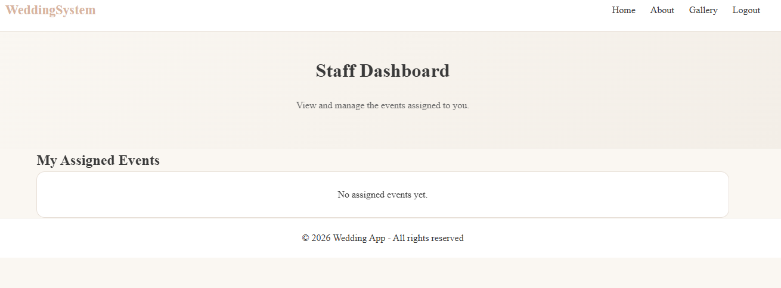

Extra features and improvements, (if any)
Screenshots and a line of explanation for each.

ERD of Final Database Design
Provide the final version of your database design (ERD).

Site Map of Final Website
Include a site map showing how the pages work together and a few sentences of explanation.

Division of Labour

Please complete the section below regarding the estimate of the division of work between the three team members.

Summary of the division of work
If the work was split in the range of 25% to 40% per team member, that is fine and simply say, “Work was evenly divided”. If this was not the case, then state with a summary sentence.
Division of work: work was evenly divided

Percentage of work completed by each partner on each class/task
Some area requires more work than others, so this is only for reference.

Filename / Task | Student Name 1 | Student Name 2 | Student Name 3
Database Design | 100%
Database implementation | 10% | 40% | 50%
GUI design |  | 100%
GUI implementation | 50% | 50% | 10%
Server-Side Validation/Sanitization | 30% | 30% | 40%
Etc.

